FARMHUB{A-05}

**2020**

SIDDHI MISHRA

SheHack’2020

10/4/2020

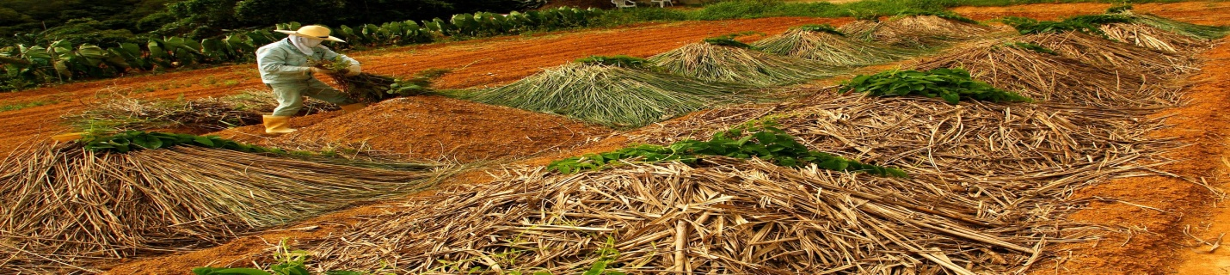

**Introduction:**

**Overview:**

**according to data of 2011 census,68.84 of Indians lives in the village & 61.5% of 1300 million India population is ruler dependent and dependent on agricultural. Due to COVID many millions of workers migrated to villages. if we truly concern about increasing GDP etc. , we can be done using commercialised our farms and let the farmers manage the Field’s production directly communicates using the technology to markets. Through that, we can evenly distribute our field production to the whole of the country and can double the income of farmers. If we can manage our production in a proper way it's easier to reduce the cost of the basic requirement of our life i.e. surely can be done by & 70% by field production, not from any multinational production industries.**

**Also it's important part of farming is the prediction of demand ,it found common trends in current years that some crop production price goes down such way that farmers couldn't get back their investment on crops and in second some crop production whose availability is less than demand tend to cause their price much high in market. Food forecasting is an important tool for farmers as well as the markets.**

**1.2) Purpose:**

**Taking the above things in consideration I have designed my project "FarmHub", which help farmer to forecast about the demand using visualisation dashboard and also provide some functionality which help farmers as well as markets in farm product management/business.** **To do this, I have followed the following steps:**

* **Use code that is written in Node.js (Node Red), with the server-side using the Express framework and the client using ReactJS.**
* **Use the pre-built IBM Watson Functionalities.**
* **Access the Watson Discovery Service through the Discovery API.**
* **Use IBM cloud DB2 services to store the Database and to generate Query.**
* **Host the app on IBM Cloud.**

**Literature Survey**

**2.1) Existing Problem:**

**Currently available farm website and application like food basket etc. are run by some market products which is aim for some organizational profit, therefore it might possibility that the data result they have given is not accurate and fair. Also the food forecasting technology is not easily accessible to farmers. Following is some popular farm management sites:**

**1. Farm Manager: Track your fields, crops and varieties for full product tractability,**

**View fields map, track fields history and more.**

**2. Agrivi: it mobile application lets farmers get fast insight into their farming activities and register key activities right from the field. It is used as an extension and supporting feature to our fully featured web farm management solution. New mobile application users should setup their farms through our web application to get insight into their farming via mobile app.etc.**

**Also I found other sites I found that it’s hard to find any Food demand forecasting sites, some available ones are for restaurants and other hotels food prediction systems.**

**So I analyze the following functionality required along with the existing system:**

1. **Forecasting the food demand: to help farmers to decide their crop for particular farm year and to decide their investment on crop accordingly.**
2. **Online platform which provide farmer to put their crop detail to be sold and help farmers to find suitable markets & markets to find farm area from where they can satisfy their requirement.**

**2.2) Proposed solution:**

**I developed a platform for farmers, which is an open-source platform where the request to sell and buy of given farm production as in form of push and pull request & forecast the food demand, it would having the following facilities as listed down:**

**1. Farmers can get predicted the market value of the crop that year and also can register through filling the form “Push Request” before they invest and start particular crop cultivation. it called predicted push request.**

**2. Different small industries and other organization can set up their requirement by only posting the request as we do in any open-source platform, it will be called an initial pull request ,through “Pull Request” form.**

**3. after the harvesting of crops, the farmer can push their actual request and get some suggestion which uses query of DB2, to which market they can pull their crop along with an accurate prediction of suitable place where market price +transportation cost will maximize the profit. Here I would also like to mention that software analyses other predicted push to request that if they push their crop with x,y,z farmer of his locality, the transportation cost can be minimized.**

**4. We can also provide food forecast technique to standardize the software product and help farmer to choose the crop for given session**

**5. We can also extend it to dairy and other agriculture product so Farming/agriculture can become business as was in a few centuries ago.**

**Theoretical Analysis:**

**Flowchart/Block diagram:**

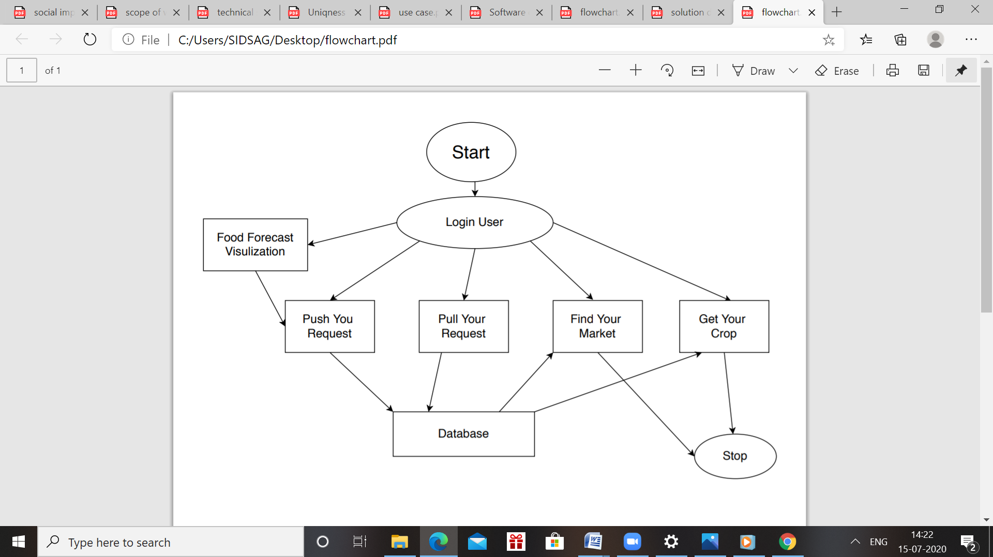

**Software Design**

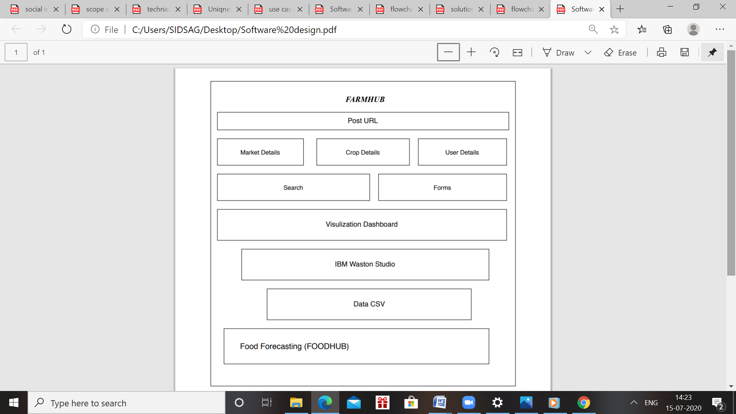

**Description:**

**Database Query Description:**

**1) Authentication from login Page from Farmer detail Database using email & password**

**2) Query from "Get you Crop" on Crop Detail database is the following:**

**Select FARMAREA from CropDetail where Crop Requested=CROP_DETAIL && MaxCOST>=(dfr-DFR)*transportation charge+MIN_COST_REQ**

**3) Query from "Find your Market" on MARKET_DETAIL is following: Select Market_Name & CONTACTAT where crop to sold=CROPreq && (dfr-DFR)*transportation charge+MinCost>=maxCOST**

**Experimental Investigation**

**In this process of developing the project I have undergone many investigation processes to learn and understand new concepts so that I can build the news search application successfully. For I had to learn and investigate following:**

* **IBM Cloud.**
* **Node Red.**
* **IBM Watson IOT.**
* **Integration of IOT with Node-Red Flow.**
* **IBM DB2 application.**
* **Integration of Database to Node-Red flow**
* **Software designing(Use cases/DFD etc.)**
* **ZOHO Writer.**

**Following is the details of application I used in my project:**

**Node-Red:** Node-RED is a programming tool for wiring together hardware devices, APIs and online services in new and interesting ways.

It provides a browser-based editor that makes it easy to wire together flows using the wide range of nodes in the palette that can be deployed to its runtime in a single-click.

**IBM Watson IOT:** .A fully managed, cloud-hosted service with capabilities for device registration, connectivity, control, rapid visualization and data storage. From chip to app to cloud, take full advantage of cognitive Watson APIs, visual dashboards, rich developer resources and industry-leading security to accelerate enterprise IoT insight.

**DB2:** IBM Db2® Database is a [relational database](https://www.ibm.com/analytics/relational-database) that delivers advanced data management and analytics capabilities for your transactional workloads. This operational database is designed to deliver high performance, actionable insights, data availability and reliability, and it is supported across Linux, Unix and Windows operating systems.

**ZOHO Writer:** Zoho Writer is an intriguing office application, to say at least. Its multiple functionalities allow writers who publish vast online content to create and edit on dot, being able to work in groups and to share content in all types of formats. This being said, Zoho Writer is incredibly powerful when it comes to cutting time and reducing communication expenses**.**

**Technical Stack**

**Flowchart**

**Use Case Diagram:**

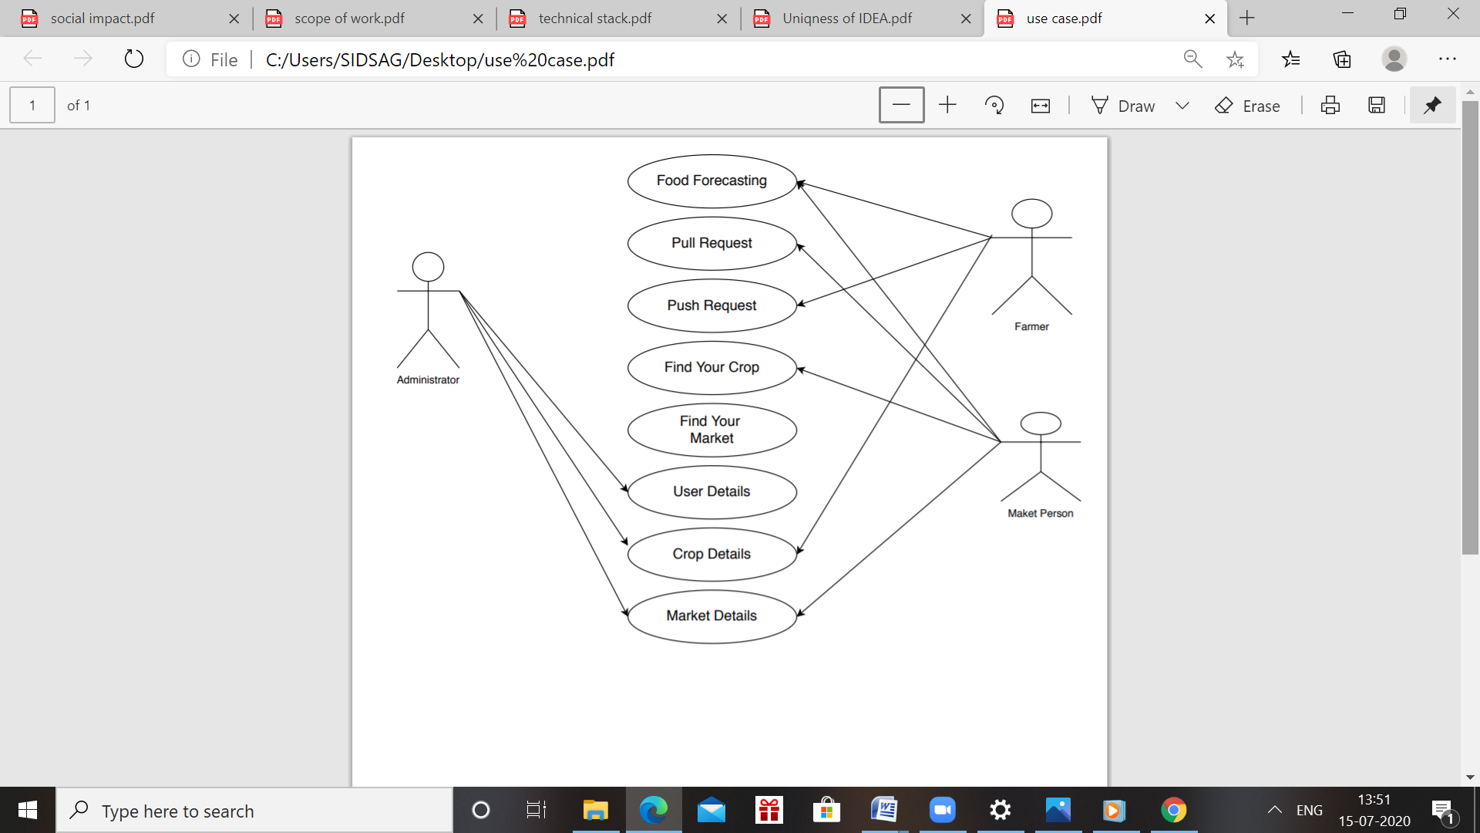

**Data Flow Diagram:**

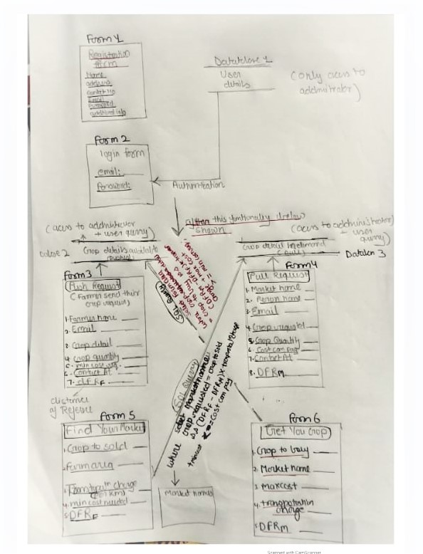

**RESULT**

**Following is the UI of my project:**

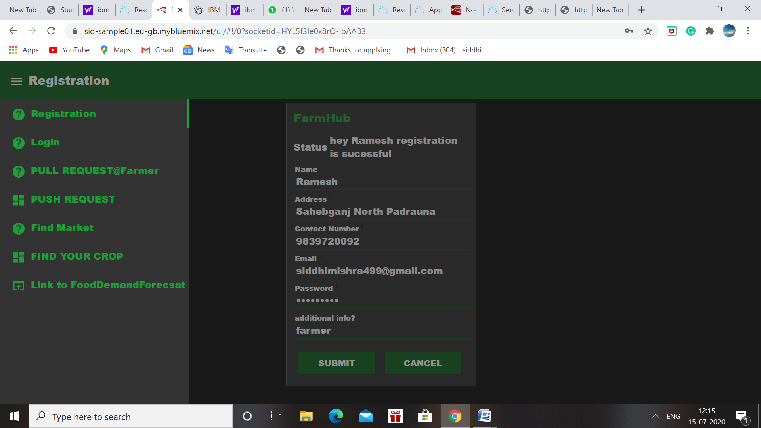 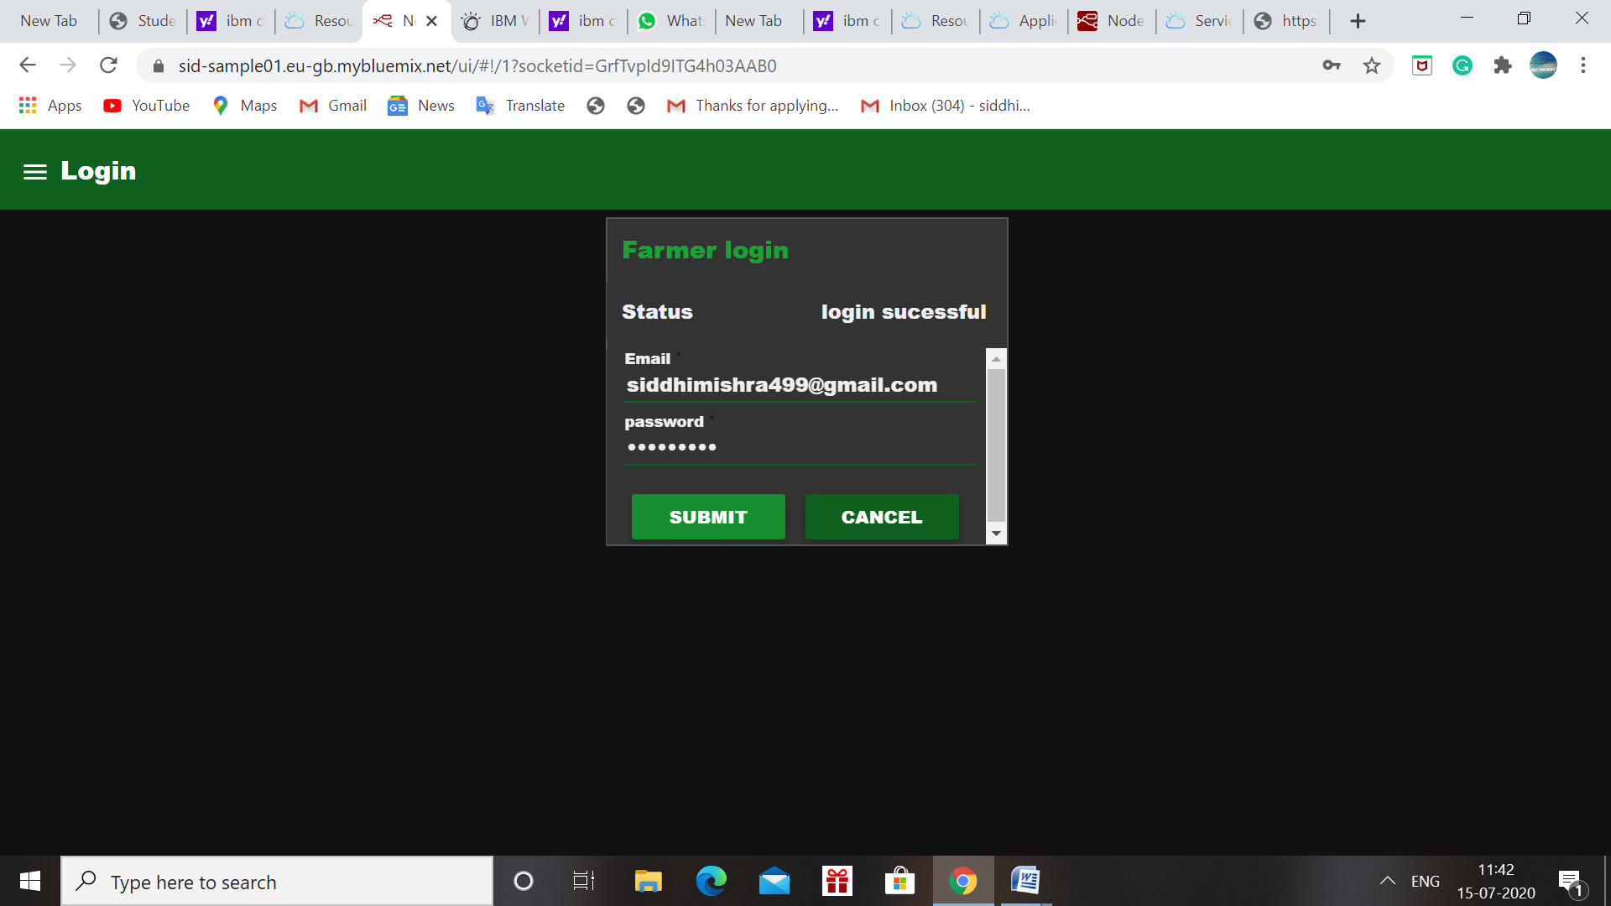

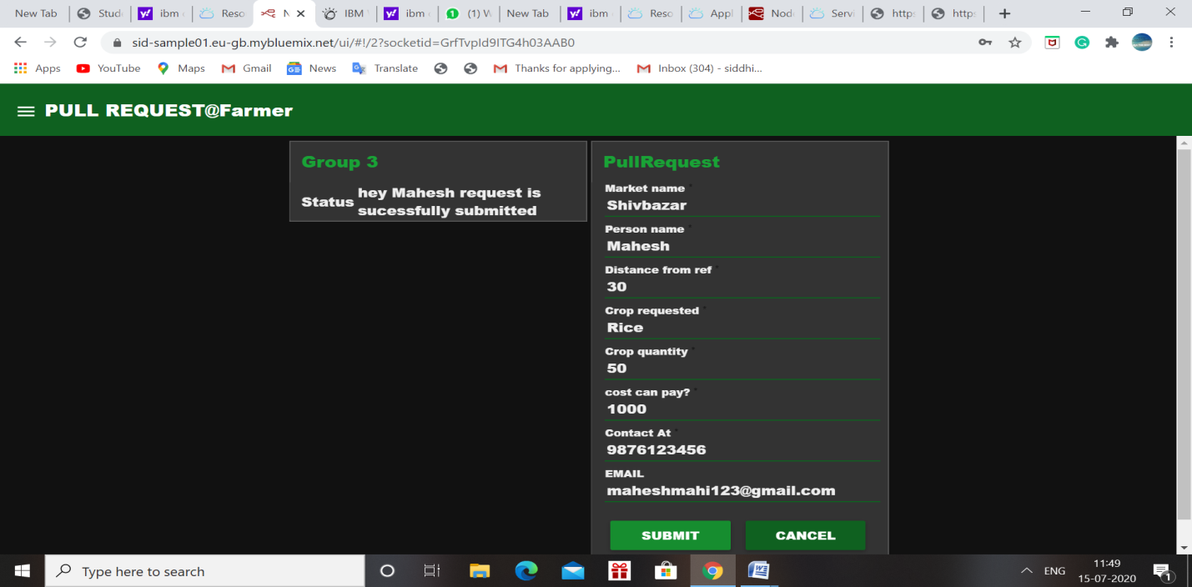

**Pull request Form (as an Initial pull request)**

**Advantage:**

**FarmHub application includes following advantages:**

* **Easy to access the food forecast demand to predict demand helpful for market to push their request earlier.**
* **Less time and without going market, we can find the best suitable market and price.**
* **Helpful to markets, taking consideration of current situation.**

**Disadvantage:**

**Project has following constraint on which work is required:**

* **Language constraint as most of the farmer hasn’t knowledge of English so language of application should be multiple.**
* **Need to work on data security.**

**APPLICATIONS**

**I am proposing a application related to farms management of our country, according to data of 2011 census,68.84 of Indians lives in the village & 61.5% of 1300 million India population is ruler dependent and dependent on agriculture .also due to COVID many lacks of workers migrated to villages. if we truly concern about increasing GDP etc. , we can be done using commercialized our farms and let the farmers manage the field's production directly communicate using this technology to markets. Through that, we can evenly distribute our field production to the whole of the country and can double the income of farmers. If we can manage our production in a proper way it's easier to reduce the cost of the basic requirement of our life i.e. surely can be done by & 70% by field production, not from any multinational production industries.**

**I choose this model as it's the most untouched part of our technology perspective as most of us consider industries and cities betterment. I am currently living in my hometown near Gorakhpur, a known farming area of Utter Pradesh. I realized that "during lockdown how all the vegetables and other farms product are ruin due to lack of direct connectivity between the channels as markets are half-closed & lack of proper management .in some parts of the country some crop product like green vegetables/fruits etc are dumped as the production of that year are more than expected so the supply of that is not done in the proper manner. I got the news that many industries/cities not getting raw farm products in a proper way & as we should have to live with this scenario for unpredicted time so such activities may demotivate farmer for further cultivation investments. if we develop this technology it can be good equipment to handle the current situation for authorities and definitely is a good initiative. So, in short, we can nullify the middleman cost of farm products which is actual loss of farmers and units of demand.**

**Note: in my description much time I used term which usually used for a business purpose, not for farmers of our country, I emphasized here that's what I have the goal to Make Farming a business for backbone of our GDP/production "our Farmers", not as any ruler level activities. As it's not only education from which our villages are deprived of, but also technology advancement is also the factor which is more confined to the cities of our country. So it's time when along with our mechanical/civil technology our software technology also give their profound contribution to the betterment of ruler area of our country.**

**Conclusion:**

**This project uses some basic working knowledge of the Watson IoT and shows how to use with Database (DB2) and Node Red to build your own news mining web application. This project also tells about the integration process of Database with the Watson IOT services to access and DB2 to Node-Red create an application FarmHub which help Famers & markets/Industries for crop production management.**

**FUTURE SCOPE:**

* **We can use some AI prediction technology to enhance the demand forecasting application.**
* **Use SQL for further retrieval of data which might helpful to farmers.**
* **Use IBM NLP application to give feature of different language option in application.**
* **Provide data security mechanism by which we can avoid misuses of data we provide to user.**
* **Develop a helping dashboard using IBM Chabot which can guide user about functionality and can resolve some common issues.**

**BIBILOGRAPHY**

**Name: Siddhi Mishra**

**College: Indira Gandhi Delhi Technical University for women, Delhi.**

**Work Title: FarmHub**

**References:**

1. IBM Cloud Documentation:

<https://cloud.ibm.com/docs/appid>

1. IBM Watson IOT: <https://cloud.ibm.com/docs/IoT/index.html>
2. IBM Cloud: <https://www.ibm.com/cloud/get-started>
3. Node red tutorial: <https://developer.ibm.com/tutorials/how-to-create-a-node-red-starter-application/>
4. Watson services and product: <https://www.ibm.com/watson/products-services>

**APPENDIX**

**Link to Node-Red UI:**

[**https://sid-sample01.eu-gb.mybluemix.net/ui/#!/5?socketid=yPzkMaOfQNMg2JXAAAB6**](https://sid-sample01.eu-gb.mybluemix.net/ui/#!/5?socketid=yPzkMaOfQNMg2JXAAAB6)

**Thanks!!**