**JOUR(4|7)79V Project Proposal**

For our final project, we propose investigating the unconscious biases involved in our politics. To do this, we will look at the Google autocomplete suggestions for various demographics and groups within the United States Congress. Within each of these groups, we will compute a “word cloud” of the most suggested search terms, and compare them, in order to find search terms disproportionately represented within certain groups. We expect that demographic groups, such as female or minority lawmakers, could potentially generate greater interest in specific areas, such as their appearance or life story. In addition, partisan groups, such as Republicans and Democrats, should have different associated search terms, since they should tend to tackle different policy areas. Examining these could give insight into what aspects of these perspectives are potentially misleading voters in making their political judgments.

In order to do so, we will use data from GovTrack using API provided by the site (<https://www.govtrack.us/developers/api>). To see if there is any difference in autosuggestion results, we ran two sets of exploratory analysis to compare gender (male and female) and party (democrat and republican). We found each keyword suggested as an autocompletion for the name of a member of Congress in each category.

First we ran word cloud analysis on each category that resulted in four figures as shown below.

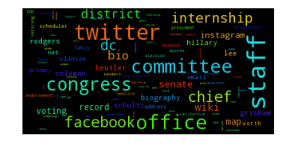

Figure Autosuggestion results for female representatives

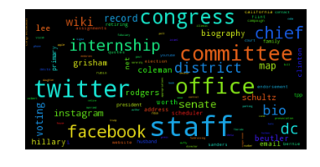

Figure Autosuggestion results for male representatives

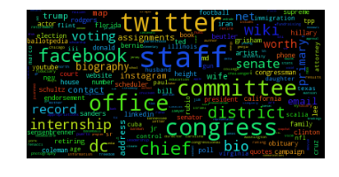

Figure Autosuggestion results for republicans

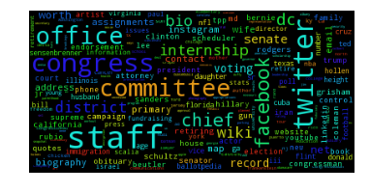

Figure Autosuggestion results for Democrats

To better capture what are the most appearing terms, we then compared the percentage of members of Congress in each category who had each keyword suggested. For example, for 121 Democrats and 139 Republicans, ‘committees’ was a suggested search term. Since there are 238 Democratic and 301 Republican members of Congress, 51% of Democrats and 46% of Republicans have ‘committees’ suggested. This means that the term skews 4.2% Democrat, making it the 5th most proportionally Democratic term in our preliminary results.

|  |  |  |  |  |
| --- | --- | --- | --- | --- |
|  | **Democrat** | **Republican** | **Female** | **Male** |
| **1** | Internship | Primary | Internship | Wife |
| **2** | Office | Facebook | Staff | Congress |
| **3** | TPP | Voting record | DC office | Wiki |
| **4** | Hillary Clinton | Trump | Twitter | Congressman |
| **5** | Committees | For Congress | Chief of staff | LinkedIn |

Our preliminary results definitely seem to have some associated stories. For example, every social network is primarily female except LinkedIn (which is suggested for only male politicians), but they are also primarily Republican except Instagram, which is noteworthy considering that the majority of female members of Congress are Democrat. This might also be related to the fact that most campaign-related queries, such as “for Congress,” are primarily Republican, as well as the current Republican control over Congress. There is some conventional wisdom that Democrats are more focused on presidential politics, which is also potentially related.

For further analysis to discover interesting finding and construct news worthy stories, we plan to make comparisons between other possible data points provided through API by govtrack.us. For example, we can compare representatives who own social media accounts versus those who don’t, or representatives who co-sponsored different types of bills with a focus on controversial ones. Comparing across different time stamps can be another option. Also we can filter out the representatives who are recently associated with some political scandals and see how autosuggestion takes different patterns across those individuals.