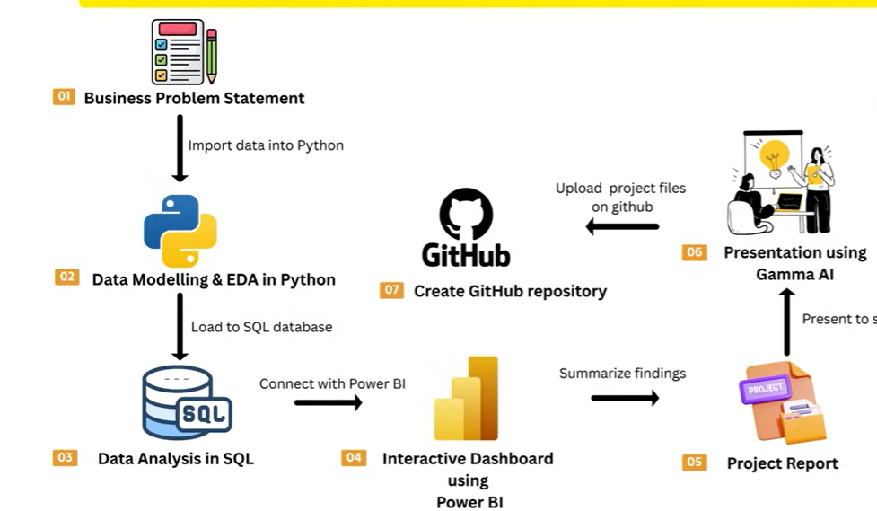

Step 1: Data Preprocessing and Acquisition
Our initial phase involves the extraction and ingestion of the dataset into Power BI. This foundational step enables us to initiate the data cleaning and preparation processes, ensuring the information is refined for effective visualization and analysis.
The dataset provided (Click HERE to view) has 3,900 rows and 18 columns (Customer ID, Age, Gender, Item Purchased, Category, Purchase Amount (USD), Location, Size, Color, Season, Review Rating, Subscription Status, Shipping Type, Discount Applied, Promo Code Used, Previous Purchases, Payment Method, and Frequency of Purchases). Now let’s bring in our data.

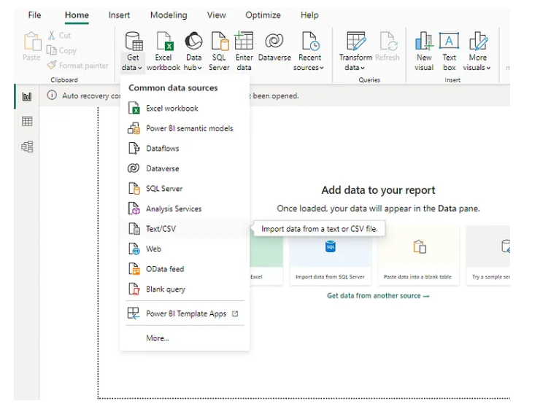

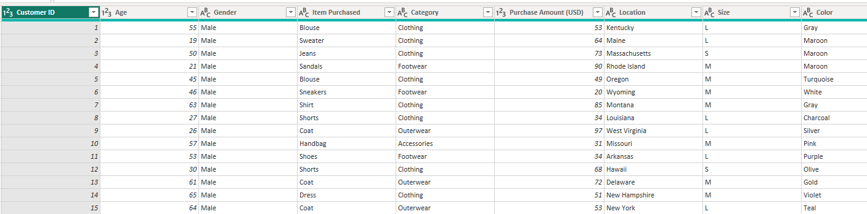

Now that the data is in the Power Query Editor, I’ve thoroughly examined the dataset. Upon inspection, the columns appear to be in good order. To ensure data integrity, I meticulously reviewed the column quality, checking for any empty cells or errors. Additionally, I verified the data type of each column, and everything seems to be in order. With confidence in the dataset’s quality, I proceeded to click on “Close & Apply” from the tab, bringing the data into Power BI Desktop for further analysis.

Step 2 : Creating Measures
These measures were instrumental in calculating various metrics. To create measures you click on “New measure”
- Total Customer: This indicates the total count of customers in the dataset, providing a clear overview of customer volume for analysis and insights. DISTINCTCOUNT(shopping_behavior[Customer ID])

2. AvgPurchasedAmt: This metric reveals the average customer expenditure, aiding in understanding spending trends for informed decision-making.
AVERAGE(shopping_behavior[Purchase Amount (USD)])

3. MaxDataPoint: This measure facilitates the line chart by showcasing the age with the highest average purchase amount, aiding in pinpointing the peak spending age.
IF(MAXX(ALLSELECTED(shopping_behavior[Age]),shopping_behavior[AvgPurchasedAmt]) = shopping_behavior[AvgPurchasedAmt], MAXX(ALLSELECTED(shopping_behavior[Age]),shopping_behavior[AvgPurchasedAmt]), BLANK())

4. MinDataPoint: This measure enables the line chart by indicating the age with the lowest average purchase amount, assisting in identifying the age group with minimal spending.
IF(MINX(ALLSELECTED(shopping_behavior[Age]),shopping_behavior[AvgPurchasedAmt]) = shopping_behavior[AvgPurchasedAmt], MINX(ALLSELECTED(shopping_behavior[Age]),shopping_behavior[AvgPurchasedAmt]), BLANK())

Step 3 : Analysis and Building Visualization
visualization is the bridge that connects raw data to meaningful insights. I harnessed power BI’s to create a variety of visuals. This is where our objectives question will be answered.
- Create a highlight table for the distribution of customers by location (state).
To accomplish this task, we’ll navigate to the Visualization pane and choose the ‘Table’ option. Subsequently, we’ll drag and drop ‘Customer ID’ and ‘Location’ into the columns section, as illustrated below.
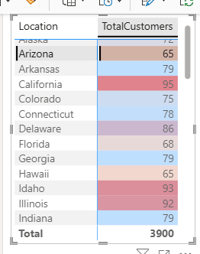

Important notes:

✅ Why the Highlight Is Not Showing
- A Table visual does not highlight automatically
- Highlighting only appears when:
  - You use conditional formatting, or
  - You use a Matrix with background color rules
Right now, you’ve only added Customer ID and Location, so Power BI has nothing numeric to color.

✅ Correct Way to Create a Highlight Table (Step-by-Step)

Step 1: Create a Measure
This is mandatory for highlighting.
Total Customers = DISTINCTCOUNT(shopping_behavior[Customer ID])

Step 2: Use the Correct Visual
👉 Matrix (Recommended)
(Matrix works better than Table for highlight views)

Step 3: Add Fields
- Rows → Location
- Values → Total Customers

2. Create a bar chart to visualize the distribution of purchase amounts by category and season.

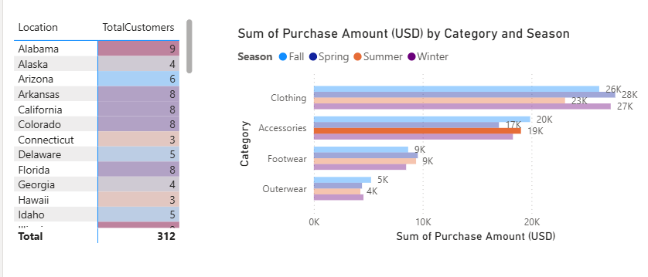
Need to set label on to see the number of each season.

The Fall season emerged as the peak period for purchases, followed by Spring and Winter, with Summer displaying the least sales activity. In terms of category-wise sales across all seasons, clothing notably dominated, closely trailed by accessories and footwear. Conversely, outerwear consistently depicted the lowest sales performance throughout the seasons.
3. Create a stacked bar chart that displays the distribution of customers based on the shipping type and the frequency of their purchases.
From the Visualization pane, we’ll opt for the Stacked Bar Chart. Next, we’ll place the shipping type on the Y-axis, the Purchase amount on the X-axis, and include the frequency of their purchases in the legend for a comprehensive representation.

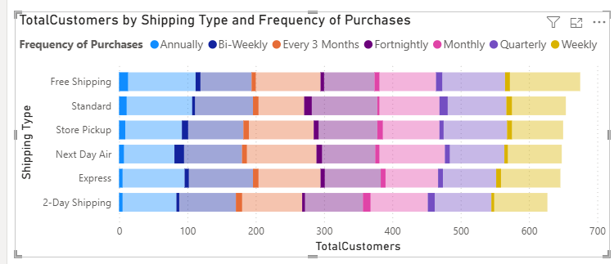

4. Build a Line chart showing the relationship between age and average purchase amount. Additionally, label the age with the highest and lowest average purchase amount.
We’ll opt for the Line Chart in the Visualizations pane, then position Age on the X-axis and Average purchase amount on the Y-axis to visualize the relationship between age and average purchase amount effectively.

The majority of our customers lean towards Free Shipping as their preferred shipping method, closely followed by Express. Store Pickup, Standard, 2-Day Shipping, and Next Day Air are relatively less favored among our customer base. When it comes to purchasing frequency, Free Shipping and Express options are favored among customers engaging in Annually and Weekly purchases. Conversely, Next Day Air and 2-Day Shipping see more traction among customers who opt for a purchasing of Every 3 months and Monthly.

1. KPI Cards Creation (Executive Summary)
Created individual KPI cards using the Card (New) visual to summarize key business metrics.
Steps:
- Created DAX measures using DISTINCTCOUNT, SUM, and AVERAGE
- Used Card (New) visual, placing one measure per card
- Configured Callout Value formatting for clarity
KPIs Created:
- Total Customers: Distinct count of Customer ID
- Locations: Distinct count of Location (state)
- Items Purchased: Distinct count of Item Purchased
- Average Age: Average of customer age, rounded to whole number
- Total Purchased Cost: Sum of Purchase Amount (USD), displayed in thousands
Purpose:
- Provide a high-level overview of customer base, geographic coverage, product diversity, demographics, and revenue

2. Highlight Table – Customer Distribution by Location
Created a highlight table to visualize customer distribution across states.
Steps:
- Inserted a Table visual
- Added Location and Customer ID fields
- Set Customer ID aggregation to Count or Distinct Count
- Applied conditional formatting using Data Bars on customer count
- Sorted table in descending order by customer count
Purpose:
- Quickly identify states with higher or lower customer concentration
- Enhance readability using visual indicators within table cells

3. Stacked Bar Chart – Customers by Shipping Type and Purchase Frequency
Built a stacked bar chart to analyze customer behavior across shipping methods and purchase frequency.
Steps:
- Selected Stacked Bar Chart visual
- Assigned Shipping Type to Y-axis
- Assigned Frequency of Purchases to Legend
- Used Total Customers (distinct count measure) as X-axis value
- Enabled data labels for customer count visibility
Purpose:
- Compare customer distribution across shipping options
- Identify how purchase frequency varies by shipping method

4. Bar Chart – Purchase Amount by Category and Season
Created a bar chart to analyze spending patterns across product categories and seasons.
Steps:
- Selected Bar Chart visual
- Assigned Product Category to Axis
- Assigned Total Purchase Amount to Values
- Used Season as Legend
- Enabled data labels to display purchase amounts for each season
Purpose:
- Identify seasonal purchasing trends
- Compare revenue contribution by product category

5. Line Chart – Age vs Average Purchase Amount (With Min/Max Highlight)
Developed a line chart to show the relationship between customer age and average purchase amount.
Steps:
- Selected Line Chart visual
- Assigned Age to X-axis
- Assigned Average Purchase Amount measure to Y-axis
- Created additional DAX measures to identify maximum and minimum average purchase amounts
- Added Max and Min measures to the chart to label peak and lowest spending ages
- Enabled data labels only for highlighted points
Purpose:
- Analyze spending behavior across age groups
- Identify peak spending age and lowest spending age

6. Pie Chart – Total Purchase Amount by Gender
Built a pie chart to compare total spending by gender.
Steps:
- Selected Pie Chart visual
- Assigned Gender to Legend
- Assigned Total Purchase Amount (SUM measure) to Values
- Enabled data labels showing value and percentage of total
Purpose:
- Compare contribution of each gender to overall revenue
- Provide an intuitive breakdown of spending distribution

7. Matrix Table – Shipping Type vs Purchase Frequency
Created a matrix to complement the stacked bar chart with detailed numeric values.
Steps:
- Inserted Matrix visual
- Assigned Shipping Type to Rows
- Assigned Frequency of Purchases to Columns
- Used Total Customers measure as Values
- Disabled unnecessary totals and gridlines for clarity
Purpose:
- Provide detailed customer counts supporting the visual analysis
- Enable precise comparison across customer segments

8. Dashboard Save and Reusability
Ensured dashboard persistence and reusability.
Steps:
- Saved the report as a PBIX file
- Enabled Auto Recovery settings
- Verified that all visuals, measures, and formatting persist when reopening the file
Purpose:
- Maintain dashboard consistency
- Enable future enhancements and reuse

