# Airflow + Databricks CDC ETL Project: Hands-On Summary

## Project Overview
This project demonstrates how to orchestrate a Databricks ETL job (Aurora Delta CDC) using Apache Airflow in a containerized environment. Airflow schedules and triggers a Databricks job via the DatabricksRunNowOperator, enabling automated, reliable data pipeline execution.

## Architecture & Components

- **Apache Airflow**: Workflow orchestration, scheduling, and monitoring.
- **Docker Compose**: Container management for Airflow, PostgreSQL, and Redis.
- **Databricks**: Cloud platform for running the Aurora Delta CDC ETL job.
- **PostgreSQL**: Metadata database for Airflow.
- **Redis**: Celery broker for distributed task execution.
- **DAGs Folder**: Contains Python DAG files, including aurora_delta_cdc_dag.py.

## Flow Chart

flowchart TD
A[Airflow Scheduler] -->|Triggers DAG| B[DatabricksRunNowOperator]
B -->|API Call| C[Databricks Job: Aurora Delta CDC]
C -->|Job Status| D[Airflow Web UI]

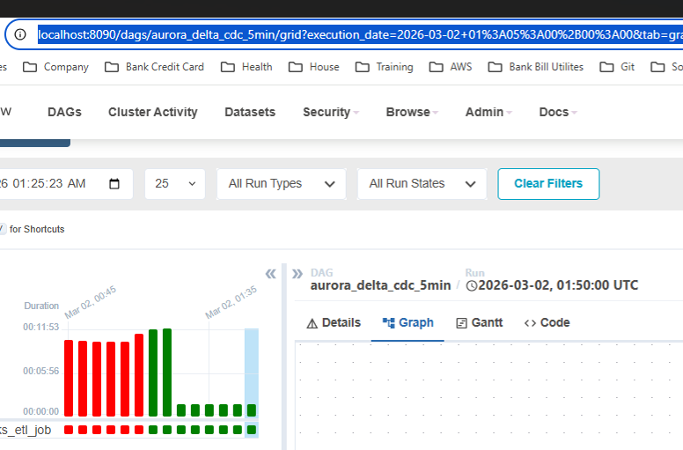

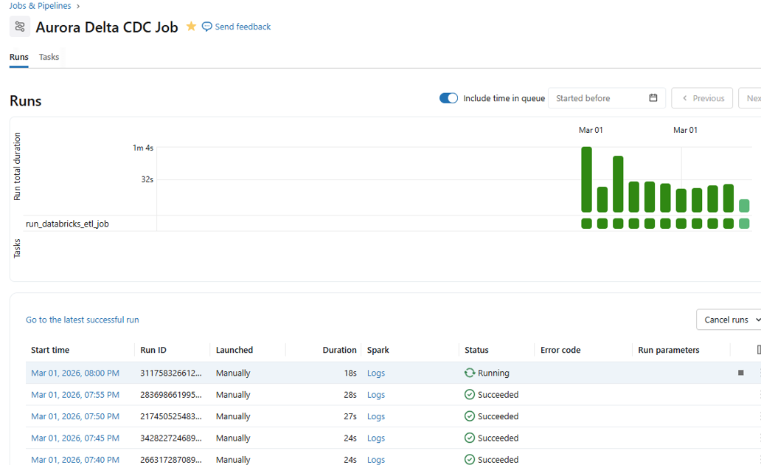

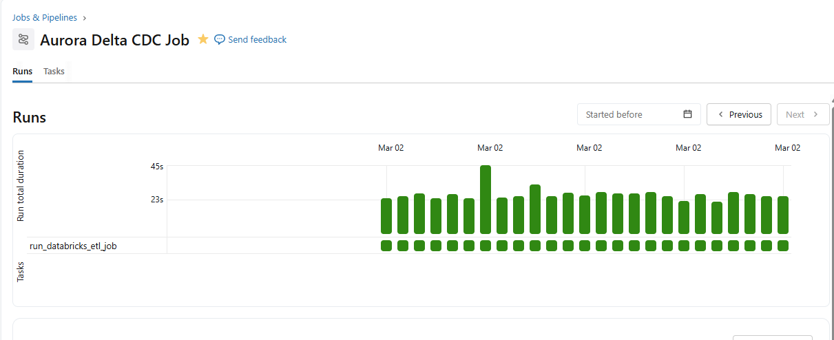

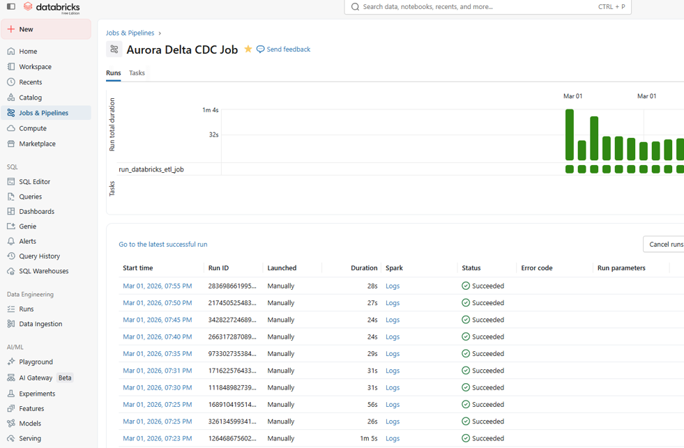
AIRFLOW TRIGGER DATABRICKS JOBS:

VERIFY CDC LOGIC :
select * from workspace.nhan_schema.eqp_status

BEORE RUN

EQP_ID STATUS STEP DEPARTMENT LOT_ID EVENT_TIME
EQP001 ONLINE STEP1 Assembly LOT1001 2024-02-01T09:10:00.000Z
EQP002 OFFLINE STEP2 Testing LOT1002 2024-02-02T10:00:00.000Z
EQP003 MAINTENANCE STEP3 Repair LOT1003 2024-02-03T08:15:23.000Z
EQP004 ONLINE STEP4 Assembly LOT1004 2024-02-04T13:45:05.000Z
EQP005 OFFLINE STEP1 Logistics LOT1005 2024-02-05T15:22:30.000Z

AFTER RUN

EQP_ID STATUS STEP DEPARTMENT LOT_ID EVENT_TIME --> NO CHANGE
EQP003 MAINTENANCE STEP3 Repair LOT1003 2024-02-03T08:15:23.000Z
EQP014 NEW TOOL STEP4 Assembly LOT1004 2024-02-04T13:45:05.000Z --> INSERT NEW TOOL
EQP005 OFFLINE STEP1 Logistics LOT1005 2024-02-05T15:22:30.000Z --> NO CHANGE
EQP001 ONLINE STEP1 Assembly LOT1001 2024-02-01T09:10:00.000Z --> NO CHANGE
EQP004 ONLINE STEP4 Assembly LOT1004 2024-02-04T13:45:05.000Z --> NO CHANGE
EQP002 OFFLINE STEP2 Testing LOT1002 2024-02-02T10:00:00.000Z --> NO CHANGE

update workspace.nhan_schema.eqp_status set status = 'OK'
WHERE EQP_ID <> 'EQP014'

AFTER UPDATE:
EQP_ID STATUS STEP DEPARTMENT LOT_ID EVENT_TIME
EQP001 OK STEP1 Assembly LOT1001 2024-02-01T09:10:00.000Z
EQP002 OK STEP2 Testing LOT1002 2024-02-02T10:00:00.000Z
EQP003 OK STEP3 Repair LOT1003 2024-02-03T08:15:23.000Z
EQP004 OK STEP4 Assembly LOT1004 2024-02-04T13:45:05.000Z
EQP005 OK STEP1 Logistics LOT1005 2024-02-05T15:22:30.000Z
EQP014 NEW TOOL STEP4 Assembly LOT1004 2024-02-04T13:45:05.000Z

NEXT RUN - CDC APPLIED
EQP_ID STATUS STEP DEPARTMENT LOT_ID EVENT_TIME
EQP003 MAINTENANCE STEP3 Repair LOT1003 2024-02-03T08:15:23.000Z
EQP014 NEW TOOL STEP4 Assembly LOT1004 2024-02-04T13:45:05.000Z
EQP005 OFFLINE STEP1 Logistics LOT1005 2024-02-05T15:22:30.000Z
EQP001 ONLINE STEP1 Assembly LOT1001 2024-02-01T09:10:00.000Z
EQP004 ONLINE STEP4 Assembly LOT1004 2024-02-04T13:45:05.000Z
EQP002 OFFLINE STEP2 Testing LOT1002 2024-02-02T10:00:00.000Z

