extract_author_data(raw):

1) REST API extract data Author

2) Insert into mySQL

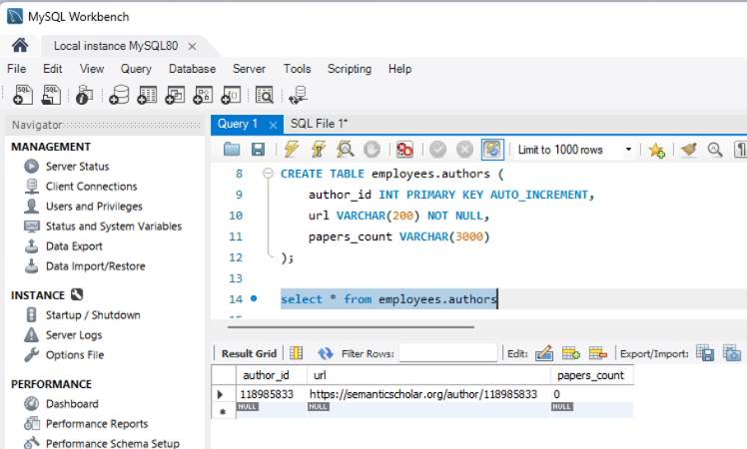
Database : employees.
Table employees.authors

