file_autoloader_lot_release\
├── autoloader.py
├── config.py
├── requirements.txt
├── 20260225\
│ └── landing\ ← Engineers upload CSV files, then the autoloader process running every minutes to read the file, extract data from the file and insert into lot_release table in Oracle DB → Lot release.
├── ARCHIVE\
│ └── 20260225\ ← Successful files will be moved to folder archive, otherwise will be moved to errors folder
├── error\ ← Failed files
└── logs\ ← Daily log files

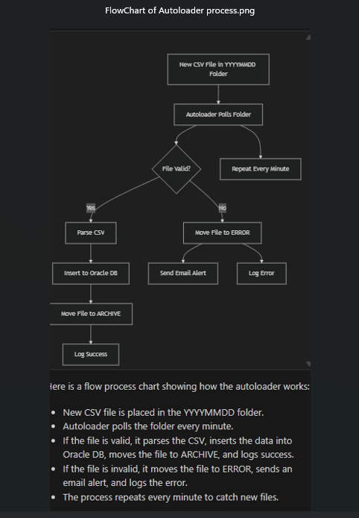

# LOT Release File Autoloader
Engineers upload CSV files to the application server, then the autoloader process running every minutes to detect new file coming, then read the file, extract data from the file and insert into lot_release table in Oracle DB → Lot release.
## Project Description
The LOT Release File Autoloader is a modern, enterprise-grade solution designed to automate the ingestion, validation, and processing of LOT release files into Oracle databases. This Python-based platform replaces legacy Tibco Business workflows, addressing key limitations such as scalability, maintainability, and integration flexibility.

## Key Features & Advantages
- Automated polling and processing of incoming LOT release files, ensuring real-time data updates.
- Robust error handling: files with missing or invalid values are automatically moved to an error folder, with detailed logging and email alerts for rapid issue resolution.
- Seamless integration with Oracle databases, supporting secure and reliable data insertion.
- Modular architecture: easily extendable for new data formats, business rules, or downstream systems.
- Enterprise-grade logging and audit trails for compliance and operational transparency.
- Configurable email notifications for operational and error events.

## Cloud & Future-Ready
- Designed for easy migration to AWS, Databricks, or other cloud platforms.
- Supports containerization and orchestration (e.g., Docker, Kubernetes) for scalable deployment.
- Can leverage cloud storage (S3), serverless compute (Lambda), and managed databases for cost-effective, resilient operations.
- Ready for integration with modern data pipelines, analytics, and AI/ML workflows.

## Business Impact
- Eliminates manual intervention and reduces operational risk.
- Accelerates data availability for business analytics and reporting.
- Provides a foundation for digital transformation and cloud adoption, enabling future enhancements and integrations.

---
Technologies involved in this project:
Python: Main programming language for the autoloader script.
Oracle Database: Target system for data insertion.
oracledb (Python library): Used for Oracle DB connectivity.
Logging module: For enterprise-grade logging and audit trails.
Email (smtplib, MIME): For sending error alerts.
Windows OS: File system and scheduling environment.
Cloud-ready design: Easily migratable to AWS, Databricks, Docker, Kubernetes.
File system operations (os, shutil, glob): For file scanning, moving, and archiving.

