+------------------+ +-------------------+ +-------------------+
| Data Source | -----> | Data Processing | -----> | Delta Lake Table |
|Oracle-direct access) | | (Spark in Databricks) | | Real time
+------------------+ +-------------------+ +-------------------+
| |
v v
+---------------------+ +------------------------+
| Optimization & | | Power BI Dashboard |
| Maintenance Scripts | | (Connects via JDBC) |
+---------------------+ +------------------------+

Technical Summary of EQP_STATUS Data Pipeline & Dashboard Project
1. Overview
This project involves creating a robust data pipeline for equipment status data, stored efficiently in Delta Lake, with periodic updates, maintenance, and visualization in Power BI. The goal is to enable real-time or near-real-time dashboarding with optimized data loading and query performance.

a. Real time equipment status data with attributes like EQP_ID, STATUS, STEP, DEPARTMENT, LOT_ID.
b. Data Ingestion & Upsert into Delta Lake

Connect to External Oracle XE (optional): Use JDBC to pull real data from Oracle database.
Data Preparation: Convert data into Spark DataFrame.
Merge Operation: Upsert (update/insert) data into Delta Lake table for incremental updates.

c. Data Optimization & Maintenance

Optimize: Use OPTIMIZE with ZORDER to improve query speed.
Vacuum: Remove obsolete files to reduce storage and improve performance.
Analyze: Update table statistics for query optimizer.

d. Data Consumption & Visualization

Power BI Connection: Use JDBC or DirectQuery to connect to the Delta Lake table.
Dashboarding: Build real-time dashboards with filters, aggregations, and visualizations based on equipment status data.

Equipment units tracked in system
EQP_ID, STATUS, STEP, DEPARTMENT, LOT_ID
Unique equipment identifier
Delta Lake Table
Storage of equipment status data
Same as Equipment attributes
Optimized for fast read/write
#################################

Power BI Dashboard
Visualization layer for insights
Filtered and aggregated data from Delta Lake
User interface for decision making

Data Pipeline
ETL/ELT process for data refresh
Data ingestion, merge, optimize, vacuum
Automates data updates

##########################POWER BI#################################
---

## Establish Connection**
- Use **DirectQuery** mode to connect Power BI directly to your Delta Lake table via your Spark SQL endpoint.

## **Summary of Visuals**

| Visual Type | Data/Measures | Purpose |
|-------------------------|--------------------------------------------------------|------------------------------------------------------|
| **Table** | All latest status info, with conditional formatting | Main status overview |
| **Pie Chart** | Count of latest statuses | Status distribution overview |
| **Stacked Bar Chart** | Count of statuses per department | Department-wise status analysis |
| **Card** | Total tools count | Quick summary |
| **Line Chart** | Status over time (optional) | Trend analysis over recent days |

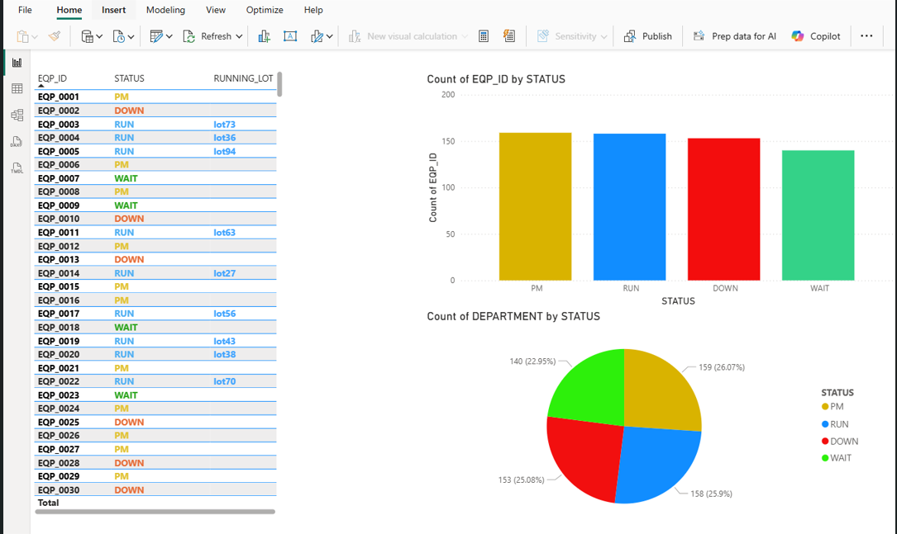

FAB EQUIPMENT STATUS MONITORING (600+ EQPID) – REAL TIME

TABLEAU : INVENTORY WITH EXPECT SHIPPED DATE – Real Time

