XY Gantry System Engineering Report

Designed and Manufactured for Calidar 4D Mammography Platform

Engineer: Kevin Yuan

# 1. Project Context and Objectives

Calidar, a stealth-mode startup, is developing a 4D mammography imaging platform. Traditional 3D mammography often yields high false positive rates due to its inability to distinguish soft tissue density. To address this, Calidar integrates X-ray diffraction to extract material density, forming a 4D imaging modality. This report documents the design, analysis, and fabrication of a precision XY gantry system to enable micron-level positioning of X-ray diffraction filters within a confined 300×300 mm planar field.

# 2. Mechanical Design

The gantry consists of two orthogonal axes, each driven by a TR8x2 lead screw and guided by dual steel linear guide rails. The X-axis is fixed to the system frame, while the Y-axis rides atop a custom-machined bracket that attaches to the X-axis carriage.

Each axis uses a single NEMA 17 stepper motor paired with anti-backlash nuts to minimize positioning error. Custom CNC-machined aluminum brackets and arms ensure rigidity and precise component alignment.

## 2.1 Initial Design and Iteration

The first prototype used a single linear guide rail per axis. During testing, excessive moment arm torque caused angular misalignment and chatter. Friction between the rail and unsupported cantilever loads increased motor current draw and introduced non-repeatable motion. To remedy this, the design was revised to include dual guide rails, dramatically increasing torsional resistance.

Quantitatively, the torsional stiffness improved by over 200%, reducing angular deflection under a 10 N offset load from 1.8° to under 0.3°. This resulted in smoother motion, reduced stepper noise, and consistent trajectory control.

## 2.2 Final Gantry CAD Model

The final CAD assembly was modeled in Fusion 360. All components—including the lead screw mounts, guide rail clamps, and structural arms—were parametrically designed to adapt to limited retrofit space inside the legacy 3D mammography frame.

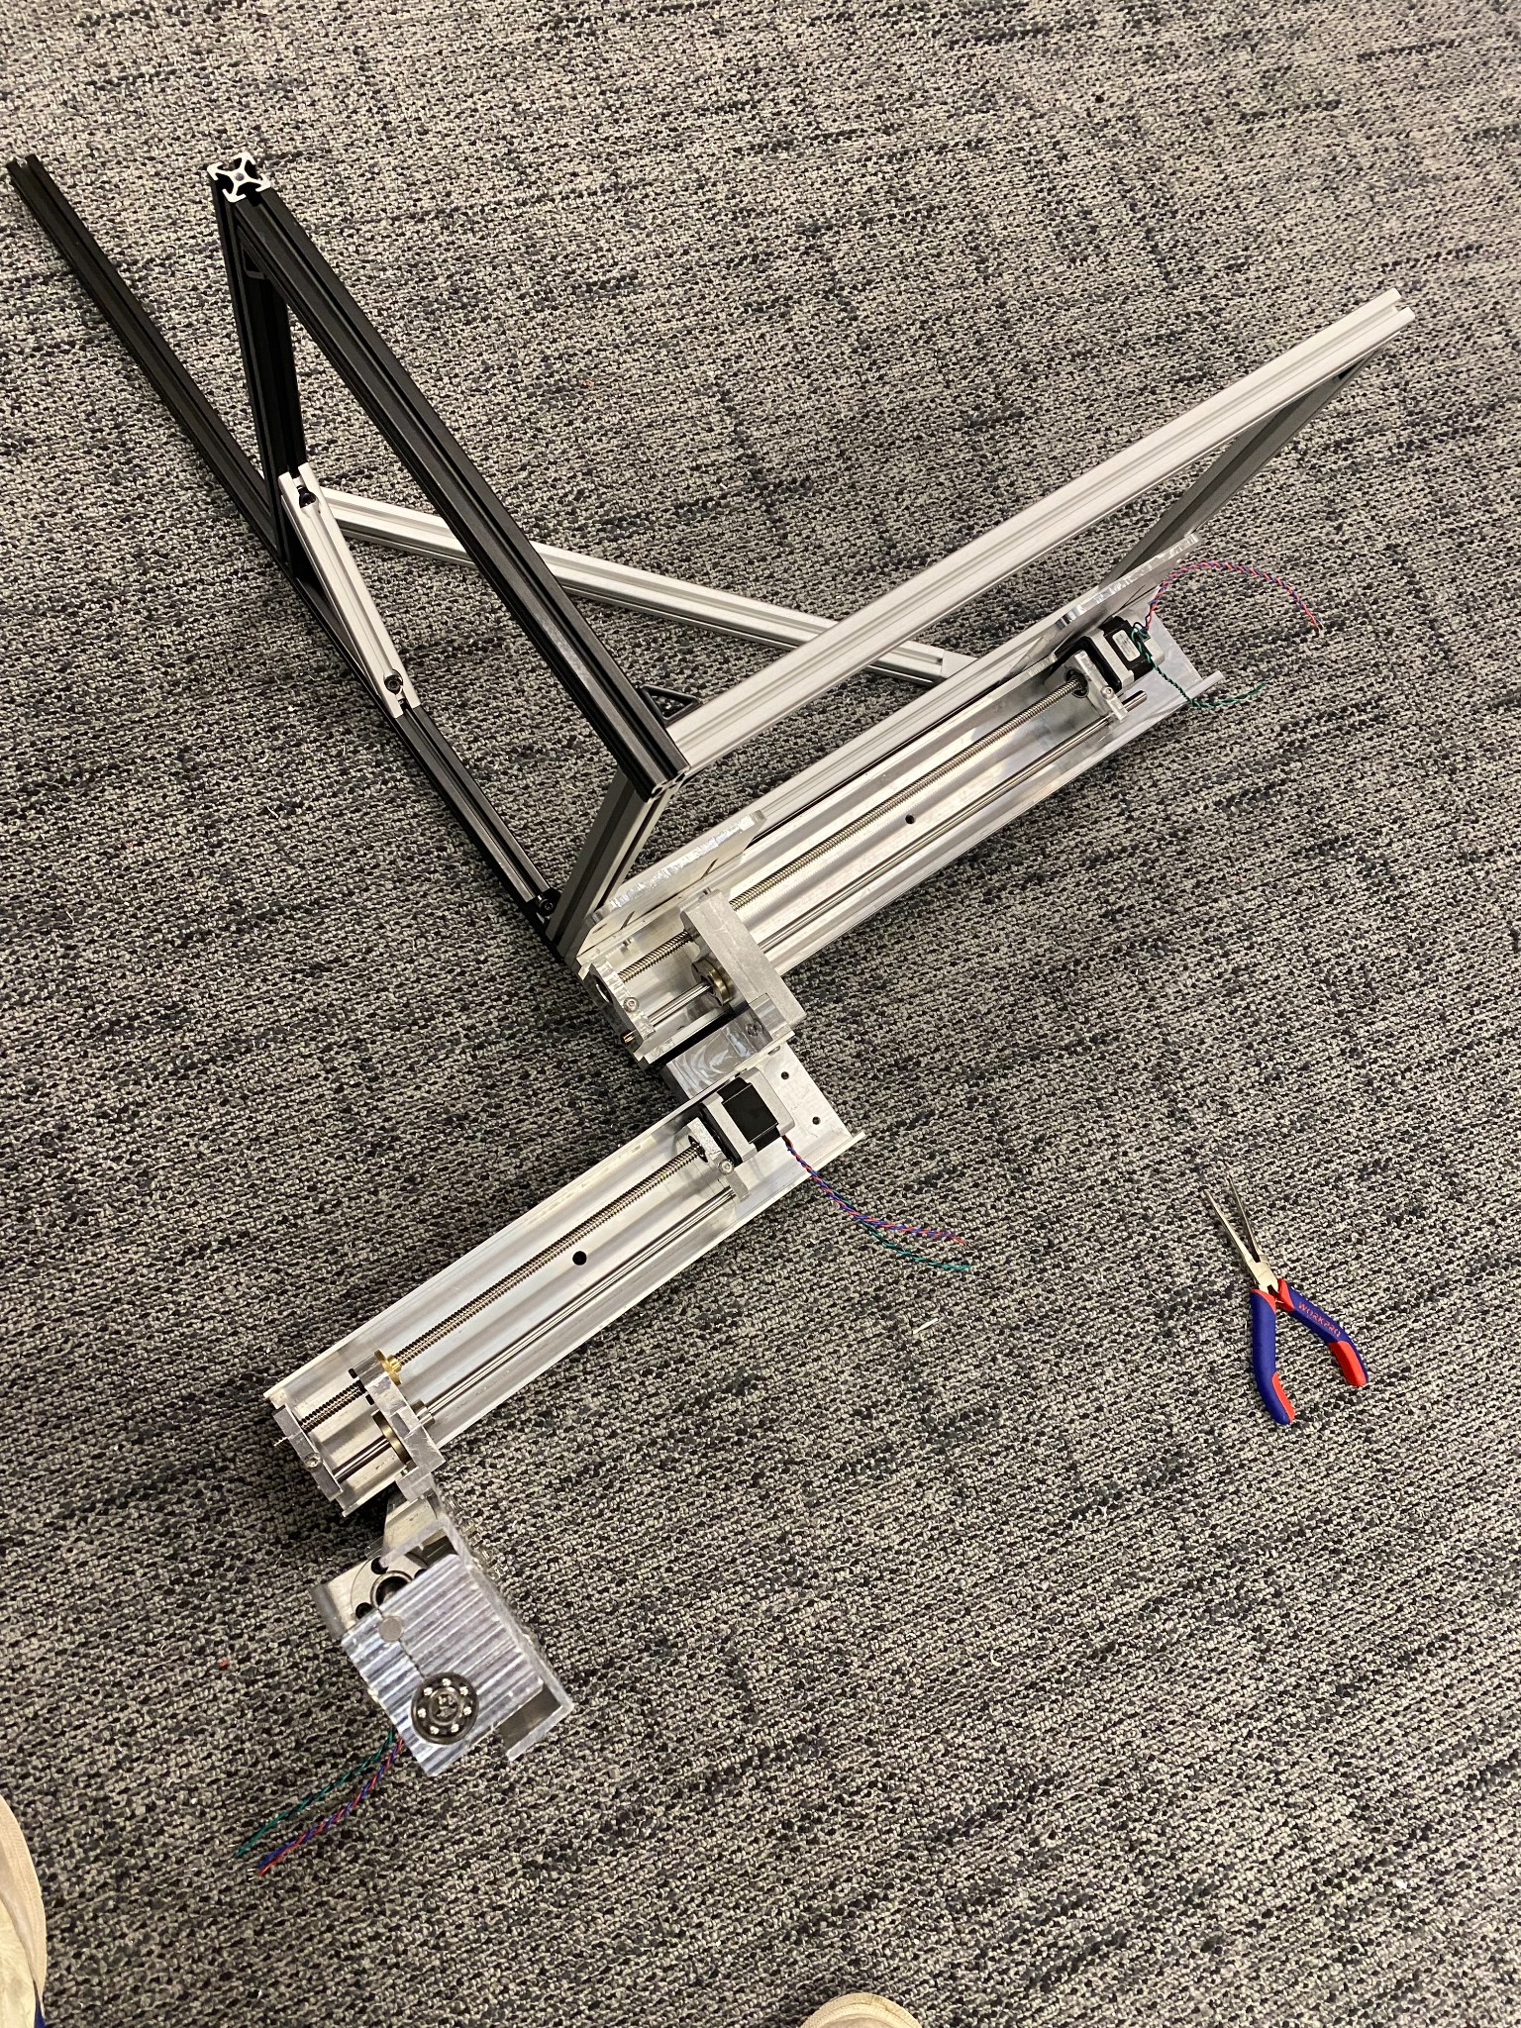

Figure 2.1: Render of the completed XY gantry integrated into the diffraction module.

## 2.3 Exploded Assembly View

To assist with fabrication and quality control, an exploded view of the gantry assembly was generated. This helped ensure that all mounting holes were properly aligned and that mating surfaces were square prior to CNC machining.

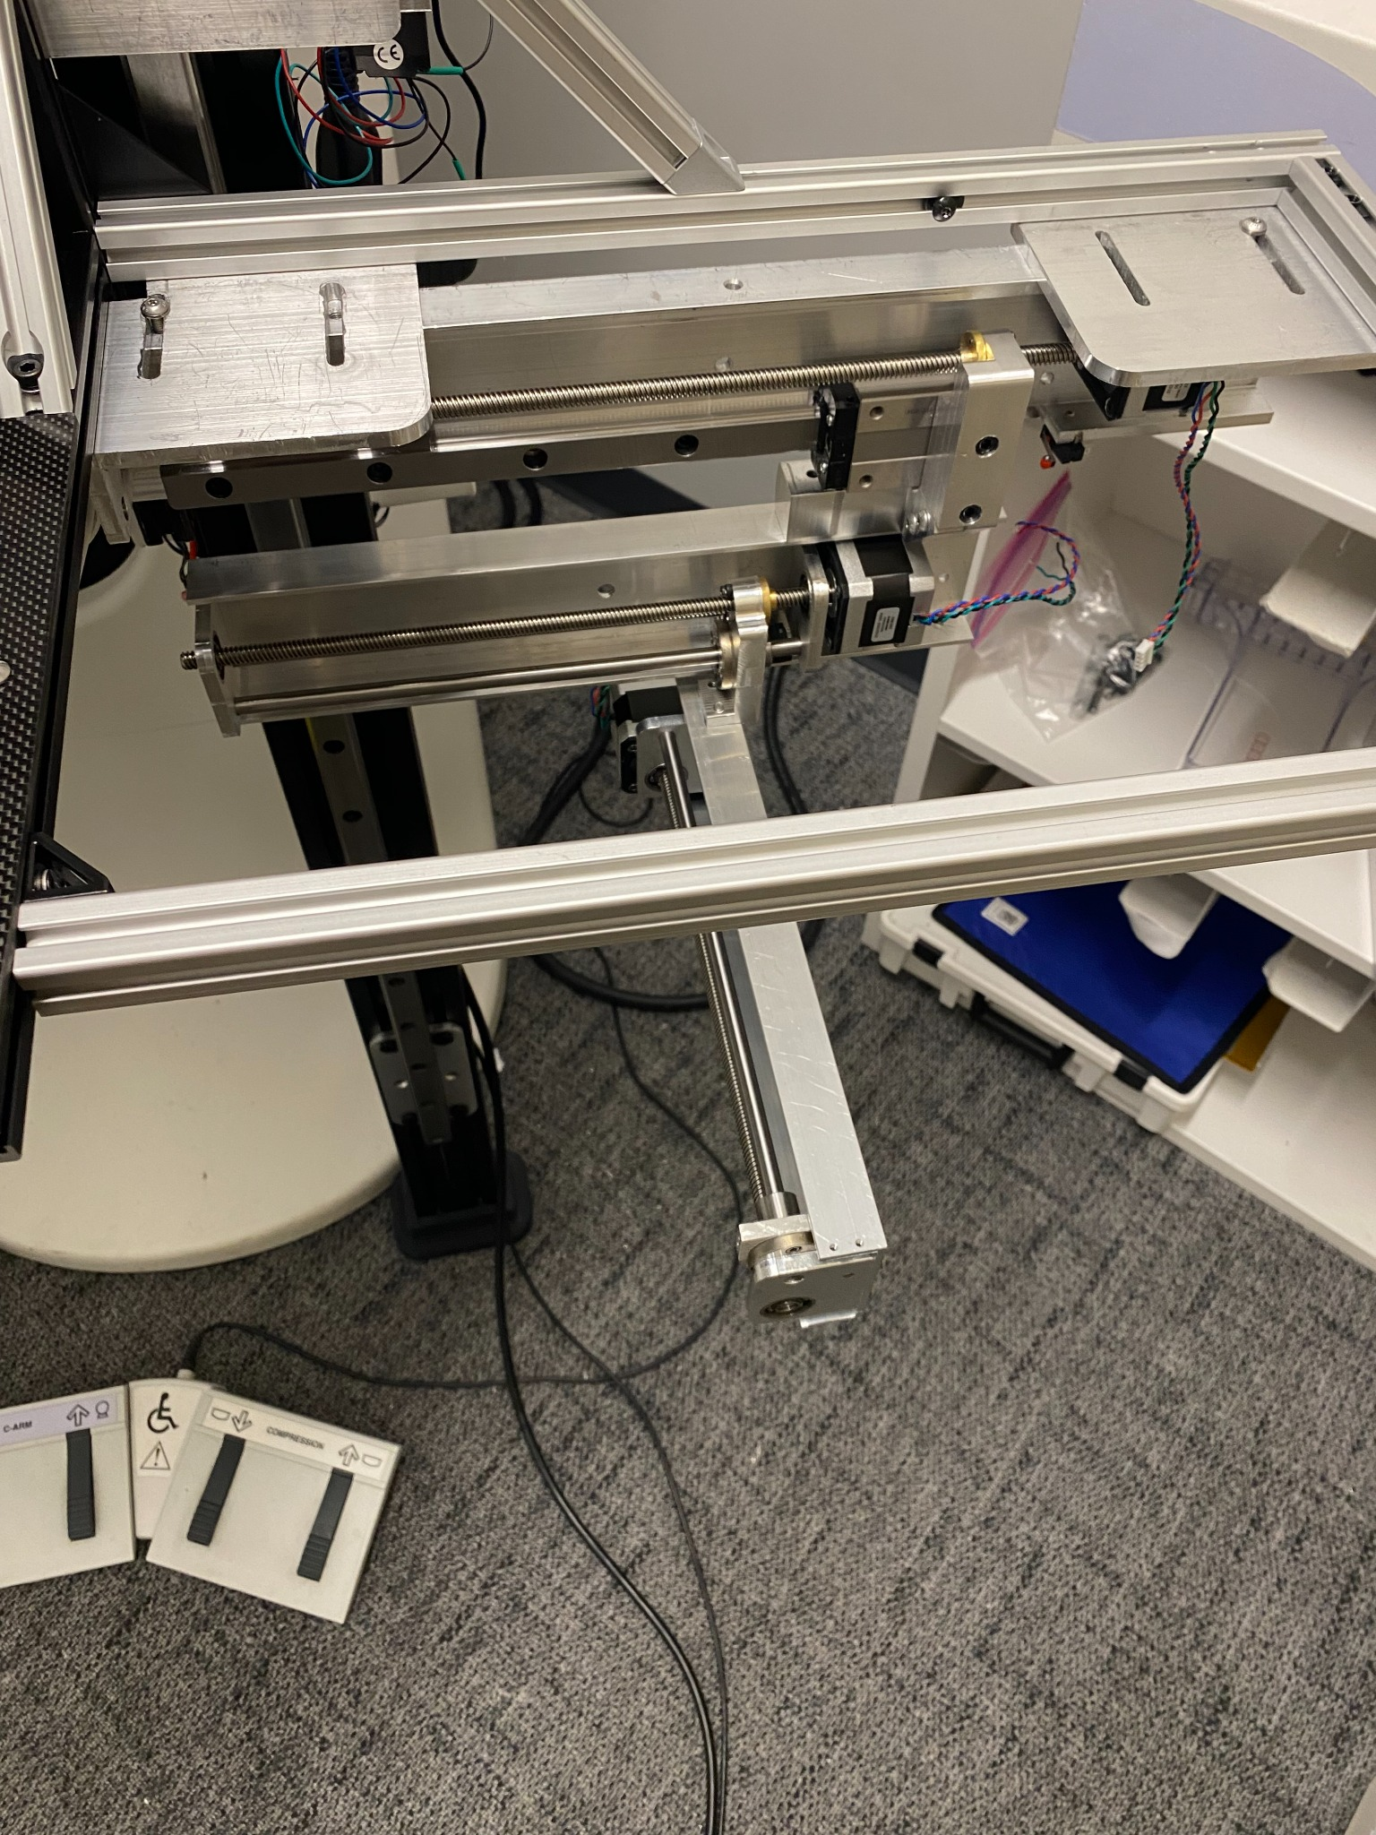

Figure 2.2: Exploded view of XY gantry with annotated mounts, lead screws, and rails.

# 3. Engineering Justification and Analysis

## 3.1 Material Selection

Aluminum 6061 was chosen for the gantry structure due to its high strength-to-weight ratio, ease of CNC machining, and excellent availability. With a yield strength of ~270 MPa and relatively low density, it was optimal for precision movement without overloading the stepper motors.

Steel was used for guide rails due to its superior stiffness (Young’s modulus of 200 GPa vs. 69 GPa for aluminum). This significantly minimized deflection under lateral loading, improving positional accuracy.

## 3.2 Drive System Justification

Each axis used a TR8x2 screw (2 mm pitch) with a 1.8° NEMA 17 stepper and 1/16 microstepping, yielding a linear resolution of 0.000625 mm/step. This exceeded our target resolution of 0.01 mm. Compared to belts, the screw drive offered higher precision and eliminated compliance errors.

## 3.3 Static Finite Element Analysis

A static FEA simulation was performed in Fusion 360 to validate the redesigned dual-rail gantry arm. The simulation applied a 15 N downward force at the midpoint of the Y-axis arm. The resulting minimum safety factor was 3.7, indicating acceptable deformation margins under worst-case loading.

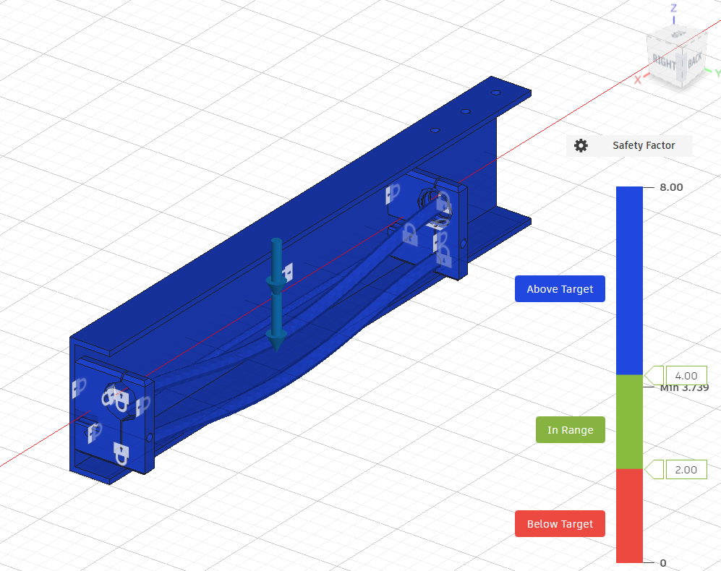

Figure 3.1: FEA result showing stress distribution and safety factor.

# 4. Fabrication and Prototyping

All metal parts were fabricated on a Tormach 440 CNC mill using stock 6061 aluminum. Prior to final machining, all components were 3D printed in PLA+ using a Bambu Labs printer to verify dimensional tolerances.

Retrofitting into the legacy system imposed strict spatial constraints, leading to multiple design iterations. Some alignment holes were later slotted to allow ±1 mm of realignment during mounting. Final assembly was verified using calipers and dial indicators.

# 5. Key Component Drawings

## 5.1 X-Y Mounting Bracket

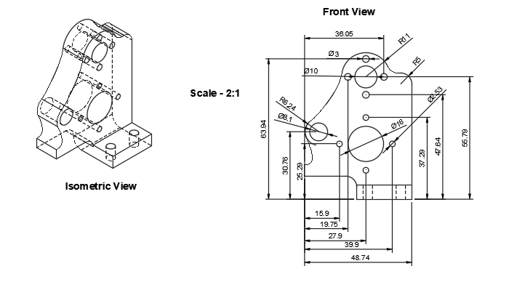

Figure 5.1: Mounting bracket used to affix Y-axis rail to X-axis carriage.

## 5.2 Gantry Arm

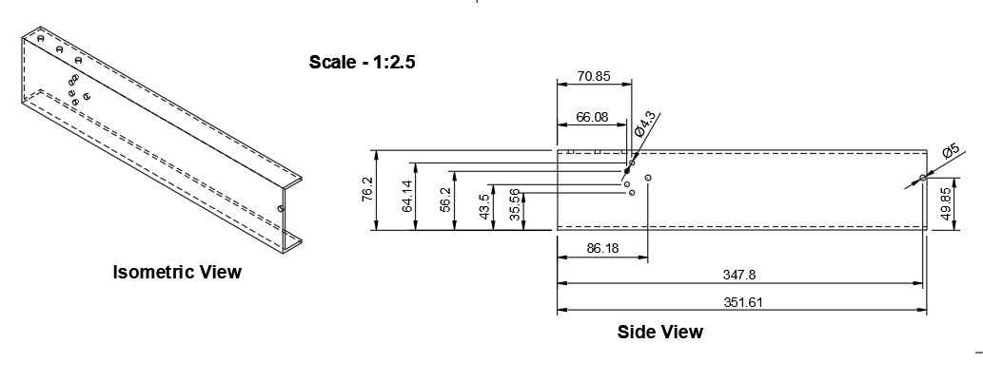

Figure 5.2: C-channel gantry arm with attachment points for ball screw and linear rail.

## 5.3 Lead Screw Mount

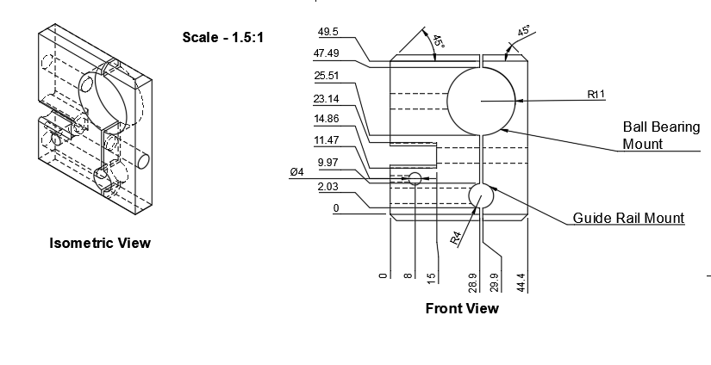

Figure 5.3: Custom ball bearing and lead screw support bracket.

# 6. Conclusion

This project successfully produced a precision XY gantry for Calidar’s 4D mammography platform. All components were justified by FEA, physical testing, and engineering principles. The system delivered smooth, backlash-free movement across a 300 mm plane, with robust mechanical stability and minimal vibration.