



**TARGETED CRIME ANALYSIS**

23. June. 2024

**Analyzing Abduction Crime Rates In ON, QC &MB**

**Submitted to: Officer Richard, RCMP officer.**

**INTRODUCTION**

This report delves into the analysis of abduction crimes in Ontario (ON), Quebec (QC), and Manitoba (MB) for the RCMP. Our goal is to uncover trends and patterns to improve collaboration and support for provincial police forces. Abduction was chosen due to its considerable prevalence and impact on both adults and youth, requiring a comprehensive analytical approach. Utilizing Microsoft PowerBI, we present detailed visualizations that reveal the frequency, distribution, and characteristics of abduction cases. These insights will aid Officer Ricard in formulating strategies to bolster law enforcement efforts and resource allocation across these provinces.

**WHY DID WE CHOOSE POWER BI?**

Power BI was selected for this project because of its exceptional data visualization capabilities, intuitive interface, and seamless integration with multiple data sources. Its advanced analytical tools and interactive dashboards enable deep insights and real-time data exploration. Compared to other tools, Power BI excels in user-friendliness, sharing, and collaboration features, making it perfect for presenting complex data clearly. Moreover, its capacity to handle large datasets ensures precise and thorough analysis, facilitating informed decision-making.

**VISUALIZATION APPROACH**

Our Power BI visualization strategy aims to deliver detailed insights into abduction crimes in Ontario, Quebec, and Manitoba over the past decade. Initially, we compared crime trends across these provinces, emphasizing year-over-year variations to pinpoint significant fluctuations and patterns. Subsequently, we focused on the top three cities with the highest crime incidents in each province, offering a detailed analysis of urban crime dynamics.

To further our analysis, we examined the correlation between youth and adult crime rates in these high-crime cities, providing insights into whether trends in youth crime might be indicative of adult crime patterns. Additionally, we employed Power BI's forecasting tools to predict abduction crime rates for the upcoming year in each province. This predictive analysis supports proactive resource allocation and strategic planning. Collectively, these visualizations present a comprehensive and actionable overview of abduction crimes, aiding law enforcement authorities in informed decision-making.

**FINDINGS**

**Compare the crimes between Ontario, Quebec and Manitoba in the last 10 years.**

The bar chart presented provides a comparative analysis of abduction crimes in the provinces of Quebec, Ontario, and Manitoba over the last decade. Each bar represents the sum of abduction incidents for a given year within the respective province.

**Highlights and Insights:**

1. **Quebec**:
   * Quebec consistently shows higher abduction crime rates compared to Ontario and Manitoba.
   * The peak year in Quebec had over 300 incidents, indicating a significant spike in abduction cases.
2. **Ontario**:
   * Ontario exhibits moderate abduction crime rates, generally lower than Quebec but higher than Manitoba.
   * There is a noticeable fluctuation in the number of incidents over the years, with no clear upward or downward trend.
3. **Manitoba**:
   * Manitoba has the lowest number of abduction incidents among the three provinces.
   * The data shows relatively stable crime rates with minor variations over the decade.

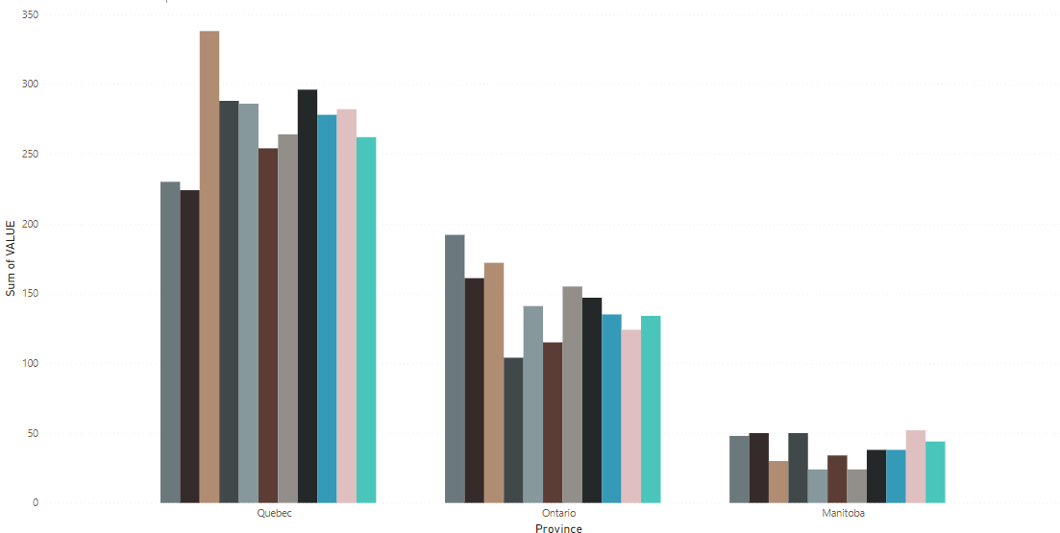

**Key Insights:**

* **Overall Trends**: Quebec's abduction crime rates are significantly higher, suggesting a need for focused intervention and resource allocation.
* **Provincial Comparisons**: Ontario’s crime rates fluctuate more than Manitoba’s, indicating possible underlying factors affecting these variations.
* **Stability in Manitoba**: The stable trend in Manitoba could imply effective crime prevention strategies or other socio-economic factors at play.

These insights provide a foundation for developing targeted strategies to address abduction crimes, with particular attention to Quebec’s higher incident rates.

**Compare the crime rates for the top 3 cities in each of Ontario, Quebec, Manitoba with the highest crime incidents over the last 10 years.**

**Ontario**

* **Cities Analyzed**: Ottawa, Thunder Bay, Toronto
* **Time Period**: 2012 - 2022

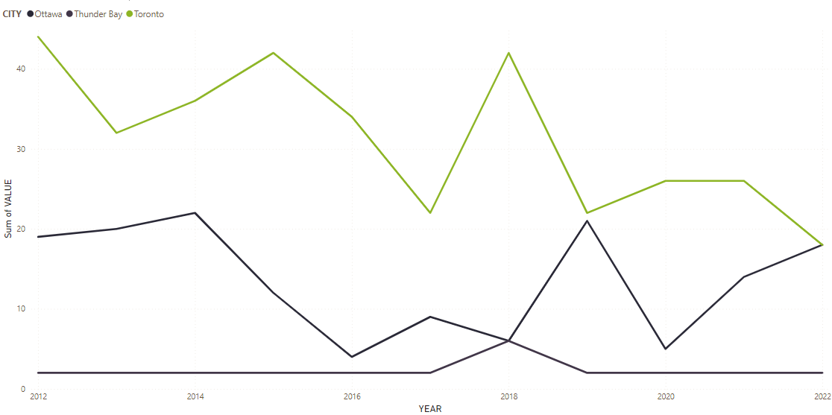**Highlights**:

* **Toronto**: Highest incidence of abduction crimes overall. Fluctuations are observed with peaks around 2016 and 2019, followed by a decline towards 2022.
* **Thunder Bay**: Exhibits a consistent trend of lower abduction crime rates with a notable increase around 2019, peaking and then sharply declining.
* **Ottawa**: Generally, maintains low levels of abduction incidents throughout the period, with slight fluctuations.

**Insights**:

* Toronto appears to be a hotspot for abduction crimes in Ontario, which may necessitate focused law enforcement and community interventions.
* The spike in Thunder Bay around 2019 warrants further investigation to understand the causes and address any underlying issues.
* Ottawa's consistently low numbers might suggest effective preventive measures, but continuous monitoring is essential to maintain this status.

**Quebec**

* **Cities Analyzed**: Lac Simon, Montréal, Richelieu Saint-Laurent
* **Time Period**: 2012 - 2022

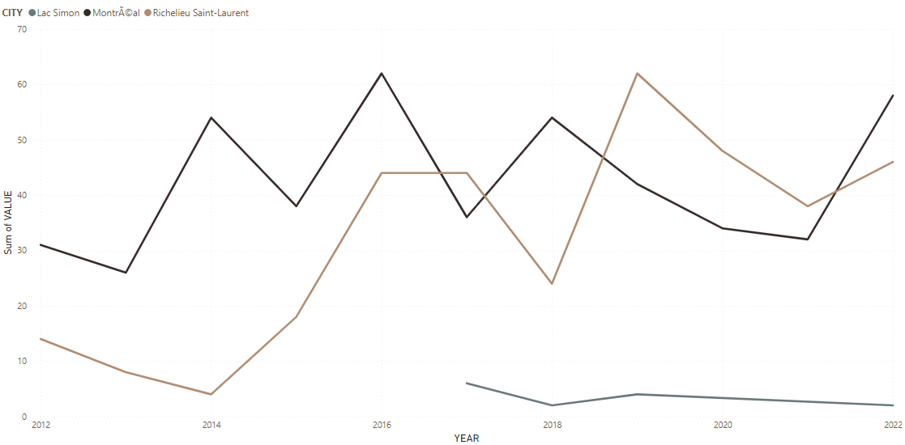**Highlights**:

* **Montréal**: Shows the highest variability and generally higher rates of abduction crimes, peaking around 2016 and again in 2021.
* **Richelieu Saint-Laurent**: Demonstrates a marked increase in incidents starting around 2014, peaking in 2016, and maintaining a relatively high level.
* **Lac Simon**: Lower and more stable rates of abduction crimes with slight increases and decreases over the years.

**Insights**:

* Montréal’s high and fluctuating abduction crime rates call for targeted crime prevention strategies and community awareness programs.
* The significant rise in Richelieu Saint-Laurent suggests a need for targeted interventions to address the increasing trend of abductions.
* Lac Simon, while having lower rates, still requires attention to ensure the crime rates remain low and to prevent any potential increases.

**Manitoba**

* **Cities Analyzed**: Cross Lake, Leaf Rapids, Winnipeg
* **Time Period**: 2012 - 2022

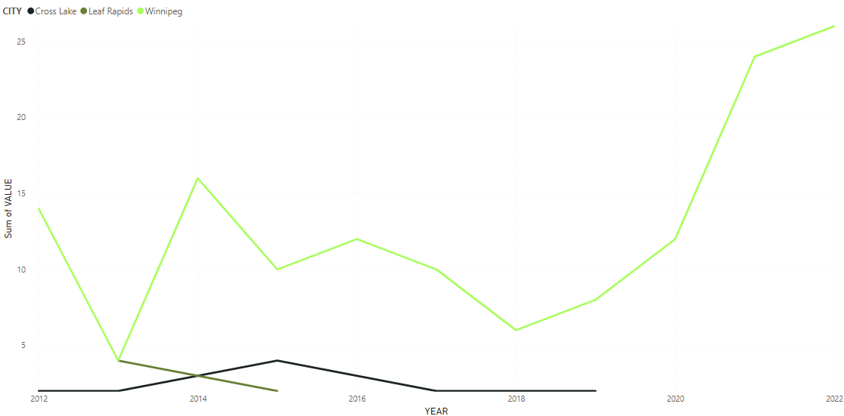

**Highlights**:

* **Winnipeg**: Displays the most pronounced increase in abduction crimes, especially notable after 2018, reaching a peak in 2022.
* **Cross Lake**: Consistently low rates of abduction crimes with slight increases around 2014 and a subsequent decline.
* **Leaf Rapids**: Shows minimal incidents, with only slight fluctuations, indicating a very low prevalence of abductions.

**Insights**:

* The sharp rise in Winnipeg’s abduction crimes from 2018 to 2022 indicates a growing concern that requires urgent attention from law enforcement and community safety programs.
* Cross Lake’s relatively stable but low numbers suggest effective control measures, yet continuous efforts are essential to sustain these results.
* Leaf Rapids, with its minimal incidents, highlights successful crime prevention efforts but should not become complacent, ensuring that preventive measures remain in place.

**Determine if there is a correlation between youth crime rates and adult crime rates for each high crime city (use same top 3 cites per provinces as above)**

**Manitoba (MB)**

1. **Cities: Cross Lake, Leaf Rapids, Winnipeg**
   * The visual indicates the total number of adults charged with abduction.
   * Winnipeg shows the highest number of adults charged with abduction, significantly higher than the other two cities.
   * Cross Lake and Leaf Rapids have much lower numbers of adults charged, with Cross Lake slightly higher than Leaf Rapids.

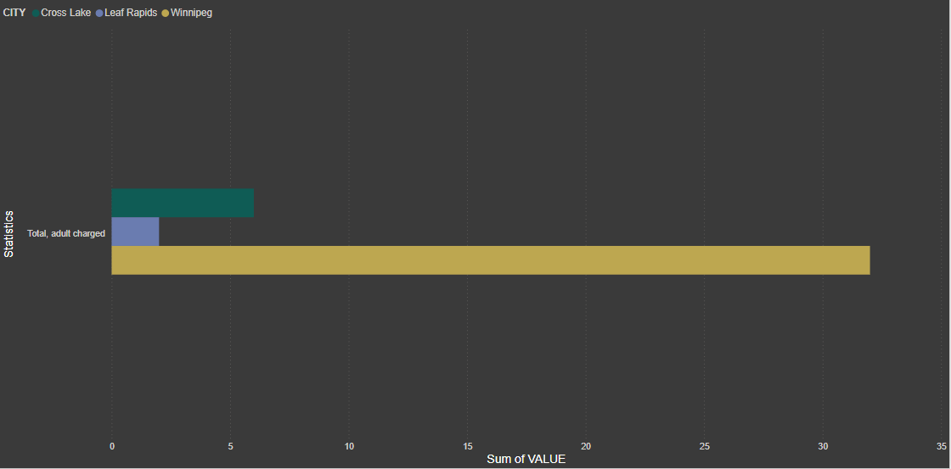

**Ontario (ON)**

1. **Cities: Ottawa, Thunder Bay, Toronto**
   * The visual breaks down the total number of adults and youths charged with abduction.
   * Toronto has the highest number of adults charged, followed by Ottawa and Thunder Bay.
   * Youth charges are significantly lower, with very few cases compared to adult charges, notably higher in Toronto than in other cities.

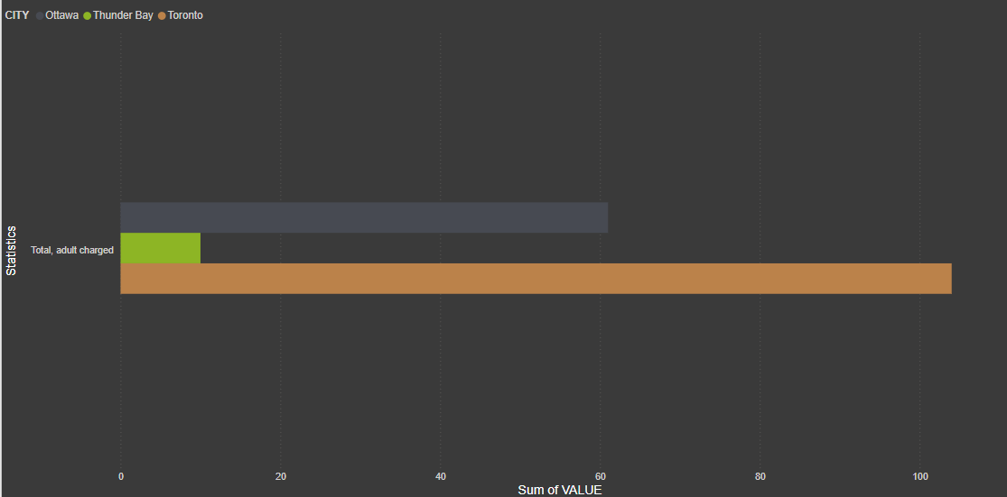**Quebec (QC)**

1. **Cities: Montreal, Richelieu Saint-Laurent**
   * The visual shows the total number of adults charged with abduction.
   * Montreal has a slightly higher number of adults charged compared to Richelieu Saint-Laurent, but the difference is not as pronounced as in the Manitoba and Ontario visuals.

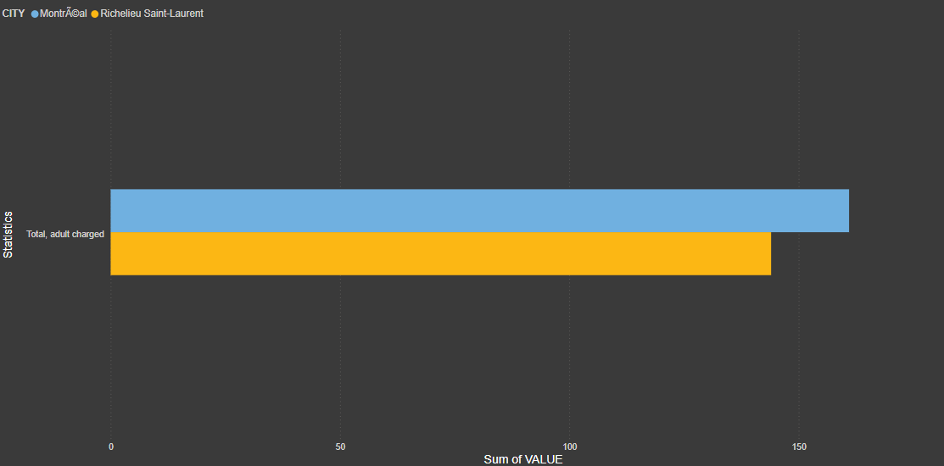

**Highlights and Insights**

1. **Manitoba (MB)**
   * **Winnipeg** stands out with the highest abduction charges, indicating it might be a hotspot for this crime within the province. This could suggest a need for focused law enforcement and community support efforts in Winnipeg.
   * **Cross Lake** and **Leaf Rapids** have much lower rates, indicating less prevalence or better control measures in these areas.
2. **Ontario (ON)**
   * **Toronto** has the highest number of abduction charges, both for adults and youths, indicating it is a significant area of concern.
   * **Ottawa** and **Thunder Bay** follow, with fewer charges, but the presence of youth charges in Toronto suggests that prevention programs should also target younger populations in this city.
   * The stark difference between adult and youth charges suggests that most abductions are committed by adults, but youth involvement should not be overlooked.
3. **Quebec (QC)**
   * **Montreal** and **Richelieu Saint-Laurent** show similar levels of adult charges, with Montreal slightly higher. This indicates a relatively even distribution of abduction incidents between the two cities.
   * Given that the difference is not very pronounced, interventions could be evenly distributed across both cities.

**Correlation Between Youth and Adult Crime Rates**

* In Ontario, there is a visible presence of youth charges alongside adult charges, especially in Toronto, suggesting a possible correlation where areas with higher adult crime rates might also experience higher youth crime rates.
* Manitoba and Quebec visuals primarily focus on adult charges, and thus do not provide data to analyze youth involvement directly.

**Forecast how the crimes will change next year in Ontario, Quebec and Manitoba.**

**Manitoba (MB)**

* **Visual Trend:** The graph shows the sum of abduction crimes from 2012 to 2022, with a forecast for 2023.
* **Key Insights:**
  + The trend starts at a high in 2012 (~100 cases) and generally declines until 2015 (~60 cases).
  + A slight increase is observed in 2016, followed by another decline reaching its lowest in 2018 (~50 cases).
  + A significant upward trend follows, peaking again around 2021 (~90 cases), then slightly dropping in 2022.
  + The forecast for 2023 shows a possible decline with a wide prediction interval, indicating uncertainty.

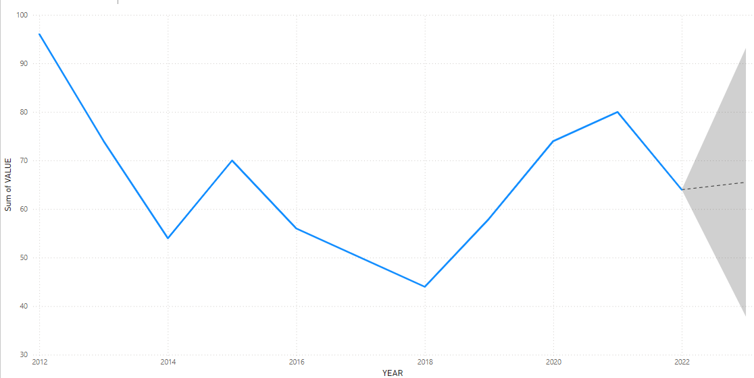

**Ontario (ON)**

* **Visual Trend:** The graph shows the sum of abduction crimes from 2012 to 2022, with a forecast for 2023.
* **Key Insights:**
  + The trend starts at a higher level (~320 cases) and generally declines until reaching a low in 2016 (~180 cases).
  + An increase is observed after 2016, peaking in 2018 (~290 cases) followed by fluctuations but generally declining again towards 2022 (~250 cases).
  + The forecast for 2023 indicates a slight decline, with a broader prediction interval, suggesting variability in the expected outcomes.

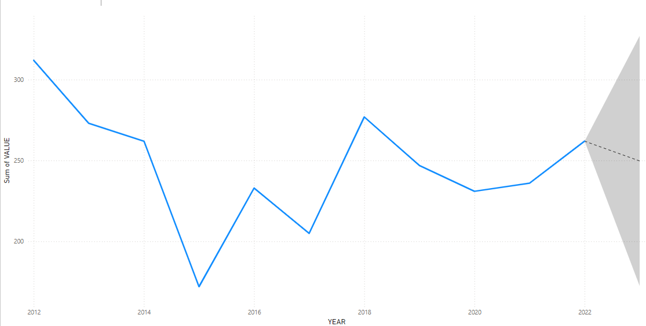

**Quebec (QC)**

* **Visual Trend:** The graph shows the sum of abduction crimes from 2012 to 2022, with a forecast for 2023.
* **Key Insights:**
  + The trend starts at around ~320 cases in 2012, remaining stable until 2014, and then rises to a peak (~500 cases) in 2015.
  + After 2015, there's a general decline until 2018 (~400 cases), followed by an increase peaking around 2020 (~750 cases).
  + The trend shows a decline towards 2022 (~600 cases).
  + The forecast for 2023 shows a potential increase, with a wide prediction interval indicating high uncertainty.

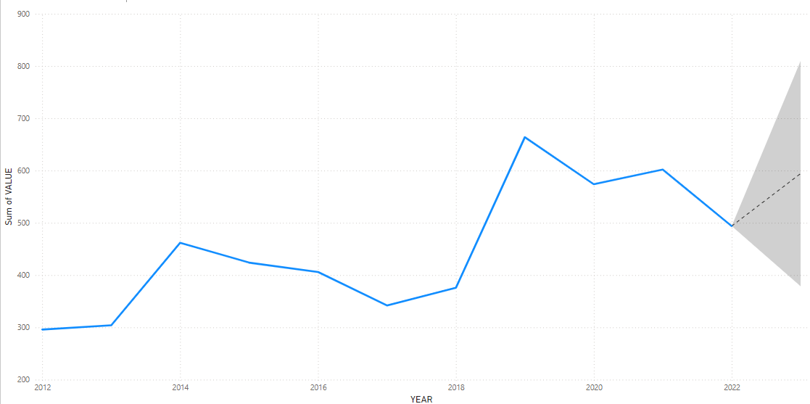

**General Highlights and Insights**

1. **Manitoba (MB):**
   * The abduction crime rate shows a cyclical pattern with notable peaks and troughs.
   * There has been a significant rise from 2018 to 2021, but it seems to be stabilizing or slightly declining into 2023.
   * The forecasted decline indicates that initiatives to curb abduction may be taking effect, though the broad prediction interval suggests vigilance is necessary.
2. **Ontario (ON):**
   * The trend shows an initial sharp decline, followed by fluctuating increases and decreases.
   * The data suggests that Quebec has experienced variable but generally reducing abduction cases post-2018.
   * The forecast indicates potential stabilization, but with a broader interval, signaling the need for continued monitoring.
3. **Quebec (QC):**
   * The trend depicts significant fluctuations with a sharp increase around 2020.
   * Recent years show a decline, but the forecast indicates a possible rise in 2023.
   * The broad prediction interval underscores the need for targeted strategies to manage and prevent abductions effectively.

**CRIME RATE PREDICTION**

* **Ontario**: The prediction model suggests that Ontario’s abduction crime rate, which has shown a cyclical pattern over the last decade, may experience a slight decline in 2023. This potential decrease indicates that recent initiatives to curb abduction crimes might be taking effect. However, the broad prediction interval underscores the need for ongoing vigilance and sustained crime prevention efforts.
* **Quebec**: For Quebec, the forecast indicates a potential stabilization in abduction crime rates, with a slight decline expected in 2023. Despite previous fluctuations, the general trend over recent years has been downward. The broader prediction interval suggests variability in outcomes, highlighting the importance of continued monitoring and targeted interventions to maintain or further reduce abduction incidents.
* **Manitoba**: Manitoba’s abduction crime rate forecast for 2023 suggests a potential increase, following significant fluctuations and a notable rise around 2020. The prediction interval is wide, indicating high uncertainty. This underscores the necessity for targeted strategies and resource allocation to manage and prevent abductions effectively, particularly in high-risk areas like Winnipeg.

These predictions emphasize the importance of adaptive and proactive crime prevention measures across all three provinces to address the unique challenges and trends observed in each region.

**CONCLUSION AND RECOMMENDATIONS**

**Conclusion**

The comparative analysis of abduction crimes in Ontario, Quebec, and Manitoba over the last decade reveals distinct trends and highlights areas requiring focused attention. Quebec consistently shows higher abduction crime rates, necessitating significant intervention. Ontario’s fluctuating crime rates suggest underlying factors influencing these variations, while Manitoba exhibits the lowest and most stable rates, although recent trends indicate a potential increase.

The analysis of crime rates in the top cities within each province shows that larger urban areas like Toronto and Montreal are hotspots for abduction crimes. This necessitates targeted law enforcement and community interventions. The correlation between youth and adult crime rates in these cities underscores the importance of addressing both demographics in crime prevention strategies.

**Recommendations**:

1. **Targeted Interventions in Quebec**:
   * **Increased Resources**: Allocate more law enforcement and community resources to Quebec, focusing on high-incidence areas like Montreal and Richelieu Saint-Laurent.
   * **Community Programs**: Implement community awareness programs and support services to address underlying causes of high abduction rates.
2. **Focused Efforts in Ontario**:
   * **Urban Hotspot Strategies**: Develop targeted crime prevention and intervention strategies for Toronto, which shows the highest incidence of abduction crimes.
   * **Investigate Fluctuations**: Conduct in-depth studies to understand the causes of fluctuations in abduction rates and address the identified factors.
3. **Sustained Efforts in Manitoba**:
   * **Monitor Rising Trends**: Closely monitor the increasing trends in cities like Winnipeg and implement proactive measures to curb the rise in abduction crimes.
   * **Maintain Stability**: Continue effective crime prevention strategies in Cross Lake and Leaf Rapids, ensuring that these measures remain in place and adapt to any emerging trends.
4. **Youth Crime Prevention**:
   * **Youth Programs**: Implement specific programs targeting youth in high-crime areas, providing education, support, and intervention to prevent youth involvement in abductions.
   * **Mentorship and Support**: Develop mentorship programs connecting at-risk youth with positive role models and support networks.
5. **Enhanced Data Analysis and Monitoring**:
   * **Continuous Monitoring**: Establish a robust system for continuous monitoring and analysis of abduction crime data across all three provinces to identify trends and respond promptly.
   * **Predictive Analytics**: Utilize advanced predictive analytics to forecast future crime trends and allocate resources efficiently.