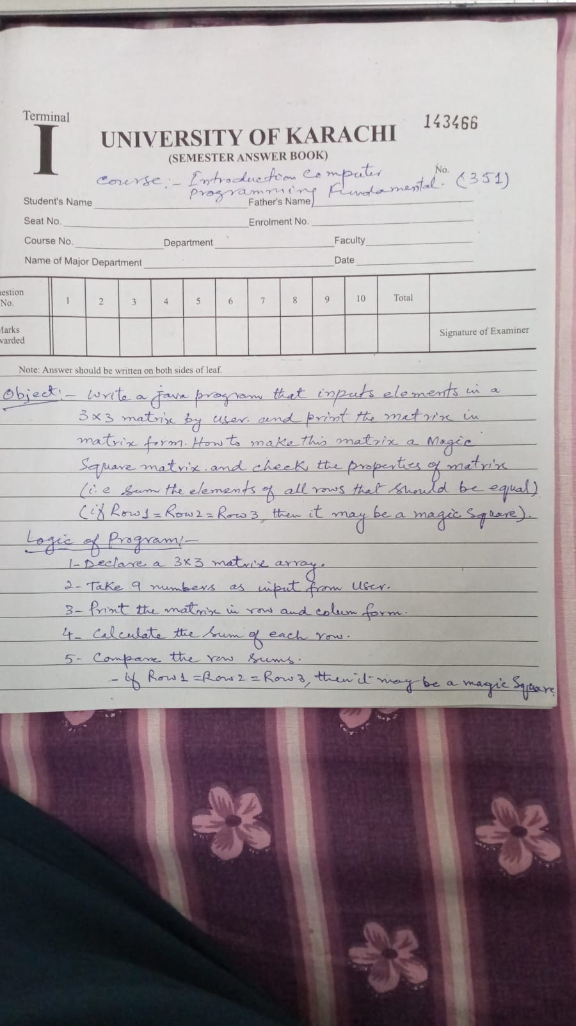
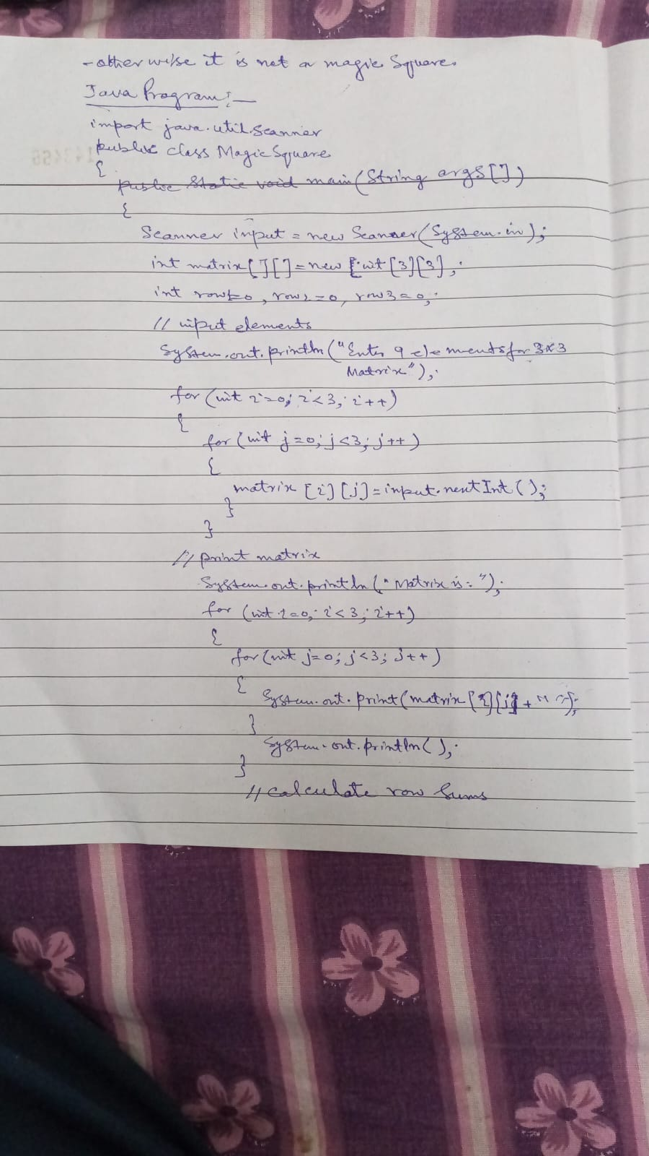

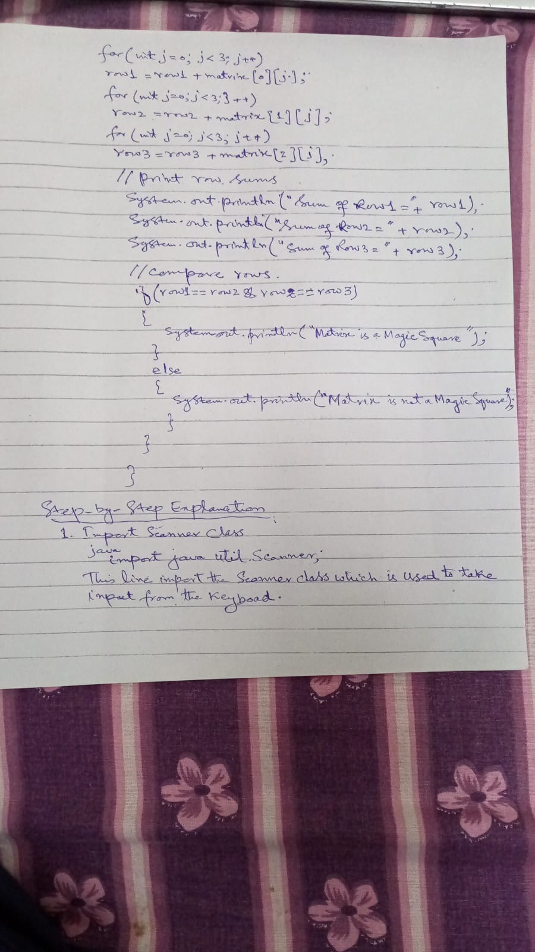

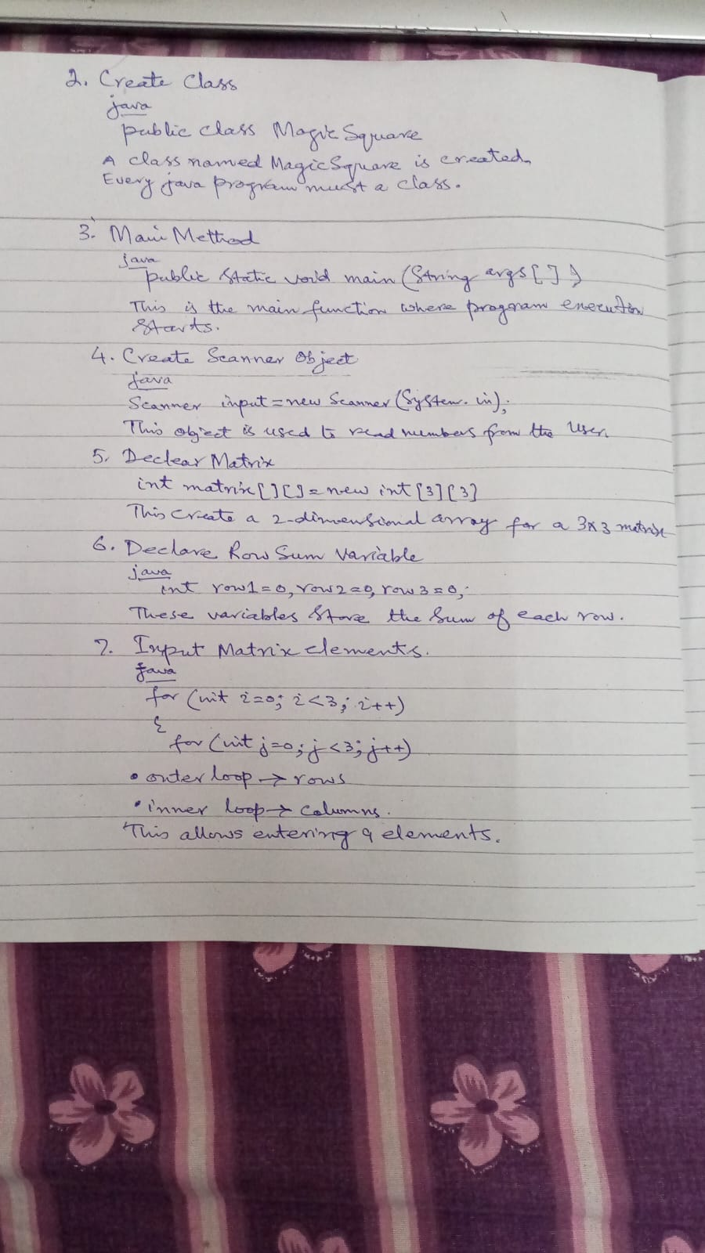

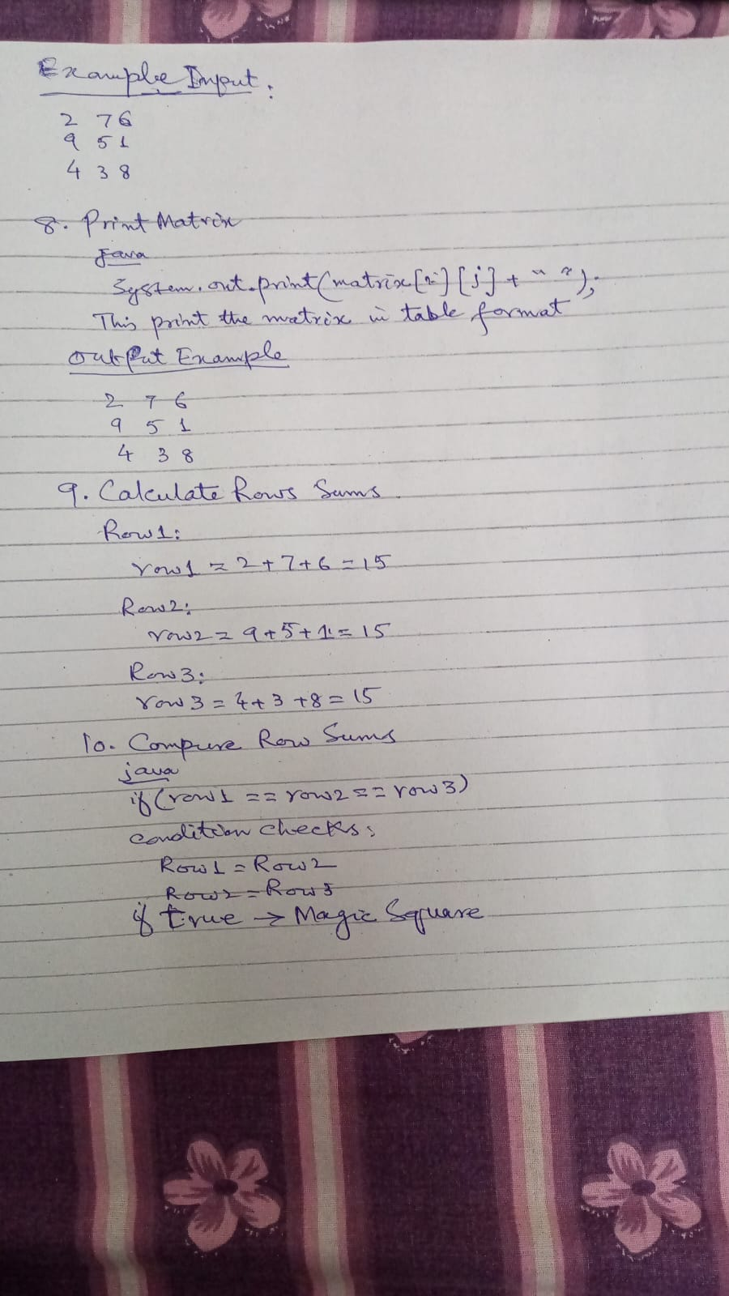

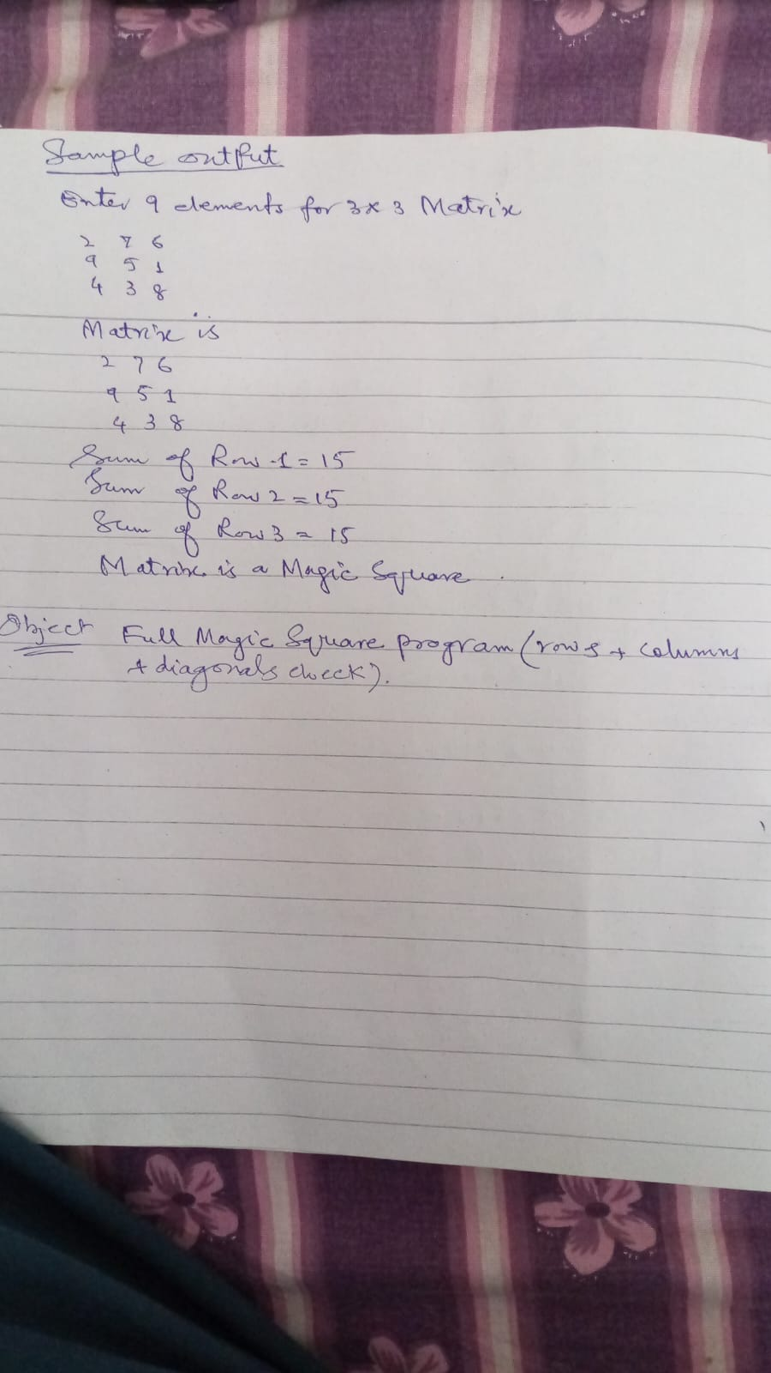

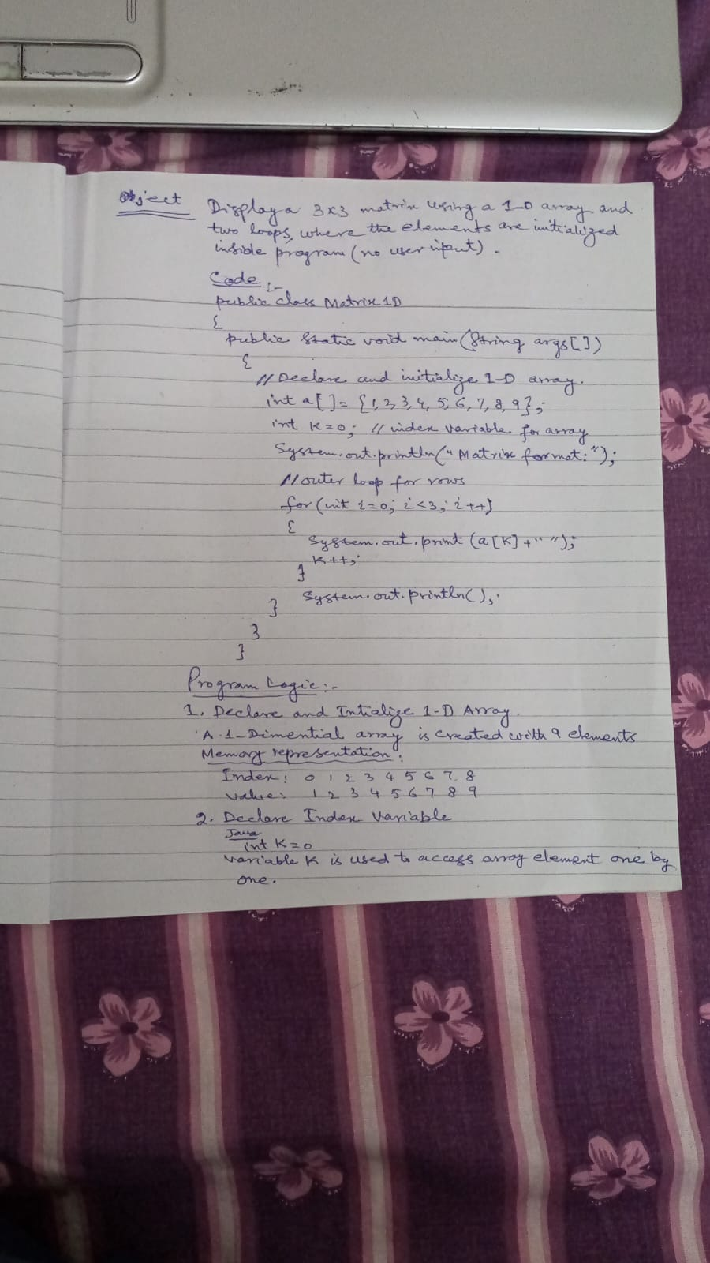

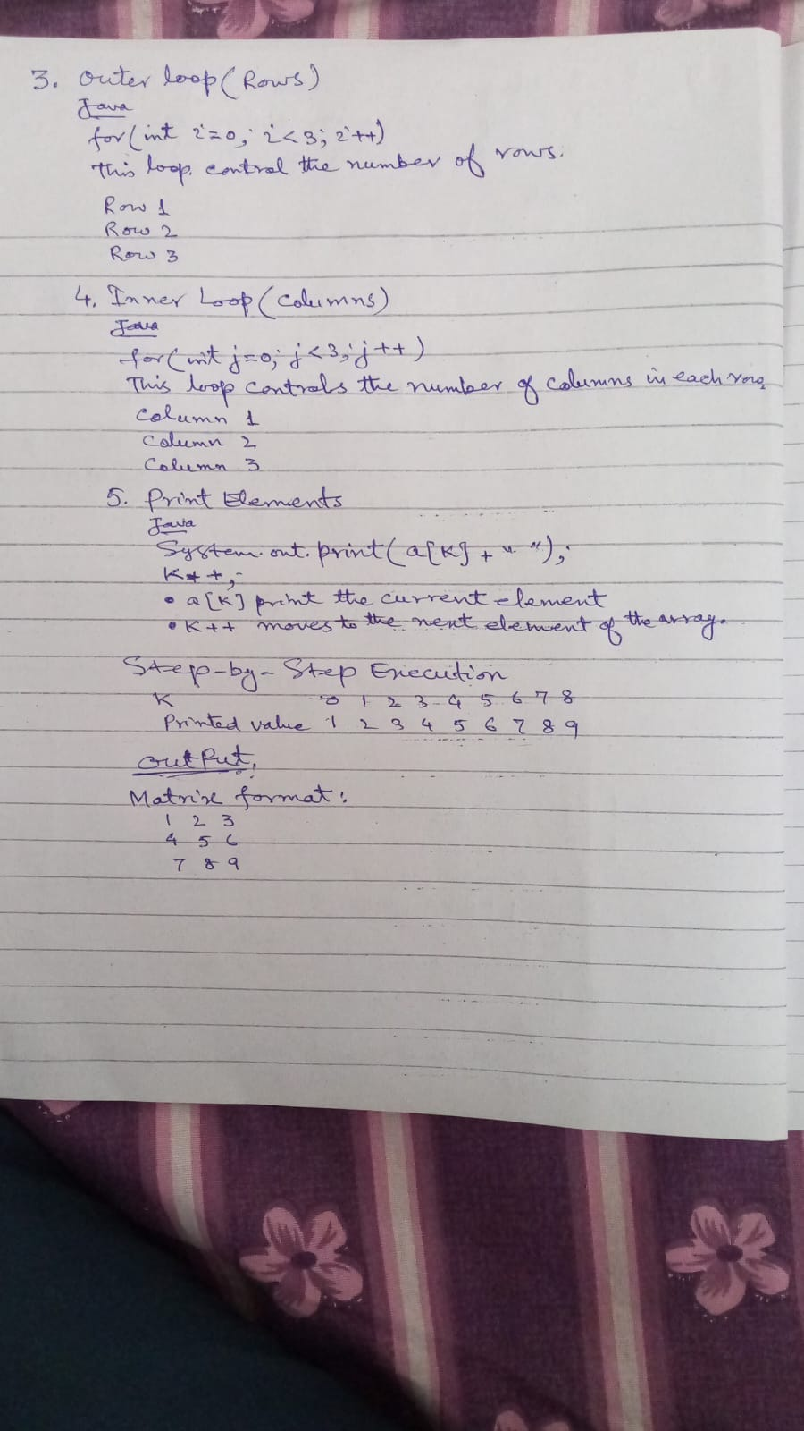

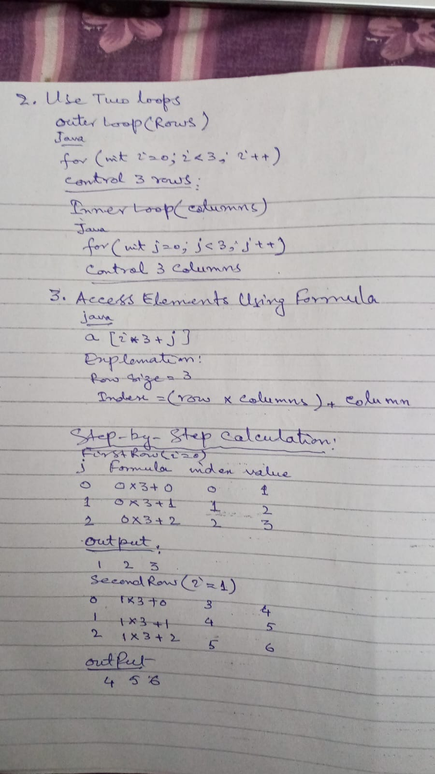

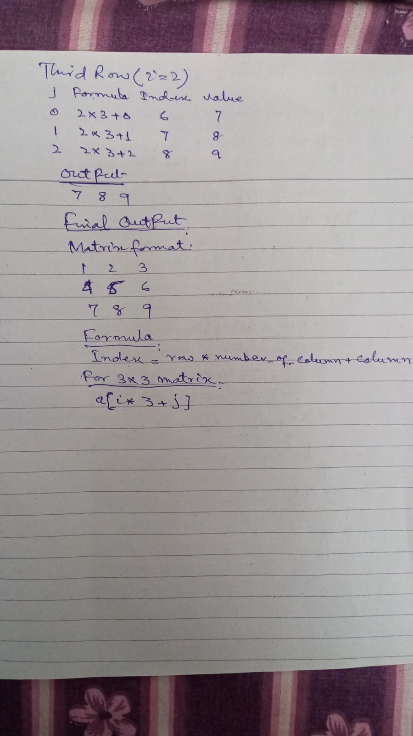

Below is a Java program to check whether a 3 × 3 matrix is a Magic Square .
Experiment: Magic Square Matrix in Java
1. Objective
To write a Java program that accepts elements of a 3 × 3 matrix from the user and checks whether the matrix is a Magic Square or not.
2. Theory
A Magic Square is a square matrix in which:
The sum of each row is equal
The sum of each column is equal
The sum of both diagonals is also equal
For a 3 × 3 magic square, all sums must be the same.
Example of a Magic Square:
8 1 6
3 5 7
4 9 2
Row sums = 15
Column sums = 15
Diagonal sums = 15
3. Algorithm (Logic)
Step 1: Start the program.
Step 2: Declare a 3 × 3 integer matrix.
Step 3: Input elements of the matrix from the user.
Step 4: Calculate the sum of first row and store it as reference.
Step 5: Calculate the sum of each row and compare with reference sum.
Step 6: Calculate the sum of each column and compare with reference sum.
Step 7: Calculate both diagonal sums.
Step 8: If all sums are equal → Matrix is Magic Square.
Step 9: Otherwise → Matrix is Not Magic Square.
Step 10: Stop.

4. Java Program
import java.util.Scanner;
public class MagicSquare
{
public static void main(String args[])
{
Scanner sc = new Scanner(System.in);
int a[][] = new int[3][3];
int i, j;
System.out.println("Enter elements of 3x3 matrix:");
// Input matrix elements
for(i=0; i<3; i++)
{
for(j=0; j<3; j++)
{
a[i][j] = sc.nextInt();
}
}
int sum = 0;
// Sum of first row
for(j=0; j<3; j++)
{
sum = sum + a[0][j];
}
int flag = 1;
// Check row sums
for(i=0; i<3; i++)
{
int rowsum = 0;
for(j=0; j<3; j++)
{
rowsum = rowsum + a[i][j];
}
if(rowsum != sum)
{
flag = 0;
}
}
// Check column sums
for(j=0; j<3; j++)
{
int colsum = 0;
for(i=0; i<3; i++)
{
colsum = colsum + a[i][j];
}
if(colsum != sum)
{
flag = 0;
}
}

// Check diagonal sums
int diag1 = a[0][0] + a[1][1] + a[2][2];
int diag2 = a[0][2] + a[1][1] + a[2][0];

if(diag1 != sum || diag2 != sum)
{
flag = 0;
}

// Final result
if(flag == 1)
{
System.out.println("Matrix is Magic Square");
}
else
{
System.out.println("Matrix is NOT Magic Square");
}
}
}
5. Explanation of Important Lines
Scanner class
Scanner sc = new Scanner(System.in);
Used to take input from the keyboard.
Matrix Declaration
Java
Copy code
int a[][] = new int[3][3];
Creates a 3 × 3 two-dimensional array (matrix).
Input Loop
for(i=0; i<3; i++)
{
for(j=0; j<3; j++)
Used to enter matrix elements row by row.
Row Sum
rowsum = rowsum + a[i][j];
Calculates the sum of each row.
Column Sum
colsum = colsum + a[i][j];
Calculates the sum of each column.
Diagonal Sum
int diag1 = a[0][0] + a[1][1] + a[2][2];
int diag2 = a[0][2] + a[1][1] + a[2][0];
Calculates both diagonals.
Final Check
If (flag == 1)
If all sums are equal → Magic Square.
6. Sample Input
8 1 6
3 5 7
4 9 2
Output:
Matrix is Magic Square

Below is a complete Java program (without OOP concepts) that:

Declares a 3×3 array
Creates/inputs the matrix after declaration
Prints the matrix
Calculates row sums
Calculates column sums
Calculates diagonal sums
Checks whether it is a Magic Square
Written in simple lab manual style with logic.
Java Program: Full Magic Square (Rows + Columns + Diagonal)
import java.util.Scanner;
public class MagicSquare
{
public static void main(String args[])
{
Scanner input = new Scanner(System.in);
// Declare matrix
int matrix[][] = new int[3][3];
int row1=0,row2=0,row3=0;
int col1=0,col2=0,col3=0;
int diag1=0,diag2=0;
// Input elements
System.out.println("Enter 9 elements for 3x3 matrix:");
for(int i=0;i<3;i++)
{
for(int j=0;j<3;j++)
{
matrix[i][j] = input.nextInt();
}
}
// Print matrix
System.out.println("Matrix is:");
for(int i=0;i<3;i++)
{
for(int j=0;j<3;j++)
{
System.out.print(matrix[i][j] + " ");
}
System.out.println();
}
// Row sums
for(int j=0;j<3;j++)
row1 = row1 + matrix[0][j];
for(int j=0;j<3;j++)
row2 = row2 + matrix[1][j];
for(int j=0;j<3;j++)
row3 = row3 + matrix[2][j];
// Column sums
for(int i=0;i<3;i++)
col1 = col1 + matrix[i][0];
for(int i=0;i<3;i++)
col2 = col2 + matrix[i][1];
for(int i=0;i<3;i++)
col3 = col3 + matrix[i][2];
// Diagonal sums
for(int i=0;i<3;i++)
diag1 = diag1 + matrix[i][i];
for(int i=0;i<3;i++)
diag2 = diag2 + matrix[i][2-i];
// Print sums
System.out.println("Row sums: " + row1 + " " + row2 + " " + row3);
System.out.println("Column sums: " + col1 + " " + col2 + " " + col3);
System.out.println("Diagonal sums: " + diag1 + " " + diag2);
// Magic square check
if(row1==row2 && row2==row3 &&
col1==col2 && col2==col3 &&
diag1==diag2 && row1==col1 && col1==diag1)
{
System.out.println("Matrix is a Magic Square");
}
else
{
System.out.println("Matrix is NOT a Magic Square");
}
}
}

Program Logic (Step-by-Stepl)
1. Declare Matrix
int matrix[][] = new int[3][3];
A 2-dimensional array is created to store 3 rows and 3 columns.
2. Input Elements
Two loops are used.
for(int i=0;i<3;i++)
{
for(int j=0;j<3;j++)
i → rows
j → columns
User enters 9 elements.
Example input
2 7 6
9 5 1
4 3 8
3. Print Matrix
2 7 6
9 5 1
4 3 8
4. Row Sum Calculation
Row 1
2 + 7 + 6 = 15
Row 2
9 + 5 + 1 = 15
Row 3
4 + 3 + 8 = 15
5. Column Sum Calculation
Column 1
2 + 9 + 4 = 15

Column 2
7 + 5 + 3 = 15
Column 3
6 + 1 + 8 = 15
6. Diagonal Sum Calculation
Main diagonal
2 + 5 + 8 = 15
Second diagonal
6 + 5 + 4 = 15
7. Magic Square Condition
Program checks:
Row1 = Row2 = Row3
Column1 = Column2 = Column3
Diagonal1 = Diagonal2
All sums must be equal
If true → Magic Square
Example Output
Enter 9 elements for 3x3 matrix:
2 7 6
9 5 1
4 3 8
Matrix is:
2 7 6
9 5 1
4 3 8
Row sums: 15 15 15
Column sums: 15 15 15
Diagonal sums: 15 15
Matrix is a Magic Square

Below is a simple Java program (without OOP concepts) that:
Declares a 1-D array
Stores elements in the array
Prints the output in matrix format
I will also explain it step-by-step like a lab manual.
Java Program: 1-D Array Printed as Matrix
import java.util.Scanner;
public class MatrixFormat
{
public static void main(String args[])
{
Scanner input = new Scanner(System.in);
// Declare 1-D array
int a[] = new int[9];
// Input elements
System.out.println("Enter 9 elements:");
for(int i=0;i<9;i++)
{
a[i] = input.nextInt();
}
// Print in matrix format (3x3)
System.out.println("Matrix format:");
for(int i=0;i<9;i++)
{
System.out.print(a[i] + " ");
if((i+1)%3==0)
{
System.out.println();
}
}
}
}
Program Logic:
1. Import Scanner Class
import java.util.Scanner;
This class is used to take input from the user.
2. Declare 1-D Array
int a[] = new int[9];
A 1-dimensional array is created to store 9 elements.
Memory representation:
a[0] a[1] a[2] a[3] a[4] a[5] a[6] a[7] a[8]
3. Input Elements
for(int i=0;i<9;i++)
{
a[i] = input.nextInt();
}
This loop stores 9 values in the array.
Example input:
1 2 3 4 5 6 7 8 9
4. Print Array in Matrix Format
if((i+1)%3==0)
Explanation:
After every 3 elements, a new line is printed.
This converts the 1-D array into 3×3 matrix format.
Example Output
Input:
1 2 3 4 5 6 7 8 9
Output:
Matrix format:
1 2 3
4 5 6
7 8 9
Important concept:
A 1-D array can be displayed as a matrix by controlling the number of elements printed per row.
Example rule:
(i + 1) % columns == 0

The difference between 1-D array and 2-D array explained with examples.

Difference Between 1-D Array and 2-D Array
Definition:
Stores elements in a single line (list)
Stores elements in rows and columns (table/matrix)
One dimension
Index: Uses one index
Representation:
Linear form
Accessing element:
a[i]
Loop required:
One loop
Example use
List of numbers, marks
Example use:
List of numbers, marks
Two dimensions:
Uses two indices (row and column)
Matrix / grid form
a[i][j]
Two nested loops
Matrix, table, spreadsheet
A 1-D array stores elements in a linear sequence, while a 2-D array organizes elements in rows and columns like a matrix. �
1-D Array Example
Declaration:
int a[] = {10,20,30,40,50};
Memory Representation:
Index: 0 1 2 3 4
Value: 10 20 30 40 50
Access Element:
a[2] = 30
Simple Program:
public class Array1D
{
public static void main(String args[])
{
int a[] = {10,20,30,40,50};
for(int i=0;i<5;i++)
{
System.out.println(a[i]);
}
}
}
Output:
10
20
30
40
50
2-D Array Example:
Declaration
int a[][] = {
{1,2,3},
{4,5,6},
{7,8,9}
};
Matrix Representation:
1 2 3
4 5 6
7 8 9
Access Element:
a[1][2] = 6
( row = 1 , column = 2 )
Simple Program:
public class Array2D
{
public static void main(String args[])
{
int a[][] = {
{1,2,3},
{4,5,6},
{7,8,9}
};
for(int i=0;i<3;i++)
{
for(int j=0;j<3;j++)
{
System.out.print(a[i][j] + " ");
}
System.out.println();
}
}
}
Output:
1 2 3
4 5 6
7 8 9
Key Points :
1-D Array:
Single index
a[i]
Example: a[3]
2-D Array:
Two indexes
a[i][j]
Example: a[1][2]
Short Definition:
1-D Array: A collection of elements stored in a single row and accessed using one index.
2-D Array: A collection of elements arranged in rows and columns and accessed using two indexes.

Logic of Addition of Two Matrices:
The logic of matrix addition is very simple.
Two matrices can be added only if they have the same number of rows and columns.
Each element of the first matrix is added to the corresponding element of the second matrix.
The result is stored in a third matrix (result matrix).
Mathematical Logic:
If
A = [aij]
B = [bij]
Then the result matrix C is:
C[i][j] = A[i][j] + B[i][j]
Where
i = row number
j = column number
Example
Matrix A
Copy code

1 2 3
4 5 6
7 8 9
Matrix B
9 8 7
6 5 4
3 2 1
Addition:
Code:
C[0][0] = 1 + 9 = 10
C[0][1] = 2 + 8 = 10
C[0][2] = 3 + 7 = 10
Result Matrix
10 10 10
10 10 10
10 10 10
Program Logic:
Declare two matrices A and B.
Declare a result matrix C.
Use two nested loops (rows and columns).
Add elements using
Code:
C[i][j] = A[i][j] + B[i][j]
Print the result matrix.

Object: Write a Java program to add two matrices where the input values are already initialized in program.

Function in Java (Method):
In Java, a function is called a method.
A function (method) is a block of code that performs a specific task and can be called (used) whenever needed.
Functions help to:
Reduce repetition of code
Make programs easier to understand
Organize the program into smaller parts
Syntax of a Function (Method)
Java
Copy code
return_type function_name(parameters)
{
// statements
}
Explanation:
return_type → The type of value the function returns (int, double, void, etc.).
function_name → Name of the function.
parameters → Input values passed to the function.
statements → Code that performs the task.
Example 1: Function Without Parameter
Java Program
class FunctionExample
{
// function definition
static void display()
{
System.out.println("Welcome to Java Programming");
}
public static void main(String args[])
{
// function call
display();
}
}

Explanation:
class FunctionExample
Creates a class named FunctionExample.
static void display()
Defines a function named display.
void means the function does not return any value.
System.out.println()
Prints the message on the screen.
public static void main(String args[])
Main method where program execution starts.
display();
Calls the display function.
Output:
Welcome to Java Programming
Example 2: Function With Parameters
Java Program
class AddFunction
{
// function definition
static int add(int a, int b)
{
int sum;
sum = a + b;
return sum;
}
public static void main(String args[])
{
int result;
// function call
result = add(5, 3);
System.out.println("Sum = " + result);
}
}
Explanation:
static int add(int a, int b)
Defines a function named add with two parameters a and b.
sum = a + b;
Adds the two numbers.
return sum;
Sends the result back to the main method.
result = add(5,3);
Calls the function and stores the returned value.
Output:
Sum = 8
Types of Functions in Java:
Function without parameter and without return value
Function with parameter but no return value
Function with parameter and return value
Short Definition:
A function (method) in Java is a block of code that performs a specific task and can be called whenever required in the program.
If you want, I can also show 3–4 small Java function programs (like IT lab exercises) that teachers commonly ask in exams.

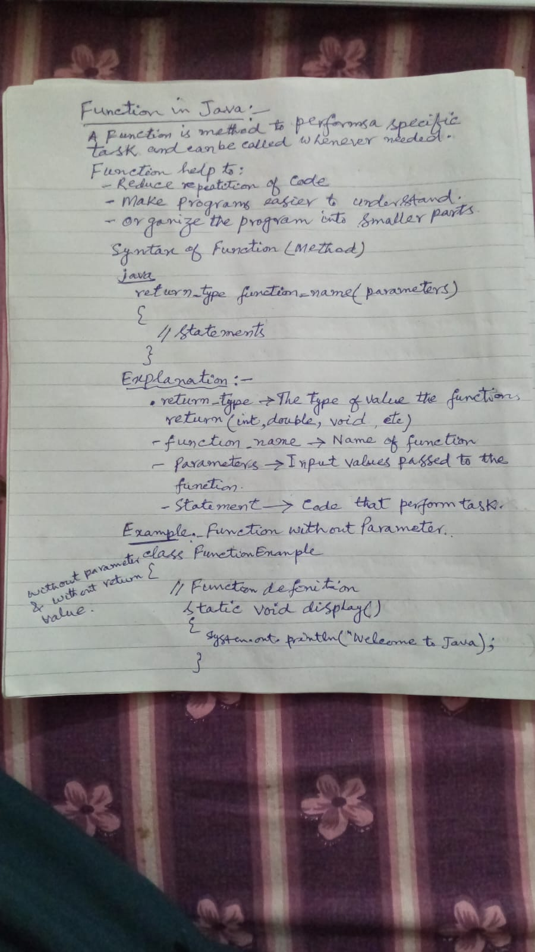

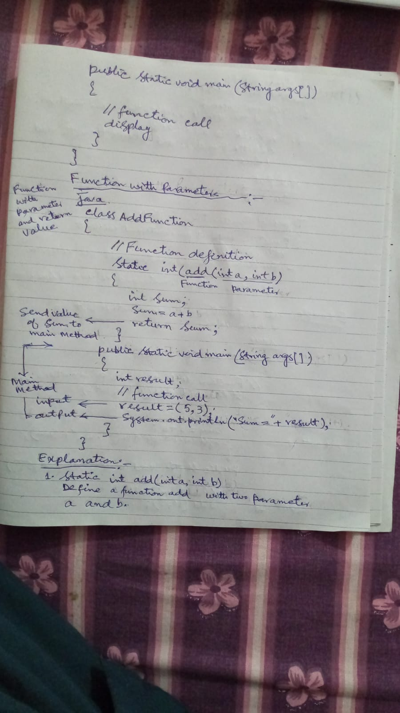

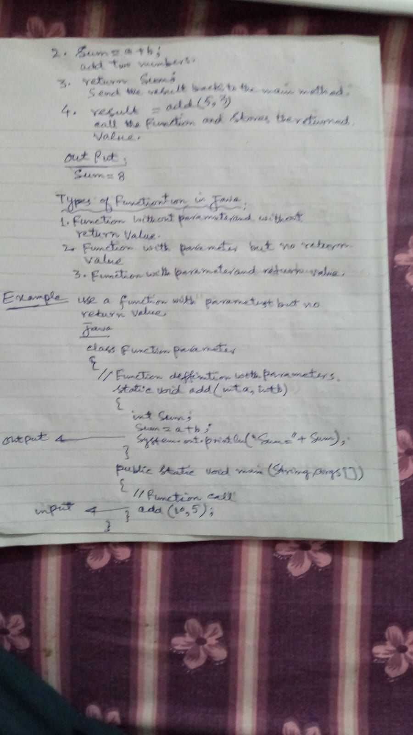

Difference Between Arguments and Parameters in Java
(Lab Manual Style Explanation)
1. Aim
To understand the difference between parameters and arguments in Java with the help of a simple program.
2. Theory
In Java, when we create and call a method (function), we often pass values to that method.
These values are handled using parameters and arguments.
1. Parameters
Parameters are variables declared in the method definition.
They receive values when the method is called.
They act like placeholders for the data.
Example (method definition):
Java
Copy code
void add(int a, int b)
Here:
a and b are parameters.
So we can say:
Parameters are variables written in the method declaration.
2. Arguments
Arguments are the actual values passed to the method when it is called.
These values are stored in the parameters.
Example (method call):
Java
Copy code
add(5, 10);
Here:
5 and 10 are arguments.
So we can say:
Arguments are the real values passed to the method.
3. Program Example (Parameters and Arguments)
Java
Copy code
class ParameterArgumentDemo
{
// Method with parameters
void add(int a, int b)
{
int sum;
sum = a + b;
System.out.println("Sum = " + sum);
}

public static void main(String args[])
{
ParameterArgumentDemo obj = new ParameterArgumentDemo();

// Method call with arguments
obj.add(5, 10);
}
}
4. Explanation of the Program
Line 1
Java
Copy code
class ParameterArgumentDemo
A class named ParameterArgumentDemo is declared.
Line 4
Java
Copy code
void add(int a, int b)
A method named add is created.
int a
int b
These are parameters.
Line 6
Java
Copy code
int sum;
A variable sum is declared.
Line 7
Java
Copy code
sum = a + b;
The values stored in parameters a and b are added.
Line 8
Java
Copy code
System.out.println("Sum = " + sum);
Displays the result.
Line 13
Java
Copy code
ParameterArgumentDemo obj = new ParameterArgumentDemo();
An object of the class is created.
Line 16
Java
Copy code
obj.add(5, 10);
The method is called.
5 and 10 are arguments.
These values are stored in parameters a and b.
5. Output
Copy code

Sum = 15
6. Difference Between Parameters and Arguments
Parameters
Arguments
Declared in the method definition
Passed in the method call
Act as variables
Act as actual values
Receive the data
Send the data
Example: int a, int b
Example: 5, 10
7. Simple Way to Remember
Parameters → Variables in method
Arguments → Actual values given to method
Example:
Copy code

Method: add(int a, int b) → Parameters
Call: add(5, 10) → Arguments
If you want, Jahangir, I can also show you 3 more Java lab-style programs:
Parameters with return value
Parameters without return value
Method without parameters but with return value
These are very common Java lab exam questions.

Below are two Java programs to calculate the factorial of a number entered by the user:
- Without Function (directly in main method)
- With Function (using a method)
1. Java Program to Calculate Factorial Without Function
Object : To write a Java program to calculate the factorial of a number entered by the user without using a function.
Theory: The factorial of a number n is the product of all positive integers from 1 to n.
Example: 5! = 5 × 4 × 3 × 2 × 1 = 120
Formula: n! = n × (n-1) × (n-2) × ... × 1
Program Code:

4. Explanation of the Program
Line 1
import java.util.Scanner;
This line imports the Scanner class to take input from the user.
Line 3
class FactorialWithoutFunction
Declares a class named FactorialWithoutFunction.
Line 5
public static void main(String args[])
Main method where program execution starts.
Line 7
int num, i;
num stores the number entered by user
i is used for loop control
Line 8
int fact = 1;
Variable fact stores the factorial result.
Line 10
Scanner input = new Scanner(System.in);
Creates Scanner object to read user input.
Line 12
num = input.nextInt();
Reads the number entered by the user.
Line 14-17
for(i = 1; i <= num; i++)
{
fact = fact * i;
}
Loop multiplies numbers from 1 to num to calculate factorial.
Line 19
System.out.println("Factorial = " + fact);
Displays the factorial result.
5. Sample Output
Enter a number: 5
Factorial = 120
2. Java Program to Calculate Factorial With Function
Object: To write a Java program to calculate the factorial of a number using a Function (method).
Program Java:
import java.util.Scanner;
class FactorialWithFunction
{
int factorial(int n)
{
int i, fact = 1;
for(i = 1; i <= n; i++)
{
fact = fact * i;
}
return fact;
}
public static void main(String args[])
{
int num, result;
Scanner input = new Scanner(System.in);
System.out.print("Enter a number: ");
num = input.nextInt();
FactorialWithFunction obj = new FactorialWithFunction();
result = obj.factorial(num);

System.out.println("Factorial = " + result);
}
}
3. Explanation of the Program
Line 3
class FactorialWithFunction
Declares the class.
Line 5
int factorial(int n)
Creates a function named factorial.
n is a parameter
It receives value from the main method.
Line 7
int i, fact = 1;
Declares variables for loop and factorial.
Line 9-12
for(i = 1; i <= n; i++)
{
fact = fact * i;
}
Loop multiplies numbers to calculate factorial.
Line 14
return fact;
Returns factorial value to the main method.
Line 23
FactorialWithFunction obj = new FactorialWithFunction();
Creates object of the class.
Line 25
result = obj.factorial(num);
Calls the function and sends num as argument.

Line 27
System.out.println("Factorial = " + result);
Displays the result.
4. Sample Output
Enter a number: 6
Factorial = 720

Main Difference Without Function and With Function
Code written directly in main()
Uses separate method
Less reusable
More reusable
Simpler program
Better program structure

Syntax of import java.util.Scanner in Java
Basic Syntax
import java.util.Scanner;
Explanation:
import
import is a Java keyword.
It is used to include a built-in package or class in a Java program.
java is the main package of Java.
util
util stands for utility package.
It contains many useful classes like Scanner, Random, Date, etc.
Scanner
Scanner is a class used to take input from the user (keyboard).
Where to Write This Statement
The import statement is written at the top of the program, before the class declaration.
Example:
import java.util.Scanner;
class InputExample
{
public static void main(String args[])
{
Scanner input = new Scanner(System.in);
int num;
System.out.print("Enter a number: ");
num = input.nextInt();
System.out.println("Number = " + num);
}
}
Explanation of Important Line
Scanner input = new Scanner(System.in);
Scanner → class name
input → object name
new → creates object
System.in → takes input from keyboard
Simple Definition :
import java.util.Scanner; is used to import the Scanner class from the util package so that a Java program can take input from the user.

