News and Experiences
  - Practical techniques to apply scientific principles to your own life.
Personal Science
2024-08-23
Table of contents

1. index

2. Prerequisites
Continuous glucose monitoring (CGM) is among the most exciting personal science experiments you can conduct on yourself. This book will explain how to get started.
Before you buy one of those expensive kits from one of the many commercial companies that offer the devices as part of their diet and nutrition programs, learn how to do it yourself for about $30 - $50. All of the direct-to-consumer kits use the same FDA-regulated device that is available at your local pharmacy for fraction of the price.
This site will show you step-by-step how to get the same results as the expensive products: an instant look at your glucose levels at any time day or night. After that, you can decide for yourself it it’s worth it for you to buy the other services.
2023-06-13 12:06 PM

3. Introduction

4. Introduction
This is a list of resources useful for building products that work with continuous glucose monitoring devices. Consider this document to be in the public domain, free to use however you like (but of course with absolutely no guarantees of accuracy).

Start with this article by Richard Sprague at NEO.LIFE: “Personalized Health Advice Every 60 Seconds”.
Also read this good overview from the NIH.

5. How to get your CGM

6. How to get your CGM
The FreeStyle Libre is available over-the-counter at most pharmacies throughout the world (including Mexico and Canada), but requires a doctor’s prescription in the United States.
A month’s supply of sensors costs under US$100, so don’t bother trying to get your health insurance to reimburse you unless you have a specific medical reason, in which case consult your doctor.
There are three ways to get one in the US:
- Ask your doctor to prescribe one for you. The Freestyle Buying Guide gives detailed information about how the product works, and what to tell your doctor. Most doctors will be happy to prescribe it if you explain that you’ll be paying out of pocket.
- Tastermonial (tastermonial.com) will connect you with a doctor who can provide a prescription for $39 (or $195 including shipment of two sensors). This is the easiest solution for most people.
- If you’re traveling to Canada, Mexico, or other countries, you can pick them up locally, or you can order one to be shipped into the US. Michael Cohn describes how he got one from Canada for about $100

6.1 What to buy
Buy the 14-day sensor by itself. If you have an iPhone 7 + or an Android, don’t bother buying the Reader (which is an additional US$200).

6.2 Commercial CGM Products
Several companies will give you a month’s worth of CGM with an app and nutrition advice for under $500.

Levels Health
https://www.levelshealth.com/ offers “metabolic health” services, including a month’s supply of CGMs and nutritionist consultation for about $400/year. They’ll sell additional sensors “at cost”.

January, Inc.
https://january.ai/ $300 2-week program includes 1 Freestyle Libre device and an app to guide your eating, fasting, and exercise choices. The app claims it will predict your glucose levels after that using their “virtual CGM”.

Nutrisense
https://www.nutrisense.io/: Join their “cohort” and receive 2 CGM devices/month and 24/7 nutritionist advice with an app that tracks your glucose, fasting, and more.
Aspect
Aspect Health focuses specifically on women’s metabolic health. You can get their “21 Day Assessment”, which includes an app, a metabolic report, and a coaching session for /$200.

7. News and Experiences
The FDA approved the first over-the-counter CGM (see Hacker News)

8. News and User Experiences
Nerdabetic (YouTube and Instagram) makes hundreds of videos describing the CGM experience.
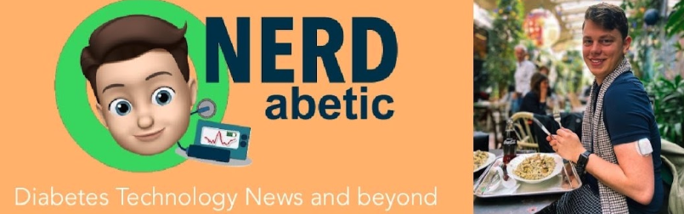
Diabetes technology news from Nerdabetic
- Self-tracker blog.kto.to documents his extensive food tests, with many links to other useful sources of information.
- New York Times Health Reporter Anahad O’Connor wrote about Nutrisense, January.ai, and his personal experience using Levels Health. https://www.nytimes.com/2021/02/08/well/diet-glucose-monitor.html
- Lydia Ramsey, senior reporter at Business Insider wrote a detailed summary (2019) of using a Dexcom G6:
- Eric Jain wrote a short, highly-readable account of his month-long experience: https://eric.jain.name/2018/11/25/tracking-blood-sugar/
  - And a Hacker News thread about his post
- Quantified Diabetes does rigorous self-experimentation at https://quantifieddiabetes.com/p/experiments.html.
- Lily Nichols is a registered dietitian who wrote “What I Learned as a Non-Diabetic”
- Jimi S, a 25-year-old diabetic wrote a lengthy review: Review: FreeStyle Libre — Abbott Diabetes Care | by Jimi S.
- “Quantified Bob” Troia wrote “How to measure personal glucose response to foods”
- Jennifer Wang writes “Am I Crazy Because I Eat Too Much Sugar?”
- Follow Jessie Inchaspe’s incredible Instagram account on her experiences with food and CGM: https://www.instagram.com/glucosegoddess/
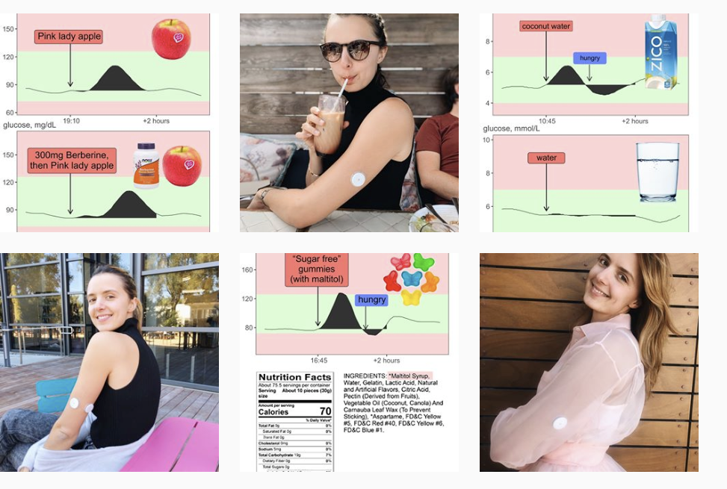 “Jessie Inchaspe Instagram”)
- Kevin Bass n-of-1: A PhD student kept (2018-19) a live Twitter feed of his CGM data
- Why Perfectly Healthy People Are Using Glucose Monitors:Time Magazine article from 2017
- Hacker News thread about CGMs and sugar metabolism
- Interactive web app with daily updates from the Personal Science glucose monitor.
- How accurate it is: a user posts side-by-side comparisons of Freestyle Libre vs pinprick
- Reddit forums Lots of posts in diabetes-related forums
Libre2 announcement (Oct 2018)

9. Diet and food-tracking

10. Diet and food-tracking
Apps and websites useful for nutrition tracking
Bitesnap: take a photo of your food and get an AI-based identification, plus macronutrients and calories. Recognizes 1300+ foods. |  |  https://getbitesnap.com/
LoseIt: Food database with 7 million+ foods, restaurant items and brands from around the world, hand curated by our on-staff nutrition experts. |  |   alt_text  https://www.loseit.com/
MyFitnessPal : 6 million foods, largest online community, connects to 50+ apps |  | MyFitnessPal  https://www.myfitnesspal.com/
Cronometer  Large, curated food database. Widely used among professionals due to its in-depth tracking of nutrients and comprehensive data export. |  |   alt_text  https://cronometer.com/

11. Using Your CGM Data

12. Using Your CGM Data
Websites and apps that help you track glucose numbers.

12.1 Use the Personal Science App
The best way to analyze your CGM data is with the CGM app from Personal Science (makers of this web site). You can upload your data and study it for free using the open source software here. Uses Docker. Requires a little setup, but it will let you upload a CSV file and generate plots like this:
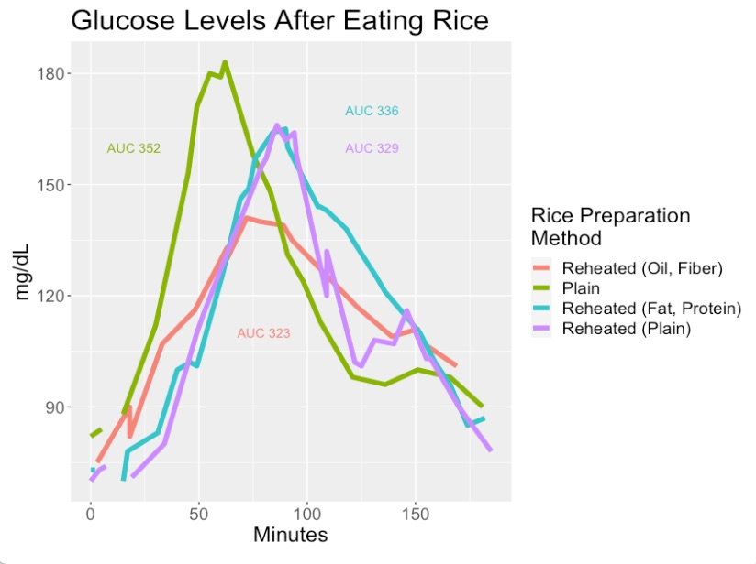

12.2 Abbott Labs Official
The most important software for Freestyle Libre downloading is the officially-supported one here:
https://provider.myfreestyle.com/freestyle-libre-resources.html
Create an account on Libreview and then you can download your data as a CSV file here:
https://www.libreview.com/meter
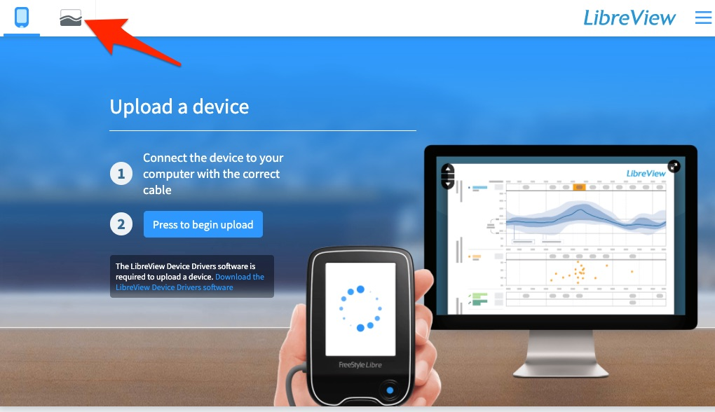
Libreview main page
Then click here: https://www.libreview.com/glucosereports
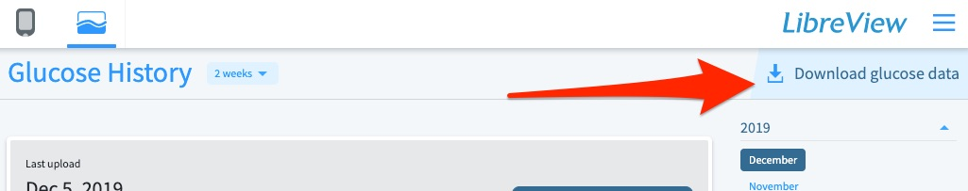
Click to download
If you have the Abbott custom reader device, you can also download a Mac or Windows version of Freestyle Libre personal CGM
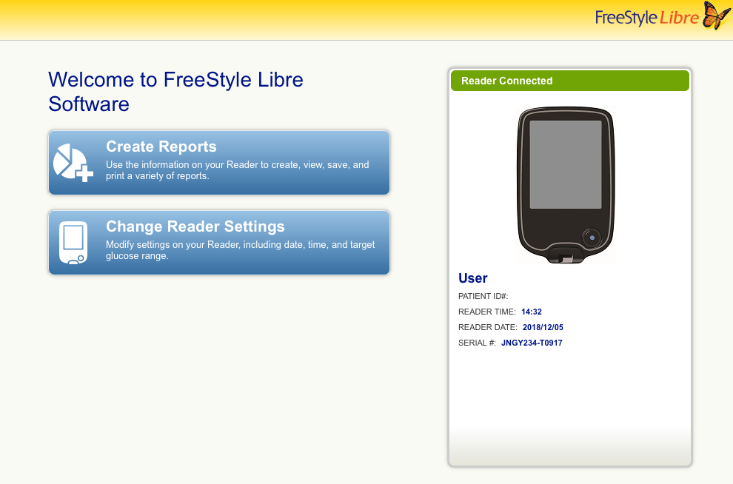
Freestyle Libre Software

12.3 International versions
Freestyle Libre devices sold in other countries will generally work everywhere if you use the app downloaded specifically for that country.
This [table by Chuck Kub] is a little old, but gives a sense of which models are available in which countries.
China: buy a reader plus 3 14-day sensor packs through Taobao for about 1800 RMB (USD$270)

12.4 Third Party
Many organizations now offer ways to upload and use your Freestyle (or other CGM) data.
Nightscout  "an open source, DIY project that allows real time access to a CGM data via personal website, smartwatch viewers, or apps and widgets available for smartphones"  See their app https://spike-app.com/ |  |  http://www.nightscout.info/
Diasend  (formerly calledGlooko) tries to let you upload data from anywhere |  |  https://diasend.com/us
Tidepool https://app.tidepool.org/patients  Open-source non-profit place to upload glucose data |  |   alt_text  https://tidepool.org
Diabetes:M |  | 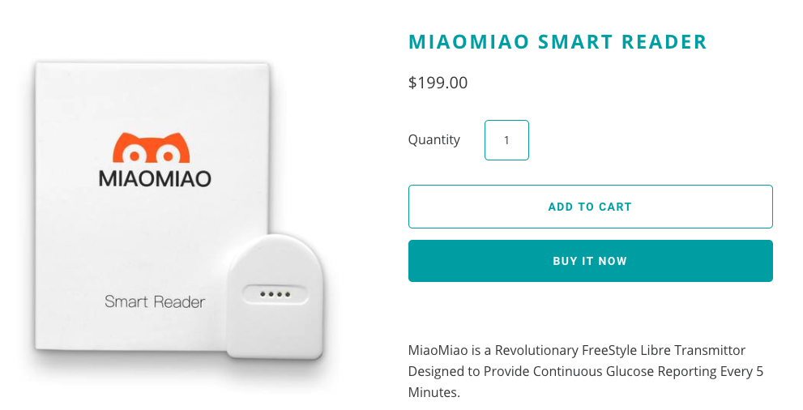  alt_text  https://diabetes-m.com/
Glimp : popular Android app |  | 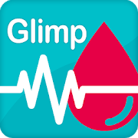  alt_text  https://play.google.com/store/apps/details?id=it.ct.glicemia

13. Open Source Software
- cgmr is an open-source R package that lets you read and process CGM data from Abbott Freestyle Libre. Includes functions to calculate iAUC and do side-by-side analyses comparing different food types over time.
- Nightscout xDrip+: https://github.com/JoernL/xDrip-plus
  - supports wireless connections to G4, G5, G6, Medtrum A6, Libre via NFC and Bluetooth, 630G, 640G, 670G pumps and Eversense CGM via companion apps. Bluetooth Glucose Meters such as the Contour Next One, AccuChek Guide, Verio Flex & Diamond Mini as well as devices like the Pendiq 2.0 Insulin Pen
  - 44 contributors, very active since Nov 2014 (latest checkin Dec 2018)
- OpenLibreReader iOS: https://github.com/blueToolz/openLibreReader-iOS-
  - a project to connect the various Libre Transmitters to the iPhone.
  - Blog post (Jan 2018) summarizing goals and status.
  - latest commit Apr 2018; Started in Nov 2017 by 2 Germans
- https://github.com/UPetersen/LibreMonitor iOS NFC reader, includes hardware instructions
  - last active: Nov 2018. Started in 2016 by 3 guys from Germany
- nahog / freestyle-libre-parser-viewer: https://github.com/nahog/freestyle-libre-parser-v tiewer
  - A parser library and viewer for CSV generated by the Abbott Freestyle Libre flash glucose meter.
  - From 2016, last commit June 2018; One guy from Ireland
- cgmnalysis: R Package on CRAN and Github cleans up data from multiple CGM devices
  - Last update October 2019

14. Advanced Topics

15. Advanced Topics

15.1 Other Sites
Sites that are useful for general background
- Abbott Freestyle Libre Users (Facebook): https://www.facebook.com/groups/748445301888935/
  - Active (20K members) and includes people from Abbott
- Diabettech site: https://www.diabettech.com/freestylelibre/
- QS Guide: Testing Food with Blood Glucose: another nice overview: https://quantifiedself.com/blog/qs-guide-testing-food-with-blood-glucose/
- Quantified Self Conference 2018 had a breakout session: see their notes here: https://forum.quantifiedself.com/t/qs18-links-and-resources/5885/4 which are based on a lengthy May 2017 thread by Gary Wolf in the same forum.
- Freestyle Libre Tips and Hacks: Youtube videos by Nerdabetic
- https://www.youtube.com/watch?v=o7R5Of-iWfk
- Reddit: /r/Diabetes
  - Especially check the thread on “Things you wished you knew about the Freestyle sensors”

15.2 Using AI
From Glucose Patterns to Health Outcomes: A Generalizable Foundation Model for Continuous Glucose Monitor Data Analysis Lutsker et al. (2024)

15.3 Software Packages
Interpreting blood GLUcose data with R package iglu an R package with zillions of CGM-related functions

15.4 Hardware

15.4.1 Freestyle Libre hardware information
- Freestyle Libre sensor teardown: Blogger Ido Roseman takes one apart, with photos.
- Reddit forum says: “it would appear that Libre sensors use NfcV, while S8 does not support NfcV (ISO 15693) but happily talks over NfcA and NfcB (ISO/IEC 14443). “
- Insulin calculator: settings/professional and password = CAA1C

15.4.2 Freestyle-compatible
Hardware devices that work with the Freestyle Libre. Using an NFC reader that talks directly to the Libre sensor, they send information to a bluetooth phone.
- MiaoMiao Shanghai company $200
- Ambrosia Systems Nightrider: $110 NFC-to-bluetooth device
- Bubblan: Supports All Libre Sensors except US Libre2 version : 139.99€

15.4.3 Other hardware
- Bionous: Seattle-Bellevue company that claims to have a low-cost non-invasive glucose reader (PHWare)
- Jobst Technologies Biosensors: hardware company that sells biosensors that detect glucose.
- http://tula-health.com/content/tech.html is raising money for a non-invasive CGM.
- OnDuo: An open resource doc about Google-Verily and Sanofi’s diabetes program that features CGM.
- Medtronic Guardian: open resource doc about another sensor+phone integrated CGM with prediction capabilities

15.5 Scientific articles
- Journal of Diabetes Science and Technology (2020) concludes that Freestyle Libre 2 performs within 20% of blood values.
- Lancet article (2016) that established the accuracy of the underlying CGM technology
- Glucotypes (2018): Stanford study claims people respond differently to foods
  - See news article summary
  - Upload your data to their online app here: https://abreschi.shinyapps.io/shinySpecClust/
- Personalized Nutrition by Prediction of Glycemic Responses (Cell: Zeevi et al 2015)
  - Highly-cited study showing differences are driven by the microbiome
- “Continuous Gluose Profiles in Healthy Subjects” (2007) study.
- FDA approval document: more details about Freestyle Libre and its authorized uses
  - (see similar approval for Dexcom, a de novo iCGM)
- “Hunting the Deceitful Turkey” 100+ page book about the tech behind non-invasive glucose monitoring
A handy table of CGM clinical trials (via AMJC)
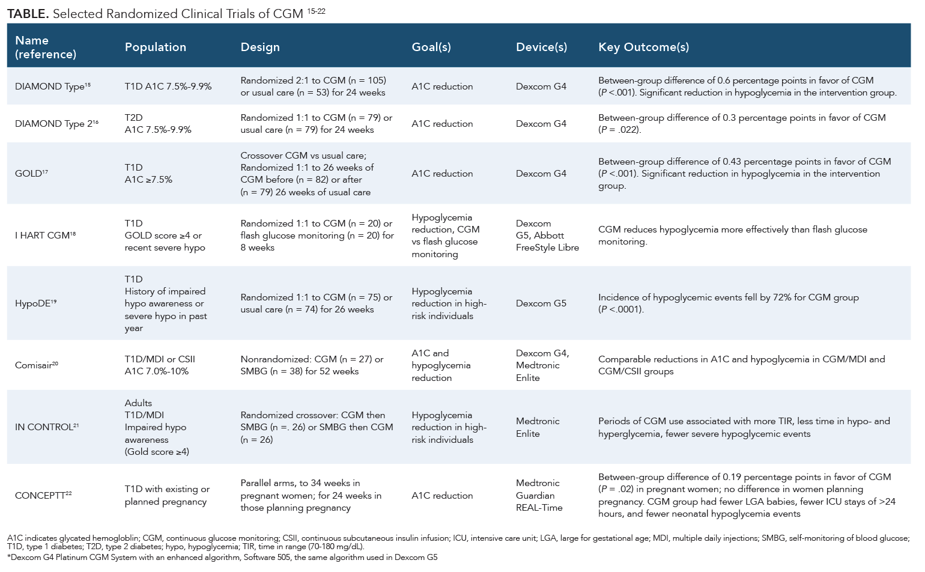
Clinical Trial RCTs

16. Other Summary Resources
Other places to find more links and other information
Continuous Glucose Monitor page for the open source Loop project.

17. References

18. References
Lutsker, Guy, Gal Sapir, Anastasia Godneva, Smadar Shilo, Jerry R Greenfield, Dorit Samocha-Bonet, Shie Mannor, et al. 2024. “From Glucose Patterns to Health Outcomes: A Generalizable Foundation Model for Continuous Glucose Monitor Data Analysis.” https://arxiv.org/abs/2408.11876.

