AN ECONOMIC IMPACT REPORT
The Economic Impact of Personize
for Sales & Marketing
As AI agents multiply, each customer is processed by tens to hundreds of agents a month — and every
agent must know the customer to reason and decide. Personize is the memory layer between AI agents and
their CRM data: it controls the exponential cost of that knowledge and turns it into revenue.

Includes a full ROI breakdown for a $50M ARR company.

EXECUTIVE SUMMARY
The economic case in one page

The number of AI agents working a revenue team's data is growing fast. Ideally, each customer is processed by tens to hundreds of agents every month — each answering a key business question: Are they qualified? What's our history with them? What do we know about their business? What's the next best action? What risk do we infer? To reason and decide well, every agent must fetch what it can about the customer. A human salesperson can research and prepare 200–300 leads a month; AI agents now do this work at far greater scale — and far greater cost if done naively.
Personize sits between AI agents and their customer data — especially the CRM. It compacts that data by up to 85% (in line with token-reduction figures widely reported across memory research) so every agent gets the right information in the fewest tokens. The financial consequences span four dimensions:
Modeled annual impact for a $50M ARR company (full breakdown in Section 6):
Dimension | What Personize does | Annual impact (illustrative)
1 · Cost control | ~20× lower LLM cost via 85% compaction; memorize via caching + Batch API | ~$231,300 saved on LLM spend
2 · Revenue | Mass personalization lifts conversion 2–10× (modeled at +10% revenue) | ~$5.0M of new-revenue potential
3 · Productivity | Controlled cost = more agent activity; the research/prep of ~80 reps on autopilot | tens of FTE-equivalents
4 · Task completion | Unified memory lets agents finish work that otherwise stalls | multiples more tasks done
**Personize investment | Paid out of the savings it delivers | ~$30–80K (≈1–2% of the upside)

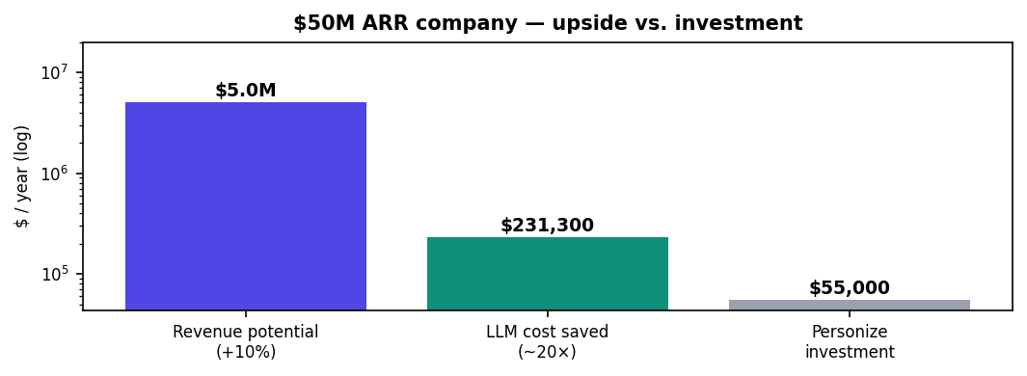
THE THESIS Personize converts the exponential cost of AI agents knowing your customers into a flat, compact one — so a company can scale to hundreds of agents with cost under control — and that same deep customer understanding powers mass personalization that drives revenue. The investment is paid out of the savings; the revenue is upside.

On rigor: cost figures trace to Personize's live pricing and current model rates; revenue and productivity figures are modeled from published market averages (cited in each section), presented as ranges, not guarantees.

SECTION 1
1 · The agent explosion meets the customer-data wall
Every agent must know the customer — and fetching that knowledge is where cost explodes.

A revenue team used to be bounded by people. One salesperson can research, prepare, and act on 200–300 leads a month — reading the CRM record, the emails, the call notes, the company's website and news, then deciding what to do. AI agents remove that ceiling: you can run tens to hundreds of agents against every customer, every month, each asking a different question — qualification, history, firmographics, next-best-action, risk.
But there's a catch. Each agent must know the customer to reason accurately and decide well, so each one fetches everything it can: CRM fields, email threads, meeting transcripts, notes, tickets, web research. For a rich B2B account that is 50,000–100,000 tokens of context per customer per year. Read cold, by every agent, every time, across thousands of customers, the cost grows exponentially with the number of agents — the single biggest reason Gartner expects over 40% of agentic-AI projects to be canceled by 2027 (escalating cost, with hidden compute ballooning 2–3× beyond estimates).
WHERE PERSONIZE SITS Personize is the memory layer between your AI agents and their customer data — especially the CRM. It reads each customer once, extracts a compact, governed memory, and serves it back to every agent in the fewest tokens. Token-reduction of 80–95% is the consistent finding across memory research (Mem0 ~90%, Zep ~94.8%, others 80–93%); Personize targets up to 85% — conservative, and the difference between a fleet you can afford and one you can't.

SECTION 2
2 · Cost Control — ~20× lower LLM cost
Compaction on recall, caching and Batch API on memorization — so scale doesn't break the budget.

Personize charges a flat, compact price (personize.ai/pricing/api): $0.003 per 1,000 tokens to memorize a record once, and $0.001 per agent recall — the same $0.001 whether the customer holds two pages or two hundred. Against running raw context through a frontier model on every recall, the gap is dramatic. At today's rates — Opus 4.8 $5/$25, Sonnet 4.6 $3/$15, GPT-5.5 $5/$30 per 1M (in/out) — one recall costs:
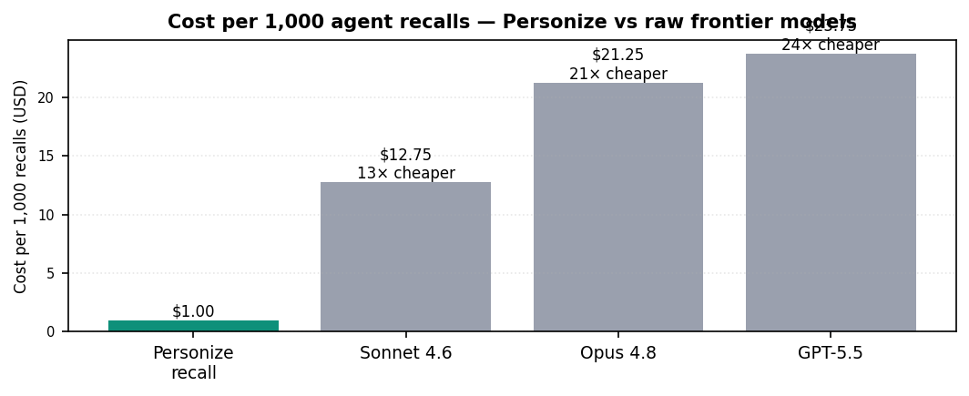
On Personize's own calculator the default workload returns up to ~23× more work per dollar — about 20× — with compact recall saving up to ~85% of context tokens. Memorization is engineered the same way: it uses the most cost-efficient models for extraction and recall, maximizes prompt caching, and routes through the Batch APIs offered by Bedrock, Anthropic and OpenAI (50% off) — so companies can memorize as much as they need about every customer. The ~20× we model is the floor; our north star is 100–200× as the extraction and recall pipeline is further optimized.
WHY IT'S STRATEGIC At a scale of hundreds of agents working thousands of customers, raw LLM cost grows with every agent you add. Personize converts that exponential curve into a flat line — so scaling the agent fleet becomes a decision, not a budget risk. For the $50M company in Section 6 this is ~$231,300 a year saved.

SECTION 3
3 · Revenue — mass personalization at the scale of thousands
Deep customer understanding powers personalization that lifts conversion — modeled conservatively at +10% revenue.

Cost control is only half the story. The same deep, unified understanding of each customer that makes agents cheap also makes them effective. Personize powers generative personalization — emails, web pages, and sales playbooks tailored per customer, at the scale of thousands — because every agent shares one accurate memory of who the customer is and what they need.
Personalization is one of the most reliable revenue levers in the data. In Personize deployments and in reports on comparable products, personalization lifts conversion 2–10× (a 1% rate becomes up to ~10%; 0.1% becomes ~2%). McKinsey independently puts the revenue lift from personalization done well at 10–15%. The same marketing and sales infrastructure, powered by Personize personalization, simply converts more of the demand it already creates.
THE ASSUMPTION WE MODEL Rather than bank a 2–10× conversion multiple, this report models a conservative +10% increase in revenue as the planning figure a company can evaluate personalization against. For a $50M ARR company that is ~$5.0M of new-revenue potential a year — while the Personize investment is a small fraction of it. The revenue is potential upside; the Personize cost is already paid for by the savings in Section 2.

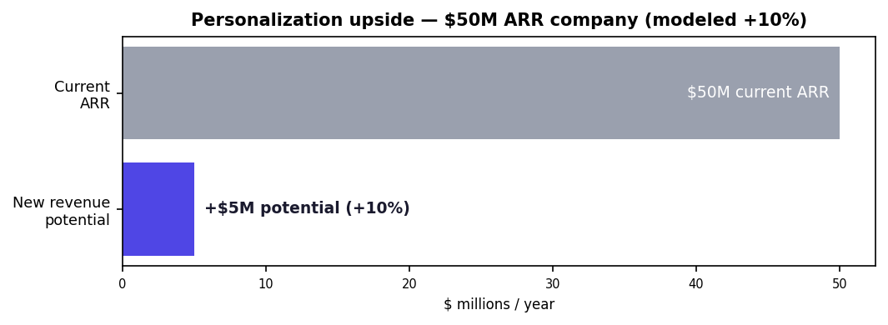

SECTION 4
4 · Productivity — tens of employees on autopilot
When cost is low, the same AI budget does far more work — and unified memory lets agents finish it.

Because Personize cuts the cost of knowing each customer by ~20×, the same AI budget delivers far more agent activity — conservatively ~20% more within a fixed budget, and far more as the gap widens. That extra capacity is expert work done on autopilot: qualification, research, account briefs, next-best-action — the work that today consumes most of a salesperson's week (Salesforce finds reps spend only ~28–30% of their time actually selling).
Sized against people: a salesperson can research and prepare 200–300 leads a month. Processing 20,000 customers a month at that rate is the equivalent of ~80 salespeople's worth of research-and-prep — running continuously, in parallel, around the clock. The fleet doesn't replace the team; it removes the ~70% of their week spent on non-selling work and redeploys it to revenue.
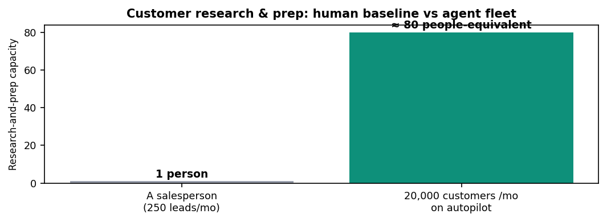
And the agents actually finish the work
More agent activity only pays off if the work completes. Unified memory is what lets long agent workflows finish instead of stalling when context runs out. Anthropic reports that adding memory lets agents complete workflows that would otherwise fail (+39% on agentic-search tasks, −84% tokens), and its enterprise customers see large throughput gains — Rakuten cut feature-delivery time from 24 working days to 5 (~5×) and agent error rate by 97% after adding managed-agent memory. The same memory-completes-tasks effect is reported across Mem0, Zep and Letta. Unified memory turns more activity into more finished work.

SECTION 5
5 · Why buy, not build — and why it's safe to scale
The integration and memory layer would take months to build and a team to maintain. And ungoverned agents are a liability.

Personize's capabilities — live two-way CRM sync, unified customer memory, schema-enforced extraction, governance and audit — are exactly what companies otherwise try to build in-house. The build-vs-buy data on comparable customer-data platforms is stark: ~$1.1M+/yr in engineering headcount, $4–5M over three years, 8–12 months to a working system, and 2–3 ML engineers on ongoing maintenance that outpaces the purchase price. With Personize there is no build cost and no ops cost — integrations, OAuth, rate limits, retries and audit are maintained for you, live in weeks.
Scaling agents also requires trust. Ungoverned agents create real liability — Air Canada was held liable for a chatbot's invented discount; a dealer's bot was talked into 'selling' a $76K SUV for $1 — and poor data quality already costs the average organization $12.9M/yr (Gartner). Personize keeps agents on-policy by construction: org guidelines injected before any write, every read/write audited, output confined to namespaced fields, and an honest 'abort instead of invent' default. Governance is what keeps an agent deployment out of Gartner's 40% cancellation statistic.

SECTION 6
6 · Full ROI breakdown — a $50M ARR company
Every number from the live calculator and the market averages above. Change the inputs; the model scales linearly.

Assumptions
Input | Value | Note
Annual recurring revenue | $50M | the personalization base
Customer + active-prospect records | 20,000 | records agents work (adjustable)
Customer data per year | 50,000–100,000 tokens | CRM + emails + transcripts + notes + web (base 75,000)
Agent recalls / customer / month | 30 (range 10–100) | ‘tens to hundreds of agents’
Personize price | $0.003/1K memorize · $0.001/recall | live pricing
Raw frontier baseline | ~$0.021 / recall; memorize ~20× Personize | Opus/GPT-5.5-class

1 · Cost — what Personize saves on LLM spend
Workload (per year) | With Personize | Run raw (frontier) | Saved
Memorize 20,000 customers × 75K tokens (1.5B tokens) | $4,500 | $90,000 | $85,500
Recall 20,000 × 30/mo × 12 = 7.2M recalls | $7,200 | $153,000 | $145,800
**Total LLM cost | $11,700 | $243,000 | **$231,300 (~21×)

At heavier agent intensity (100 recalls/customer/month — squarely in the 'hundreds of agents' range) recall alone moves to ~$510K raw vs ~$24K with Personize: ~$486K saved. The more agents you run, the more Personize saves.
2 · Revenue — personalization upside
Modeled at +10% of $50M ARR = ~$5.0M of new-revenue potential a year (personalization lifts conversion 2–10× in practice; +10% revenue is the conservative planning figure). This is upside, not cost offset.
3 · Productivity — capacity reclaimed
~80 salespeople-equivalent of research-and-prep on autopilot, plus the throughput from agents that finish more of what they start. At a typical fully-loaded cost this is several million dollars of expert capacity redeployed from admin to selling.
The bottom line
Annual line | Impact | Type
LLM cost saved (compaction ~20×) | ~$231,300 (up to ~$486K at scale) | hard saving
Avoided in-house build/ops | ~$1.1M+/yr equivalent | avoided cost
New-revenue potential (+10%) | ~$5.0M | upside
Productivity reclaimed | ~80 FTE-equiv of research/prep | capacity
**Personize investment | **~$30–80K / yr | ≈1–2% of the upside

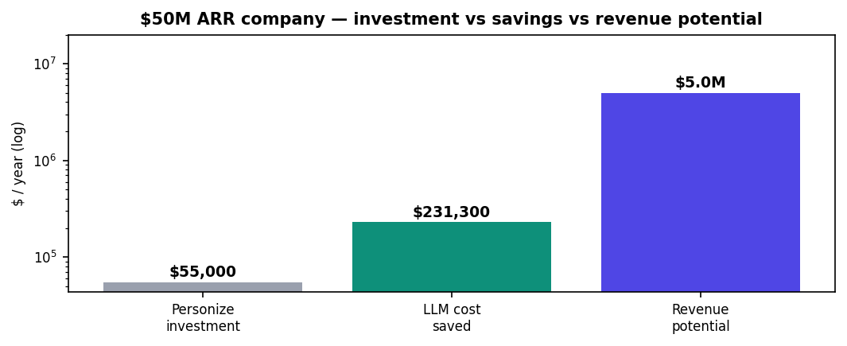
HOW TO READ IT Personize's cost (~$30–80K) is fully covered by the LLM savings it delivers (~$231,300+) on your existing AI spend — so the memory layer is effectively free. The ~$5.0M of revenue potential and the ~80-person productivity gain are upside on top. That is the economic case: control the exponential cost of AI agents, then use the same memory to grow.

Methodology: cost figures use Personize's live pricing and current published model rates; revenue and productivity are modeled from published market averages (cited below) and are ranges, not guarantees. Inputs are illustrative for a $50M ARR company — change records, tokens/customer, or recalls/month and the model scales linearly.
Sources
- Personize live pricing & calculator — $0.003/1K memorize, $0.001/recall, up to ~23× more work/dollar: personize.ai/pricing/api
- Memory token-reduction (80–95% consistently reported) — Mem0 ~90% (26K→1.8K tokens); Zep ~94.8%; A-Mem 85–93%; MemMachine ~80%: mem0.ai, getzep.com.
- Frontier model pricing (2026) — Opus 4.8 $5/$25, Sonnet 4.6 $3/$15 (platform.claude.com); GPT-5.5 $5/$30, Batch $2.50/$15 (openai.com/api/pricing); Batch −50%, caching −90% (Anthropic, OpenAI, Bedrock).
- Personalization — lifts revenue 10–15% / conversion 2–10×: McKinsey (Value of getting personalization right), Twilio Segment (State of Personalization), Epsilon.
- Productivity — reps sell ~28–30% of time (Salesforce); gen-AI sales/marketing potential $0.8–1.2T and +12.2% tasks/25% faster/40% quality (McKinsey; BCG × Harvard).
- Task completion / memory — Anthropic: memory completes otherwise-failing workflows (+39%, −84% tokens); Rakuten 24→5 days delivery, −97% errors (anthropic.com); Mem0/Zep/Letta corroborate.
- Build vs buy — in-house memory/CDP ~$1.1M+/yr, $4–5M/3yr, 8–12 months, ~5:1 gap: Gartner, Amperity, CDP Institute.
- Risk — Gartner: >40% of agentic-AI projects canceled by 2027 (cost/ROI/governance); poor data quality $12.9M/yr; AI-error liability (Air Canada, Chevrolet).

