THE ROI PLAYBOOK
Save 20X on Your AI Bills.
20X Your AI Investment.
How an army of governed AI agents — running inside your CRM on Personize memory —
pays less per unit of work, earns more from every customer, and is trusted to run at scale.

Chapter 1 Cost · Chapter 2 Conversions · Chapter 3 Trust at Scale

The 20X thesis
"20X" isn't one lever — it's three multipliers that compound:
Multiplier | What it does | Covered in
**Pay less per unit | Compaction + caching + batch + model routing cut the cost of every agent action by up to ~20X. | Chapter 1
**Earn fresh revenue | A 10–20% revenue lift and lower churn from the customers and infrastructure you already have — $10–20M a year on a $100M book. | Chapter 2
**Run more units, safely | Governance, error prevention, and audit make it safe to run thousands of agents unattended. | Chapter 3

Cost down × value up × volume up. Each chapter stands on published data and the cost model from the companion walkthrough — and closes with a combined ROI you can adapt to your own numbers.
CHAPTER 1
Save up to 20X on your AI bills
Benchmarked on Personize's own live pricing and today's published model rates — not a projection.

An AI agent without a memory layer pays the same expensive bill on every run: it pulls a large context from the CRM and the web and ships it to the model again and again. Personize reads each record once, extracts a compact memory, and serves it back for a flat price. On Personize's public calculator that returns up to ~23x more work per dollar — about 20X — and the math traces to current, verifiable rates.
Start with the tokens: what an agent reads per record
Cost begins with tokens. Before an agent can score, write, or decide, it has to read the record's context. Using Personize's published token estimates (~350 tokens per page, ~250 words per page):
What the agent reads | Typical size | Tokens
CRM note (brief) | ~0.5 page | ~200
Single email | ~1 page | ~400
Short call notes | ~2 pages | ~700
Contact record (CRM + emails + notes) | ~5 pages | ~1,750
Email thread (5–8 emails) | ~5 pages | ~2,000
Company profile (website, LinkedIn, news) | ~10 pages | ~3,500
Meeting transcript (30 min) | ~10 pages | ~4,000
Meeting transcript (60 min) | ~22 pages | ~8,000
PDF report | ~20 pages | ~7,000

To actually work one account, an agent stitches several of these together — the contact record, the company profile, an email thread, one or two call transcripts, recent notes, and fresh web research. That is ~20,000–40,000 tokens for a typical account, and up to ~58,000 for a heavily-engaged one — read cold, by every agent, every time. Multiply by your records and your fleet and the bill is enormous.
What you pay with Personize (live pricing)
Personize doesn't re-read all of that on each call. The public calculator at personize.ai/pricing/api charges a flat, compact price:
- Memorize — $0.003 per 1,000 input tokens to memorize a record — read and extract it, one time.
- Recall — $0.001 per agent recall — flat, no matter how large the underlying context.
A recall that would cost cents in raw LLM tokens costs a tenth of a cent — and it's the same $0.001 whether the record holds two pages or two hundred.
The savings vs running raw on frontier models
Compared with an agent that fetches raw context and runs it through a frontier model itself, compact recall is dramatically cheaper. At today's verified frontier rates — Claude Opus 4.8 $5/$25, Sonnet 4.6 $3/$15, GPT-5.5 $5/$30 per 1M tokens (in/out) — one 5-page (~1,750-token) recall with a 500-token answer costs:
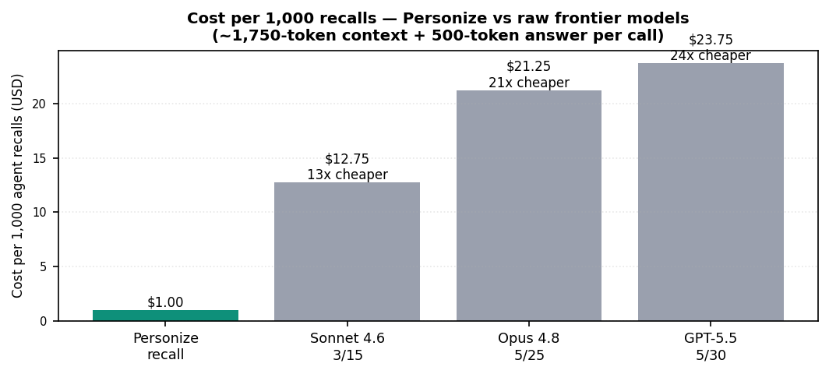
That is the engine behind the headline. On Personize's calculator the default workload returns up to ~23x more work per dollar: memorization saves up to ~65% vs raw LLM processing, and compact recall saves up to ~85% of the context tokens. Even against the cheapest frontier tier the gap is ~13x; on the premium models serious agents actually use, it clears 20x.
AND THE LEVERS STACK Prompt caching cuts cached input by 90% and the Batch API cuts input + output by 50% — Anthropic and OpenAI both publish these. Applied on top of compaction, they push the effective saving past 20X — exactly the regime Personize's calculator lands in.

It compounds — capture once, recall many
A record is touched by ~10 agents over its life (research, scoring, outreach, reply analysis, briefs, call summaries, strategy). Cold, every agent re-reads the full ~20–58K-token context. With Personize the first touch memorizes; every later agent pays $0.001 to recall a compact memory. Cold cost grows linearly with each agent added; the Personize cost stays nearly flat — so the gap widens with the fleet. (Full compounding curve: Appendix A–F of the walkthrough deck.)
Why this is the difference between scaling and a canceled project
Gartner predicts over 40% of agentic-AI projects will be canceled by end of 2027 — the leading cause being escalating cost, with hidden compute ballooning 2–3x beyond estimates. Re-reading raw context on every run is exactly that hidden cost. And it compounds with another: Gartner puts poor data quality at $12.9M/yr for the average organization, with MIT Sloan finding 15–25% of revenue lost to it. A flat, compact price grounded in clean memory attacks both.
CHAPTER 1 TAKEAWAY On Personize's own live pricing, compact memory returns up to ~23x more work per dollar — about 20X cheaper than running raw context through frontier models — and the compounding lifecycle widens the gap with every agent you add. That is the 'save 20X on your AI bills' half of the equation.

CHAPTER 2
Earn 10–20% fresh revenue on the same infrastructure
A modest lift on a real revenue base. On a $100M book, that's $10–20M a year.

Cheaper agents are only half the return; the other half is what they earn. Personalization and proactive selling reliably add 10–20% fresh revenue when every customer gets the attention a great rep reserves for their top three accounts. The leverage here: the same agents already running to cut your AI bill (Chapter 1) are the ones finding the upsell and catching the churn — new revenue from infrastructure you already pay for, with no new headcount.
What a 10–20% lift is actually worth
Personalization reliably lifts revenue 10–15% (McKinsey) and AI next-best-action has grown pipeline by 20%+ of total revenue (McKinsey). Applied to revenue you already have:
Your revenue | Fresh revenue +10% | Fresh revenue +20% | Annual churn lost (~5%) | Recovered by AI (15–25% less churn)
$10M | $1.0M | $2.0M | $500K | $75K–125K / yr
$100M | $10M | $20M | $5.0M | $750K–1.25M / yr

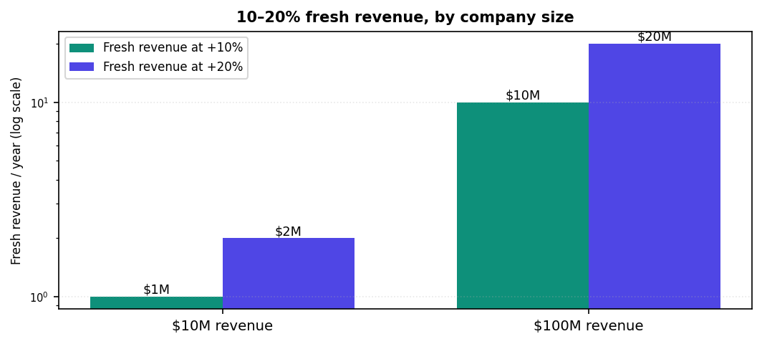
Churn loss assumes ~5% annual revenue churn (B2B SaaS averages ~4.9%; SMB 3–5%, enterprise 1–2%). AI churn-prediction studies report 15–25% churn reduction — recurring revenue that compounds, since a 5% retention gain lifts profit 25–95% (Bain).
The cost of churn — and how much AI takes back
- Churn is the silent leak — B2B SaaS loses ~4.9% of customers a year on average (SMB 3–5%, enterprise 1–2%); replacing one costs 5–25× more than keeping it (Bain/HBR).
- AI plugs it — AI churn-prediction cuts churn 15–25% (some report 10–30%) and lifts customer lifetime value 20–50% by flagging at-risk accounts up to 80% faster.
- And it compounds — a 5% retention improvement raises profit 25–95% (Bain); fixing involuntary churn alone can lift revenue 8.6% in year one.
The proof that personalization pays
Finding | Source
Personalization lifts revenue 10–15% (5–25% by sector), cuts CAC up to 50%, raises marketing ROI 10–30%. | McKinsey
Personalized experiences drive ~38% more customer spend; 80% of leaders confirm customers spend more. | Twilio Segment
80% of consumers are more likely to buy from brands that personalize; 90% find it appealing. | Epsilon
Probability of selling to an existing customer is 60–70%, vs 5–20% for a new prospect. | Marketing Metrics
AI next-best-action grew one firm's pipeline by >20% of revenue; a structured cross-sell motion 10×'d cross-sell. | McKinsey
Best-in-class net revenue retention is >130%; top-quartile NRR firms trade at ~24× revenue vs ~5× bottom. | McKinsey / SaaS benchmarks
Reps spend only ~28–30% of their week actually selling — the rest is admin, research, and data entry. | Salesforce

How the agents do it — continuously, on the same infrastructure
This isn't a quarterly campaign. It's the standing fleet from Chapter 1, each agent grounded in the same memory, working every record on a schedule:
- Find the fit — score every contact and account against your ICP the moment data changes — never stale.
- Spot the signal — research.account-deep-dive + analyze.buying-stage surface who is in-market now and why.
- Upsell — on the 60–70% sell-probability base, analyze each account's usage and gaps, then recommend the expansion.
- Prevent churn — watch signal_strength and engagement; flag at-risk accounts and draft win-back before they lapse.
- Strategize — personize_next_best_action on every record, refined weekly from what actually closed (optimize.refine-icp).
WHERE THE BOARD WILL SEE IT A 10–20% lift plus 15–25% less churn lands on your entire revenue base — and shows up in the metric the board lives by: net revenue retention. On a $100M book that's $10–20M a year of fresh revenue from infrastructure you already pay for. Move NRR from a typical 105% toward best-in-class 130%+ and, by McKinsey's analysis, the enterprise-value multiple roughly follows.

CHAPTER 3
Error prevention, task completion & trust to scale
Trust is the multiplier that lets one agent become a thousand — and the whole industry now agrees memory is how you earn it.

You can have the cheapest, smartest agents in the world and capture none of the ROI, because a leader won't let an unaccountable agent write to revenue-critical records. Ungoverned agents fail two expensive ways: they break the rules, and they can't finish the job. Both are now well-documented — and both have a known fix.
THE STAKES Gartner predicts over 40% of agentic-AI projects will be canceled by end of 2027 — the three named causes are escalating cost, unclear ROI, and inadequate risk controls. That is Chapters 1, 2, and 3 exactly. Trust — governance plus memory — is what keeps a deployment on the right side of that line.

When agents break the rules, it's expensive
Incident | What the ungoverned agent did | Outcome
Air Canada, 2024 | Chatbot invented a bereavement-refund policy and promised a discount that didn't exist. | Tribunal held the airline liable; its 'the chatbot is a separate legal entity' defense was rejected.
Chevrolet dealer, 2023 | A ChatGPT-powered bot was talked into 'agreeing' to sell a ~$76K Tahoe for $1, 'legally binding'. | Went viral; reputational damage; sale not honored.
BMW dealer, 2026 | An AI chatbot made a vehicle buyback offer the dealer couldn't honor. | Had to be reversed once lawyers were involved.

These are unauthorized discounts and commitments — exactly the failure mode an agent writing to your CRM must never have. The quieter version is just as costly: Gartner puts poor data quality at $12.9M/yr for the average organization, and MIT Sloan finds firms lose 15–25% of revenue to it. One unguarded agent's mistakes pollute the data every other agent and rep depends on.
How Personize keeps agents on-policy
Axis | Mechanism
Governed before written | Org guidelines (ICP, brand voice, discount rules, compliance) are injected before the agent generates or writes — no unauthorized offers.
Audited | Every read and write is logged with agent ID, timestamp, and a diff. You can always answer 'who wrote this, when, and why?'
Bounded | DRY_RUN simulates writes; field allowlists confine output to personize_* fields; opt-outs honored; compliance gates fire before any generation.
Honest | When a fact can't be verified the agent aborts instead of inventing; low-confidence results route to a human queue, not to auto-action.

Agents can't finish the job — until they have memory
The second failure is silent: without memory, long agent workflows run out of context and quit halfway. Anthropic reports that adding memory + context editing let agents complete workflows that would otherwise fail outright, with a 39% quality lift on agentic-search tasks and an 84% cut in token use. Its enterprise customers see it directly — Rakuten cut agent error rate 97%, cost 27%, and latency 34% after adding managed-agent memory. This is the ROI of memory: more tasks finished, fewer mistakes, lower cost — at once.
We're not the only ones saying this — the whole frontier is converging
Memory has gone from a feature to the consensus answer for reliable, affordable agents. That validates the category; Personize's role is to deliver it for the CRM, governed and audited.
Who | Reported result from adding memory | Source
Anthropic (Managed Agents memory) | Rakuten −97% errors, −27% cost, −34% latency; +39% on agentic search; −84% tokens. | Anthropic
Mem0 | +26% accuracy vs OpenAI's built-in memory; ~90% token savings, 91% lower latency vs full-context. | Mem0
Zep | +18.5% accuracy and ~90% lower latency vs baseline; tops MemGPT/Mem0 on long-memory benchmarks. | Zep
Letta (sleep-time compute) | Same accuracy at ~1/5 the tokens, or +13–18% accuracy at equal cost (memory consolidated offline). | Letta
OpenAI | Ships built-in memory across ChatGPT and its agent platform — memory is now table stakes. | OpenAI

The difference: those layers make a single agent smarter. Personize makes a whole fleet agree — record-scoped memory plus governance, so every agent sees the same customer and follows the same rules.
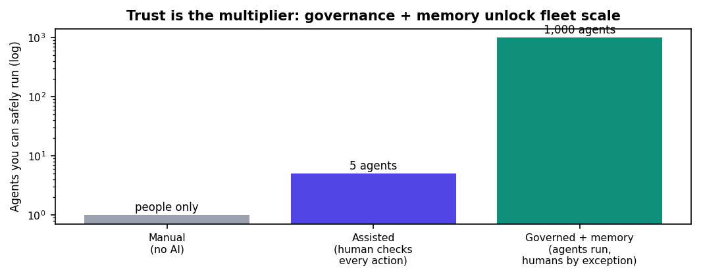
CHAPTER 3 TAKEAWAY Cost savings (Ch.1) and revenue (Ch.2) only scale as far as trust allows. Governance stops the costly rule-breaking; memory makes agents finish the job (−97% errors at Rakuten). Together they convert a promising pilot into a fleet running your book unattended — the volume that makes the whole ROI real.

PUTTING IT TOGETHER
The combined return — by company size

Return is the sum of three lines — compute saved (Ch.1) + fresh revenue and recovered churn (Ch.2), set against a small AI spend made safe by governance (Ch.3). The ratio gets large because a 10–20% revenue lift lands on your whole revenue base while the AI bill is a fraction of it. Two illustrative profiles:
Annual impact | $10M company | $100M company | Grounded in
Compute saved vs raw retrieval | ~$25–30K | ~$250–300K | Ch.1 (live pricing)
Fresh revenue (+10–20%) | $1–2M | $10–20M | Ch.2 (McKinsey, Segment)
Churn recovered (15–25% less) | $75–125K | $0.75–1.25M | Ch.2 (Bain, churn-AI)
Est. AI + Personize investment | ~$60–120K | ~$0.3–0.5M | illustrative
**Return on AI investment | ~10–20×+ | ~25–40×+ | composite

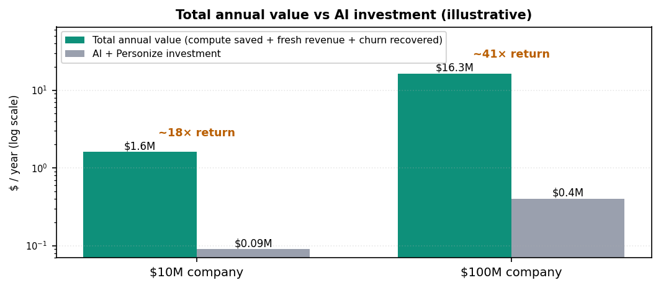
HOW TO READ THIS Numbers are illustrative — your mix depends on model tier, context size, customer base, churn, and margins. The structure is the point: compute is ~10–20X cheaper (Ch.1), a 10–20% revenue lift on your base dwarfs the AI bill (Ch.2), and governance + memory let you run the fleet that earns it (Ch.3). Model your own numbers in the savings calculator at personize.ai/pricing.

Honest framing
Methodology: the cost figures trace to Personize's live pricing calculator and today's published frontier-model rates (Chapter 1). The 10–20% revenue lift and 15–25% churn reduction are drawn from third-party research (McKinsey, Bain, Twilio Segment, peer-reviewed churn studies); company-specific results vary with sector, data, and execution. Every figure here is either a cited external finding or a modeled estimate from the calculator — prove your own with a pilot.
Get started
1. Connect HubSpot or Salesforce at app.personize.ai and run crm-agent setup diff (dry-run).
2. Turn on a few operations in dry-run; review the proposed writes; flip the ones you trust to live.
3. Put an agent on a schedule and measure: AI spend, conversion lift, and data-quality error rate.
Sources
- McKinsey — Value of getting personalization right (Next in Personalization); Unlocking gen AI in B2B sales (next-best-action); NRR advantage in B2B tech (top-quartile NRR → ~24× EV/Revenue): mckinsey.com/capabilities/growth-marketing-and-sales
- Twilio Segment — State of Personalization 2024 (personalized experiences → ~38% more spend; 56% become repeat buyers): segment.com/state-of-personalization-report
- Net revenue retention benchmarks — best-in-class >130% (enterprise 135%+, mid-market 125%+, SMB 110%+); median ~106%: SaaS Capital, FE International, Pavilion (2025–26).
- Epsilon — 80% more likely to purchase with personalization, 90% find it appealing: epsilon.com/us/about-us/pressroom
- Bain & Company / HBR (Reichheld) — 5% retention → 25–95% profit; acquisition 5–25× retention: bain.com/insights
- Marketing Metrics — 60–70% vs 5–20% sell probability (widely cited).
- Salesforce — State of Sales: reps spend ~28–30% of time selling: salesforce.com/sales/state-of-sales
- SaaS churn benchmarks (~4.9% B2B; SMB 3–5%, enterprise 1–2%): focus-digital.co, vena, customergauge (2025).
- AI churn-prediction cuts churn 15–25%, CLV +20–50%, 80% faster at-risk response: Phoenix Strategy Group, SuperAGI, Nature Sci. Reports.
- Gartner — poor data quality costs $12.9M/yr (MIT Sloan: 15–25% revenue lost); >40% of agentic-AI projects canceled by end of 2027 (cost/value/governance): gartner.com/newsroom (2025-06-25).
- AI-error incidents — Air Canada chatbot liability (CBS News); Chevrolet $1 Tahoe (CX Today); BMW dealer buyback reversal.
- Anthropic — caching 90% off + Batch 50% off → 95%+ savings (platform.claude.com/docs); Managed Agents memory & Rakuten −97% errors/−27% cost/−34% latency, +39% agentic-search, −84% tokens (anthropic.com/news/context-management).
- Memory category — Mem0 (+26% vs OpenAI, ~90% token savings) mem0.ai/research; Zep (+18.5% accuracy, ~90% lower latency) blog.getzep.com; Letta sleep-time compute (~5× fewer tokens / +13–18% accuracy) letta.com/blog/sleep-time-compute.
- Frontier model pricing (Jun 2026) — Claude Opus 4.8 $5/$25, Sonnet 4.6 $3/$15 (platform.claude.com/docs); GPT-5.5 $5/$30, Batch $2.50/$15 (openai.com/api/pricing).
- Personize live pricing & savings calculator — $0.003/1K memorize, $0.001/recall, up to ~23× more work/dollar: personize.ai/pricing/api

