图像识别
图像识别，是利用计算机对图像进行分析和处理，以帮助人们理解和识别各种不同模式的目标和对像的技术。图像识别技术一直是一个热门的研究课题，虽然现有的方法有很多，但是还都不是万能的。请你针对以下几张图片提出你的模型，来正确判别上面的数字。

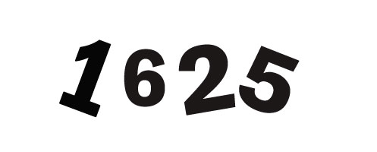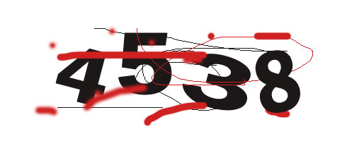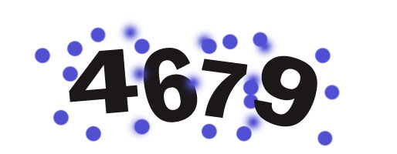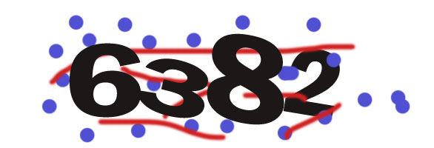

Image Recognition
Image recognition, is the technology by using the computer to analysis and process the image, to help people understand and identify the various objectives and different modes of image. Image recognition technology has always been a hot research topic, although there are many existing methods, it is not a panacea. For the following few pictures, Please put your own model to determine the correct letter above.

