The judges scoring, note | Team number：  10469 | The judges scoring, note
The judges scoring, note | Problem：  B | The judges scoring, note
Title：Book Recommendation
This paper mainly studies the books recommend problem, and analyzes the factors that influence the score of books by collaborative filtering algorithm and books similarity analysis, then predicts the scores of these books which specified readers who have not read. At last, it respectively recommends three books to the specified readers based on tag similarity and reading preference model.
Problem 1: This paper, according to the correlation analysis and classification of data statistics, found that the average scores of books, the user's habits of scoring and users' reading preference (tag) have different impact on users’ score.
Problem 2: For the specified readers, this paper adopts the cosine similarity to calculate similarity between each book which need to predict and all books that this reader have scored and ranked the book by their similarity, selected the top 10 books as a neighbor set, according to this books’ score of neighbor set by this reader to predict his score for this book. In order to check up the accuracy of the prediction, this paper put a small part of the scoring record as a test set, then use MAE index to measure prediction error, the results show that prediction is good.
Problem 3: This paper use the cosine similarity to calculate per book’s tag symbiosis of similarity, set a user reading preference model to calculate the similarity between user s and matched-degree between users’ reading preferences and tags, integrated the two indexes to get the recommended index. According to the recommended index, we recommend three books to the specified users.
Key words: Collaborative filtering, Cosine similarity, Label similarity, Reading preference model, Recommend index

Model hypothesis
1. The reading interests of users throughout the grading process have not changed.
2. The user would like to read the book that he interested in.
3. Different labels represent different categories of books.
4. The user would like to read a book several times if he is interested in this book.

Symbol description
Symbol | Details
 | Book quality
 | The popularity of the books
 | Users’ score preference
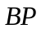 | Users’ book preference
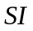 | Influence of the social cycle
 | The similarity of books
 | Co-occurrence of the book tags
 | Users ’similarity
 | The matched-degree between user and book
 | Recommendation index

Question analysis
Question one:
Objectively, the score of books are based on the quality, and it is also influenced by the individual preference. According to the data that is given by the accessory, in the first place, we define the quality of book Q, the popularity degree of the book P, user’s individual preference of score IP, user’s preference of book BP, and the influence of personal social circle SI. Then we analyze the influence of these factors to the score respectively.

Question two:
In conditions that do not take into account subjective factors, the same user has similar to books should be of the same quality grading. First of all, we use collaborative filtering recommendation algorithm based on similarity of books to find books similarity of the neighbor with the projections set; then, we use the neighbors set for predicting books give a prediction score.
Question three:
To recommend books, it should as far as possible in line with the user's reading preferences. First of all, we derive user attention to books. Secondly, we find the reading preferences of users, then please recommend books that meet users ' preferences on the user's index and, finally, find the highest recommend index books recommended to the user.

Model Solution
Question one
The impact of the book quality Q
We assume the average score of book can indicate the book quality Q, and define it as follows:
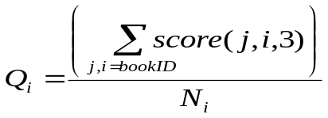
The 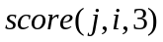 shows the score of book i which is marked by the user j.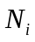 represents the number of user who marked the book i.
We randomly select 100 users from the accessory of user book score, and then make three steps to analyze it, the process are as follows:
Step1: Find he books which is marked by the user and its score.
Step 2: Calculate the average score of these book.
Step 3: Calculate the correlation coefficient between the book score and book quality and make a hypothesis testing to examine whether it is relevant.
Here is the result table:
Book ID | score | numbers | Book quality
962729 | 4 | 959 | 4.116788
356405 | 4 | 463 | 4.164147
836383 | 4 | 588 | 4.061224
284550 | 4 | 998 | 3.942886
723581 | 4 | 1145 | 4.135371
827305 | 4 | 478 | 3.920502
572786 | 4 | 232 | 4.025862
473690 | 4 | 319 | 3.833856
964695 | 4 | 1063 | 4.235183
929118 | 4 | 497 | 4.046278
The correlation coefficient R=0.57359,confidence level P=1.4614e-046.

The impact of the book popularity degree
Because the number of book tag reflect the popularity degree of book ,we define the popularity degree P as follows:
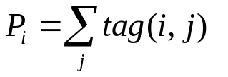
The 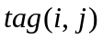 shows the j-th tag of book i.
We randomly select 100 users from the accessory of user book score, and then make three steps to analyze it, the process are as follows:
Step 1: Find he books which is marked by the user and its score.
Step 2: Calculate the popularity degree of these books.
Step 3: Calculate the correlation coefficient between the book score and book popularity degree and make a hypothesis testing to examine whether it is relevant.
Here is the result table:
Book ID | score | Tag number
304070 | 3 | 17
419461 | 3 | 0
394406 | 4 | 17
995198 | 4 | 18
523511 | 4 | 0
471206 | 4 | 24
726758 | 4 | 17
798662 | 3 | 13
877201 | 3 | 20
378626 | 3 | 16
The correlation coefficient R=0.1368,confidence level P=0.0018234.
IP: User’s score preference
Firstly, we can define the IP:
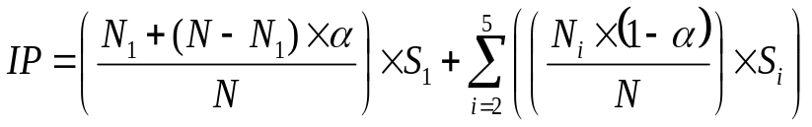
In this formula,
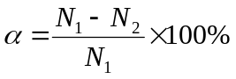
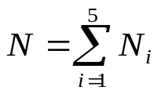
We randomly select 100 users from the accessory of user book score, and make a process to each individual:
Step1: Find the marked book and the score of the users
Step2: Calculate the IP.
There are an example of a user which ID is 7245481,the result is as follows:
Score | Appearing times
1 | 1
2 | 7
3 | 131
4 | 359
5 | 19
IP=3.909

Question two
This question we adopt the collaborative filtering recommendation algorithm based on the book similarity, and then predict the book score of accessory predict.txt.
- Firstly, we need to define the similarity between the books, the process are as follows:
Find the user who marked the book i and j, n represents the number of these users, so the book i and j have its vector 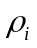 and 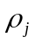 respectively in n dimension space, the similarity between book i and j is
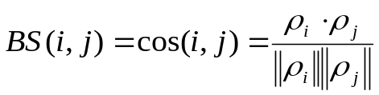
- Establish the score matrix S.
The first six column of the matrix S indicate the books which is needed to predict for the user 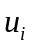,and marked it as 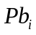,the next n column indicate the books which is marked by the user. We can set there are n number of books, so the matrix will have n+6 column. The first row of matrix S shows the users, the next m rows indicate the user who participated in the marking. Supposing there are m number users, so the matrix would have m+1 row.
- Predicting the score
The detail processes are as follows:
Step1: take matrix S in the 1th column element and subsection j column element, 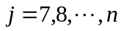, respectively remember for and 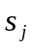;
Step2: take in and in the which are not containing 0 of line, remember for 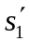 and 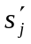, if no take to, we can define 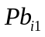 and 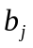 of similar degrees for 0; or with formula (1) begged and of similar degrees 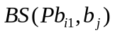;
Step3: take similar degrees supreme of 10 books, composed neighbors set 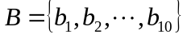, which books and of similar degrees supreme 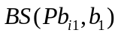, books and 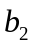 of similar degrees followed, and so on.
Step4: asks the user for the predicted score:
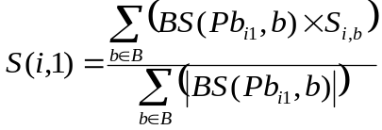
- Make a forecast for the six users
The results are as follows:
7245481
794171 | 381060 | 776002 | 980705 | 354292 | 738735
4 | 3.8 | 3.6 | 3.8 | 3.6 | 3.6
7625225
473690 | 929118 | 235338 | 424691 | 916469 | 793936
3.800161 | 3.399658 | 4 | 4 | 3.800061 | 3.799982
4156658
175031 | 422711 | 585783 | 412990 | 134003 | 443948
4.6 | 3.4 | 4 | 4 | 3.6 | 3.8
5997834
346935 | 144718 | 827305 | 219560 | 242057 | 803508
4.599925 | 4.799826 | 4.400263 | 4.600099 | 4.400368 | 4.599396
9214078
310411 | 727635 | 724917 | 325721 | 105962 | 235338
4 | 4 | 4.2 | 3.6 | 3.8 | 4.2
2515537
900197 | 680158 | 770309 | 424691 | 573732 | 210973
3.399379 | 3.199388 | 3.799433 | 3.799829 | 4 | 3.799717

In order to examine the prediction, we use the mean absolute error(MAE) to judge the accuracy of the forecast. We suppose the prediction set as 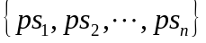,real score set as 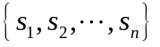.
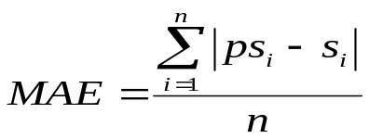
There are the table of the comparable data.
7245481

Book ID | 962729 | 356405 | 836383 | 284550 | 723581 | 827305
Forecast score | 3.846279 | 3.846045 | 4 | 3.99992 | 3.845464 | 3.922996
Actual  Score | 4 | 4 | 4 | 4 | 4 | 4
7625225
Book ID | 702699 | 962729 | 642256 | 794171 | 836383 | 284550
Forecast score | 3.845917 | 4 | 4 | 3.845978 | 4 | 4
Actual  Score | 4 | 4 | 4 | 4 | 4 | 4
4156658
Book ID | 345849 | 220930 | 732533 | 566113 | 500788 | 242605
Forecast score | 3.690256 | 3.230769 | 3.615385 | 3.230769 | 3.384615 | 3.921765
Actual  Score | 4 | 4 | 4 | 4 | 4 | 4
5997834
Book ID | 885390 | 702699 | 962729 | 723581 | 381060 | 964695
Forecast score | 4 | 5 | 5 | 4 | 4 | 4
Actual  Score | 4 | 5 | 5 | 4 | 4 | 4
9214078
Book ID | 776002 | 144718 | 242462 | 424691 | 557713 | 438265
Forecast score | 4.07757 | 4.07708 | 4.154254 | 3.922162 | 4.076416 | 3.999463
Actual  Score | 4 | 4 | 4 | 4 | 4 | 4
2515537
Book ID | 284550 | 981616 | 585307 | 916469 | 131620 | 549623
Forecast score | 3.537614 | 3.230474 | 3.461628 | 3.307315 | 3.614623 | 3.614518
Actual  Score | 4 | 4 | 4 | 4 | 4 | 4

Question three
In order to express the user’s preferences more accurately, we adopt the book recommendation algorithm which based on label similarity for the question three. Because the user preference model contains a series of factors, and each factor has different impact on users’ book preference, so the user preference model can be defined as a six-tuple.
Define: It can be set that the user preference model as a six-tuple set , the set 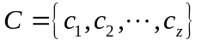 is the users’ ID set; set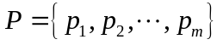 is the books ID set; 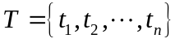 is the set of book tag.  is the co-occurrence similarity which based on user’s label. 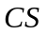shows the similarity of book preference between the users.  represents the matched-degree between the user’s preference and book tags. The details of these concept are as follows.
: The co-occurrence similarity which based on user’s label
The book tags reflect the focus that some book or user to certain types of information. So, it is necessary to acquire the similar information of the book tags in order to study the tag recommendation system.
From some book site we can see that the user often has its own tags, which can reflect the personal preference. But in this question the user don’t have its own tags, we just could use the book which is connect with the user to estimate the user’s preference. We can use the ‘user-book’ and the ‘book-tag’ relationship to define the tag relationship which based on the users. Firstly, we set the book as the row vector, set the tag as the column vector, and then we can establish the ‘book-tag’ matrix 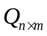;we also can establish the ‘user-book’ matrix 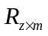,which let the user as the row vector and the book as the column vector. Above this, we can get the ‘user-tag’ matrix:
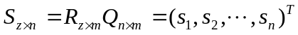
The non-zero value of row vector indicate the tags of the same book or else, 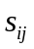 indicates the times that the tag appear in the book set which is read by the user .and then we can get the tag co-occurrence matrix:
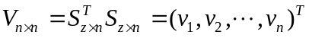
So, in the tag co-occurrence matrix, every table row or every table column is a tag vector, the calculation of tag similarity can transfer to the calculation of tag vector similarity. There we adopt the cosine similarity to calculate the tag co-occurrence similarity degree. The definition is as follows:
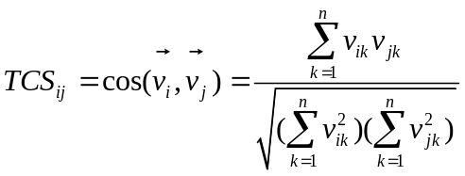
CS: user’s similarity
The book focus degree of users
Because the differences among the users, user has different focus degree on different books. We assume if the user marked a book, this book would get 1 point, and if the book history reveals the user used to read this book, it would get 1 point per time. So, the focus degree of user 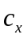to book 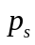 is as follows:
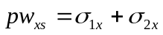
Among this,
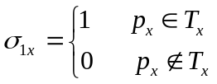
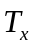 represents the book that user has marked.
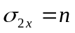
represents the times that the book appears in the reading history of user .To sum up ,we can define the book focus degree vector:
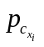 represents the book that the user 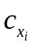 has read , 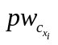 represents the focus degree that user to the book .
In order to calculate the preference weight of the users, it can be set
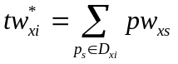
The 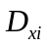 represents the set of tag 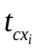,so the weight of tag to the user is
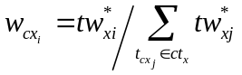
At last, in order to describe the similarity of user and 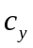,there are the definition of CS:
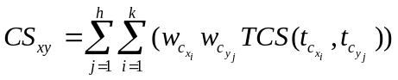
CPS: The matched-degree between user and book
Because the book preference vector and book tag vector are not in the same vector space, so in order to solve this problem. We use the CPS to describe the matched-degree.
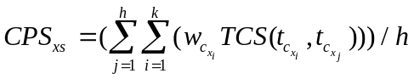
If a user is interested in a book, not only under the influence of the users match the books, but also by the user with user preference relations influence the reading of books original. In predicting the probability of a user interested in a book in the process, consideration should be given to the relationship of these two. According to the analysis, we can see that the 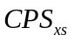 and 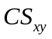 locate in different dimension, so we can use the generally Euclidean distance to calculate the data. The ‘user-book’ recommendation index is as follows:
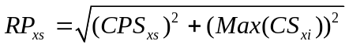
In conclusion, we can recommend reading for the user based on the recommendation index. We on topics requires of 6 user used books recommended algorithm, first through MTALAB count all books label of TCS, then according to user scoring data and reading records count each user on each label of preference weights, thus can calculation out each user and remaining user of and each a user and each this books of value, thereby can is out "user-books" recommended index.
And based on the "user-book" recommendation index, select that user didn't read and recommend the highest index of 3 as recommended reading, which results in the following table:
User ID | R1 | R2 | R3
7245481 | 499360 | 594018 | 225884
7625225 | 499360 | 121935 | 594018
4156658 | 594018 | 570129 | 551643
5997834 | 284550 | 105810 | 121935
9214078 | 594018 | 284550 | 499360
2515537 | 594018 | 499360 | 570129

Model summary
Model I
Advantages:
1. It covers the many possible factors.
2. It demonstrated analytical results through a table, which is very intuitive.
Disadvantages:
1. Randomly selected number of users is limited, where may be a chance.
2. The habit of scoring metrics to users lacking a scientific basis.
3. It failed to analyze the impact of user’s friend.
Model II
Advantages:
1 According to user score rating estimates for not scoring, scoring reflects the user habits impact on scoring. ；
2. Through scoring the cosine similarity between different users to describe similarity between items reflects the influence of grading the quality of books on.
3. Selected a subset of the data from the scoring record as a test set, and test the accuracy of the model shortcomings.
Disadvantages:
1. Examination number not many, there may be a chance.
2. Influence of friends does not take into account users ' concerns about the scoring.
Model III
Advantages:
1. The analysis of the similarity between the tags is the book’s division of a kind.
2. Considering the similarity between user and user preference matches the book labels, as well as its impact on recommended.
Disadvantages:
1. User involvement of measured points plus the number of the book, equivalent to the weight of the individual, science of weight without testing.
2. Without considering the impact of user's friends on the books recommended.

Reference book
[1]ZHANG Guang-wei, KANG Jian-chu,LI He-song.Context Based Collaborative Filtering Recommendation Algorithm[J].Journal of System Simulation,2006
[2]Chen Xiang,Qiu Xiuzhen.Tag similarity-based cooperator recommendation[J].CHINA SCIENCEPAPER,2013
[3]DENG Ai-Lin,ZHU Yang-Yong,SHI Bai-Le.A Collaborative Filtering Recommendation Algorithm Based on Item Rating Prediction[J].Journal of Software,2003

Appendix
1.Question 2：
1.Predict the score
clear
clc
load score.mat;
load predict.mat;
bs=user_book_score;
pred=predict;
id=2515537;
pu(2,1)=id;
k=2;
for i=1:36
if pred(i,1)==id
pu(1,k)=pred(i,2);
k=k+1;
end
end
for i=1:length(bs)
if bs(i,1)==id
pu(1,k)=bs(i,2);
pu(2,k)=bs(i,3);
k=k+1;
end
end
k=2;
z=22;
for i=1:length(bs)
if (bs(i,1)~=id)
if (ismember(bs(i,2),pu(1,2:7))==1)
if (bs(i,1)~=z)
z=bs(i,1);
k=k+1;
pu(k,1)=z;
end
%%pu(k,find(pu(1,:)==bs(i,2)))=bs(i,3);
end
end
end
for i=1:length(bs)
if ismember(bs(i,1),pu(:,1))==1
if (ismember(bs(i,2),pu(1,:))==1)
pu(find(pu(:,1)==bs(i,1)),find(pu(1,:)==bs(i,2)))=bs(i,3);
end
end
end
for m=2:7
for j=8:length(pu(1,:))
k=1;
for i=2:length(pu)
if (pu(i,j)~=0)&&(pu(i,m)~=0)
fenshu(k,1)=pu(i,m);
fenshu(k,2)=pu(i,j);
k=k+1;
end
end
a=fenshu(1:k-1,1);
b=fenshu(1:k-1,2);
sim=(dot(a,b))/(norm(a)*norm(b));
simz(m,j)=sim;
end
end
simz(1,8:length(pu(1,:)))=pu(2,8:length(pu(1,:)));
for t=2:7
for i=0:length(pu(1,:))-8
for j=8:length(pu(1,:))-i-1
if isfinite(simz(t,j))==0
simz(t,j)=0;
end
if (simz(t,j))<(simz(t,j+1))
a1=simz(:,j);
simz(:,j)=simz(:,j+1);
simz(:,j+1)=a1;
end
end
end
s1=0;
s2=0;
for i=8:12
s1=simz(1,i)*simz(t,i)+s1;
s2=simz(t,i)+s2;
end
prep=s1/s2;
pu(2,t)=prep;
end
2.Question three：
1.Estabish the matrix
clear
clc
load score.mat;
bs=user_book_score;
people(1)=bs(1,1);
k=2;
for i=1:length(bs)
if ismember(bs(i,1),people)==0
people(k)=bs(i,1);k=k+1;
end
end
load pb.mat;
load ttag.mat;
load tag;
sb=zeros(8369,1129);
for i=1:length(tag)
j=2;
m=0;
while ((isfinite(tag(i,j)))&&(m==0))
sb(find(pb==tag(i,1)),find(ttag==tag(i,j)))=1;
j=j+1;
if j==54
m=1;j=53;
end

end
end

3.Calculate the TCS
load gs.mat;
for i=1:length(gs)
for j=1:length(gs)
tcs(i,j)=(dot(gs(i,:),gs(j,:)))/(norm(gs(i,:))*norm(gs(j,:)));
if(norm(gs(i,:))*norm(gs(j,:)))==0
tcs(i,j)=0;
end
end
end

load rb.mat
load cy.mat
load sb.mat
rbpw=zeros(4071,1129);
for i=1:length(rb)
for j=1:length(rb(1,:))
if rb(i,j)==1
a=find(sb(:,j)==1);
pw=0;
for t=1:length(a)
pw=pw+cy(i,a(t));
end
rbpw(i,j)=pw;
end
end
end
4.Calculate the CPS
load rb.mat;
load sb.mat;
load tcs.mat;
cps=0;
for x=1:6
a=find(rb(x,:)~=0);
k=length(a);
for s=1:8369
b=find(sb(s,:)==1);
h=length(b);
for j=1:h
for i=1:k
cps=cps+qz(x,a(i))*tcs(a(i),b(j));
end
end
cps=cps/h;
ccps(x,s)=cps;
end
end
5.Calculate the CS
load rb.mat;
load qz.mat;
load tcs.mat;

for x=1:6

a=find(rb(x,:)~=0);
k=length(a);
for y=1:4071
cs=0;
b=find(rb(y,:)~=0);
h=length(b);
for j=1:h
for i=1:k
cs=cs+qz(x,a(i))*qz(y,b(j))*tcs(a(i),b(j));
end
end
ccs(x,y)=cs;

end
end
6.Calculate the RP
clear;
load rs.mat;
load qz.mat
load rb.mat
load tcs.mat
load sb.mat
load ccs.mat
load ccps.mat
rpp=zeros(6,8369);
for x=1:6
for s=1:8369
r=find(rs(:,s)~=0);
max=0;
for i=1:length(r)
if ccs(x,r(i))>max
max=ccs(x,r(i));
end
end

cs=max;
cps=ccps(x,s);
rpp(x,s)=sqrt(cps^2+cs^2);
end
end
7.Recommendation index
clear
load pb.mat
load rpp.mat
load rs.mat
for i=1:6
k=0;
while(k<3)
max=0;
for j=1:8369
if rpp(i,j)>=max
max=rpp(i,j);
num=j;
end
end
if rs(i,num)==0
k=k+1;
tj(i,k)=pb(num);
end
rpp(i,num)=0;
end
end

