The judges 1 scoring ,note | Team number：  20038 | The judges 3 scoring, note
The judges 2 scoring, note | Problem：  B | The judges 4 scoring, note
Title:：Collaborative Filtering-Model of Book Recommendation System
Abstract
With the rapid development of information technology and Internet, people from an era of scarcity gradually entered the era of information overload. For information-consumers, finding themselves interested in information from a large amount of information is a very difficult task; as regard to information producers, letting the production information stand out,and getting the attention of the masses of users is also a very difficult task. In order to solve this contradiction, established three models based on principal component analysis to relevant books, prediction score model, the collaborative filtering recommendation model, solves the difficulty to find high quality books from numerous data.
For questions I: Based on the correlation theory, establish a decorrelation principal component analysis model,obtaining the main factors affecting the user evaluation of books. First of all, the data were analyzed and screened to identify factors that might be affecting the score books. Secondly, establish the principal component analysis model to study whether the chosen factors affect the evaluation of books. Finally, through the analysis obtaining the factors affecting the user book is tag number of books and indirect attention (attention friends).
For question II: Based on linear regression theory, a predictive scoring model which can predict book ratings is established.First of all,a scoring matrix belongs to predict user and a scoring matrix to rated user are build, each book introduce a feature matrix 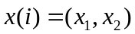, and a parameter matrix is introduced for each user hereafter we use linear regression on the scoring matrix , the resulting matrix is ​​then optimized by the gradient descent, finally we obtain the model parameters matrix 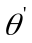,a book-score-prediction model can be build with this method that the parameter matrix multiplied by the characteristic matrix. We use this model to predict book’s score rated by the six people in the annex. Then we analyse error by comparing the predicted score and the given score .The analysis result verifies our predicted values are accurate.
For question III: Based on collaborative filtering technology, we establish a collaborative filtering recommendation model,soon afterwards system can recommend books to users they maybe interested based on this model .First of all, coefficient matrix can be established according to scoring matrix from questionII. Secondly, by comparing the MAE values between the modified cosine similarity matrix and the similarity matrix of Pearson,we get several users have the greatest similarity with suggested users in the annex.Finally system can search several books read by greatest similarity user and recommend the appropriate book to suggested users..
Finally,we analyze the advantages and disadvantages of these models.This paper research the score and book recommendation system,and successfully recommend appropriate books to users. In addition,the mathematical model established in this paper has strong character of
Keywords: Principal component analysis; Regression prediction; Collaborative filtering ; Similarity matrix

Collaborative Filtering-Model of Book
Recommendation System

Restatement and Analysis of Problem
With the continuous development of information technology and the Internet, a lot of information to emerge in front of us. Users face of these information is difficult to find the content they are really interested in, and the information provider is difficult to accurately convey the quality of information to the interested user. Therefore, it is very important value for information provider that the study of books score to issue recommendations on quality books for the user .
Problem I: Requires identify the impact factor that the user scores of books. Need to tap text and database information of the title given, to be reasonable given the data analysis, screening, to identify factors that might be affecting the score books, through modeling, the Institute selected factors that can affect whether users of books evaluated.
Problem II: Asked to predict the users have not read the books score based on predict.txt annex. According to the impact factor that identifies users score of books at the problem I, as an argument to establish score prediction model based on the project and obtained score.
Problem III: Requires recommend three books that each user have not seen. From the user's point of view, he should be concerned with people with similar interests have seen the books to find a relatively high score books as the user ultimately recommended books from the middle. So, how to better identify high similarity with the user to other users is the need to solve the problem.

Hypothesis of the Model
2.1 Through data mining, we only consider three possible factors that the number of labels, the attention, the number of books have been read without other factors.
2.2Friends relationship is unidirectional.
2.3The projects of user not rated are assumed the average score of the line .
2.4Does not consider the issue of the original data missing

3. Illustration of Symbols
Sign Illustration
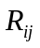 ：correlation coefficient
 ：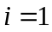expressed bookmark 1, 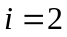 expressed bookmark 2
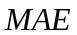 ：the average absolute deviation
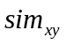 ：the similarity between users and projects
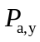 ：the scores of target user predicted the goals not rated
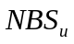 ：nearest neighbor set of users
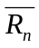 ：the average score of user and user for project's

Establishment and Solution of the Model

4.1 The decorrelation model based on Principal component analysis
4.1.1 Relevance theory
Principal component analysis^{[1]} is a statistical analysis methods which use dimension reduction technique to transform the numerous variables into a few main components (i.e. integrated variable). Each the principal components is the linear combination of the original variables and they are Uncorrelated, So as to reflect the vast information of the original variables by the principal components. This method can overcome the shortage which only own one Index can not reflect on the whole score feature, this method introduce a wide range of indicators But in turn several factors complicated are attributed to the main ingredients, Allowing to simplify complex problems, at the same time it can find out more scientific and accurate factors affecting the books evaluation.
First, according to the data ,we Identify several factors that could affect scores of books. They are ：1、The frequency of the book reading ;2、indirect attention (a book relationship data embodied in the user social net); 3, the number of labels books.
Secondly, conduct the overall test of the three factors, namely to analyze if every element (i.e. single index) is feasible, valid, and authentic. (the so-called feasibility, refers to whether the index can obtain the correct value, those who cannot or is difficult to obtain accurate data of the index, or even can make but the cost is very high, is not feasible,) the correctness, refers to the index calculation method and calculation scope and calculation contents should be scientific. The so-called truth, is mainly the quality analysis of specific evaluation data, need to conform to a specific comprehensive evaluation method.
Finally, the comprehensive evaluation index system of the measurement object is divided into a number of different part or side (i.e. subsystem), and gradually subdivided, until every part and the side can be used to describe the statistical indicators and implementation of specific. In order to exclude the interference of irrelevant information, this paper uses principal component analysis to the related method in, exclude the small relativity between all the indexes overlap factor, thus we get the factors influencing the user books on the score.
4.1.2 Establishment and solution of the model
According to the label data, the relationship data and the books data, use matlab to data mining , the program statements in Appendix I. In order to exclude the interference of irrelevant information, using principal component analysis method to eliminate large index correlation to get the final evaluation index.
First, calculate the correlation coefficient matrix:
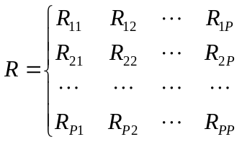 （1）
In the formula (1), 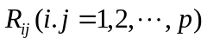 correlation coefficient of the original variables and 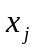, the calculation formula is as follows:
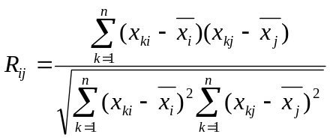 (2)
Because  is a real symmetric matrix (i.e. 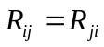) so we only need to calculate the upper triangle element the lower triangular elements, as shown in table 1:
Table 1 Correlation Coefficients Matrix
Correlations
 |  | Indirect attention | Read the number of times | Books tag number
Indirect attention | Pearson Correlation | 1 | -.064 | -.110
Indirect attention | Sig.（2-tailed） | . | .195 | .255
Indirect attention | N | 19 | 19 | 19
Read the number of times | Pearson Correlation | -.064 | 1 | .559*
Read the number of times | Sig.（2-tailed） | .195 | . | .013
Read the number of times | N | 19 | 19 | 19
Books tag number | Pearson Correlation | -.110 | .559* | 1
Books tag number | Sig.（2-tailed） | .255 | .013 | .
Books tag number | N | 19 | 19 | 19
*.Correlation is significant at the 0.05 level (2-tailed).
Then according to the results of correlation analysis in Table 1, the Relevance between The frequency of the book reading and the label number is relatively large.The frequency of the book reading is Eliminate. Finally this paper obtained factors affecting users to book score as shown in figure 1.

Books grading factors

Indirect attention
Books tag number

Fig.1 A Final Index Number

4.2 Predictive Book’s Scoring of the Model
4.2.1 Establishment of the model
For each BookID and Booktag belongs to the label, this label can be understood reader preferences for the types of books that readers’ read feature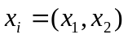. Read the feature contains implicit information of reader for books, the associated data mining can get the relationship between books and user ratings. There are many data mining methods, such as linear regression, machine learning system design, as well as support vector machines and other methods. Machine learning process for all involved in the literature, can be regarded as a mathematical model to optimize the parameters of the solution process, a broad term learning process can be transformed into an optimization problem. Machine learning process has three elements which impact on the efficiency and effectiveness of learning, 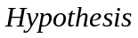function, 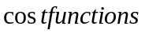 function and 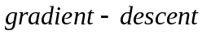 function.
Integrated the advantages and disadvantages of each method, we use the optimization of multivariable linear regression^{[3]}relationship between books and readers score between features.
After data processing users get books score table, this table is a two-dimensional vector, as shown in Table 2.
Table 2 List of Being Predicted with Known Data
user  book | 7245481 | 4156658 | 9977150 | 7625225  (Did not predict) |  | 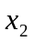
473690 | 4 | 0 | 0 | ？
929118 | 4 | 0 | 0 | ？
235338 | 4 | 4 | 5 | ？
424691 | 4 | 4 | 5 | ？
916469 | 4 | 0 | 4 | ？
793936 | 4 | 4 | 0 | ？

Introduction of parameters for each reader, construct supervision methods, the scoring matrix column by column and linear regression models were optimized to obtain model parameters. Multivariate assuming that the output is determined by multidimensional, the input multi-dimensional features. Multiple linear regression models: 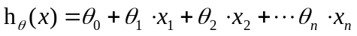.We Select two characteristics to regress prediction. To enhance the accuracy of the model, each reader is introduced corresponding constant term characteristics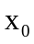 and parameters 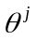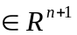, each user are trained a 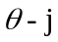. Optimization model is as follows:
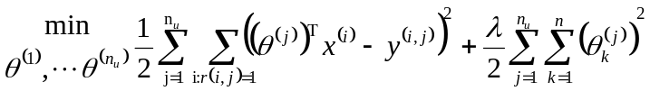
Gradient descent update:
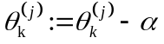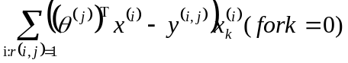
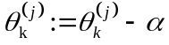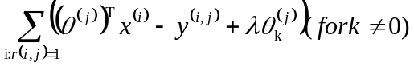
Univariate learning methods of decreasing gradient parameters:
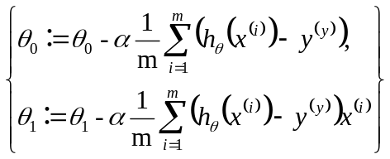 （3）
4.2.2 Solution of the model
The parametersof 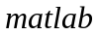 linear regression process and after training based on rote learning whose optimization program parameters in Appendix II. User whose ID No. is 7625225of the solution process and results of six books in Tables 3 and 4, the remaining five predicted scores in Table 3.
Table 3 Preliminary Treatment of the Data
User  Book | 7245481 | 4156658 | 9977150 | 7625225  (Did not predict)
473690 | 4 | 0 | 0 | ？ | 0.9 | 0
929118 | 4 | 0 | 0 | ？ | 1.0 | 0.01
235338 | 4 | 4 | 5 | ？ | 0.99 | 0
424691 | 4 | 4 | 5 | ？ | 0.01 | 1.0
916469 | 4 | 0 | 4 | ？ | 0.1 | 1.0
793936 | 4 | 4 | 0 | ？ | 0 | 0.9

Table 4 ID No. 7625225’s Rating Prediction on 6 books
User  Book | 7245481 | 4156658 | 9977150 | 7625225  (predicted ) | 7625225  (actual)
473690 | 4 | 0 | 0 | 4.17 | 4
929118 | 4 | 0 | 0 | 4.14 | 4
235338 | 4 | 4 | 5 | 4.25 | 5
424691 | 4 | 4 | 5 | 4.31 | 4
916469 | 4 | 0 | 4 | 4.24 | 5
793936 | 4 | 4 | 0 | 4.24 | 5
4.2.3 Test of the model
The comparative analysis chart of ID No. 7625225’s prediction and the known remarks value on six books, as shown in Figure2.
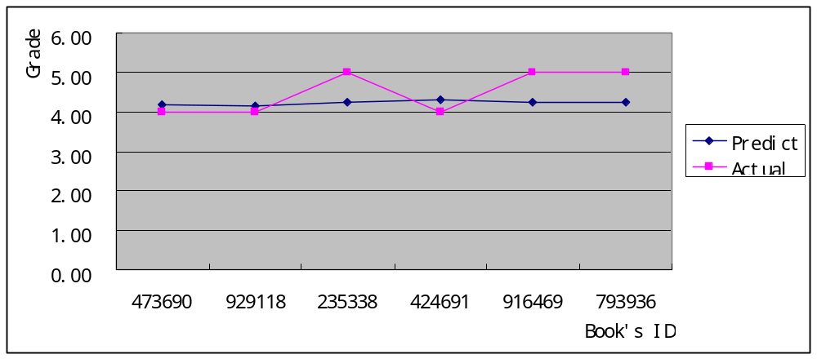
Fig.2 Contrast between Predictive Value and the True Value
From the above chart we can see, the predicted value fluctuates in the vicinity of the actual value given in the title of this article, and that the absolute error of relatively small is 0.015 is calculated by SPSS. Therefore, the model predicted score obtained more accurate.

4.3 Collaborative filtering recommendation model
4.3.1 Recommended principles
For each user to recommend 3 books they have never read, based on the principle of 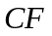 among articles^{[2,4]}, only in the calculation of neighbors the goods itself, and not from the user's point of view, which is based on user preferences on items to find similar items, and then according to the user's historical preferences, recommend similar items to him. From the computational point of view, is that all the user preference for a certain object as a vector to calculate the similarity between items of similar goods, articles, according to user preference to predict the current user is not expressed preference items, obtained a list of ranked as a recommended. Below gives an example, a for goods, according to all user's historical preferences, like user a items like item , the item  and item is quite similar, but users like articles , so can infer user may also like item . The book recommended flow chart is as follows:
Book A

Book B

Book C

Book A
√
√
Book B

√
Book C

√
√
recommendation
User/Book
√
Book A
Book B
Book C
similarity
Love
Recommend
Fig.3 The Books Recommended Flow Chart
The following information can be obtained from the flow chart collaborative filtering recommendation technology based on items most users for some item scores are similar, the assumption that the current users of these item scores were also similar. Then find the similarity between two users to solve in this paper is especially important. Work flow chart in Figure 3 gives the collaborative filtering algorithm is given by the score matrix, get the similarity relationship between user to user, so as to find out the books. For example, the user of 1, 2, 3 of the project , scores were {3，4，5}and {3，4，5}, the fourth users of project a score of 1, because the project , the score of is very similar, indicating that and are very similar, we can think of the fourth users on project the score is similar with score on the project, Therefore the use of collaborative filtering recommendation algorithm is Appropriate.

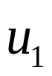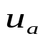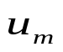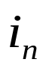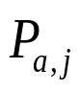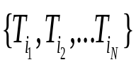
…
…
…
…
Target users
Enter a rating matrix
Similarity calculation
Prediction
Recommend
CF recommendation algorithm
Items to predict
Fig.4 Flow Chart of Collaborative Filtering Recommendation Algorithms
4.3.2 Establishment of the model
Through the above work flow chart^{[5]}, the Item-based method requires three steps:
(1)obtaining score of User-item data;
(2)The nearest neighbor search for target items, namely the similarity calculation;
(3)Generating recommendation
First of all, score data has been provided by the second model , then with the method of nearest neighbor and Pearson, cosine and improved cosine similarity algorithm to calculate the similarity between users
(I)Pearson similarity algorithm:
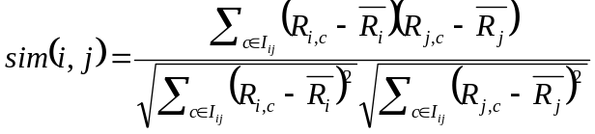
(II)Cosine similarity algorithm:
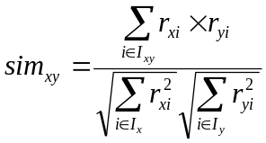
The remarks matrix, all the scores of each item can be regarded as a column vector of this matrix, similarity calculation of two items can be between two column vector by calculating two projects the corresponding cosine value, to represent the similarity of these two projects using the cosine value. indicates the similarity between user and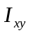 present the item set which is remarked by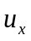and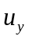, 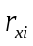 and 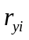represent the score remarked byand.
The modified cosine similarity algorithm:
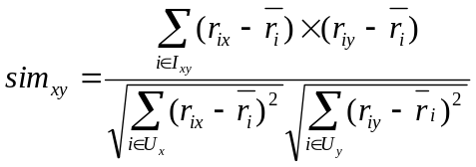 （5）
The cosine similarity scale problems of different user ratings did not consider the measure method, some users tend to score lower, some users tend to score higher, the modified cosine similarity measure to improve the defect by averages core minus the user. Indicates the similarity between users and users, represents the average score of 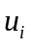. Use Matlab to evaluate the user item matrix is established and improved cosine similarity matrix calculation procedures in Appendix III.
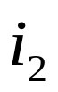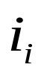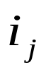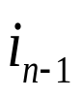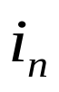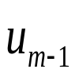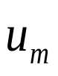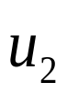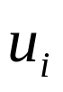
R R
R R
R R
R
-
-
R
…
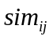
Fig.5 Calculation Diagram of Collaborative Filtering Algorithm Based on Similarity Project
According to the calculation method of similarity, To find the user - item neighbor, based on the principle of The similarity threshold of neighbor selection. Through the MATLAB for data filtering, calculating^{[6,8,9]} and have Data segmentation with the book label, user’s remark The reader of historical data And the social relationship Data. mining with MATLAB, extract the user factor matrix and object factor matrix, to extract implicit information from massive data be in mining, the relationship between data, sorting out the relationship between books and books ID tag number corresponding to the user ratings matrix, books, social network relations between user and book, and between the user similarity matrix, and to classify books, provide technical support for algorithm design and data processing. The two-dimensional spatial point set diagram as figure 6.
The calculation based on The similarity threshold neighbor is a restriction on the maximum value of the far and near neighbor, fall in the current point as the center, distance of all points in the region of K as the neighbor, calculated by this method the neighbor number is uncertain, but the similarity does not appear larger error. The B shown in Figure 6, starting from 1, the similarity in the K neighborhood, point 2, point 3, point 4 and 7, this method to calculate the neighbor similarity degree is better than the fixed number of neighbors, especially the treatment of the isolated point.
A：K-neighborhoods
B：Threshold-based neighborhoods

8
5
6
4
3
2
1
7
1
7
2
4
3
8
6
5
K
Fig.6 Similar Neighbors Calculation Sketch
Similar to nearest neighbor measurement method of target users, the next step is to generate the corresponding recommendation. The nearest neighbor set user set by , the user to the project prediction score 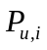 can get to the nearest neighbors in item score by user calculated as follows:
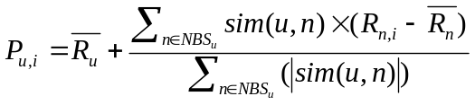 （6）
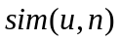 indicates the similarity between user and user , 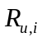user to the project of thescore, 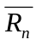represent user and user to the project's average remarks.
4.3.3 Test and solution of the model
Evaluation criteria for recommendation include statistical precision of measurement methods and decision support accuracy measurement method. The average absolute deviation statistical precision of measurement in (mean absolute error) is easy to understand, can be measured to the recommendation quality directly, is a kind of the most commonly used method to measure the quality of recommendation，The average absolute deviation of as a metric. The accuracy of the deviation between the average absolute deviation of through user rating and the actual computational prediction of user rating prediction metrics, smaller, more high quality of recommendation. A prediction of user remark set representation for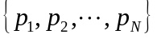, the actual user rating corresponds to the set 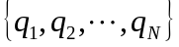, then is defined as the mean absolute deviation:
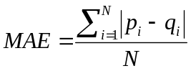 （7）
Calculate the accuracy of recommendation value , analyze experimental error. First calculate the Category attribute similarity all new projects and other projects, and obtains the new project by category similarity, the nearest neighbor prediction, calculate value, draw line graph, as shown in Figure 7, as shown in figure 8:
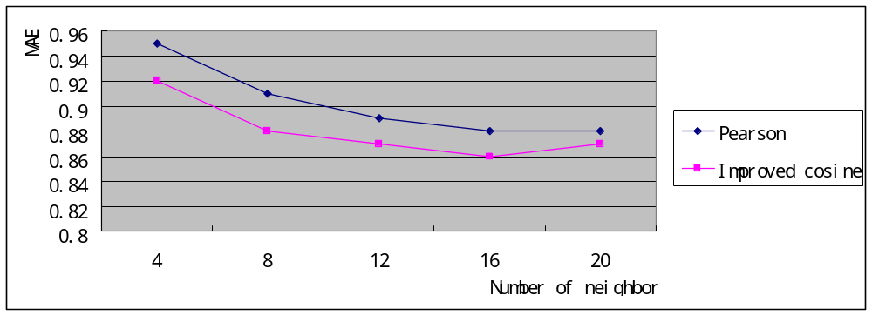
Fig.7 MAE Contrast Charts between the Improved Cosine and Pearson Prediction Formula
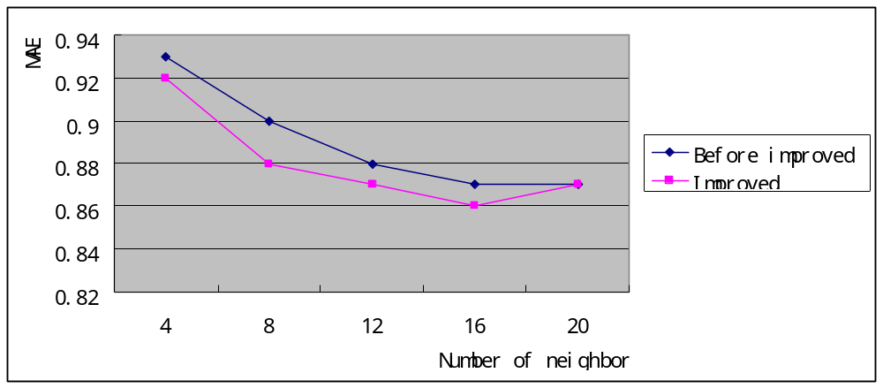

Fig. 8 MAE Contrastline Chart between the Former and Modified Cosine Formula
Figure 7-8 shows the analysis, based on three similarity calculation formula: cosine, cosine and Pearson adjustment formula, the improved prediction formula calculated is lower than pearson and former formula, demonstrated improved predictive formula recommended by the system to improve the effectiveness of precision, which proves the improvement compared to the previous prediction formula Pearson prediction formula to improve and better, to a certain extent, improve the system in the case of rating data sparse under the recommendation accuracy.
Using software^{[7]} to search, to find matching, and eventually give it six people each recommended 3 books, the results are as shown in table 5:
Table 5 Each User Recommended 3 Books
 | 7625225 | 4156658 | 5997834 | 9214078 | 7245481 | 2515537
Book1 | 219560 | 356405 | 105810 | 120925 | 105962 | 542175
Book2 | 345849 | 144718 | 156860 | 156236 | 129822 | 976811
Book3 | 547253 | 423577 | 161014 | 172132 | 203204 | 799779

Improvement of the Model
According to the data subject given user_book_score.txt, deal with the similarity between the project and the project get 35577757 sparse matrix. Since scoring matrix sparsity causes two items rated intersection becomes small, even an empty set, the calculated similarity is likely very small, even zero. However, it is certainly not true that you think the two projects are completely dissimilar if the two projects common score collection is empty. Although the number of users is a lot, the number of users that jointly review there is few. Therefore, the minority user's point of view does not represent everyone. However, that the items of these common score collection is few was not considered separately in the general algorithm for calculating the similarity. In fact, they are obtained the similarity by calculating is not accurate that causes the accuracy of the similarity calculation is reduced. Finally, the recommendate accuracy of the algorithm is affected.
From the above point of view, calculating the similarity of the two projects, basically ,we can conclude that: the number of users of the two projects rated together is more, indicating the calculated similarity is more reliable. On the contrary, the number of users of the two projects rated together is fewer, the calculated similarity is more questionable. So the similarity calculation of the general algorithm should be improved. We should add a similarity factor, the number of projects rated intersection,and using this factor to reduce the impact on the similarity of those amplified. We can get an idea of ​​similarity calculation formula:
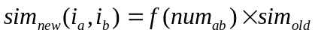 （8）
Improved algorithm to obtain the similarity of projects and projectsis expressed as 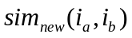. The number of the projects and projects rated together is expressed as 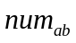. A function of as a parameter is expressed as 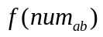. a degree of influence on b The output value of the function that the number of project intersection degree of influence on general similarity algorithm. The similarity of the results obtained by the ordinary method is expressed as 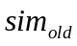.
Where is selected: 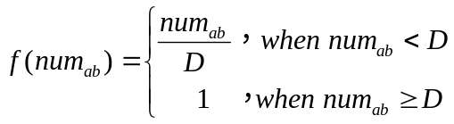
D is the boundary of the intersection number . When the number of the two projects intersection rated over D, then it is reliable that the similarity obtained through traditional similarity calculation formula is reliable. On the contrary, When the number of the two projects intersection rated less than D, it is unreliable that the similarity obtained through traditional similarity calculation formula is reliable ,so we have to be multiplied by a weighting factor.
when seeking the project similarity , class properties need to be considered . The problem of new projects can be alleviate by class properties.
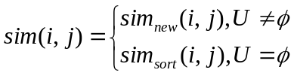 （9）
Compared with the traditional algorithm, one of the advantages of the improved algorithm is that the similarity between the projects can all be calculated ,no matter what state the recommended system. Many new items not rated data, but it is very likely to get its nearest neighbor by item category similarity. Then the system can predict and recommend by nearest neighbor of new projects. Finally, to a certain extent, the issue of new projects can be alleviated.

Evaluation and Promotion of the Model
6.1 Advantages
1．All the analysis is based on the basis of obtained data, the prediction results is convincing.
2. Application of principal component analysis for the selected factors of overall inspection, find out the influence of the factor score well and reasonable.
3. Optimization of linear regression, and the prediction precision is improved.
6.2 Disadvantages
Put forward to solve the problem of sparse data. But due to time constraints, we have no time to solve the sparsity problem.
6.3 Promotion of the model
In the background of information now soaring, recommendation system is particularly important, recommendation system is also more and more attention from the academic circles. This paper selected the most recommendation technology widely used: collaborative filtering recommendation technology as a model to study the score and book recommendation, and draw a reasonable conclusion. The mathematical model established in this paper has strong "portability", we can use this model is widely used in network, media, film and other areas.

References
[1]Gaoxiangbao,donghanqing, SPSS data analysis and application,Beijing: Tsinghua University Press,2007
[2]DENG Ai-Lin, ZHU Yang-Yong, SHI Bai-Le. A Collaborative Filtering Recommendation Algorithm Based on Item Rating Prediction，Journal of Software，1000-9825/2003/14(09)1621：1624-1626，2003.
[3]http://blog.csdn.net/lifeitengup/article/details/9174419#comments
[4]Jijun，THE FILM WE BSITE CONSTRUCTION BASED ON A COLLABORATIVE FILTERING RECOMMENDATION ALGORITHM，Harbin Institute of Technolog y,2009,12.
[5]Yaozhong,Weijia,Wuyue,China Journal of Information Systems, l22,Oct.2008:78-96
[6]Donglin,Bingjing:PUBLISHING HOUSE OF ELECTRONICS INDUSTRY,2009.1
[7]Chenjie，MATLAB Collection,Beijing,PUBLISHING HOUSE OF ELECTRONICS INDUSTRY,2011.
[8]http://www.360doc.com/content/14/0513/10/13256259_377162634.shtml [9]http://blog.csdn.net/lifeitengup/article/details/9174419#comments

Appendix
Appendix I
1.load('peoplebeviewdinuser_social.mat')
>> x=peoplebeviewd(:);
x=sort(x);
d=diff([x;max(x)+1]);
count = diff(find([1;d])) ;
frenqency_of_people_be_viewd=[x(find(d)) count];

2.load('booktag.mat')
load('booktable.mat')
B=sort(booktabel(:));
a=B(B~=0);
x=a(:);
x=sort(x);
d=diff([x;max(x)+1]);
count = diff(find([1;d])) ;
y =[x(find(d)) count];

3.load('usersid of user_read_history.mat')
>> load('books which are read of user_read_history.mat')
>> user_read_history=[VarName4 VarName5];
>> sorted_user_read_history_by_bookid= sortrows(user_read_history,2);
>> B=sort(VarName5(:));
>> x=B(:);
x=sort(x);
d=diff([x;max(x)+1]);
count = diff(find([1;d])) ;
frenqency_of_bookid=[x(find(d)) count];
Appendix II
b = regress(y,X)
regras()
B1X=zeros(row_a,row_a);
for i=1:row_a
for j=1:row_a
if(j~=i)
B1X(i,i)=B1X(i,i)-B1X(i,j);
end
end
end

V1=zeros(row_a,row_a);
for i=1:row_a
for j=1:row_a
if(i~=j)
V1(i,j)=-Wa(i,j);
V1(i,i)=V1(i,i)+Wa(i,j);
end
end
end
V1a=inv(V1+ones(row_a))-1/(row_a^2)*ones(row_a);
a1=V1a*B1X*a;

segma=0;
for i=1:row_a
for j=i+1:row_a
Theta=segma+Wa(i,j)*Da(i,j)*Da(i,j);
end
end
Theta=segma+trace(a'*V1*a)-2*trace(a'*B1X*a);
Appendix III
User’s ID | Book’sID | Prediction  remark | User’s ID | Book’sID | Prediction  remark
7245481 | 794171 | 4.05 | 7625225 | 473690 | 4.17
7245481 | 381060 | 4.27 | 7625225 | 929118 | 4.14
7245481 | 776002 | 4.36 | 7625225 | 235338 | 4.25
7245481 | 980705 | 4.13 | 7625225 | 424691 | 4.31
7245481 | 354292 | 4.17 | 7625225 | 916469 | 4.45
7245481 | 738735 | 4.23 | 7625225 | 793936 | 4.73
4156658 | 175031 | 4.03 | 5997834 | 346935 | 4.20
4156658 | 422711 | 4.26 | 5997834 | 144718 | 4.34
4156658 | 585783 | 4.01 | 5997834 | 827305 | 4.14
4156658 | 412990 | 4.01 | 5997834 | 219560 | 4.20
4156658 | 134003 | 4.14 | 5997834 | 242057 | 4.32
4156658 | 443948 | 3.98 | 5997834 | 803508 | 4.15
9214078 | 310411 | 4.19 | 2515537 | 900197 | 4.16
9214078 | 727635 | 4.11 | 2515537 | 680158 | 4.11
9214078 | 724917 | 4.12 | 2515537 | 770309 | 4.32
9214078 | 325721 | 4.22 | 2515537 | 424691 | 4.31
9214078 | 105962 | 4.19 | 2515537 | 573732 | 4.07
9214078 | 235338 | 3.60 | 2515537 | 210973 | 4.08
Appendix IV
1.s=find(bookidnumbertrans(1,:)==user_book_score1(1,2))
load('user_book_score.mat')
>> a=user_book_score(:,1);
>> x=a(:);
x=sort(x);
d=diff([x;max(x)+1]);
count = diff(find([1;d])) ;
useridnumber=[x(find(d)) count];
>> b=user_book_score(:,2);
>> x=b(:);
x=sort(x);
d=diff([x;max(x)+1]);
count = diff(find([1;d])) ;
bookidnumber=[x(find(d)) count];
>> user_book_score1=sortrows(user_book_score,1);
>> bookidnumbertrans=bookidnumber';
for i=1:3557
flag=useridnumber(i,2);
while flag
location=find(bookidnumbertrans(1,:)==user_book_score1(flag,2));
bookid(i,location)=user_book_score1(flag,3);
flag=flag-1;
end
end

2.load('C:\Users\chang\Desktop\jiyuyonghuxiangsixingjuzhen.mat')
load('C:\Users\chang\Desktop\predict.mat')
load('useridnumber.mat')
load('user_read_history.mat')
for i=2:7
location=find(useridnumber(:,1)==predict(i,1)); [rowmax,order] = max(g(location,:)')
l=useridnumber(order,1);
location1=find(user_read_history(:)==l)

