The judges scoring, note | Team number：  20001 | The judges scoring, note
The judges scoring, note | Problem：  C | The judges scoring, note
Title：Designing a Family Summer Vocation Travelling
Abstract
During summer vacation, many families would like to plan a travel with their children, therefore, the solution for the balance among route, time and consumption becomes emergent. This essay not only works out the shortest travel route with the application of Floyd algorithm, but also solves travel consumption and time problem according to GM(1,1) Grey Prediction Model as well as improvement of TSP(Travel Salesman Problem), finally designs the ‘comfortable’ travel plans for different families.
About the problem of tourist routes, we select five scenic spots in Nanjing as tourist routes: the Japanese Invasion museum, Zhongshan scenic spot, Nanjing Confucius temple, Nanjing museum, Nanjing University. According to the mutual distance between each scenic spot, using Floyd algorithm, we calculate the shortest travel route: the Japanese Invasion museum-Nanjing museum-Nanjing Confucius temple-Nanjing university-Zhongshan scenic spot.
To solve the problem of travel consumption and time, we consider about it based on the confirmed travel route. The tour cost would consist of accommodation, transportation, tickets and other fees. Considering the problem of accommodation, we make use of the relationship between the population of Nanjing tourism and the income of the travel accommodation services in recent years to reach the average daily accommodation consumption of every tourist. By the establishment of GM (1, 1) grey model, we forecast the daily accommodation consumption in 2014 which arrives at 97 RMB. As for the calculation of transportation, we divide traffic into three ways: bus, subway and self-driving. According to different cost and time that depends on the different ways of transportation, we establish an optimized model of the least required transportation costs and time by using the improved traveling salesman model. Using MATLAB software, we made our solution: take subway from the Japanese Invasion Museum to the Nanjing museum and take buses for the rest of the route, which reached the conclusion: the minimum transportation cost is 6 RMB each, while the the shortest transport time is 200 minutes.
Considering the demands of different families, the common families often travel by bus or subway for the least transportation cost when the travel route fixed. The travel costs for three days is 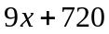, as for four days is 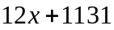 (x stands for other cost). For the rich families, without considering the cost, the travel route is the same with question one when demanding the least travel time which reaches 44 minutes for transport and 19 hours for touring in all scenic spots
In conclusion, this essay designs the most ‘comfortable’ travel plans for different families by using Floyd algorithm, GM(1,1) Grey Prediction Model and ‘comfortable’ travel plans, and make evaluation and promotion of the whole model.
Key words: Floyd algorithm, GM(1,1) Grey Prediction Model, improved TSP (Travel Salesman Problem), ‘comfortable’ travel plans

TABLE OF CONTENTS
1 problem restatement-------------------------------------------------------------------------- 2
2 questions Analysis ---------------------------------------------------------------------------- 2
2.1 first questions Analysis -------------------------------------------------------------------2
2.2 Second questions analysis-----------------------------------------------------------------3
3 model assumes--------------------------------------------------------------------------------- 3
4 Symbol Description -----------------------------------------------------------------------------3
5 modeling and solving the model---------------------------------------------------------------3
5.1 Model 3 Floyd shortest path---------------------------------------------------------------3
5.2 cost model takes ---------------------------------------------------------------------------5
5.2.1 GM (1,1) gray prediction model ---------------------------------------------------5
5.2.2 transportation cost model ----------------------------------------------------------8
5.3 Different Family Fare program -------------------------------------------------------9
6 Improved model ------------------------------------------------------------------------------11
7 Evaluation and promotion model ------------------------------------------------------------11
7.1 Model Evaluation --------------------------------------------------------------------------11
7.2 Model Promotion --------------------------------------------------------------------------11
8 References --------------------------------------------------------------------------------------11
9 Appendix ----------------------------------------------------------------------------------------12

Designing a Family Summer Vocation Travelling
1 problem repeat
As the development of people's living, not only people pursue the material enjoyment, but also has a certain spirit demand. Because parents is busy working, children's learning assignment is too heavy ,they doesn't have much time for fun. So during the summer vacation, many parents choose to take their children go out tourism, alleviate the pressure of work and study. For tourism, different families have different demand (the number, cost constraints, time constraints, etc.), considering travel itinerary, cost, time and other factors, build a model to solve the following problems:
1. Designed for travel family shortest path, time and cost of travel routes.
2. According to the established model, for the different needs of family travel plans for reference.
2 problem analysis
This part is a series of questions for family with children during the summer vacation to travel, consider the weather is hot during the summer vacation and travel with the children, we choose low average temperature in July and August, the transportation is convenient, has "the six dynasties ancient capital", "ten at will," said, a profound culture, one of the important birthplace of Chinese civilization as a travel city of nanjing.
And select the museum by the Japanese invaders, zhongshan scenic spot, nanjing Confucius temple, nanjing museum, nanjing university, five tourist attractions tourism route analysis.
2.1 problem analysis
In view of the problems, design travel packages need to make travel plans, develop a suitable route for all families. All visitors hope that they can be able to have the longest sightseeing tour, and the shortest time to the destination, so choose the shortest path theory can solve the problem. Tourists in the shortest possible time to traffic conditions, to be bound each scenic spot, and do not repeat, first of all, through access to information [1] to understand the selected five spots of the distance between each other, the shortest path Floyd model, concluded five spots between the shortest path problem.
After solving the shortest travel route, need calculation the cost of this and a matter of time. First travel costs including accommodation, catering, transport, entertainment, etc., for accommodation this consumption, statistical yearbook [2] by nanjing at home and abroad in recent years, Nanjing tourism accommodation services revenue and the number of tourist, daily average housing consumption is calculated by tourists, and grey prediction model is established, according to recent data to predict the average consumption amount every tourist accommodation, 2014, as a fixed housing consumption.
According to the traffic consumption, first, assume the first tourist attractions, tourists have arrived Nanjing all the tourist traffic cost only includes the cost of the conversion . So transportation mainly depends on the selection of different transportation and the number of differences ,and different sites have different ways of transportation. Transportation can be divided into three types: bus, subway, and drive. Each scenic spot is obtained by access to information [3] of the different between the different modes of transportation cost and time. Traveling salesman problem solving shortest route according to the theory of improving the traveling salesman problem is transformed into: shortest path is known, according to the improvement of different cost to establish cost minimum traveling salesman problem, and combining the multi-objective optimization problem, solving route known cases minimum cost the shortest time.
2.2 problem two analysis
Different families have different demand, so we need to make different travel packages, to focus on family, would not consider cost problem, so, for this kind of family, they will choose a convenient transportation, such as taking a taxi, and charter. For comfortable family, we need consider more, a lot of families tend to make time properly, but some families prefer to make economic properly, different demand conditions have different views of travel plan. Considering the factors, through different comparative analysis it is concluded that the most suitable for travel packages.
3 model assumptions
1. Assume that the transportation costs of every family only consider the cost between two scenic spots of.
2. Assuming that the passenger travel when the weather is good, no bad weather.
3. Assume that the passenger transportation time only include riding time, ignore to the time of waiting for the bus.
4 Symbol Description
The symbols meaning | The total distance
 | travel route
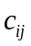 | the cost of transport from the scenic spot i to the scenic spot j
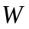 | family travel
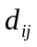 | the spend of time from the scenic spot i to the scenic spot j
 | total cost needed for the transportation
 | in addition to transportation, accommodation and other costs of admission
 | the shortest time needed for transportation
 | bus fee
 | taxi fees
 | The cost of tickets
 | family travel
5．Establishment and Solution of model
5.1 The shortest path of Floyd model
The basic idea of Floyd algorithm [4-5] is: for an undirected network whose number of vertices is n, set up a phalanx 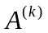of , in addition to the diagonal matrix elements, which are equal to zero, while the other element 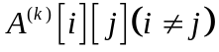 represents the directed path length from vertex to vertex 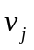, k represents calculation procedure, 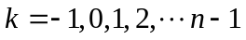. represents the directed path length from vertex to vertex , middle vertex serial number is not greater than k.
In the beginning: 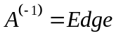 (adjacency matrix of the chart), which stands for the weighting of the directed edge between two random vertices as the shortest path length.
(1) for two random vertices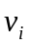 and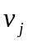, if a directed edge between them exists, then take the weighting of the directed edge as the shortest path between them.
(2) if there is no directed edge between them, take 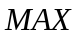 as the shortest path between them.
Using recursion to calculate 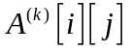 .
After adding the vertex 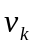 as intermediate vertex, compare the combination of the shortest path length from to 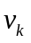 and to with the original shortest path length from to , which is to say comparing 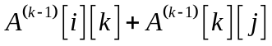 with 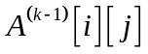, and take the smaller as the value of 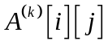
Therefore, the recursion formula of Floyd algorithm is: 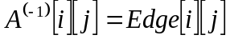
(1)
Select the five scenic spots in Nanjing as the tourist routes, including A represents The Japanese Invasion Museum, B represents Zhongshan Scenic Area, C represents the Nanjing Confucius Temple, D represents Nanjing University, and E represents Nanjing Museum. Get the distance between the scenic spots and turn it into the location relationship shown in figure 1 by checking data.

A
D
E
B
6
5.5
10.6
8.4
8.4
5
3.7
11
5
C

Figure 1 The location relationship of the scenic spots

By looking into data, get the distance between the scenic spots, and listed in table 1.
Table 1 the distance of scenic spots between each other
Attractions code | A | B | C | D | E
A | 0 | 11 | 5.5 | 6 | 3.6
B | 11 | 0 | 10.6 | 8.4 | 8.4
C | 5.5 | 10.6 | 0 | 5 | 3
D | 6 | 8.4 | 5 | 0 | 3.7
E | 3.6 | 8.4 | 3 | 3.7 | 0
Take the distance between the scenic spots as the weighting of directed edge, choose the distance between two random spots as adjacency matrix of figure. First, select point A as starting point, then make adjacency matrix by taking the distance from point A to the other four point as the weighting, after comparing, the minimal distance is from point A to point E, then take point E as starting point, establish adjacency matrix with consecutive point of point E, get the results after compare. After successively makeing iterative recursion, finally concluded that the the shortest travel route between five scenic spots is A - E-C-D-B, which is the Japanese Invasion Museum, Nanjing Museum, Nanjing Confucius Temple, Nanjing University, Zhongshan Scenic Area, as shown in figure 2.
A
E
C
D
B
3.6
5
5
8.4

Figure 2 The Shortest Travel Route
According to the distance between scenic spots, the shortest travel route can be obtained as follows:

5.2 takes the cost model
5.2.1 GM (1,1) gray prediction model
Through access to information [ 2 ] to get part of the year in Nanjing tourism economy in recent years, the main indicators : the total number of tourist arrivals and tourism , through the years of 2008-2012 calculated daily per capita consumption lodging shown in Table 2
Table 2 -day stay during the 2008-2012 per capita consumption
Years | 2008 | 2009 | 2010 | 2011 | 2012
consumption per person | 87 | 81 | 83 | 85 | 88
According to the gray model theory [ 6-7 ] established a gray system model , forecast 2014 average tourist spending this day in Nanjing , the establishment of tourist accommodation daily average consumption time series as follows :
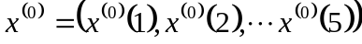
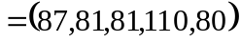
Do generate a cumulative number of columns
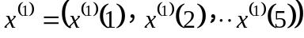
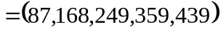
Among
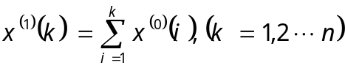
Gray derivative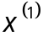 is defined as
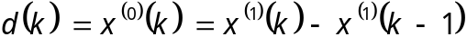
So close to the mean sum of the number of columns that
Then
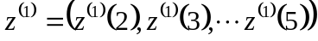
Ash equations define the model as follows:
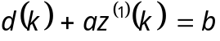
That
The corresponding equations for the albino
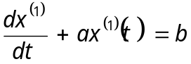
Building a data matrix , the data vectors and parameter vector
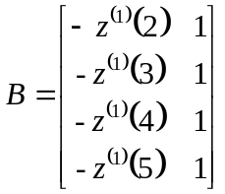
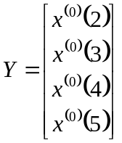
By parameter vector
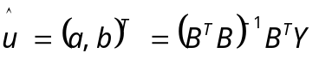
MATLAB is calculated
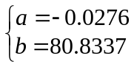
Will bring ( 3 ) formula:
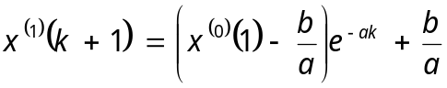
Solving the number of column values ​​generated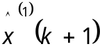 And restore the value of the model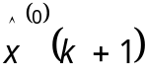
Order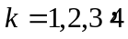 From ( 4 ) can be considered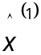, Take
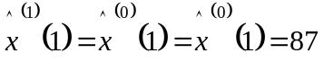
By the
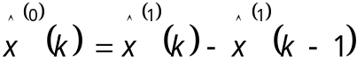
Take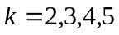 Available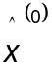
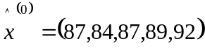
This model is used to predict the 2013-2014 average travel consumer spending day stay in Nanjing is 97 yuan.
Model Checking :
Gray prediction system for tourist accommodation in Nanjing average daily consumption models were tested
(1)Residual test : Order residuals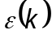, The formula is:
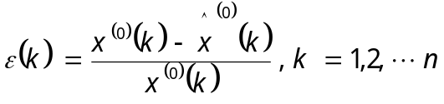
If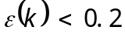, Can be considered to achieve the general requirements, If 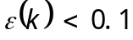, then that achieve higher demand.
(2)Level than the deviation test:
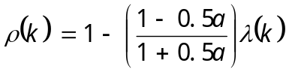
If 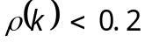, you think to achieve the general requirements , if 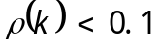, you think to achieve a higher requirement.
Stay inspection each year with an average consumption level than the deviation of the residuals shown in Table 3 :
Table 3 year stay with the class average daily consumption of more than offset the residual
years | The actual value | Predictive value | residual | Level than the deviation
2008 | 87 | 84 | -0.037 | 0.0592
2009 | 83 | 84 | -0.048 | -0.0673
2010 | 85 | 87 | -0.047 | -0.0623
2011 | 85 | 89 | -0.047 | -0.0623
2012 | 88 | 92 | -0.045 | 0.0518
From the data in Table 3 it can be seen : the residuals are less than the predicted values ​​to achieve higher requirements ; level than the deviation is less than 0.1 , the predicted value to achieve a higher requirement. In summary, the predictive value of this model is very accurate .
5.2.2 transportation cost model
The improved TSP model [ 8-9 ] to solve the traffic on the shortest travel route traffic to spend time with the least problems.
Old traveling salesman problem referred to as TSP, is the most basic routing problem , the problem is the starting point in the search for a single traveler departure , after passing through all the needs of a given point , and finally back to the origin of the minimum path cost . TSP ball improved shortest path problem into solving the minimum required transportation spending time with the least traffic problems .
Under the premise of the shortest route , each room will have two spots to choose from three types of transportation , cost of each transport mode as shown in Table 4.
Table 4 paragraphs from the different modes of transportation costs (NT $ )
路段 | AE | EC | CD | DB
Bus fee | 1 | 2 | 1 | 2
Drive ree | 13 | 11 | 16 | 24
Subway fee | 2 | 2 | 2 | 4
The time required for each transport mode as shown in Table 5 .
Table 5 paragraphs from different modes of transport units of time ( minutes )
 | AE | EC | CD | DB
Time needed for the bus | 90 | 60 | 50 | 30
Time needed for drive | 60 | 70 | 50 | 40
Time needed for the subway | 21 | 18 | 11 | 9
Transport costs and create a function based on the time required to transport data in Table 4 and Table 5 :
Said from the first attractions attractions to the cost
0-1 variables introduced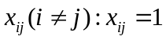 Said from the attractions to the first attractions by bus , 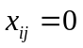 It means that from the first to the first attractions attractions not take the bus , that choose to take the subway , the model can be expressed as :
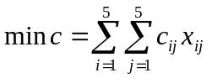 （5）
Constraint is :
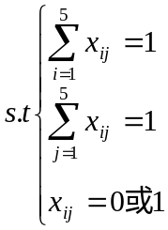
I represents the time from the first to the j attractions attractions selected transportation required
The time required for transportation :
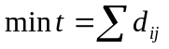 （6）
Was solved by MATLAB : In the shortest travel route has been determined , the lowest transportation cost 6 yuan per person , the shortest travel time is 200 minutes, that is : from A to E subway , take the bus the rest of the segment .

5.3 Different Family Fare program
Different designs of the ‘comfortable’ travel plans for different families.
For rich families，the way of traveling they choose is taking taxi. The total consumption is 89 RMB.
At first, take half day to visit the Memorial Hall of the Nanjing massacre, make the children know more about the crimes committed by the Japanese army doing during the Anti-Japanese Wartime。
Then come to Zhongshan Scenic Area, make the children relaxed as well as visit all kinds of famous attractions, such as Mingxiaoling, which is spectacular and has unique shape, especially has the undiscovered mysterious underground palace. If feeling a bit hasty in half a day, they can choose to come again the next day
Tourism for three days：
common families：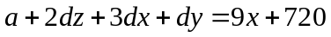
Rich families ：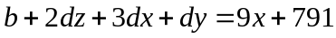
Tourism for four days：
common families：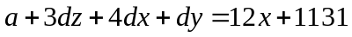
Rich families ：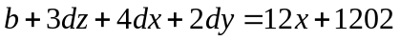
To save time, save money and consideration convenient comprehensive, generally will choose traveled by buses or taxis, because taxis and buses could connected random each of two scenic spots. We used a bus instead of money saving way, a taxi in stead of quick and convenient way.
In the case of no limitation of travel costs, we are supposed to visit the five scenic spots within minimizing time. The time of visitors consists of two parts, including the time on the road and the residence time.
Definedas the total travel time, as the time on the road,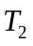 as the residence time
Therefore, the overall objective function is
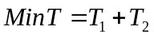 （7）
represents the time spending from the scenic spot to the scenic spot , 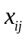represents variable 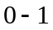 from the scenic spot to the scenic spot . For tourists visiting the five spots, so visitors’ time on the way is:
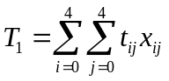 （8）
The total residence time required for tourists in the five scenic area is:
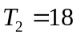
In conclusion, the overall objective function for [10 to 11] is :
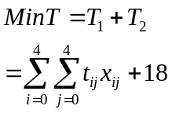 （9）
Restrained by tourist scenic spots, starting from the Japanese Invasion Museum, and five scenic spots to visit
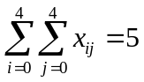。
In order to spend the least time, established the objective function for each scenic spot：
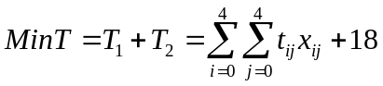 （10）
Constraints as
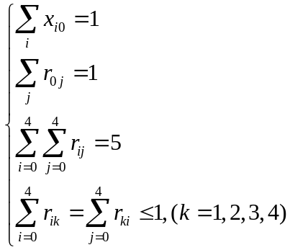 （11）
By using LINGO software, the solution: travel route for the Japanese invaders museum, nanjing museum, nanjing Confucius temple, nanjing university - zhong shan scenic spot
In the least total time, regardless of the cost, about 19 hours total travel time, namely need three days can finish five scenic spots all around, the time needed for transportation to 44 minutes.

6 Improvement of model
Different household demand situation, the author of this paper, in view of the cost, according to the family economic condition will be divided into general family, wealthy families.Fixed the travel route, in view of the two kinds of family consumption, through calculated adapted to the general families and rich families choose and reference of different modes of transportation cost.Considering the travel time for the summer vacation, all can have more time, this model does not travel to the long-term and short-term considerations, can according to the length of time to make different travel route.In this paper, it can also be selected more choice of tourist attractions in the city, and on the basis of a single tourist routes, extended to establish different travel route, in order to meet the needs of travel time different travel packages of different users, and establish the model of solving, let visitors in time and cost to get more satisfaction.Can also be more specific tourism family classification, and according to different consumption idea to establish model and solve

7 Evaluation and promotion model

7.1 Model Evaluation
This model to study the tourist route optimization design research methods, using the quantitative analysis method for its potential applications in the tourist route optimization design, reduce the tourism enterprises and tourists travel cost. In model 2 cost simulation accuracy and reliability have reached a very high level.
Model fully to the need to do enough analysis of different family, at the same time, considering that because of different family and household demand will have different ideas, different for differences in travel time assembly, considering the visiting time is three days or four days. We also made the forecast, the time to visit the scenery can get the amount of time.
of course, mathematical modeling, after all, is only for realistic approach rather than a representation. May is not entirely accurate. In the interest of time, certain influence travel route, not be considered.

7.2 Model Promotion
This model, the first is the shortest way to solve the problem, to limit cost, unlimited time travel distance road model analysis, the scenic spot selection too little, caused the route is relatively single, different situation to consider will appear the same route. If the selected sites increased to a certain degree of cases, can according to different situation analysis, there will be a different route.
At the same time can also be used in other areas such as transportation problem, the postman problem, in the shortest path to reduce the time on the way. From costs may, according to recent years, or nearly a period of time of accurate data, and by using the model to predict the future budget and the cost for a period of time, for the plan to do a reference. At the same time also can provide a theoretical basis for decision of their leaders, and it is reasonable to involves the assignment problem.
For the power sector in mountain area of repair equipment, large may have different locations need to repair, but has the mountain road reaches the specified location, relevant departments can undertake planning by using model idea, choose a different route to repair, can choose to go all the time the shortest, or walk through all repair point shortest distance.
Model 3 in express delivery company is more apparent, express company will be a large number of goods abroad, for the choice of the plane the train and can be used to transport cost model, can be fully comparing time and costs, optimization model is set up, make form double restriction of time and cost, to make better choices.

8.References
[1] Nanjing map, 2014.5.24.

Http://map.baidu.com/? Newmap=1&s=s%26wd%3D%E5%8D%97%E4%BA%AC%E5%B8%82%26c%3D315&from=alamap&tpl=mapcity

[2] Nanjing Municipal Bureau of statistics, http://www.njtj.gov.cn/file/nj2004/2013/renmin/index.htm, statistical yearbook of Nanjing City, 2014/5/24.

[3] Ticket prices, 2014.5.24.

Http://www.nju.gov.cn/

[4] Yin Jianhong, Wu Kaiya, "graph theory and algorithm", Hefei: University of Science and Technology of China press, 2003.

[5] Lin Jun, "research and Realization of the shortest path algorithm.".

[6] Ge Chunzhi, Wang Yadong, Wang Rongxin, Qu Li Liang, Shi Yunbo, "Research on optimal solution of traveling salesman problem genetic algorithm based on multi volume".

[7] Ma Li, "MatLab mathematical modeling and experiment", Beijing: Tsinghua University, 2010.

[8] Li Jing Jiao, Zhao Lihong, Wang Aixia, "pattern recognition", Beijing: Publishing House of electronics industry, 2010.11.

[9] Chen Junbin, Yang Yue, "optimization", Beijing: Sinopec press, 2010.12.

[10] Cao Xu, "tourism route optimization design research", the paper number: 10742070104093422012.4.
［11］Wang Haiying, Huang Qiang, Li Chuantao, Zhu Baozeng, "the graph theory algorithm and its MATLAB implementation", Beijing: Beihang University press, 2010.2.
9. Appendix
Appendix one：
GM(1,1) Grey Prediction Model：
x0=[87 81 83 85 88];
n=length(x0);
lamda=x0(1:n-1)./x0(2:n)
range=minmax(lamda)
x1=cumsum(x0)
for i=2:n
z(i)=0.5*(x1(i)+x1(i-1));
end
B=[-z(2:n)',ones(n-1,1)];
Y=x0(2:n)';
u=B\Y
x=dsolve('Dx+a*x=b','x(0)=x0');
x=subs(x,{'a','b','x0'},{u(1),u(2),x1(1)});
yuce1=subs(x,'t',[0:n-1]);
digits(6),y=vpa(x)
yuce=[x0(1),diff(yuce1)]
yuce=[x0(1),diff(yuce1)]
epsilon=(x0-yuce1)
delta=abs(epsilon./x0)
rho=1-(1-0.5*u(1))/(1+0.5*u(1))*lamda
Appendix two：
2008—2012 Nanjing tourist accommodation income levels
unit：ten thousand yuan
 | 2008 | 2009 | 2010 | 2011 | 2012
Tourist hotel revenue | 389171.1 | 404925.3 | 469234.3 | 563794.5 | 583574.1
General hotel revenue | 52093.9 | 43220 | 46348.8 | 230531.7 | 57372.9
Other accommodation income | 0 | 8362.2 | 9308.5 | 9502.5 | 10146.5
Total revenue | 441265 | 456507.5 | 524891.6 | 803828.7 | 651093.5
2008—2012 the total number of visitorsin Nanjing unit：ten thousand people
 | 2008 | 2009 | 2010 | 2011 | 2012
The number of domestic tourism | 4960 | 5520 | 6366 | 7181 | 7950
Number of inbound travelers | 119.52 | 113.45 | 130.88 | 150.64 | 162.71
The total number of people | 5079.52 | 5633.45 | 6496.88 | 7331.64 | 8112.71

