The judges scoring, note | Team number：  20009 | The judges scoring, note
The judges scoring, note | Problem：  C | The judges scoring, note
Title：Family Summer Travel Packages Design.
Abstract
With the development of society and economy, and the improvement of people's living standards, tourism has become one of the important living styles for family. .It is an important activity to improve the quality of people's life. As a new trend, family tourism will have a great effect on the further development of the tourism industry.
Different family has different needs for tours. In order to solve the problem, this paper creates a table which takes all determining varieties into consideration. It bases its study on the 2011 Yearbook of Tourism Statistics and the expenses cost of different family, and it adopts principal component analysis and performs the procedures in SAS. The conclusion is as follows that: the most influential determining factor is time and the second determining factor is cost.
In order to provide the best tour plan for different family, this paper selects eight tourist attractions in Xi’an and establishes objective programming model for different family needs. The model takes route, cost and time into consideration and through Matlab, it can be concluded as following:
When travel costs are not limited, follow the route " Beilin ,Yang tomb , Qianling ,mausoleum , Zhouzhi ,Famen Temple ,Museum, Big Wild Goose Pagoda ,Cuihuashan " the least time; When the travel time unlimited, in accordance with the line, "Beilin, Yang tomb ,Qianling, mausoleum, Famen Temple ,Museum, Cuihuashan, Louguantai Big Wild Goose Pagoda, "the least cost; when travel time is limited (eg 3 days) when, in accordance with the line," Yang tomb, mausoleum,Beilin, Museum, Big Wild Goose Pagoda, Cuihuashan ,Famen temple "number of attractions to visit for up to 5 months; When travel expenses limited (eg 1000) when, according to the line, "Beilin, Museum, Big Wild Goose Pagoda, mausoleum ,Cuihuashan ,Famen Temple" number of attractions to visit up to five.
Besides, based on the classification on travel defined by World Tourism Organization (WTO), the paper analyzes the advantages of Group Travel: travelers can choose their own way to travel according to their motives and purposes. When their motive is fully implemented, the expectation of tour from the travelers can be satisfied.
Then, a multivariate linear regression model is put forth to test traveling plans to determine the best one.
Finally, this paper discusses advantages and possible approaches to improve the model.
Key words：principal component analysis, goal planning, SAS, multiple linear regression equation, utility maximization
Family Summer Travel Packages Design

- issue restated
Summer approaching, many parents would choose at this time to take the kids to travel, but every family is different, you need to consider different factors such as the number of families, travel time, and the economic situation of families, to establish tourism tourism purposes the manner, place, route and so on. Some people want to save time, some people want to save money, as well as to reduce the distance, choose a suitable way is very important, that facilitate their choice but also take into account their own circumstances.
Thus this paper there are three problems to be solved, first screened to determine
the most important factor for the following principal components analysis to reduce the error, and the other is to have different needs to design a family tour packages and determine the best travel route, This paper considers the traveling by car and tour.
Finally, the best of course, how to test the best of the packages.
- Analysis
For the problem: First, different families have different needs ( size, cost constraints , time constraints , etc. ) , they want to know what factors influence the choice of the greatest ways we need statistics, but too many factors that will analyze advantageous way to travel trouble , so it is necessary to identify the most important factor in order to further solve the problem. Referring to past data table to filter out data to their advantage to create the table. Using principal component analysis method to get a comprehensive index, and then run the main draw of the first component and the second principal component in SAS by data.
For question two: selected tourist city in Shanxi eight spots, whether or swim team Walks tours are an important part of the connection with the tourist destination. Designed tours conducive to select the destination of the tourists have to arrange their travel activities, to avoid "roaming" , and it helps to play the function of various tourist spots and tourist rational use of time , there are plans to also help tourists disposable travel expenses and so on. First, the way driving line objective function for the different needs of people considered separately , at least when the objective function of time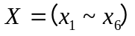
When the cost of a minimum objective function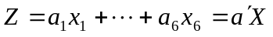
Then use graph theory to tourist attractions as vertices in the graph, traffic routes can be seen as the various attractions on the map edge, the edge weights on behalf of other attractions from a distance to attractions, and finally the use of the shortest path problem solving selected design issues after tourist attractions tourist routes, using Matlab solve time and cost required for each package.
For question three: The above model established four tour packages, tourists can choose according to their own situation to fit their circumstances package, but this package is for the best, how to build a package described in this article is the best package. Multiple linear regression model in this paper carried out a score draw packages created package is the best package.
- Assuming the model
1 weather for tourism
2 scenic open 8:00-18:00
3 Fees and other costs 100RMB per meal;
4 way to travel is by car, the speed of 70 kilometers per hour;
5 car per kilometer oil costs 0.6 RMB per crossing fee is 5RMB;
6 daily driving and travel time is 10 hours, the other for dates, accommodation an average of 100 per day;

- Symbols Explain
Symbols | Explain
 | The total cost of travel
 | The total time of travel
N | The number N tour attractions
 | Fractional value travel packages
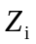 | I-attractions Accommodation
 | Time spent in the i-th attractions
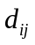 | From the i-th to the j-th attractions attractions
 | Tourist attractions in the i-th ticket costs spent
 | Tourist attractions from i to j-th attractions time spent driving
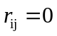 | Said tourists do not reach the first j attractions from the i-th attractions
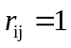 | Represents the j-th attractions tourists arrived from the i-th Attractions
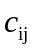 | Transportation costs from the i-th visitor attractions to spend the j attractions

5. The first Modeling and Solution
5.1 model preparation
Different families have different circumstances and some people some time to consider the factors that people should consider the situation to spend, some people are shopping and some sightseeing tours, some will consider the child's preferences. Create a table by each of these reasons statistical factors affecting the choice of approach.
Table 1 The way to travel is not the same variable values
Index  Index  Value  Variable | Time (days)  X1 | cost (RMB) X2 | trip (km) X3 | family income X4 | Shopping (%) X5 | Tour (%) X6
car1 | 3 | 7000 | 400 | 10000 | 60 | 30
Group2 | 5 | 5000 | 1000 | 6000 | 20 | 40
Visit3 | 4 | 3000 | 600 | 4000 | 10 | 30
Other 4 | 2 | 1000 | 100 | 3000 | 10 | 10
5.2 model established
There are car, groups, exercise, four other way to travel, time, cost, travel, family income, shopping, sightseeing six indicators, denoted, design principal component relationships:
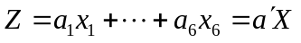 （1）
Find the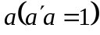, the maximum the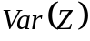, i.e. 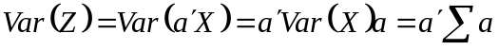 is the maximum, correlation matrix:
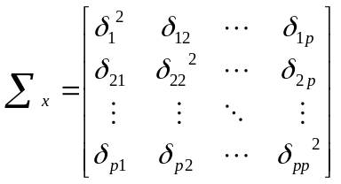
Find the characteristic roots and the corresponding unit eigenvectors and cumulative contribution rate.
In SAS run the program receive:
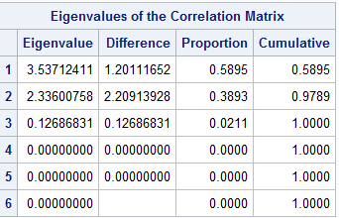
Figure 1 correlation matrix

As can be seen from Figure 1 the contribution of the first principal component was 58.95%, the cumulative contribution rate before the two principal components reached 97.88%, so just use two principal components can be a good reflection of their needs, so reduces the hassle of having to consider so many factors, but to meet their demands. Another feature of the fourth fifth and sixth value is 0, one can conclude that six indicator variables (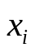, i = 1,2,3,4,5,6) has a linear relationship, characterized by the maximum of two months the eigenvector corresponding to the value of the first and second derived main components.
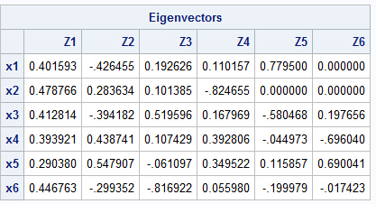
graph 2 coefficient of each of the main components of the

Figure 2 to write the first main component and second main component of the relationship:
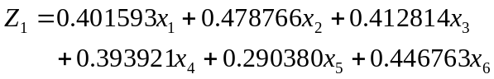 （2）
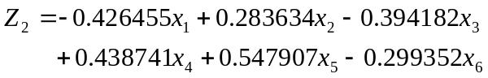 （3）
5.3 Analysis of the main factors
Value of each component of the feature vectors of the principal components can be interpreted, the individual characteristic points corresponding to the largest values ​​of the first feature vectors are positive, it is the number of days the reaction and travel distance of travel, so called first a main component of the time factor. The second largest eigenvalue of the eigenvector corresponding to the first component (time factor), and the third component (stroke coefficients) and sixth component (coefficient of view) is negative, the other positive, it reflect costs and monthly family income situation said second main component of the cost, so the cost and time is the most important factor, then build models from the following discussion and maybe a factor.

6. Establish and solve the model II
6.1 Travel costs are not limited to, the shortest travel route optimization design
6.1.1 Establishment of the objective function
Under the conditions of travel costs are not limited to, the requirements of the eight spots are tour again, with a minimum of time. Tourists spent time consists of two parts, part time on the road, the other part is the time spent in the sights. So T2 is defined as the time visitors spend on the road, T2 attractions for tourists to stay in time, to get the overall objective function is:
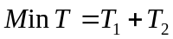 （4）
Requires visitors to tour again eight attractions, so visitors spend on the road
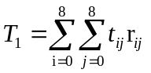 （5）
The amount of time visitors stay for eight spots is 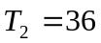
Therefore, the ultimate objective function is:
（6）
=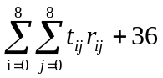 （7）
6.1.2 Constraints
Because starting from Beilin, requiring take eight tourist attractions are tours again, so
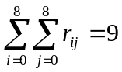 （8）
To make the time spent exploring the shortest tour route should be surrounded by a closed circle, and each attraction can only go from one side, the other side out, so the constraint conditions are as follows:
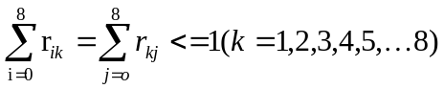，且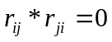 （9）
When k = 0, the departure from Beilin, so
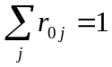 （10）
Similarly:
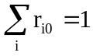 （11）
6.1.3 build models
According to the objective function and constraints, model building:
（12）
=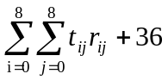 （13）
Constraints:
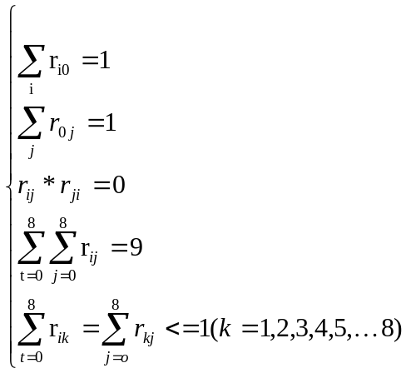 （14）
6.1.4 Solving the model
Use of graph theory, from Table 4 (Appendix 2) can be drawn from the matrix of time
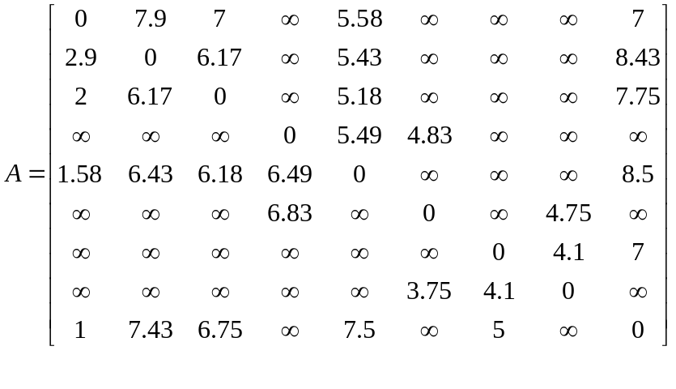
Then use Matlab to solve the shortest way to spend time is 76 hours, then the best route to travel Beilin ,Yang tomb , Qianling ,mausoleum , Zhouzhi ,Famen Temple ,Museum, Big Wild Goose Pagoda ,Cuihuashan.
6.2 Tourist route optimization design of the least cost and unlimited tourism time
6.2.1 The establishment of objective function
The whole cost of tourism include fees of entrance tickets, transportation, eating, and accommodation. The fees are certain, so all design of tourist route must make tourists tour 8 spots. And total fees of transportation, accommodation, eating and else must be the least. We express accommodation fees in m1, transportation fees in m2, eating fees and else in m3, fees of entrance tickets in m4.So the objective function is:
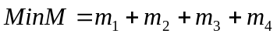 （15）
We express transportation fees in m2, and 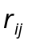 is used for deciding 0-1 variables from the i scenic spot to the j scenic spot. Then we express transportation fees from the i scenic spot to the j scenic spot in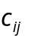.
So fees of each scenic spot are:

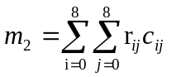 （16）
We express fees of entrance tickets in m, and tourists tour 8 scenic spots. So total fees of entrance tickets are:
（17）
Tourists tour ten hours during the daytime，and then need to find hotels .The accommodation fees are average 100 RMB every day. We express total time of tourism in T. So total fees of accommodation are:
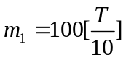 （18）
Owing to average eating fees every day are 100 RMB, and T is the total time of tourism. So total fees of eating and else (for example: shopping):
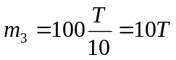 （19）
In conclusion, the last objective function is:
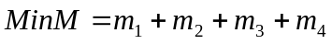
=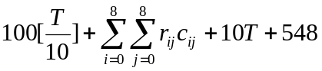 （20）
6.2.2 constraint conditions

Constraint conditions still apply here in 6.1.2.
i.e.

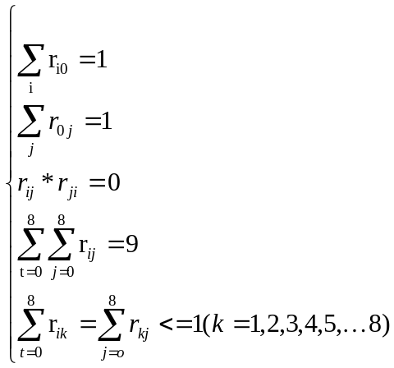 （21）
And constraint condition of total tourism time T is:
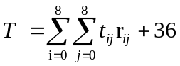
6.2.3 The establishment model system
According to the objective function and constraints, we set up model system
the objective function is
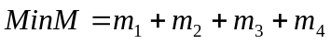
=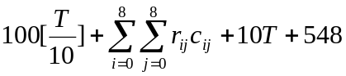 （22）

Constraint condition： 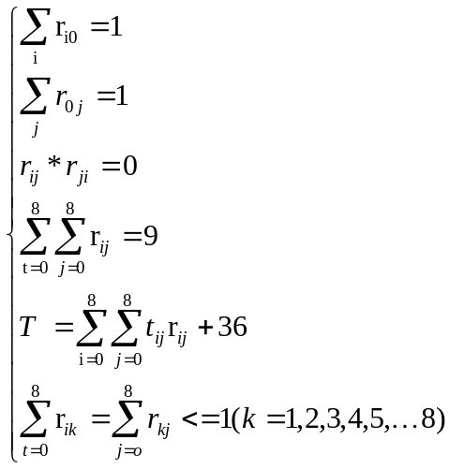 （23）
- Solution of model
Using the method of graph theory, by the table 5 (appendix 2) cost of matrix are obtained

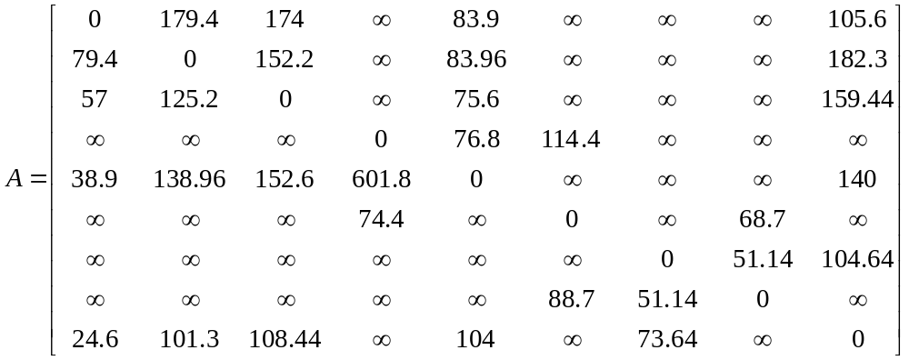
Then we use Matlab and work out a minimum cost is 1872 RMB. The best tourism route at this time is:
The forest of steles →Yang’s tomb →Emperor Qinshihuang→ QianLing→Famen temple →History Museum → The Wild Goose Pagoda →Cuihua Mountain→ building of great wild goose pagoda

6.3 Travel time is limited, as many attractions tour line design
- The establishment of objective function
Because of limited travel time the problem is given 3 days in the model. Then the total travel time in this 3 days (including the road to spend time and time travel costs) for 30 hours, within the 30 hours as many scenic spots, so reasonable arrangement time, reasonable tourist route is essential. So the objective function of this problem only needs to be improved for the 6.2.1 model:, other constraints conditions are the same. Then a constraint based on travel time is not more than three days, i.e.
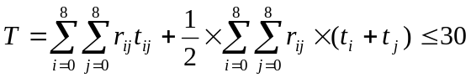 （24）
- The establishment model system
We change the objective function of 4.2.2 to

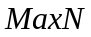 （25）
Constraint conditions:
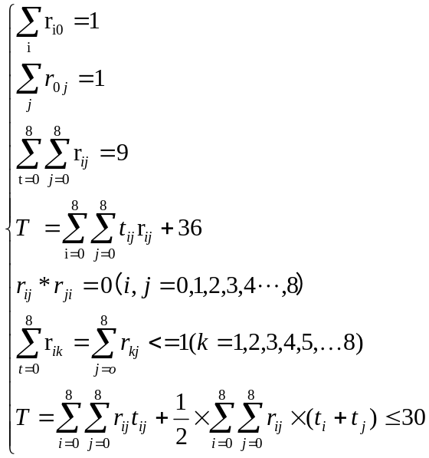 （26）
- The solution of the model
Limited travel time is three days, the type (26) can be computed in tourist attractions number is five, the road to spend time of 27 hours, the shortest path between tourism route:
The forest of steles →Emperor Qinshihuang→ History Museum → The Wild Goose Pagoda →Cuihua Mountain→ Famen temple

6.4 The cost of Travel is limited, as many attractions tour line design
- The establishment of objective function.
The problem for travel expenses is limited, in the model given the cost of 1000 RMB, then use this 1000 RMB should be as much as possible of the scenic spots, so reasonable arrangement time, reasonable arrangements for the tour route is crucial. So the objective function of this problem only needs to be improved for the 6.2.1 model: ,other constraints conditions are the same. Then a constraint based on tourism is the cost of not more than 3000 yuan, i.e.
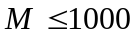
Specific expression is:
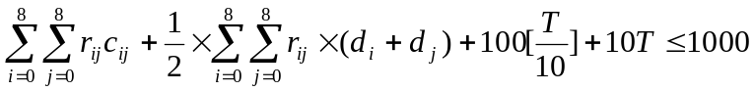 （27）
- The establishment of the model
change the objective function that 6.2.2 to
（28）
constraint conditions:
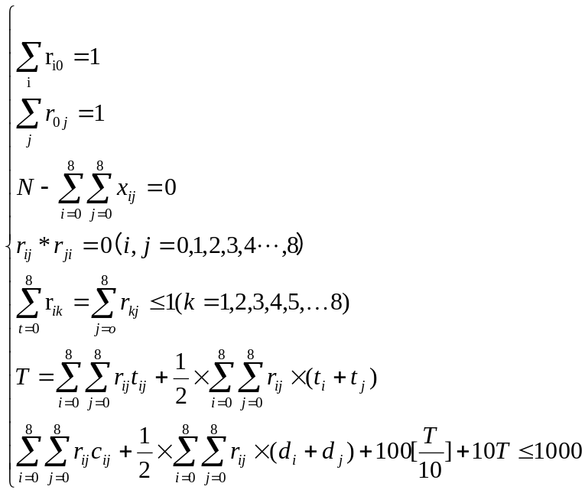 （29）
- Solution of the model
Qualified travel expenses for 1000, substitution (29) can be calculated in tourism scenic spots for five least cost 893.8 RMB, the travel route for the forest of steles is obtained by the short circuit: The forest of steles →Emperor Qinshihuang→History Museum → The Wild Goose Pagoda →Cuihua Mountain→ Famen temple

二、Group travel
6.5 Travel package utility of consumers
Package tour is a total package form of tourism, for consumers, flexibility of its activities is limited, and travel for the purpose of the same, it does not need to travel consumers to take the time to arrange travel activities, which makes the tourism consumers to visit more scenic spots in a short time, and you can also through the smart bargaining from tourism to the lower price, so the package has the characteristics of high efficiency, low cost.
In addition, this kind of tourism form another advantage is that the tourism consumers can get accurate understanding of the in tourism to their travel packages provided by information, "such as tourists before travelling by reading travel schedule to know in advance the whole itinerary (Hanefors & Larsson, 1993; Dann, 1997), and the time characteristics of the tourism activities, events and produced a series of tourism income expectations (Lewis, 1994)," [8]. So, package tour to make travel more easy and convenient way, which is favored by many travel consumer. Travel through consumers choose package tour packages, so as to achieve the desire of the tourism consumer expectations.

6.6 The package effect of tourism consumers
The package tour is a kind of autonomy stronger form of tourism, with the popularity of this form of tourism, a lot of people also increases greatly for this form of research. Such as backpack to travel. "O (O.R eilly, 2006) study, points out that as a long, long way to travel is one of the independent backpack tourism gradually become accepted, and become one of the mainstream way of travel behavior, and even become a with the pursuit of freedom, its development and value realization idea way of tourism, many tourists will backpack tourism as a possibility to enjoy in the process of their growth, pleasant, or adult responsibility before a period of happiness and independence" [8].
So, for those who have the age is bigger for the family of children, this kind of tourism way more attractive, and he is this kind of tourism way can choose on their own sites, control the cost of travel time and travel cost, so as to achieve the desire of the tourism consumer expectations.

7. Establish and solve the model III
7.1 model established
Multivariate linear regression equation 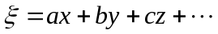.Verify whether the model is the model for the best travel packages, multiple linear regression analysis were as follows:
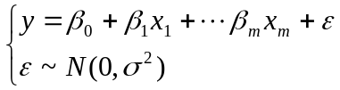 (30)
Where 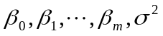are unrelated to the unknown parameters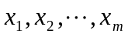, which is called the regression coefficients.
Were obtained in n independent observations (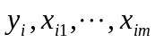), i =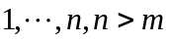, from (30) to give
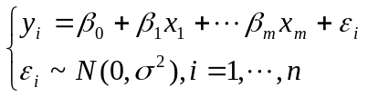 (31)
Note
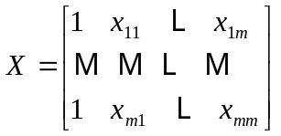,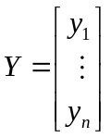
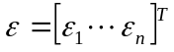,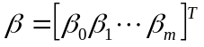
Expressed as
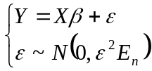 (32)
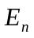 is the identity matrix of order n.
7.2 Solving the model
The use of Matlab (see 10.4.3 operating procedures) for solving linear regression equation results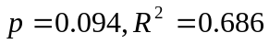, When the interval is set criteriaR> 8:00 considered equation is linear, the problem is the output value 0.828, so the equation is linear, and
Used here indicates the time variable, said variable cost, y represents rated value, set the value out of 5 stars. So
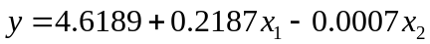 (33)
7.3 pairs of the model test package
Table 2 standards of very good, good, fair, poor
Standard | Well | Good | General | Poor
Ratings range | 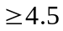 | 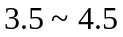 | 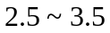 | 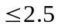

7.3.1 Test Package A
Solving the results according to 6.1.4, the time variable = 7.6, variable cost = 1894, substituting the formula (33) was:
, Comparison Table II scoring criteria, so that a good package.
7.3.2 Inspection Package B
According to the results of 6.2.4 solving, time variable cost variable into the equation (33) was:
>4.5, Comparison Table II scoring criteria, so the package two is very good.
7.3.3 Test Package C
According to the results of 6.3.4 solving, time variable cost variable into the equation (33) was:
>4.5, Comparison Table II scoring criteria, so the package three very well.
7.3.4 Inspection Package D
According to the results of 6.3.4 solving, time variable cost variable into the equation (33) was:
>4.5, Comparison Table II scoring criteria, so the four packages are also very good.

8 .Advantages and Improving Direction models
This study enriches the research methods to optimize the design of the tourist routes, showing discuss analytical methods given in the tourist route optimization potential application design, reduce travel costs of tourism enterprises and tourists. This article discusses how to make tourism tourists travel the shortest distance, least time, the problem of the lowest cost. Model structure is simple, clear, can better solve practical problems; structural model closer to reality; meet market relations; model up easily, without tedious calculations; obtained results of the model closer to reality, in line with our common-sense understanding. Of course, the article also has some shortcomings, due to limited time, so do not adequately consider the psychological flash prime tourist satisfaction and so on. However, in practical problems, but also the satisfaction of tourists travel route optimization design of a factor that must be considered, further research can be carried out by APT models.

9. Literature
[1] GAO Hui Xuan, practical statistical methods and SAS systems, Peking University Press, 2001.
[2] GU base hair, Liu Baoding, Shi Quan sound. Operations Research, Beijing: Science Press, 2011.
[3] Chenguang Ting, Qiu Zheyong. Mathematical modeling, Beijing: Higher Education Press, 2010.
[4] Fangdong Yun, graph theory in the tourist route of choice [J]. Changchun University of Technology, 2009, vol twenty-fifth
Period.
[5] Wu Kai, tourist route optimization operations research problems [D]. ​​Northeast Finance anthropology, 2003.
[6] Wang Haiying, Huang Qiang, Li Chuantao etc. Graph Theory Algorithms Based on MATLAB [M]. Beijing Aerospace human science publishing
Press, 2010.2.
[7] Bondy JA, Murty USA, graph theory and its application [M]. Name Wu Wang, M., Beijing, Science Press, 1984.
[8] Yong, autonomy and choice of tourism - a utility-based economic framework .2007 Monthly, second
Twelve volumes.

10 Appendix
Appendix 1: Factors affecting the issue of a form in different ways
Table 1 way to travel is not the same variable values
Index  Index  Value  Variable | Time (days)  X1 | cost (RMB) X2 | trip (km) X3 | family income X4 | Shopping (%) X5 | Tour (%) X6
car1 | 3 | 7000 | 400 | 10000 | 60 | 30
Group2 | 5 | 5000 | 1000 | 6000 | 20 | 40
Visit3 | 4 | 3000 | 600 | 4000 | 10 | 30
Other 4 | 2 | 1000 | 100 | 3000 | 10 | 10

Appendix 2: Issues a SAS program
data L58;
input number x1-x6@@;
cards;
1 3 7000 400 10000 70 30
2 5 5000 1000 6000 20 40
3 4 3000 600 4000 10 40
4 2 1000 100 3000 10 10
;
proc princomp data=L58 prefix=Z out=O58;
var x1-x6;
proc plot data=O58;
plot Z2*Z1 $ number='* ';
proc sort data=O58;
by Z1;
proc print data=O58;
var number Z1 Z2 x1-x6;
run;

Appendix 3: Question two each data table
Table 2 scenic ticket price and length of stay
Scenic number | Where the provinces (states) | Interest | Things stay when | Scenic ticket prices
1 | Baoji | Famen | 5 | 100
2 | Xian yang City | Qianling | 5 | 122
3 | Xi'an | Louguantai | 5 | 30
4 | Xi'an | Yang Tomb | 4 | 45
5 | Xi'an | Cuihuashan | 3 | 70
6 | Xi'an | Shaanxi Provincial History Museum | 4 | 50
7 | Xi'an | Big Wild Goose Pagoda | 4 | 50
8 | Xi'an | Qin Shi Huang Mausoleum | 6 | 81

Table 3 units of distance between various tourist attractions: km
 | 0 | 1 | 2 | 3 | 4 | 5 | 6 | 7 | 8
0 | 0 | 124 | 86.7 |  | 64.7 |  |  |  | 41
1 | 124 | 0 | 42 |  | 56.6 |  |  |  | 160.5
2 | 86.7 | 42 | 0 |  | 42.7 |  |  |  | 122.4
3 |  |  |  | 0 | 53 | 74
4 | 64.7 | 56.6 | 42.7 | 53 | 0 |  |  |  | 98.3
5 |  |  |  | 74 |  | 0 |  | 31.2
6 |  |  |  |  |  |  | 0 | 1.9 | 39.4
7 |  |  |  |  |  | 31.2 | 1.9 | 0
8 | 41 | 160.5 | 122.4 |  | 98.3 |  | 39.4 |  | 0

Table 4 attractions between cost unit: Yuan
 | 0 | 1 | 2 | 3 | 4 | 5 | 6 | 7 | 8
0 | 0 | 179.4 | 174 |  | 83.9 |  |  |  | 105.6
1 | 79.4 | 0 | 152.2 |  | 83.96 |  |  |  | 182.3
2 | 57 | 125.2 | 0 |  | 75.6 |  |  |  | 159.44
3 |  |  |  | 0 | 76.8 | 114.4
4 | 38.9 | 138.96 | 152.6 | 601.8 | 0 |  |  |  | 140
5 |  |  |  | 74.4 |  | 0 |  | 68.7
6 |  |  |  |  |  |  | 0 | 51.14 | 104.64
7 |  |  |  |  |  | 88.7 | 51.14 | 0
8 | 24.6 | 101.3 | 108.44 |  | 104 |  | 73.64 |  | 0

Table 5 time units between various tourist attractions: hours
 | 1 | 2 | 3 | 4 | 5 | 6 | 7 | 8 | 9
1 | 0 | 7.9 | 7 |  | 5.58 |  |  |  | 7
2 | 2.9 | 0 | 6.17 |  | 5.43 |  |  |  | 8.43
3 | 2 | 6.17 | 0 |  | 5.18 |  |  |  | 7.75
4 |  |  |  | 0 | 5.49 | 4.83
5 | 1.58 | 6.43 | 6.18 | 6.49 | 0 |  |  |  | 8.5
6 |  |  |  | 6.83 |  | 0 |  | 4.75
7 |  |  |  |  |  |  | 0 | 4.1 | 7
8 |  |  |  |  |  | 3.75 | 4.1 | 0
9 | 1 | 7.43 | 6.75 |  | 7.5 |  | 5 |  | 0

2
8
1
3
4
5

7
6

i(i=0,1,2,3,4,5,6,7,8),Where i = 0 represents the starting point of Xi'an Beilin ,i=1,2,3,4,5,6,7,8, Representing eight tourist attractions Famen Temple, Qianling, Louguantai, Yang Tomb, Cuihuashan, Shaanxi History Museum, Big Wild Goose Pagoda, the mausoleum;

Appendix 4: Second problem solver Matlab
1 for the shortest time program:
clc,clear
a=zeros(9);
a(1,2)=790;a(1,3)=700;a(1,5)=558;a(1,9)=700;
a(2,1)=290;a(2,3)=617;a(2,5)=543;a(2,9)=843;
a(3,1)=200;a(3,2)=617;a(3,5)=518;a(3,9)=775;
a(4,5)=549;a(4,6)=483;
a(5,1)=158;a(5,2)=643;a(5,3)=618;a(5,4)=649;a(5,9)=850;
a(6,4)=683;a(6,8)=475;
a(7,8)=410;a(7,9)=700;
a(8,6)=375;a(8,7)=410;
a(9,1)=100;a(9,2)=743;a(9,3)=675;a(9,5)=750;a(9,7)=500;
a=a+a';
a(find(a==0))=inf;
pb(1:length(a))=0;pb(1)=1;index1=1;index2=ones(1,length(a));
d(1:length(a))=inf;d(1)=0;temp=1;
while sum(pb)<length(a)
tb=find(pb==0);
d(tb)=min(d(tb),d(temp)+a(temp,tb));
tmpb=find(d(tb)==min(d(tb)));
temp=tb(tmpb(1));
pb(temp)=1;
index1=[index1,temp];
temp2=find(d(index1)==d(temp)-a(temp,index1));
index2(temp)=index1(temp2(1));
end
d, index1, index2

2 Find the least cost program:
clc,clear
a=zeros(9);
a(1,2)=1794;a(1,3)=1740;a(1,5)=839;a(1,9)=1056;
a(2,1)=794;a(2,3)=1522;a(2,5)=840;a(2,9)=1823;
a(3,1)=570;a(3,2)=1252;a(3,5)=756;a(3,9)=1594;
a(4,5)=768;a(4,6)=1144;
a(5,1)=389;a(5,2)=1390;a(5,3)=1526;a(5,4)=6018;a(5,9)=1400;
a(6,4)=744;a(6,8)=687;
a(7,8)=511;a(7,9)=1046;
a(8,6)=887;a(8,7)=511;
a(9,1)=246;a(9,2)=1013;a(9,3)=1084;a(9,5)=1040;a(9,7)=736;
a=a+a';
a(find(a==0))=inf;
pb(1:length(a))=0;pb(1)=1;index1=1;index2=ones(1,length(a));
d(1:length(a))=inf;d(1)=0;temp=1;
while sum(pb)<length(a)
tb=find(pb==0);
d(tb)=min(d(tb),d(temp)+a(temp,tb));
tmpb=find(d(tb)==min(d(tb)));
temp=tb(tmpb(1));
pb(temp)=1;
index1=[index1,temp];
temp2=find(d(index1)==d(temp)-a(temp,index1));
index2(temp)=index1(temp2(1));
end
d, index1, index2

3 linear regression equation procedures.
x1=[1 8 7 3 4 2 5 6]';
x2=[270 2100 1870 816 895 540 1330 1600]';
y=[4.6 4.9 5 4.8 4.9 4.7 4.8 4.7]';
x=[ones(8,1),x1,x2];
[b,bint,r,rint,stats]=regress(y,x);
b,bint,stats
Results of the operation are:
b =

4.6189
0.2187
-0.0007

bint =

4.4243 4.8135
-0.1849 0.6222
-0.0022 0.0008

stats =

0.686 3.9374 0.0940 0.0093

