The judges scoring, note | Team number：  20026 | The judges scoring, note
The judges scoring, note | Problem：  c | The judges scoring, note
Title：Design of the family summer travel plans
Abstract
Nowadays, Tourism has become the people's way of life, it is important to improve the quality of life of the people. With the arrival of summer, many parents will take their children to travel. In this paper, according to the different needs of different families, we consider from the actual situation, and establish the model in order to provide the appropriate travel route for different family.
According to the travel route choice, we consider how to spend a minimum and transform it into the problem that travel the shortest line. The choice of seven different attractions, Qingdao city is the first, "study of the shortest path problem, we use branch and bound method", and use the Floyd algorithm to calculate the distance between any two spots, we also construct a weighted undirected graph (Figure 1), and calculate the shortest route (Figure 2):., Secondly, we choose 11 different Qingdao city attractions, the establishment of TSP model, and use the Lingo software, the shortest route (Figure 3):
According to the travel consumption, we consider the family composition (the age of the child) will have an impact on the tourism consumption. According to the structure of tourism consumption data from different families, we use Excel to draw a pie chart (Figure 4-8) were compared and analyzed, and the child age occupy a small part in the pie chart, accommodation costs account for a large proportion, as the age grows, sightseeing expenses increase, entertainment expenses reduce.
According to the analysis of different families, family with children travel alone have effect on stay, accommodation, catering, shopping and so on. According to the survey data in men and women go to Qingdao tourism, we use SPSS software to analyze the data of T test, correlation test and the residence time and accommodation, the sample variance equal and unequal that double tail significantly greater than 0.05, which means that there is no difference between the male and female consumers stay time, accommodation. Correlation test using Pearson card to verify the eating and shopping, significantly the value of 0.554>0.05 SIG in the diet, it is clear that there is no difference between the male and female consumer on food. To verify the relationship between shopping, it is not related to food souvenirs of significant value for 0.0889>0.05, gender and smoke wine tourism souvenirs not related significantly to bilateral 0.028<0.05, from these we can see that men and women are different from shopping.
Through the analysis and verification, we Formulate economy, luxury two tour packages for the selection of different families. And improve the model.

Keywords: branch and bound method, Floyd algorithm, TSP model, T test, and Pearson chi square test

Design of the family summer travel plans
1.Restatement of the problem
With the development of economy and the progress of material civilization, people want to have more time to improve the quality of life, but most will choose to travel, so tourism has gradually become a way of life. As the summer vacation is approaching, many parents will take the children to the city tourism at this time, but different families have different needs (number, cost limit, time limit and so on), for most families, they are required to most tourist attractions with the least money in the shortest period of time. Optionally, a tourist city (such as your city), you can consider the travel route, cost, time and other important factors, so we design a best travel packages for the different needs of the family.
2.The basic assumptions
1. Assuming the tourists drive during the tour, the speed is 50km/h.
2. Each 1km for 1 dollar when the cars are driven
3. Assuming that the data which is referred to is fit with the facts.
4. The first spots are based on the first starting point.
5. The family has one child.
6. Tickets are the unified fare; they do not distinguish between adults and children.
7. No special instructions at each point are the same.
3.Symbol description
M | The total cost of tourism
n | The total cost of tourism
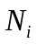 | The first tourist attractions to the collection of the ith a tourist attraction
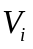 | The ith a tourist attraction
 | Is visit scenic spots
 | The next tour
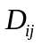 | The distance from I to j attractions
m | The number of tourist attractions

4. Analysis of the problem
To develop a suitable travel packages for different family to consider is the main problem of time, cost, the number of children, family factors such as age and gender, the time is the main effect of viewing spots, according to the time, we can build up different views for the family that has different time. no matter the long or short the time is, we hope the distance are the shortest, so it needs to build the shortest path model to analyze viewing spots with the shortest distance.
To meet the people's consumption level of tourism consumption, tourist's income level is high, economic base of buying travel product is better, the income level determines the level of consumption, but also determines the demand satisfied degree, which determines the changes in consumption structure. Tourist income is high, they travel may need to stay in hotels and eat food, while the ordinary family can watch most, accommodation, the food and traffic demand is not high, may be people own tent by themselves.
The number of families and the family of the child's age and gender will affect the tourism consumption structure of the family, so we also have to consider the age of family size and family children on the package selection.
5.Establishing and solving of the model
5.1 Model 一: "For the branch and bound method" model:
5.1.1 The establishment of the model
When the travel time is less, generally in about a week's time we formulate 7 tourist attractions, we established "the branch and bound method" model to study the shortest path problem, with each element in the matrix of order n D to represent the various attractions of the distance between the various scenic spots, and the distance between the no direction, then the n matrix of order D is a symmetric matrix, first in D of each element in each row of the minus the minimum nonzero elements, get a new matrix, empathy with each column also minus the minimum elements, and then select the elements starting point and some spots between the zero elements will be deleted from the column the new matrix, repeat the above steps, until the emergence of matrix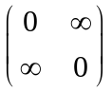, which contains all the attractions, but only once, stop, otherwise, repeat the above steps.
First uses Floyd algorithm to calculate the distance between any two spots, constructing a weighted undirected graph, as shown in figure (1). Note: the distance a magnification of 10 times^{[1]}.
1
2
3
4
5
6
7
65
18
23
166
73
304
35
268
78
141
33
49
314
75
165
146
256
105
48
272
288
Figure 1 a weighted undirected graph of the distance between the various attractions

Note: 1.Zhanqiao 2. Ba Da Guan 3. Fangte Magic Kingdom in 4. five four square 5.Laoshan 6. small Qingdao Park 7. Qingdao underwater worl
5.1.2Solution of the model:
1 2 3 4 5 6 7
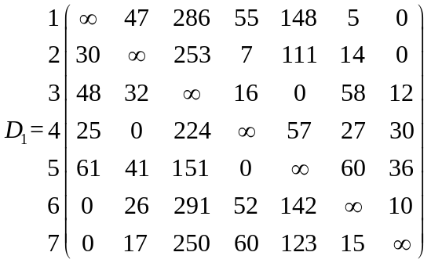

1 2 3 4 5 6 7
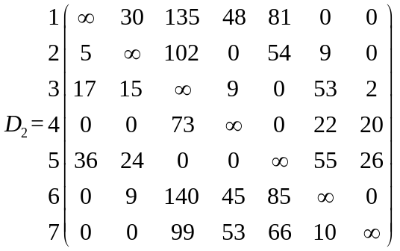
Established by the "branch and bound method" of the model and the algorithm of
matrix, a, to the first row of the matrix, the seventh column off, get the matrix: 2 of the "branch and bound method" model:

1 2 3 4 5 6
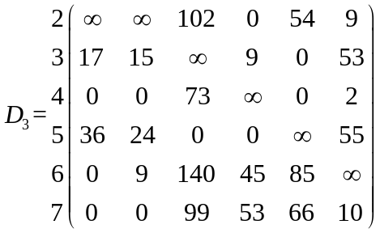

1 2 3 4 5 6
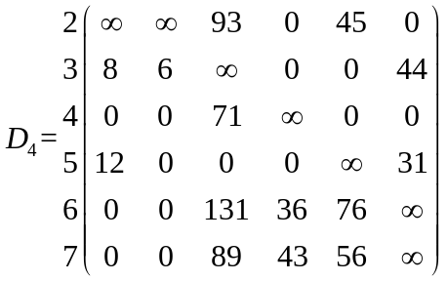

1 2 3 4 5 6
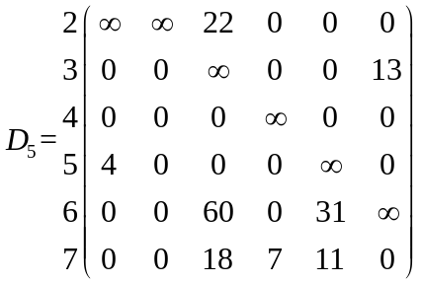
From the matrix, can choose the vertex 2 added in the middle of the road, a road, the first row, second column off, so that:
1 3 4 5 6
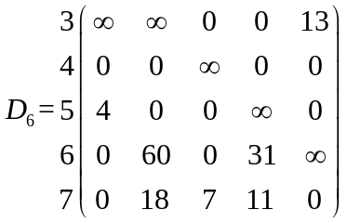

1 3 4 5 6
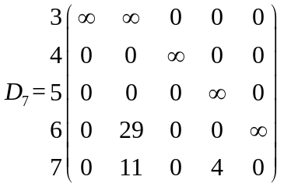
1 3 4 5 6
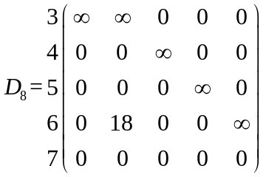
From the matrix, choose to vertex 4 added to the road, the road. The first row, fourth column off, so that
1 3 5 6
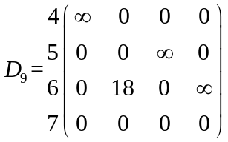

1 3 5 6
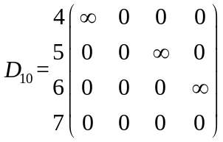
The vertex 5 added to the road by road, the first row and the fifth column off, and so:
1 3 6
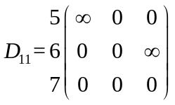
The vertex 3 added to the road on the road, the first row and the third column off, and so:
1 6
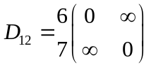
Finally the vertex 6 added, thereby the total weight of a minimum of 776 so that the best travel route is: Zhanqiao - Qingdao underwater world - Ba Da Guan - the five four square – Laoshan - Fangte Magic Kingdom in - small Qingdao Park. A walking time: 77.6/50=1.6 hours. ^{[2]}
Zhanqiao
Qingdao under waterworld
Ba Da Guan
the five four square
Laoshan
Fangte Magic Kingdom in
small Qingdao Park
Figure 2 travel route (1)
5.2Model two:TSP model
5.2.1 The TSP model analysis and established

We assume that the travel time is very abundant about half a month or so, visitors can take the 11 tourist attractions all tour end, at least need to travel expenses. The solutions to the problems are combinatorial optimization problems, so we use the recursive method to solve the dynamic programming model is more convenient for the. ^{[5]}
Assuming that the tourists are from the beginning of the first scenic spots in Zhanqiao, a tourist walked to the first I tourist attractions, denoted as: 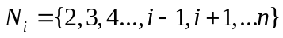represented by first tourist attractions to the middle spots part I tourist attractions set, 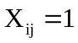 for the route from i to j, 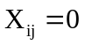don't go for route from i to j, The TSP model can be expressed as:
 | 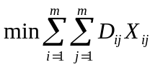 | (1)

 | 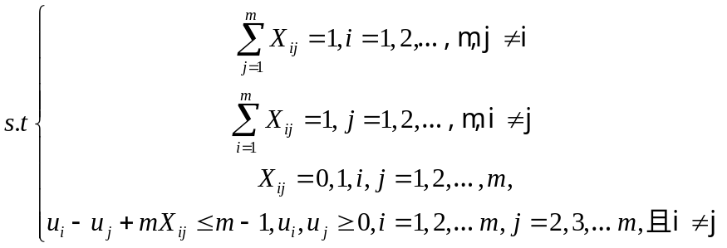 | (2)

5.2.2 Solution of the TSP model
First uses Floyd algorithm to calculate the distance between the tourist attractions (unit: km) Note: magnification: 10
Table 1 The distance between any two spots
The  Dista-nc-e  betw-ee-n  the  two  sites | Zhanqiao | BA DA Guan | Fang-te Mag-ic King Park | The five four squa-re | Lao  shan | A smal-l  Qingdao  park | Qingdao underwat-er | Fishing community fishing village | Zhongshan road business district | Qingdao international beer festival | Big bead mountain scenic spot
Zhanqiao | 0 | 65 | 304 | 73 | 166 | 23 | 18 | 45 | 520 | 258 | 500
BA DA Guan | 65 | 0 | 288 | 48 | 146 | 49 | 35 | 54 | 502 | 250 | 537
Fang-te Mag-ic King Park | 304 | 288 | 0 | 272 | 256 | 314 | 268 | 221 | 518 | 293 | 716
The five four squa-re | 73 | 48 | 272 | 0 | 105 | 75 | 78 | 53 | 461 | 238 | 562
Lao  shan | 166 | 146 | 256 | 105 | 0 | 165 | 141 | 151 | 367 | 135 | 839
smal-l  Qingdao  park | 23 | 49 | 314 | 75 | 165 | 0 | 33 | 44 | 522 | 285 | 519
Qingdao underwat-er | 18 | 35 | 268 | 78 | 141 | 33 | 0 | 32 | 509 | 274 | 514
Fishing community fishing village | 45 | 54 | 221 | 53 | 151 | 44 | 32 | 0 | 484 | 236 | 505
Zhongshan road business district | 520 | 502 | 518 | 461 | 367 | 522 | 509 | 484 | 0 | 263 | 1172
Qingdao international beer festival | 258 | 250 | 293 | 238 | 135 | 285 | 274 | 242 | 263 | 0 | 898
Big bead mountain scenic spot | 500 | 537 | 716 | 562 | 839 | 519 | 514 | 505 | 1172 | 898 | 0

Our hypothesis and two spots in the table1 based on the distance between, the solving processes:Let Vi denote the I City, i=1,2,3,4,5,6,7,8,9,10,11, the following relationship with spots corresponding:

Table 2 Attractions of symbols
V1 | V2 | V3 | V4 | V5 | V6 | V7 | V8 | V9 | V10 | V11
Zhanqiao | BA DA Guan | Fang-te Mag-ic King Park | The five four squa-re | Lao  shan | smal-l  Qingdao  park | Qingdao underwat-er | Fishing community fishing village | Zhongshan road business district | Qingdao international beer festival | Big bead mountain scenic spot
Program description: according to the travel business model, LINGO fitting, where DIST is the distance between the tourist attractions,m is the number of target sites.
The operations results are just part of the data useful analysis are as follows:

Variable | Value | Reduced Cost
m | 11.00000 | 0.000000
X(1,6) | 1.000000 | 23.00000
X(2,3) | 1.000000 | 288.0000
X(3,4) | 1.000000 | 272.0000
X(4,5) | 1.000000 | 105.0000
X(5,8) | 1.000000 | 151.0000
X(6,7) | 1.000000 | 33.00000
X(7,2) | 1.000000 | 35.00000
X(8,9) | 1.000000 | 484.0000
X(9,10) | 1.000000 | 263.0000
X(10,11) | 1.000000 | 898.0000
So the tourist attractions (VI) between the path of:
The result shows that the passenger sightseeing routes: Zhanqiao - A small bird park - Qingdao underwater world – Ba Da Guan - Fangte Magic Kingdom – The five four square - Laoshan - Fishing community fishing village- Zhongshan road business district - Qingdao international beer festival - Big bead mountain scenic spots

Zhanqiao
A small bird park
Qingdao underwater world
Ba Da Guan

Fangte Magic Kingdom
The five four square
Laoshan
Fishing community fishing village
Zhongshan road business distric
Qingdao international beer festival
Big bead mountain scenic spot

Zhanqiao

Figure 3 Tours (2)
Effective data [4] through LINGO program concluded, we can travel the shortest path of the 11 attractions: 306.3 km. A walking time: 306.3/50=6.126 hours.
The various attractions tickets price and average daily consumption such as shown in table (1):
Table 3 The attractions tickets and average daily consumption
project | Zhanqiao | BA DA Guan | Fang-te Mag-ic King Park | The five four squa-re | Lao  shan | A smal-l  Qingdao  park | Qingdao underwat-er | Fishing community fishing village | Zhongshan road business distric | Qingdao international beer festival | Big bead mountain scenic spot
tickets | 0 | 0 | 200 | 0 | 90 | 15 | 210 | 60 | 128 | 120 | 40
Average daily consumption | 90 | 120 | 130 | 150 | 110 | 130 | 120 | 150 | 120 | 100 | 120
Note: all unified fare.
Total cost = tickets + travel (fuel) + local consumption (eat, live, row).
The A package (7 spots) in the calculation of costs:
A family with n travel:
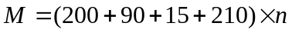+77.6+=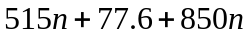
The B package (11 spots) in the calculation of costs:
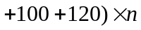+306.3=853n+1340n+306.3
5.3Model optimization
5.3.1 The influence of different family composition of tourism consumption
The fee calculation does not take into account the family income factors, error and the family composition will cause cost. So we go to the family composition and family income were analyzed, then the total cost calculation, error [5] reduces the total cost will be.
Investigation of different composition family tourism consumption structure of Qingdao in the family:

Table 4 family consumption structure
category | a baby | Children 2 to 5 years of age | Children 6 to 12 years of age | Children 13 to 18 years of age | College students'
accommodation | 155 | 135 | 61 | 111 | 145
traffic | 120 | 128 | 196 | 98 | 146
food and beverage | 100 | 99 | 115 | 144 | 98
visit | 15 | 33 | 45 | 78 | 80
shopping | 25 | 19 | 20 | 100 | 115
entertainment | 55 | 51 | 15 | 13 | 12
According to the table data using Excel2003 to make the pie chart for each category of family tourism consumption structure analysis:

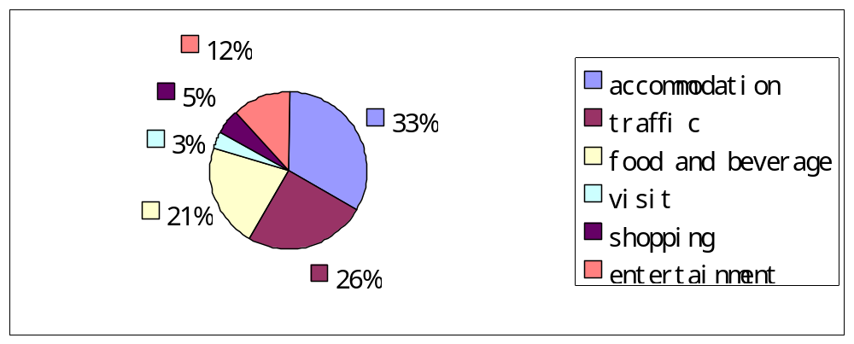
Figure 4 a baby in the family consumption structure
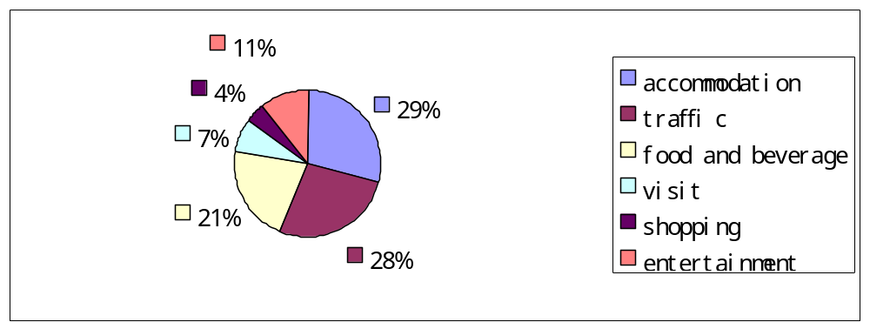
Figure 5 2-5 years old children in family consumption structure

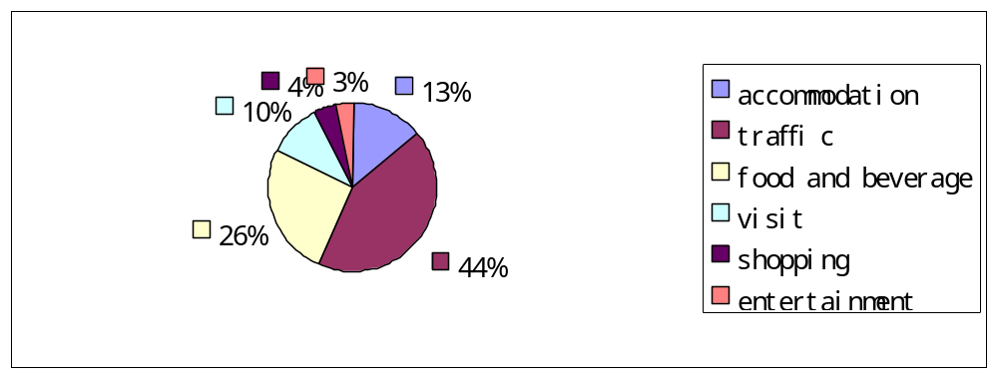
Figure 6 6-12 years old children in family consumption structure
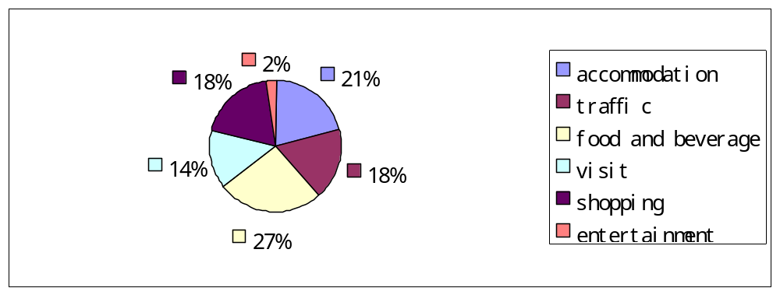
Figure7 13-18 years old children in family consumption structure
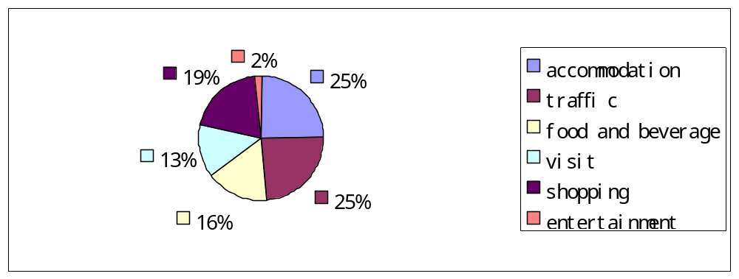
Figure 8 students family consumption structure

From the pie chart can see directly, when he was young accommodation consumption accounted for 30%, youth accommodation accounted for 13%, adult accommodation (21%) can be learned in childhood and adult accommodation consumption is higher, lodge in the youth consumption is low.
In sightseeing, the childhood (7%), youth (10%), as an adult (14%), can be seen as the growth of the age in the field of tourism consumption showed a trend of growth.
In entertainment, childhood (11%), youth (4%), as an adult (2%), it can be seen that with age in the entertainment consumption showed a trend of decline.
5.3.2 The influence of parents' gender on tourism consumption
Considering the parents' gender on retention time, the influence of the food, accommodation, shopping, investigation in traveling to Qingdao data using SPSS software to the men and women can get the following analysis [9] :
1.Residence time
In the following table (5) for gender T test results on time.

Table 5 T test results
 | Neat of variance test |  | Such as the mean T test
 | The F value | A significant degree | The T value | Significant degree (two-tailed)  ）
The sample variance equal hypothesis | 2.643 | 0.075 | 1.189 | 0.133
Sample variance is not equal to the hypothesis | 2.643 | 0.075 | 1.176 | 0.143
The table below sex of residence time of T test results, the variance in the system testing in the F value is 2.643, a significant degree of 0.075>0.05, so the two population variance in the sample variance is equal, equal and unequal sample hypothesis double tail was significantly greater than 0.05, so that men and women, can travel consumers in Qingdao tourism stay time does not exist.
2.Diet
Gender on restaurants and food selection using the Pearson chi-square test, Pearson correlation coefficient between gender and restaurant food, such as table (6) :
Table 6 Pearson chi-square test results
Restaurant category | Fancy restaurant | Fancy restaurant | Popular restaurants | Street food | Bring your own food
gender | Pearson  Correlation | -0.022 | 0.02 | 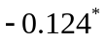 | 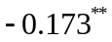
gender | Sig  (2-tailed) | 0.554 | 0.612 | 0.037 | 0.010
**.Correlation is significant at the 0.01 level (2-tailed).
*.Correlation is significant at the 0.05 level (2-tailed).
From the table Pearson shows gender directly with the high-end restaurant of the correlation coefficient for -0.022, said the two incomplete, and the negative correlation between SIG, the significant value of 0.554>0.05, said at the 0.05 significant level, gender and choose to high-end restaurants do not want to close, empathy and to the restaurant was not correlated (SIG 0.612>0.05), but when it comes to the street food and food, the correlation between sig values were less than 0.05, so that gender affects prepare your own food and to eat street food.
3.Accommodation
The following table (7) for accommodation on gender T test results:
Table 7 T test results on accommodation
 | The F value | A significant degree | The T value | Significant degree (two-tailed)
The sample variance equal hypothesis | 3.12 | 0.082 | 1.435 | 0.154
Sample variance is not equal to the hypothesis | 3.12 | 0.082 | 1.437 | 0.153
T test was performed on gender and accommodation, the variance in test, F value for the statistic value of 3.089, significant probability is 0.082, because Sig>0.05, that two general equal variance, T=1.435, T distribution two tailed significance is 0.154, Sig>0.05, so it can be concluded and tourism consumption in the accommodation mode there is no difference.
4. tourism shopping
On gender and tourist souvenirs is selected by Pearson chi square test. The correlation coefficient between gender and brand clothing, souvenirs, obtains the two is incomplete, and is negative correlation. It’s not related to bilateral significant value for the 0.008<0.01, so at a significance level of 0.01 negative not related to two assumptions. Gender and tobacco and liquor tourism souvenirs not related to bilateral significant for 0.028<0.05, so in the 0.05 and two significant level negation not related to the hypothesis. Bilateral was not related to sex and food tourism souvenirs for the 0.0889>0.05, so the gender and whether to buy food souvenirs are not related. Gender and with local characteristics of souvenirs not related to bilateral significant for 0.759>0.05, said at the 0.05 level of significance, sex, whether to buy local souvenirs tourism souvenirs not related.
Table 8 gender shopping consumption Pearson chi-square test results

 |  | Brand clothing | Wine/cigarette | Food | Souvenirs with local characteristics
sex | Person  correlation | 0.260** | 0.116* | 0.008 | 0.020*
sex | Sig.（2-tailed） | 0.008 | 0.028 | 0.889 | 0.079
**.Correlation is significant at the 0.01 level (2-tailed).
*.Correlation is significant at the 0.05 level (2-tailed).
According to the analysis， female consumers relative to male consumers prefer brand clothing. The male consumer prefers tobacco and souvenirs. Whether to buy food with local characteristics and souvenirs there is no difference.
The influence of gender on tourism:
Through the T test validation showed the residence time and hotel, tourism consumption on housing and residence time for men and women there is no difference, through the Pearson chi-square correlation is educed for eating and shopping tourism consumption in the diet there is no difference between men and women, but there are differences in terms of shopping.
The expenditures of the tourists in the tourism process drawn from high to low is arranged as follows:
Male: 1.Accommodation2.Entertainment3.Traffic4.Visit5.Diet6.Shopping
Famle: 1.Accommodation2.Shopping3.Visit4.Traffic5.Diet6. .Entertainment

Table 9 accommodation meals, drinks prices
The scenic area number | Scenic spot name | Accommodation fees |  |  | Food and beverage cost
The scenic area number | Scenic spot name | low | middle | high | low | middle | high
1 | Zhangqiao | 145 | 190 | 600 | 90 | 150 | 320
2 | Ba Da Guan | 130 | 280 | 630 | 80 | 170 | 330
3 | Fang-te Mag-ic King Park | 130 | 250 | 830 | 80 | 160 | 350
4 | The five four squa-re | 190 | 450 | 900 | 100 | 200 | 370
5 | Lao  shan | 99 | 140 | 278 | 70 | 150 | 300
6 | A smal-l  Qingdao  park | 150 | 170 | 630 | 80 | 140 | 320
7 | Qingdao underwat-e | 120 | 240 | 630 | 70 | 160 | 320
8 | Fishing community fishing village | 120 | 195 | 625 | 60 | 160 | 330
9 | Zhongshan road business distric | 135 | 230 | 1000 | 70 | 170 | 360
10 | Qingdao international beer festival | 145 | 300 | 650 | 80 | 170 | 350
11 | Big bead mountain scenic spot | 120 | 300 | 450 | 70 | 160 | 300
Analysis by above knowable, tourists of different income levels, the number of families, children age will affect the size of the family in the tourism consumption, so we according to the need of different families made the following packages [10] :

Meal plan

Economic package (mainly to visit )

Luxurious package (mainly meet demand)

A:double or three people (the child age small)

B：Double or three people
(older children )

C:Double (the child age small)

D：Synchronized(older children)

E：Three people (the child age small)

F: Three people (older children)

Zhanqiao | BA DA Guan | Fangte Magic King Park | May 4th square | Lao  shan | A small  Qingdao  park | Qingdao underwater | Fishing community fishing village | Zhongshan road business district | Qingdao international beer festival | Big bead mountain scenic spot

A:Zhanqiao→Qingdao underwater(two days)→BA DA Guan→May 4th square→Laoshan→Fangte Magic King Park(two days)→A small Qingdao park→Zhan Qiao
B:Zhanqiao→Qingdao underwater(two days)→BA DA Guan→May 4th square→Laoshan→Fangte Magic King Park(two days)→A small Qingdao park→Zhanqiao
C: Zhanqiao→A small lQingdao park→Qingdao underwater(two days)→BA DA Guan→Fang-te Magic King Park(two days)→May 4th square→Laoshan→Fishing community fishing village→ Zhongshan road business district( the mother stopped 2 days, father. 1 day) →Qingdao international beer festival( the mother is 1 day, my father took the stop 2-3 days) → Zhanqiao
D: Zhanqiao→A small Qingdao park→Qingdao underwater world→ BA DA Guan→Fang-te Magic King Park→ May 4th square → Laoshan →fishing community fishing village (2 days) →zhong shanroad business district (mother stop 2 days, father. 1 day) → Qingdao international beer festival, mother took 1 day, my father took the stop 2-3 days) →Zhanqiaor
E: Zhanqiao →A small jade bird park → Qingdao underwater world (2 days) → BADAGuan- fant dream kingdom (2 days) →May 4th square →Laoshan → fishing community fishing village (2 days) →Zhongshan road business distric(2 days)t → Qingdao international beer festival (2 days) →Zhanqiao
F: Zhanqiao→A small jade bird park → Qingdao underwater world → BADAGuan→the fantasy kingdom →May 4th square →the laoshan →fishing community fishing village (2 days) →Zhongshan road business district(2 days) →Qingdao international beer festival (2 days) →Zhanqiao

6 model evaluation and improvement
6.1 evaluation of the model
6.1.1 advantages:
(1) in the search for the best travel route, using the branch and bound method "and are applied to solve the traveling salesman model is transformed into the weighted wireless diagram for minimum weight of Hamiltonian cycle, feasible model is established, by using lingo software, saving operation time, improve the accuracy of the results, the branch and bound method is an important method of solving integer programming.
(2) through the Excel software runs draw a pie chart, we can see accurate each household consumption structure the proportion
(3) through the analysis of different family of tourism psychology, make the results more close to actual.
6.1.2 faults:
(1) data collection, due to the limited time and energy, the investigation has certain limitation, only in parts of Qingdao on the basis of the data for statistical analysis.
6.2 model improvement:
(1) in terms of data only consider the data in part of Qingdao, should collect more data for analysis.
(2) in the improved model should introduce the weather and emergency model, more accurately grasp the whole process, make the model more close to actual.

7 reference
[1] Zhen nursery Dong . Mathematical modeling method and practice [M]. Beijing: national defence industry press, 2006
[2] the optimization design of tourism route, subei mathematical modeling of the eighth, 2011, http://www.docin.com/p-540591117.html, 2014.5.24
[3]HuiZhang, ZhengDeZhao ,LiZhaoYang ,YuLiangZhao.The algorithm and application of the TSP problem research [R]. Computer applications and software, 04, 2009
[4] Qiyuan Jiang ,Jinxing Xie, Jun Ye. Mathematical model (fourth edition) [M]. Beijing: higher education press, 2011.
[5] Zhonggeng Han. Mathematical modeling method and its application [M]. Higher education press, 2005.
[6] Yunquan Hu, Yaohuang Guo. Operational research tutorial [M]. Tsinghua university press, 2007.
Cuckoo.
[7] YuDu.Optimization mathematical model and LINGO software [R]. QianXiNa national normal college journal, 2008, 03
[8]HongLanWang. Urban tourism consumption research [C]. Shandong normal university, master degree theses of master of 2008.6.3
[9]LeiLi based on gender difference of tourism consumption behavior research [C]. Master degree theses of master of Shanghai normal university in 2012.4
[10] Shilin Liu, ChenLi, LuWang. Tourism design based on hierarchical analysis and graph model and its evaluation [C]. Economic management, 2009
The appendix
MODEL:
SETS:
ATTRACTION/1..11/:U; ！Define 11 sites

LINK(ATTRACTION,ATTRACTION):dist,x; ! DIST for distance matrix, X as the decision variables;
DATA:
DIST= 0 65 304 73 166 23 18 45 520 258 500
65 0 288 48 146 49 35 54 502 250 537
304 288 0 272 256 314 268 221 518 293 716
73 48 272 0 105 75 78 53 461 238 562
166 146 256 105 0 165 141 151 367 135 839
23 49 314 75 165 0 33 44 522 285 519
18 35 268 78 141 33 0 32 509 274 514
45 54 221 53 151 44 32 0 484 236 505
520 502 518 461 367 522 509 484 0 236 505
258 250 293 238 135 285 274 242 263 0 893
500 537 716 562 839 519 514 505 1172 893 0
！This is a distance matrix concrete data;

ENDDATA
m=@SIZE(ATTRACTION);
MIN=@SUM(LINK:DIST*X); ! The objective function;
@FOR(ATTRACTION(K):@SUM(ATTRACTION(I)|I#NE#K:X(I,K))=1;
@FOR(ATTRACTION(K):@SUM(ATTRACTION(J)|J#NE#K:X(J,K))=1;
@FOR(ATTRACTION(I):@FOR(ATTRACTION(J)|J#GT#1#AND#I#NE#J;
U(I)-U(J)+m*X(I,J)<=m-1);):
@FOR(ATTRACTION(I):u(I)<=m-1);
@FOR(LINK:@BIN(X)); ! X is 0-1 variables;
END

