评委一评分，签名及备注 | 队号：  20069 | 评委三评分，签名及备注
评委二评分，签名及备注 | 选题：  C | 评委四评分，签名及备注
题目： Family summer tour packages designed
Summary
With the improvement of the national economy，it is not only the pursuit of material comfort，more attention to spiritual enjoyment，more and more parents take their children to travel during the holidays，In this paper, an example for the summer tour packages Suzhou design Article 21 attractions in Suzhou collected data，In transport costs and distance proportional to the different attractions of accommodation equal, there are five tours and other attractions to be under the assumption.First, find any with Floyd shortest path algorithm between two spots , followed by obtaining all the scenic traverse the shortest distance needed by ant colony algorithm,Identify the most and least-cost attractions two lines.Time constraints in different situations , the cost and the time and cost constraints dual constraints， respectively，least cost，shortest tour attractions goal to establish a maximum number of 0-1 linear programming model，Attractions in five will go under the premise，identified with the minimum number of attractions element method , the problem is abstracted as the traveling salesman problem，solved by ant colony algorithm，rationality finally backtracking to verify the conclusions to arrive in the most excellent route.Features of this paper is to discuss family size classification , gradually filtering through the attractions, is converted to the traveling salesman seeking the shortest path problem ,Features of this paper is to discuss family size classification，gradually filtering through the attractions， is converted to the traveling salesman seeking the shortest path problem ,The optimal solution by ant colony algorithm is designed to optimize the line under several different needs，some families for tourists to choose from packages.Final results are as follows ( in ordinary family of three , for example) :
1 , tour all 21 attractions minimum cost required : 10561.86 yuan ;
2 , Must Do Tour five required minimum cost : 2627.41 yuan ;
3 , at the time ( 8 days ) constraints , the visit attractions of 12-16 - 20 - 11 - 9-8-7-6-4-3-12
4, in the expense ( 3,300 yuan ) constraints , the tour route for :12 -16-8-7-6-4-12
5, in the time (13 days) and expense (7,500 yuan) dual constraints, the tour itinerary is: 12-13-14-15-16-19-20-21-11-9-8-7-6-4-3-12 cost : 5897.34 .
Keywords: 0-1 programming model ant colony algorithm TSP smallest element method

Contents
1 Restatement of the problem 1
1.1 The problem background 1
1.2 to solve the problem 1
2 The analysis of the problem 1
3 Symbolic description 2
4 The basic assumptions 3
5 Data acquisition and processing 3
5.1 Data collection 3
5.2 Attractions distribution diagram 5
5.3 The shortest distance between any two spots 5
6 Establishing and solving of the model 7
6.1 Ant colony algorithm for solving the minimum distance model based on traversal. 7
6.1.1 The basic idea 7
6.1.2 The basic ant colony algorithm process 9
6.2.1 enumeration method 12
6.2.2 the enumeration algorithm for optimal route using the basic ideas 13
7 Model evaluation 24
8 The extension of the model 25
9 Improved optimization model 25
10 Prospects model 26
References 26

1 Restatement of the problem

1.1 The problem background
Suzhou has a long history and is one of the national first batch of 24 historical and cultural city, with its unique landscape is known as the "garden city" in China, known as "paradise on earth", the "Oriental Venice", "east shuicheng" reputation. Suzhou garden is the representative of China's private home. listed by UNESCO as a world cultural heritage, is one of the best tourist resort [1].But because of the difference of family and the influence of various factors, such as time limit and cost limit, so try to make the visit plan to spend the least money to visit the most scenic spots.

1.2 to solve the problem
According to the topic request, this paper selects 21 Suzhou AAAA scenic spots to consider the object, and considering the fare, tickets, food, accommodation and other factors, to satisfy the given boundary conditions, complete the following about the family summer tour route design problem:
Firstly, in the scientific evaluation on the basis of the travel cost, total cost as small as possible as the goal, the design of a one month (30 days) time, optimal route traveled 21 spots.
Secondly, the tour, in several will vist attractions (Humble Administrator's Garden, Huqiu mountain scenic area, the Lingering Garden, the ancient town of Tongli, Mudu town) under the premise, design a least expensive travel costs and less time tourist routes.
Thirdly, at a given cost constraints, design the total time at least as much as possible and to visit more attractions.
Fourthly, in the time constraints, design the total cost is minimized as much as possible and to visit more attractions.
Finallly, in time and cost constraints, design a most viewed attractions tourist routes.

2 The analysis of the problem
By collecting distance between all the major attractions in Suzhou, the best time to stay in the various attractions, accommodation and tickets to various attractions, food and beverage charges after information, the article would issue the following abstract.
Due to many factors families choose packages to analyze only one important factor, such as: the number, cost, time, distance, time and price, because of its complex relationships, family size are discussed and analyzed by way of classification, reducing analysis optimization difficulty, to simplify the problem.
Here is a family-friendly tour packages designed, it should consider the cost of the child's problems, hoping to make the cost of the child's specific, identified technology, optimization can reduce the difficulty of computing problems.
Question of the requirements of the design package, it is not only designed a line, two factors were analyzed in the remaining time and costs, because it is the most optimal route, and to meet the different needs, therefore a factor which should be limited to achieve more tour attractions, and other factors to achieve minimization problem; same time to analyze the situation when these two factors have both qualifications, but also achieved under the premise of satisfying the constraints, as many attractions to explore more , so that the tour one of the most scenic spots become established model for the purpose.
Tourism is mainly to enjoy the scenery and experience the Suzhou local customs, it should at least consider making the journey time (ie, the minimum transportation cost), so make time better spent on attractions, the survey shows far greater than the travel time of stay, can be considered only when it is time to consider the stay, the problem becomes simple.
According to tourist attractions and routes issues contained in articles can be abstracted as one for the most short-circuit problem, and this problem is not only the shortest distance, shortest time, and also consider the issue of up attractions. Define these different constraints, the plan is uncertain linear programming problem, the problem can be solved.

3 Symbolic description
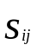：The distance between the two sites and;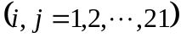；
;
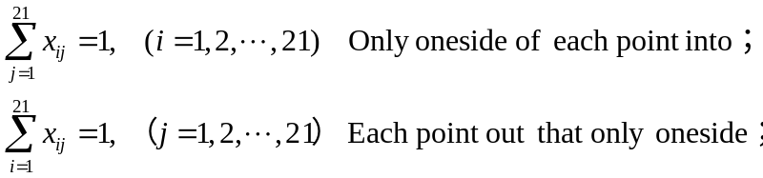
is the time of staying scenic spots；
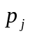 is the tickets’price of scenic spots.

4 The basic assumptions
(1) Through the inquiry Suzhou restaurants price from the Internet, we use the standard of 150 yuan / double standard^{[2]}, of food to 60 yuan / person per day, children 30 yuan / person per day^{[3]}.
(2) Set in the journey within each sightseeing sojourn time, no longer be separate computing. And it doesn't consider the difference between day and night, is also general during the day to reach the spots.
(3) Itinerary does not include tourism in certain spots in the distance, as well as by the family to go to Suzhou.
(4) The traveler at the end of a tourist attractions to the next destination, by means of transport is very smooth, there will not be stranded and other unforeseen circumstances.
(5) Walk back and forth between any two points are equal, and will be subject to the linear distance between the two spots.
(6) For the highway charge no clear price section, the highway mileage between two tourist spots (km) divided by the average speed of (60km/h) estimation ^{[4]}.
(7) Attractions fares are comprehensive compromise is a certain value, assuming that children's tickets and students tickets are half of the adult.
(8) Assuming the tour route from Humble Administrator's Garden (first verify the attractions from the station recently) ^{[5]}, then returned to Humble Administrator's Garden.
(9) Considering Suzhou city bus, taxi driving prices, reasonable calculation, we assume that a family trip fare is 1.5 yuan per kilometer ^{[6]}, only with the drive related, has nothing to do with a number (based on 3-6's), and on the transportation way, without considering any other the cost in transportation costs, and do not consider the influence of weather on the rides and attractions.

5 Data acquisition and processing

5.1 Data collection
The territory of Suzhou 21 tourist attractions name ^{[7]} and the corresponding sojourn time, attractions tickets, latitude and longitudedata ^{[8][9]}，See Table 1.

Table 1 21 names of scenic spots and fares, longitude and latitude, the sojourn time schedule
Serialnumber | The names of the places | Longitude | Latitude | Ticket price | sojourn time
1 | Dongshan scenic spot | 117.535846 | 23.736714 | 150 | 1.5
2 | Dome mountain scenic spot | 120.439952 | 31.269882 | 80 | 1
3 | White stream ecological park | 120.490331 | 31.2920736 | 50 | 0.5
4 | Mudu ancient town | 120.52134 | 31.255418 | 78 | 0.5
5 | Suzhou Park | 120.549297 | 31.292801 | 160 | 1
6 | Hanshan Temple | 120.567857 | 31.310561 | 20 | 0.5
7 | Huqiu Mountain Scenic Area | 120.579211 | 31.335077 | 57 | 1.5
8 | Lingering Garden | 120.5931157 | 31.3149134 | 40 | 0.5
9 | West Ring Temple law buildings | 120.59758 | 31.31468 | 25 | 0.5
10 | Suzhou pan Gate Scenic Area | 120.617882 | 31.2889933 | 25 | 2
11 | Lion Grove Garden | 120.6296499 | 31.3207994 | 30 | 1
12 | Humble Administrator's Garden | 120.629876 | 31.324361 | 70 | 1
13 | Garden of the Master of Nets | 120.634151 | 31.297881 | 30 | 1
14 | Retreat Park Scenic Area | 120.6874722 | 31.1611139 | 60 | 0.5
15 | Jinji Lake Scenic Area | 120.6947551 | 31.3115396 | 40 | 1
16 | The ancient town of Tongli | 120.717561 | 31.153182 | 120 | 1
17 | Zhouzhuang | 120.845657 | 31.124254 | 100 | 1
18 | The ancient town of Luzhi | 120.8703241 | 31.269632 | 60 | 2
19 | Jinxi ancient town | 120.902499 | 31.172066 | 36 | 1
20 | Ting Linyuan | 120.949787 | 31.391015 | 20 | 0.5
21 | Qiandeng Town | 121.0027612 | 31.2660459 | 50 | 1

5.2 Attractions distribution diagram
By the known information can be roughly draw the location ^{[10]} these 21 spots distribution as shown below, each labeled number for eachspots number.
1
1
2
3
4
5
6
7
9
8
10
11
12
13
15
14
18
16
19
17
20
21
Figure 1 All attractions map

5.3 The shortest distance between any two spots
Using Floyd algorithm of which can calculate the shortest distance between any two spots, the distance matrix of a 21*21 are shown below, by Hypothesis 7, the matrix is a symmetric matrix, the unit for km^{[11]}..

Table 2 The shortest distance between the various scenic spots.
 | 1 | 2 | 3 | 4 | 5 | 6 | 7 | 8 | 9 | 10
1 | 0 | 323.46 | 368.4 | 332.4 | 339 | 337.6 | 338.974 | 340.4 | 341 | 343.2
2 | 323.5 | 0 | 5.56 | 9 | 12.21 | 14.21 | 15.432 | 16.98 | 17.54 | 19.76
3 | 368.4 | 5.56 | 0 | 3.447 | 6.55 | 8.658 | 9.88 | 11.43 | 11.99 | 14.1
4 | 332.4 | 9 | 3.447 | 0 | 3.115 | 5.225 | 6.453 | 7.3998 | 8.552 | 10.77
5 | 339 | 12.211 | 6.55 | 3.115 | 0 | 2 | 3.224 | 4.774 | 5.329 | 7.548
6 | 337.6 | 14.21 | 8.658 | 5.225 | 2 | 0 | 1.224 | 2.775 | 3.33 | 5.551
7 | 339 | 15.432 | 9.88 | 6.453 | 3.224 | 1.224 | 0 | 1.556 | 2.11 | 4.333
8 | 340.4 | 16.98 | 11.43 | 7.3998 | 4.774 | 2.775 | 1.556 | 0 | 0.555 | 2.778
9 | 341 | 17.539 | 11.99 | 8.552 | 5.329 | 3.33 | 2.11 | 0.555 | 0 | 2.223
10 | 343.2 | 19.758 | 14.1 | 10.77 | 7.548 | 5.551 | 4.333 | 2.778 | 2.223 | 0
11 | 344.5 | 21.091 | 15.54 | 12.1 | 8.881 | 6.882 | 5.66 | 4.107 | 3.552 | 1.34
12 | 344.5 | 21.091 | 15.54 | 12.1 | 8.881 | 6.882 | 5.66 | 4.107 | 3.552 | 1.341
13 | 344.9 | 21.534 | 15.98 | 12.55 | 9.324 | 7.326 | 6.11 | 4.552 | 4 | 1.777
14 | 350.7 | 27.428 | 21.89 | 18.44 | 15.23 | 13.25 | 12.036 | 10.48 | 9.93 | 7.71
15 | 351.7 | 28.195 | 22.76 | 19.32 | 16.1 | 14.1 | 12.876 | 11.32 | 10.66 | 8.548
16 | 354.2 | 30.87 | 25.33 | 21.88 | 18.67 | 16.68 | 15.472 | 13.92 | 13.36 | 11.14
17 | 368.2 | 45.08 | 39.43 | 36.09 | 32.88 | 30.89 | 29.671 | 28.12 | 27.56 | 25.34
18 | 371 | 47.73 | 42.18 | 38.74 | 35.52 | 33.52 | 32.302 | 30.75 | 30.19 | 27.97
19 | 374.5 | 51.287 | 45.74 | 42.3 | 39.08 | 37.09 | 35.0866 | 34.31 | 33.76 | 31.53
20 | 379.9 | 56.612 | 51.06 | 47.62 | 44.4 | 42.4 | 41.181 | 39.63 | 39.07 | 36.85
21 | 385.8 | 62.493 | 56.94 | 53.5 | 50.28 | 48.29 | 47.065 | 45.51 | 44.96 | 42.74

（Continue to table 2.）
11 | 12 | 13 | 14 | 15 | 16 | 17 | 18 | 19 | 20 | 21
344.5 | 344.5 | 344.9 | 350.7 | 351.7 | 354.2 | 368.2 | 371 | 374.5 | 379.9 | 385.8
21.09 | 21.09 | 21.53 | 27.43 | 28.2 | 30.87 | 45.08 | 47.73 | 51.29 | 56.61 | 62.49
15.54 | 15.54 | 15.98 | 21.89 | 22.76 | 25.33 | 39.43 | 42.18 | 45.74 | 51.06 | 56.94
12.1 | 12.1 | 12.55 | 18.44 | 19.32 | 21.88 | 36.09 | 38.74 | 42.3 | 47.62 | 53.5
8.881 | 8.881 | 9.324 | 15.23 | 16.1 | 18.67 | 32.88 | 35.52 | 39.08 | 44.4 | 50.28
6.882 | 6.882 | 7.326 | 13.25 | 14.1 | 16.68 | 30.89 | 33.52 | 37.09 | 42.4 | 48.29
5.66 | 5.66 | 6.11 | 12.04 | 12.88 | 15.47 | 29.67 | 32.3 | 35.09 | 41.18 | 47.07
4.107 | 4.107 | 4.552 | 10.48 | 11.32 | 13.92 | 28.12 | 30.75 | 34.31 | 39.63 | 45.51
3.552 | 3.552 | 4 | 9.93 | 10.66 | 13.36 | 27.56 | 30.19 | 33.76 | 39.07 | 44.96
1.34 | 1.341 | 1.777 | 7.71 | 8.548 | 11.14 | 25.34 | 27.97 | 31.53 | 36.85 | 42.74
0 | 1.135 | 0.509 | 6.448 | 7.254 | 9.868 | 24.05 | 26.68 | 30.25 | 35.56 | 41.4
1.135 | 0 | 0.488 | 6.425 | 7.229 | 9.845 | 24.03 | 26.66 | 30.22 | 35.53 | 41.42
0.509 | 0.488 | 0 | 5.939 | 6.644 | 9.361 | 23.55 | 26.18 | 29.74 | 35.06 | 40.94
6.448 | 6.425 | 5.939 | 0 | 1.294 | 3.389 | 17.6 | 20.3 | 23.81 | 29.17 | 35.03
7.254 | 7.229 | 6.644 | 1.294 | 0 | 2.789 | 16.84 | 19.45 | 23.02 | 28.33 | 34.22
9.868 | 9.845 | 9.361 | 3.389 | 2.789 | 0 | 14.26 | 16.94 | 20.47 | 25.83 | 31.7
24.05 | 24.03 | 23.55 | 17.6 | 16.84 | 14.26 | 0 | 2.928 | 6.269 | 11.69 | 17.5
26.68 | 26.66 | 26.18 | 20.3 | 19.45 | 16.94 | 2.928 | 0 | 3.582 | 8.855 | 14.73
30.25 | 30.22 | 29.74 | 23.81 | 23.02 | 20.47 | 6.269 | 3.582 | 0 | 5.37 | 11.18
35.56 | 35.53 | 35.06 | 29.17 | 28.33 | 25.83 | 11.69 | 8.855 | 5.37 | 0 | 5.925
41.4 | 41.42 | 40.94 | 35.03 | 34.22 | 31.7 | 17.5 | 14.73 | 11.18 | 5.925 | 0

6 Establishing and solving of the model

6.1 Ant colony algorithm for solving the minimum distance model based on traversal.

6.1.1 The basic idea
Ant colony algorithm is a natural evolutionary algorithm by simulating the behavior of ants routing. When ants find food, they can always find the optimal path from food to a nest between. This is because the ants will be released in the search for a path in the path of a special pheromone, when they have not walked across an intersection when it randomly pick a path in front row, at the same time releasing the route length about pheromones, the longer the path, the lower the concentration of hormones released when the ants come again later this intersection when choose the path hormone concentrations higher probability will be relatively large, thus forming a positive feedback. Hormone concentrations optimal path is growing, while the other path hormone concentrations but it will abate with the passage of time. Thus, the entire colony will eventually find the optimal path ^{[12].}
Use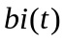Said cityThe number of ants, T represents the amount of information on the time path, represents the number of attractions, the total number of ants, Then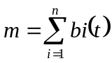
First test time, the amount of information on each path are equal, areP, 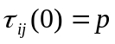. And because the ants can not be repeated through the same city, thus established taboo table(Or records are not traversed path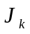) 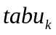(Take a positive integer) to record ant traversed the city, and make dynamic adjustments over time.
Were randomly dispersed nodes ants on the same flight, in accordance with the following formula for the probability of successive visit various cities nodes: ant probability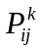 to access the next node:
Here, there
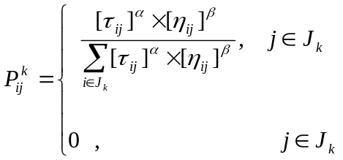
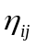 heuristic function is represented by a node to node , it is clear from the more long-term look lower degree, so in this 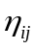 to 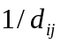.
Over time, there may be two situations: ① Before leaving each ant pheromones gradually disappear; ② After several cycles, the residual pheromone path too, drowned ants choose the path to the desired degree of affected. To avoid this, in both cases, the completion of one cycle each ant, we introduce the parameters of the residual pheromone updated.  pheromone evaporation rate, is available in [0,1] variable values ​​for the control of two pheromone proportion.
After time units provided after the completion of a cycle ant, the amount of the pheromone on the adjustment path according to the following formula:
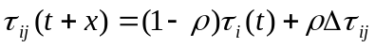
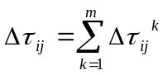
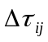: ant the cycle was left in the path of the pheromone strength.
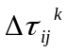: left on the ant path 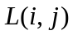 pheromone strength.
Upon completion of the colony access to all nodes in the process of coming back in, according to the quality of the resulting solution is to modify the intensity of pheromone on the path, in order to guide other ants choose the path to achieve population the purpose of cooperation, determine whether the system is stopped last condition (stop condition may be the maximum number of iterations, the computer running time, or the system is to achieve accuracy to achieve data) is satisfied, if the condition is not satisfied, then the search begins again ant path, create a new solution; otherwise, the system will exit the operation, the output of the results obtained. As can be seen from the above, the basic idea of ​​the ant colony optimization algorithm is a shorter path to better the quality of the solution and the distance the more they can attract more ants. It is through this repeated ant memory and learning process, has been the shortest path, namely global optimal solution.
We will longitude and latitude of each city by transforming a spherical coordinate system projected onto the horizontal and vertical coordinates, respectively, on a two-dimensional plane point in time can be obtained directly solving the linear distance between the two places, namely 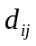.

6.1.2 The basic ant colony algorithm process
In this case, the specific steps to achieve the basic ant colony algorithm is as follows：
(1) Parameter initialization：
Make；
Set the maximum number of cycles 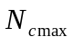，Number of cycles 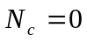；
Ants placed on the nodes, placing ants in each node ;
Initialize pheromone amount on each edge 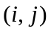 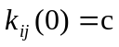as a constant, the initial time ; 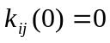.
tialization taboo table 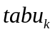 and path table 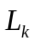
(2). Set the index number 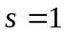, the starting city for ant k 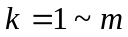 placed taboo table, and repeat these steps until the complete filling taboo table:
For, 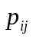 transition probability is calculated using the formula, select the next attractions based on pseudo-random proportional rule, will move to the next ant , attractions and fill taboo table, while recording ants route index number increment.
(3) for 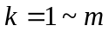, 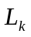 based on the recording ant walking total circulation path lengths to find the best route.
(4) calculate each ant pheromone increment 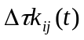;
(5) 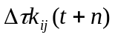 update pheromone amount on each path;
(6) Empty the tabu list and route tables.
(7) 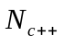, if 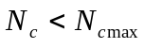 returns to step 2, otherwise, the loop ends.
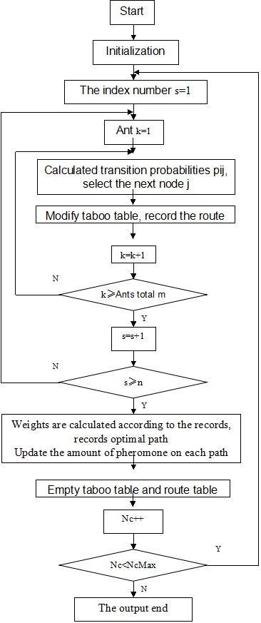
Figure 2 basic ant colony algorithm program flowchart
This model takes into account all the circumstances and tour attractions. Tickets must be known to all attractions, so to ensure the establishment of the optimal model, is to ensure a minimum travel expenses, food expenses at least, that travel the shortest total time to a minimum. Write the following ant colony algorithm to find the optimal path program. By the ant colony algorithm to get the optimal initial route, shown in Figure 3.

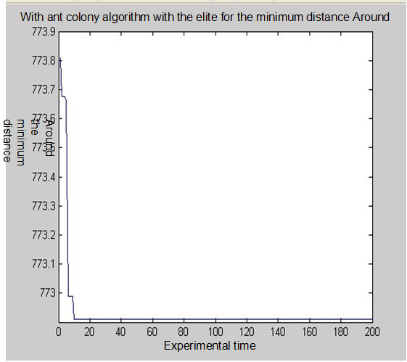

Figure 3 ant colony algorithm for the model with a minimum distance Around
Eventually obtained the following results:
Around the minimum distance: 772.9090km. The least cost route is corresponding thereto:
"12-20-21-19-18-17-16-15-14-13-11-10-9-8-7-6-5-4-3-2-1-12"
Total time = travel time + time to visit
The total time to obtain approximately: 18 days. The results here it takes a computer running time is 1.374356 seconds.
2
3
4
5
6
7
9
8
10
11
12

13
15
14
18
16
19
17
20
21
1
Figure 4: The optimal model of a roadmap

Establish the significance of this model is that if tourists want to swim all the sights, the best solution is to this model, which also limited the time to visit us, that is a panoramic tour, consuming at least 21 days, give us an important reference value.
Depending on the number of households below the consumption calculated as follows:
Table 3 Different models of a number of family members in the course of consumption

Household Size /person | Diet /yuan | Accommodation /yuan | Fare /yuan | Tickets /yuan | Total
3（2-1） | 3150 | 3000 | 1159.3635 | 3252.5 | 10561.8635
4（2-2） | 3780 | 3000 | 1159.3635 | 3903 | 11842.3635
5（2-2-1） | 5670 | 6000 | 1159.3635 | 5854.5 | 18683.8635
6（2-2-2） | 6300 | 6000 | 1159.3635 | 6505 | 19964.3635

6.2 The optimal route based on model enumeration method

6.2.1 enumeration method
Enumeration method is the use of computing speed, high precision characteristics of all possible situations to solve problems, enumerate out, left out to be tested, to find out the answer to meet the requirements, selecting the right (pieces fundamental reason cited) object lies optimization, specifically to reduce the solving steps to solve the solution space narrowing, or make the program more readable and easier to write ^{[13]}, thus enumeration method is through the sacrifice of time in exchange for answers the comprehensiveness of the algorithm.

6.2.2 the enumeration algorithm for optimal route using the basic ideas
Step One: Determine the enumeration object enumeration determines the scope and conditions; Step Two: enumerate all possible solutions; step Third: verify whether the results are the solution of the problem.
The survey analysis can be obtained think will go to Suzhou attractions: Humble Administrator -12, Tiger Mountain Scenic Area -7, -8 Lingering Garden, Tongli Town -16, -4 five Mudu town attractions.
There are 24 kinds of enumerated the following situations:

12-4-7-8-16-12
12-4-16-7-8-12
12-4-8-7-16-12
12-4-16-8-7-12
12-4-8-16-7-12
12-4-7-16-8-12

12-16-7-8-4-12
12-16-7-4-8-12
12-16-8-7-4-12
12-16-8-4-7-12
12-16-4-8-7-12
12-16-4-7-8-12

12-7-8-16-4-12
12-7-8-4-16-12
12-7-16-8-4-12
12-7-16-4-8-12
12-7-4-8-16-12
12-7-4-16-8-12

12-8-7-16-4-12
12-8-7-4-16-12
12-8-4-16-7-12
12-8-4-7-16-12
12-8-16-7-4-12
12-8-16-4-7-12

Can be obtained from the analysis of A-B-C-D-E-A and A-E-D-C-B-A these two lines the same effect, so screening results are listed below 12 kinds of situations:
12-4-7-8-16-12
12-4-8-16-7-12
12-4-7-16-8-12

12-16-7-8-4-12
12-16-8-4-7-12
12-16-4-7-8-12

12-7-8-16-4-12
12-7-8-4-16-12
12-7-16-4-8-12

12-8-7-16-4-12
12-8-4-7-16-12
12-8-16-4-7-12

The distance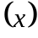 and cost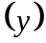 as a function of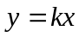 (scale factor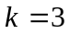 yuan / km), can be obtained by calculating the route "12-16-8-4-7-12" is the shortest and least expensive route
2
3
4
5
6
7
9
8
10
11
12

13
15
14
18
16
19
17
20
21
1
Figure 5 the model of optimal route two map

The results can be arranged according to the algorithm specific itinerary is as follows:
First day: Arrival by car from the train station near the Humble Administrator's Garden, stay at the hotel. After the break, sightseeing Humble Administrator's Garden. The next day: in the morning from the hotel to reach Tongli Town, experience the unique style town, places on the same night in town.
Day Three: The third day arrived Lingering Garden, Lingering Garden tour scenery. Afternoon departure and arrival from the park to stay Mudu town, places in Mudu town.
Day Four: Morning tour continues Mudu town in the evening you can walk through town, still places in Mudu town.
Day Five: in the morning to go to Tiger Hill scenic, tourist attractions Tiger, Tiger places in the evening.
Day Six Tour not play attractions, afternoon return home by car.
Consider for this route attraction tickets, accommodation, food and other factors, the tour takes six days, five nights stay, a different route home staff to implement the fee as shown in Table

Table 4：The number of families in two different models under theconsumption

Family size(person) | Diet (yuan) | Catering accommodation /(yuan) | The fare /(yuan0 | Admission ticket /(yuan) | Total
3（2-1） | 900 | 750 | 64.9107 | 912.5 | 2627.4107
4（2-2） | 1080 | 750 | 64.9107 | 1095 | 2989.9107
5（2-2-1） | 1620 | 1500 | 64.9107 | 1277.5 | 4462.4107
6（2-2-2） | 2340 | 1500 | 64.9107 | 1640 | 5544.9107

6.3 Models three best route, time constraints under
integer programming model
The introduction of a matrix 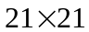, wherein the variable element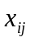 is 0-1, 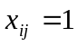 represents the route when we set contains from the area directly to the area, or do not directly contain scenic to , to make the entire cost of the cruise line at least, that minimize the objective function:
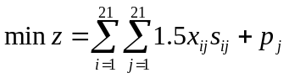

Limited constraints:
① Since most visited each attraction once, so each row of the matrix  and each are 0 or 1 out;
② When and in order to ensure the connectivity of the whole chain, even if two or more unconnected chains appear, we ask that each row and each column sum equal to the sum.
③ We designed the course to course within a month, also need to increase the constraints on time ^{[14].}
Therefore, a complete linear programming model

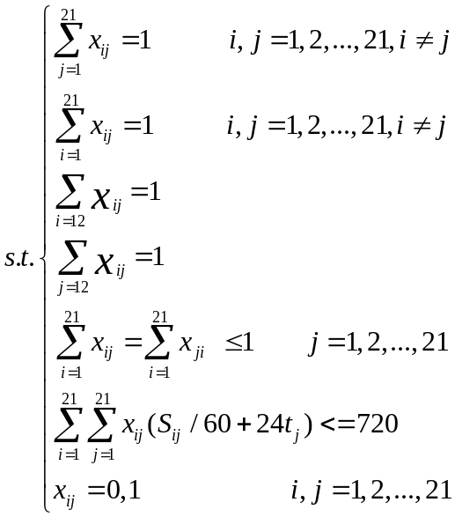
(Where is the first scenic play time)
These factors into consideration, we have a time constraint for the eight days, the first 0-1 planning matrix to obtain the number of elements in the subset approximate solution based on greedy method, based on the weighted priority screening high priority for each attraction attractions.
Greedy algorithm to solve the problem of the basic steps:
1 a mathematical model to describe the problem.
2 to solving the problem into several sub-problems.
3 for each sub-problem solving, get local sub-optimal solution of the problem.
4 handle partial solution the optimal solution original solution to the problem of a synthetic solution ^{[15].}
Process of implementation of the algorithm: the initial solution starting from a problem; while the former can be given towards the overall goal of further elements do find a solution feasible solution; combination of all the elements of a solution of the problem of a feasible solution.
On the basis of the five must-see attractions, the outward extension of stay Select fewer attractions, and gradually over time to more attractions, greedy method allows optimal value every step taken under the current circumstances, continue to expand Attractions data until reaching 21 so far.
One calculated by enumeration method, and for a limited time eight days compared to the final conditions are met several possible to determine the additional attractions 20,11,9,3,6, so this time to explore the sights of 12,16 , 20,11,9,8,7,6,4,3, then ant colony algorithm for optimal route. 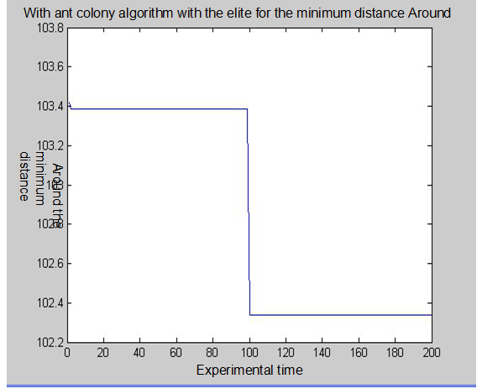
Figure 6 the model with the ant colony algorithm for the minimumtravel the journey
Ant colony algorithm for solving the preliminary final result can be obtained as follows:
Around least get away: 102.3317km. The least cost route is corresponding thereto:
"12-16-20-11-9-8-7-6-4-3-12"
Total time = travel time + time to visit
The total time to obtain approximately: 8 days. The results here it takes a computer running time is 0.866165 seconds.
2
3
4
5
6
7
9
8
10
11
12

13
15
14
18
16
19
17
20
21
1
Figure 7 the model of optimal route three map

Different family members to implement the route cost as shown in table 5.
Table 5 number of families in three different models under theconsumption
Household Size / person | Diret/yuan | Accommodation /yuan | Fare  /yaun | Tickets  /yuan | Total
3（2-1） | 1200 | 1050 | 306.9951 | 1275 | 3831.9951
4（2-2） | 1440 | 1050 | 306.9951 | 1530 | 4326.9951
5（2-2-1） | 2160 | 2100 | 306.9951 | 2295 | 6861.9951
6（2-2-2） | 2400 | 2100 | 306.9951 | 2550 | 7356.9951

In order to meet the psychological needs of the people, will go under five attractions included the premise of the greedy method, considering the factors of stay, ticket prices, etc., available to meet the conditions when most tourist attractions in the following 10, which is the shortest distance between two as shown in Table 6
Table 6: the shortest distance between the scenic spots in threeunder the route model
 | 3 | 4 | 6 | 7 | 8 | 9 | 11 | 12 | 16 | 20
3 | 0 | 3.447 | 8.658 | 9.88 | 11.43 | 11.99 | 15.54 | 15.54 | 25.33 | 51.06
4 | 3.447 | 0 | 5.225 | 6.453 | 7.39998 | 8.662 | 12.1 | 12.1 | 21.88 | 47.62
6 | 8.658 | 5.225 | 0 | 1.224 | 2.775 | 3.33 | 6.882 | 6.882 | 16.68 | 42.4
7 | 9.88 | 6.453 | 1.224 | 0 | 1.556 | 2.11 | 5.66 | 5.66 | 15.472 | 41.181
8 | 11.43 | 7.39998 | 2.775 | 1.556 | 0 | 0.555 | 4.107 | 4.107 | 13.925 | 39.63
9 | 11.99 | 8.662 | 3.33 | 2.11 | 0.555 | 0 | 3.552 | 3.552 | 13.36 | 39.07
11 | 15.54 | 12.1 | 6.882 | 5.66 | 4.107 | 3.552 | 0 | 1.135 | 9.868 | 35.56
12 | 15.54 | 12.1 | 6.882 | 5.66 | 4.107 | 3.552 | 1.135 | 0 | 9.845 | 35.53
16 | 25.33 | 21.88 | 16.68 | 15.472 | 13.925 | 13.36 | 9.868 | 9.845 | 0 | 25.833
20 | 51.06 | 47.62 | 42.4 | 41.181 | 39.63 | 39.07 | 35.56 | 35.53 | 25.833 | 0
6.4 Optimal route models have cost under the constraint
View and online searching through the literature tourism spending per capita amount of time around 1006 yuan ^{[16]}, in which we take 1100 yuan cost constraints limit as the tourist route.
Because this model is only the total cost constraint, not as limitations on the time, the 0-1 model no restrictions:
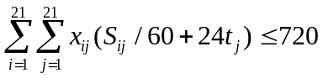（Itineraries are designed within a month）
The first model is estimated using the smallest element method, and then get the optimal solution by the ant colony algorithm and verify its legitimacy with backtracking.
The following elements of the improved method to estimate the minimum. Algorithm steps to do on the cost matrix D times the following cycle:.Finding a minimum 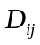value of D，Order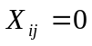；The first column of all data D to infinity，If 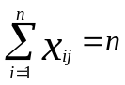，D-line data can be changed to positive infinity all。Meet the conditions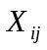 of the recording during the cycle number ^{[17]}。
On the basis of the five must-see attractions, the outward expansion, Select fewer attractions tickets, tickets for the gradual transition to higher sights, with the smallest element method allows optimal value every step taken under the current circumstances, the constant increased data item until the data reaches 21 attractions far, in the course of the cycle of the number of records in order to meet the conditions of the attractions.
One calculated by enumeration method, with limited costs 2,500 yuan compared to the final conditions are met several possible to determine the additional attractions of 6, so this time to explore the sights of 12,16,7,8,4,6 , then ant colony algorithm for optimal route.
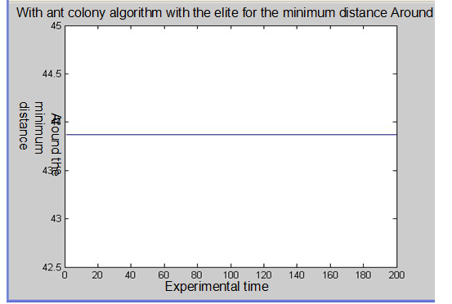
Figure 8: model with the ant colony algorithm for the fourth minimumaround the journeyAnt colony algorithm for solving the preliminary final result can be obtained as follows:
Around least get away: 43.87km. The least cost route is corresponding thereto:
"12-16-8-7-6-4-12"
Total time = travel time + time to visit
The total time to obtain approximately: 5 days. The results here it takes a computer running time is 0.173136 seconds.
2
3
4
5
6
7
9
8
10
11
12

13
15
14
18
16
19
17
20
21
1
Figure 9 the model of optimal route four map
Table 7 number of families in four different models under theconsumption
Household Size / person | Diet  /yuan | Accommodation  /yuan | Fare /yuan | Tickets /yuan | Total
3（2-1） | 750 | 600 | 131.61 | 926.5 | 2408.11
4（2-2） | 900 | 600 | 131.61 | 1155 | 2786.61
5（2-2-1） | 1350 | 1200 | 131.61 | 1732.5 | 4414.11
6（2-2-2） | 1500 | 1200 | 131.61 | 1925 | 4756.61

In order to meet the psychological needs of the people, will go under five attractions included the premise of the smallest element method, considering the factors of stay, ticket prices, etc., can get up to when you meet the conditions of the following six attractions, they pairwise shortest from the following table:
Table 8 The shortest distance between attractions models under four routes between
 | 4 | 6 | 7 | 8 | 12 | 16
4 | 0 | 5.225 | 6.453 | 7.3998 | 12.1 | 21.88
6 | 5.225 | 0 | 1.224 | 2.775 | 6.882 | 16.68
7 | 6.453 | 1.224 | 0 | 1.556 | 5.66 | 15.472
8 | 7.3998 | 2.775 | 1.556 | 0 | 11.32 | 13.92
12 | 12.1 | 6.882 | 5.66 | 11.32 | 0 | 9.845
16 | 21.88 | 16.68 | 15.472 | 13.92 | 9.845 | 0

6.5 time constraints and the cost model under optimal route
By the analysis of Suzhou attractions and comprehensive consideration of the household economy, especially to set the time and cost constraints of this model - time constraint is 13 days, the cost constraint is 2500 yuan.
Comprehensive measure of the cost and time of issue, create the following model to evaluate:
1 Determine the multi-objective linear programming optimization model ^{[18]}, this question only consider the cost and time optimization of two factors;
2 Given the priority of each target element. In this problem, with cost as the first priority, and time is the second priority.
3 For a given index dimensionless processing, so that each index comparable.
Described by the cost and time of two matrices, given the non-dimensional treatment:
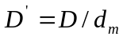Wherein 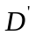 matrix is processed after the non-dimensional, 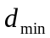 matrices to describe the smallest element.
4 For the cost and time of two matrices, take the same position coordinates dimensionless quantity integrate to form a new dimensionless quantity, as solving the matrix.
5 Using the smallest element method to determine the costs and time while satisfying constraints, the number of elements have to bear with the original diagram subset. Given the priority of various attractions, heuristics may be used to select the optimal path. Which is the right of each attraction:
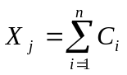
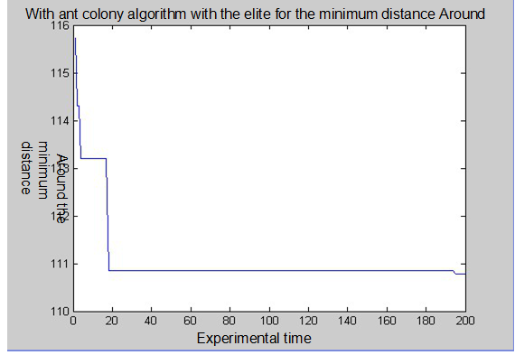
Figure 10 model with the ant colony algorithm for the fifth minimum around the journeyAnt colony algorithm for solving the preliminary final result can be obtained as follows:
Around least get away: 110.7800km. The least cost route is corresponding thereto:
"12-13-14-15-16-19-20-21-11-9-8-7-6-4-3-12"
Total time = travel time + time to visit
The total time to obtain approximately: 13 days. The results here it takes a computer running time is 0.640140 seconds.
2
3
4
5
6
7
9
8
10
11
12

13
15
14
18
16
19
17
20
21
1

Figure 11 Five optimal model roadmap

Table 9: The number of different families of five routes in the consumption model

Household Size / person | Diet  /yuan | Accommodation /yuan | Fare  /yuan | Tickets  /yuan | Total
3（2-1） | 1950 | 1800 | 332.34 | 1815 | 5897.34
4（2-2） | 2340 | 1800 | 332.34 | 2178 | 6650.34
5（2-2-1） | 3510 | 3600 | 332.34 | 3267 | 10709.34
6（2-2-2） | 3900 | 3600 | 332.34 | 3630 | 11462.34

Table 10: The shortest distance between attractions model under five routes between

 | 3 | 4 | 6 | 7 | 8 | 9 | 11
3 | 0 | 3.447 | 8.658 | 9.88 | 11.43 | 11.99 | 15.54
4 | 3.447 | 0 | 5.225 | 6.453 | 7.3998 | 8.552 | 12.1
6 | 8.658 | 5.225 | 0 | 1.224 | 2.775 | 3.33 | 6.882
7 | 9.88 | 6.453 | 1.224 | 0 | 1.556 | 2.11 | 5.66
8 | 11.43 | 7.3998 | 2.775 | 1.556 | 0 | 0.555 | 4.107
9 | 11.99 | 8.552 | 3.33 | 2.11 | 0.555 | 0 | 3.558
11 | 15.54 | 12.1 | 6.882 | 5.66 | 4.107 | 3.558 | 0
12 | 11.54 | 12.1 | 6.882 | 5.66 | 4.107 | 3.558 | 1.135
13 | 15.98 | 12.55 | 7.326 | 6.11 | 4.552 | 4 | 0.509
14 | 21.89 | 18.44 | 13.25 | 12.036 | 10.48 | 9.93 | 6.448
15 | 22.76 | 19.32 | 14.1 | 12.876 | 11.32 | 10.66 | 7.254
16 | 25.33 | 21.88 | 16.68 | 15.472 | 13.92 | 13.36 | 9.868
19 | 45.74 | 42.3 | 37.09 | 35.0866 | 34.31 | 39.76 | 30.25
20 | 51.06 | 47.62 | 42.4 | 41.181 | 39.63 | 39.07 | 35.56
21 | 56.94 | 53.5 | 48.29 | 47.065 | 45.51 | 44.96 | 41.4

12 | 13 | 14 | 15 | 16 | 19 | 20 | 21
11.54 | 15.98 | 21.89 | 22.76 | 25.33 | 45.74 | 51.06 | 56.94
12.1 | 12.55 | 18.44 | 19.32 | 21.88 | 42.3 | 47.62 | 53.5
6.882 | 7.326 | 13.25 | 14.1 | 16.68 | 37.09 | 42.4 | 48.29
5.66 | 6.11 | 12.036 | 12.876 | 15.472 | 35.0866 | 41.181 | 47.065
4.107 | 4.552 | 10.48 | 11.32 | 13.92 | 34.31 | 39.63 | 45.51
3.558 | 4 | 9.93 | 10.66 | 13.36 | 39.76 | 39.07 | 44.96
1.135 | 0.509 | 6.448 | 7.254 | 9.868 | 30.25 | 35.56 | 41.4
0 | 0.488 | 6.425 | 7.229 | 9.845 | 30.22 | 35.53 | 41.42
0.488 | 0 | 5.939 | 6.644 | 9.301 | 29.74 | 35.06 | 40.94
6.425 | 5.939 | 0 | 1.294 | 3.389 | 23.81 | 59.17 | 35.03
7.229 | 6.644 | 1.294 | 0 | 2.789 | 23.02 | 28.33 | 34.22
9.845 | 9.301 | 3.389 | 2.789 | 0 | 20.47 | 25.83 | 31.7
30.22 | 29.74 | 23.81 | 23.02 | 20.47 | 0 | 5.37 | 11.18
35.53 | 35.06 | 59.17 | 28.33 | 25.83 | 5.37 | 0 | 5.925
41.42 | 40.94 | 35.03 | 34.22 | 31.7 | 11.18 | 5.925 | 0

7 Model evaluation
This paper is based on the programming model, based on ant colonyalgorithm is used, the advantages of the programming model, theobjective function and the constraint conditions of meaning are very clear, and with the minimum element method were estimated, so that each model basically can get the optimal solution. The model andmethod is widely used in the article is simple, experimental computertime spent less, every problem in accordance with the number ofdifferent families who are listed in the section, but also can providemore choices for different family. Also according to the differentmodels compared with each other and mutual enrichment, design better, more comprehensive the optimal travel route under different conditions.
This paper uses MATLAB, Excel and other software, and ant colony algorithm, the enumeration method, Floyd method, play their respective advantages, improve the efficiency and the accuracy ofthe solution, so that the article illustrated, more intuitive andreadable.
This model was established in speed, unit trip costs are based on theassumption of constant, the actual situation is not close to the reality of life; in solving complex problems, are using the basic ant colony algorithm, solving method is single, lack of diversification and theratio of: just designed for optimizing the route several fixed under the conditions of the family, can't meet all the demand, lack of mobility,only representative, not comprehensive. The model considers onlythe rational factors, lack of emotional factors, site selection is fixed,can't let visitors more comprehensive appreciation scenery in Suzhou.

8 The extension of the model
Ant colony algorithm for solving minimum traversing distance model can also be applied to the communication network routing problembased on node selection, reasonable circuit, so that the bus routenode shortest. The 0-1 integer programming model can be extended to the assignment problem in real life, the rational allocation of tasks,can meet the specific assignment request condition, the total effect is the best solution.

9 Improved optimization model
Model straight-line distance between the two cities instead of the actual distance to make things simple, but with the actual situation of the track, improved model to make the journey closer to the actual journey, the resulting model is more practical.
When you create the model, ignoring the impact of holidays on ticket prices, considering the changes in ticket prices, will be more comprehensive solution to the problem. Model, the best route is designed only under certain conditions, and can not serve all passengers, improved model, to make conditions more flexible, more diverse programs and better meet the needs of travelers.
The method used in the model is too simple, when dealing with the same problem, if using different methods to analyze, make the results more accurate. And selected attractions too little, in the improved model, you should add more attractions for analysis optimization.
In the model design ignores some emotional factors, while improving the model, adding some emotional issues to consider, making the best route to get a more humane, more attractive and tempting.

10 Prospects model
Ant Colony Algorithm optimization model in dealing with complex optimization problems, especially discrete optimization problems show strong superiority. Ant colony, the basic principle is already under clear conditions, it is important to develop algorithms that model to solve the problem, so that to solve the problem more effectively. Programming model is an important branch of operational research, many complex problems can be abstracted as linear, nonlinear, integer,0-1 planning. Can be used to deal with the management of the enterprise's activities, including cutting issues, batching problem, location problem, assignment problem, investment issues, packing problem, the shortest path problem, the minimum spanning tree problem and the optimal route, and many other seemingly helpless subject.
Floyd algorithm is simple and effective, due to the compact triple loop structure , for dense graph, execution times more efficient than Dijkstra algorithm. Enumeration method is the use of computing speed , high precision characteristics of all possible situations to solve problems, left out to be tested, to find out the answer to meet the requirements , through the sacrifice of time in exchange for a comprehensive answer the basic idea of ​​the object to determine the enumeration , enumeration and determine the scope of the condition , the enumeration of possible solutions , to verify whether the solution to the problem . The smallest element method can be applied to materials distribution problems , in the transportation of materials to ensure minimal total cost while improving customer satisfaction.
Microsoft Office Excel is a spreadsheet software package , it is widely used , can be achieved without additional software programming requires programming to complete complex calculations , can be a variety of statistical data , computing, processing and rendering graphical statistics. Matlab is an efficient engineering computing language , which will computing, visualization , and programming functions into one easy-to- use environment. Typical applications include math , algorithm development , data acquisition, system modeling and simulation , data analysis and visualization , science and engineering drawings and application software development.
This article uses the ant colony algorithm Matlab programming, the code simple , visual features can be seen.

References
[1] Suzhou，http://baike.baidu.com/view/2239.htm?fr=aladdin，2014-5-23
[2] Car fare inquiry，http://www.trip8080.com/，2014-5-23
[3] Restaurant price inquiry，http://lvyou.baidu.com/suzhou/meishi/，2014-5-23
[4] Hotel check，http://lvyou.baidu.com/suzhou/zhusu/，2014-5-23
[5]Averagespeedcar,http://zhidao.baidu.com/link?url=R3H5ublUtUsAEnAaiQfYAQ_XhMBzsHIpzD6bSf3bb8Y1WSEcUPV8vTFiSvgJN3iLFNlyRWDszp6kIOIDpC9_I_，2014-5-23
[6] [10] From the station closest，http://map.baidu.com/?newmap=1&s=s%26wd%3D苏州市%26c%3D224&from=alamap&tpl=mapcity，2014-5-23
[7] AAAA interest，http://baike.baidu.com/view/2239.htm?fr=aladdin，2014-5-23
[8] Attraction tickets，http://lvyou.baidu.com/suzhou/jingdian/，2014-5-23
[9] Coordinates inquiry，http://www.hjqing.com/find/jingwei/index.asp，2014-5-24，
[11] Xiong Yijie, operations research tutorials[M]. Beijing,:National Defense Industry Press，2007
[12] Li Siyong，Ant colony algorithm and its application[M]. Harbin: Harbin Institute of Technology Press，2004年
[13] Lihui，Educational equipment logistics planning[M]. Beijing: Peking University Press，2010年3月
[14] Chenhua，Mathematical modeling[M]. Beijing: Science Press，2012年2月
[15]Chen Guoliang， Parallel algorithm practice[M]. Beijing: Higher Education Press， 2004
[16] Li Meixia，Domestic tourists spent 1,006 yuan per capita in the province, Shanxi Economic Daily[N]. F592, B01 Edition，2013年11月3日
[17]Hu Xinsheng，Logistics Management quantitative analysis method[M]. Beijing:China Central Radio and Television University Press 2009年1月
[18]TravelingSalesmanProble，http://baike.baidu.com/view/1162183.htm?fr=aladdin，2014-5-25

Appendix: elite ant colony algorithm for solving shortest path traversal code
function [TM,LM] = ASPSP(C)
%
% Description of the procedures：
% The procedures for the use of problem with the elite ant strategy for solving traveling salesman。
%
% Variable description：
% The input variables：
% C：The shortest distance matrix；
% The output variable：
% TM：Approximate optimal path；
% LM：The approximate shortest distance；
%
%
tic;
D = C;
alpha = 1;
beta = 5;
rho = 0.5;
Q = 100;
Tao0 = 1e-6;
e = 5;
Maxtime = 200;
n = length(D);
m = n;
Ta = Tao0*ones(n,n) - Tao0*eye(n);
TM = [];
LM = 100000;
ant = zeros(m,n+1);
ata = zeros(m,n);
for i = 1:m
for j = i+1:n
ata(i,j) = 1/D(i,j);
ata(j,i) = ata(i,j);
end
end
for time = 1:Maxtime
for k = 1:m
city(k,:) = 1:n;
end
s = 1;
for i = 1:m
ant(i,s) = unidrnd(n);
ant(i,n+1) = ant(i,s);
city(i,ant(i,s)) = 0;
end
while s < n
p = zeros(m,n);
for i = 1:m
A(i) = 0;
for j = 1:n
if city(i,j) ~= 0
A(i) = A(i) + (Ta(ant(i,s),j)^alpha)*(ata(ant(i,s),j)^beta);
end
end
for j = 1:n
if city(i,j) ~= 0
p(i,j) = (Ta(ant(i,s),j)^alpha)*(ata(ant(i,s),j)^beta)/A(i);
end
end
pp = unifrnd(0,1);
j = 1;
while pp>0
pp = pp - p(i,j);
j = j + 1;
end
j = j - 1;
ant(i,s+1) = j;
for k = 1:n
if city(i,k) == j;
city(i,k) = 0;
break;
end
end
end
s = s + 1;
end
L = compu(ant,D);
[Lmin,t] = min(L);
if Lmin < LM
LM = Lmin;
TM = ant(t,:);
end
deltaTa = zeros(m,n);
for i = 1:m
for j = 1:n-1
deltaTa(ant(i,j),ant(i,j+1)) = deltaTa(ant(i,j),ant(i,j+1)) + Q/L(i);
end
end
for j = 1:n-1
deltaTa(TM(j),TM(j+1)) = deltaTa(TM(j),TM(j+1)) + Q/LM;
end
for i = 1:m
for j = 1:n
Ta(i,j) = rho*Ta(i,j) + deltaTa(i,j);
end
end
trace(time) = LM;
end
figure(1);
plot(trace);
toc;

function D = Distance(C)
n = length(C);
D = zeros(n,n);
for i = 1:n
for j = i+1:n
D(i,j) = norm(C(:,i) - C(:,j));
D(j,i) = D(i,j);
end
end

function L = compu(ant,D);
for i = 1:length(D)
L(i) = 0;
for j = 1:length(ant)-1
L(i) = L(i) + D(ant(i,j),ant(i,j+1));
end
end

