  For office use only
  T1 | ________________
  T2 | ________________
  T3 | ________________
  T4 | ________________
  Team Control Number
  1904845
  Problem Chosen
  A
  For office use only
  F1 | ________________
  F2 | ________________
  F3 | ________________
  F4 | ________________
2019
MCM/ICM
Summary Sheet
(Your team's summary should be included as the first page of your electronic submission.)
The dragon exists from the Late Triassic to the end of the Cretaceous, and many archaeologists now study its fossils. In order to clearly understand the dragon's characteristics, behaviors, habits, diet and the interaction with environment, we first design the dragon's growth model and ecological impact model.Based on this model, we build the dragon's caloric intake and body weight model, home range model, and climate-affected animal and plant models.
We begin with
Next,
Further,
Besides,
Finally,
Keywords:

Content
1 Introduction 2
1.1 Background 2
1.2 Restatement of the Problem 2
1.3 Overview of Our Work 2
2 General Assumptions and Symbol Description 3
2.1 General Assumptions 3
2.2 Symbol Description 3
3 Model Theory 4
3.1 XXXXX Model 4
3.2 XXXXXX Algorithm 4
3.3 XXXXXX Algorithm 4
4 XXXXX Model 5
4.1 Review of Literatures 5
4.2 A Simplified Model of XXX 5
4.3 XXXX Analysis 5
4.4 Model establishment 5
4.5 Model Results 5
5 XXXXX Model 6
5.1 Review of Literatures 6
5.2 A Simplified Model of XXX 6
5.3 XXXX Analysis 6
5.4 Model establishment 6
5.5 Model Results 6
6 Sensitivity Analysis and Model Validation 7
6.1 Sensitivity Analysis 7
6.2 Model Validation 7
7 Strengths and Weaknesses 8
7.1 Strengths 8
7.2 Weaknesses 8
8 Conclusion and Future Work 8
8.1 Conclusion 8
8.2 Future Work 8
9 References 9
10 Appendices 10

Introduction

Background
The dragon is a magical species in the fiction “A Song of Ice and Fire” that exists as a partner in the protection of human territory. The dragon feeds on fish, aquatic invertebrates, and other land animals. Before eating, the dragon likes to roast the food with the dragon flame.

In reality, its species belong to the pterosaurs in the zoology department. The pterosaur is an extinct reptile that survived from about 210 million years ago to 65 million years ago. Most pterosaurs are carnivores. At the end of the Cretaceous, many animals suffered extinction, seriously affecting the food sources of pterosaurs, and the pterosaurs were gradually extinct.

In this paper, we pay more attention to the dragon characteristics, behaviors, habits, diet and getting along with the environment, exploring the ideal living conditions, that is, adequate food, environment suitable for growth, dragon's impact on biology and the environment.

Restatement of the Problem
The dragon is a reptile with body scales and sharp teeth and claws. When hatched, the dragons are small, roughly 10 kg, but the adult dragon could grow up to swallow the entire mammoth. The dragons are carnivores. As with other animals that migrate, dragons might travel to different regions of the world with very different climates.

Many factors influence the development and survival of the dragon, and climate is the most important factor. The climate affects the source of biological food, and the amount of food in the dragon changes, which in turn affects the growth and development of the dragon. We assume climate change as changes in air temperature and humidity.

The problems that we need to solve in this paper are:
- Consider the food, climate impact, and establish a dragon growth model.
- Determine the impact of dragons on ecology, including biological and environmental impacts.
- Determine the energy consumption and calorie intake of the dragon.
- Support the area required by the three dragons
- Supporting a dragon needs community area for varying levels of assistance that can be provided to the dragons
- Analysis of the impact of climate on dragon life activities
- With respect to climate change, provide guidance about how to maintain the realistic ecological underpinning of the fiction “A Song of Ice and Fire”.

Overview of Our Work

General Assumptions and Symbol Description

General Assumptions
To simplify our model, we make the following assumptions: Each of our assumptions is justified and is consistent with the basic fact.
- the dragon is flying in North America, the environment in which it lives is safe, and the flames do not cause damage to the environment.
- After the dragon matures, the body weight fluctuates with the climate, and the saturation value is stable at 10,000kg.

(本章约占2页)

Symbol Description
Table 1:Symbol Description
Symbol | Description | Symbol | Description

Model Theory

定义与符号说明
符号 | 符号说明 | 符号 | 符号说明
 | 其它生物在u时刻的数量 |  | 龙在u时刻的数量
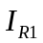 | 其它生物独立生存时的增长率 | 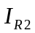 | 龙独自存在时的死亡率
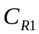 | 龙掠取其它生物的能力 | 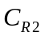 | 其它生物对龙的供养能力
u | 时间

分别以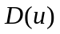,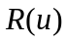表示龙和其它动物在时刻u的数量。假设龙是以其它动物为食物的。其它动物独立生存时，数量的增长应服从马尔萨斯模型，但是有龙的存在，则被龙吃掉是其它生物死亡的一个重要原因。两物种相遇（发生被吃现象）是偶然的，相遇机会与两个群体规模乘积成正比，所以在马尔萨斯模型的基础上增加一项: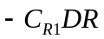，即

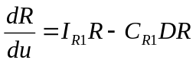
假定龙的出生率与群体规模成正比，而真正能活下来的只是那些找到食物的（与其它动物相遇部分），所以它的有效出生率与两物种规模成正比。假定它的自然死亡率也与群体规模D成正比，即

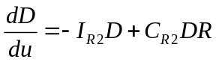

给定其它生物和龙的初始值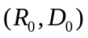，其它动物与龙增长规律性可用常微分方程组描述（Volterra模型）

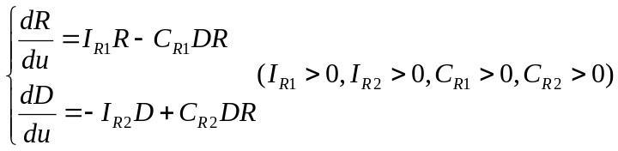 (1)

模型的求解
首先将式（1）的两式相除，消去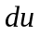得到
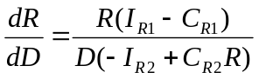
这是可分离变量方程

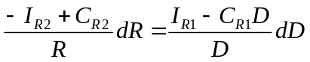

两边积分得到的通解
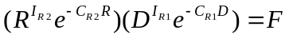 (2)

其中常数F由初始条件确定。

式（2）的解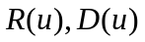描述了其它动物和龙的数量随时间的变化过程，但是得不到的解析解，需要用数值算法求解。
不妨假设代入式（1）和式（2）得
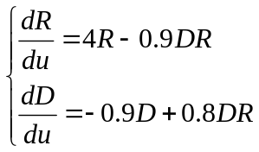
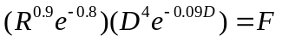

为了分析其它生物和龙的数量随时间的变化，不妨任取三组数据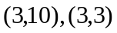分别作为其它动物和龙数量的初值，用Matlab编程求得模型的数值解并绘制其它动物和龙数量随时间变化的图像，二组不同初值对应的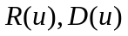的图形分别见图1，图2

XXXXX Model

(约5-6页)

Review of Literatures

A Simplified Model of XXX

XXXX Analysis

Model establishment

Model Results

XXXXX Model

Review of Literatures

A Simplified Model of XXX

XXXX Analysis

Model establishment

Model Results

Sensitivity Analysis and Model Validation

Sensitivity Analysis

(约2页)

Model Validation

Strengths and Weaknesses

Strengths
(3到6点即可)

Weaknesses
(3到6点即可)

Conclusion and Future Work

Conclusion
From the above analysis,we can come to a conclusion that

Future Work

References

Appendices

