  For office use only
  T1 | ________________
  T2 | ________________
  T3 | ________________
  T4 | ________________
  Team Control Number
  5048
  Problem Chosen
  B
  For office use only
  F1 | ________________
  F2 | ________________
  F3 | ________________
  F4 | ________________

2009 Mathematical Contest in Modeling (MCM) Summary Sheet
In this paper, we develop a series of mathematical models to investigate the relationship between electricity utilization and cell phone numbers both in current America and the future.
Our basic model analyzes the change of energy consumption during the landline- to- mobile replacing process. We begin with using the logistic equation to model cell phone subscribers as a function of time. Afterwards we apply Monte Carlo Simulation to simulate the number of landline phones within the dynamic process. By using the accurate data of power consumption under different modes, our first models reveal:
The electricity utilization peaks around 2019(about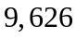 (barrel/day)) and becomes steady after 2041 (about 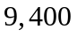 (barrel/day)).
The optimal way of providing phone service is to provide only landlines from the energy perspective.
Our second model deals with energy waste of different rechargers. To quantify the energy waste of cell phone chargers, we categorize the wasteful practice into several types and calculate the corresponding energy waste. Then given the accurate data, we have these results,
The waste of total cell phones per day is about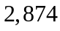 (barrel/ day)
The total waste of various consumer electronics per day is about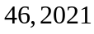 (barrel/day)
Our extended model takes into account the population and economic growth over the next 50 years. We use Cohort-Component Method to predict the population growth in every 10 years. Then we use the predicted population to adjust the logistic equation in our basic model. The modulated model shows that:
The total energy consumption keeps growing and reaches about 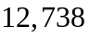 (barrel/day) at 2050.

contents
1. Introduction 4
2. Restatement of the problems 4
3. Terms 5
4. Assumptions and Hypotheses 5
5. Our Basic Model: Calculation of the Electricity Utilization during the Transition and Steady State 5
5.1Model the Growth of Cell Phone Subscribers: the Logistic Equation 6
5.2 Energy Consumed by one Cell Phone per Day 8
5.3 Analysis of the Factors that Influences the Landline Number 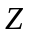 10
5.4 Calculation of 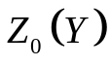 and 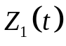 11
5.5 Energy Consumed by a Landline Phone per Day 12
5.6 Total Energy Consumption of Providing Phone Service 13
5.7 Optimal Way of Providing Phone Service to “Pseudo US” 14
6. Energy of Recharge Waste 16
6.1 Different Kinds of Recharge Waste Behaviors 17
6.2 Estimate of the Recharge Time 17
6.3 Calculations of Energy Wasted 18
6.4 Barrels of Oil Equivalent to Energy Wasted 18
7. Energy Wasted by the Current U.S. 19
7.1 Our Data Gathering Approach 19
7.2 Time Spent on the Idle Mode 20
7.3 Power Measurements 20
7.4 Number of Units in Current U.S. Houses 20
7.5 Calculation of Current Energy Wasted 20
7.7 Barrels of Oil Equivalent to Energy Wasted 21
8. Energy Prediction for Providing Phone Service 23
8.1 The Method of Projecting the Population 23
8.2 Assumption and Principals 23
8.3 Modeling the Population 23
8.4 Economic Growth Analysis 24
8.5 Population Growth and Impact on Phone Energy Consumption 24
8.6 Number of Cell Phones in the Future 24
8.7 Discussion on the Number of Landline 25
9 Model Strengths and Weaknesses 25
10 Results 26

Analysis of the Relationship Between Total Energy Consumption with Cell Phone Numbers

1. Introduction
Energy crisis and global warming have long been a concern to our society. Therefore, finding appropriate ways to minimize the energy consumption is a long-term strategy to maintain our society’s sustainable development.
Due to the technological development, the cell phone’s performance has been greatly improved. More and more people nowadays tend to substitute their landlines with cell phones. In this paper, we investigate changes of total cell phones number. And we research the relationship between total energy consumption for providing phone service and the cell phones number. Furthermore we study the energy waste of cell phones and other recharger type.
According to the results of our model, we can provide some guidance for the government to initiate some strategies to control total energy consumption for providing phone service.

2. Restatement of the problems
The problem here can be categorized into two main types:
Analyze the relationship between total energy consumption for providing phone services and the cell phone numbers
Analyze the energy waste of cell phone chargers and the total energy waste of various recharger types.
To solve the first question, we must determine the energy consumption of cell phones and landline phones. Thus we need to calculate the total number of cell phones and landline phones. We should also evaluate the corresponding energy consumed by one phone per day.
To figure out the second type, we categorize the wasteful practice and calculate the energy waste respectively.
After we accomplish the tasks above, we can use the relationship to display the change of electricity utilization in current US and select the optimal way of providing phone services. Also we can find out the energy waste of cell phone chargers and various recharger types.

3. Terms
Total Energy Consumption: (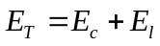)
Total Energy Consumption of Cellular Phone: (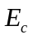)
Total Energy consumption of Landline phone: (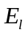)
Number of total Cell phone Subscribers: ()

Number of total landline phone subscribers: ()
Waste Energy of Cellular Phones: (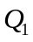)
Waste Energy of Various Consumer Electronics: (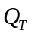)

4. Assumptions and Hypotheses
Total Energy consumption only consists of two parts: energy consumed by cellular phone and landline phone .We do not take into account the energy consumed by Other facilities such as end office facilities ,transmission facilities and repeater facilities which are indispensable parts of the telecommunication network.

We assume each person has less than one cell phone.

The recharge cycle of a battery is 10 hours.

We consider all the batteries and chargers are the same.

Everyone needs to maintain communication with the outside.

If some member of the household does not have a cell phone, then the household should include at less one landline due to keeping communication with the outside.

5. Our Basic Model: Calculation of the Electricity Utilization during the Transition and Steady State
We define the following total energy consumption function and subsequently present a detailed explanation.
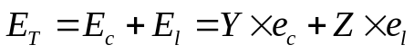 (1)

Where,
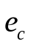 refers to energy consumed by one cell phone per day .
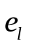 refers to energy consumed by one landline phone per day.

5.1Model the Growth of Cell Phone Subscribers: the Logistic Equation
We model the growth of total cell subscribers with the logistic equation,
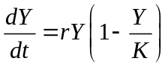 (2)
Where r is the intrinsic growth rate of and is the carrying capacity. For simplicity, we let a = r and b =r/k, so that
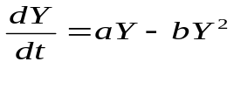
With the initial condition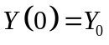, the equation has closed-form solutions,
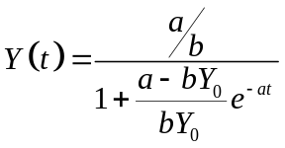
Let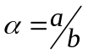,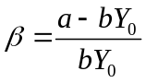, so that
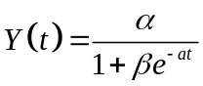 (3)
Let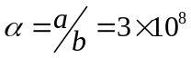, we get
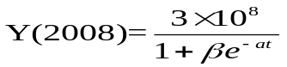
A typical logistic curve of is shown in Fig.1.
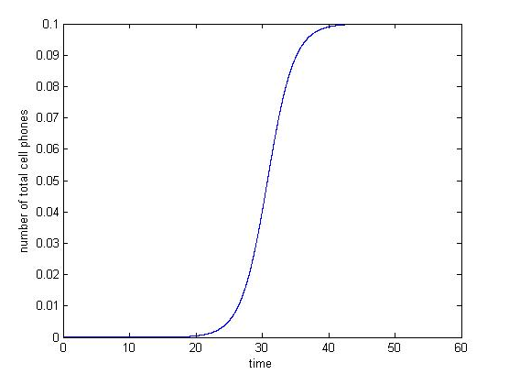
Fig. 1 Number of total cell phone subscribers vs time.
Given the accurate number of cell phone subscribers from 1985 to 2005 [1] (Table 1), we use the nonlinear curve fitting method to adjust the parameters to make it fits to the actual data.

Table 1. Number of cell phone subscribers from 1985 to 2006

Year | Subscribers | Year | Subscribers
1985 | 340,213 | 1996 | 44,042,992
1986 | 681,825 | 1997 | 55,312,293
1987 | 1,230,855 | 1998 | 69,209,321
1988 | 2,069,441 | 1999 | 86,047,003
1989 | 3,508,944 | 2000 | 109,478,031
1990 | 5,283,055 | 2001 | 128,374,512
1991 | 7,557,148 | 2002 | 140,766,842
1992 | 11,032,753 | 2003 | 158,721,981
1993 | 16,009,461 | 2004 | 182,140,362
1994 | 24,134,421 | 2005 | 207,896,198
1995 | 33,758,661 | 2006 | 233,000,000

Finally, we obtain the simulated logistic equation,
Y=307022493.59803/(1+195.09934*exp(-0.28656*t))……… (4)
Whose graph is shown in Fig. 2.

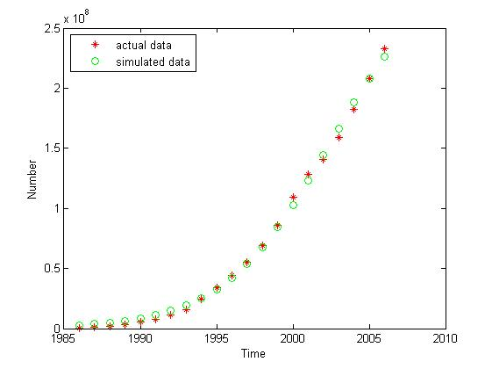
Fig. 2 The number of total cell phone subscriber vs time

From Fig. 2, we can find that the simulated curve fits so well to the actual data.
Moreover, we use the cell phone number in 2008 to test our model’s rationality.
The predicted number in 2008,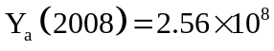
The actual number in 2008, Y=
The two data are surprisingly close; therefore, it is reasonable to use the equation (4) to calculate the number of cell phone subscribers.

5.2 Energy Consumed by one Cell Phone per Day

We obtain the following information from reference [2].
Table 2. Power and energy supplied by the cell for different operating modes (The recharging cycle is ten hours).
Subsystem | Energy in(kJ) | Energy out(kJ) | Efficiency (%)
Battery | 6.42 | 6.05 | 94.3
Phone | 28.17 | 6.42 | 22.8
Travel charger  (plugged 10 h) | 74.03 | 28.17 | 38.1
System overall with charger plugged 10h | 74.03 | 6.05 | 8.2
System overall  with charger  plugged 24h | 110.22 | 6.05 | 5.5

Table 3. Daily energy consumption and efficiency when the battery is charged in the
phone.

Operating Mode | Average Power(W) | Time(min) per 24 Cycle | Energy(kJ)
Stand-by | 0.086 | 731.5 | 3.78
Two-way calls | 0.314 | 72.5 | 1.37
Cell calls | 0.416 | 36 | 0.9
Total |  | 840 | 6.05
We use 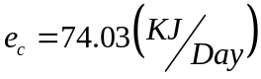 as the energy consumed by one cell phone per day.
By multiplying the equation (4) with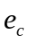, we obtain the final expression of energy consumption of total cell phones:

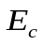= {307022493.59803/(1+195.09934*exp(-0.28656*t))}*74.03(KJ) (5)

Whose graph is shown in Fig.3
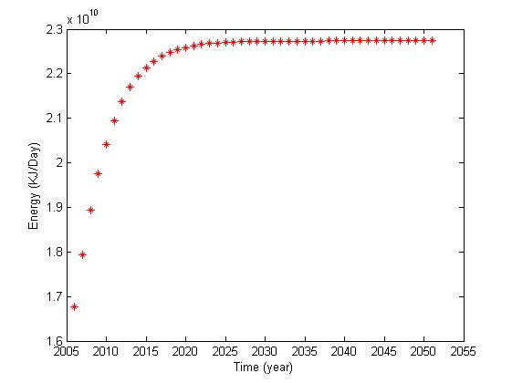
Fig.3 Energy consumption of total cell phones per day vs. time

5.3 Analysis of the Factors that Influences the Landline Number
There are two main factors that determine the number Z.
One factor is that everyone needs to maintain communication with the outside .Therefore, if some members of the house do not have a cell phone, then the household should have at less one landline.(According to the assumptions made above. )

The second factor is that cell phone has many shortcomings under the current technological level .Some of the shortcomings are listed as follows:
1) Cell phones do not last as long as landline phones. (For example, the cell phone gets lost and breaks. Also the cell phone has to be periodically recharged)
2) Signal of the cell phone is easily influenced by the atmosphere and geography.
Hence, an appropriate number of landline phones is needed to complement the shortcoming.
Thorough the analysis above, we can approximately divide the number Z into two categories which originates from different reasons,
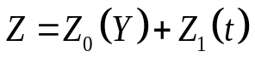 (6)
Where,
refers to the necessary number of landlines for maintaining the communication with the outside .
refers to the number of landlines needed for complementing the shortcomings of cell phones under the current technological level.

5.4 Calculation of and
(1)Calculation of the necessary number of landlines (Using Monte Carlo Simulation)
As we discuss above, the necessary number of landlines to maintain communication if there are not enough cell phones subscribed in USA.
Given the current number of cell phones Y (less than 300million), we use Monte Carlo Simulation method to simulate the distribution of cell phones in the current US. First we can assume that 100million households exist in the current US, with 3 members each (Reference [3]).
Noting that:
Each house is assigned with a unique number (ranging from 1 to 3million).
Each cell phone is randomly distributed to the house.

The total number of cell phones distributed to ki family does not exceed 3(based upon our assumption made above).

Algorithm (steps) is given as follows:

Before phone Y is distributed, the computer assigns a random integer g (ranging from 1 to 300 million) to the phone. Then Phone is distributed to the corresponding house according the value of g. The cycles will end until the last cell phone is distributed.
Counting the number of houses that have less than 3 cell phones after the distribution process, we get the necessary number of landline phones.
(2)Calculation of the Number of Complemented Landline Phones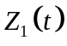

The complemented landline phones can help alleviate the inconvenience caused by cell phone’s inherent shortcomings under current technological level.
Considering that electronic technology is updated every 18 months [], some of the cell phone’s inherent shortcomings can be overcome and new functions are developed. Thus some people will choose to substitute their landline phones with cell phones. Using the accurate number of landline phones from 2005 to 2007[Reference 4], we apply nonlinear curve fitting method to get as a function of time,
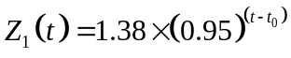 (7)

5.5 Energy Consumed by a Landline Phone per Day
Most of the energy is consumed under active mode (average power is about 2.5watts). We neglect the energy consumed by landline phone under stand-by operation mode. We assume the total time of landline’s active mode is the same as the cell phone (about 108.5 minutes per day from table1.). Hence the energy consumed by one landline phone per day is,
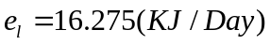

By combining equations (6), (7) and, we have the final expression of the total landline phone’s energy consumption per day,
(8)
Whose graph is shown in Fig.4..
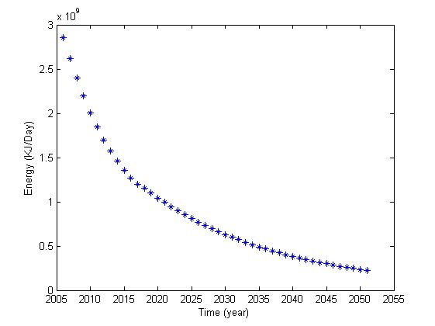
Fig.4 Energy consumption of total landline phones per day Vs time

5.6 Total Energy Consumption of Providing Phone Service
By Combining Equation (5) and (8), we could display the graph shown in Fig.5.
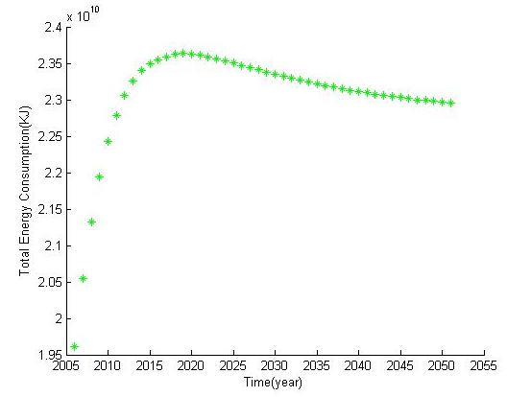
Fig.5. Total energy consumptions Vs time

If we plot,and 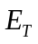 in the same coordinates ,the graph is given in Fig.6.
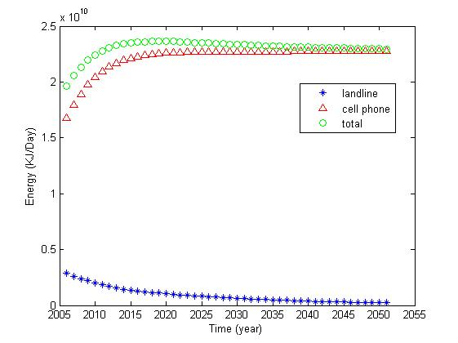
Fig.6,and Vs. time
So, From Figure 5, we find that first increases to the maximum value (about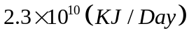) and then decreases to a steady value (about).

5.7 Optimal Way of Providing Phone Service to “Pseudo US”
From the energy perspective, the optimal way would minimize the total energy consumption Fig.7displays total energy consumption as a function of cell phone.
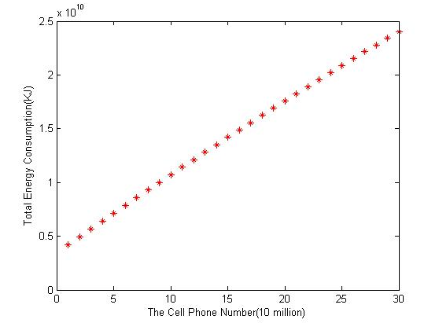
Fig.7 Total energy consumption as a function of the cell phone number

From the graph, we conclude that using landline phones only to provide phone service is the optimal way from an energy perspective.
Discussion of the consequences underlying different ways
We categorize the consequences into two main aspects
Impacts on the Environment and Energy Consumption
Impacts on the Society
Analysis of the consequences of Having only Cell Phones
From the energy and environment perspective, we can conclude the following impacts:
More energy is needed to provide phone service to the country than having both the cell phones and landline phone. (From Figure 7). Thus this can add more pressure on the social economic and energy distribution.
Moreover, this could aggravate the environmental burden due to more 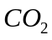emissions.

From the social perspective, we can conclude some following consequences:
Cell phones help fostering a sense of safety and security. Indeed this is one the basic functions of the devices.
Cell phones help us coordinate activities .The ability is, perhaps, one of the most central advantages of the cell phones. It has led to new ways of organizing everyday life. It provides flexibility in the way we plan our days. In its broadest sense, it can well be that the cell phone will lead to changes in the organization of urban life
Beyond the functional use of the cell phone, the device has led to a different understanding of interaction and networking among teens. The devices allows for a type of anytime-anywhere-for-whatever –reason type of access to other members of the peer group. This means that the social network is more tightly bound together and dynamic in its organization and location
The cell phone has the capacity to increase the functional viability of very small groups and single individuals, because they have increased opportunities to mobilize additional resources from outside actor
Cell phone allows for the development of stronger in-group ties. It leads to the sharing of experiences and emotions more immediately than almost any other mediated form of contact, save face-to-face interaction
Cell phone can be a disturbing resource in public places .The ringing of a mobile phone in a bus or a restaurant is the butt of many bitter comments
Analysis of the consequences of having only landline phones
From the energy and environmental aspect, we can draw some impacts as following:
Less energy is needed to provide phone service to the country than other ways (from Figure 7). This can alleviate the pressure on the social economic and energy distribution.
This can reduce the environmental burden due to less emissions
From the social aspect, we can find that the landlines do not have all the advantages that the cell phones have. Thus the society with only landlines cannot best satisfy the social need and facilitate the social communication.
But it is not a disturbing resource in the public places. At this sense, it is a more friendly communication device compared with cell phones.
Analysis of the consequences of having both cell phones and landline phones
An appropriate mixture of the two is an acceptable and reasonable way in providing phone services to the country both from two aspects. Firstly, from the energy and environment perspective, the energy needed can be appropriate, thus, it will not add too much burden on the environment and the economic. Secondly, from the social aspect, this way can satisfy the social need and help facilitate social communication.

6. Energy of Recharge Waste
In Req.1 we assume the charging time to be 10 hours to be in consistent with the energy consumption of the call mode in an energy drain-recharge cycle. However, it is not proper using this data to calculate the energy of recharge waste for the recharge time in real society is certainly not 10 hours. So we need to estimate the recharge time first.

6.1 Different Kinds of Recharge Waste Behaviors
We classified three kinds of recharge behaviors:
·conventional recharge: charge the phone when it is powerless and pull out the recharger device the moment the phone is fully charged. This type of charge pattern consumes the essential energy to balance the electricity usage of cell phones. So we exclude it from the energy waste model.
·10 hour recharge: charge the phone every night and pull out the recharger device the next day, we average the charge time to be 10 hours.
We should note that：the cell phone does not need to be charged every night. It is a waste of energy when the cell is fully charged but with the phone on the recharger.
·24 hour recharge: charge the phone at night and always keep the recharger plugged in, we average the not-charged time to be 14 hours and the other 10 hours obey the 10 hour recharge pattern. Obviously, energy is wasted all over the day.

6.2 Estimate of the Recharge Time
By referring to literature about Probability and Numeral Statistic, we come across an important clue: the number of receiving or answering the call submits to Poisson distribution with parameter:
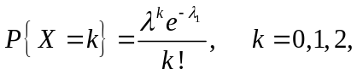

at the same time, the time length during a call obeys exponential distribution with parameter:
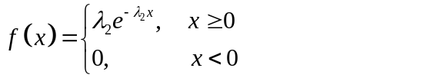

After referring to related research, we get information about the mathematical expectation of the two distributions (and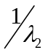).The source of energy consumption during the call and standby mode comes from Table1and Table 2. Thus we obtain the total energy consumption for one cell phone per day. The recharge time is expected to be 2 hours approximately. Some literature research strongly supports our result. Motorola Advanced Technology Center [Ion V. Nicolaescu, William F. Hoffman] released a graph showing that the charging time to be 7500 seconds. We then applied 2 hours as the recharging time.

6.3 Calculations of Energy Wasted
We calculated the energy wasted every day by the following equation.
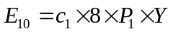 (9)
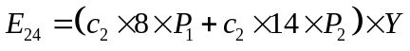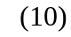
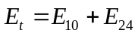 (11)
Where

= the time range with the battery is fully charged,

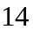= the time range only the recharger plugged in,
= the percentage of subscribers applying 10 hour recharge,
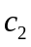= the percentage of subscribers applying 24 hour recharge,
= the total number of the subscribers in the “Pseudo US”,
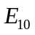= the energy wasted under the 10 hour recharge condition,
= the power wasted when the battery is fully charged,
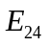= the energy wasted under the 24 hour recharge condition,
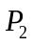= the power wasted with only the recharger plugged in,
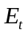= the energy wasted totally,
To ascertain the value of and, we resorted to a survey on the recharge behavior in America, and both choose the data 0.3. And we also find that =1W. For, we get it from Table 3. =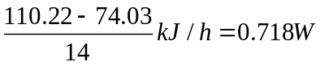

6.4 Barrels of Oil Equivalent to Energy Wasted
As is known to everyone, oil burns to release heat. In theory, the heat is converted to electrical energy totally. However, in reality, that is impossible for the heat machine could not get an efficiency of 100%. The optimal value can be 40%. (Reference 7) From dictionary, we get the relationship between barrel oil and energy:
1 barrel oil equivalent = 1.7 MWh (heat)
Considering the heat machine efficiency, we conclude that:
1 barrel oil equivalent =0.68 MWh
Apply the detailed data to the equation, we get = 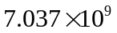kJ,
Converting the energy into barrels of oil, we get the result: the barrel of oil is 2875.

7. Energy Wasted by the Current U.S.
We reported a preliminary estimate on the total energy waste, considering various recharger types (TV, DVR, printer, fax/copiers, monitor and so forth). Electronics of different category involved in our research are listed in Table 1.

Table 4: Electronics Involved in Our Research
Video | Audio | Set-top Boxes | Telephony | Offices
Analog TV  Digital TV  VCR  DVR | Component Stereo  Compact Stereo  Portable Stereo  Clock Radio | Analog Cable Box  Digital Cable Box  Satellite Receiver  Game Console | Answering Device  Cordless Phone  Cordless Ans. Dev.  Cell Phone Charger | Monitors  Printers  Faxes/Copiers  Other Peripherals

Notes: TV = television, VCR = videocassette recorder, DVD = digital versatile disc.

7.1 Our Data Gathering Approach
When the device is left plugged in but not in charge, we define this as an idle mode. Namely, idle may occur (1) after the service ends but before the user switches the unit off or (2) the unit is plugged in and appears off to the user. Some consumers never switch off units with idle modes.

We resorted to a bottom-up approach combining direct measurements of individual devices and survey data. The approach consists of three major steps for each recharger:
- estimate the time of the idle mode.
- measure the power use of actual product in this mode.
- estimate the number of units of that device in current U.S.

7.2 Time Spent on the Idle Mode
Conventional surveys are of no use in estimating the usage for the Idle mode, which is critical for the accurate estimate of unit energy use. Estimating this pattern involved large sums of data sources and usage assumptions that varied from product to product. Because of the complexity to collect precise statistics, we combine anecdotal data and reasonable guesses to evaluate the value of usage under Idle pattern.

7.3 Power Measurements
An accurate estimate of energy waste requires an estimate of the energy use in the idle mode. It is a tremendous job to do the experiment ourselves in such limited time. Fortunately, somebody (Karen Rosen and Alan Meier, Reference 8) had conducted this method. They used a true RMS wattmeter that was custom-built for measuring low power levels with high resolution and accuracy. We applied the result to support our model.

7.4 Number of Units in Current U.S. Houses
To get the accurate data about the number of the devices, we employ two methods: one used ownership report and the other sales data in recent years. Mostly, the two methods yield similar stock estimates. When the results differed significantly, we choose the data that seems more probable.

7.5 Calculation of Current Energy Wasted
We weighted the arithmetic mean of the measured power level to reflects the average usage profile of a certain kind of device, we then multiply this by the number of seconds every day, obtaining the average unit energy waste(UEW). National energy waste per day () were calculated as the product of UEW and number of units nationwide. The equation is as follows:
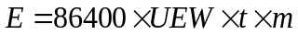 (12)
where
stands for national energy waste per day(KWh)
 means average unit energy waste(KW)
is the time percentage of the Idle mode
is the number of units in current U.S.

Table 6 shows the average measured power level in watts, idle mode time percentage and daily UEW values.

Table 6: Usage, Power, and Unit Energy Waste of different devices (UEW)

Devices | Units Measured | Idle Mode |  | UEW
Devices | Units Measured | Power/(W) | Time/(%) | Wh/d
Analog TV | 372 | 4.6 | 84 | 92.736
Digital TV | 14 | 8.8 | 84 | 177.408
VCR | 126 | 7.59 | 96 | 174.8736
DVD | 18 | 6.82 | 96 | 157.1328
Component Stereo | 119 | 11 | 81 | 213.84
Compact Stereo | 19 | 11.8 | 90 | 254.88
Portable Stereo | 22 | 2.43 | 94 | 54.8208
Clock Radio | 33 | 1.7 | 99 | 40.392
Analog Cable Box | 42 | 11 | 78 | 205.92
Digital Cable Box | 5 | 23 | 78 | 430.56
Satellite Receiver | 31 | 16 | 78 | 299.52
Game Console | 12 | 1.1 | 78 | 20.592
Answering Device | 27 | 3.2 | 99 | 76.032
Cordless Phone | 30 | 2.6 | 35 | 21.84
Cordless Ans. Dev. | 23 | 1.1 | 35 | 9.24
Cell Phone Charger | 7 | 1 | 75 | 18
Monitors | 13 | 48 | 85 | 979.2
Printers | 4 | 8.4 | 89 | 179.424
Faxes/Copiers | 5 | 30 | 99 | 712.8
Other Peripherals | 20 | 7.8 | 95 | 177.84

7.7 Barrels of Oil Equivalent to Energy Wasted

As is known to everyone, oil burns to release heat. In theory, the heat is converted to electrical energy totally. However, in reality, that is impossible for the heat machine could not get an efficiency of 100%. The optimal value can be 40%. From dictionary, we get the relationship between barrel oil and energy:
1 barrel oil equivalent (bboe) = 1.7 MWh (heat)
Considering the heat machine efficiency, we conclude
1 barrel oil equivalent (bboe) =0.68 MWh
Estimates of units, energy wasted and barrels of the oil are given in Table 7.

Table 7: Estimates of Units, Energy Wasted and Barrels of the Oil

Device | Units | Idle Energy | Barrels of oil
Device | (Million) | (GWh/d) | Barrels of oil
Analog TV | 286 | 26.5225 | 39003.67
Digital TV | 3.6 | 0.638669 | 939.2188
VCR | 215 | 37.59784 | 55290.92
DVD | 5.4 | 0.848517 | 1247.819
Component Stereo | 90 | 19.2456 | 28302.35
Compact Stereo | 65 | 16.5672 | 24363.53
Portable Stereo | 95 | 5.207975 | 7658.788
Clock Radio | 210 | 8.482321 | 12474
Analog Cable Box | 60 | 12.3552 | 18169.41
Digital Cable Box | 5 | 2.1528 | 3165.882
Satellite Receiver | 16 | 4.792321 | 7047.529
Game Console | 60 | 1.23552 | 1816.941
Answering Device | 87 | 6.614784 | 9727.624
Cordless Phone | 95 | 2.0748 | 3051.176
Cordless Ans. Dev. | 45 | 0.4158 | 611.4706
Cell Phone Charger | 81 | 1.458 | 2144.118
Monitors | 80 | 78.336 | 115200
Printers | 83 | 14.89219 | 21900.28
Faxes/Copiers | 30 | 21.384 | 31447.06
Peripherals | 300 | 53.352 | 78458.82
Total | 1912 | 314.174 | 462020.6

To clearly show the contribution proportion of different devices to the energy waste, we plot a figure (Fig.8)underneath.

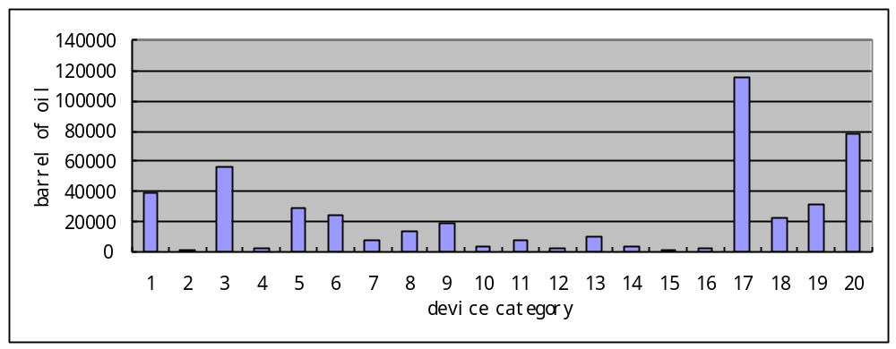

Fig.8 the barrels of oil needed for different device categories.

8. Energy Prediction for Providing Phone Service
We first predict the population and economic growth in the next 50 years, then discuss their impact on the number of landline and cell phones respectively. The energy consumption of every landline and cell phone is already known based on Req.1. Finally, we sum up the two kinds of energy by simple multiplication and addition.

8.1 The Method of Projecting the Population
There exists large amount of method to predict future population. We adopt the method of projecting population inspired by a report from U.S. Population Division (by Frederick W. Hollmann, Tammany J. Mulder, and Jeffrey E. Kallan).

8.2 Assumption and Principals
According to the stipulation, the definition of the population with respect to who is included and the characteristics of included people remains the same throughout the projection period. Future populations are derived from a base population through the projection of population change by its major demographic components, births, deaths, and migration.

8.3 Modeling the Population
The component method is expressed by the following equation:
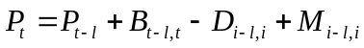 (13)
where
P_{t} = population at time t;
P_{t-1} = population at time t-1;
B_{t-1,t} = births, in the interval from time t-1 to time t;
D_{t-1,t} = deaths, in the interval from time t-1 to time t; and
M_{t-1,t} = net migration, in the interval from time t-1 to time t.
We define two kinds of individual age groups: the initial age group, which is births during the interval from t-1 to t; any other age group as of the last birthday, denoted by a. The equation is replaced by the two equations below:
P_{t}(0) = B_{t-1,t} - D_{t-1,t}(0) + M_{t-1,t}(0) (14)
P_{t}(a) = P_{t-1}(a-1) - D_{t-1,t}(a) + M_{t-1,t}(a) (15)
We refer to the population series from April 1, 1990, to January 1, 1999, as the base series for the projections. Births and deaths are produced by calendar year; immigration data by federal fiscal year. Data sources used to estimate the components of population change for the base series are produced for ten-year intervals.

8.4 Economic Growth Analysis
Economic growth certainly stimulates consumer’s desire to purchase, and therefore improves the frequency of changing cell phones for most subscribers. However, in our model, as is mentioned above, subscribers could have no more than one cell phone. That is, the economical level has little effect on the cell phone-hold numbers.
We therefore neglect the economic influence in terms of energy consumption. We focus our attention on the main factor----population growth.

8.5 Population Growth and Impact on Phone Energy Consumption
As the population increases, the subscriber of phone holders changes undoubtedly. We develop our model in Requirement 1. Considering the population growth model, we hold on the opinion that the total number of cell phones growth rate is unchanged. Different from the former one, the carrying capacity K is no longer 300 million, instead, it (the maximum number) means the temporary population.

8.6 Number of Cell Phones in the Future
From the predicted population for the next five decade (the result is listed in Fig.), we apply the data into the differential equation. Thus we obtain the number of cell phones. Fig.9 shows the detailed data.

Fig.9 The number of population and cell phones for the next five decade
Year | 2010 | 2020 | 2030 | 2040 | 2050
Population | 308,936,000 | 335,805,000 | 363,584,000 | 391,946,000 | 419,854,000
Number of Cell Phones | 275,758,295 | 331,691,788 | 361,602,962 | 390,081,959 | 418,037,067

8.7 Discussion on the Number of Landline
From Fig.9 showed above, we easily find out that the subscriber of cell phones approaches the maximum population number. As the assumptions mention above, we have absolute reasons to believe that the necessary number of landlines for maintaining the communication with the outside 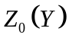 is much fewer compared with the number of cell phones. The number of landlines needed for complementing the shortcomings of cell phones under the current technological level has no connection with the population and economic factor. Then we conclude that the amount of landline subscriber does not change over the population and economic growth.
To sum up, after discussing the factors based on the reasonable assumptions and mathematical model, we draw the conclusion that the population growth mainly affects the number of cell phones only, and the economic factor does little matter. We calculate the energy needs for providing phone service. The result is listed below in Fig.10.

Fig.10 Energy by Cell Phone, Landline, and Barrel of Oil

Year | 2010 | 2020 | 2030 | 2040 | 2050
Energy by Cell Phone(kJ) | 20414386579 | 24555143066 | 26769467277 | 28877767425 | 30947284070
Energy by Landline(kJ) | 2007894502 | 1043491371 | 629252830 | 382045636 | 234164169
Total Energy(kJ) | 22422281081 | 25598634437 | 27398720107 | 29259813061 | 31181448239
Barrel of Oil(kJ) | 9159.428546 | 10456.95851 | 11192.28763 | 11952.53802 | 12737.51971

9 Model Strengths and Weaknesses
Strengths

The fitting curve of cell phone numbers vs. time we obtain is in good agreement with the actual data of cell phone subscribers ranging from 1985 to 2005. Moreover the predicted cell phone subscribers in 2008 using our model fit so well with actual data in 2008.()

We take into account of the cell phone numbers and current technological level when calculating the number of landline phones. The two factors are comprehensive in reflecting the number of cell phones.

We categorize the modes of chargers and the cell phone subscriber’s behavior when calculating the energy waste by one cell phone in detail.
Therefore, this detailed classification reflects the problem accurately.

Weakness

Total Energy consumption only consists of two parts: energy consumed by cellular phone and landline phone .We do not take into account the energy consumed by other facilities such as end office facilities ,transmission facilities and repeater facilities which are indispensable parts of the telecommunication network.
We assume each person has less than one cell phone. This assumption does not take into account the possibility one person has more than one cell phone.
We do not take into account of the actual different distribution among different age groups.

10 Results
Our first model gives out the result:
1. The electricity utilization peaks around 2019(about 9626(barrels/day)) and becomes steady after 2041(about 9400(barrels/day))
2. The optimal way of providing phone service is to provide only landlines from the energy perspective.
Our second model reveals:
1. The waste of total cell phones per day is about2847(barrel/day)
2. The total waste of various consumer electronics is about 462021(barrel/day)
Our extend model shows that,
1. The total energy consumption keeps growing and reaches about 12738(barrel/day)

