  For office use only
  T1 | ________________
  T2 | ________________
  T3 | ________________
  T4 | ________________
  Team Control Number
  10134
  Problem Chosen
  C
  For office use only
  F1 | ________________
  F2 | ________________
  F3 | ________________
  F4 | ________________

2011 Mathematical Contest in Modeling (MCM) Summary Sheet
Practicability and Development of Electric Vehicles
Summary
In order to determine the practicability and development of electric vehicles, We use both mathematical models and computer simulations to analyze the energy, charging and environmental issues of electric vehicles.
In Task 1, we establish a DEA model with three fossil fuels, and we specify the relative energy saving potential of the three fossil fuels. Before developing DEA model, we obtain the development law of coal, oil and natural gas in some typical countries, lay data foundation for DEA model, and predict the expected future of energy development. We also study the development regularity of renewable energy and infer that it is of great possibility to increase electricity from this kind of energy.
In Task 2 , Through our calculations about charging at off-peak times, it can improve the actual utilization of distribution system and the negative impact produced by the harmonic currents can also be a better solution. On the other hand ,we turn to comparing different ways of charging ，then make it achievable to a comprehensive charging scheme for maximizing practicality of electric Vehicle. Ultimately，we come up with a simple business development model for its future in our own opinion .
In Task 3, we compare environmental impact of various traffic modes. Under circumstances of considering air pollution and CO2 emissions caused by electric vehicles directly or indirectly, we develop a environmental cost model, from which we obtain powerful explanation for the large practicability electric vehicles.
Finally, we build Logistic model that synthesizes energy in Task 4, charging and environment factors. We make comprehensive analysis for these factors, which is helpful for confirming the practicality of electric vehicles and deducing that it has wide development space.

Task 1: energy issues
The development of fossil energy consumption
We put the principle and method of fitting problem into use and combine with the relevant data given in the topic. Considering consumption of coal, oil, natural gas and theirs development in some countries, it can lay a foundation for the potential of energy saving, which will be discussed in the following content.
Model Setup
The problem studied here belongs to one-dimensional curve fitting. Suppose that there are n different discrete points for（,）( i =1,2,…n), the fitted curve equation we want to find is y=P(x) and variance of fitting function is =P()-(i=1,2,…n), its common standards have:
Rule 1 : Select P(x) to get the minimum of absolute value sum of all deviation, namely
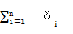=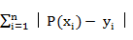 min
Rule 2 : Select P(x) to get the minimum of absolute value maximum of all deviation, namely
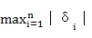=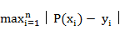 min
Rule 3 : Select P(x) to get the minimum of sum of squares of all deviation, namely
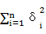= min
Relative to character, due to rule 3 is the most convenient for calculation, we select the fitted curve according to rule 3. Rule 3 is also called as the least-square principle, the corresponding curve fitting method as the least squares.
Determining the standards, we should determine the fitting function form. First of all, We use Matlab to map scatterplot of the given data. And then, Observe the general form of the curve , elect several common curve to fit separately and choose curve fitting of the best effect. Matlab provides a polynomial least-square fitting function ployfit (x, y, n), which calls format for
P= ployfit(x,y,n)
Among them, the x and y are horizontal y-coordinate of given data; n is fitting polynomial times; the return value P is coefficient vector of fitting polynomial according to the independent variable drop power arrangement.
Model Solution
According to the data form Statistical_Review_of_World_Energy provided from network resources in the topic, we chose four country in different regions. They are USA in North America, China in Asia, Australia in Australia, Germany in Europe. The following is our reasons: the four countries distribute in different areas, are energy consuming nations and have stronger representative.
In Matlab, we make linear curve fitting for relationship between the consumption and year in the United States, China, Australia, Germany respectively. The consumption is in the field of coal, oil and gas.
Model Result
In the following expressions, x is years (Statistical_Review_of_World_Energy form for 1965-2009).In order to enable drawing more convenient, we select 1965 as a benchmark, 1966 as the first year.
The development regularity of coal consumption in the four countries
Comparing scatterplot with fitting figure through procedure in figure 1, we can obtains the fitted curve equation of coal consumption in the United States, China, Australia, and Germany respectively:
y= -0.0103+ 0.6224 -1.9531x+ 300.9395
y= 0.0315-1.38244 +30.0532x+ 90.5968;
y= -0.0011+0.0713 -0.1535x+ 11.2391
y= 0.0017 -0.1404+ 1.2600x+146.7230;
In the above expressions, Y is coal consumption for a year.

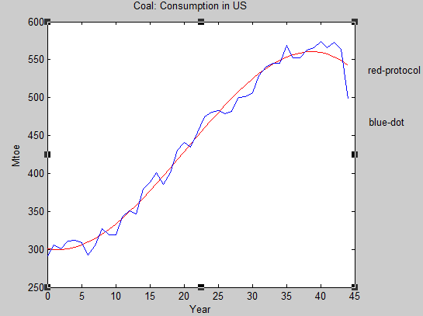
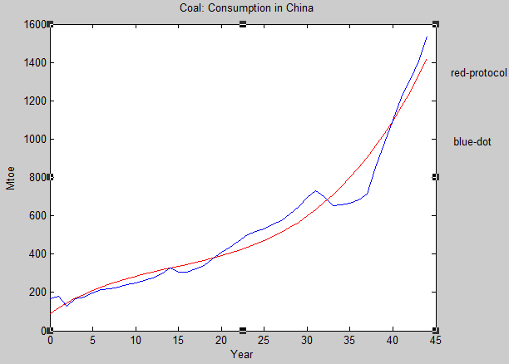

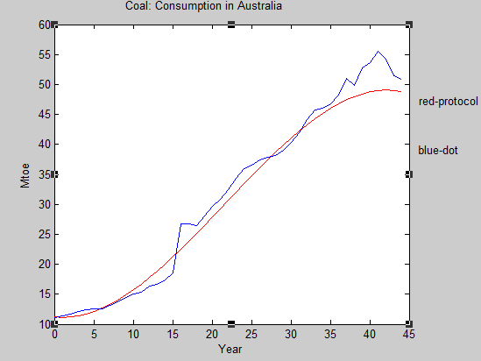
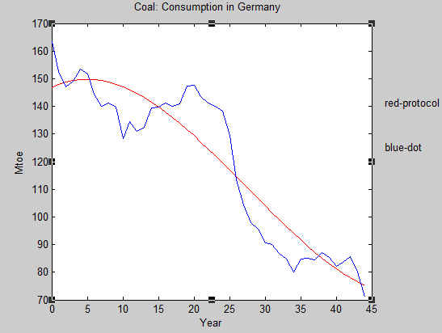

Figure 1 . Scatterplot and fitting figure of coal consumption in the four countries
The development regularity of oil consumption in the four countries
Comparing scatterplot with fitting figure through procedure in figure2,we can obtains the fitted curve equation of oil consumption in the United States, China, Australia, and Germany respectively:
y= 0.0156 -1.0753 +25.8490x+ 589.3825;
y= 0.0100 -0.4493 + 9.8254 x+-0.5671;
y= 0.0007 -0.0471 + 1.2569x+ 18.7175;
y= 0.0038 -0.3081+ 6.6972x+101.3914;
In the above expressions, Y is coal consumption for a year.

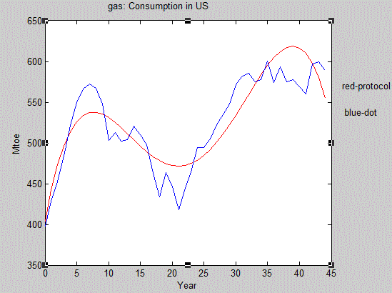
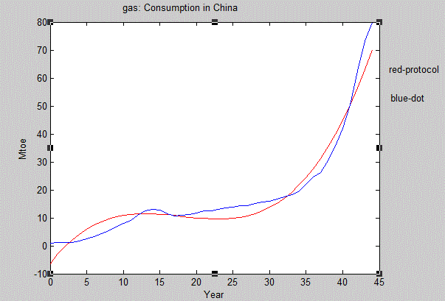

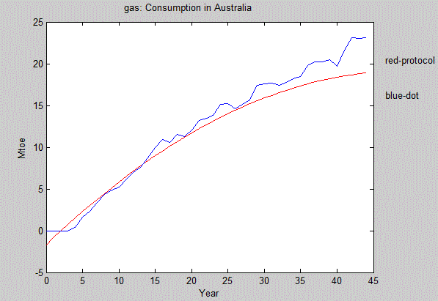
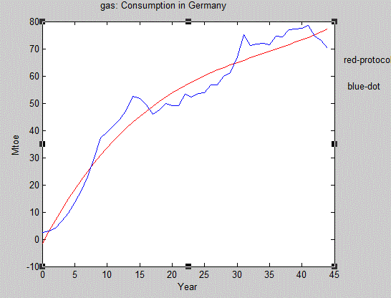

Figure 2. Scatterplot and fitting figure of oil consumption in the four countries
The development regularity of gas consumption in the four countries
Comparing scatterplot with fitting figure through procedure in figure3,we can obtains the fitted curve equation of gas consumption in the United States, China, Australia, and Germany respectively:
y=-0.0017 + 0.1532 -4.3363 + 42.4410x+404.1816;
y=0.0038 -0.2048 + 3.3915x -6.3359;
y=-0.0084+0.8381x-1.6993;
y=0.0010 -0.1044+4.44210x -1.39670;
In the above expressions, Y is coal consumption for a year.

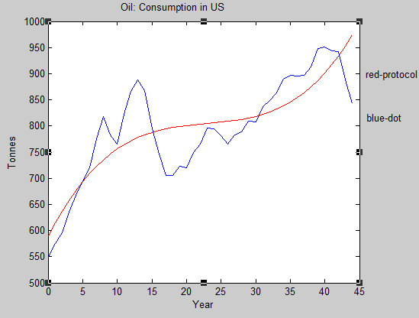
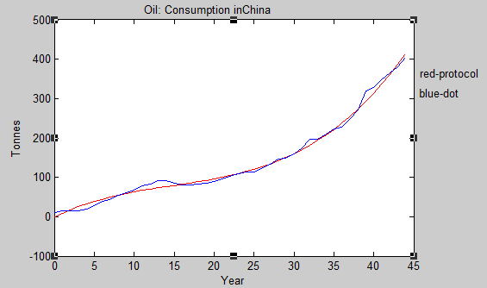

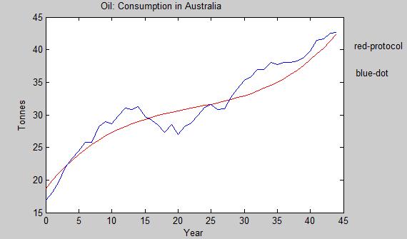
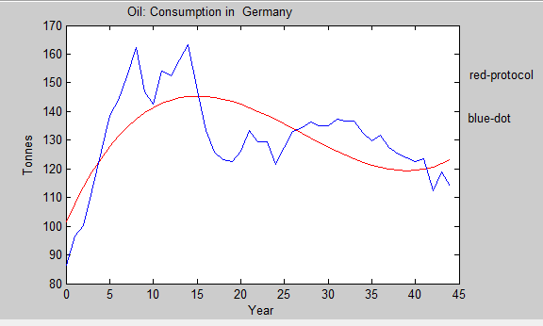

Figure 3. Scatterplot and fitting figure of gas consumption in the four countries
Model conclusion and analysis
By the above results, the law of development of each kind of energy in the four countries are three times function form y=a+b+cx+d. This form not only can determine the development of the year state at random, but also can predict the future development trend of energy consumption. What the most important is that it can provide powerful mathematical basis for DEA model which will be set below.
The development regularity of renewable energy
In order to infer whether it is of possibility to increase electricity from renewable energy sources such as solar, wind or not, we try to determine using solar energy, wind development regularity. Here is no need to develop specific models .We can use Excel and Statistical_Review_of_World_Energy table data to get changing curves of Annual consumption in solar and wind energy in Figure 4.
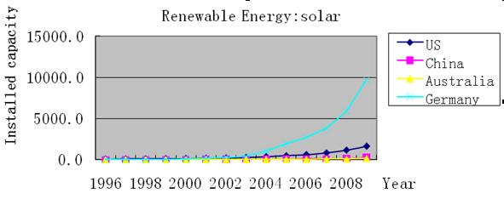
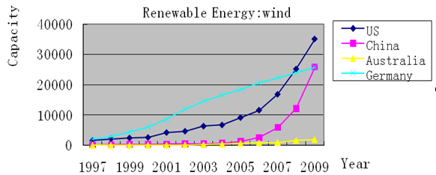
Figure 4. Annual consumption in solar and wind energy
It can be seen from the figure that for the solar, wind and other renewable energy sources, its consumption is increasing year after year, shows a similar trend of exponential growth. Therefore, renewable energy has a certain development space. Meanwhile, combining with related figure 5 searched in the web links which shows upward trend of year renewable energy for electricity generation, we can draw a conclusion that from solar, the growth of electricity generation from wind and other renewable energy is of possibility.
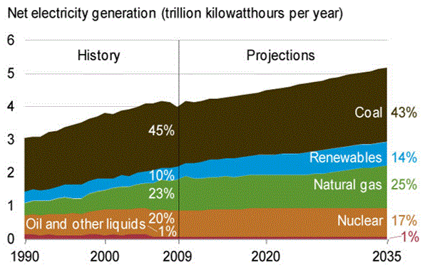
figure 5 Electricity generation by fuel ,1990-2035
DEA model
DEA model is used to estimate comprehensive power generation efficiency of fossil-fuel and energy saving potential of different types of fuel.
Model Setup
DEA (DEA) is proposed by Charnes in 1978 and has become an important tool to evaluate the system of energy and environment, for example, to compare the technical efficiency of different plants (Zhou et a1., 2008). Research in energy efficiency, DEA also has been widely used, for example, total factor energy efficiency measurement (Hu and Wang, 2006; Zhou et a1., 2008). However, it is not much to evaluate and compare fossil fuel power generation efficiency in different countries by the application of DEA. We set up a DEA model for evaluating the efficiency of fossil fuel power generation and energy saving potential.
We select the United States, China, Australia and Germany and V do the assumptions: the input indicators are the amount of coal consumption, oil consumption, gas consumption for power generation. Output indicators is the total capacity . The DEA model that can be used to measure fossil fuel power saving potential of the nth countries is as follows:
=max(/+/+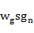/)
+=
+
+
≥
≥0,k=1,2,…,N
≥0,n=1,2,…,N (1)
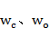、are respectively importance factors of coal, oil and natural gas saving potential (ie, the ratio of energy saving potential to the actual energy consumption). Importance factors can also be expressed by the ratio of electric energy production of coal, oil, natural gas to fossil fuel power generating capacity. That is to say, If three kinds of input and one output is of different unit, the calculation results unchanged. By solving expression (1),we can get the energy saving potential of the nth country in the field of coal, oil and natural gas power generation、和. And, in turn, we can estimate reduction potential of in respect of fossil fuel power. The optimal value of model provides standardized indicators that evaluate energy-saving potential of the overall of fossil fuels. On this basis, it can be used to evaluate a comprehensive efficiency of fossil fuel power:
EEI=1-=1-/+/+/
Model Solution
In the application expression (1), it is necessary to determine importance factor of the three types of fuel saving potential. We use fitting curve equation of the three energy consumption, combine with figure 5 and calculate the ratio of coal, oil and natural gas generating capacity. As a result , the ratio of electricity generation of coal, oil, natural to total electricity generation. On this basis, calculation of the United States, China, Australia, Germany on the different types of fossil fuels energy-saving potential is of possibility. Figure 6,7,8 give the relative energy saving potential of these countries in the electric generation of coal, oil and natural gas.
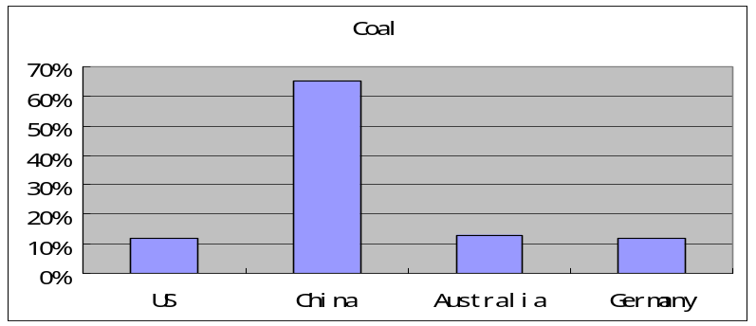
Figure 6 relative energy saving potential in the electric generation of coal
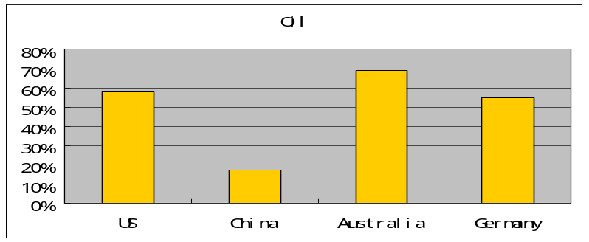
Figure 7 relative energy saving potential in the electric generation of oil
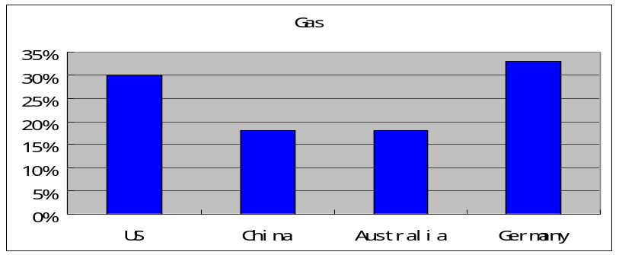
Figure8 relative energy saving potential in the electric generation of gas
Analysis of model and conclusion
It can be seen from the above figures, The relative energy saving potential of various energy generation does not do the same in the four countries. China's relative energy-saving potential of coal power generation is ahead of the other countries, reaching 60%. However, in the field of oil, China is far from other countries and Australia is the winner. For natural gas energy, the four countries have some potential, while a larger proportion in Germany. According to subject requirements, we contact the outcome and draw a conclusion that the United States, China, Australia, Germany, can respectively save fossil fuels through greater efforts to use oil, coal, oil, oil. However, in order to save oil by use of electric vehicles, then the amount of oil for power generation should be reduced accordingly. All countries can choose the energy which is of high energy saving potential to conduct electricity besides oil.
Task 2 Charging issues
Background
Electric vehicles have the batteries which are disassembled and the chargers which can be moved, so that people can charge batteries at home, in the daytime or in the work place. Charging batteries at off-peak times can improve the work efficiency of power stations and effectively avoid the electricity demand in the daytime, at the same time, electricity can still meet the user's needs without additional power. On the other hand, it also can reduce the peak-valley gap, improve the actual utilization of the electricity distribution system and widen the consumer market of terminal electricity. But with large quantities of electric vehicle’s batteries in power systems and the nonlinear load of charging equipment, the power quality will become bad , so much so that it will cause a big harmonic current(The impact of harmonic currents and harmonic voltage on power system is called harmonic pollution). The charging time of battery is approximately eight hours. The main shortcoming of conventional charging pattern is the long battery recharging time and the demand for electricity appeared to be insatiable, when there is an emergency operation. The performance of electric vehicle still exists most shortcomings such as heavy weight, the short driving distance, the short lifetime in its battery and so on, compared with fuel vehicles.
Strategy 1: harmonic pollution
The production of harmonic pollution
Nowadays there are two kinds of charging equipment. One is "uncontrolled rectifier + wave chopper ", the other is "uncontrolled rectifier + DC/DC converter (have high-frequency transformer) ".
"Uncontrolled rectifier + wave chopper " belongs to the early product, which is comprised of industrial frequency transformers, uncontrolled rectifier and wave chopper. The features of it is its low output DC voltage ripples , good dynamic performance, power frequency isolation, big volume ,large harmonic current ，low efficiency and so on. This kind of charging equipment injects big harmonic currents to power system. 5 times harmonic currents contain 60 ~ 69 percent, seven times for 40 ~ 49percent, 11 and 13 times for 10~ 13percent. The distortion rate of harmonic currents reaches 86. 2%.Such charging equipment produces too much harmonic pollution. The waveform characteristic of voltage and current is shown in figure 9.
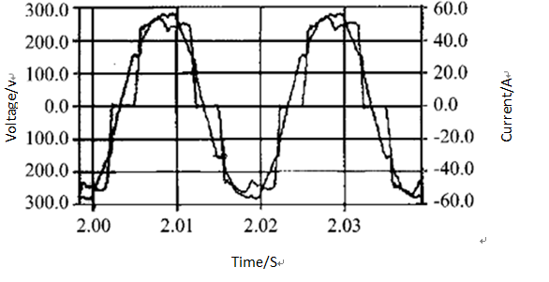
Figure 9 the typical waveform characteristics of voltage and current of early charger
The charging equipment of "uncontrolled rectifier + DC/DC converter (have high-frequency transformer) " is comprised of industrial frequency transformers, three-phase uncontrolled rectifier, high-frequency transformer, isolated DC/DC converter and so on. Three-phase uncontrolled rectifier circuits rectify three-phase AC current. After filtering, it provides DC input for high-frequency DC/DC power converters circuits. The output of high-frequency DC/DC power converters circuits charge for the battery through the output filter circuit. The features of it is its low output DC voltage ripples , good dynamic performance, high frequency isolation, small volume ,large harmonic current ，low efficiency and so on. The waveform characteristic of voltage and current is shown in figure 10. The distortion rate of harmonic current is still as high as 26.5 percent; odd harmonic current bigger, especially 5, 7, 11 and 13 times harmonic is far more than the GB/Z17625. 622003 prescribed access conditions.
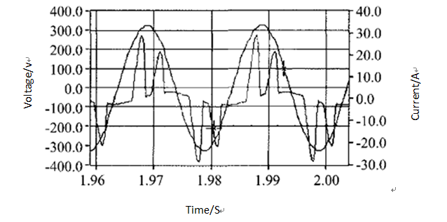Figure 10 the typical waveform characteristics of voltage and current of Common charger
The possible measures to deal with Harmonic pollution
Using the new charging device: New charging equipment is composed of the high-frequency DC / DC converter and PWM rectifier.Rectifier sides adopt PWM technology, which has high power factor and smaller harmonic current. The total harmonic distortion injected to the power grid can be less than 5%, corresponding to the harmonic current is also small. This kind of charging device can be used without additional harmonic treatment device, when it is in power systems. But its complicated structure, high cost and working performance still need further improvement.
The use of filters in the power system: We consider two cases, passive AC filter and active filter.
Plan 1. Using Passive AC filter
Passive AC filter is defined as power capacitors, reactors (often hollow) and the combination of resistors and other filtering devices, the load in parallel with the charging station. In addition to the role of the filter, it also takes the reactive power compensation and the role of regulator into account. Because of its simple structure, reliable operation and easy to maintain, it is widely used. Of course, the design of LC should be carried out for the 5,7,11,13 harmonics governance and capacity designed should not only meet the harmonic current absorption’s need, but also avoid non-merits and demerits of compensation.
Plan 2. Using active filter
Charger is time-varying load and the load characteristics change quickly. Filtering, reactive power compensation and voltage requirements are difficult to balance, sometimes, so that passive filtering cannot meet the requirements. Using active filtering technology, the choice of the compensation capacity has the formula to follow:
S₁=Kηζ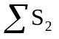
K—Reliability coefficient, take 1. 05 ~ 1. 20;
η-Charger charging efficiency;
ξ- Containing rate of harmonic currents produced by charger in the AC power input;
S₂-power of single charger.
If the access point in the charging station installed near the capacitor compensation device may lead to 5,7 times Resonator, charging station design needs to be tested, if necessary, to consider charging the capacitor station slip road near the access point to transform (change 4.5% or 6% reactor rate).
Coordinate the number of charger for each charging station:
Since harmonic currents’ phase angle produced by each electric vehicle charger is generally different, so harmonic compensation even harmonic offset is possible to appear. The larger of the number of charger used in each charging station, the more likely is harmonic compensation produced by harmonic current flow through the charging station to appear. We can build the following model,
Model: Figure 11 shows the situation that k electric cars are charging in a charging station and the harmonic resulted from them have a great influence on power system. We can use any car, for example, the A car represents these cars’ state-of-charge (SOC), at the same time, using ξ₁, ξ₂, ξ₃ ⋯ ξ_{k} to represent the corresponding voltage. At any given moment, a car charging in the stations may be completely discharged, part of the discharge, or fully charged (had already charging for a period of time.) Thus, their states of charge can use any of a number by a single probability density function to describe any number range from completely discharge to completely be filled with electricity.
Analysis
The charging current I which each electric car batteries required can use Fourier series represent.
I=∑{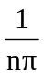[ sin ( nβ₂) - sin ( nβ₁ ) - sin ( nβ₄ ) +sin ( nβ₃ ) ] co s( nωt) } +∑{[cos ( nβ2 ) +co s( nβ₁) + cos( nβ₄ ) - cos ( nβ₃ ) ] sin ( nωt) }
β₁ ,β₂ ,β₃ ,β₄ —electrical conductivity of electric vehicle battery charger angle; n-harmonic frequency. It also can be abbreviated as I = cos( nωt +φn ) ,c_{n}=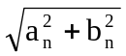,φ_{n} = tan a ( b_{n} / a_{n} ).
where c_{n}—harmonic amplitude; φn— the first n harmonics relative angle.
……
Charging station
The power supply system
Grid harmonic current
EV
EV
EV
Figure 11
EV
Many car electric vehicle in unity charging station charging
Electric car battery voltage of probability density function

218
300
0
Area=1
PDF
The battery voltage/V
Figure 12
Assuming the battery voltage is linear with SOC (linearly related), then all electric vehicle battery voltage can use a uniform probability density function of representation (such as the voltage range of 218 ~ 300 V), as shown in Figure 12.
As with different voltage levels for battery, β1, β2, β3 and β4 are also different. So, for the same k car in charging station, their c_{n} and φ_{n} is different. All the harmonics in the complex plane are added to make some order of harmonic compensated. If the Monte Carlo method, the charging station’s total harmonic distortion of input current values can be represented as
E=[THD]= =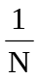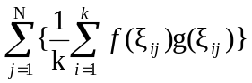
Where N—Monte Carlo Calculation of the total number of calculations;
—the i electric vehicles when the battery voltage calculate the j times;
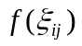、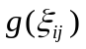—The corresponding probability density function and total harmonic distortion degree.
The relationship between the number of electric vehicles charged in a charging station and THD expectations is shown in Figure 13. Obviously, the larger is N, the smaller is the curve fluctuations (higher accuracy).When N = 100, the accuracy is enough. Seen from the figure, with the increase in the number of electric vehicles, THD value will decrease. When electric vehicles charging in the same station increase the number of infinite, THD can be reduced to a minimum. In fact, when the actual control capacity of each charging station is 10 electric vehicles, the corresponding THD values are close to the minimum, and thus controlling 10 car electric vehicles is the best choice.
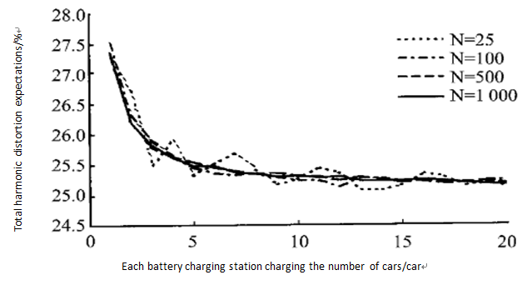
Figure 13 Curves of relationship between the number of electric vehicles in station and the total harmonic distortion expectations
The above figures are based on a typical electric car charger (such as the VRLA battery).When use different electric vehicles and battery charger, the best number of electric vehicles will also change.
Conclusions
After developing a model to consider how to coordinate the number of charger for each charging station, we can calculate the best number of vehicles charging in a station. It is of great help on the issue of a reasonable construction of charging stations.
Conclusions of Strategy 1
The negative impact which electric vehicle battery charging device connected to the grid on the power system is obvious, but we can use the new equipment and organic from a coordinated approach to deal with other aspects. In the meanwhile, We can calculate the number of stations to recharge electric cars in a region.
Strategy 2: The best method of charging and the influence of electricity change on vehicle electric business model
Through the analysis to the current electric vehicle market, we can kwon that there existing three different kinds of method of charging.
The advantages and disadvantages of three different charging models Slow charging of alternating current
After the termination of the discharge of the battery, it should be charged immediately (in special circumstances it should not exceed 24 h). The charge current is very low, about 15 A. This charge is called the conventional charge (Normal charge). The advantages of conventional charge mode are as follow:
•Although the charging time is longer, the charger and installation costs are lower for the reason that the use of power and current rating is not critical.
•It can take advantage of low power charging time to reduce the charge cost. It can improve the charging efficiency and prolong battery life.
DC Fast Charging
Fast Charge is also known as emergency charge .Large current provides short time charging service to electric car. Generally charging current of 150 ~ 400 A. The advantages of fast charging mode are as follow:
•Charging time is short.
However, compared with conventional charge mode, there are some disadvantages of fast charge:
•"Fast charge" is not fast, but reduces the battery life.
•Charging station is of high cost and profit model is questionable.
•It is easy to result in harmonic pollution.
•Vehicle price is high and not conducive to the popularity of electric vehicles.
Charge replacing the battery
By direct replacement of charging batteries for electric vehicles, we can achieve the purpose. Because the weight of the battery pack is large, specialized requirements of replacing the battery is higher.
Using this model, there are the following advantages:
•Electric car user can rent batteries to change those battery that have run out of. It is not only helpful for improving vehicle use efficiency, but also increase the conveniences and promptness.
•It can improve the charging efficiency and prolong the life of the battery.
•Charging for the replaced battery in the low periods, it can reduce the cost, improve economic efficiency of vehicle operating.
•It can solve charging time , accumulation charge quantity, battery quality, onward travel distance and price problem.
•It can discover single cell batteries in time, which is of positive significance for the problem of maintenance.
The main problems that this model is faced with are:
•Standardization of electric car and battery.
• Design and improvement of electric automobile.
• Construction and management of charging station.
•Circulation management of the battery.
The influence of electricity change on business model
For example,the RENAULT-NISSAN Company in Japan ,its way of changing battery is mainly based on the following business mode 1:
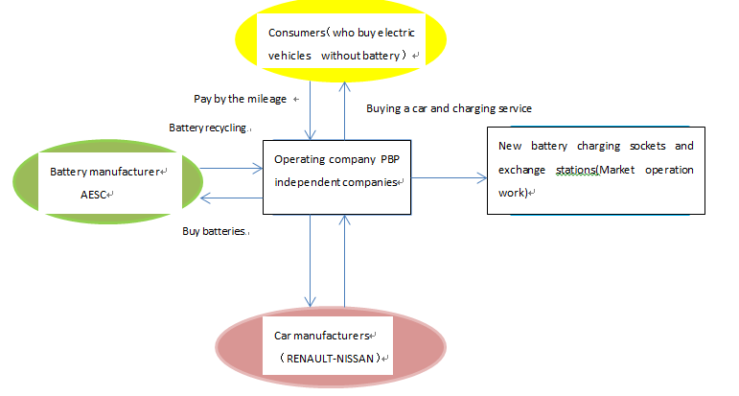
The advantage of this model can be summarized as "balance of interests", battery manufacturers, depots, operating companies and power companies can be found in the space of its profits, which has the enthusiasm to drive electric cars forward. The consumers that have little need to buy batteries worried less about the effectiveness of the battery and the lower price of electric vehicle, consumers’ desire to purchase is also greatly enhanced.
Slow or fast charge based on the following business model two:
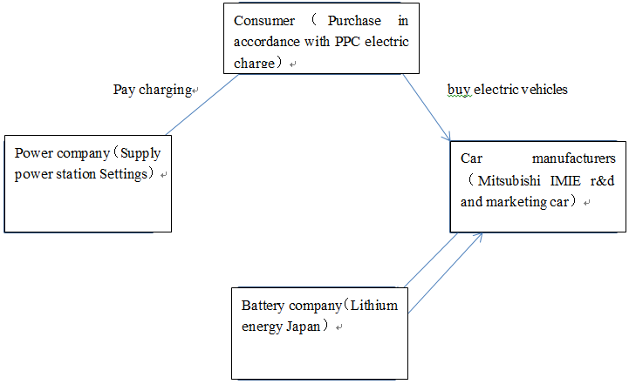
This model is Japan's business model. The business model of BYD and other manufacturers in China is similar to this traditional business model car.
In addition, as we have the idealistic views of our new energy electric cars ,we come up with the following business model three, hoping to explore.
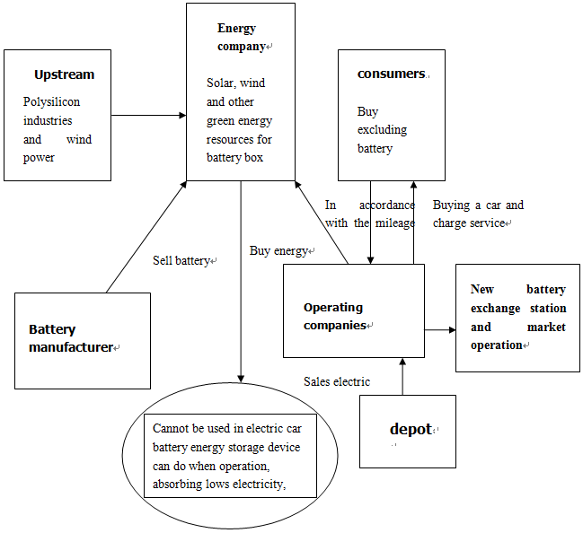
Task 3 Environmental issues
The various modes of transport on environment
Fuel vehicle emissions are a major source of air pollution. For example, in the end of 1995 , cars in the United States was 195.6 million (an average of 1.3 people have a car). Vehicle emissions of harmful gas emissions account for emissions in the United States are: CO accounts for 66%, HC is 31%, is 43%, particulate is 17%, is 23%, Pb is 37%. Overall estimated, 42% of air pollutants in the United States come from motor vehicles emissions. According to the study estimates, economic losses caused by air pollution in the United States is about $ 229,000,000,000 per year, including loss of human health, environmental damage, agricultural losses ,which are 1350,860,80 billion U.S. dollars and an average of about $ 1,200 per vehicle cause loss of 2 times to the fuel costs. For other industrial countries, although the extent of pollution is slightly different, roughly the same. Even some cities in developing countries such as Mexico City, Bangkok, air pollution caused by vehicle emissions is also very serious. Direct pollution of electric vehicles is very small, but there are potential sources of pollution coming from the electric cars. Stepping back and considering that the wind, hydroelectric power are used to drive electric cars, and they are zero emissions, then there is no air pollution? No, because any flooding would submerge a large number of biological and bio-corruption will produce large amounts of greenhouse gases. According to calculations, a hydropower generates lkwh electricity and C02 released by the submerged bio-is 209.
In the life cycle process, emissions of different modes of transportation are also different because of different materials used in production, the use of fuel and the use of the process. The following table 1 is a comparison of various means of transport.
Table 1 Energy consumption and emissions of a variety of transportation
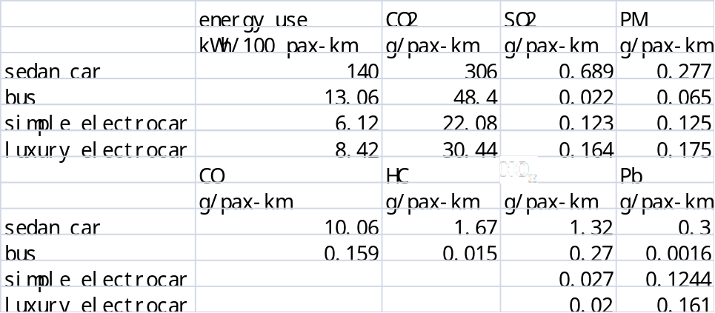
Bus energy consumption and emissions are the largest, but it also has the largest capacity. In the use phase, compared with the bus, energy use and greenhouse gas emissions of electric vehicle are very small, but the S02 and PM emissions are 2.3 times and 5.7 times to the bus. Unleaded gasoline is leaded, so the bus and car exhaust emissions are also in lead emissions. In the U.S., the lead content of gasoline must not exceed 13mg / L (Lankey, Davidson et a1.1998). Lead emissions on the table contain the gasoline emissions. Emissions in the process of production and disposal occupy an important position in emission of lead. CO, hydrocarbons (HC) and nitrogen oxides (NOx) emissions can not know in the production of electric vehicles and power production process, but the bus's exhaust emissions are known. However, several other emissions of electric vehicles are lower than the bus except lead emission.
Emissions and treatment after the end of the life cycle of electric vehicles
In China, more than 90% of electric vehicles use lead-acid batteries as an energy source. Battery of simple electric car weighs about 14kg and it weighs about 18kg in luxury models of electric car . Lead in the battery exists in the form of oxide and sulfate lead,whose content is about 70% of battery weight. Batteries of different manufacturers are slightly different weight.
Recycling the lead
Lead pollution is not only the most troublesome problem of electric cars, but also hinder the development of electric cars in the United States in the 1990s. There are several stages of the process of lead pollution: 1) galena smelting stage; 2) battery production stage; 3) lead recovery phase; 4) non-recyclable waste lead. Loss rate is expressed by loss of unit weight of lead in unit weight of batteries. Americans Lave and Hendrikson in 1995 said that 4% lead loses in the use of primary process, 1% loses in the battery manufacturing process, 2% lead in the recycling process. That is, if the battery is made of 100% of the original production of lead, 3% lead will lose. In most industrialized countries, the recovery of lead is more than 90%.
Treatment of lead-acid battery scrap
With most of the scrap in the recovery of VRLA batteries, there is no flow of acid in the shell. If it is need to deal with the excess acid ,it can be completed by calcium hydroxide or sodium hydroxide the neutralization:
+Ca=Ca+2
+2NaOH=+2
Generation in the reaction of calcium sulfate is gypsum, which can be directly landfill disposal. Sodium sulfate can be used as household cleaners. In fact, this process has become a basic way to deal with other wastewater.
Air pollution on health effects produced by electric cars
Emission rate of S02 and PM are higher in the life cycle of electric vehicles, while emission of is lower than others. When people shift from electric cars to motor vehicle traffic transportation mode, S02 and PM emissions reduced, but the NOx emissions have risen. In the impact on public health, the impact of S02 and NOx is higher than the PM for 4-6 times. Research shows that If lead concentration in every cubic meters of air every increases 1 micrograms (1000 micrograms is equal to l mg) , The lead in human blood per litre lead 1.5 microgram accordingly. Lead accumulation in the atmosphere is about 1 meter from the ground, while this location is just child's breathing zone. Lead absorption in children with acute respiratory rate is higher than in adults .Under normal circumstances, 99% of lead that adult intake is discharged by relieving themselves, and excretion of lead in children is only 66%.There is still one-third accumulates in the body. It is reported that, under normal circumstances, the human blood lead concentrations exceeding 30 micrograms per liter will show neurotoxicity. The younger, the stronger sensitivity to the lead. Lead on the blood-brain barrier damage is mainly causing blood-brain barrier dysfunction, whose serious consequences is that intravascular water permeates of the human brain, causing brain edema.
The study also shows that for families with coal as fuel, the average level of lead in indoor air is 18 times higher than outdoor. Children's blood lead levels are significantly higher than no-coal-fired home. In the surrounding areas Lead-zinc mine tailings dam and lead-zinc smelter, Main plant per kilogram contains lead up to 3 grams , and if we use these plants with higher lead as fuel, it will also have a serious impact on human health .
Impact of pure electric vehicles on the CO2 emissions
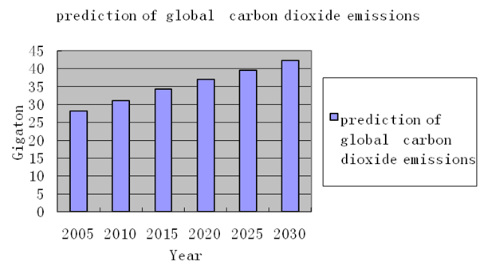
Figure 14 The forecast of global carbon dioxide emissions
Figure 9 shows the forecast of global carbon dioxide emissions. With pure electric vehicles replacing the traditional car, it will reduce CO2 emissions 52% per vehicle. 2 miles of annual driving, a conventional internal-combustion-engine car consumes 8 liters oil per hundred kilometers .The annual consumption of gasoline is 1600 liters and produces about 4.8 tons of CO2. To calculate with 12 degrees electricity per hundred kilometers, annual electric consumption of pure electric vehicles is 2400 degrees. If you take the effect of trough to peak power factor into account, assuming 80% of the automotive battery charges during the night, then each power electric cars actually add 480 degrees and the annual CO2 emission is 0.5 tons, which is less than traditional internal combustion engine vehicles by nearly 90 %. If you take the trend that the proportion of thermal power in the energy structure drops to 70% by 2020 into account, CO2 emissions of pure electric vehicles will further reduce to 0.375tons.
The promotion of electric vehicles have significant effects on reducing CO2 emissions in the automobile industry, but little effect on overall emissions.CO2 emissions in the automobile industry is about 16% of total emissions now. By 2020, assuming pure electric vehicles account for 10% of car ownership, then replacement of each pure electric vehicles will be 90% reduction and the entire auto industry will be reduction of 9%.The reduction of CO2 emissions in the automobile industry lead to an overall reduction nearly 1.5%. Figure 10 is emission structure of CO2

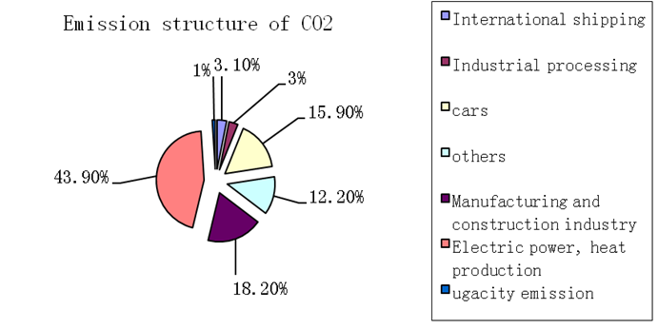
Figure 15 Emission structure of CO2
Environmental cost model: comparison of pure electric cars and diesel car's impact on the environment
When consumers use diesel car, automobile discharges a large number of pollutants, including carbon dioxide, carbon monoxide, sulfur dioxide, which causes serious pollution of air. It has become one of the major sources of air pollution.
Model background
Environmental costs of energy can provide the conditions for solving the above problem, which is through environmental taxes. The following is the definition of environmental tax: it is for the units and individuals who make the development, protection and use of environmental resources. According to their development and utilization of environmental resources, the extent of pollution and protection, Environment tax is a collection or reduction system. Energy tax on energy consumption can make consumers thrifty in energy consumption, and reduce environmental damage.
Model setup
Learn from the Danish energy tax measures, we build environmental cost model as follow:
CE=r×L。
Thereinto, CE is the environmental costs; r is the energy and environmental taxes; L is consumption of the internal combustion vehicle fuel per hundred kilometers.
Model conclusion and analysis
Through the above model, we can not only compare electric car with internal combustion vehicles on the influence of environment, but also compare the influence status of their the influence status in the full cycle cost .
As pure electric vehicles are powered by electricity, in the process of moving there is without exhaust emissions. Consumers do not need to bear the environmental costs. We do not take noise pollution caused by electric cars and internal combustion vehicles (the noise of electric vehicles is much lower than internal combustion cars) into consideration. From the above analysis, the consumer has the full electric vehicle life cycle cost (without considering the time value of money), LCC model is as follows:
LCC=CA+CM+CDR+CE。
Thereinto, LCC is the full cycle cost of consumer s who own electric vehicles; CA is the acquisition cost; CM is maintenance costs for the driver; CDR is the scrap cost; CE is the environmental costs (for the consumer, CE of pure electric vehicles is approximately zero.)
Internal combustion vehicle life cycle cost model also includes the acquisition cost, driving maintenance costs, scrap costs and environmental costs.The difference is the composition of maintenance cost drivers, namely
CM′=+P×L
Thereinto, CM is the driving maintenance costs; is maintenance costs of internal combustion automotive parts; P is the price of gasoline.Consumers have the full life cycle of internal combustion vehicles cost:
LCC′=CA′+CM′+CDR′+CE′
Thereinto, LCC′ is the full cycle cost of consumer s who own internal combustion vehicles; CM′ is maintenance costs for the driver; CDR′ is the scrap processing costs; CE′ is the environmental costs.
Logistic model: To predict future trends of electric vehicles
Model setup
The Dutch biological mathematician Verhulst introduce constant Nm to express the largest population that natural resources and environmental conditions could allow And assuming that the net relative growth rate is equal to r(1-).Namely, the net relative growth rate increases with N (t). When N (t) tend to , the net relative growth rate tends to zero. Therefore, the equation =rN in exponential model changes into
= r(1-)N
Assuming when t=0, the population is , that is
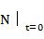=
Equation solution is
N(t)=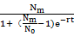
It is easy to see when t tends + ∞, N (t). tends to .
This model is the Logistic model. The result has been calculated that agree well with the actual situation.
On the basis of this model, Nm is considered as the maximum number of electric vehicles that energy, environmental conditions can allow (assuming electric cars replace all internal combustion vehicles) Tthe net relative growth rate is equal to r(1-) and is the total number of electric vehicles globally at present. the Logistic model can obtain the number of electric cars a year.
Model conclusion and analysis
In solution of this equation, the most important step is to solve the Nm. Data and theoretical basis obtained in task 1 and 3 can be used to get Nm. However, specific method for solving the problem has not yet been determined because of the time and pending further study. Once find Nm, we can get N (t). In this case, through the results , we can predict the future trends of electric vehicles and determine its use of universality.
We forecast that the electric car is of extensive practicability in the future.
Reference
【1】Electric Vehicles of Yesterday Carry Us into Tomorrow William R. Young, Jr. Florida Solar Energy Center 300 State Road 401 Cape Canaveral, Florida 32920 (407) 783-0300
【2】1.1 World Consumption of Primary Energy by Energy Type and Selected Country Groups (U.S. Physical Units), 1980-2006 1a. Energy Consumption (Standard U.S. Physical Units) All updated by December 31, 2008 www.eia.doe.gov/iea/

【3】Historical data Download the full excel workbook from 1965-2009 http://www.bp.com/productlanding.do?categoryId=6929&contentId=7044622

【4】Introduction to Pattern Recognition: A Matlab ApproachSergios Theodoridis Dr Academic Press 2009

【5】Zhaoshou Dai Shiliang Sun Higher education press 2007.7 Concise Course of Mathematical Modeling

【6】Yanlian Lai Guoping He Tsinghua University Press 208.12 Optimization method

