Low Level Design (add product module)

Project Code | Team1
Project Name | Library Management System

Prepared/Modified by | Role | Date of Preparation
Rahul Vishwakarma, Pradnya Shukla | Software Engineer | 09/11/2017
Reviewed by | Role | Date of Review
Pratik Potdar | Software Engineer
Approved by | Role | Date of Approval
 | Training Manager
Circulation List | pratik.potdar@capgemini.com  aditi.dumbre@capgemini.com  priyanka.chaudhary@capgemini.com  naveen.gownivaripalli@capgemini.com  rahul.d.vishwakarma@capgemini.com  pradnya.shukla@capgemini.com | Version Number of the template:1.0
Version Number | 1.0

Table of Contents

1. Description Of The Unit 3
2. References 3
3. Assumptions 5
4. Class Diagrams 6
5. Sequence Diagrams 7
6. Design Components 8
6.1 List Of UI Components 8
6.2 List Of Design Classes 9
7. Re-Usable Routines/Components 11
8. Messages 12
9. Configuration Files 13
10. Crud Matrix Table 14
11. Data Mapping Matrix 15
12. Action Flow Matrix 16
13. Program Specification / Pseudo Code 17
REVISION HISTORY OF THE WORK PRODUCT 2

Description Of The Unit
This project is aimed at developing Library Management System (LiMS) for the college library. This is an Intranet based application that can be accessed throughout the campus. This system can be used to search for books/magazines; reserve books, and issue/return books from the library. This is an integrated system that contains both the user component and the librarian component.

The process starts with the Registration. In this, the user is registered according to its post i.e librarian or student and after all the validations the user is registered and it’s information is stored in the database.

The students can do the following functions viz. place a request for books from the available books and they can also check the status of the requested books whether they are issued by the librarian or not. If it is issued by the Librarian then the student is getting information about the return date and if the student returns the book after the expected return date then fine will be charged to the respective student.

The librarian can do the following functions viz. include new books or remove some books
from the inventory and they can also manage return and issue book operations.

References

Reference | Description
Repository reference | https://IGTEBLRSVNTNG.igatecorp.com/svn/B230Jul15PLPTeam3_JEE
Class Diagram | /Project Documents/Design Documents/HLD/Class Diagrams/ Class Diagrams
URS | /Project Documents/Requirements/Case Study/ Survey Management System .doc
UTP | /Project Documents/Test Plan/UTP/Test Case/ Test_Case_Create_Survey_module.xls
DB Design | /Project Documents/Design Documents/HLD/DB Design/ Survey Management System_Team3_DBDESIGN.xls

Assumptions

Assumptions:
The Librarian will issue the book to student within three days after the registration date.

Class Diagrams

Class Diagram

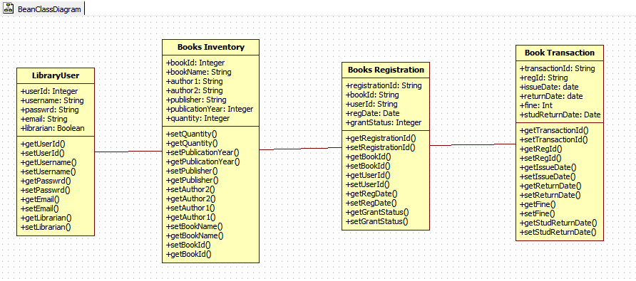

Sequence Diagrams

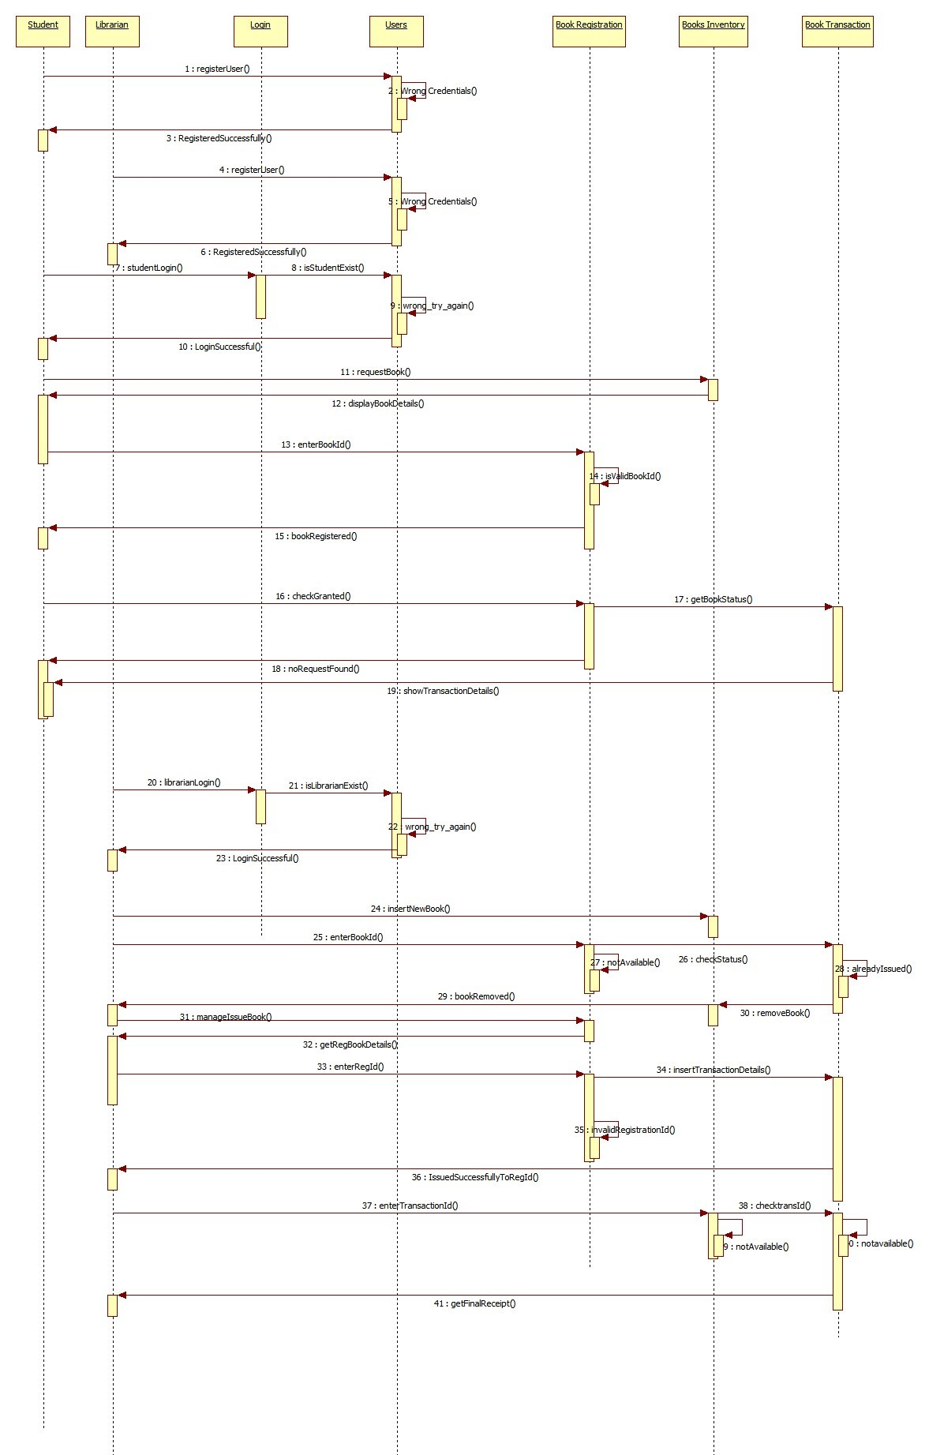

Design Components

List Of UI Components

List Of Design Classes
Sr. No. | LLD Name | Class Name | Method Name | Method Description
1 | Library Management System | BookInventory,  BookRegistrationDetails, BookTransaction,  LibraryUser | Appropriate Getters and Setters methods, | Getters and Setters are used to retrieve and set the property values respectively.
2 | Library Management System | HomeController,  LibrarianController,  Studentcontroller | registration(Model model):  Model  login(Model model):String  addBook(Model model):Model  displayBooks(Model model):Model  removeBook(@RequestParam("bookId") int bookId,Model model):Model  regBooks(Model model):Model  returnBook(Model model):model  findAll()):model  statusCheck(HttpServletRequest request):Model  logoutAction(HttpServletRequest req,Model m):String  goToStart(HttpServletRequest request, Model model):Model | Login() describes the login part of the student and the librarian.  addBook():Librarian can add the books to inventory.  Registration():This is common for both student and librarian.  displayBooks():this will display all the books to student for registering purpose.  regBooks():to register a particular book  logoutAction():This is for logout.  returnBook():This is called for returning the books.
3 | Library Management System | ILibrarianService,  IStudentService,  LibraryServiceImpl,  StudentServiceImpl | isLibrarianExist:Boolean  ArrayList<BookInventory>:Array  ArrayList<BookRegistrationDetails>: Array  ArrayList<BookTransaction>: array  updateStatus()  updateTransaction()  calFine()  delReturnBook()  getFinalReceipt()
4 | Library Management System | ILibrarianDao,  IstudentDao,  LibrarianDaoimpl,  StudentDaoimpl | isLibrarianExist:Boolean  ArrayList<BookInventory>:Array  ArrayList<BookRegistrationDetails>: Array  ArrayList<BookTransaction>:array  updateStatus()  updateTransaction()  calFine()  delReturnBook()  getFinalReceipt()

Re-Usable Routines/Components

Re-Usable Routines/Components

- CSS files
- Database properties files

Messages

#. | Type | Message Text
M1 | Error | Please enter username
M2 | Error | Username must contain minimum 4 maximum 10 characters
M3 | Error | Please enter password
M4 | Error | Password must contain minimum 8 maximum 16 characters
M5 | Error | Please enter valid Email
M6 | Error | Please enter your Email ID
M7 | Error | Please choose appropriate field
M8 | Error | Id is required

Configuration Files

File Name | Path | Description
web.xml | LibraryManagementSystem/WebContent/WEB-INF | To configure the bean properties.
dispatcher-servlet.xml | LibraryManagementSystem/WebContent/WEB-INF | To configure the request mapping and view resolver.
jpaContext.xml | LibraryManagementSystem/WebContent/WEB-INF | To configure with the database.

Crud Matrix Table

# | Table Name | Create | Read | Update | Delete
1. | Users | Y | N | N | N
2. | booksregistration | Y | Y | Y | N
3. | book_inventory | Y | Y | Y | Y
4. | book_transaction | Y | Y | Y | N

Data Mapping Matrix

Sr. No. | Screen Label | Field Source | Field Type | Data Type | Max Length | Data Flow | Mandatory
1 | User name |  | Textbox | Varchar2 | 10 | UI→D | Yes
2 | password |  | Textbox | Varchar2 | 16 | UI→D | Yes
3 | EmailId |  | Textbox | Varchar2 | NA | UI→D | Yes
4 | Are you Librarian |  | radio | Boolean | NA | UI→D | Yes
5 | Enter Librarian name |  | Textbox | Varchar2 | 10 | D → UI | Yes
6 | password |  | Textbox | Varchar2 | 16 | D→UI | Yes
7 | Enter Student name |  | Textbox | Varchar2 | 10 | D → UI | Yes
8 | password |  | Textbox | Varchar2 | 16 | D → UI | Yes

Legend
D → UI (Database to User Interface)
UI → D (User Interface to Database)
UI (User Interface Only)

Action Flow Matrix

Sr. No. | Action | Description | Process
1 | On click of User registration link | A new page is displayed where user is registered according to its post and it is inserted into the database. | The user clicks on the link and a new homepage is displayed after filling all the details it will be directed to its respective page according to its functions.
2 | On click of Librarian login link | Librarian login page is displayed. | After clicking on this link, librarian is asked to enter the username and password and after this the librarian can perform various function like add books, remove books, manage issue and return books.
3 | On click of Student login link | Student login page is displayed. | After clicking on this link, Student is asked to enter the username and password and after this the librarian can perform various function like place a request for a particular book and check grant status.

Program Specification / Pseudo Code

14.1 < ACTION:REGISTRATION>
BEGIN
Click on the UserRegistration link in order to register.

Navigate to register page.
Enter the username
Enter the password
Enter the EmailId
Select whether librarian or not.
Enter recovery question
- Textbox is used to write the username,password,emailed,recovery question.
- Radio button is used to answer librarian or not.

Client Side Scripting(validation):

Username must contain minimum 4 maximum 10 characters
Password must contain minimum 8 maximum 16 characters
Email must be in valid format.
All the fields are mandatory.

If all data is validated correctly ,Navigate to success page.
Else Navigate to register page.

The conformation message of registration as student or librarian along with Registration details (userid, username) are displayed
END

14.2<ACTION:STUDENT_LOGIN >

BEGIN
Click on the StudentLogin link in order to login.

Navigate to StudentLogin page.
Enter the username
Enter the password
- Textbox is used to write the username
- Textbox is used to write the password
Server Side Scripting(validation):
Username and password for librarian or student is checked in Users table
If exists then,
Call Login (@RequestParams() Model model, HttpServletRequest request) in LibraryController class Navigate to SuccessLogged page.
Choose an operation to be done among given options.
  - Place a request for a book
  - Check Status for a book
  - Log Out
Link according to choice is to be clicked
- Place a request for a book
Call retrieveDetails() method to display available books in library.
The books already issued are not displayed in available books.
Click APPLY link to request for book.
Call doApply(@RequestParams() Model model, HttpServletRequest request) in LibraryController class Navigate to BookApplySuccess page.
The details of books applied are displayed on next page along with the note to remember book id in order to check status of requested book..

2. Check Status for a book

Call statusCheck(HttpServletRequest request) method LibraryController class Navigate to Resultstatus page.
The status of book with book id is displayed as “the book is issued”, “the book is not yet issued” or “the book is not requested”.

3. Log Out

Session.invalidate() is called and student is not allowed to make changes unless login is performed again.

END

REVISION HISTORY OF THE WORK PRODUCT

# | Date | Version # | Section Changed | Details of changes made | Approved By
1 | 09/11/2017 | 1.0 | LLD prepared | N/A

