**RESULTS SCREENSHOTS**

Below Screenshot is the sign-up page for new user.

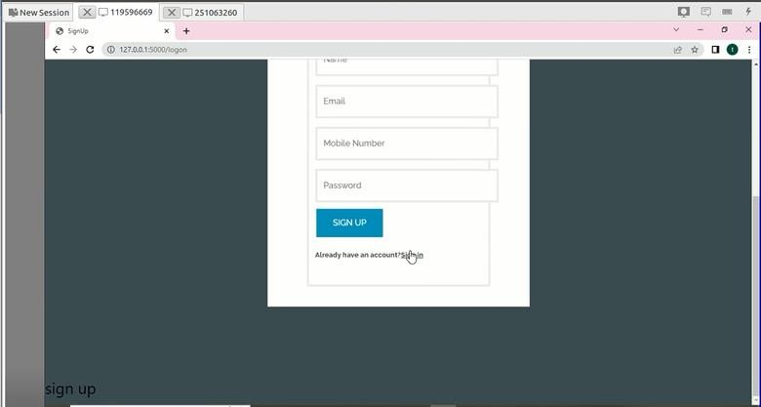

**Screenshot-1 Sign-up page**

Below Screenshot is the sign-in page for user

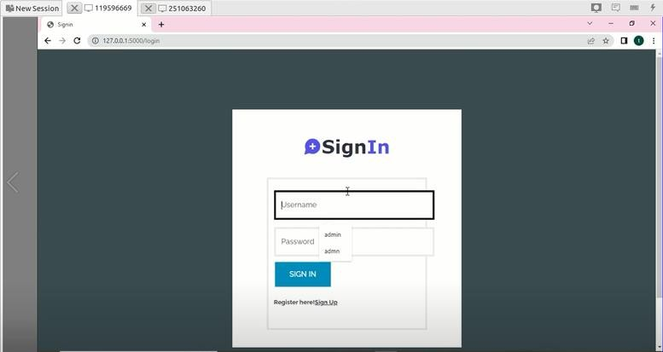

**Screenshot-2 Sign-in page**

Below Screenshot is the home page after the user sign-in

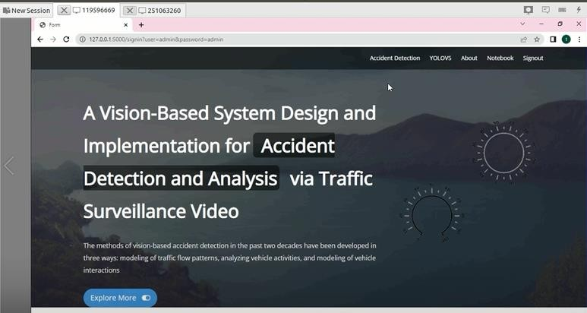

**Screenshot-3 Home Page**

Below Screenshot is the input of any image or video

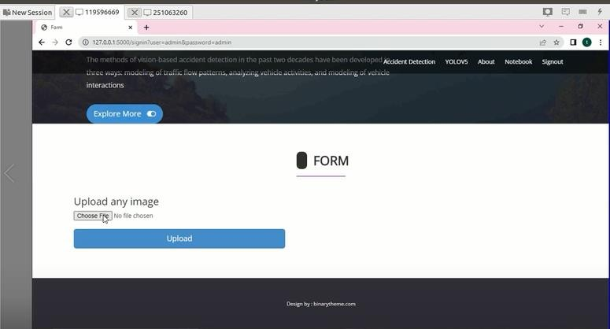

**Screenshot-4 Upload Image**

Below Screenshot is the choosing file from our directory

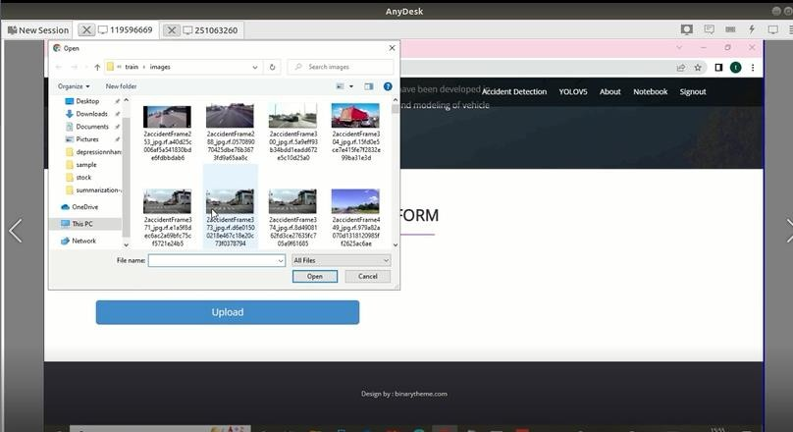

**Screenshot-5 Choosing File**

Below Screenshot is the accident detection with moderate accident

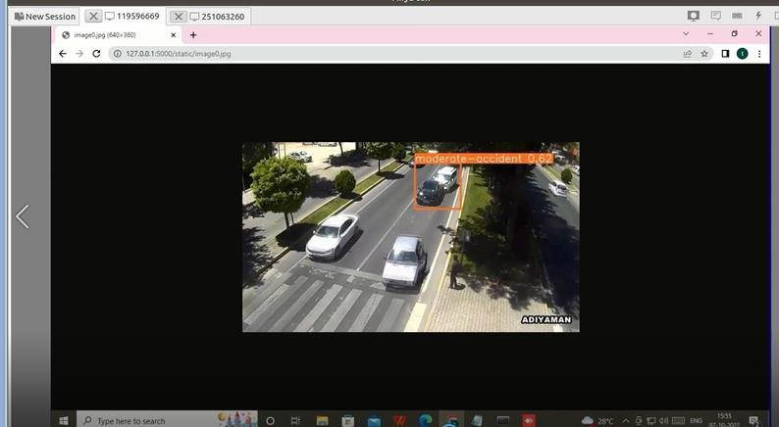

**Screenshot-6 Moderate Accident Detected**

Below Screenshot is the accident detection with severe accident

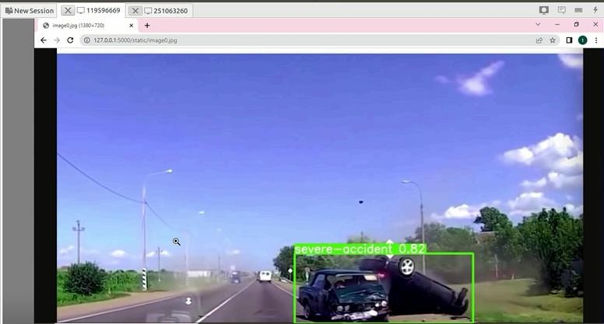

**Screenshot-7 Severe Accident Detection**

Below Screenshot is the accident detection with moderate accident

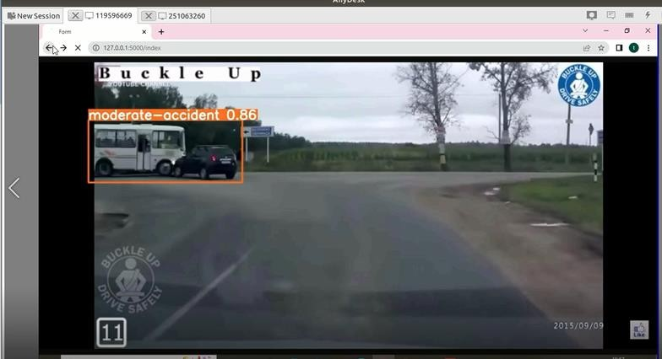

**Screenshot-8 Moderate Accident Detected**

Below Screenshot is the accident detection with severe accident

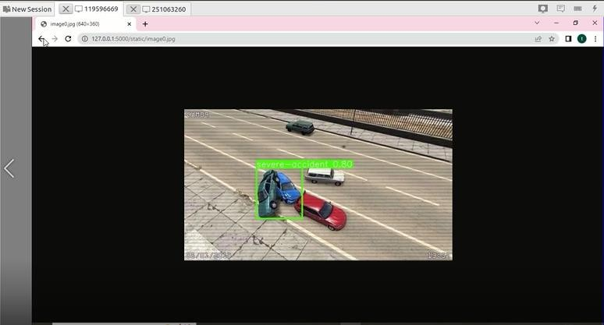

**Screenshot 8.1.9 Severe Accident Detected**