Querubin Santana Sevilla 29-04-2018

FINAL PROJECT

Introduction

Name: Metroid

It is a platform-shooter game in 2D, there would be a general map, showing your current location and not showing the rooms that you have not entered.

The rooms may vary in size and shape, allowing a horizontal and verticval scroll.

The character starts with some basic habilities and stats, and the player can find upgrades for his stats and new ones defeating enemies or finding hidden spots in the map.
At the start of a game, the character must be capable of: jumping, moving horizontally, aim in diagonal, shoot and crouch

As the game progresses and the player overcomes certain challenges, the player can upgrade his abilities and find new ones like; charge the shot to increment the damage and size of it, double jump (i was thinking that i can do the double jump if the player charges the shot to full power, and then he jumps and shoots down), the ability of shooting missiles that would run out at some point (you need to recharge your ammo in save rooms or killing enemies).

There can also be upgrades for your HP and missile capacity hidden in the map

There will also be save points to save your game and refill your ammo and HP

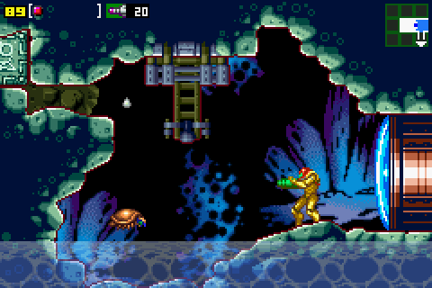

Deliveries

-Delivery 1: Implement the classes diagram and put in the correct order all the screens.

-Delivery 2: The player now can move with an animation to the left, the right, and can aim up, creation of the movements for the ball form, and animations when standing still.

-Delivery 3: Implementation of the diagonal aim, CreateNewShots function has been programmed, the function DrawAllShots, has been implemented, now the class Sprite gets his Spritesheet from the constructors below.

-Delivery 4: Creation of a welcome screen with and animation, a background image and a title image.

-Delivery 5: Upload the project to Github using Sourcetree to control the versions, the moveplayer function is now in player class, weapons now fire when pressing M (only in one direction at the moment), created the room, map, and block class to build a room (with a text file) and put the player in there.

Delivery 6: Convert to small modular functions the MovePlayer function, convert the Room class in SquareRoom class, and add a CompleteRoom class to join the individual SquareRooms and allow more larger, modular rooms. Create a LoadFromFile function to load the SquareRooms individually, and create the LoadCompleteRoom function to load the current room using all the adjacent SquareRoom LoadRoom functions.

Delivery 7: Program collisions between Sprites, implement gravity, Player’s capability of jumping, draw the shots correctly depending on the Player’s aimDirection, remove the shots that collide with a Block, implement a full room in the game surrounded by blocks.

Delivery 8: Create rooms width a function that reads them from a text file, create a saving room where you can save the game and refill your HP and ammo

Delivery 9: Connect the rooms with each other, and create a general map depending on the position of each room.

Delivery 11: Show your current position in the map.

Delivery 12: Program the enemy class and the behaivior of the first enemy. It will charge at the player when spotted.

Delivery 12: Basic implementation of a boss fight (phase change when his HP gets to some point, weak spots, collisions)

Delivery 13: Create the attack patters of the boss and change his behavior depending of the phase in which you are.

Delivery 14: Creation of a small cinematic at the start of the game, and a game over screen that asks you if you want to try again.

Delivery 15: Creation of a main menu with 3 save slots, game configuration, credits. It also will show a small animation.

Delivery 16: Creation of a welcome screen and a credits screen that show animations.

Delivery 17: Implementation of water in some rooms, where you sink to the bottom, your life decreases over time, your speed is reduced, and your jump height is decreased too.

Delivery 18: Program some new permanent character upgrades (jump with the sphere form, ice missiles that freeze the enemies in place, the shots can go through enemies, a suit to breathe and walk normally in water)

Delivery 19: When you shoot an ice missile into water it creates an iceberg that floats and you can stand on it, a map room that discovers all the rooms that are not hidden.

Delivery 20: Implementation of diferent colored doors and keys (if you find for example a red key, you can open all the red doors)(some doors that open only if you shoot a missile at them, and some that only open if you press a button).

Delivery 21: Make the controls compatible with a gamepad

Delivery 22: Program new basic character abilities (climb ladders, hold on to horizontal ladders and move left and right on them, shoot while climbing)

Classes diagram:

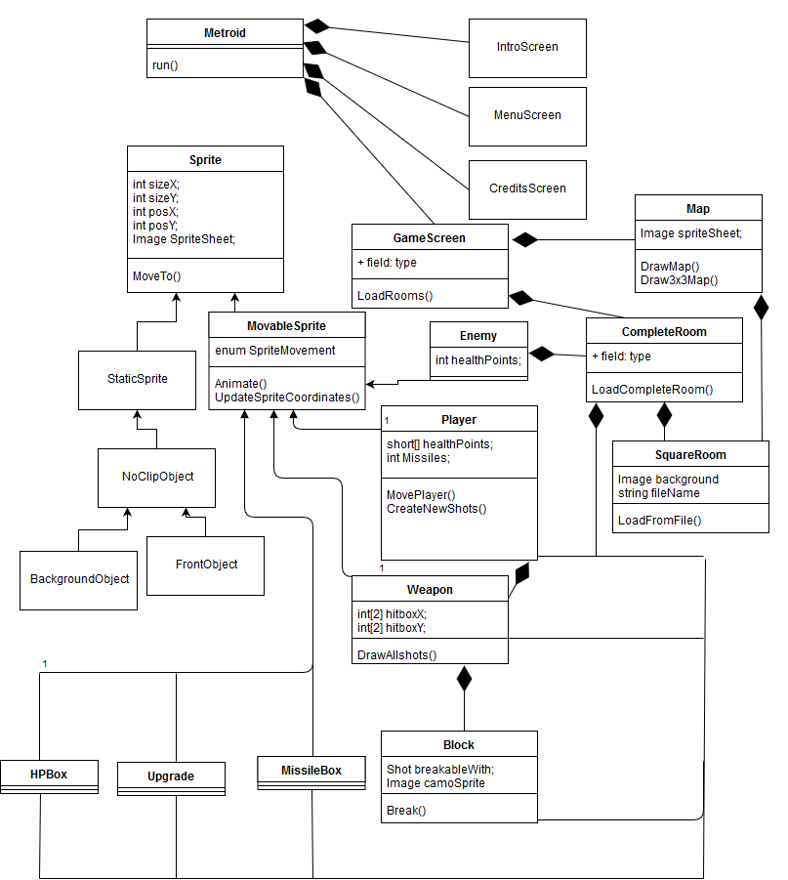

File format

We will save the SquareRooms layout in text files , we will write chars in the text for each sprite in the room, and load them in the CompleteRoom class. Additionally we will save information about the positions and ids of each CompleteRoom and SquareRoom in a text file with this syntax:

A:1=0,0:2=1,0:3=0,1;

-A is the id of the CompleteRoom
-The random character that appear are separators.
-The numbers in front of the equals sign are the ids of the SquareRooms that compose the CompleteRoom.
-The numbers separated by commas are the Coordinates of the SquareRoom in the CompleteRoom.
. To save the game, we will save the info about the player and the current CompleteRoom.

Requirements

-The character must move smoothly and shoot at all directions with its correct animation, it should be able to go through doors and load the next room. Additionally, if you press the pause button, it should display you a map, with information of the rooms that you have discovered.

-The upgrades that the character grabs should display in the menu too, with some information about them, to remind the player how to use them, additionally if the player goes to a room with an upgrade in it, it should display a circle in the map, once the player takes the upgrade it should display a dot.

-The enemies must have the correct attack or move pattern, and drop some health packs or missile boxes when they are destroyed (It depends on the enemy). Some of them will reappear when you re-enter the room(normal enemies), and the other ones will show a corpse and never spawn again (Bosses).

-The map will have different zones, each one with varied enemies, puzzles, and upgrades that allow you to go back to an old zone and unlock new paths. The map will be composed of modular rooms of different sizes, connecting all the zones.

-The controls will be configurable as well as the audio and video options. They must be compatible with gamepads and joysticks.

Real Deliveries:

-Delivery 1: Try to implement the classes diagram and put in the correct order all the screens.

-Delivery 2: The player now can move with an animation to the left, the right, and can aim up, creation of the movements for the ball form, and animations when standing still.

-Delivery 3: Implementation of the diagonal aim, CreateNewShots function has been programmed, the function DrawAllShots, has been implemented, now the class Sprite gets his Spritesheet from the constructors below.

-Delivery 4: Creation of a welcome screen with and animation, a background image and a title image.

-Delivery 5: Upload the project to Github using Sourcetree to control the versions, the moveplayer function is now in player class, weapons now fire when pressing M (only in one direction at the moment), created the room, map, and block class to build a room (with a text file) and put the player in there.

Delivery 6: Added the SquareRoom and CompleteRoom classes, added a load function to the SquareRoom class that loads a room individually. Added a small animation in the welcome screen, and split the MovePlayer function in more small modular functions.

Delivery 7: Added collisions between Sprites, implemented gravity, programmed the player’s capability of jumping but is not working right now. Draw a simple CompleteRoom combining multiple SquareRooms (They will be moved to a separate function)
Delivery 8: The player can now jump, created the function LoadMap() to load the SquareRooms inside the correct CompleteRoom from a text file. Created the function WriteMap to write the info of the Completerooms in the same file.

