AZERBAIJANI TECHNICAL UNIVERSITY

Faculty of Information Technologies and Telecommunications
Department of Cybersecurity

Discipline: “Python for cybersecurity”

Report for Laboratory Work № 4
« Creating a script for working with JSON »

Performed by:
Student of group 6424E
Pervin Zahidli
Nasimi oglu

Accepted by:
Instructor: Najafli Javad Vagif oglu

Baku
2025

- Create a simple Python application that reads a to-do list from a JSON file, allows the user to add new tasks, and saves the updated list back to the JSON file.

import json
import os
FILE_NAME = "tasks.json"
def load_tasks():
if not os.path.exists(FILE_NAME):
return []
with open(FILE_NAME, "r") as file:
return json.load(file)
def save_tasks(tasks):
with open(FILE_NAME, "w") as file:
json.dump(tasks, file, indent=4)
def show_tasks(tasks):
if not tasks:
print("\nNo tasks yet.")
return
print("\nTo-Do List:")
for i, task in enumerate(tasks, start=1):
print(f"{i}. {task}")
def add_task(tasks):
task = input("\nEnter new task: ")
if task.strip():
tasks.append(task)
print("✅ Task added.")
else:
print("❌ Empty task not added.")
def main():
tasks = load_tasks()
while True:
print("\n--- TO-DO APP ---")
print("1. Show tasks")
print("2. Add task")
print("3. Exit")
choice = input("Select option: ")
if choice == "1":
show_tasks(tasks)
elif choice == "2":
add_task(tasks)
save_tasks(tasks)
elif choice == "3":
save_tasks(tasks)
print("👋 Goodbye!")
break
else:
print("❌ Invalid choice")
if __name__ == "__main__":
main()

Cyberpython-task4
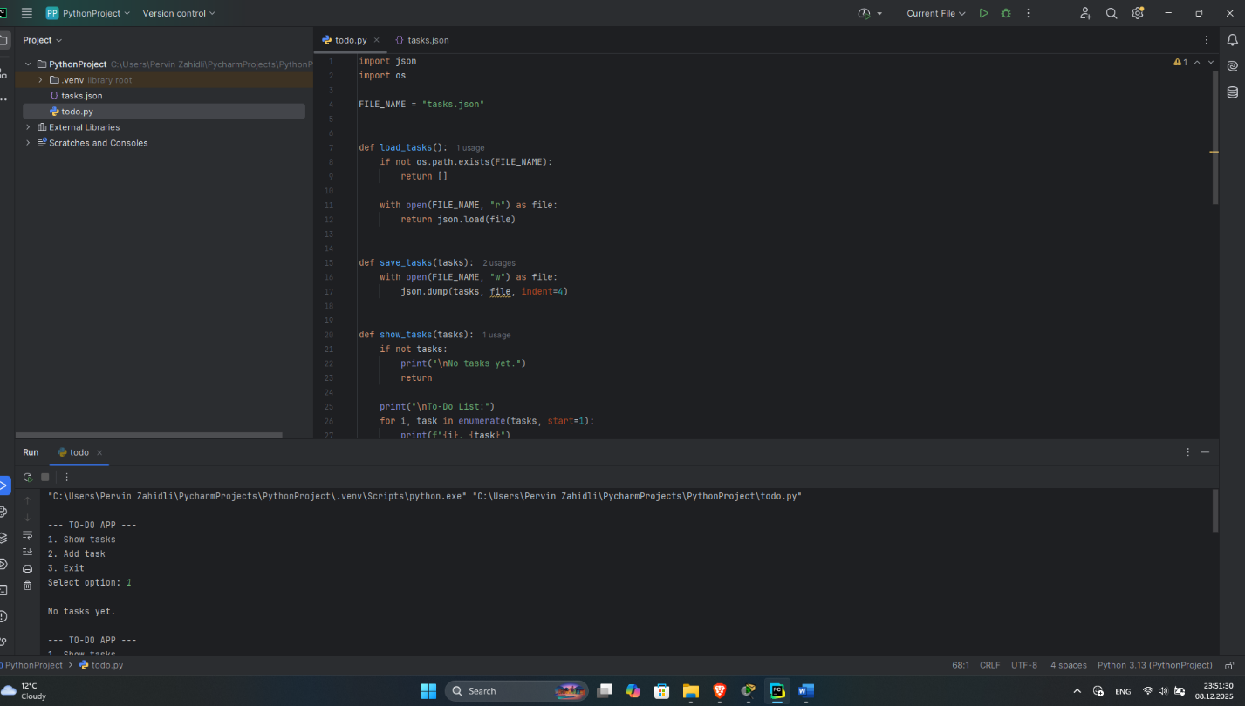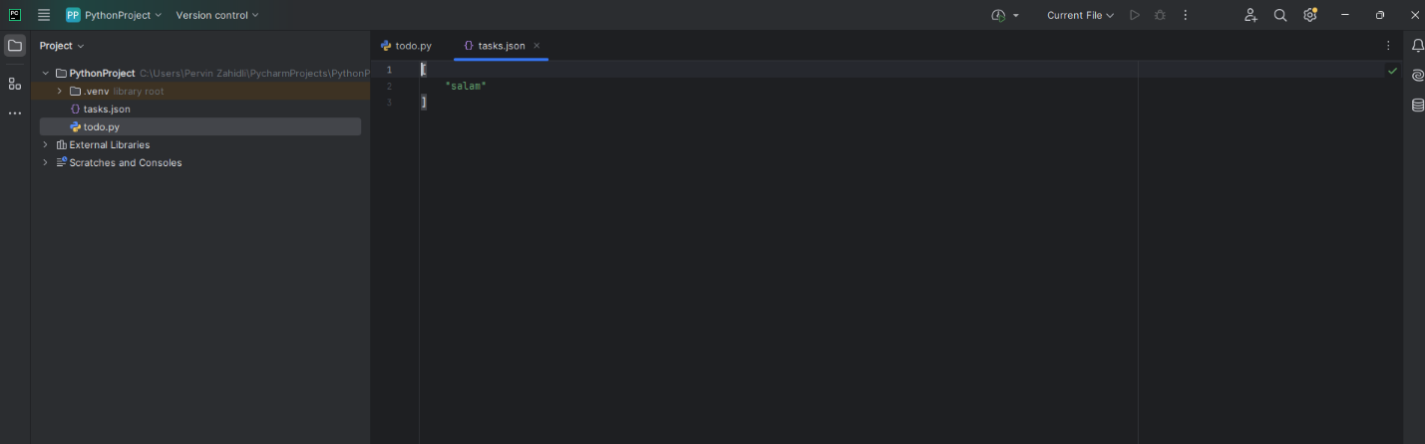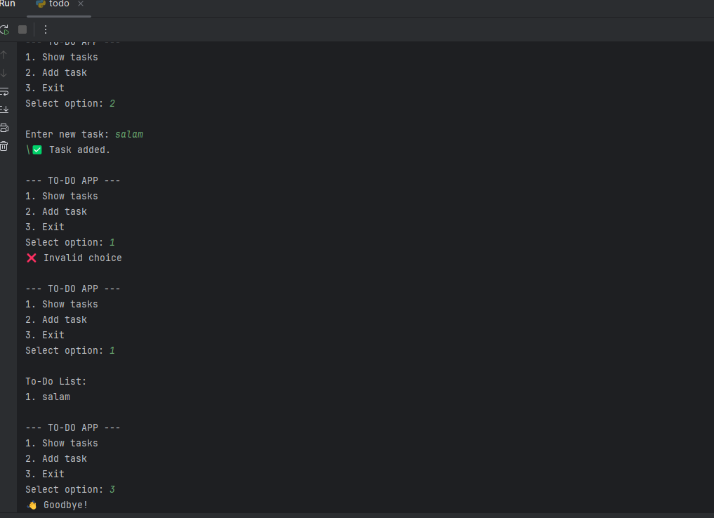
Python To-Do List Application
Introduction
This project is a simple Python-based To-Do List application designed to help users manage daily tasks effectively. The application uses a JSON file to store tasks permanently, allowing data to be saved and loaded each time the program is executed.

Application Description
The To-Do List application allows users to view existing tasks, add new tasks, and store all tasks in a JSON file. The program runs in a console environment and is suitable for beginners learning file handling and data storage in Python.

Use of JSON File
A JSON file is used as the data storage format because it is lightweight, human-readable, and easy to handle in Python. All tasks are stored as a list in the tasks.json file. Each time a task is added, the file is automatically updated.

Program Functionality
- Loads existing tasks from a JSON file at startup
- Displays all tasks to the user in an ordered list
- Allows the user to add new tasks through keyboard input
- Saves all changes back to the JSON file
- Prevents empty tasks from being added

This Python script is a simple command-line To-Do List application that allows the user to manage tasks and store them permanently using a JSON file.
How it works:
- tasks.json
This file is used to store tasks permanently, so they are not lost when the program closes.
- load_tasks()
Checks if tasks.json exists.
  - If it exists, it loads and returns the list of tasks.
  - If not, it returns an empty list.
- save_tasks(tasks)
Saves the current list of tasks into tasks.json in a readable (indented) JSON format.
- show_tasks(tasks)
Displays all tasks with numbering.
If there are no tasks, it informs the user.
- add_task(tasks)
Asks the user to enter a new task.
  - If the input is not empty, the task is added.
  - Empty input is rejected to avoid invalid tasks.
- main()
Acts as the main program loop:
  - Shows a menu (show tasks, add task, exit)
  - Handles user input
  - Saves tasks before exiting

Technical Implementation
The application is implemented using built-in Python libraries such as json and os. The json module is used to read and write structured data, while the os module is used to check whether the JSON file exists before loading it.
The program follows a modular structure with separate functions for loading tasks, saving tasks, displaying tasks, and adding new tasks. This improves code readability and maintainability.

User Interaction
Users interact with the program through a simple text-based menu. By selecting options from the menu, users can view tasks, add new tasks, or exit the application. All user inputs are processed safely to avoid invalid entries.

Conclusion
This project demonstrates basic concepts of Python programming, including file handling, JSON data storage, user input processing, and modular coding. The application can be extended further by adding features such as task deletion, task completion status, or a graphical user interface.

