Click the Start button and type "cmd." Then press Enter or open the "Command Prompt."  
  
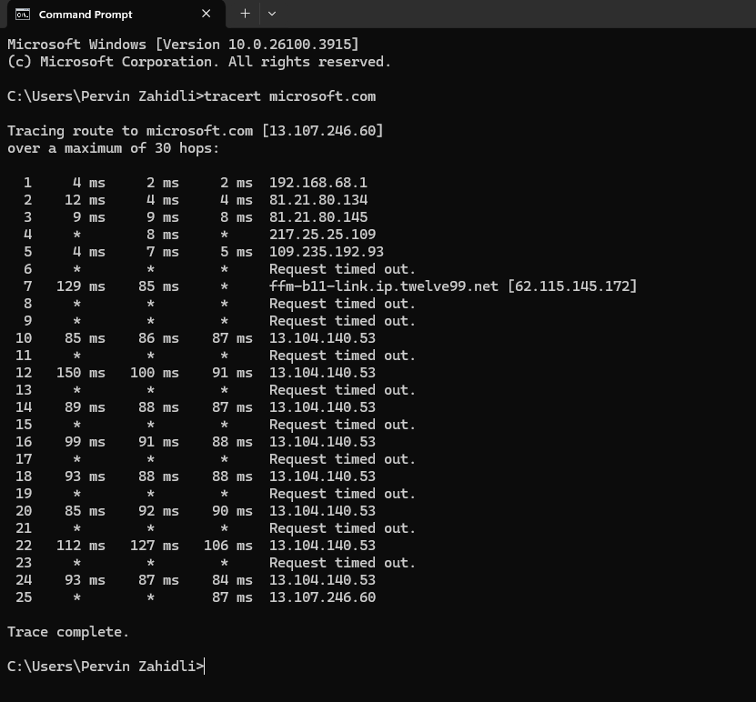

The tracert microsoft.com command used 25 hops to reach the destination.