IN2026 Coursework Documentation
Mert Ors - ACWW156

Asteroids That Split Into Smaller Asteroids When Hit
I chose to implement asteroids that split into smaller bits. The asteroids turn into smaller asteroids twice and then they disappear in my implementation. The class already had a collision detection for detecting when asteroids get destroyed so all I had to do was to implement a function. To keep track of variables like the size of the asteroid bounding shape and the size of the sprite and how many times the asteroid got destroyed so it would stop splitting I have created variables that are stored in asteroid objects and also gave them initial values for the initial size, scale and times it will split in two.
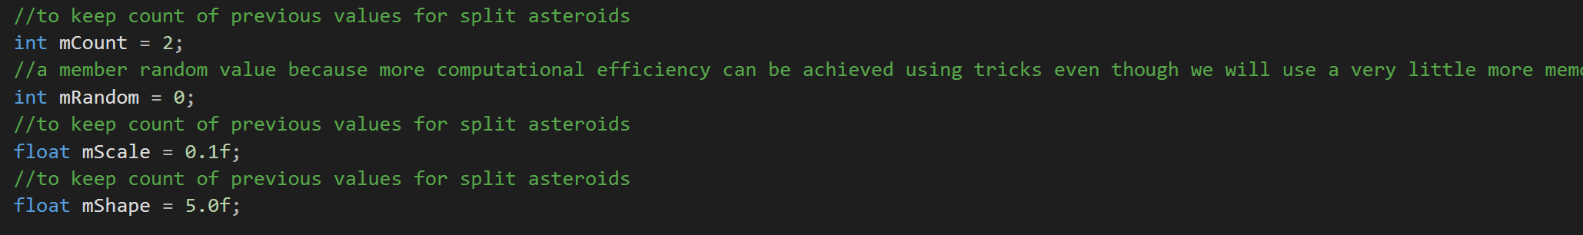
As I have said before there was already a way of tracking collision and so forth to check if the asteroid got destroyed so all I had to do was to create smaller asteroids after the asteroid was destroyed and to accomplish that I have created a function to do that and called it on the collision listener. The function basically creates a new asteroid object and takes the parameters count shape and scale as values from the older asteroid to create the new one and sets them for the new asteroid to half and then sets the location for the asteroid to the location of the previous one. This function only gets called if the mCount is bigger than zero and gets called twice (or can be called in a for loop) for scalability.
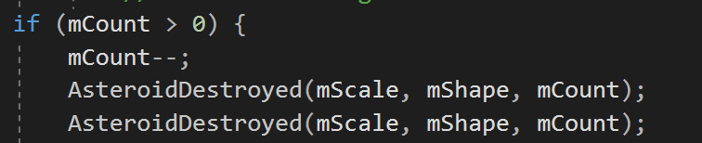
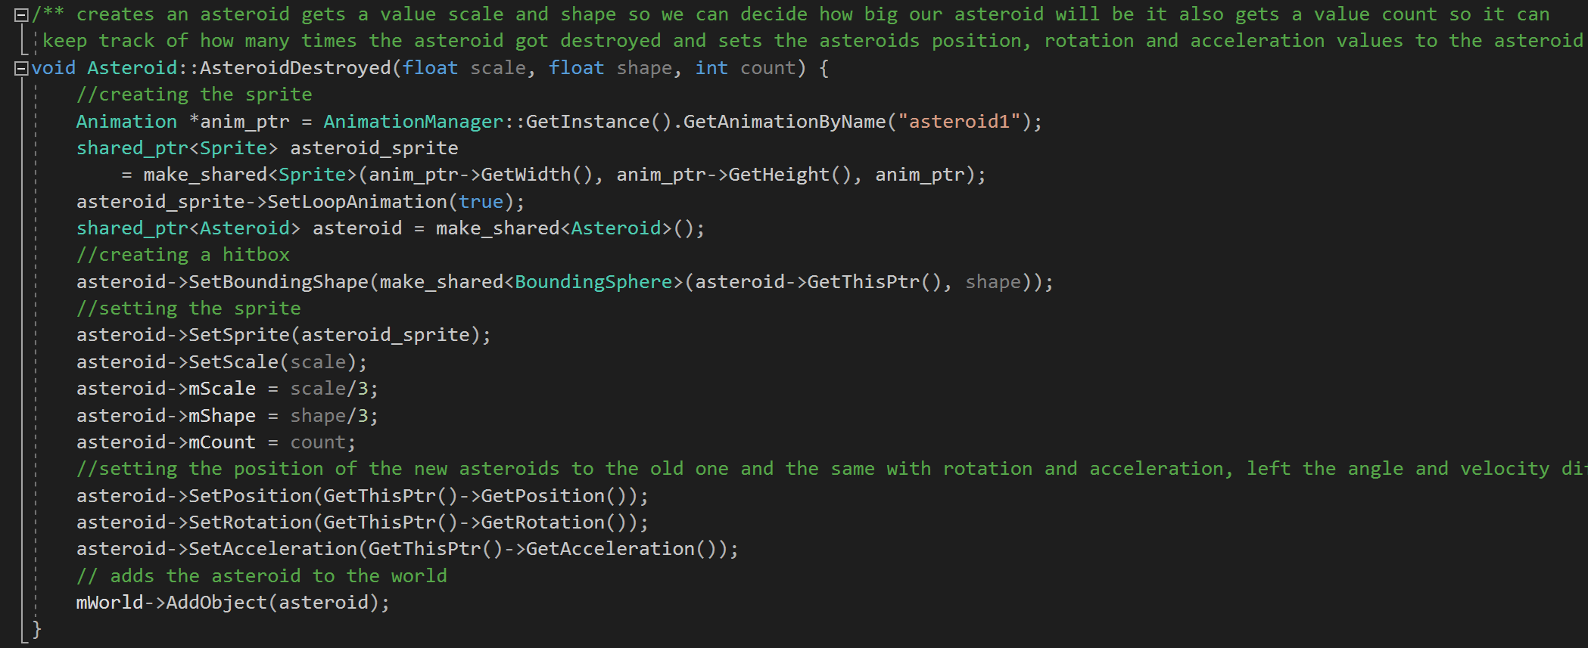
I have not set the rotation and acceleration to the previous values as I wanted them to be random (the other way sometimes an asteroid comes on you and you shoot it and keeps coming for you and flying mechanics are a little too flimsy to deal with that). The asteroids splitting can be seen in the screenshots.
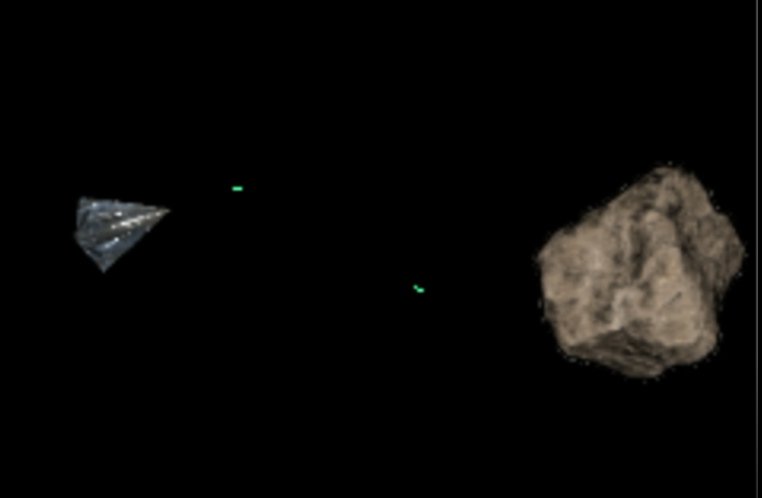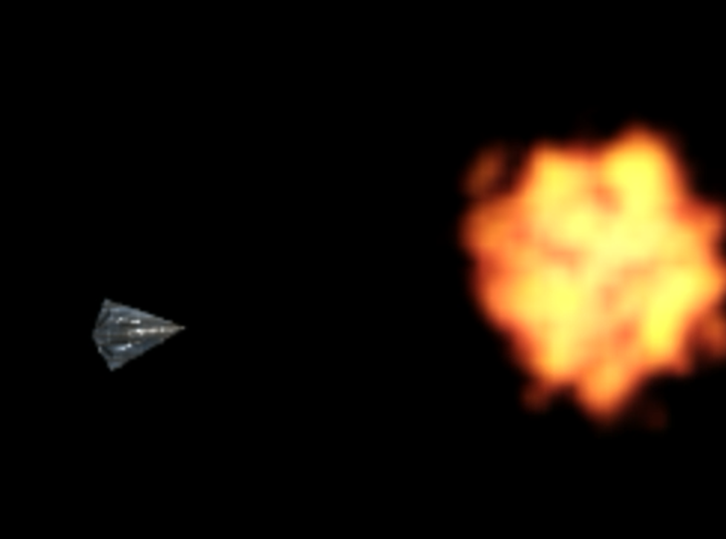
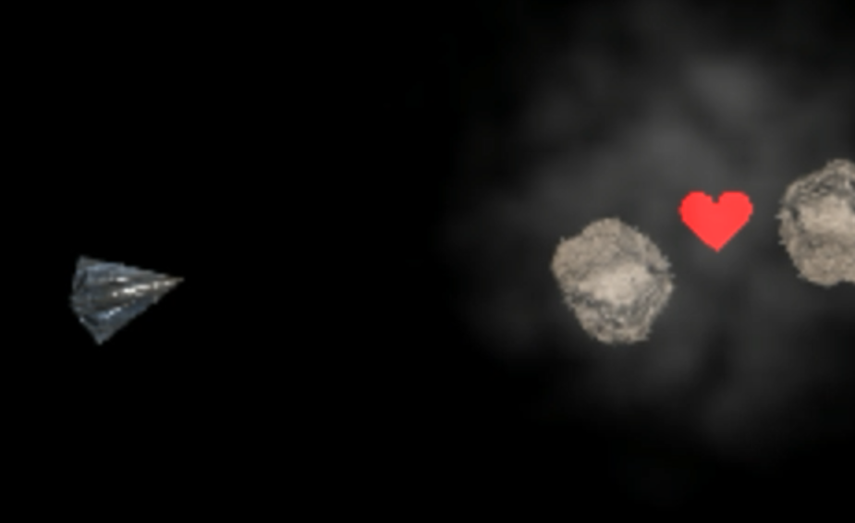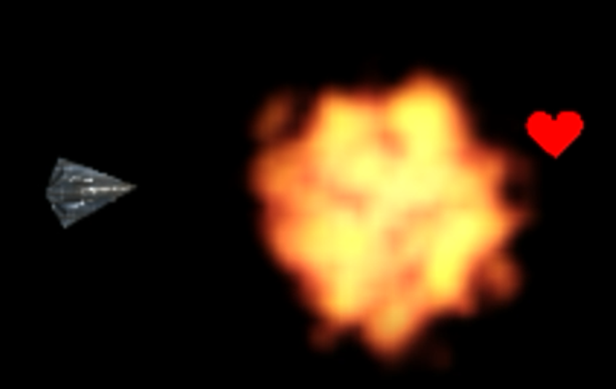
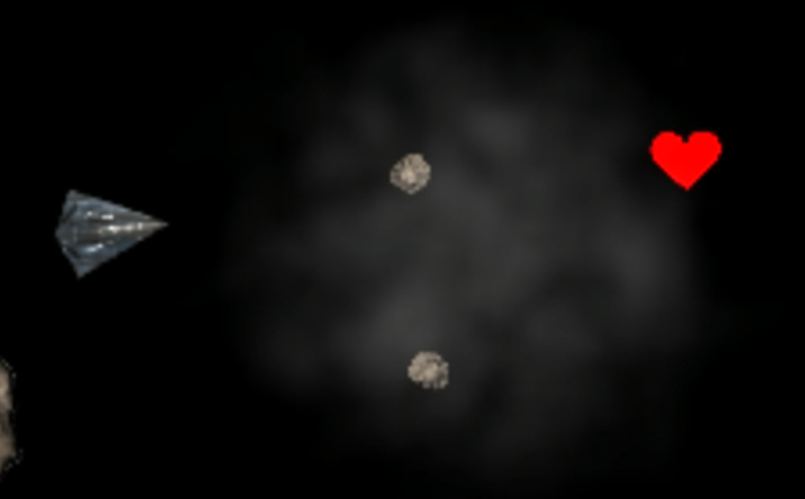

Power Ups
I have decided to implement power-ups. Power ups are essentially game objects that add to the gameplay, they are a way of rewarding the player for accomplishing a task in our case destroying asteroids. They add different mechanics to the games and I think a game without power ups would lack flavour so I have implemented them. There are three different power ups in my implementation that all use the Powerup class so I am going to explain them further on but first I would like to explain how my Powerup class works. In my class I just create a basic gameobject and listen for collisions with the spaceship if it gets destroyed our powerups do as well (it gets too messy when we listen to other collisions), I don’t add a specific sprite to them or a size and initialize that on creation as it varies on powerup.
I have used a header file here for everything as it is not a big class. You can see that I don’t have a variable called type here or a way of storing the type of the powerup as I just use the sizes for the bounding shapes or the scales of their sprites to identify their types.
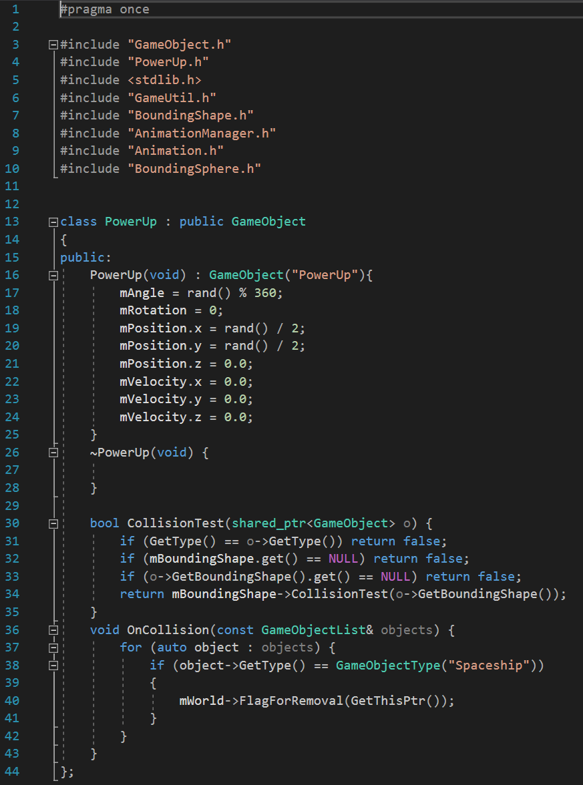
I decided to create power ups whenever asteroids get destroyed and assign them a type and a shape there as well so I have set a random value and used if statements (there are only 3 power ups so there was no need for a switch-case) You can see the function that creates the power ups down there and it just takes a random value as its parameter.

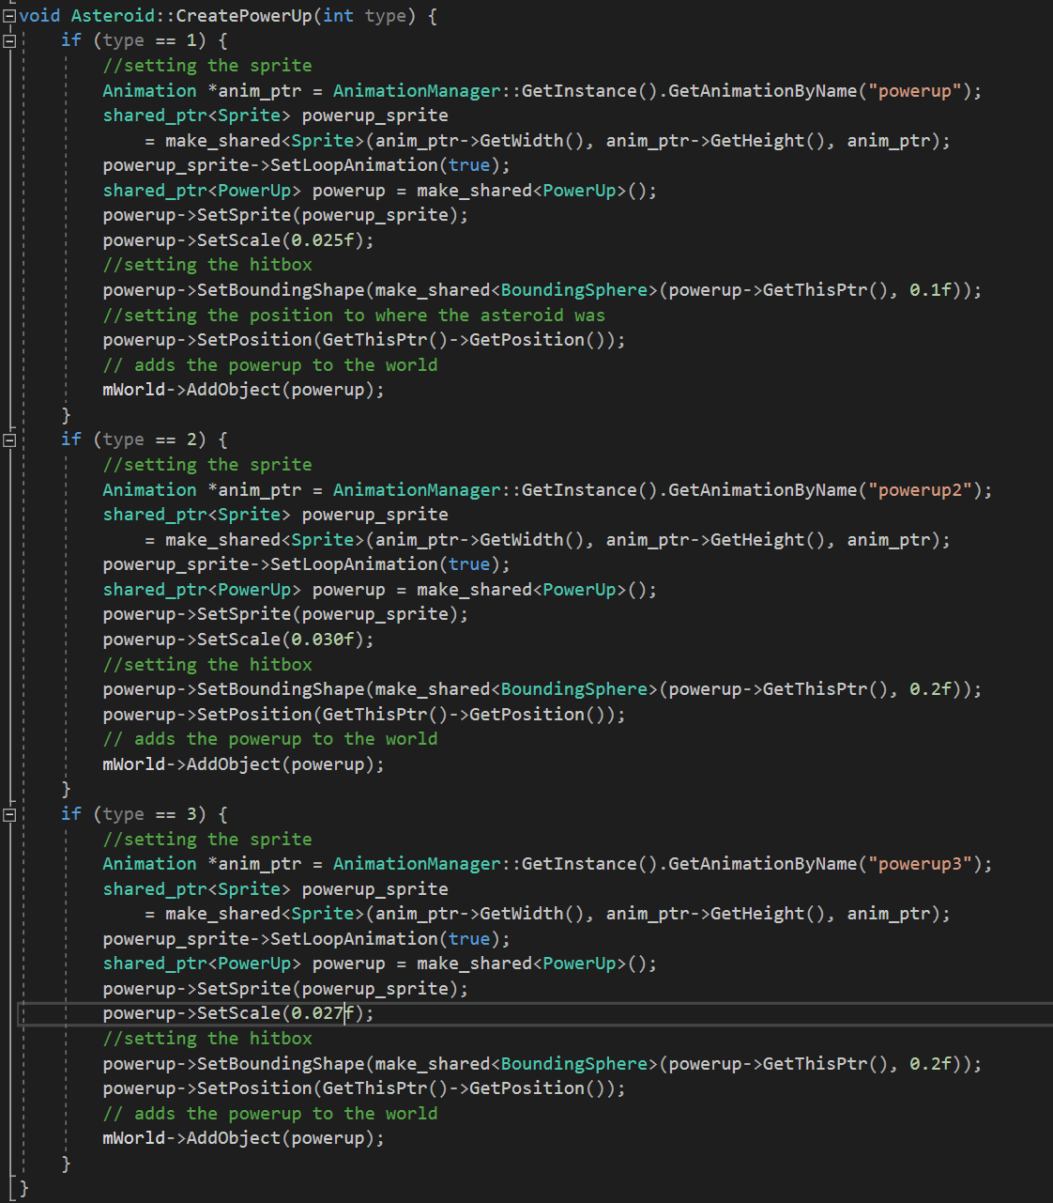

One Up
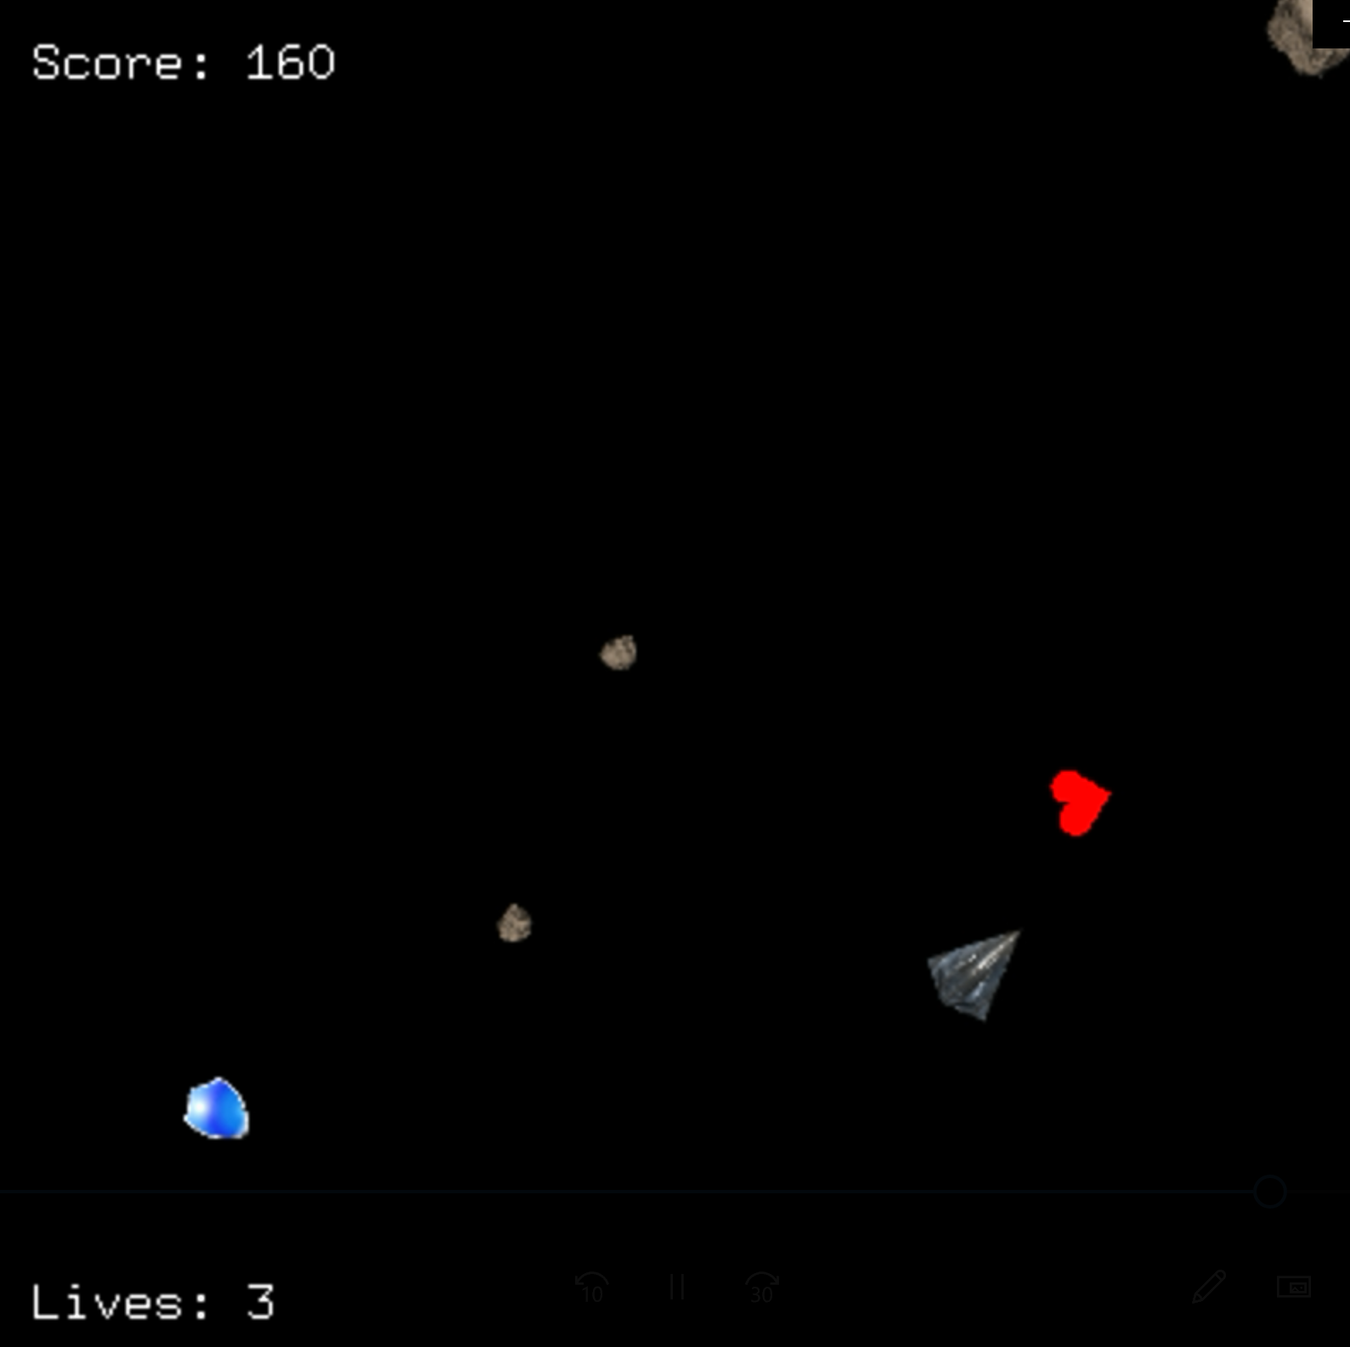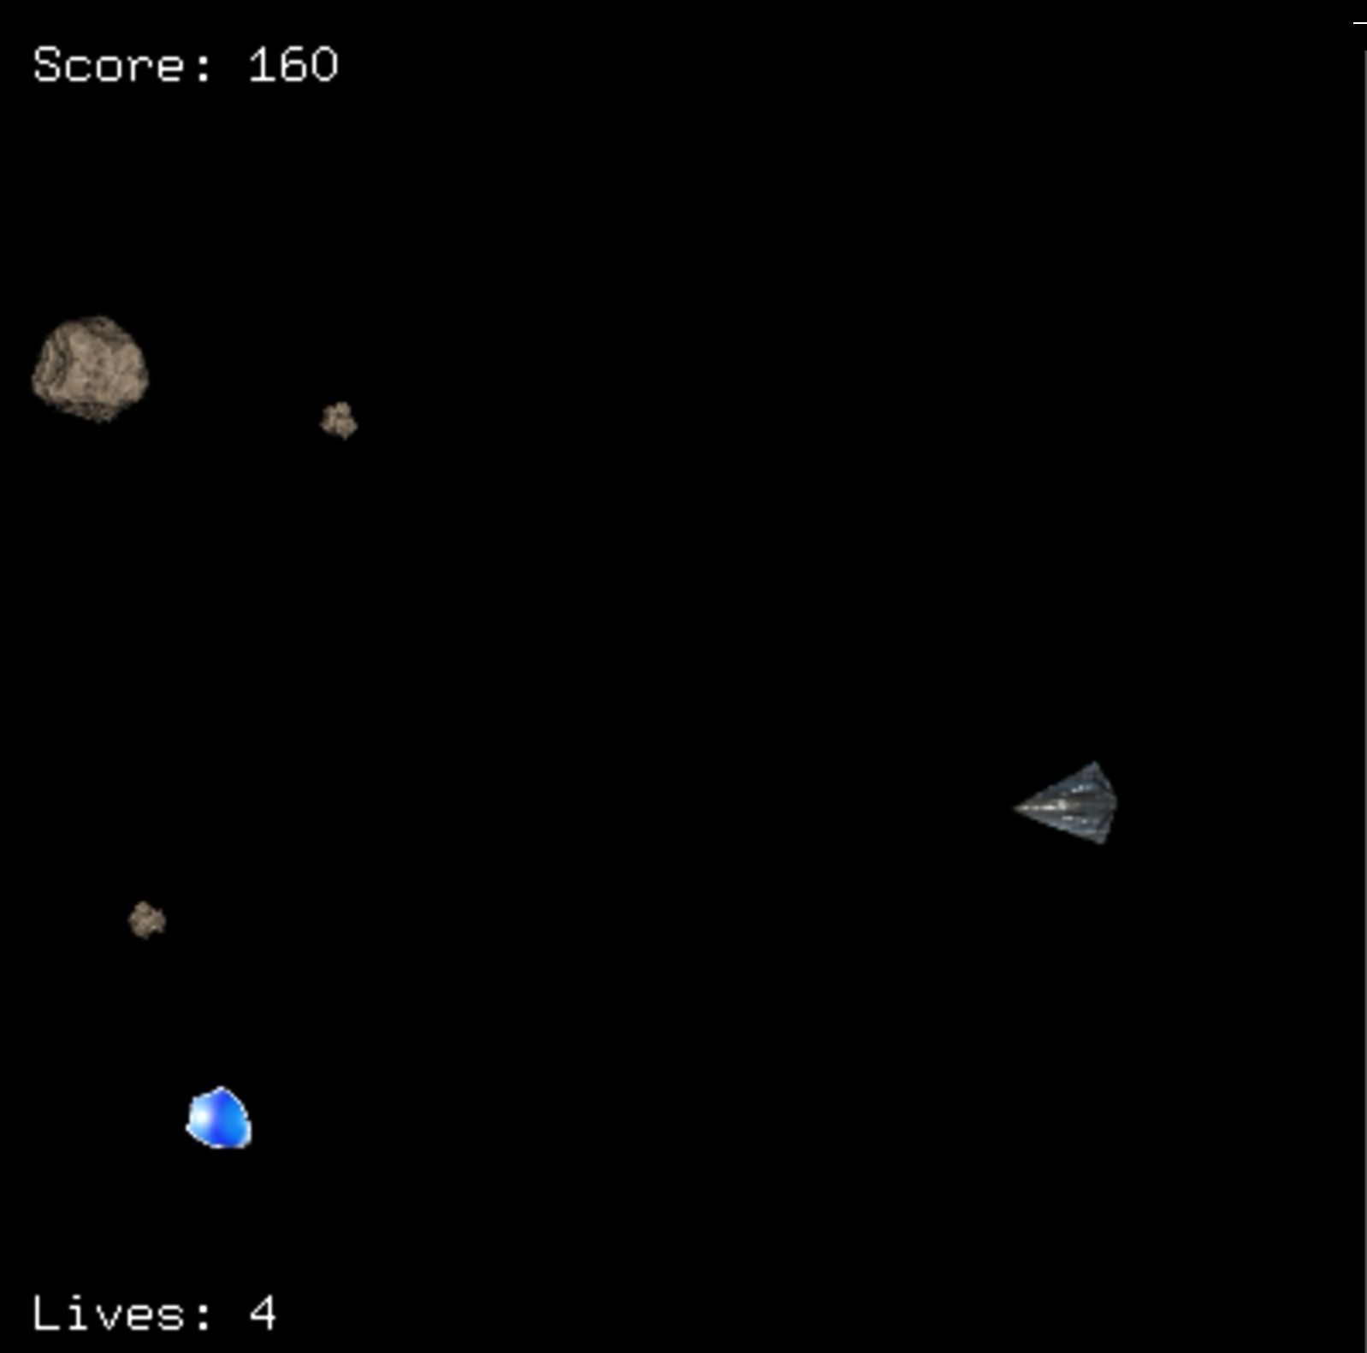
My first power up was a one up! This power up just gives us another life and removes our shields if they are on (as it is too overpowered the other way around) and also updates the health bar every time it is taken. I have implemented this in two different classes. I had to change the Player class to create a oneUp function and I had to call this function and update the health of the player on the gui whenever a power up object was removed as the power ups only collided with the player spaceship so I could use this.
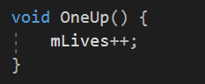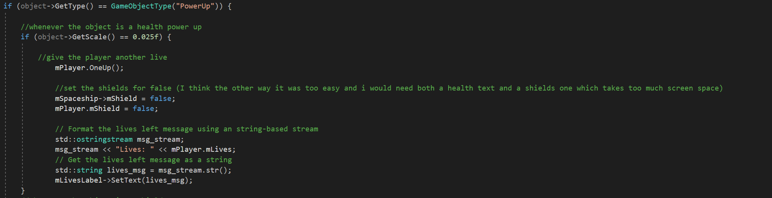

Shields!
I have implemented shields in the game, the main two differences between a shield and a power up is that you can only keep one shield and when your shield gets broken and your spaceship does not respawn so it keeps its previous location (the second one can be an advantage or a disadvantage regarding the situation but definitely more fun) You also lose your shields when you get a health powerup. I had to extend the Player class for not deducting lives, the spaceship class to avoid removing the spaceship on collision and asteroids to implement the whole functionality for this powerup.
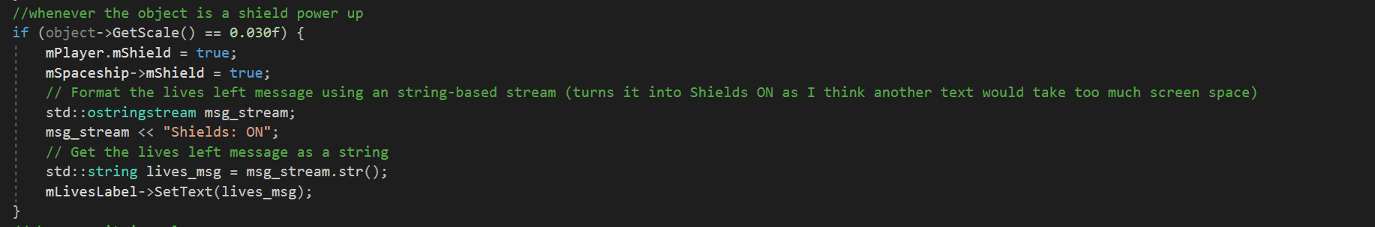
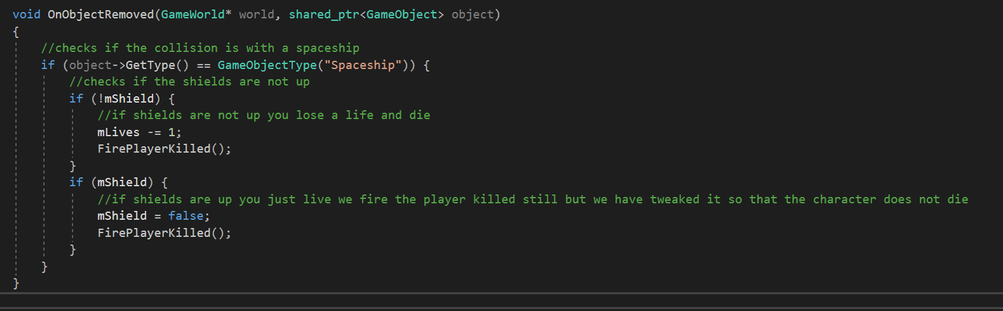
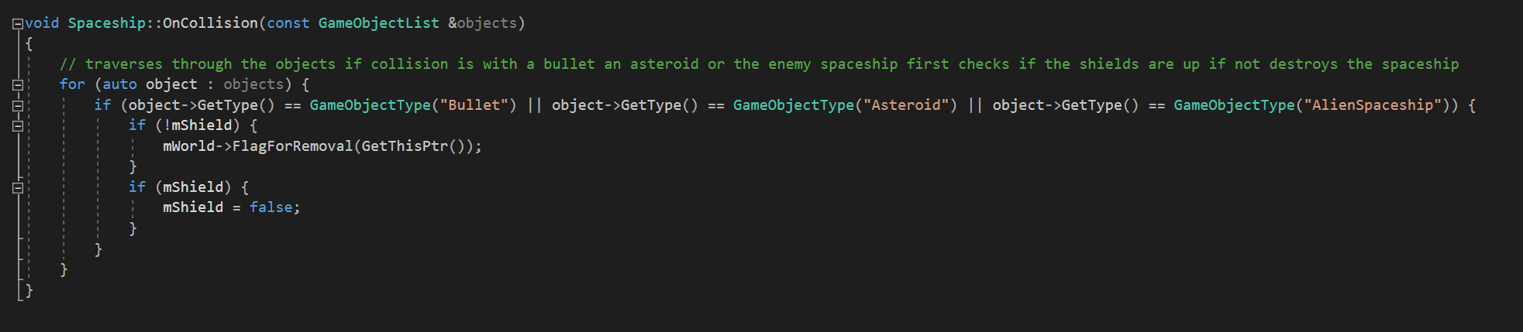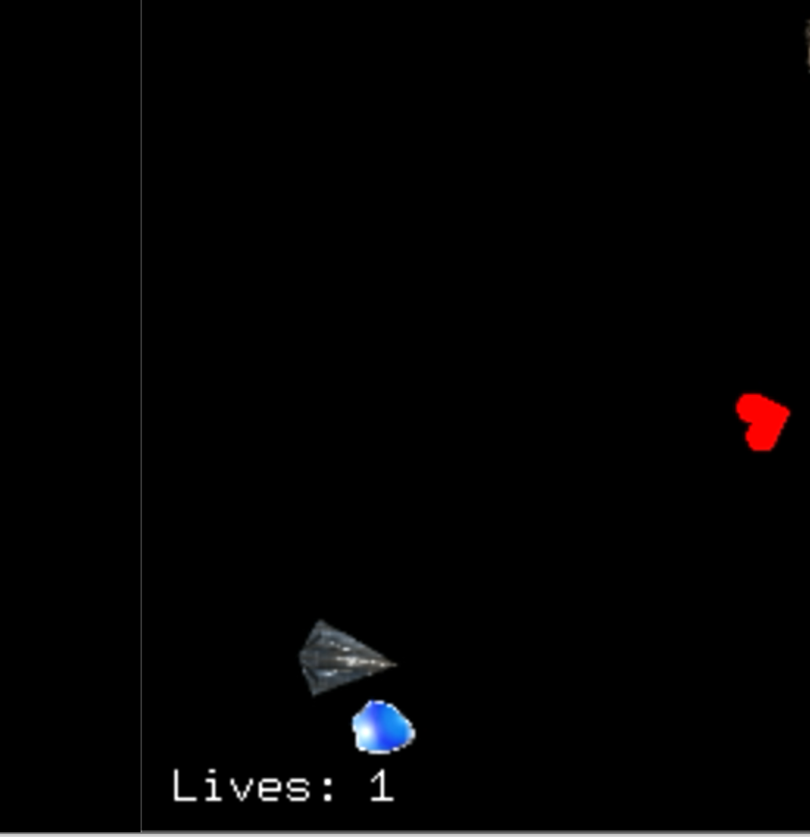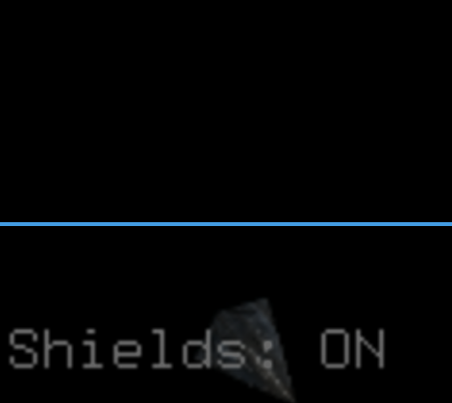

Shooting Upgrade!
The third extension of the powerups is a shooting upgrade, instead of one bullet our spaceship gets to shoot three bullets and that’s about it, we keep a variable and set it to true to check if the upgrade is taken and you never lose it! It is quite rare though. To accomplish that I have just created an if statement for the shoot function and created two more bullets inside it that are 60 degrees bent on different sides.
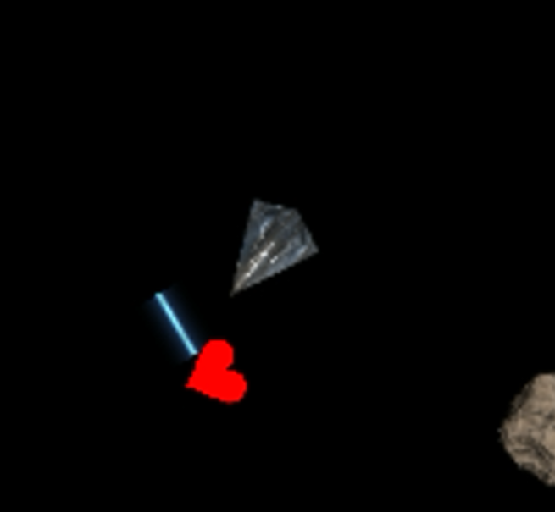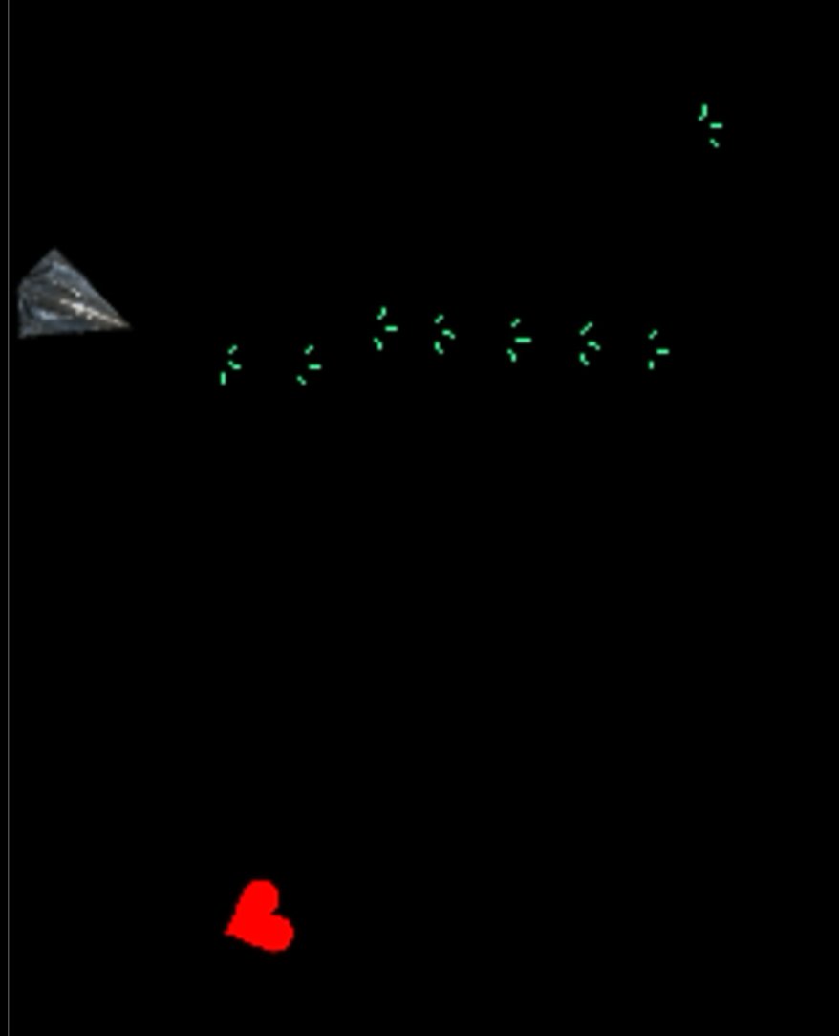
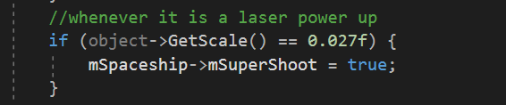
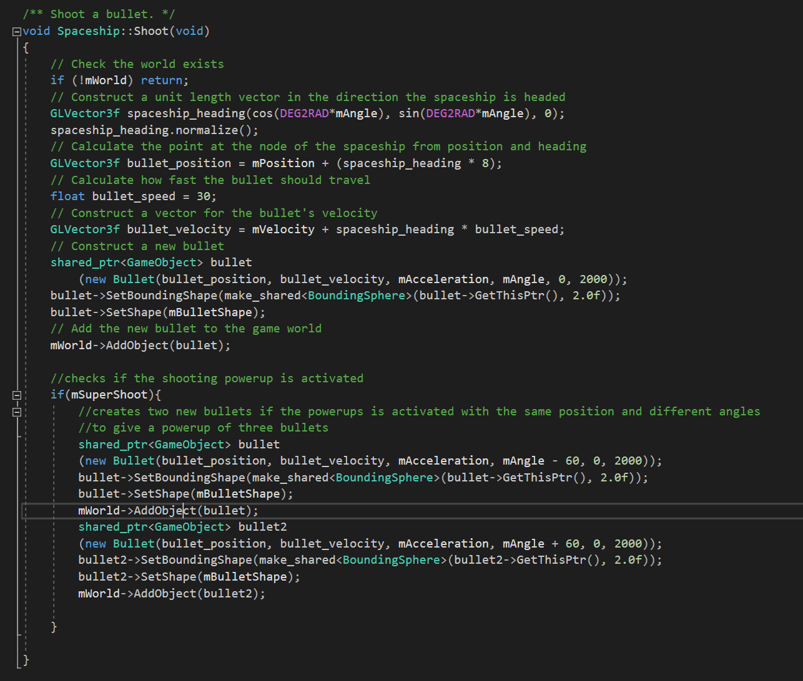

Alien Spaceship
I have decided to make an alien spaceship that attacks us and follows us around, to do that I have created a class to get instances of. I have created a function inside the alien spaceship class to make it do its alien spaceship activities called shoot (it was intended for just shooting but then ended up being used for path finding which i wasn’t planning to implement). This function gets called every 1000 timely thing and it makes our alien spaceship follow us around and shoot at us every now and then. I think using time for following mechanics was a good idea because it gives the alien spaceship a more natural
vibe.
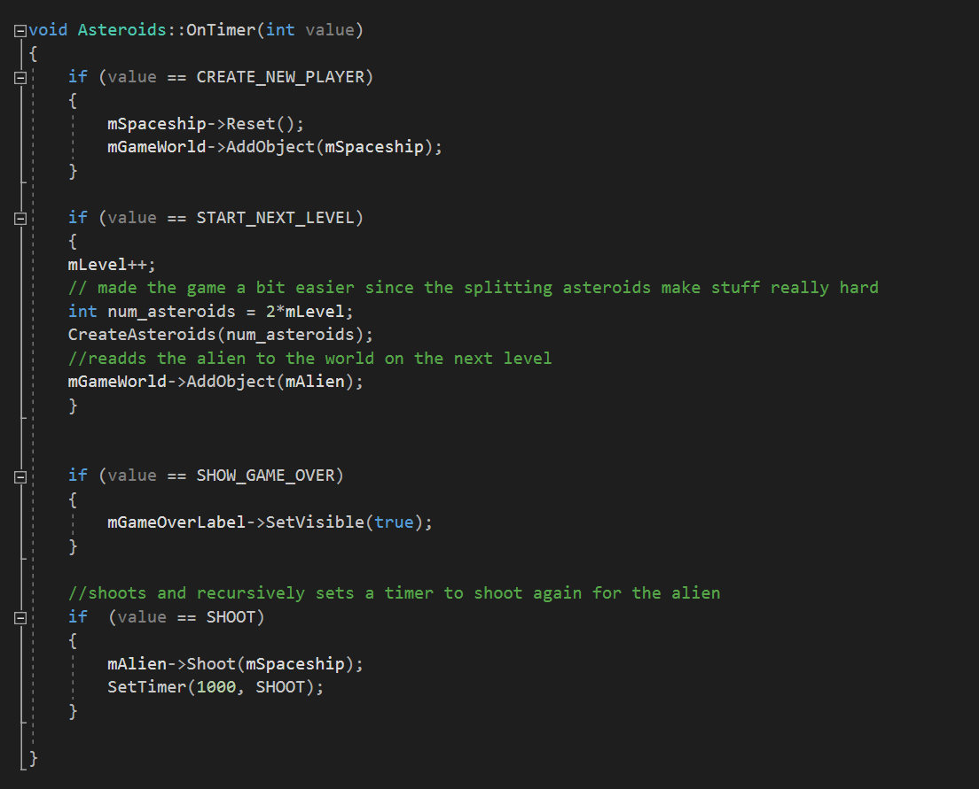
I have called this function recursively from itself to make the spaceship constantly follow us around and shoot. Everything else is not as interesting as they are just setting up sprites velocity etc. but I will also mention the shoot function with more detail here.
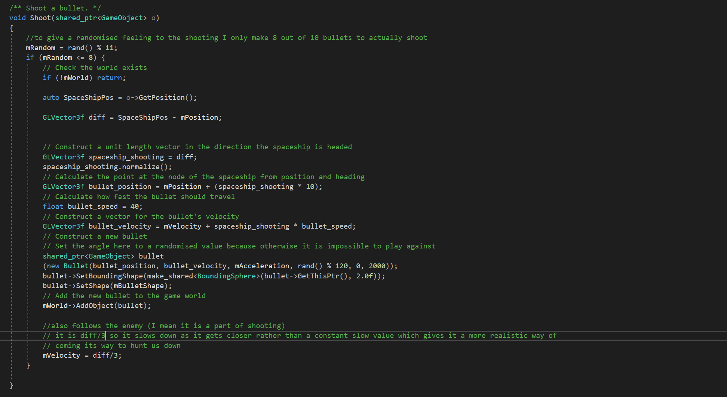
I have created the vector variable diff and made it equal to the difference between our and alien spaceships position, then I have created bullets every time with the position pointing towards the friendly spaceship (I had to use pen and paper for this and tried to use tan of the vector but it didn’t look as smooth so went back to this idea).
I have also set the velocity of the alien spaceship to diff/3. It is a difference over three instead of the exact same difference so it gives the alien spaceship a natural slowing down effect when it gets closer to us.

