✦ ✦ ✦
LOBBY OF STORIES
A free home for anyone’s words
The Story Behind the Story
Built and written by Kelvin Wilch
Project Report · 2026

Once Upon a Browser Tab
Every good story starts with a kid who couldn’t put a book down. Mine started with three of them, stacked on a nightstand: a demigod, a wizard, and a whole universe of caped problem-solvers.
I grew up inside Percy Jackson, Harry Potter, Story driven video games like Lara Croft, and the Marvel Cinematic Universe together with their comics. Camp Half-Blood, platform nine-and-three-quarters, and the back half of a Marvel post-credits scene basically raised me. They didn’t just entertain me, they gave me the itch. If these worlds could exist, why couldn’t I build one of my own?
So, I did the most reasonable thing a story-obsessed person can do: I started writing my own. And then I built a place to put it.
That place is Lobby of Stories: a website where stories live for free, out in the open, for anyone who wants to read them. No velvet rope. Just a lobby, lit up, with the doors propped open.

The Spark
Here’s the thing nobody tells you about loving stories: at some point, reading them stops being enough. You start filling in what happens next. You argue with the ending. You imagine the character the author forgot to write. That’s the moment a reader quietly becomes a writer.
I hit that moment and ran with it. But then I ran into the next problem, the boring, grown-up one. Where do you actually put a story so people can read it? The options felt either complicated, expensive, or wrapped in so many rules that the fun leaked out.
My answer was simple: if the front door is the problem, build another front door that’s to your liking.
Lobby of Stories is that door. I wanted the thing I wished existed when I was a kid scribbling fan-fiction in the margins: a clean, free, friendly place to publish, and an even friendlier place to read.

What Lobby of Stories Actually Is
In one sentence: it’s a free library that anyone can both read from and add to.
It’s not only for novelists with a five-book saga in their head (though they’re very welcome). It’s for the person with one good short story. The poet with a notebook full of half-finished verses. The friend who writes beautiful things and never shows anyone. Lobby of Stories is built for all of them.

The two doors
- The reading door: browse and discover stories, open one up, and read it in a clean, distraction-free reader — episode by episode, scene by scene.
- The writing door: make an account, I publish your own short stories or poems, and watch them go live for the world. For free. Always for free.
Read for free. Publish for free. That’s the whole deal, and that’s the point.

A Walk Through the Lobby
If you wandered onto the site, here’s the little tour you’d get. 

The Discover shelf
This is where you go to find your next read. Stories are laid out to browse like a shelf you can actually see — covers, titles, the works — so finding something that grabs you feels like browsing a bookstore, not filling out a form.
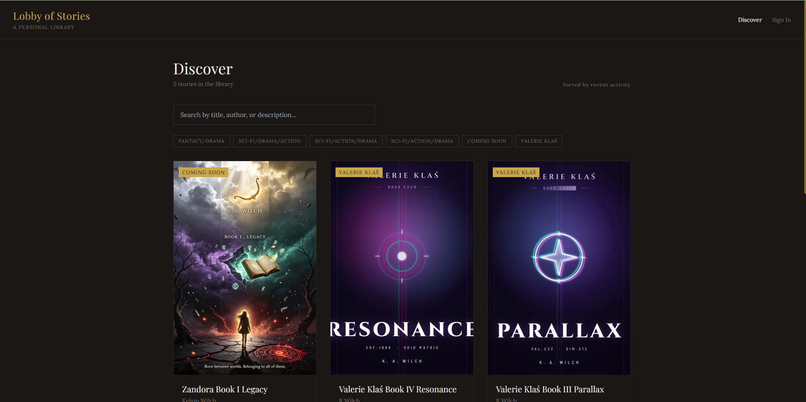

The reader
Open a story and the world quiets down. Lobby of Stories organizes longer works into episodes and scenes, a bit like chapters that know how to pace themselves. And because nothing is more annoying than losing your place, the site quietly remembers where you stopped reading and brings you right back.
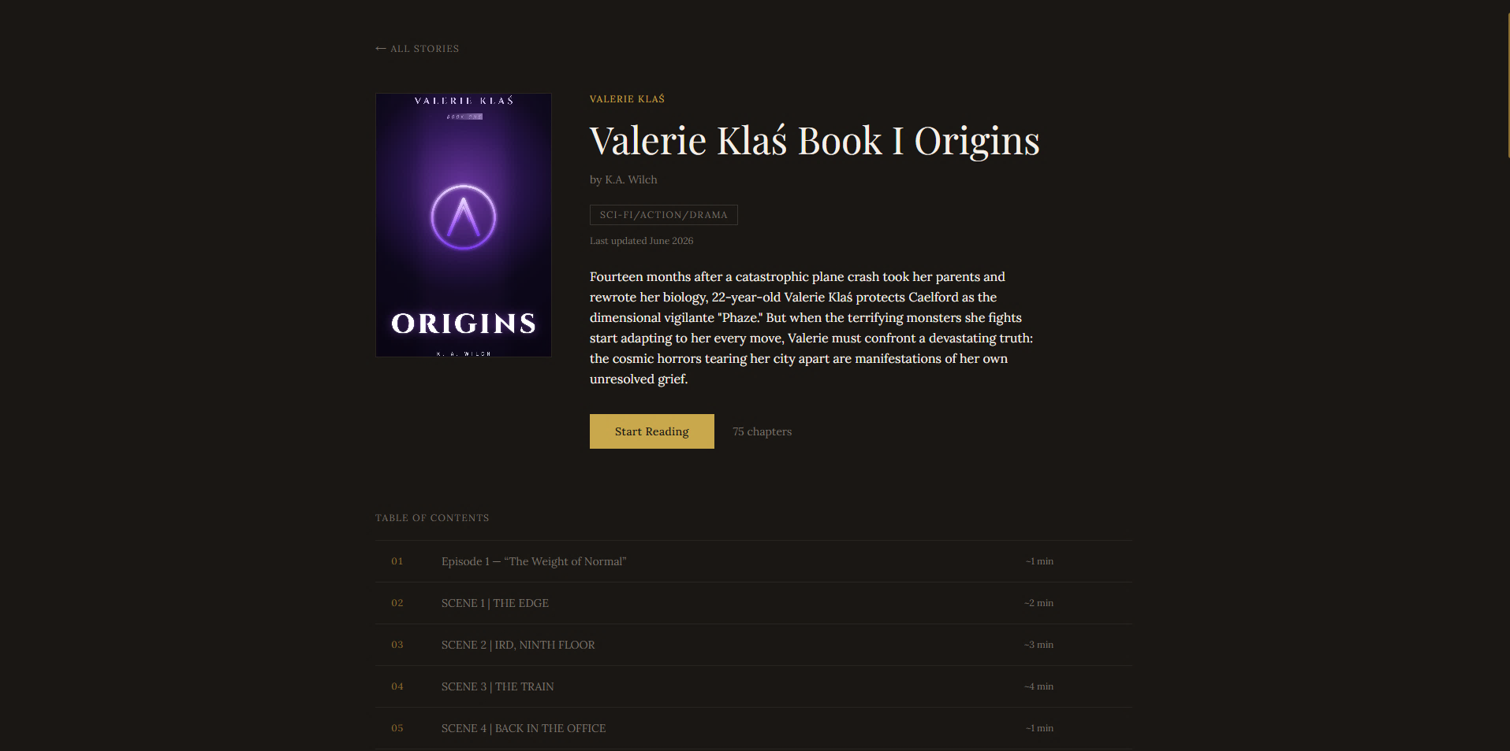

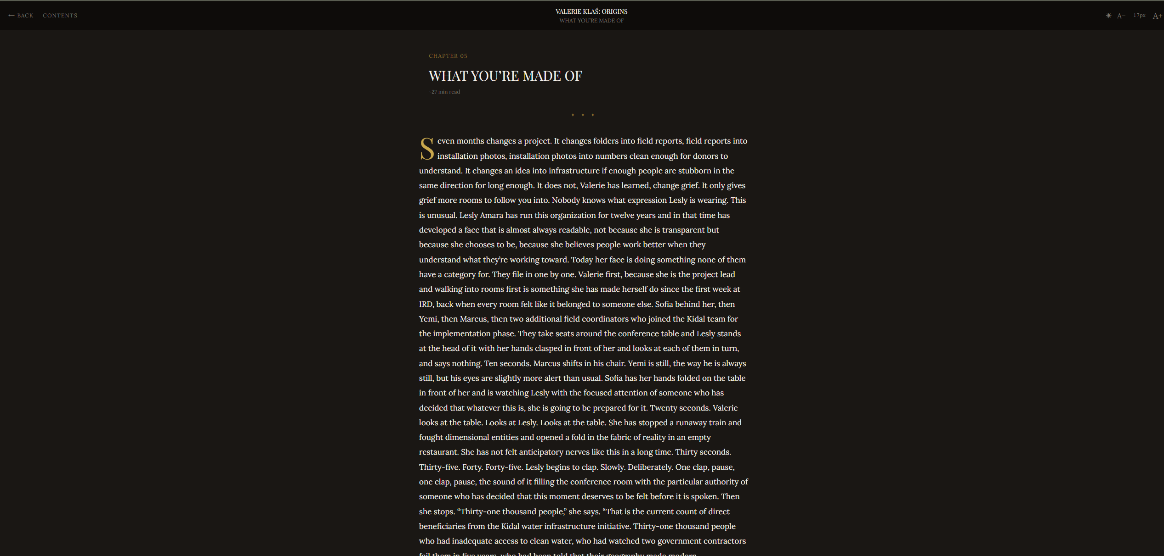

The writer’s desk
Behind the scenes there’s a tidy space for putting a story together, adding a cover, writing the description, building it out scene by scene, and pressing publish when it’s ready to meet readers. The messy magic of writing, with the publishing part made it painless.
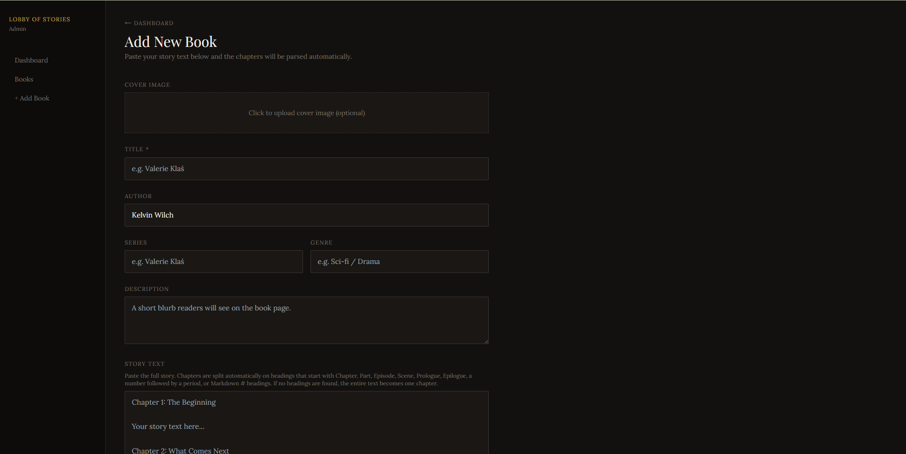
Lobby of Stories is a real, modern web app. It’s built on today’s tools a fast React-based framework, a proper database so stories and reading progress are saved safely, secure sign-in so accounts are protected, and cloud hosting so it’s online and ready whenever someone wants to read. Translation: it’s not a toy. It’s the genuine article, running on the same kind of foundations the big sites use.
I didn’t just dream up a website. I learned how to build one, then actually built it.

Why It’s Free
Because the stories that shaped me didn’t ask me to prove I deserved them. I checked Percy Jackson out of a library. I borrowed Harry Potter. I watched, re-watched, and quoted Marvel until my friends begged me to stop. They just asked for my attention and gave me a whole imagination in return.
Lobby of Stories runs on that same idea. A good story shouldn’t need a credit card to be read. And a new writer shouldn’t need permission, a publisher, or a budget to be heard. Free to read, free to publish.

What This Taught Me
- That a favorite book can grow into a finished, working website if you let the obsession do something useful.
- That building software is its own kind of storytelling, you’re just writing instructions instead of dialogue, and the computer is a very literal reader.
- That “free and open” is a design decision, and it shapes everything from the front page to the sign-up button.
- That finishing something and actually shipping it, doors open, feels even better than imagining it.

What’s Next
Every lobby is really an invitation to keep going. Some of the rooms I’d love to add next:
- More ways for readers to follow writers they love and get notified when new chapters land.
- A friendlier first-time experience for brand-new writers publishing their very first piece.
- Little touches — bookmarks, favorites, reading streaks, that make coming back feel like a habit, not a chore.
But the heart of it is already standing: a free home for anyone’s words.
✦
The doors are open. Come read something.
Lobby Of Stories
References
Wilch, K. (2026). Lobby of Stories: A free home for anyone's words. https://lobbyofstories.space/discover
Wilch, K. (2026). Lobby of Stories [Computer software]. GitHub. https://github.com/perzival-22/lobbyofstories

