Software Requirements Specification
Railway Reservation System
Software Engineering Laboratory Project
Department of Computer Science and Engineering, PES University
Team 11, Class 5A CSE
Version 1.0 Date: 09 September 2026 Status: Submitted for review

Team
Name | SRN | Work owned in this document
Abhigyan Dutta | PES2UG24CS019 | Document owner. Sections 1, 2, 4, 5 and 8, and the final consistency pass
Akash Singh | PES2UG24CS042 | Section 3 interfaces, and review of the performance numbers in Section 5
Aditya Alur | PES2UG24CS052 | Section 5.1.2 security requirements and Section 6
Aditya G. Mule | PES2UG24CS031 | Section 7 use case models and the UC-03 flow

Revision history
Version | Date | Author | Change summary
0.1 | 05 Sep 2026 | Abhigyan Dutta | Outline, scope and first cut of the functional requirements
0.2 | 06 Sep 2026 | Aditya Alur | Booking, waitlist and refund requirements rewritten after the team walked through a Tatkal booking by hand
0.3 | 06 Sep 2026 | Aditya G. Mule | Use case diagrams and the UC-03 flow added as Section 7
0.4 | 07 Sep 2026 | Akash Singh | External interfaces filled in, load figures in Section 5 corrected
0.5 | 08 Sep 2026 | Abhigyan Dutta | Requirement set cut back to what the team can build this semester, duplicates removed and IDs renumbered
1.0 | 09 Sep 2026 | Abhigyan Dutta | Traceability matrix completed and requirement IDs frozen for the rest of the course

Approvals
Role | Name | Signature / Email | Date
Course Coordinator | Prof. Pavithra
Class Coordinator | Prof. Deena Hajim

Table of Contents
1. Introduction 3
2. Overall description 4
3. External interface requirements 5
4. System features 6
5. Non functional requirements 8
5.1 Security 9
6. Quality attributes and acceptance tests 10
7. System models and diagrams 10
8. Requirements traceability matrix 13

How to read this document
Functional requirements are numbered RRS-F-001 to RRS-F-020 and grouped by feature in Section 4. Non functional requirements are RRS-NF-001 upwards in Section 5 and security requirements are RRS-SR-001 upwards in Section 5.1.2. Every requirement carries one acceptance criterion a tester can mark pass or fail, and every requirement marked High priority appears in the traceability matrix in Section 8. Values that railway policy can change, such as the Tatkal opening time or a cancellation charge, are held as configuration, so the requirement is written against the configured value and not against the number itself.
The requirement set was deliberately cut back in version 0.5. Anything the team could not build and test in the time available was dropped rather than left in as a promise, which is why features such as segment wise berth reuse and concession fares are named in Section 1.2 as out of scope.

1. Introduction

1.1 Purpose
This document specifies the software requirements for a Railway Reservation System, an online and counter based platform for searching trains, reserving berths, paying for and cancelling tickets, and preparing the reservation chart before a train departs. It states what the system must do, the limits it works inside, and how each requirement will be verified. It is written for the members of Team 11 who will build and test the system in the remaining laboratory sessions, and for the faculty evaluating this submission.

1.2 Scope
The system covers passenger accounts, train and availability search, reservation against class and quota, berth allocation including RAC and waitlist, fare calculation, payment through an external gateway, ticket issue with a PNR and a QR code, cancellation with rule based refunds, waitlist promotion, chart preparation and ticket checking on board. Both the passenger channel and the reservation counter are in scope and they share one inventory.
The following are out of scope for this release, either because they belong to another system or because the team chose to keep the build achievable:
- Train operations. Running, signalling and delay management are not part of this system, which only reads the published schedule.
- Freight, parcel, unreserved and season ticketing. Passenger reservation only.
- Segment wise berth reuse, concession fares and saved traveller profiles. All three were in the first draft and were dropped in version 0.5 as more than the team can build and test properly.
- The payment gateway itself. The system initiates and reconciles payments, it does not process card data.

1.3 Audience
Developers and testers on the team, the booking clerk at a reservation counter, the administrator who maintains schedules, quotas and fare rules, the ticket examiner who checks tickets on board, and the evaluators assessing this submission.

1.4 Definitions and acronyms
Term | Meaning as used in this document
PNR | Passenger Name Record, the reference that identifies one booking and all passengers on it
Quota | A share of the berths in a class set aside for a category of passenger, for example general, ladies or Tatkal
RAC | Reservation Against Cancellation. The passenger may board and shares a berth, and is promoted to a full berth if one is released
Waitlist | An ordered queue of passengers with no berth, promoted to RAC or confirmed as cancellations arrive
Tatkal | A late release quota that opens at a fixed time one day before departure
Chart preparation | The point at which allocation is frozen, coach and berth numbers are published and remaining waitlisted tickets are cancelled
Others | TTE travelling ticket examiner, OTP one time password, RBAC role based access control, RTM requirements traceability matrix, WCAG Web Content Accessibility Guidelines

1.5 References
- Software Engineering laboratory handout and SRS template, Department of CSE, PES University.
- IEEE 830 style section headings, used here as the outline.
- Team 11 requirements table and use case model from the earlier laboratory sessions, which Sections 4 and 7 extend.

2. Overall description

2.1 Product perspective
The system is a web application with three front ends over one shared inventory. Passengers use a public site or a mobile browser. Booking clerks use a counter application inside a reservation office, where a booking is made while a person stands at the window. Ticket examiners use a handheld application on board, where there is no usable network for most of the journey, so the prepared chart is downloaded before departure.
Behind them sits the reservation core, which owns the seat inventory, the waitlist order and the PNR records, and which talks to an external payment gateway and to an SMS and email service. The one thing the design treats as sacred is the inventory. Two passengers holding the same berth is worse than a booking that fails, so the requirements in Section 4.3 are written to make failure the safe outcome.

2.2 Major product functions
- Passenger registration with a verified mobile number
- Train and availability search between two stations for a date, by class and quota
- Reservation with berth allocation, RAC and an ordered waitlist, including the Tatkal window
- Itemised fare calculation and payment through an external gateway
- PNR and QR ticket issue, delivered by SMS and email
- Cancellation with slab based refunds and automatic waitlist promotion
- Chart preparation, coach and berth publication, and ticket checking on board
- Schedule, quota and fare administration with an audit trail of privileged actions

2.3 User roles and characteristics
Role | What they need from the system
Passenger | Books for self and family, checks PNR status, cancels when plans change. Wants as few screens as possible and an honest answer on whether a waitlisted ticket is likely to clear.
Booking Clerk | Works a queue at a counter window. Needs a fast keyboard driven screen and needs to be stopped from issuing a ticket the inventory cannot support.
Reservation Administrator | Maintains schedules, coach composition, quota splits and fare rules. Small in number, high privilege, works from an office.
Ticket Examiner | Verifies tickets on a moving train with no network, working from the chart held on the device.

2.4 Operating environment
- Passenger channel: current versions of Chrome, Firefox and Safari on desktop, and Android or iOS mobile browsers, usable on a weak or intermittent mobile data connection
- Counter application: desktop browser on a reservation office terminal, keyboard driven, connected to a receipt printer
- Handheld application: Android device, version 12 or later, with local storage for the downloaded chart
- Server side: Linux hosts behind a load balancer and a relational database with a strong isolation level on the inventory tables

2.5 Constraints
- Card data must never reach our servers. Payment goes through the gateway's hosted page, so the system holds a token and a reference only.
- Seat inventory must be strictly consistent rather than eventually consistent, so the booking path has to lock the inventory row instead of trusting a cached count.
- Fares, quota splits, cancellation slabs and the Tatkal opening time are policy values that change without notice, so they must be configurable without a code release.
- Load is not uniform. The Tatkal window produces a burst many times the normal booking rate in its first minute, and the system is sized for that minute.

2.6 Assumptions and dependencies
- The train schedule and coach composition are loaded before booking opens for a date.
- The payment gateway is available. If it is not, bookings cannot be confirmed, and the system holds the berth only for the payment window rather than working around the outage.
- Every passenger account has a reachable mobile number, which is the account key.
- Server clocks are synchronised, because the Tatkal opening time and the cancellation cutoff are both decided on server time.

3. External interface requirements

3.1 User interfaces
- Passenger channel: the booking flow is limited to four screens, search then selection then passenger details then payment, with the fare breakup shown before payment starts and a countdown showing how long the berths are held.
- Counter application: one screen per booking, fully operable from the keyboard, showing availability, fare and the payment choice together so the clerk does not switch screens mid transaction.
- Administration console: table based screens for schedule, quota and fare rules, and any rule change shows how many future bookings it would affect before it is applied.
- Handheld application: a coach wise passenger list searchable by berth or PNR, with a visible indicator of when the chart was last synchronised. WCAG 2.1 level AA labels and contrast apply across all three front ends, and the passenger channel is offered in English, Hindi and Kannada.

3.2 Hardware interfaces
- Receipt and ticket printer at the reservation counter, driven through the standard print path
- Device camera or QR scanner on the handheld for reading the QR code on a ticket, with manual PNR entry as the fallback
- Card terminal at the counter, operated by the gateway rather than by this system, which receives only the result

3.3 Software interfaces
Interface | Direction | Purpose and form
Payment gateway | Outbound and inbound callback | Hosted payment page, then a signed callback carrying the result. JSON over HTTPS. Callbacks are verified, may repeat, and are handled idempotently
Refund service of gateway | Outbound | Refund initiation and status polling for cancellations and for payments that could not be allocated
SMS and email provider | Outbound | Ticket delivery and waitlist promotion alerts, each with a message reference for tracing
Train schedule feed | Inbound | Timetable, halts and coach composition, loaded before booking opens for a date
Chart download | Outbound | The handheld pulls the frozen chart for a train before departure and works from that copy offline

3.4 Communications
- TLS 1.2 or higher on every connection, with TLS 1.3 preferred. Plain HTTP is redirected and not served.
- JSON over HTTPS for all service calls. Every request carries a correlation identifier that is written to the audit log, which is what makes a disputed booking traceable afterwards.
- Payment callbacks are verified by signature and can be accepted more than once without changing the outcome, because a gateway that does not receive our acknowledgement will retry.
- Retry with backoff on notification delivery and on chart download, with a cap so one failing device cannot flood the server.

4. System features
Every requirement in this section is functional. Priority is High for anything a reservation cannot be issued without, Medium for anything that can be worked around manually for a short time, and Low for convenience. Each row carries one acceptance criterion a tester can mark pass or fail.

4.1 Passenger account
Req ID | Requirement (the system shall...) | Type | Pri. | Source | Acceptance criteria / Test case
RRS-F-001 | accept a registration containing name, mobile number, email and password, and refuse it if the mobile number is already held by an active account | Func. | High | Business | AC: a second registration on an existing mobile number is refused with a message naming the field. Test: TC-REG-01
RRS-F-002 | verify the mobile number by a one time password that expires after 10 minutes, before the account can complete a booking | Func. | High | Security | AC: an unverified account cannot reach payment, and a password older than 10 minutes is refused. Test: TC-REG-02

4.2 Train and availability search
Req ID | Requirement (the system shall...) | Type | Pri. | Source | Acceptance criteria / Test case
RRS-F-003 | list trains running between an origin and a destination on a chosen date with train number, name, departure and arrival times and the classes offered | Func. | High | Business | AC: for a station pair and date with three known trains, all three appear with correct times and no train that does not run that day. Test: TC-SRCH-01
RRS-F-004 | show availability per class and quota as a confirmed count, an RAC count and a waitlist length, computed from live inventory no more than 30 seconds old | Func. | High | Business | AC: after a booking is confirmed the displayed count falls by one within 30 seconds. Test: TC-SRCH-02

4.3 Reservation and berth allocation
Description: the core of the system. These requirements exist so that when two passengers want the last berth, exactly one of them gets it.
Req ID | Requirement (the system shall...) | Type | Pri. | Source | Acceptance criteria / Test case
RRS-F-005 | never allocate the same berth on the same train and date to two bookings, whatever the order or timing of concurrent requests | Func. | High | Safety | AC: with 200 concurrent requests against 10 free berths, exactly 10 confirmations are issued and no berth number repeats. Test: TC-BOOK-01
RRS-F-006 | hold the selected berths for 10 minutes while payment is completed, and release them automatically when the hold expires | Func. | High | Business | AC: a held berth is not offered to a second passenger inside 10 minutes and is offered again after the hold lapses. Test: TC-BOOK-02
RRS-F-007 | allocate from the free berths of the requested quota first, then RAC, then waitlist, in the order requests were accepted | Func. | High | Policy | AC: 20 requests against 5 berths and 2 RAC positions produce 5 confirmed, 2 RAC and 13 waitlisted in request order. Test: TC-BOOK-03
RRS-F-008 | limit one booking to six passengers, and to four passengers when the Tatkal quota is used | Func. | Medium | Policy | AC: a seventh passenger is refused on a general booking and a fifth on a Tatkal booking. Test: TC-BOOK-04
RRS-F-009 | open Tatkal booking for a train only at the configured opening time on the day before departure, and refuse any earlier attempt with the time it will open | Func. | High | Policy | AC: a request one minute early is refused and states the opening time, one at the opening time is accepted. Test: TC-BOOK-05

4.4 Fare, payment and ticket issue
Description: money leaves the passenger's account here, so these requirements are written around what happens when the payment and the allocation disagree.
Req ID | Requirement (the system shall...) | Type | Pri. | Source | Acceptance criteria / Test case
RRS-F-010 | compute the payable amount as base fare by class and distance, reservation charge, taxes and convenience fee, and display the breakup before payment begins | Func. | High | Finance | AC: the displayed total equals the sum of the shown components and matches a hand calculation for three sample journeys. Test: TC-PAY-01
RRS-F-011 | hand payment to the external gateway on its hosted page and store only a transaction reference and a token, never a card number or verification code | Func. | High | Security | AC: a database and log inspection after a payment finds no card number and no verification code. Test: TC-PAY-02
RRS-F-012 | confirm the booking, issue a PNR with a QR code and send the ticket by SMS and email only after the gateway reports the payment as successful | Func. | High | Business | AC: a failed or abandoned payment leaves no PNR and returns the held berths to availability, and a successful one produces one ticket message. Test: TC-PAY-03
RRS-F-013 | treat a repeated or late payment callback as the same event, so that one payment can never produce two tickets | Func. | High | Finance | AC: the same callback delivered five times results in one PNR and one charge. Test: TC-PAY-04
RRS-F-014 | initiate a full automatic refund and notify the passenger when a payment succeeds but allocation cannot be completed, recording the refund reference against the transaction | Func. | High | Finance | AC: a forced allocation failure after payment produces a refund record with a reference and a message to the passenger. Test: TC-PAY-05

4.5 Cancellation and waitlist movement
Description: cancellations are not an edge case on a railway, they are the mechanism by which waitlisted passengers travel at all.
Req ID | Requirement (the system shall...) | Type | Pri. | Source | Acceptance criteria / Test case
RRS-F-015 | allow cancellation up to the configured cutoff before departure, compute the refund from the active slab table, and refuse a later request while stating the cutoff that applied | Func. | High | Policy | AC: cancellations either side of two slab boundaries return the slab amounts, and a request after the cutoff is refused with the cutoff named. Test: TC-CAN-01
RRS-F-016 | release the berth on cancellation and promote the earliest RAC passenger to it, then the earliest waitlisted passenger into the vacated RAC position, notifying both | Func. | High | Policy | AC: cancelling one confirmed berth moves exactly one RAC and one waitlisted passenger up, in queue order, with two notifications sent. Test: TC-CAN-02

4.6 Chart preparation and ticket checking
Req ID | Requirement (the system shall...) | Type | Pri. | Source | Acceptance criteria / Test case
RRS-F-017 | prepare the reservation chart at the configured hours before departure, freeze allocation, publish coach and berth numbers, and cancel any remaining waitlisted tickets with a full refund | Func. | High | Ops | AC: at the configured hour every confirmed ticket shows a coach and berth, no further allocation is accepted, and each remaining waitlisted ticket has a refund record. Test: TC-CHT-01
RRS-F-018 | let a ticket examiner verify a ticket by scanning its QR code or entering the PNR against the prepared chart, including from the chart copy held on the device with no network | Func. | High | Ops | AC: a valid ticket returns valid with the network disconnected, and a cancelled ticket and a ticket for another train both return invalid with the reason. Test: TC-CHT-02

4.7 Administration
Req ID | Requirement (the system shall...) | Type | Pri. | Source | Acceptance criteria / Test case
RRS-F-019 | let an administrator maintain train schedules, coach composition, quota splits and fare rules with an effective date, without a code release | Func. | High | Ops | AC: a fare rule with a future effective date does not affect today's bookings and does affect one made after that date. Test: TC-ADM-01
RRS-F-020 | record every privileged action, meaning fare and quota changes, manual refunds, chart edits and clerk overrides, in an append only audit log that can be filtered by user and date | Func. | High | Security | AC: each of the five action types performed once appears in the log with actor, target and time, and an attempt to edit or delete a log row fails. Test: TC-ADM-02

5. Non functional requirements
Each of these names a number and the load it is measured under, because a requirement that only says the system should be fast cannot be tested. The load figures are what a four person team can generate and defend with a scripted test, not national scale traffic.
Req ID | Requirement | Category | Priority | Acceptance criteria / Measurement
RRS-NF-001 | The booking path shall return a confirmation or a refusal in under 3 seconds at the 95th percentile while sustaining 50 booking attempts a second | Performance | High | Load test at 50 attempts a second reports 95th percentile under 3 s with no failed inventory write. Test: TC-PERF-01
RRS-NF-002 | Availability search shall return results in under 2 seconds at the 95th percentile with 1000 concurrent users searching | Performance | High | Load test with 1000 virtual users reports 95th percentile under 2 s. Test: TC-PERF-02
RRS-NF-003 | Seat inventory shall reconcile exactly against issued tickets, with zero discrepancy, after a test run that includes a simulated Tatkal burst | Reliability and integrity | High | Reconciliation job after the burst run reports zero mismatched berths. Test: TC-REL-01
RRS-NF-004 | The booking service shall be available for 99.5 percent of each month, excluding the declared nightly maintenance window | Reliability | Medium | Monthly uptime report shows 99.5 percent or better. Test: operations report
RRS-NF-005 | Card data shall never be stored, logged or transmitted by this system | Security and compliance | High | A scan of database, logs and traffic captures finds no card number or verification code. Test: TC-SEC-01
RRS-NF-006 | The passenger channel shall meet WCAG 2.1 level AA and shall complete the booking flow within 30 seconds of transfer time on a connection throttled to 1 Mbps | Usability and accessibility | Medium | Accessibility audit passes at level AA and a throttled run of the booking flow stays under 30 s. Test: TC-UX-01

5.1 Security

5.1.1 Security objectives
Three objectives, in the order the team would defend them if it had to choose:
- The seat inventory and the money must always agree, and every transaction must be attributable. A ticket is a paid contract for a specific berth, so a system that sells the same berth twice, or charges without issuing, fails at the only thing it is for.
- Passenger and payment data must stay confidential. A PNR record holds names, ages and a journey, which is enough to track a person, so those records must not be lookupable in bulk and card data must never enter the system at all.
- Every privileged action must be accountable to one named person. Clerks and administrators can change fares and issue manual refunds. Those powers are needed at a counter, so the control is not to remove them but to record each use under RRS-F-020 where it cannot be quietly deleted.

5.1.2 Security requirements
Req ID | Requirement (the system shall...) | Type | Priority | Acceptance criteria / Test case
RRS-SR-001 | enforce TLS 1.2 or higher on every network connection, including gateway callbacks and chart download, and redirect plain HTTP | Security | High | A scan reports no connection below TLS 1.2 and no service answering on plain HTTP. Test: TC-SEC-02
RRS-SR-002 | accept payment only through the gateway's hosted page, and hold no card number, expiry or verification code in any store, log or backup | Security | High | A scan of stores, logs and backups finds no card data. Test: TC-SEC-03
RRS-SR-003 | apply role based access control with least privilege, require a second factor for booking clerk and administrator sign in, and lock a counter terminal after 5 minutes idle | Security | High | A clerk account cannot reach the administration console, single factor sign in is refused, and an idle terminal locks. Test: TC-SEC-04
RRS-SR-004 | return only masked passenger details to an unauthenticated PNR status lookup, showing initials and no age, and limit any client to 30 lookups a minute | Security and privacy | High | An unauthenticated lookup shows initials only and the 31st lookup in a minute is refused. Test: TC-SEC-05
RRS-SR-005 | store passwords using a memory hard hashing function with a per account salt, and lock an account for 15 minutes after 5 failed sign in attempts | Security | High | Stored values are not reversible by lookup and a sixth failed attempt is locked out. Test: TC-SEC-06

6. Quality attributes and acceptance tests
Exit criteria for acceptance. Every requirement marked High in Sections 4, 5 and 5.1.2 is implemented and verified, no High priority non functional requirement is failing, the traceability matrix in Section 8 shows a test case against every High priority requirement, and no critical or high severity defect is open against the allocation, payment or cancellation paths.
Attribute | What it means here | How it is accepted
Inventory integrity | No berth is ever held by two bookings, and refusing a booking is preferred to overselling | TC-BOOK-01 at 200 concurrent requests, plus the TC-REL-01 reconciliation
Financial correctness | One payment produces one ticket, and a payment without a ticket produces a refund | TC-PAY-03 to TC-PAY-05, and a reconciliation of charges against issued PNRs
Queue fairness | RAC and waitlist promotion follows the order requests were accepted, with no overtaking | TC-BOOK-03 and TC-CAN-02, checked against a hand maintained queue
Burst tolerance | The Tatkal opening minute does not degrade into timeouts or double allocation | TC-PERF-01 run as a one minute spike from idle
Data protection | Passenger records cannot be harvested and card data is never present | TC-SEC-01, TC-SEC-03 and TC-SEC-05
Reach | The passenger channel is usable on a low end phone, a slow connection and with a screen reader | TC-UX-01 accessibility audit and throttled run

Acceptance test suites: Registration, Search, Booking, Tatkal, Payment, Cancellation, Chart and Checking, Administration, Performance, Reliability, Security and Accessibility. They run in that order because each suite depends on data the previous one creates, and the Performance suite runs last on a restored copy so a load run cannot corrupt functional test data.

7. System models and diagrams
Two use case diagrams are used rather than one. A single diagram covering the passenger channel, the counter, the administration console and the on board handheld became unreadable as soon as the include and extend relationships were added, so the model is split by who is standing in front of the screen. Both were drawn with an online UML tool and the source files are in the team repository under diagrams.

7.1 Use case diagram 1: passenger channel
Actors: Passenger (primary), Payment Gateway (supporting), Notification Service (supporting).
UC ID | Use case | Relationships
UC-01 | Register and verify account | includes Verify Mobile by OTP
UC-02 | Search trains and availability | none
UC-03 | Book a ticket | includes Hold Berths, includes Make Payment, extended by Book under Tatkal
UC-04 | Cancel a ticket | includes Compute Refund, includes Promote Waitlist
UC-05 | Check PNR status | none
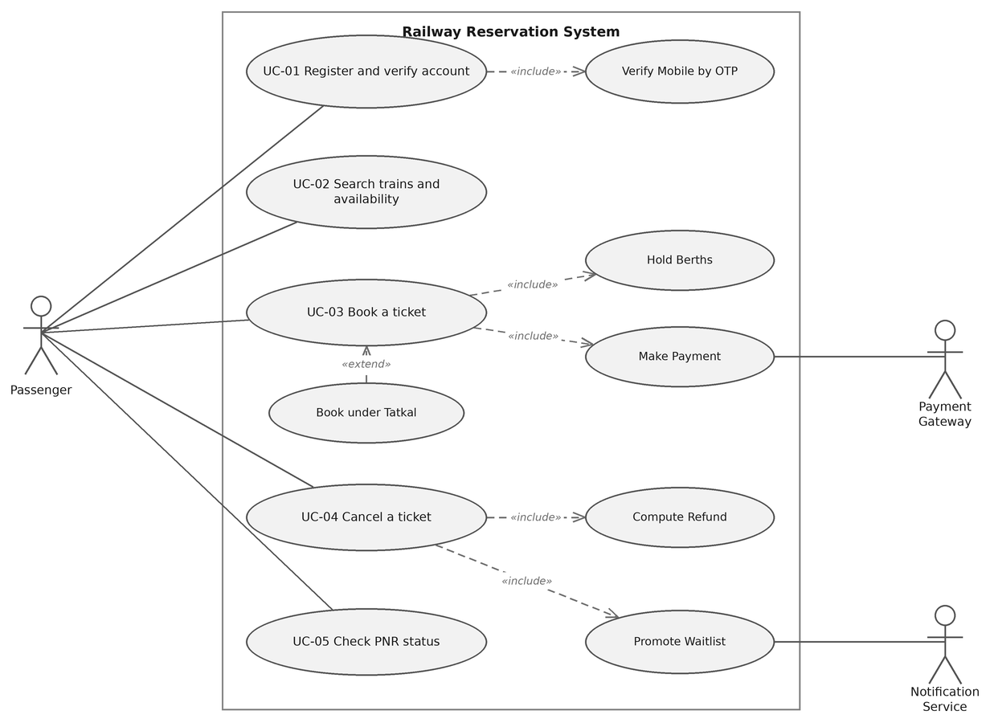
Figure 1. Use case diagram for the passenger channel

7.2 Use case diagram 2: counter, administration and on board
Actors: Booking Clerk (primary), Reservation Administrator (primary), Ticket Examiner (primary), Payment Gateway (supporting).
UC ID | Use case | Relationships
UC-06 | Issue ticket at counter | includes Hold Berths, includes Collect Payment
UC-07 | Prepare reservation chart | includes Allocate Berth, includes Cancel Remaining Waitlist
UC-08 | Verify ticket on board | includes Load Offline Chart
UC-09 | Maintain schedule, quota and fare rules | includes Write Audit Entry
UC-10 | Issue manual refund | includes Write Audit Entry
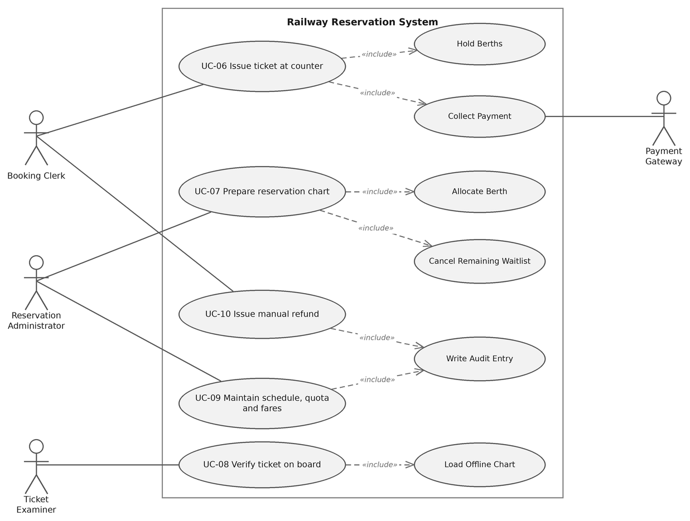
Figure 2. Use case diagram for the counter, administration and on board channels

7.3 Use case flow for UC-03, Book a ticket
Field | Value
Use case | UC-03 Book a ticket
Primary actor | Passenger
Supporting actors | Payment Gateway, Notification Service
Preconditions | The passenger is signed in with a mobile number verified under RRS-F-002, booking is open for the chosen train and date, and the chart for that train has not yet been prepared
Postconditions | A PNR exists with a confirmed, RAC or waitlisted status for every passenger on it, the inventory reflects the allocation, one payment is recorded against it, and the ticket has been sent by SMS and email

Main success scenario
- The passenger searches for trains between two stations on a date and the system lists them with availability by class and quota.
- The passenger selects a train, a class and a quota, and the system reports the berths it can offer.
- The passenger enters up to six passengers with age, gender and berth preference.
- The system holds the required berths for 10 minutes and shows the fare breakup with a countdown.
- The passenger confirms and the system hands the transaction to the payment gateway on its hosted page.
- The gateway reports the payment as successful.
- The system converts the hold into an allocation, decrements the inventory and generates a PNR with a QR code.
- The system sends the ticket by SMS and email and displays the PNR with coach and berth where already allocated.
- The use case ends successfully.

Alternate flow 6a, payment declined or abandoned
- 6a1. The gateway reports the payment as declined, or the payment window closes with no result.
- 6a2. The system releases the held berths back to availability and shows the reason given by the gateway.
- 6a3. A second attempt is offered with the same passenger details, and availability is rechecked first because the berths may have gone.
- 6a4. After two failed attempts the booking is abandoned, nothing is charged and no PNR is created.

Alternate flow 7a, payment succeeded but allocation failed
- 7a1. The gateway confirms payment, but the hold has lapsed or the berths are no longer available.
- 7a2. The system does not issue a PNR and does not retry allocation silently.
- 7a3. It initiates a full automatic refund under RRS-F-014 and notifies the passenger with the refund reference.
- 7a4. The failure is written to the audit log with the correlation identifier, so the case can be traced if the passenger disputes it.

8. Requirements traceability matrix
Status codes: N not started, P in progress, A accepted. Every High priority requirement appears here. The two Medium priority functional rows are tracked in the team repository rather than in this document.
Req ID | Requirement short | Section / design ref | Module | Test case | Status
RRS-F-001 | Unique registration | 4.1 / DS-Acc-01 | AccountService | TC-REG-01 | N
RRS-F-002 | OTP verification | 4.1 / DS-Acc-02 | AccountService | TC-REG-02 | N
RRS-F-003 | Train search | 4.2 / DS-Srch-01 | SearchService | TC-SRCH-01 | N
RRS-F-004 | Live availability | 4.2 / DS-Srch-02 | InventoryService | TC-SRCH-02 | N
RRS-F-005 | No double allocation | 4.3 / DS-Inv-01 | InventoryService | TC-BOOK-01 | N
RRS-F-006 | Ten minute hold | 4.3 / DS-Inv-02 | InventoryService | TC-BOOK-02 | N
RRS-F-007 | Quota, RAC, waitlist order | 4.3 / DS-Alloc-01 | AllocationEngine | TC-BOOK-03 | N
RRS-F-009 | Tatkal window | 4.3 / DS-Alloc-02 | AllocationEngine | TC-BOOK-05 | N
RRS-F-010 | Fare breakup | 4.4 / DS-Fare-01 | FareEngine | TC-PAY-01 | N
RRS-F-011 | Hosted payment only | 4.4 / DS-Pay-01 | PaymentAdapter | TC-PAY-02 | N
RRS-F-012 | Ticket only after payment | 4.4 / DS-Pay-02 | BookingService | TC-PAY-03 | N
RRS-F-013 | Idempotent callbacks | 4.4 / DS-Pay-03 | PaymentAdapter | TC-PAY-04 | N
RRS-F-014 | Auto refund on failure | 4.4 / DS-Pay-04 | RefundService | TC-PAY-05 | N
RRS-F-015 | Cutoff and slab refund | 4.5 / DS-Can-01 | RefundService | TC-CAN-01 | N
RRS-F-016 | Waitlist promotion | 4.5 / DS-Can-02 | AllocationEngine | TC-CAN-02 | N
RRS-F-017 | Chart preparation | 4.6 / DS-Cht-01 | ChartService | TC-CHT-01 | N
RRS-F-018 | Offline ticket verification | 4.6 / DS-Cht-02 | HandheldApp | TC-CHT-02 | N
RRS-F-019 | Schedule and fare admin | 4.7 / DS-Adm-01 | AdminConsole | TC-ADM-01 | N
RRS-F-020 | Privileged action audit | 4.7 / DS-Aud-01 | AuditLog | TC-ADM-02 | N
RRS-NF-001 | Booking latency under load | 5 / DS-Perf-01 | BookingService | TC-PERF-01 | N
RRS-NF-002 | Search under load | 5 / DS-Perf-02 | SearchService | TC-PERF-02 | N
RRS-NF-003 | Inventory reconciles | 5 / DS-Rel-01 | InventoryService | TC-REL-01 | N
RRS-NF-005 | No card data held | 5 / DS-Sec-01 | PaymentAdapter | TC-SEC-01 | N
RRS-SR-001 | TLS floor | 5.1.2 / DS-Sec-02 | Platform | TC-SEC-02 | N
RRS-SR-002 | Hosted page, no card store | 5.1.2 / DS-Sec-03 | PaymentAdapter | TC-SEC-03 | N
RRS-SR-003 | RBAC, second factor, lock | 5.1.2 / DS-Sec-04 | AuthService | TC-SEC-04 | N
RRS-SR-004 | Masked PNR lookup | 5.1.2 / DS-Sec-05 | StatusAPI | TC-SEC-05 | N
RRS-SR-005 | Password hashing and lockout | 5.1.2 / DS-Sec-06 | AuthService | TC-SEC-06 | N

End of document. Version 1.0, Team 11.

