Software Architecture and Design Specification
Railway Reservation System
Software Engineering Laboratory Project, PES University
Team 11, Class 5A CSE
Version | Date | Status
1.2 | 10 November 2026 | Submitted for review

Team
 | Abhigyan Dutta | Akash Singh | Aditya Alur | Aditya G. Mule
SRN | PES2UG24CS019 | PES2UG24CS042 | PES2UG24CS052 | PES2UG24CS031

Revision history
Ver | Date | Author | Change summary
0.1 | 05 Sep 2026 | Abhigyan Dutta | Outline, scope and first cut of the functional requirements
0.2 | 06 Sep 2026 | Aditya Alur | Booking, waitlist and refund requirements rewritten after the team walked through a Tatkal booking by hand
0.3 | 06 Sep 2026 | Aditya G. Mule | Use case diagrams and the UC-03 flow added as Section 7
0.4 | 07 Sep 2026 | Akash Singh | External interfaces filled in, load figures in Section 5 corrected
0.5 | 08 Sep 2026 | Abhigyan Dutta | Requirement set cut back to what the team can build this semester, duplicates removed and IDs renumbered
1.0 | 09 Sep 2026 | Abhigyan Dutta | SRS traceability matrix completed and requirement IDs frozen
1.0 | 13 Sep 2026 | Abhigyan Dutta & Akash Singh | SAD v1.0: architecture, design, STRIDE threat model, API contracts, traceability to SRS completed
1.1 | 09 Nov 2026 | Abhigyan Dutta | Stale placeholder note replaced, handheld open issue updated for the PWA, tooling updated to GitHub Projects and CI coverage; implementation deviations recorded in docs/DEVIATIONS.md
1.2 | 10 Nov 2026 | Abhigyan Dutta | Sprint 2 complete: payment, tickets, refunds, cancellation, chart, handheld, administration and security built to this design; differences recorded in docs/DEVIATIONS.md (D14 onwards)

Approvals
Role | Name | Signature / Date
Course Coordinator | Prof. Pavithra
Class Coordinator | Prof. Deena Hajim

1. Introduction

1.1 Purpose
This document specifies the architecture and design of the Railway Reservation System. It translates the requirements in the SRS (version 1.0, 09 September 2026) into component structure, interface contracts, data flow and technology choices. It is written for Team 11 developers and testers, and for faculty evaluation.

1.2 Scope
Covers all SRS in-scope functionality: passenger accounts, search, reservation with RAC/waitlist/Tatkal, fare and payment, cancellation with promotion, chart preparation, offline ticket verification, and administration. Three front ends (passenger web, counter, handheld) over one shared inventory. Out-of-scope items from SRS Section 1.2 remain out of scope.

1.3 Audience
Developers and testers on the team, the faculty evaluators, and anyone who will maintain or extend this system after the current semester.

1.4 Definitions
Term | Meaning
ADR | Architecture Decision Record, a short document capturing one design choice and its reasoning
STRIDE | Threat classification: Spoofing, Tampering, Repudiation, Information Disclosure, Denial of Service, Elevation of Privilege
DDD | Domain Driven Design, structuring code around business concepts rather than technical layers
Other terms (PNR, RAC, RBAC, TLS, WCAG, Tatkal) are defined in SRS Section 1.4.

2. Document Overview

2.1 How to use this document
Section 3 covers architecture: goals, component breakdown, chosen pattern, technology stack, risks, traceability to SRS, and security architecture including a STRIDE threat model. Section 4 covers design: module structure, sequence diagrams for two core flows, API contracts for two components, error handling, UX decisions, and open issues. Section 5 contains the appendices.
The component diagram is in Section 3.3 and the two sequence diagrams are in Section 4.2. Their editable sources (PlantUML and draw.io) and image files are in the project repository under diagrams. Differences between this design and the Sprint 1 and Sprint 2 implementation are recorded, with reasons, in docs/DEVIATIONS.md in the repository.

2.2 Related documents
Document | Relationship
SRS, Railway Reservation System, Team 11, v1.0 | This SAD implements those requirements. IDs (RRS-F-xxx, RRS-NF-xxx, RRS-SR-xxx) are referenced throughout.
Software Test Plan (STP) | Will reference modules and interfaces defined here.
RTM (SRS Section 8) | Design reference column (DS-xxx) points into this document.

3. Architecture

3.1 Goals and constraints
Inventory integrity. No berth allocated twice (RRS-F-005). This is non-negotiable. Every other goal is secondary.
Financial correctness. One payment produces one ticket. Payment without ticket produces refund (RRS-F-012 to RRS-F-014). Payment adapter is idempotent.
Burst tolerance. Tatkal window spike: 50 req/s at p95 under 3 seconds (RRS-NF-001).
Offline capability. Ticket examiner works from downloaded chart with no network (RRS-F-018).
Data protection. Card data never stored (RRS-NF-005, RRS-SR-002). PNR lookups masked (RRS-SR-004).
Constraints: Strict consistency on inventory (row-level locking, not eventual consistency). All policy values (fares, quotas, slabs, Tatkal time) in configuration tables, not code. Payment via gateway hosted page only.

3.2 Stakeholders and concerns
Stakeholder | Primary concern
Passenger | Fast booking, honest availability, prompt ticket, refund on cancellation
Booking Clerk | Keyboard-driven speed, cannot issue unsupported ticket
Reservation Administrator | Change fare/quota rules with effective date, full audit trail
Ticket Examiner | Verify tickets offline from chart on device
Faculty evaluator | Separation of concerns, traceability, testability
Development team | Modularity so four people work in parallel

3.3 Component diagram
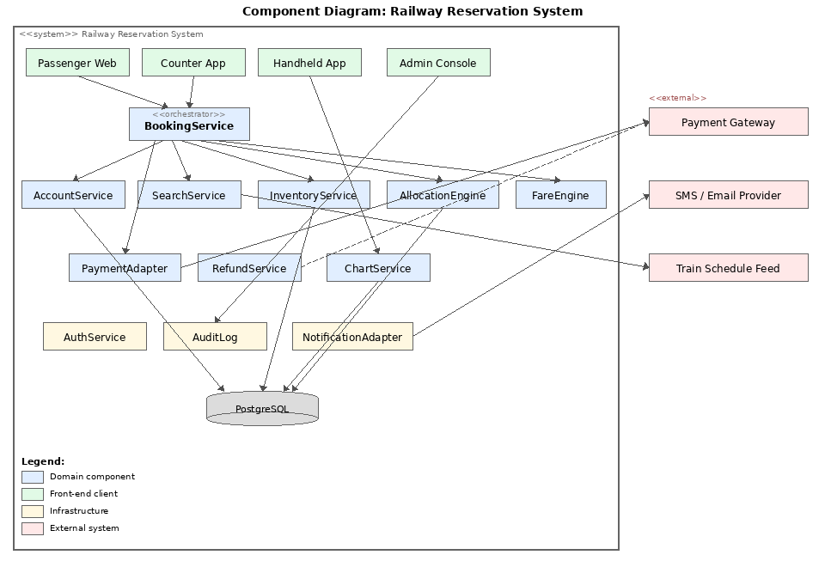Figure 1. UML component diagram showing domain modules, front-end clients, infrastructure, external systems and the database.
Components (nine domain):
AccountService, SearchService, InventoryService, AllocationEngine, FareEngine, BookingService, PaymentAdapter, RefundService, ChartService.
Infrastructure:
AuthService, AuditLog, NotificationAdapter. Front ends: Passenger Web, Counter App, Admin Console, Handheld App.
External:
Payment Gateway, SMS/Email Provider, Train Schedule Feed.

3.4 Component descriptions
Component | Responsibility | SRS reqs
AccountService | Registration, OTP verification, profile storage | F-001, F-002
SearchService | Train and availability lookup from live inventory (max 30 s stale) | F-003, F-004
InventoryService | Owns seat inventory table. Holds berths, releases expired holds, confirms allocation. Enforces no-double-allocation via row-level locking. | F-005, F-006, NF-003
AllocationEngine | Confirmed / RAC / waitlist decision per quota. Tatkal window check. Waitlist promotion on cancellation. | F-007 to F-009, F-016
FareEngine | Computes fare breakup from configuration tables (base fare, reservation charge, taxes, convenience fee). | F-010
BookingService | Orchestrates booking flow: hold, price, pay, confirm, generate PNR, notify. | F-012
PaymentAdapter | Gateway hosted page handoff. Receives and verifies signed callbacks. Idempotent. | F-011, F-013
RefundService | Slab-based refund on cancellation. Auto refund when payment succeeds but allocation fails. | F-014, F-015
ChartService | Prepares chart at configured time. Freezes allocation, publishes berths, cancels remaining waitlist. Serves chart download. | F-017, F-018
AuthService | RBAC, second factor for clerk/admin, session management, lockout after 5 failures. | SR-003, SR-005
AuditLog | Append-only log of privileged actions. Cannot be edited or deleted. | F-020
AdminConsole | Schedule, quota, fare rule maintenance. Impact preview before applying changes. | F-019
HandheldApp | PWA for the course demo: service worker caches the chart in IndexedDB, html5-qrcode library for QR scanning. Runs on Android Chrome offline. Production note: would wrap in Capacitor to produce a native APK with guaranteed local storage and MDM distribution. | F-018
NotificationAdapter | Transactional outbox pattern: booking and notification intent are written in one DB transaction to a pending_notifications table. A background worker polls, sends via SMS/email HTTP APIs, and marks sent. Retries on provider failure. No message queue needed. | Multiple

3.5 Architecture pattern and rationale
Chosen pattern: modular monolith with domain-driven boundaries.
Single application with clearly separated internal modules, each owning its own tables and exposing a JS module interface. Not microservices (a four-person team cannot operate independent pipelines or service mesh; the inventory invariant is easier with a single DB transaction). Not a flat layered monolith (no guidance on which service may call which; becomes tangled with nine components).
ADR-01: Pessimistic row-level locking on inventory for booking path, using SELECT ... FOR UPDATE via parameterised queries through the pg driver inside a transaction. Optimistic locking at 50 concurrent req/s during Tatkal causes high retry rate. Pessimistic lock held only for one DB transaction (milliseconds).
ADR-02: All policy values in DB config tables with effective-date column. SRS requires changes without code release (RRS-F-019). Effective date lets admin set up future rules that activate automatically.
ADR-03: Transactional outbox for notification delivery. When BookingService confirms a booking, it writes the PNR row and a pending_notifications row in the same database transaction. A background worker polls this table every few seconds, sends each notification, and marks it sent. If the SMS/email provider is down, the row stays and retries next poll. This gives guaranteed-at-least-once delivery with no message queue infrastructure, just one extra table and a 20-line worker.

3.6 Technology stack
Layer | Choice | Rationale
Language + runtime | Node.js 20 LTS, JavaScript | Team familiarity. Single language for server and front end. Async I/O handles the I/O-bound booking path well.
Framework | Express 4.x | Minimal, well-documented, large ecosystem. Fastify is an alternative if the team wants built-in schema validation.
Database | PostgreSQL 15 | Serialisable isolation and row-level locking natively. Free on lab machines.
DB layer | pg (node-postgres) with parameterised queries | Raw driver, no ORM. The team writes SQL directly. FOR UPDATE for row-level locking. One fewer dependency to learn than Knex or Prisma.
Front end | EJS templates (server-rendered) + vanilla JS | Max 4 screens per SRS. Same language as backend, no build step needed.
Handheld | PWA (service worker + IndexedDB + html5-qrcode) | JS ecosystem, offline via service worker. IndexedDB for chart. Production: wrap in Capacitor for native APK.
Payment | Gateway hosted page + webhooks | No card data enters system.
Containerisation | Docker Compose (Node app + PostgreSQL) | Eliminates dependency mismatch across four dev machines. docker compose up gives everyone the same environment.
CI/CD | npm, GitHub Actions, SonarCloud | Required by course specification. SonarCloud has full JS support.
Testing | Jest (unit), Supertest (integration), k6 (load) | Jest is the standard JS test runner. Supertest tests Express routes. k6 generates Tatkal burst load.

3.7 Risks and mitigations
Risk | Likelihood | Impact | Mitigation
Deadlock under concurrent booking (rows locked in different order) | Medium | High | Always lock in ascending berth-ID order. TC-BOOK-01 runs 200 concurrent requests.
Gateway callback after hold expiry: paid but no berth | Low | High | Auto refund under RRS-F-014. No silent confirmation.
Tatkal burst overwhelms connection pool | Medium | Medium | Pool sized for 50 concurrent tx. Validated by k6 (TC-PERF-01).
Chart download fails on handheld (network drop) | Medium | Medium | Retry with backoff. Shows last chart with timestamp.

3.8 Traceability to SRS requirements
Every component in Section 3.4 lists the SRS requirement IDs it implements. The RTM in SRS Section 8 maps each requirement to a design reference (DS-xxx) that points here:
Design ref (from RTM) | Component(s) | SRS requirement(s)
DS-Acc-01, DS-Acc-02 | AccountService | F-001, F-002
DS-Srch-01, DS-Srch-02 | SearchService, InventoryService | F-003, F-004
DS-Inv-01, DS-Inv-02 | InventoryService | F-005, F-006
DS-Alloc-01, DS-Alloc-02 | AllocationEngine | F-007, F-009
DS-Fare-01 | FareEngine | F-010
DS-Pay-01 to DS-Pay-04 | PaymentAdapter, BookingService, RefundService | F-011 to F-014
DS-Can-01, DS-Can-02 | RefundService, AllocationEngine | F-015, F-016
DS-Cht-01, DS-Cht-02 | ChartService, HandheldApp | F-017, F-018
DS-Adm-01, DS-Aud-01 | AdminConsole, AuditLog | F-019, F-020
DS-Perf-01, DS-Perf-02 | BookingService, SearchService | NF-001, NF-002
DS-Rel-01 | InventoryService | NF-003
DS-Sec-01 to DS-Sec-06 | PaymentAdapter, AuthService, StatusAPI | NF-005, SR-001 to SR-005

3.9 Security architecture
Implements three SRS security objectives (Section 5.1.1): inventory-money agreement, data confidentiality, privileged-action accountability.
STRIDE threat model for the booking path:
Category | Threat | Control | Req
Spoofing | Attacker books using another's account | OTP-verified mobile (F-002). Second factor for clerk/admin (SR-003). | F-002, SR-003
Tampering | Fare modified between display and payment | Fare computed server-side, signed into payment request. Mismatch triggers refund. | F-010, F-014
Repudiation | Clerk denies issuing manual refund | Append-only audit log with actor, target, timestamp (F-020). Cannot be deleted. | F-020
Info disclosure | Bulk PNR harvest to track passengers | Masked details for unauthenticated lookup. 30 lookups/min rate limit. | SR-004
Denial of service | Fake booking flood during Tatkal exhausts holds | Holds auto-expire. Rate limiting. Connection pool sized for burst. | F-006, NF-001
Elevation | Passenger gains admin access | RBAC enforced server-side. Clerk cannot reach admin endpoints. | SR-003
Platform controls: TLS 1.2+ everywhere (SR-001). Hosted payment page only (SR-002). Passwords: memory-hard hash + per-account salt, lockout after 5 failures (SR-005).

4. Design

4.1 Design overview
Modules map one-to-one to components in Section 3.4. Each owns its DB tables and exports a JS module interface. Cross-module calls go through these exports, never direct table access. The booking flow touches six modules in sequence:
SearchService, InventoryService, FareEngine, PaymentAdapter, InventoryService (confirm), NotificationAdapter.
Orchestration lives in BookingService. The cancellation flow touches RefundService, InventoryService, AllocationEngine, NotificationAdapter.

4.2 Sequence diagrams
Sequence Diagram 1: UC-03 Book a Ticket (main success + alt fragments)
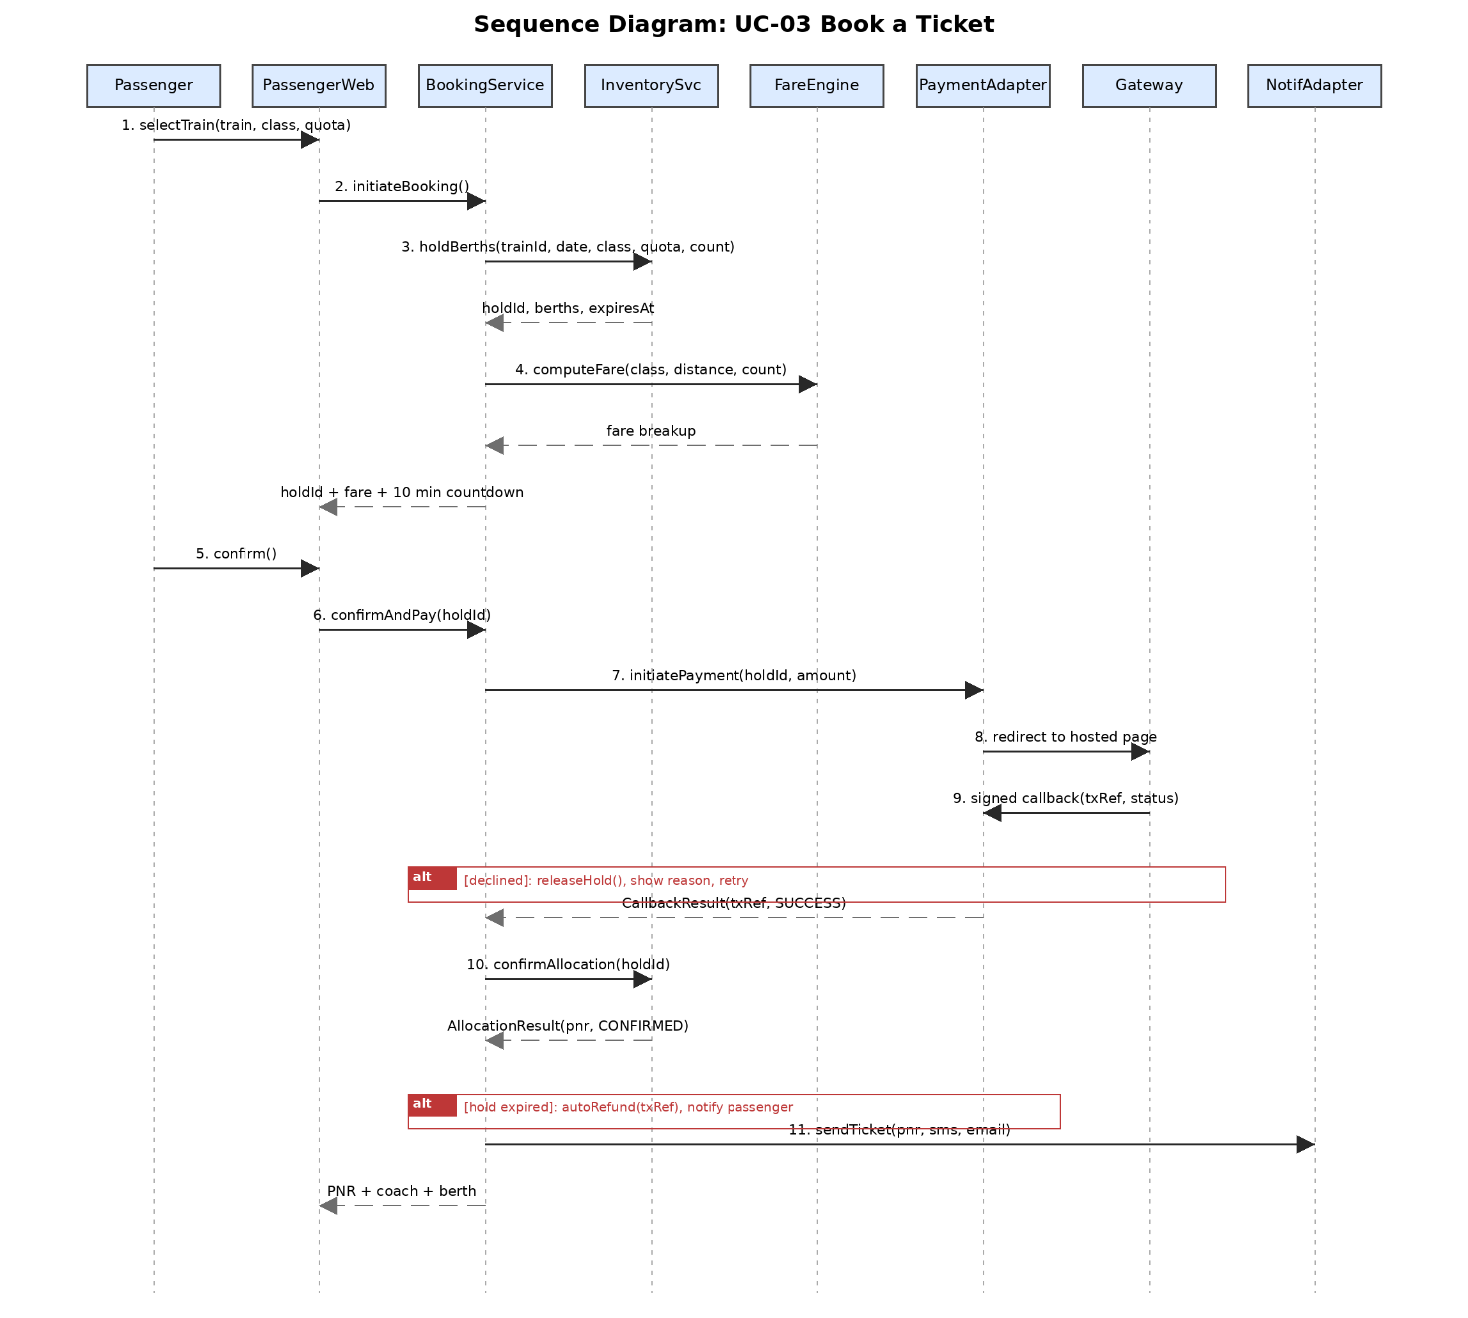

Participants:
Passenger, PassengerWeb, BookingService, InventoryService, FareEngine, PaymentAdapter, Gateway, NotificationAdapter.

Flow:
(1) Passenger selects train, class, quota.
(2) PassengerWeb calls BookingService.initiateBooking().
(3) BookingService calls InventoryService.holdBerths() which acquires row-level lock and marks berths held for 10 minutes.
(4) BookingService calls FareEngine.computeFare() and gets itemised breakup.
(5) Returns hold ID, fare, countdown to passenger.
(6) Passenger confirms; BookingService calls PaymentAdapter.initiatePayment().
(7) Passenger redirected to gateway hosted page.
(8) Gateway sends signed callback to PaymentAdapter.receiveCallback().
(9) PaymentAdapter verifies signature, checks idempotency.
(10) BookingService calls InventoryService.confirmAllocation().
(11) PNR with QR generated.
(12) NotificationAdapter sends ticket by SMS and email.
(13) PNR, coach, berth displayed.

Alt 6a (payment declined): PaymentAdapter returns failure. BookingService calls InventoryService.releaseHold(). Reason shown. Second attempt offered, availability rechecked. After two failures, booking abandoned.
Alt 10a (hold expired after payment): InventoryService.confirmAllocation returns failure. BookingService triggers auto refund (RRS-F-014). Passenger notified with refund reference. Logged with correlation ID.

Sequence Diagram 2: UC-04 Cancel a Ticket (main success)
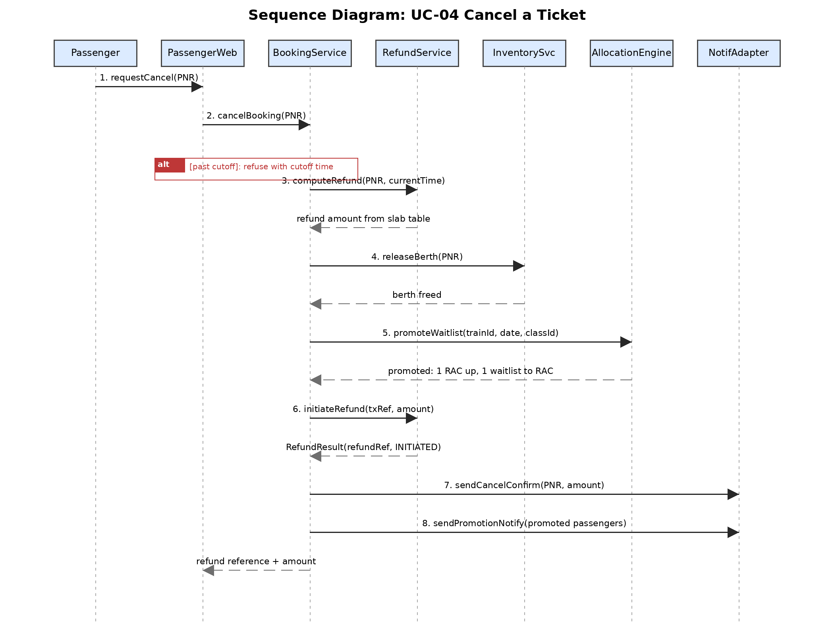Participants:
Passenger, PassengerWeb, BookingService, RefundService, InventoryService, AllocationEngine, NotificationAdapter.

Flow:
(1) Passenger requests cancellation.
(2) BookingService checks cutoff (RRS-F-015); refuses if past cutoff.
(3) RefundService.computeRefund() looks up slab table.
(4) InventoryService.releaseBerth() frees the berth.
(5) AllocationEngine.promoteWaitlist() moves earliest RAC up, earliest waitlisted into RAC.
(6) RefundService.initiateRefund() calls gateway.
(7) NotificationAdapter sends cancellation confirmation and promotion notifications.
(8) Refund amount and reference displayed.

4.3 API design
Two internal JS module interfaces (not REST endpoints). Express route handlers call these; they are the contract between modules.
Interface 1: InventoryService
Method | Parameters | Returns | Behaviour
holdBerths | trainId, date, classId, quotaId, count | HoldResult {holdId, berths, expiresAt} | Row-level lock. Marks berths held for 10 min. If not enough free, allocates RAC/waitlist. Throws InsufficientInventoryException.
confirmAllocation | holdId | AllocationResult {pnr, status} | Checks hold not expired. Converts to permanent. Throws HoldExpiredException.
releaseHold | holdId | void | Releases held berths. Idempotent.
releaseBerth | pnr | void | Frees berth on cancellation.
Interface 2: PaymentAdapter
Method | Parameters | Returns | Behaviour
initiatePayment | holdId, amount, currency | PaymentRedirect {redirectUrl, txRef} | Creates PENDING record. Returns gateway URL. No card data.
receiveCallback | payload, signature | CallbackResult {txRef, status} | Verifies signature. If already processed, returns stored result (idempotent). Otherwise updates record.
initiateRefund | txRef, amount | RefundResult {refundRef, status} | Calls gateway refund API. Records reference. Settlement is async.

4.4 Error handling, logging and monitoring
Every module returns a result object or throws a named Error. Express error-handling middleware catches these and maps them to HTTP responses. No stack trace returned to client. Correlation ID included in user-facing error for tracing.
Payment disagreements (money moved, allocation failed) are highest severity: handled by auto-refund (RRS-F-014), logged at ERROR with correlation ID, written to audit log.
Logging: Structured JSON via Winston or Pino. Every line: correlation ID, timestamp, module, severity. No PII in logs. PNR masked in production.
Monitoring: Health endpoint (UP/DOWN). Booking failure count per hour in metrics table. Reconciliation job (TC-REL-01) compares inventory against issued PNRs after every test run.

4.5 UX design
Passenger booking: four screens (search, selection, passenger details, payment). Fare breakup and hold countdown shown before payment (RRS-F-010, RRS-F-006). Counter: single screen, fully keyboard-operable. Handheld: coach-wise list searchable by berth/PNR, chart sync timestamp visible. All three: WCAG 2.1 AA, 4.5:1 contrast, keyboard nav. Passenger channel in English, Hindi, Kannada (RRS-NF-006).

4.6 Open issues and next steps
ID | Issue | Target
O-01 | Connection pool sizing for Tatkal burst to be validated with k6 | Sprint 2
O-02 | Retry/backoff parameters for notification delivery not decided | Sprint 2
O-03 | Confirm PWA camera access and offline chart storage on lab Android devices | Sprint 1
O-04 | Mock gateway needed for idempotency integration test (TC-PAY-04) | Sprint 2

5. Appendices

5.1 Glossary
See Section 1.4 for SAD-specific terms. SRS Section 1.4 for domain terms. Additional: Express (Node.js web framework), pg/node-postgres (PostgreSQL driver), PostgreSQL (relational DB), EJS (server-side template engine), Docker Compose (multi-container dev environment), Capacitor (wraps a web app into a native mobile APK), html5-qrcode (JS library for camera-based QR scanning), transactional outbox (pattern where the app writes a notification intent into a DB table in the same transaction as the business data, and a background worker delivers it), k6 (load testing tool), SonarCloud (static analysis), Jest (JS test framework), Supertest (HTTP assertion library), PWA (Progressive Web App, works offline via a service worker).

5.2 References
IEEE 42010:2022, Systems and software engineering, Architecture description.
OWASP Top 10 (2021): https://owasp.org/www-project-top-ten/
STRIDE threat modelling: Microsoft Security Development Lifecycle.
SRS, Railway Reservation System, Team 11, v1.0, 09 September 2026.
Course mini-project handout, UE23CS341A, PES University.

5.3 Tools
draw.io for UML diagrams. Git/GitHub for version control. GitHub Projects for the backlog and sprint board. ESLint and Jest coverage in CI for static analysis and coverage. GitHub Actions for CI/CD. Swagger/OpenAPI if REST endpoints are exposed externally.

End of document. Version 1.2, Team 11.

