Software Requirements Specification (SRS)
Project: Bank Management System
Team: Team 11
Implementation language: C / C++
Version: 1.0
Authors: <Name> (PES1UG24AM305); <Name> (PES1UG24AM318); <Name> (PES1UG24AM334); Dhanush S (PES1UG24AM360)
Date: 05-09-2025
Status: Draft - for review

Revision history
Version | Date | Author | Change summary | Approval
0.1 | 04-09-2025 | Requirements Lead | Skeleton raised against the SRS template; scope and actor set agreed by the team | Draft
1.0 | 05-09-2025 | Team 11 | Full SRS: 29 FRs, 7 NFRs, 4 security objectives, 7 security requirements, 2 use-case diagrams, 43-row RTM | Pending review

Table of Contents
1. Introduction
2. Overall description
3. External interface requirements
4. System features (detailed)
5. Non-functional requirements (detailed)
6. Quality attributes & Acceptance tests
7. System models and diagrams
8. Requirements Traceability Matrix (RTM)

1. Introduction
1.1 Purpose
This document is the Software Requirements Specification for the Bank Management System built by Team 11. It states the functional and non-functional requirements, the external interfaces, the security objectives and the verification criteria for a system that handles core banking operations - deposit, withdrawal, balance inquiry, funds transfer and the account records behind them. It is the reference against which the C/C++ implementation, the design document and the test plan are written and assessed.
1.2 Scope
The system maintains customer and account records for a single bank branch and performs the transactions against them: opening and closing accounts, authenticating operators, accepting deposits, paying out withdrawals within the applicable limits, transferring funds between accounts held at the bank, answering balance and statement queries, and keeping the ledger and audit trail that make every balance explicable.
This is the bank-side system. Explicitly out of scope: ATM terminal hardware and self-service kiosk interfaces; inter-bank settlement (NEFT, RTGS, UPI); cheque clearing; loan origination and interest accrual; card issuance and EMV processing; internet and mobile banking front-ends; and statutory reporting to the central bank. Where an out-of-scope channel would ordinarily feed the bank, its transactions are assumed to arrive through the Teller interface.
1.3 Audience
The Team 11 developers implementing the system in C/C++, the QA lead writing and executing the test plan, the course coordinator and evaluators assessing the deliverable, and any team member picking up an unfamiliar module later in the project.
1.4 Definitions
Account - a ledger position held by a customer, of type Savings or Current, in one of the states ACTIVE, LOCKED or CLOSED.
Journal (transaction journal) - the append-only record of every balance-changing operation.
Audit log - the append-only record of every privileged, non-monetary action.
Paise - the smallest currency unit; all monetary values are stored as integer paise so that no rounding error can arise.
Reconciliation - the check that an account's balance equals its opening balance plus the sum of its journal entries.
Minimum balance - the floor a Savings account may not be taken below by a withdrawal.
Overdraft - a sanctioned limit by which a Current account may go negative.
Session - the period between a successful authentication and the operator signing out.
Acronyms: SRS (Software Requirements Specification), FR (Functional Requirement), NFR (Non-Functional Requirement), SR (Security Requirement), SO (Security Objective), RTM (Requirements Traceability Matrix), UC (Use Case), TC (Test Case), CLI (Command Line Interface), PIN (Personal Identification Number), RBAC (Role-Based Access Control), I/O (Input/Output), UAT (User Acceptance Testing).

2. Overall description
2.1 Product perspective
The product is a new, self-contained console application, delivered as a single executable built from C/C++ sources and persisting its data in local files. It is not a component of a larger system and it consumes no external service. It replaces manual ledgers and spreadsheets at a single branch counter.
The absence of a network is the defining architectural fact about this system. It removes an entire class of threats, and in exchange it places the whole of the confidentiality obligation on operating-system file permissions and on how credentials are stored at rest, which is why section 5.1 is weighted towards those concerns rather than towards transport security.
2.2 Major product functions (detailed)
- Create customer records and open Savings or Current accounts against them
- Modify customer contact details, with the previous value retained
- Close an account, transferring any residual balance out first
- Authenticate customers by PIN and staff by password, and lock an account after repeated failures
- Enforce role-based authorisation across Customer, Teller and Manager
- Accept deposits and pay out withdrawals within balance, minimum-balance, overdraft and daily limits
- Transfer funds between two accounts held at the bank, atomically
- Answer balance inquiries and produce mini-statements and date-range statements
- Append every balance change to a transaction journal and every privileged action to an audit log
- Reconcile stored balances against the journal and detect tampering
- Generate the end-of-day report and let a Manager inspect the audit log
2.3 User roles and characteristics (expanded)
- Customer: an account holder, of no assumed technical skill, authenticating with an account number and PIN. Operates only on their own accounts and only through the menu. Uses the system occasionally and needs every prompt and refusal to be self-explanatory.
- Bank Teller: counter staff, the heaviest user of the system, working through it continuously during banking hours. Opens accounts, records customer detail changes and performs transactions on a customer's behalf. Values speed of entry and unambiguous error messages over guidance.
- Bank Manager: supervisory staff, accountable for the branch reconciling at end of day. Closes accounts, unlocks locked accounts, runs the end-of-day report and inspects the audit log. Uses the system briefly but holds its most dangerous privileges, which is why those privileges are separated in BMS-F-012.
There are no system actors. The system integrates with nothing, so every actor in section 7 is a human operator.
2.4 Operating environment
A desktop or laptop computer running Windows or Linux, operated from a terminal. Built with g++ targeting C++17, using MinGW on Windows, with no dependency beyond the C++ standard library and the platform C runtime. Data is held in files in a single data directory alongside the executable.
The system is designed for single-instance operation. Two instances running against one data directory would race on the account file, so a lock file prevents the second from starting.
2.5 Constraints
- The implementation language is fixed to C/C++ by the course, and no third-party library may be used; this rules out an embedded database and makes the file format and its crash-safety the team's own responsibility.
- No network interface may be assumed, so confidentiality rests on file permissions rather than on transport security.
- Monetary values must be integer paise. Floating point is prohibited in the money path, because binary floating point cannot represent decimal currency exactly and a bank that mis-rounds is worthless.
- Only one instance may run against a data directory at a time, enforced by a lock file.
- The system is delivered by four students within one semester, which bounds it to a single console application with file persistence rather than a client-server deployment.

3. External interface requirements
3.1 User interfaces
A menu-driven text console. The menu presented is determined by the authenticated role, so a Customer is never shown an operation they cannot perform - the menu is a convenience, not the security boundary, which is stated in BMS-SR-007. PIN and password entry is not echoed to the terminal (BMS-F-014). Every rejection states the reason and the corrective action on one line and returns the operator to the menu rather than terminating (BMS-NF-005). Output is formatted for an 80-column terminal so that statements and reports remain aligned on a default console.
3.2 Hardware interfaces
None beyond a standard keyboard and character display. The system drives no card reader, cash dispenser, deposit acceptor or receipt printer; those belong to the ATM channel, which section 1.2 places out of scope. Where a printed record is needed, the system writes a formatted text file that the operator may print through the operating system.
3.3 Software interfaces
The system calls no external service API. Its software interfaces are:
- The host filesystem, holding the account file, the append-only transaction journal, the audit log, the configuration file and the instance lock file.
- The C++17 standard library, for I/O, containers and time.
- The operating system, for two facilities the standard library does not provide portably: disabling terminal echo during credential entry, and setting owner-only file permissions (BMS-SR-006). Both are confined to a single portability header, per BMS-NF-004.
3.4 Communications
None. The system performs no network input or output, opens no socket and listens on no port. This is a deliberate scope decision rather than an omission: it eliminates spoofing, man-in-the-middle and remote denial-of-service from the threat model, and concentrates the remaining risk on local file access and on the integrity of the stored ledger, which security objectives SO-1 and SO-2 address directly.

4. System features (detailed)
Each requirement below carries an acceptance criterion and a reference test case. IDs follow BMS-F-###, numbered in blocks of ten by feature area so that a requirement can be added to a block later without renumbering the rest. The Source column names the stakeholder the requirement answers to.

4.1 Customer & Account Management
Description: Creation and lifecycle of customers and their accounts, from opening through modification to closure. This section owns the identifiers every other section depends on.
Req ID | Requirement (shall...) | Type | Priority | Source/Stakeholder | Acceptance criteria / Test case ref | Comments / Dependencies
BMS-F-001 | The system shall create a customer record capturing name, address, contact number and government ID reference, and shall assign a unique customer ID that is never reused. | Functional | High | Bank Teller / Business | AC-BMS-F-001: A new customer receives an ID unused by any existing or closed record. Test: TC-ACC-01 | Customer ID is the key used by BMS-F-002
BMS-F-002 | The system shall open a Savings or Current account against an existing customer ID, assign a unique account number, and set the opening balance to the amount deposited at opening. | Functional | High | Bank Teller / Business | AC-BMS-F-002: The account is created in ACTIVE state with the stated type and balance. Test: TC-ACC-02 | Account type drives BMS-F-032 and BMS-F-033
BMS-F-003 | The system shall allow a Bank Teller to modify a customer's address and contact number, recording both the previous and the new value. | Functional | Medium | Bank Teller | AC-BMS-F-003: The change succeeds and an audit entry holds the old and the new value. Test: TC-ACC-03 | Name and ID reference are not editable; audit via BMS-F-063
BMS-F-004 | The system shall close an account only when its balance is zero, shall set its state to CLOSED, and shall reject every subsequent transaction on it. | Functional | High | Bank Manager / Business | AC-BMS-F-004: Closure at zero balance succeeds; a later deposit to that account is refused. Test: TC-ACC-04 | Non-zero balances are handled by BMS-F-006
BMS-F-005 | The system shall retrieve an account by account number, and shall list every account belonging to a given customer ID. | Functional | Medium | Bank Teller / Customer | AC-BMS-F-005: Both lookups return the correct records; an unknown key returns a not-found message rather than a crash. Test: TC-ACC-05 | Read path used by every transaction module
BMS-F-006 | The system shall, where closure is requested on an account holding a non-zero balance, transfer the residual to a nominated ACTIVE account before performing the closure. | Functional | Medium | Bank Manager / Business | AC-BMS-F-006: The residual is moved, the source reaches zero, and closure then succeeds, all as one unit. Test: TC-ACC-06 | Extension of BMS-F-004; reuses BMS-F-050

4.2 Authentication & Access Control
Description: Establishing who the operator is and what their role permits. Successful authentication is a precondition of every operation in sections 4.3 to 4.7.
Req ID | Requirement (shall...) | Type | Priority | Source/Stakeholder | Acceptance criteria / Test case ref | Comments / Dependencies
BMS-F-010 | The system shall authenticate the operator by account number and PIN for customers, or staff ID and password for Tellers and Managers, before permitting any operation. | Functional | High | Security / Business | AC-BMS-F-010: Correct credentials open a session; incorrect credentials are refused without revealing which field was wrong. Test: TC-AUT-01 | Credential storage governed by BMS-SR-001
BMS-F-011 | The system shall lock an account after three consecutive failed PIN attempts and shall record an audit event naming the account and the time. | Functional | High | Security | AC-BMS-F-011: The fourth attempt is refused as LOCKED even when the PIN is correct. Test: TC-AUT-02 | Cleared only by BMS-F-013
BMS-F-012 | The system shall enforce role-based authorisation, restricting account opening and customer modification to Tellers, and closure, unlocking and reporting to Managers. | Functional | High | Security / Business | AC-BMS-F-012: A Teller requesting an end-of-day report is refused; a Manager succeeds. Test: TC-AUT-03 | Checked at the service layer per BMS-SR-007
BMS-F-013 | The system shall allow a Bank Manager to unlock a locked account, resetting the failed-attempt counter to zero and writing an audit entry. | Functional | Medium | Bank Manager | AC-BMS-F-013: After unlocking, the correct PIN authenticates and the counter reads zero. Test: TC-AUT-04 | Reverses BMS-F-011
BMS-F-014 | The system shall not echo a PIN or password to the terminal as it is typed, and shall overwrite the credential in memory once the comparison is complete. | Functional | High | Security | AC-BMS-F-014: Terminal echo is disabled during entry and the buffer is zeroed after use. Test: TC-SEC-02 | Implements part of BMS-SR-001

4.3 Deposit
Description: Crediting an account, with the validation and journalling that make the credit trustworthy.
Req ID | Requirement (shall...) | Type | Priority | Source/Stakeholder | Acceptance criteria / Test case ref | Comments / Dependencies
BMS-F-020 | The system shall accept a deposit of a strictly positive amount into an ACTIVE account and shall credit the balance as a single atomic operation. | Functional | High | Customer / Bank Teller | AC-BMS-F-020: The balance increases by exactly the deposited amount; no partial credit is observable. Test: TC-DEP-01 | Atomicity depends on BMS-NF-002
BMS-F-021 | The system shall reject a deposit that is zero, negative, exceeds the single-transaction ceiling, or targets an account that is not ACTIVE, stating which condition failed. | Functional | High | Business / Security | AC-BMS-F-021: Each of the four rejection cases returns its own message and leaves the balance unchanged. Test: TC-DEP-02 | Input validation per BMS-SR-004
BMS-F-022 | The system shall append a ledger entry for every deposit, carrying the account number, amount, resulting balance, timestamp and operator identity. | Functional | High | Audit / Business | AC-BMS-F-022: Exactly one journal record exists per successful deposit. Test: TC-DEP-03 | Append-only per BMS-SR-005

4.4 Withdrawal
Description: Debiting an account within the limits set by account type, minimum balance, overdraft sanction and the daily ceiling.
Req ID | Requirement (shall...) | Type | Priority | Source/Stakeholder | Acceptance criteria / Test case ref | Comments / Dependencies
BMS-F-030 | The system shall verify that the available balance and the remaining daily withdrawal limit both cover the requested amount before debiting the account. | Functional | High | Business / Security | AC-BMS-F-030: A withdrawal breaching either limit is refused and the balance is unchanged. Test: TC-WDR-01 | Daily counter reset by BMS-F-062
BMS-F-031 | The system shall apply the debit and append the corresponding ledger entry as a single atomic operation, so that a failure leaves neither applied. | Functional | High | Business / Audit | AC-BMS-F-031: Terminating the process mid-write leaves balance and journal consistent on restart. Test: TC-REL-01 | Depends on the write-ahead journal in BMS-NF-002
BMS-F-032 | The system shall refuse a withdrawal from a Savings account that would take the balance below the configured minimum balance. | Functional | High | Business | AC-BMS-F-032: A withdrawal leaving less than the minimum is refused; one leaving exactly the minimum succeeds. Test: TC-WDR-02 | Applies to Savings only, not Current
BMS-F-033 | The system shall permit a Current account to be overdrawn up to its sanctioned overdraft limit, and shall refuse any withdrawal beyond that limit. | Functional | Medium | Business | AC-BMS-F-033: A withdrawal inside the overdraft succeeds and yields a negative balance; beyond it is refused. Test: TC-WDR-03 | Optional extension of the withdrawal flow

4.5 Balance Inquiry & Statements
Description: Read-only views of an account's current position and its transaction history.
Req ID | Requirement (shall...) | Type | Priority | Source/Stakeholder | Acceptance criteria / Test case ref | Comments / Dependencies
BMS-F-040 | The system shall display the current balance of an account to its authenticated holder, or to a Teller acting on that account. | Functional | High | Customer | AC-BMS-F-040: The figure displayed equals the stored balance to the paisa. Test: TC-BAL-01 | Read-only; writes no ledger entry
BMS-F-041 | The system shall generate a mini-statement listing the last ten transactions on an account, most recent first. | Functional | Medium | Customer | AC-BMS-F-041: Exactly ten entries are listed newest first, or fewer if the account has fewer. Test: TC-BAL-02 | Reads the journal written by BMS-F-060
BMS-F-042 | The system shall generate a statement of all transactions on an account between two given dates inclusive, together with a closing balance. | Functional | Medium | Customer / Bank Teller | AC-BMS-F-042: Entries outside the range are excluded and the closing balance reconciles. Test: TC-BAL-03 | Reconciliation per BMS-F-061

4.6 Funds Transfer
Description: Moving money between two accounts at the bank. The atomicity requirement here is the hardest correctness obligation in the system.
Req ID | Requirement (shall...) | Type | Priority | Source/Stakeholder | Acceptance criteria / Test case ref | Comments / Dependencies
BMS-F-050 | The system shall transfer a stated amount between two accounts held at the bank, applying the debit and the credit as one atomic unit so that both succeed or neither does. | Functional | High | Customer / Business | AC-BMS-F-050: After an injected failure between the two legs, both balances read their original values. Test: TC-TRF-01 | The core integrity obligation of the system
BMS-F-051 | The system shall reject a transfer where source and destination are the same account, or where either account is not ACTIVE. | Functional | High | Business / Security | AC-BMS-F-051: Self-transfer and transfer to a CLOSED account are refused with distinct messages. Test: TC-TRF-02 | Checked before any balance is touched
BMS-F-052 | The system shall enforce the per-transaction and per-day transfer ceilings, maintaining a running daily total for each source account. | Functional | Medium | Business | AC-BMS-F-052: A transfer crossing the daily ceiling is refused even where each individual transfer is within the per-transaction limit. Test: TC-TRF-03 | Shares the daily counter with BMS-F-030

4.7 Ledger, Audit & Reporting
Description: The record that makes every balance explicable. This section is where security objective SO-2 becomes enforceable behaviour.
Req ID | Requirement (shall...) | Type | Priority | Source/Stakeholder | Acceptance criteria / Test case ref | Comments / Dependencies
BMS-F-060 | The system shall append every balance-changing operation to a transaction journal, and shall expose no operation that updates or deletes an existing journal record. | Functional | High | Audit / Security | AC-BMS-F-060: No code path writes to an existing journal offset; the file is opened in append mode only. Test: TC-LED-01 | Realises security objective SO-2
BMS-F-061 | The system shall provide a reconciliation check verifying that every account balance equals its opening balance plus the sum of its journal entries. | Functional | High | Audit / Bank Manager | AC-BMS-F-061: Reconciliation passes on clean data and names the offending account on tampered data. Test: TC-LED-02 | The detection mechanism behind SO-2
BMS-F-062 | The system shall generate an end-of-day report totalling deposits, withdrawals and transfers for the day, with the closing balance of every account. | Functional | Medium | Bank Manager | AC-BMS-F-062: Totals equal the sum of that day's journal entries by type. Test: TC-LED-03 | Manager-only per BMS-F-012; resets daily counters
BMS-F-063 | The system shall record every privileged action - account closure, customer modification, account unlocking and report generation - in an audit log naming the operator, the action and the timestamp. | Functional | High | Audit / Security | AC-BMS-F-063: Each privileged action produces exactly one audit record. Test: TC-LED-04 | Viewed through BMS-F-064; storage per BMS-SR-005
BMS-F-064 | The system shall allow a Bank Manager to view the audit log filtered by operator or by date, in read-only form. | Functional | Low | Bank Manager | AC-BMS-F-064: Filters return the matching subset and the view offers no edit or delete action. Test: TC-LED-05 | Manager-only per BMS-F-012

5. Non-functional requirements (detailed)
NFRs below are measurable and tied to the test plan. IDs follow BMS-NF-###. Two of them - BMS-NF-002 on crash-safety and BMS-NF-003 on integer currency - are properties the functional requirements silently depend on, and are stated here so that they are tested rather than assumed.
Req ID | Requirement | Category | Priority | Acceptance criteria / Measurement
BMS-NF-001 | Any single transaction - deposit, withdrawal, transfer or balance inquiry - shall complete within 500 ms on the reference machine for a data set of up to 10,000 accounts. | Performance | High | Mean over 1,000 operations at or below 500 ms on the stated configuration. Test: TC-PERF-01
BMS-NF-002 | No committed transaction shall be lost if the process terminates abnormally; the system shall write to a journal before mutating the account file and shall recover a consistent state on restart. | Reliability / Durability | High | Process killed at 20 randomised points mid-write; every account reconciles on restart. Test: TC-REL-01
BMS-NF-003 | All monetary values shall be stored and computed as 64-bit signed integers denominated in paise; floating-point types shall not appear anywhere in the money path. | Data Integrity | High | Source inspection finds no float or double in the money path; decimal rounding error is unreproducible. Test: TC-SEC-03
BMS-NF-004 | The system shall compile without warnings under g++ -std=c++17 -Wall -Wextra -Werror on both Linux and Windows (MinGW), with platform-specific code confined to a single portability header. | Portability | Medium | Clean build on both toolchains. Test: TC-PORT-01
BMS-NF-005 | Every rejected operation shall state the reason and the corrective action in one line of plain English, and shall return the operator to the menu rather than terminating the program. | Usability | Medium | Every rejection path in section 4 reviewed against this rule; none terminates the program. Test: TC-UX-01
BMS-NF-006 | The system shall be organised in presentation, service and persistence layers with no global mutable state, so that each service module is unit-testable without the menu layer. | Maintainability | Medium | Every service module has at least one unit test that links without the CLI translation unit. Test: TC-PORT-02
BMS-NF-007 | The system shall hold 10,000 accounts and 100,000 journal entries without any operation exceeding 2 seconds. | Capacity / Scalability | Low | Soak test at the stated volume; the slowest recorded operation is under 2 s. Test: TC-PERF-02

5.1. Security

5.1.1 Security Objectives
Four security objectives govern this system. They are stated as the properties an attacker must not be able to violate. Every security requirement in 5.1.2 traces to at least one of them, and the trace is recorded in the RTM Comments column.
The threat model is shaped by section 3.4: with no network, the adversary is someone with access to the host machine or to the data files, or an operator acting outside their role.
SO-1 - Confidentiality of customer data and credentials at rest
The system stores personally identifiable customer data and authentication secrets in local files. Neither a PIN nor a password may be recoverable from those files, and account data must not be readable by other users of the host machine.
SO-2 - Integrity and non-repudiation of the transaction ledger
A balance is only as trustworthy as the record that explains it. Every balance change must be attributable to an operator and a time, must be append-only, and any tampering with the stored data must be detectable by reconciliation rather than silently absorbed.
SO-3 - Memory safety and input robustness
The system is written in C/C++, where an unchecked buffer write or an unvalidated numeric input is a direct route to memory corruption. No input from an operator or a data file may write outside its buffer, overflow an integer, or drive the program into undefined behaviour.
SO-4 - Least privilege across operator roles
A Customer, a Teller and a Manager hold materially different powers. No operator may perform an action outside their role, and the check enforcing this must not live in the menu code, where reaching the operation by another path would bypass it.

5.1.2 Security Requirements
Req ID | Requirement (shall...) | Type | Priority | Acceptance criteria / Test case ref
BMS-SR-001 | The system shall store customer PINs and staff passwords only as salted cryptographic hashes, and shall never write a credential in plaintext to any file, log or terminal. | Security | High | AC: Inspection of every data file finds no plaintext credential and each record carries a distinct salt. Test: TC-SEC-01
BMS-SR-002 | The system shall bounds-check every write to a fixed-size buffer, and the functions gets, strcpy, strcat, sprintf and scanf with an unbounded string conversion shall not appear in the source. | Security | High | AC: A search for the banned functions returns no hit; an over-length name input is truncated safely rather than overflowing. Test: TC-SEC-04
BMS-SR-003 | The system shall perform every monetary addition and subtraction in 64-bit signed integer paise with an explicit overflow check before the operation, and shall refuse the transaction rather than wrap. | Security / Data Integrity | High | AC: A deposit that would overflow the balance is refused with a stated reason; no wrap is observable. Test: TC-SEC-03
BMS-SR-004 | The system shall validate every numeric and menu input for type and range before use, and shall re-prompt on invalid input rather than proceeding with an indeterminate value. | Security | High | AC: Alphabetic input to an amount field, and a menu choice outside range, both re-prompt with no state change. Test: TC-SEC-05
BMS-SR-005 | The system shall open the transaction journal and the audit log in append mode only, and shall expose no operation capable of modifying or removing an existing record in either. | Security / Audit | High | AC: Source inspection finds no non-append open of either file, and no menu path offers edit or delete. Test: TC-SEC-06
BMS-SR-006 | The system shall create its data files with owner-only permissions and shall refuse to start when the data directory is group- or world-writable. | Security | Medium | AC: Files are created with owner-only permissions; loosening the directory causes a refusal to start with a clear message. Test: TC-SEC-07
BMS-SR-007 | The system shall perform the role authorisation check inside the service layer immediately before the privileged operation, not in the menu layer that routes to it. | Security | High | AC: A unit test calling the service function directly with a Teller role is refused, with no menu involved. Test: TC-SEC-08

6. Quality attributes & Acceptance tests
Exit criteria for acceptance: every High-priority functional requirement implemented and verified; no failing High-priority non-functional requirement; zero open critical or major defects; reconciliation (BMS-F-061) passing across the full test data set; and an RTM in which every requirement maps to at least one executed test case with a Pass result.
Acceptance test suites, each named for the test-case prefix it owns:
- Account (TC-ACC-01..06) - customer creation, account opening, modification, closure, lookup, residual transfer
- Authentication (TC-AUT-01..04) - credential check, lockout, role enforcement, unlock
- Deposit (TC-DEP-01..03) - credit, rejection cases, journalling
- Withdrawal (TC-WDR-01..03) - limits, minimum balance, overdraft
- Balance & Statements (TC-BAL-01..03) - balance, mini-statement, date-range statement
- Transfer (TC-TRF-01..03) - atomicity, rejection cases, ceilings
- Ledger & Reporting (TC-LED-01..05) - append-only journal, reconciliation, end-of-day report, audit capture, audit view
- Performance (TC-PERF-01..02) - transaction latency, capacity soak
- Reliability (TC-REL-01) - crash-safety of the write-ahead journal
- Security (TC-SEC-01..08) - credential storage, no echo, integer overflow, buffer safety, input validation, append-only enforcement, file permissions, service-layer role check
- Usability (TC-UX-01) - every rejection states reason and remedy
- Portability (TC-PORT-01..02) - clean build on both toolchains, modules unit-testable in isolation
Quality attributes in priority order. Data integrity comes first: a banking system that loses or invents money has failed regardless of every other property, which is why BMS-NF-003 and BMS-F-061 are High priority. Security follows, because the data is personal and the ledger must be trustworthy. Reliability is third - a crash mid-transaction must not corrupt the ledger. Performance, usability and portability follow, in that order; none of them can be traded against the first three.

7. System models and diagrams

7.1 UML Use-Case diagrams
Two use-case diagrams model the system. Diagram 1 covers the account transactions a Customer or Teller performs; Diagram 2 covers account administration, audit and reporting. Together they carry eighteen use cases, eight «include» relationships and two «extend» relationships.
Arrow direction follows UML: «include» points from the base use case to the included one; «extend» points from the extending use case to the base it extends. Two included use cases are deliberately shared by several bases - UC-07 Record Ledger Entry is included by Deposit, Withdraw Cash and Funds Transfer, and UC-15 Record Audit Entry by Close Account, Modify Customer Details and Unlock Locked Account. That sharing is the point of «include»: the behaviour is specified once and reused, which is also why BMS-F-060 and BMS-F-063 are each a single requirement rather than one per calling feature.
The included and extending use cases (UC-06, UC-07, UC-08, UC-15, UC-16, UC-17, UC-18) carry no direct actor association, because they are entered from within a base use case rather than initiated on their own.
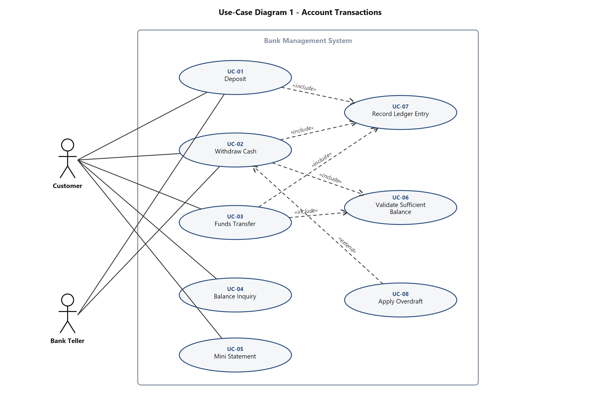
Figure 1 - Use-Case Diagram 1: Account Transactions
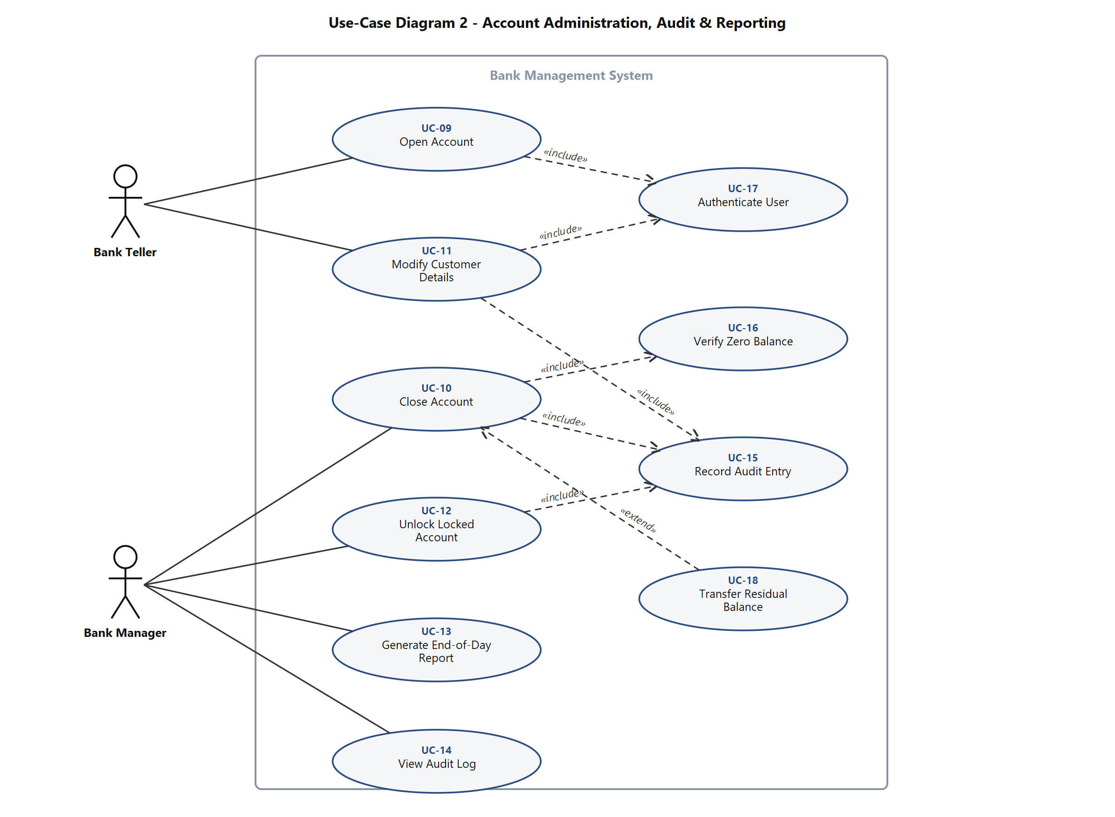
Figure 2 - Use-Case Diagram 2: Account Administration, Audit & Reporting
Use-case inventory: UC-01 Deposit, UC-02 Withdraw Cash, UC-03 Funds Transfer, UC-04 Balance Inquiry, UC-05 Mini Statement, UC-06 Validate Sufficient Balance, UC-07 Record Ledger Entry, UC-08 Apply Overdraft, UC-09 Open Account, UC-10 Close Account, UC-11 Modify Customer Details, UC-12 Unlock Locked Account, UC-13 Generate End-of-Day Report, UC-14 View Audit Log, UC-15 Record Audit Entry, UC-16 Verify Zero Balance, UC-17 Authenticate User, UC-18 Transfer Residual Balance.

8. Requirements Traceability Matrix (RTM)
Status legend: N = Not started, P = Partially implemented, A = Accepted (implemented and test passed). Every requirement in sections 4, 5 and 5.1.2 appears exactly once. The Module column names the C/C++ module that will own the behaviour, and the Comments column names either the backlog story that carries the work or the security objective the requirement serves, so a requirement can be walked to its code, its test and its plan without leaving the repository.
Req ID | Requirement short | Section ref / Design Spec | Module | Test case(s) | Status (N/P/A) | Comments
BMS-F-001 | Create customer record | 4.1 / DS-ACC-01 | AccountModule | TC-ACC-01 | N | Story 1.1
BMS-F-002 | Open account | 4.1 / DS-ACC-02 | AccountModule | TC-ACC-02 | N | Story 1.2
BMS-F-003 | Modify customer details | 4.1 / DS-ACC-03 | AccountModule | TC-ACC-03 | N | Story 1.3
BMS-F-004 | Close account at zero balance | 4.1 / DS-ACC-04 | AccountModule | TC-ACC-04 | N | Story 1.4
BMS-F-005 | Retrieve account by number or customer | 4.1 / DS-ACC-05 | AccountModule | TC-ACC-05 | N | Story 1.2
BMS-F-006 | Transfer residual balance on closure | 4.1 / DS-ACC-06 | AccountModule, TransactionModule | TC-ACC-06 | N | Story 1.5
BMS-F-010 | Authenticate customer or staff | 4.2 / DS-AUT-01 | AuthModule | TC-AUT-01 | N | Story 2.1
BMS-F-011 | Lock after 3 failed PIN attempts | 4.2 / DS-AUT-02 | AuthModule | TC-AUT-02 | N | Story 2.2
BMS-F-012 | Role-based authorisation | 4.2 / DS-AUT-03 | AuthModule | TC-AUT-03 | N | Story 2.3
BMS-F-013 | Manager unlocks account | 4.2 / DS-AUT-04 | AuthModule | TC-AUT-04 | N | Story 2.4
BMS-F-014 | No echo, clear credential buffer | 4.2 / DS-AUT-05 | AuthModule | TC-SEC-02 | N | Story 2.1
BMS-F-020 | Atomic deposit credit | 4.3 / DS-DEP-01 | TransactionModule | TC-DEP-01 | N | Story 3.1
BMS-F-021 | Reject invalid deposit | 4.3 / DS-DEP-02 | ValidationModule | TC-DEP-02 | N | Story 3.1
BMS-F-022 | Journal every deposit | 4.3 / DS-DEP-03 | LedgerModule | TC-DEP-03 | N | Story 3.1
BMS-F-030 | Check balance and daily limit | 4.4 / DS-WDR-01 | TransactionModule | TC-WDR-01 | N | Story 3.2
BMS-F-031 | Atomic debit plus journal | 4.4 / DS-WDR-02 | TransactionModule, LedgerModule | TC-REL-01 | N | Story 3.2
BMS-F-032 | Savings minimum balance | 4.4 / DS-WDR-03 | TransactionModule | TC-WDR-02 | N | Story 3.3
BMS-F-033 | Current account overdraft | 4.4 / DS-WDR-04 | TransactionModule | TC-WDR-03 | N | Story 3.4
BMS-F-040 | Display current balance | 4.5 / DS-BAL-01 | TransactionModule | TC-BAL-01 | N | Story 4.1
BMS-F-041 | Mini-statement, last ten | 4.5 / DS-BAL-02 | LedgerModule | TC-BAL-02 | N | Story 4.2
BMS-F-042 | Date-range statement | 4.5 / DS-BAL-03 | LedgerModule | TC-BAL-03 | N | Story 4.3
BMS-F-050 | Atomic two-leg transfer | 4.6 / DS-TRF-01 | TransactionModule | TC-TRF-01 | N | Story 5.1
BMS-F-051 | Reject self or inactive transfer | 4.6 / DS-TRF-02 | ValidationModule | TC-TRF-02 | N | Story 5.1
BMS-F-052 | Transfer ceilings | 4.6 / DS-TRF-03 | TransactionModule | TC-TRF-03 | N | Story 5.2
BMS-F-060 | Append-only journal | 4.7 / DS-LED-01 | LedgerModule | TC-LED-01 | N | Story 6.1
BMS-F-061 | Reconciliation check | 4.7 / DS-LED-02 | LedgerModule | TC-LED-02 | N | Story 6.2
BMS-F-062 | End-of-day report | 4.7 / DS-RPT-01 | ReportModule | TC-LED-03 | N | Story 6.3
BMS-F-063 | Audit privileged actions | 4.7 / DS-LED-03 | LedgerModule | TC-LED-04 | N | Story 6.1
BMS-F-064 | View audit log | 4.7 / DS-RPT-02 | ReportModule | TC-LED-05 | N | Story 6.4
BMS-NF-001 | Transaction within 500 ms | 5 / DS-PERF-01 | All service modules | TC-PERF-01 | N | Story 7.7
BMS-NF-002 | Crash-safe write-ahead journal | 5 / DS-REL-01 | PersistenceModule | TC-REL-01 | N | Story 7.2 - hardest NFR
BMS-NF-003 | Integer paise, no floats | 5 / DS-INT-01 | TransactionModule | TC-SEC-03 | N | Story 7.1
BMS-NF-004 | Clean -Wall -Wextra -Werror build | 5 / DS-PORT-01 | Build system | TC-PORT-01 | N | Story 7.6
BMS-NF-005 | Reason and remedy on rejection | 5 / DS-UX-01 | CLI / MenuLayer | TC-UX-01 | N | Story 7.6
BMS-NF-006 | Layered, unit-testable modules | 5 / DS-ARCH-01 | All modules | TC-PORT-02 | N | Story 7.6
BMS-NF-007 | 10,000 accounts under 2 s | 5 / DS-PERF-02 | PersistenceModule | TC-PERF-02 | N | Story 7.7
BMS-SR-001 | Salted credential hashing | 5.1.2 / DS-SEC-01 | AuthModule | TC-SEC-01 | N | SO-1 / Story 7.3
BMS-SR-002 | Bounds-checked buffers, banned functions | 5.1.2 / DS-SEC-02 | All modules | TC-SEC-04 | N | SO-3 / Story 7.4
BMS-SR-003 | Integer overflow checks on money | 5.1.2 / DS-SEC-03 | TransactionModule | TC-SEC-03 | N | SO-3 / Story 7.1
BMS-SR-004 | Validate all input before use | 5.1.2 / DS-SEC-04 | ValidationModule | TC-SEC-05 | N | SO-3 / Story 7.4
BMS-SR-005 | Append-only journal and audit log | 5.1.2 / DS-SEC-05 | LedgerModule | TC-SEC-06 | N | SO-2 / Story 7.2
BMS-SR-006 | Owner-only file permissions | 5.1.2 / DS-SEC-06 | PersistenceModule | TC-SEC-07 | N | SO-1 / Story 7.5
BMS-SR-007 | Role check in the service layer | 5.1.2 / DS-SEC-07 | AuthModule | TC-SEC-08 | N | SO-4 / Story 7.5

