Software Requirements Specification (SRS)
Project: Podcast Guest Scheduling & Outline Builder
Problem Statement: #60 - Media, Events & Community
Version: 1.0
Authors: Dhanush S (PES1UG24AM360); <Team member 2> (<SRN>); <Team member 3> (<SRN>); <Team member 4> (<SRN>)
Date: 05-09-2025
Status: Draft - for review

Revision history
Version | Date | Author | Change summary | Approval
0.1 | 02-09-2025 | Dhanush S | Skeleton raised from the Lab 1 requirements table and Lab 2 backlog | Draft
1.0 | 05-09-2025 | Mini-project team | Full SRS: 23 FRs, 7 NFRs, 3 security objectives, 6 security requirements, 2 use-case diagrams, RTM | Pending review

Approvals
Role | Name | Signature / Email | Date
Course Coordinator
Requirements Lead | Dhanush S
QA / Test Lead | <Team member 3>

Table of Contents
1. Introduction
2. Overall description
3. External interface requirements
4. System features (detailed)
5. Non-functional requirements (detailed)
6. Quality attributes & Acceptance tests
7. System models and diagrams
8. Requirements Traceability Matrix (RTM)

1. Introduction
1.1 Purpose
This document is the Software Requirements Specification for the Podcast Guest Scheduling & Outline Builder, the system defined by Problem Statement #60 (Media, Events & Community). It states the functional and non-functional requirements, the external interfaces, the security objectives and the verification criteria that the mini-project team will build and test against. It is the contract between the requirements captured in Lab 1, the backlog planned in Lab 2, and the design and test artefacts that follow.
1.2 Scope
The system lets a Show Host publish recording availability, lets a Podcast Guest reserve a conflict-free interview slot and submit a structured talking-point outline, lets the Host vet that outline, and generates a timestamped run-of-show production sheet exportable as PDF. Calendar invites and reminders are dispatched through an external Calendar & Notification Service.
Out of scope: audio or video recording, editing and hosting; payment or sponsorship management; transcript generation; publishing to podcast directories; and the internal implementation of the external calendar and email providers, which are consumed only through their published APIs.
1.3 Audience
Mini-project developers, QA engineers, the course coordinator and evaluators, and any team member joining the repository later and needing the authoritative requirement set.
1.4 Definitions
Episode board - the per-booking workspace holding the guest outline, host notes and generated run-of-show.
Run-of-show - the ordered, timestamped list of segments the episode is recorded from.
Slot - a bookable interval inside a published availability window.
Talking point - one guest-supplied bullet of discussion material.
Acronyms: SRS (Software Requirements Specification), FR (Functional Requirement), NFR (Non-Functional Requirement), RTM (Requirements Traceability Matrix), UC (Use Case), TLS (Transport Layer Security), HSTS (HTTP Strict Transport Security), IANA (Internet Assigned Numbers Authority), RBAC (Role-Based Access Control), WCAG (Web Content Accessibility Guidelines), DST (Daylight Saving Time), UTC (Coordinated Universal Time), SO (Security Objective), UAT (User Acceptance Testing).

2. Overall description
2.1 Product perspective
The product is a new, self-contained web application. It is not a replacement for an existing system. It sits between two human parties who today coordinate by email, and it depends on one external system boundary: a Calendar & Notification Service that delivers iCalendar invites, confirmations and reminders. That service is modelled as a supporting actor rather than as an internal component, because the acceptance criteria of the supplied FR-001 require a calendar invite to be sent, which places the delivery mechanism outside the system boundary.
2.2 Major product functions (detailed)
- Publish and block Host recording availability
- Present and reserve conflict-free interview slots
- Reschedule a confirmed booking
- Submit, draft and revise a structured talking-point outline
- Attach biography and reference links to an outline
- Review, approve, reject and reorder submitted talking points
- Insert host-authored segments into the running order
- Generate a timestamped run-of-show and recompute it on edit
- Export the run-of-show as a formatted PDF production sheet
- Dispatch calendar invites, confirmations and 24-hour reminders
- Authenticate users and restrict episode boards to their two participants
- Administer accounts and inspect the audit log
2.3 User roles and characteristics (expanded)
- Podcast Guest: an invited interviewee, often non-technical and in a different timezone from the Host. Interacts with the system a handful of times per episode and must be able to book and submit material without training or an account tutorial.
- Show Host: the producer of the show. The heaviest user, returning weekly, and the only role that publishes availability, approves content and generates the production sheet.
- Administrator: operates the deployment. Suspends abusive accounts and reads the audit log. Does not read episode content in the normal course of duty.
- Calendar & Notification Service: supporting system actor. Accepts delivery requests and reports success or failure; has no user interface within this system.
2.4 Operating environment
Server: a Linux host running the application server and a relational database, reachable over HTTPS. Client: current versions of Chrome, Edge, Firefox and Safari on desktop and mobile; no installed client software. The system must operate correctly for users in different IANA timezones simultaneously, including across daylight-saving transitions.
2.5 Constraints
- The PDF export latency target of under one second is fixed by the supplied NFR-001 and constrains the choice of PDF library and the decision to render server-side.
- All timestamps are stored in UTC; local time is a presentation concern only.
- Episode boards are private to two named parties, which rules out shareable unguessable-link access as the sole protection and requires authenticated authorisation.
- Calendar delivery is best-effort through a third-party provider; the system owns retry and audit, not delivery itself.
- The project is delivered by a four-member student team inside one semester, which bounds the architecture to a single deployable application rather than a distributed service estate.

3. External interface requirements
3.1 User interfaces
A responsive web UI with three surfaces: a public booking page reachable by link without an account, an authenticated episode board shared by Host and Guest, and a Host console for availability, review and run-of-show generation. All slot times are rendered in the viewer's local timezone with the timezone abbreviation shown explicitly. Booking and submission flows conform to WCAG 2.1 Level AA per PGS-NF-005.
3.2 Hardware interfaces
None. The system requires no special-purpose hardware and interacts with no peripheral devices. It runs on commodity server hardware or a cloud virtual machine and is reached from standard personal computing devices.
3.3 Software interfaces
- Calendar & Notification Service API: outbound HTTPS/JSON. Send iCalendar (RFC 5545) invites, confirmations and reminders; returns a per-message delivery status consumed by PGS-F-042.
- Relational database: bookings, outlines, approvals and the append-only audit log. The unique constraint that makes PGS-F-004 correct lives here.
- PDF rendering library: server-side, invoked by ExportService under the PGS-NF-001 latency budget.
- IANA time zone database: timezone rules for PGS-NF-007.
3.4 Communications
HTTPS with TLS 1.2 or higher for all browser and API traffic, with HSTS enforced (PGS-SR-001). Outbound notification calls retry with exponential backoff to a maximum of three attempts, after which a permanent failure is written to the audit log rather than silently dropped.

4. System features (detailed)
Each requirement below carries an acceptance criterion and a reference test case. IDs follow PGS-F-###. The Source column names the originating stakeholder and, where the requirement was carried forward, the Lab 1 requirement or Lab 1 use-case relationship it derives from.

4.1 Availability & Scheduling
Description: A Show Host declares when they are free to record; a Podcast Guest reserves one of those times and is guaranteed it is conflict-free. This section carries the scheduling half of the supplied FR-001 and all of FR-002.
Req ID | Requirement (shall...) | Type | Priority | Source/Stakeholder | Acceptance criteria / Test case ref | Comments / Dependencies
PGS-F-001 | The system shall allow a Show Host to publish recurring weekly availability windows, each with a start time, end time and IANA timezone. | Functional | High | Show Host / FR-002 (Lab 1) | AC-PGS-F-001: A published window appears on the guest booking page in the guest local timezone. Test: TC-SCH-01 | Timezone data from IANA tzdb; depends on PGS-NF-007
PGS-F-002 | The system shall allow a Show Host to mark specific dates or date ranges as blocked, overriding any recurring window that falls inside them. | Functional | High | Show Host / FR-002 (Lab 1) | AC-PGS-F-002: No bookable slot is offered on a blocked date; booking on a blocked date is rejected. Test: TC-SCH-02 | Realises the Fail condition of the supplied FR-001
PGS-F-003 | The system shall present a Podcast Guest only those slots that are inside a published window, not blocked, and not already reserved. | Functional | High | Podcast Guest / FR-001 (Lab 1) | AC-PGS-F-003: The slot list excludes blocked and reserved slots for every query. Test: TC-SCH-03 | Read path over PGS-F-001, PGS-F-002, PGS-F-004
PGS-F-004 | The system shall re-validate slot availability inside a single atomic transaction at the moment the Guest confirms, and reject the booking if the slot was taken in the interim. | Functional | High | Podcast Guest / UC-01 include | AC-PGS-F-004: Two concurrent confirmations for one slot yield exactly one booking and one rejection with a retry prompt. Test: TC-SCH-04 | Requires a DB unique constraint on (host_id, slot_start)
PGS-F-005 | The system shall allow a Podcast Guest to release a confirmed slot and select a different one up to 24 hours before the scheduled start. | Functional | Low | Podcast Guest / UC-01 extend | AC-PGS-F-005: Reschedule succeeds at more than 24h and is refused with an explanatory message at 24h or less. Test: TC-SCH-05 | Triggers re-issue of the calendar invite (PGS-F-040)

4.2 Guest Content Submission
Description: A Podcast Guest supplies the discussion material for the episode, so the Host can prepare around what the guest actually wants to cover. This section carries the outline half of the supplied FR-001.
Req ID | Requirement (shall...) | Type | Priority | Source/Stakeholder | Acceptance criteria / Test case ref | Comments / Dependencies
PGS-F-010 | The system shall allow a Podcast Guest to submit an ordered list of structured bullet-point talking points, each up to 280 characters. | Functional | High | Podcast Guest / FR-001 (Lab 1) | AC-PGS-F-010: Submitted points persist in the order given; a point over 280 characters is rejected at input. Test: TC-OUT-01 | Ordering is user-controlled, not alphabetical
PGS-F-011 | The system shall allow a Podcast Guest to attach biography and reference links, accepting only well-formed absolute http or https URLs. | Functional | Low | Podcast Guest / UC-02 extend | AC-PGS-F-011: A valid https URL is stored; javascript:, file: and relative URLs are rejected. Test: TC-OUT-02 | Optional per the extend relationship; see PGS-SR-005
PGS-F-012 | The system shall persist an outline as an editable draft and allow the Guest to revise it until the Host records an approval decision. | Functional | Medium | Podcast Guest | AC-PGS-F-012: A draft survives sign-out and sign-in; edits are refused once the outline is approved. Test: TC-OUT-03 | State machine: DRAFT to SUBMITTED to APPROVED or REJECTED
PGS-F-013 | The system shall attach the submitted outline to the episode board of the booking it belongs to. | Functional | High | Show Host / FR-001 (Lab 1) | AC-PGS-F-013: Opening the episode board shows the booking and its outline together. Test: TC-OUT-04 | Realises the Pass condition of the supplied FR-001

4.3 Host Review & Approval
Description: The Show Host vets submitted material before it reaches the production sheet, and every decision is attributable after the fact.
Req ID | Requirement (shall...) | Type | Priority | Source/Stakeholder | Acceptance criteria / Test case ref | Comments / Dependencies
PGS-F-020 | The system shall allow a Show Host to approve, reject or reorder each submitted talking point individually. | Functional | Medium | Show Host / FR-004 (Lab 1) | AC-PGS-F-020: Each point carries an independent decision; reordering persists across sessions. Test: TC-REV-01 | Only approved points reach PGS-F-030
PGS-F-021 | The system shall require a non-empty comment when a Show Host rejects a talking point, and shall return that comment to the Guest. | Functional | Medium | Show Host / FR-004 (Lab 1) | AC-PGS-F-021: Rejection without a comment is refused; the Guest sees the comment on the rejected point. Test: TC-REV-02 | Notification delivered by PGS-F-042
PGS-F-022 | The system shall allow a Show Host to insert host-authored segments (intro, sponsor read, outro) at any position in the running order. | Functional | Medium | Show Host | AC-PGS-F-022: A host segment appears at the chosen position and is timed like any other segment. Test: TC-REV-03 | Host segments bypass the approval state machine
PGS-F-023 | The system shall record every approval, rejection and reorder action in an append-only audit trail with actor, timestamp and previous value. | Functional | High | Assessment / Security | AC-PGS-F-023: Each decision produces exactly one immutable audit record. Test: TC-REV-04 | Supports SO-2; storage governed by PGS-SR-006

4.4 Run-of-Show Generation & Export
Description: Approved material becomes the timestamped running order the episode is recorded from, and the PDF production sheet handed to the producer.
Req ID | Requirement (shall...) | Type | Priority | Source/Stakeholder | Acceptance criteria / Test case ref | Comments / Dependencies
PGS-F-030 | The system shall generate a run-of-show sheet containing every approved talking point and host segment in running order, each with a planned duration. | Functional | High | Show Host / FR-003 (Lab 1) | AC-PGS-F-030: The generated sheet contains all approved segments and no rejected ones. Test: TC-ROS-01 | Default duration 5 minutes per segment
PGS-F-031 | The system shall compute a cumulative start timestamp for each segment from the episode start time and the sum of the preceding durations. | Functional | High | Show Host / FR-003 (Lab 1) | AC-PGS-F-031: Segment n starts at episode_start plus the sum of durations 1..n-1, accurate to the second. Test: TC-ROS-02 | Pure function; unit-testable in isolation
PGS-F-032 | The system shall allow a Show Host to edit any segment duration and shall recompute all downstream timestamps on save. | Functional | Medium | Show Host | AC-PGS-F-032: Changing segment 2 shifts segments 3..n by the delta and leaves segment 1 unchanged. Test: TC-ROS-03 | Recomputation reuses PGS-F-031
PGS-F-033 | The system shall export the run-of-show as a formatted PDF production sheet carrying the episode title, date, guest name and timed segment table. | Functional | High | Show Host / NFR-001 (Lab 1) | AC-PGS-F-033: The PDF opens in a standard reader and contains every field listed. Test: TC-ROS-04 | Latency budget defined in PGS-NF-001

4.5 Notifications & Calendar Integration
Description: Both parties are told what they have committed to and are reminded before it happens. All delivery is via the external Calendar & Notification Service.
Req ID | Requirement (shall...) | Type | Priority | Source/Stakeholder | Acceptance criteria / Test case ref | Comments / Dependencies
PGS-F-040 | The system shall dispatch an iCalendar (RFC 5545) invite to the Guest and the Host within 60 seconds of a confirmed booking. | Functional | High | Calendar & Notification Service / FR-005 (Lab 1) | AC-PGS-F-040: Both parties receive an invite whose start time matches the booked slot. Test: TC-NOT-01 | Realises the Pass condition of the supplied FR-001
PGS-F-041 | The system shall send a reminder to both parties 24 hours before the scheduled recording start. | Functional | Medium | Calendar & Notification Service / FR-005 (Lab 1) | AC-PGS-F-041: A reminder is delivered in the window T-24h plus or minus 5 minutes. Test: TC-NOT-02 | Suppressed if the booking was cancelled
PGS-F-042 | The system shall notify the Host on outline submission and the Guest on each approval decision, retrying failed deliveries with exponential backoff up to three attempts. | Functional | Medium | Calendar & Notification Service | AC-PGS-F-042: A simulated provider failure produces three retries and one logged permanent failure. Test: TC-NOT-03 | Delivery outcome written to the audit log

4.6 Accounts, Access & Administration
Description: Identity, authorisation and operational oversight. This section is where NFR-002 from Lab 1 becomes enforceable behaviour.
Req ID | Requirement (shall...) | Type | Priority | Source/Stakeholder | Acceptance criteria / Test case ref | Comments / Dependencies
PGS-F-050 | The system shall authenticate users with an email address and password, and shall require email verification before a Host may publish availability. | Functional | High | Security / Show Host | AC-PGS-F-050: An unverified Host cannot publish availability; a verified Host can. Test: TC-AUT-01 | Password storage governed by PGS-SR-002
PGS-F-051 | The system shall restrict every episode board to its owning Host and the invited Guest, denying access to all other authenticated users. | Functional | High | Security / NFR-002 (Lab 1) | AC-PGS-F-051: A third authenticated user requesting the board receives HTTP 403. Test: TC-AUT-02 | Enforced server-side per PGS-SR-003
PGS-F-052 | The system shall provide an Administrator function to suspend an account and to view booking, delivery and approval audit logs. | Functional | Low | Administrator | AC-PGS-F-052: A suspended account cannot sign in; audit entries are listed read-only. Test: TC-ADM-01 | Administrator role is distinct from the Host role

5. Non-functional requirements (detailed)
NFRs below are measurable and tied to the test plan. IDs follow PGS-NF-###.
Req ID | Requirement | Category | Priority | Acceptance criteria / Measurement
PGS-NF-001 | The run-of-show PDF export shall complete in under 1 second for outlines of up to 30 segments, at the 95th percentile. | Performance | High | 95th percentile at or below 1.000 s over 500 exports at 50 concurrent users. Test: TC-PERF-01
PGS-NF-002 | The slot-availability page shall render within 2 seconds at the 90th percentile under a load of 100 concurrent guests. | Performance | Medium | 90th percentile at or below 2.0 s in a JMeter run at 100 concurrent users. Test: TC-PERF-02
PGS-NF-003 | The system shall provide 99.5% monthly availability, excluding announced maintenance windows. | Reliability / Availability | High | Uptime report shows 99.5% or better per calendar month. Test: TC-OPS-01
PGS-NF-004 | All episode-board content and guest contact details shall be transmitted over TLS 1.2 or higher and shall not be readable by unauthenticated users. | Security / Confidentiality | High | TLS scan reports no protocol below 1.2; anonymous board request returns 401. Test: TC-SEC-01
PGS-NF-005 | The guest booking and outline submission flows shall conform to WCAG 2.1 Level AA. | Usability / Accessibility | Medium | Automated axe-core scan reports zero Level AA violations; keyboard-only walkthrough passes. Test: TC-UX-01
PGS-NF-006 | The system shall support 500 active Hosts and 5,000 bookings per month with no change to the deployed architecture. | Scalability | Low | Soak test at the stated volume holds the PGS-NF-002 latency target. Test: TC-PERF-03
PGS-NF-007 | The system shall store all instants in UTC and render them in each user's IANA timezone, remaining correct across daylight-saving transitions. | Correctness / Portability | High | A booking made across a DST boundary displays the same wall-clock time to both parties. Test: TC-SCH-06

5.1. Security

5.1.1 Security Objectives
Three security objectives govern this system. They are stated as the properties an attacker must not be able to violate, and each security requirement in 5.1.2 traces to at least one of them.
SO-1 - Confidentiality of unreleased episode material
Episode outlines, guest contact details and run-of-show sheets are commercially sensitive before broadcast. Only the owning Host and the invited Guest may read an episode board, in transit and at rest. This objective is the security reading of NFR-002 from Lab 1.
SO-2 - Integrity and non-repudiation of the approved running order
The run-of-show is the artefact the episode is recorded from. Every approval, rejection and reorder must be attributable to an actor and a time, and must not be silently alterable after the fact.
SO-3 - Availability and abuse resistance of the public booking endpoint
The booking page is reachable without authentication by design. It must resist automated slot-hoarding and credential brute-forcing without degrading service for legitimate guests.

5.1.2 Security Requirements
Req ID | Requirement (shall...) | Type | Priority | Acceptance criteria / Test case ref
PGS-SR-001 | The system shall enforce TLS 1.2 or higher on all network connections and shall send an HTTP Strict-Transport-Security header on every response. | Security | High | AC: TLS scan shows no protocol below 1.2 and an HSTS header with max-age of at least 31536000. Test: TC-SEC-01
PGS-SR-002 | The system shall store passwords only as Argon2id hashes with a per-user salt, and shall never write a password or session token to any log. | Security | High | AC: Database inspection shows no plaintext password; a log search for credential patterns returns nothing. Test: TC-SEC-02
PGS-SR-003 | The system shall perform a server-side authorisation check on every episode-board resource, keyed to the authenticated principal rather than to a client-supplied identifier. | Security | High | AC: Substituting another user's board id returns HTTP 403, not 200. Test: TC-SEC-03
PGS-SR-004 | The system shall rate-limit the sign-in endpoint to 5 attempts per account per 15 minutes and the booking endpoint to 10 requests per IP address per minute. | Security | Medium | AC: The 6th sign-in attempt and the 11th booking request return HTTP 429. Test: TC-SEC-04
PGS-SR-005 | The system shall HTML-escape all guest-supplied talking points and link text on output, and shall reject any URL scheme other than http or https. | Security | High | AC: A stored script payload renders as inert text; a javascript: URL is refused at input. Test: TC-SEC-05
PGS-SR-006 | The system shall write booking, approval and notification-delivery events to an append-only audit log retained for 12 months, with no delete or update path exposed to any application role. | Security / Audit | Medium | AC: An attempted UPDATE on the audit table fails on privileges; a 12-month-old entry is still retrievable. Test: TC-SEC-06

6. Quality attributes & Acceptance tests
Exit criteria for acceptance: every High-priority functional requirement implemented and verified; no failing non-functional requirement in the High priority band; zero open critical or major defects; and an RTM in which every requirement maps to at least one executed test case with a Pass result.
Acceptance test suites, each named for the test-case prefix it owns:
- Scheduling (TC-SCH-01..06) - availability, blocking, slot presentation, concurrency, reschedule, timezone correctness
- Outline (TC-OUT-01..04) - talking points, links, drafts, episode-board attachment
- Review (TC-REV-01..04) - approve, reject with comment, host segments, audit trail
- Run-of-show (TC-ROS-01..04) - generation, timestamps, recompute, PDF export
- Notification (TC-NOT-01..03) - invite, reminder, retry and permanent-failure logging
- Authentication & Admin (TC-AUT-01..02, TC-ADM-01) - verification gate, board isolation, suspension and audit view
- Performance (TC-PERF-01..03) - export latency, page latency, soak
- Security (TC-SEC-01..06) - TLS/HSTS, password storage, authorisation, rate limiting, output escaping, audit immutability
- Usability (TC-UX-01) - WCAG 2.1 AA conformance
Quality attributes in priority order: security and confidentiality first, because the product holds unreleased commercial material; then correctness of scheduling, because a double-booked or mistimed slot destroys the product's core promise; then performance, bounded by the one-second export target; then usability and accessibility; then scalability, which the expected volume does not yet stress.

7. System models and diagrams

7.1 UML Use-Case diagrams
Two use-case diagrams model the system. Diagram 1 covers the guest-facing scheduling and submission half; Diagram 2 covers host-side production and administration. Together they carry all fifteen use cases, four «include» relationships and three «extend» relationships.
Arrow direction follows UML: «include» points from the base use case to the included one; «extend» points from the extending use case to the base it extends. Extension use cases (UC-08, UC-09, UC-12) are deliberately not given a direct actor association, because they are entered from an extension point in the base use case rather than initiated independently.
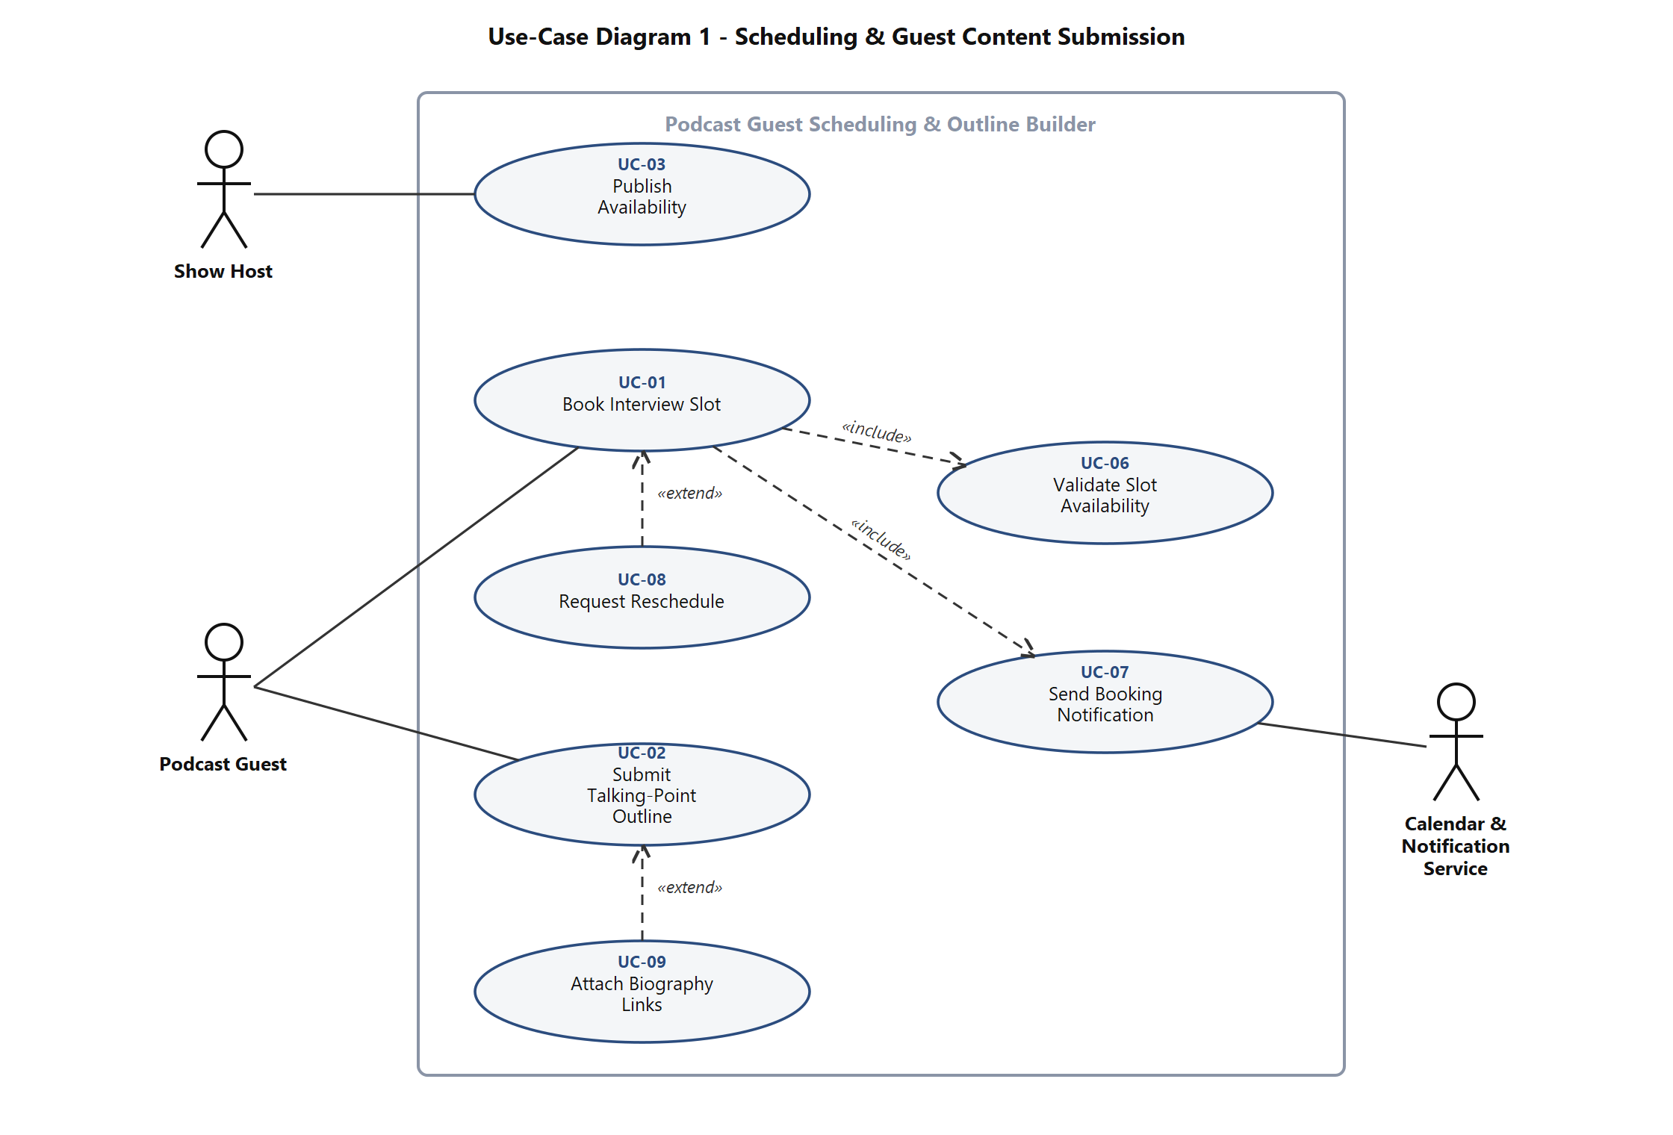
Figure 1 - Use-Case Diagram 1: Scheduling & Guest Content Submission
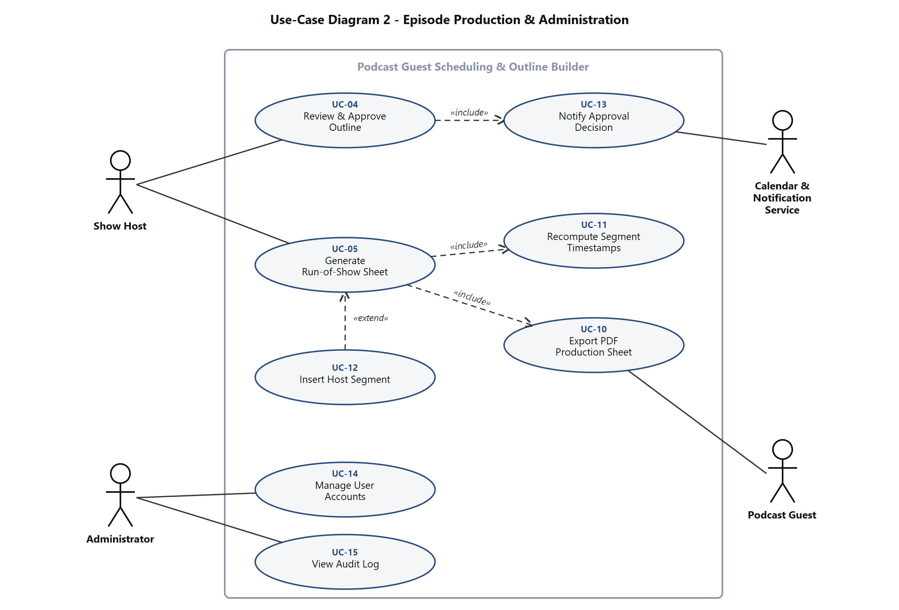
Figure 2 - Use-Case Diagram 2: Episode Production & Administration
Use-case inventory: UC-01 Book Interview Slot, UC-02 Submit Talking-Point Outline, UC-03 Publish Availability, UC-04 Review & Approve Outline, UC-05 Generate Run-of-Show Sheet, UC-06 Validate Slot Availability, UC-07 Send Booking Notification, UC-08 Request Reschedule, UC-09 Attach Biography Links, UC-10 Export PDF Production Sheet, UC-11 Recompute Segment Timestamps, UC-12 Insert Host Segment, UC-13 Notify Approval Decision, UC-14 Manage User Accounts, UC-15 View Audit Log.

8. Requirements Traceability Matrix (RTM)
Status legend: N = Not started, P = Partially implemented, A = Accepted (implemented and test passed). Every requirement in sections 4, 5 and 5.1.2 appears exactly once. The Comments column names the Lab 2 Jira story that carries the work, so a grader can walk requirement to backlog item to test case without leaving the repository.
Req ID | Requirement short | Section ref / Design Spec | Module | Test case(s) | Status (N/P/A) | Comments
PGS-F-001 | Publish availability windows | 4.1 / DS-SCH-01 | SchedulingService | TC-SCH-01 | N | Jira story 1.1
PGS-F-002 | Block dates | 4.1 / DS-SCH-02 | SchedulingService | TC-SCH-02 | N | Jira story 1.1
PGS-F-003 | Show bookable slots only | 4.1 / DS-SCH-03 | SchedulingService, WebUI | TC-SCH-03 | N | Jira story 1.2
PGS-F-004 | Atomic slot re-validation | 4.1 / DS-SCH-04 | SchedulingService | TC-SCH-04 | N | Jira story 1.3
PGS-F-005 | Reschedule booking | 4.1 / DS-SCH-05 | SchedulingService | TC-SCH-05 | N | Jira story 1.4
PGS-F-010 | Submit talking points | 4.2 / DS-OUT-01 | OutlineService | TC-OUT-01 | N | Jira story 2.1
PGS-F-011 | Attach biography links | 4.2 / DS-OUT-02 | OutlineService | TC-OUT-02 | N | Jira story 2.2
PGS-F-012 | Editable outline drafts | 4.2 / DS-OUT-03 | OutlineService | TC-OUT-03 | N | Jira story 2.1
PGS-F-013 | Attach outline to episode board | 4.2 / DS-OUT-04 | OutlineService | TC-OUT-04 | N | Jira story 2.1
PGS-F-020 | Approve, reject or reorder points | 4.3 / DS-REV-01 | ReviewService | TC-REV-01 | N | Jira story 3.1
PGS-F-021 | Mandatory rejection comment | 4.3 / DS-REV-02 | ReviewService | TC-REV-02 | N | Jira story 3.1
PGS-F-022 | Insert host segments | 4.3 / DS-REV-03 | ReviewService | TC-REV-03 | N | New in mini project
PGS-F-023 | Audit approval decisions | 4.3 / DS-REV-04 | AuditService | TC-REV-04 | N | Supports SO-2
PGS-F-030 | Generate run-of-show | 4.4 / DS-ROS-01 | RunOfShowService | TC-ROS-01 | N | Jira story 3.2
PGS-F-031 | Cumulative timestamps | 4.4 / DS-ROS-02 | RunOfShowService | TC-ROS-02 | N | Jira story 3.2
PGS-F-032 | Edit durations and recompute | 4.4 / DS-ROS-03 | RunOfShowService | TC-ROS-03 | N | New in mini project
PGS-F-033 | Export PDF production sheet | 4.4 / DS-EXP-01 | ExportService | TC-ROS-04 | N | Jira story 3.3
PGS-F-040 | Send calendar invite | 4.5 / DS-NOT-01 | NotificationService | TC-NOT-01 | N | Jira story 4.1
PGS-F-041 | 24-hour reminder | 4.5 / DS-NOT-02 | NotificationService | TC-NOT-02 | N | Jira story 4.1
PGS-F-042 | Submission and decision notices with retry | 4.5 / DS-NOT-03 | NotificationService | TC-NOT-03 | N | New in mini project
PGS-F-050 | Authenticate users | 4.6 / DS-AUT-01 | AuthService | TC-AUT-01 | N | Jira story 4.2
PGS-F-051 | Restrict episode board | 4.6 / DS-AUT-02 | AuthService | TC-AUT-02 | N | Jira story 4.2
PGS-F-052 | Admin suspend and audit view | 4.6 / DS-ADM-01 | AdminConsole | TC-ADM-01 | N | New in mini project
PGS-NF-001 | PDF export under 1 s (p95) | 5 / DS-EXP-01 | ExportService | TC-PERF-01 | N | Given NFR-001
PGS-NF-002 | Slot page within 2 s (p90) | 5 / DS-SCH-03 | WebUI, SchedulingService | TC-PERF-02 | N
PGS-NF-003 | 99.5% availability | 5 / DS-OPS-01 | Platform | TC-OPS-01 | N
PGS-NF-004 | TLS and private boards | 5 / DS-AUT-02 | Platform, AuthService | TC-SEC-01 | N | Given NFR-002
PGS-NF-005 | WCAG 2.1 AA | 5 / DS-UX-01 | WebUI | TC-UX-01 | N
PGS-NF-006 | 500 hosts, 5,000 bookings per month | 5 / DS-OPS-02 | Platform | TC-PERF-03 | N
PGS-NF-007 | UTC storage, timezone-correct display | 5 / DS-SCH-06 | SchedulingService, WebUI | TC-SCH-06 | N
PGS-SR-001 | TLS 1.2+ and HSTS | 5.1.2 / DS-SEC-01 | Platform | TC-SEC-01 | N | SO-1
PGS-SR-002 | Argon2id password hashing | 5.1.2 / DS-SEC-02 | AuthService | TC-SEC-02 | N | SO-1
PGS-SR-003 | Server-side authorisation | 5.1.2 / DS-SEC-03 | AuthService | TC-SEC-03 | N | SO-1
PGS-SR-004 | Rate limiting | 5.1.2 / DS-SEC-04 | ApiGateway | TC-SEC-04 | N | SO-3
PGS-SR-005 | Output escaping and URL allowlist | 5.1.2 / DS-SEC-05 | WebUI, OutlineService | TC-SEC-05 | N | SO-1
PGS-SR-006 | Append-only audit log | 5.1.2 / DS-SEC-06 | AuditService | TC-SEC-06 | N | SO-2

