Software Architecture & Design (SAD) - Architecture Justification
Name: Vidit Soni SRN: PES1UG24AM318 Section: F
Team 11 - Person 2 (Architecture/Design & Transaction module) Date: 02-10-2026 Version: 1.1
Scenario: Bank Management System - a single-branch C/C++ console application for deposit, withdrawal, balance inquiry and fund transfer, with the append-only ledger and audit trail behind every balance. Built against SRS v1.0.

Revision History
Version | Date | Author | Description
1.0 | 29-09-2026 | Vidit Soni | First issue in the Lab 3 format: architecture selection and justification, technology stack, component diagram, sequence diagrams, module interfaces, threat model, traceability to SRS v1.0.
1.1 | 02-10-2026 | Vidit Soni | Added the sections of the course SAD template that the Lab 3 format does not have: Introduction, Revision History, Approvals, Stakeholders (12), Risks (13), Open Issues (14) and Glossary (15). Sections 1-11 are unchanged.

Approvals
Approval is recorded here once each reviewer has read the document and agreed to the boundaries that concern their modules (sections 9.4 and 9.6).
Name | Role | Approves | Signature | Date
Vidit Soni | Author - Person 2 (Architecture/Design, Transaction module) | Whole document
Dhanush | Reviewer - Person 1 (Auth, Validation, Account) | Sections 9.4 and 9.6: customer and credential records, closure transfer, role check
Adarsha E | Reviewer - Person 3 (Ledger read, Report, Build) | Sections 9.4 and 9.6: journal format, audit helper
Course faculty | Approver | Whole document

Introduction

Purpose
This document records the software architecture of the Team 11 Bank Management System (BMS): which architecture was chosen and why, how the components divide the work, what each module promises to the others, which threats the design answers, and which design decision covers each requirement of the SRS. It is the contract that Persons 1, 2 and 3 code against.

Scope
The document covers the BMS as specified in SRS v1.0: a single-branch, single-process C++17 console application that keeps its data in local files. It covers customer and account lifecycle, authentication and roles, deposit, withdrawal, balance inquiry and statements, fund transfer, the append-only journal and audit log, and the end-of-day report. The system has no network interface (SRS 3.4) and uses no third-party library (SRS 2.5).
Out of scope for v1.0: networked or multi-branch deployment, a full-screen TUI (a possible later stretch behind the service layer), keyed integrity protection or encryption of the data files, and an idle-session timeout (see sections 13 and 14).

Intended audience
The three team members who implement the modules, whoever writes and runs the Test Plan, and the course faculty who review the design against the template.

References
- Software Requirements Specification (SRS) v1.0, Team 11 - Bank Management System.
- SAD_Traceability.md (29-09-2026), the source of the table in section 11.
- ROLES.md, which assigns Persons 1-3 to modules.
- Test Plan, Team 11, which holds TC-PERF-01, TC-PERF-02 and TC-SEC-08 cited in this document.
- Lab 3 SAD format, followed by sections 1-11.

Document overview
Sections 1-6 give the architecture decision, its reasons, the alternatives rejected, and the technology stack. Section 7 is the component diagram and section 8 the sequence diagrams for withdraw and transfer. Section 9 defines the module interfaces and on-disk formats, section 10 is the threat model and section 11 the traceability table. Sections 12-15 list the stakeholders, the risks, the open issues and the glossary.

1. Architecture Selection
We chose Layered Architecture for the Bank Management System.

2. Architectural Choice
The system is divided into three layers: Presentation (CLI / MenuLayer), Service (AuthModule, ValidationModule, AccountModule, TransactionModule, LedgerModule, ReportModule) and Persistence (PersistenceModule, the only code that touches the data files). Each layer only calls the layer below it. The build and toolchain gate cuts across all three.
Unlike a design with a separate security layer above the business layer, authorisation here lives inside the Service layer. BMS-SR-007 requires the role check to run inside the service function, immediately before the privileged operation, so a check placed only in front of the services could be bypassed by calling a service directly.

3. Reasons
Reason 1
The system is small and its three users (Customer, Teller, Manager) all follow the same flow: menu, then role check and validation, then the business rule, then the file. A layered design matches that flow, so the system is easy to build, understand and test by a team of three in one semester.
Reason 2
A balance change, its journal entry and the account record must always agree. Because every file access goes through one PersistenceModule, the write-ahead journal (BMS-NF-002) and the append-only rule (BMS-SR-005) are enforced in exactly one place. A transfer touches two accounts; in a client-server or microservice design that would need a distributed commit, whereas here it is one local journal batch (BMS-F-050).
Reason 3
BMS-NF-006 asks for modules that are unit-testable without the menu. With strict layering and no global state, each service module links and runs without the CLI, and the presentation layer can be replaced later (for example by a full-screen TUI) without touching the service layer.
Alternatives considered
Alternative | Why it was rejected
Single-file monolith (menu, rules and file I/O mixed together) | No module can be tested without the menu (BMS-NF-006), and role checks and file rules would be scattered instead of enforced in one place.
Client-server or microservices | The SRS gives the system no network interface by design (section 3.4), no third-party library is allowed, and two-account transfers would need a distributed commit instead of one write-ahead journal.
Embedded database such as SQLite | Section 2.5 of the SRS forbids third-party libraries, so the team owns the file format and its crash-safety; that is why PersistenceModule is a first-class component.

4. Security Advantage
Every privileged service function starts with authorise(role, operation), so a Teller who reaches a Manager operation by any route other than the menu is still refused; the menu only hides options (BMS-SR-007, BMS-F-012). PersistenceModule exposes append-only functions for the journal and audit log and has no update or delete function, so no caller can rewrite history (BMS-SR-005). It also refuses to start if the data directory is group- or world-writable (BMS-SR-006).

5. Performance Benefit
All layers run in one process and call each other directly, with no network or inter-process calls. A withdrawal or transfer costs one journal append with one fsync plus one or two fixed-offset record writes, and never scans all accounts. The fsync is the dominant cost and is expected to sit well inside the 500 ms limit of BMS-NF-001 at 10,000 accounts; TC-PERF-01 and TC-PERF-02 will confirm it.

6. Technology Stack
Item | Choice
Language and standard | C++17 with g++ (the course fixes C/C++). Standard library and platform C runtime only; no third-party library (SRS 2.5).
Build gate | g++ -std=c++17 -Wall -Wextra -Werror on Linux and on Windows with MinGW. Platform code (terminal echo off, owner-only file permissions) lives in one portability header (BMS-NF-004).
Money | int64_t paise everywhere; float and double never appear in the money path. Add and subtract go through overflow-checked helpers built on __builtin_add_overflow and __builtin_sub_overflow (BMS-NF-003, BMS-SR-003).
Storage | Local files in one data directory: accounts.dat and customers.dat (fixed-width records updated in place), journal.log and audit.log (append-only), bank.cfg, bank.lock.
Process model | Single instance. bank.lock stops a second instance racing on the account file (SRS 2.4).
User interface | Line-based console menu, so tests can be scripted; a full TUI would sit behind the service layer as a later stretch.

7. Component Diagram
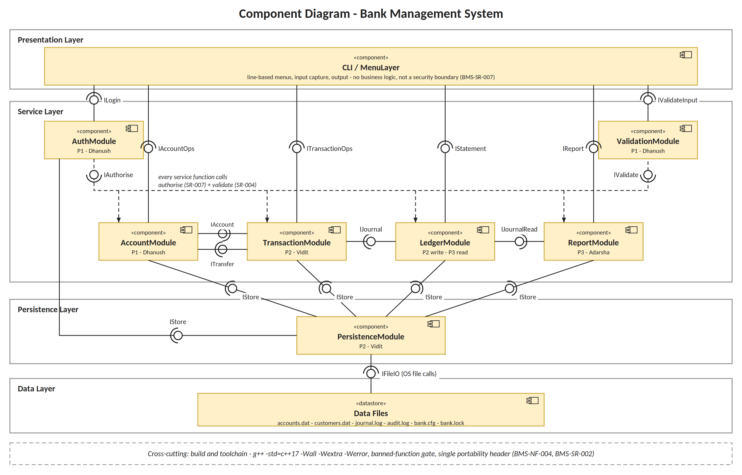
Key: a ball is a provided interface and a socket is a required interface. Every interface is an in-process C++ function call, not a network call. The dashed bus shows that every service function calls IAuthorise and IValidate. ITransfer is injected into AccountModule (see section 9.6).

7.1 Component Descriptions
Component | Layer | Owner | Responsibility | Provides | Reqs
CLI / MenuLayer | Presentation | Unassigned in ROLES.md (to confirm) | Role-specific menus, input capture and formatted output. Holds no business logic and is not a security boundary. | - | 3
AuthModule | Service | P1 - Dhanush | Authenticates customers and staff, enforces lockout, and supplies the role check every privileged operation calls. | ILogin, IAuthorise | 10
ValidationModule | Service | P1 - Dhanush | Type and range validation of every operator input, and the account-pair checks for transfers, before any other module uses the value. | IValidateInput, IValidate | 6
AccountModule | Service | P1 - Dhanush | Customer and account lifecycle: create, open, look up, modify and close. Gives TransactionModule account state and balance read/update. | IAccountOps, IAccount | 9
TransactionModule | Service | P2 - Vidit | Deposit, withdrawal, transfer and balance; their limits; all integer-paise money arithmetic. | ITransactionOps, ITransfer | 14
LedgerModule | Service | P2 (write), P3 (read) | The append-only journal and audit log; statements and reconciliation read from it. | IJournal, IJournalRead, IStatement | 11
ReportModule | Service | P3 - Adarsha | End-of-day report and read-only audit-log view. | IReport | 5
PersistenceModule | Persistence | P2 - Vidit | All file I/O: record formats, the write-ahead protocol, crash recovery, file permissions and the instance lock. | IStore | 5
Build & toolchain | Cross-cutting | P3 - Adarsha | Warning-free portable build on g++ and MinGW; the gate that enforces the banned-function rule. | - | 3

8. Sequence Diagrams

8.1 Withdraw
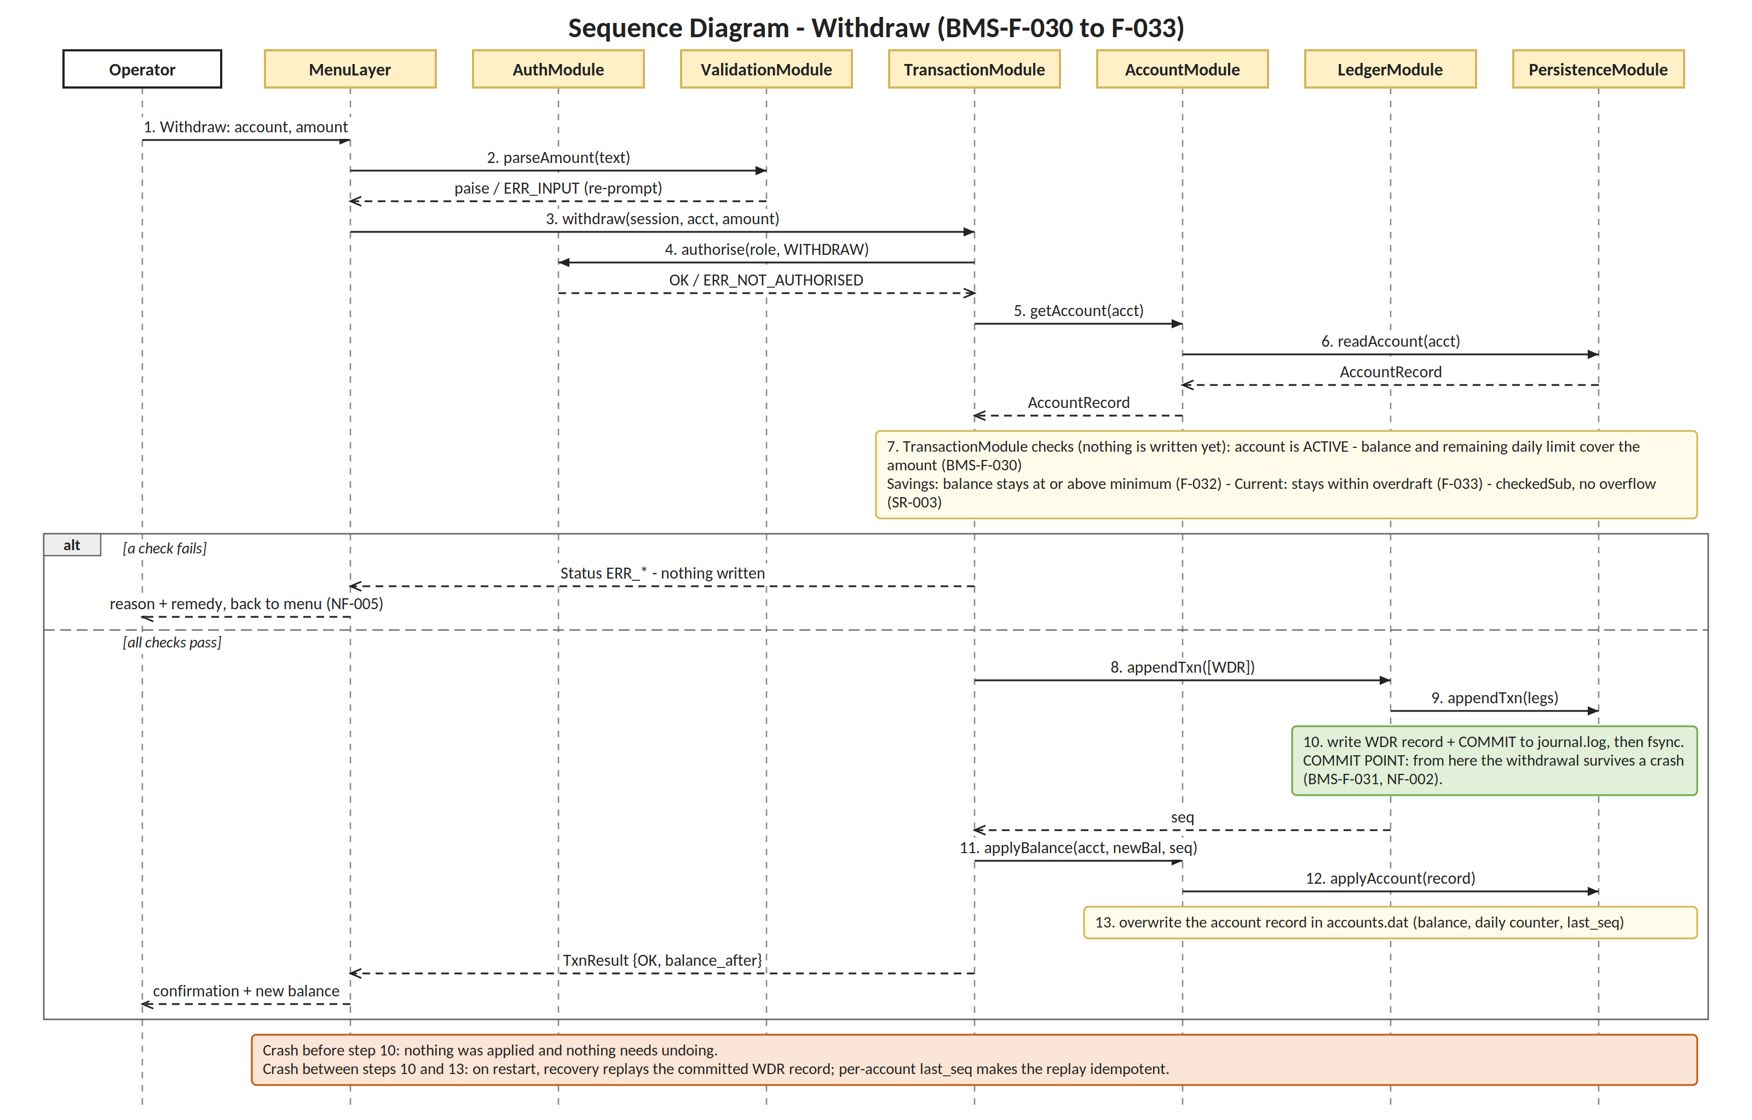
Precondition: the operator is logged in and MenuLayer holds Session {operator_id, role}. All three layers are exercised, from MenuLayer through the Service modules to Persistence. Steps 1-7 change nothing, step 10 is the commit point, and steps 11-13 apply the result.

8.2 Fund Transfer
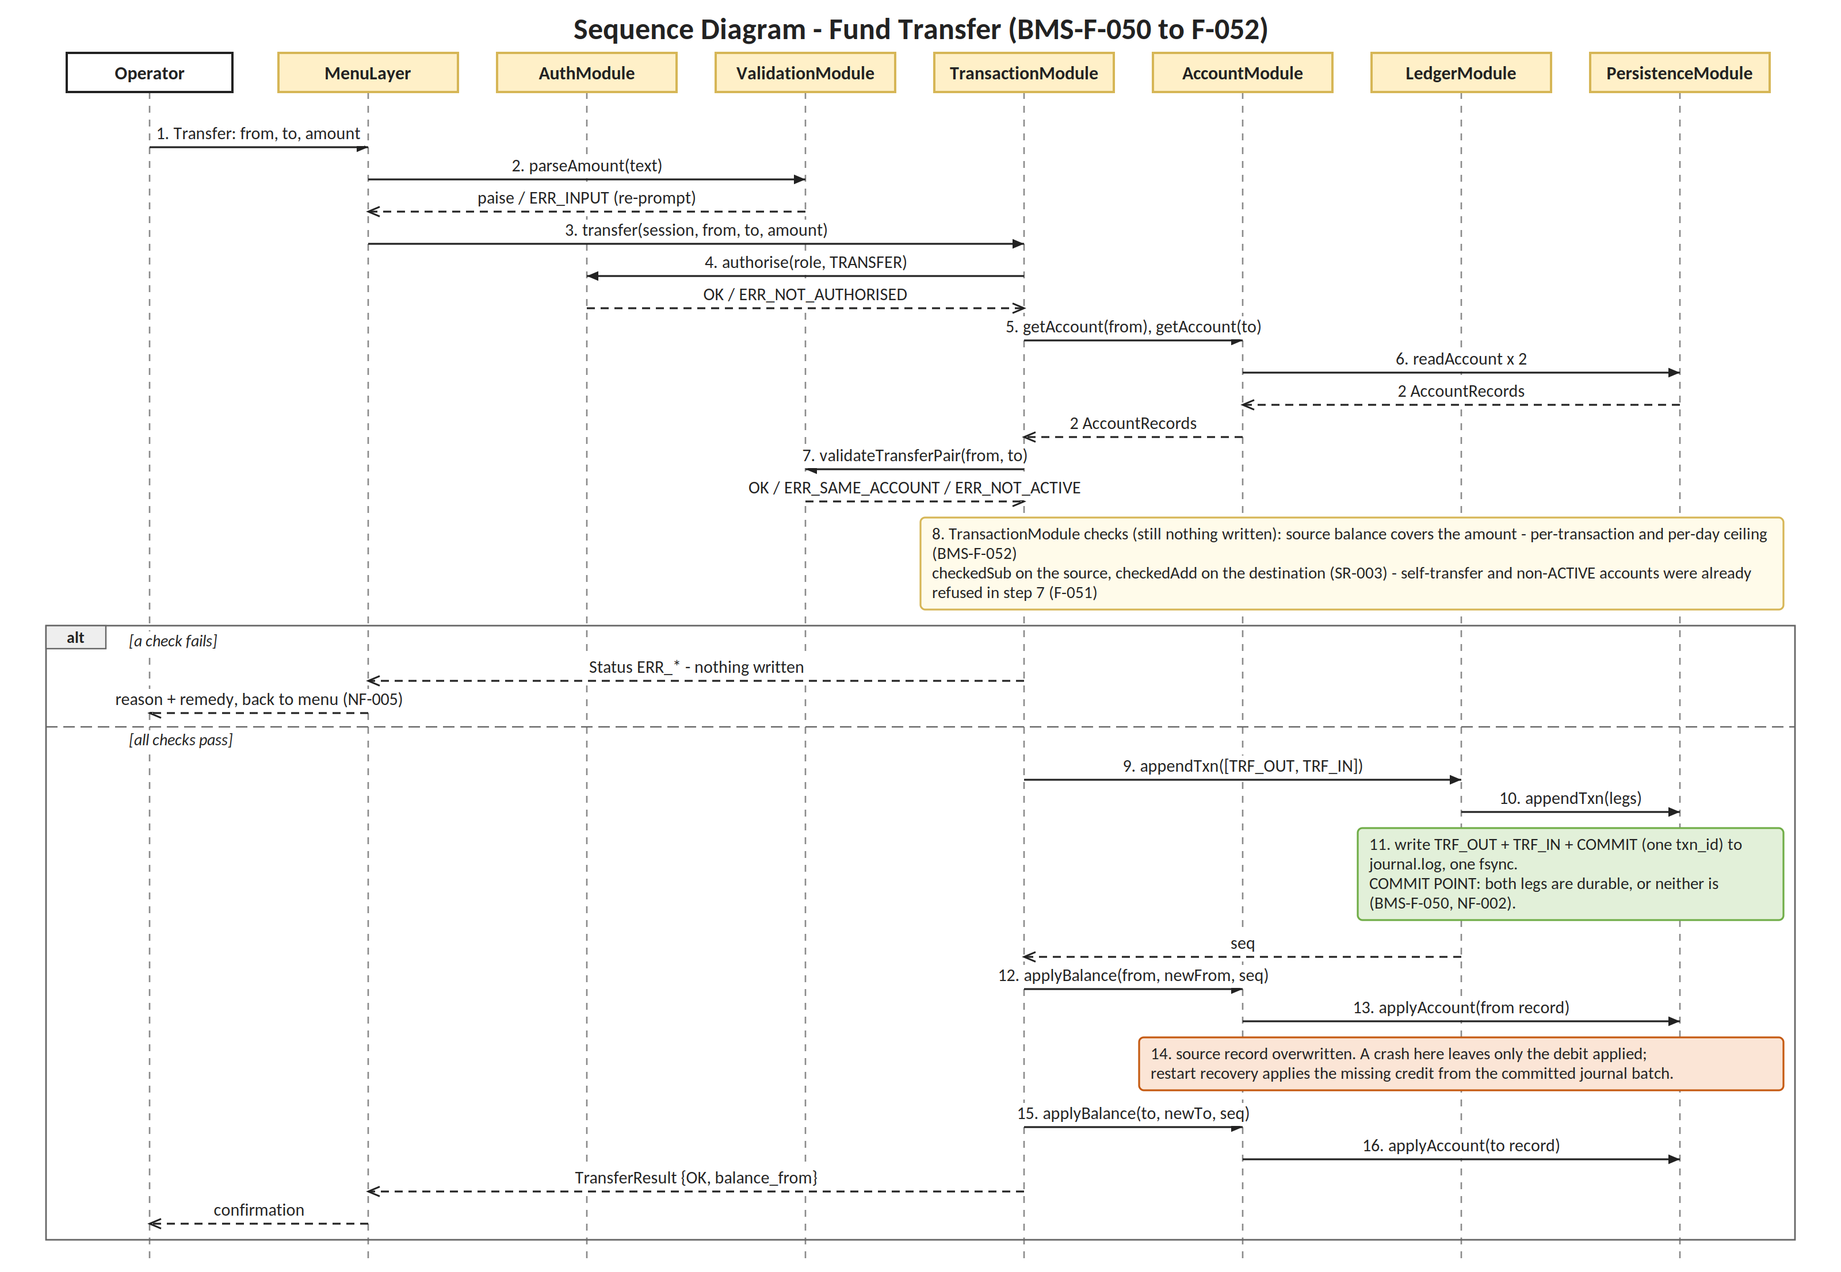
Precondition as for withdraw. Steps 1-8 change nothing and step 11 is the single commit point for both legs. Steps 12-16 apply the legs one at a time; if a crash lands between them, restart recovery applies the missing leg from the committed journal batch.

9. Module Interface Definitions
The template asks for at least two components; the two owned by Person 2, TransactionModule and PersistenceModule, are defined in full. The signatures below are the contract that Persons 1 and 3 code against.

9.1 Shared types and conventions
- Paise = int64_t. AccountNo = uint32_t. Session { operator_id, role } is created by AuthModule at login and passed explicitly; there are no global variables.
- Every function returns a Status (or a result struct holding one) instead of throwing, so each rejection can name its reason and remedy (BMS-NF-005). The Status-to-message table lives in MenuLayer.
- Money helpers in money.h: bool checkedAdd(Paise a, Paise b, Paise& out) and bool checkedSub(...) return false on overflow, and the caller then returns ERR_OVERFLOW.

Status | Meaning | Requirement
OK | The operation completed and, if it changes money, is committed. | -
ERR_INPUT | Text is not a valid number or menu choice; the caller re-prompts with no state change. | BMS-SR-004
ERR_AMOUNT_NOT_POSITIVE, ERR_ABOVE_TXN_LIMIT | Amount is zero or negative; amount exceeds the per-transaction ceiling. | BMS-F-021, F-052
ERR_ACCOUNT_NOT_FOUND, ERR_NOT_ACTIVE, ERR_SAME_ACCOUNT | Unknown account; account is LOCKED or CLOSED; source and destination are the same. | BMS-F-021, F-051
ERR_INSUFFICIENT_FUNDS, ERR_DAILY_LIMIT | Balance does not cover the amount; the daily withdrawal or transfer ceiling would be crossed. | BMS-F-030, F-052
ERR_BELOW_MIN_BALANCE, ERR_OVERDRAFT_EXCEEDED | Savings minimum balance would be breached; Current overdraft limit would be exceeded. | BMS-F-032, F-033
ERR_OVERFLOW | The arithmetic would overflow int64_t; refused rather than wrapped. | BMS-SR-003
ERR_NOT_AUTHORISED | The session role is not allowed to perform this operation. | BMS-SR-007
ERR_IO, ERR_CORRUPT | A file operation failed (for example disk full); a record failed its CRC and reconciliation is needed. | BMS-NF-002

9.2 TransactionModule (Service layer)
Calls IAuthorise, IValidate, IAccount and IJournal. Each function begins with authorise() and performs no write until every check has passed.
Signature | Precondition | Postcondition | Returns (errors)
TxnResult deposit(const Session& s, AccountNo acct, Paise amount) | Amount already parsed by ValidationModule. | Balance rises by exactly amount and one DEP journal record exists (F-020, F-022); otherwise nothing changed. | NOT_AUTHORISED, AMOUNT_NOT_POSITIVE, ABOVE_TXN_LIMIT, ACCOUNT_NOT_FOUND, NOT_ACTIVE, OVERFLOW, IO
TxnResult withdraw(const Session& s, AccountNo acct, Paise amount) | As deposit. | Debit and one WDR record commit together; daily counter advanced (F-030, F-031). Savings minimum and Current overdraft enforced (F-032, F-033). | As deposit, plus INSUFFICIENT_FUNDS, DAILY_LIMIT, BELOW_MIN_BALANCE, OVERDRAFT_EXCEEDED
TransferResult transfer(const Session& s, AccountNo from, AccountNo to, Paise amount) | from and to are checked, not assumed, to differ. | Both legs commit in one journal batch or neither does (F-050); per-day total updated (F-052). | NOT_AUTHORISED, SAME_ACCOUNT, NOT_ACTIVE, ACCOUNT_NOT_FOUND, INSUFFICIENT_FUNDS, ABOVE_TXN_LIMIT, DAILY_LIMIT, OVERFLOW, IO
BalanceResult balance(const Session& s, AccountNo acct) | Session is the holder, or a Teller acting on the account. | Returns the stored balance and writes no journal record (F-040). | NOT_AUTHORISED, ACCOUNT_NOT_FOUND
class ITransfer { virtual TransferResult transfer(const Session&, AccountNo from, AccountNo to, Paise) = 0; }; | Injected into AccountModule at start-up. | Lets closeAccount() move a residual balance (F-006) without AccountModule linking against TransactionModule. | As transfer

9.3 PersistenceModule (Persistence layer)
The only module that opens a data file. Called through IStore by the Service layer. Note what is missing on purpose: there is no function that updates or deletes a journal or audit record (BMS-SR-005).
Signature | Contract | Errors
Status openStore(const std::string& dir, Store& out) | Refuses if dir is group- or world-writable (SR-006); creates files owner-only; takes bank.lock (one instance); then runs recovery (section 9.5). | IO, CORRUPT
void closeStore(Store&) | Flushes and releases bank.lock. | -
Status readAccount(Store&, AccountNo, AccountRecord&) | Fixed-offset read; verifies the record CRC. | ACCOUNT_NOT_FOUND, CORRUPT
Status appendTxn(Store&, const JournalEntry* legs, size_t n, uint64_t& seq) | Writes the n leg records and a COMMIT record to journal.log in append mode, then one fsync. The batch is durable when this returns OK and invisible if it does not. | IO
Status applyAccount(Store&, const AccountRecord&) | Overwrites one account record in place. Precondition: the COMMIT covering rec.last_seq is already durable. | IO
Status appendAudit(Store&, const AuditEntry&) | The single audit-append helper used by AuthModule and AccountModule (F-063). | IO
Status readJournalLast(Store&, AccountNo, size_t n, std::vector<JournalEntry>&) | Last n entries for the account, newest first, read backwards from the end of the file (F-041). | IO, CORRUPT
Status readJournalRange(Store&, AccountNo, Date from, Date to, std::vector<JournalEntry>&) | Entries between two dates inclusive (F-042). | IO, CORRUPT
Status readDailyTotals(Store&, Date, DailyTotals&) | Per-day totals for the end-of-day report (F-062). | IO
Status readCustomer / writeCustomer, readStaff / writeStaff (Store&, ...) | Customer and staff records, including credential hash, salt and failed-attempt count, for AccountModule and AuthModule. | IO, CORRUPT

9.4 On-disk record formats
Fixed here first, because Person 3 cannot write statements until the journal format is settled.
Record | Layout | Rules
journal.log entry (one text line) | seq | txn_id | type | acct | amount_paise | balance_after_paise | utc_timestamp | operator_id | crc32  type is DEP, WDR, TRF_OUT, TRF_IN or COMMIT. A COMMIT line carries the txn_id and the number of legs.  Example: 1042|77|WDR|100234|500000|1250000|2026-09-29T10:15:02Z|T007|9F3A61C2 | Append-only. seq strictly increases. A batch counts only if its matching COMMIT follows; an incomplete trailing batch is ignored at recovery. crc32 catches torn writes; it is not tamper protection.
audit.log entry (one text line) | seq | utc_timestamp | operator_id | event | target | detail | crc32 | Append-only. Event codes (for example LOCKOUT, UNLOCK, CUSTOMER_MODIFY) to be agreed with Person 1.
accounts.dat record (fixed width) | acct_no, cust_id, type (SAV or CUR), state (ACTIVE, LOCKED, CLOSED), opening_balance_paise, balance_paise, overdraft_limit_paise, daily_withdrawn_paise, daily_transferred_paise, counter_date, last_seq, crc32 | Offset = record index x record size. Updated in place only by applyAccount(). last_seq is the seq of the last journal leg applied to this account.

9.5 Crash recovery (runs inside openStore)
- Read journal.log forward and collect every batch that ends in a matching COMMIT; ignore an incomplete trailing batch, so a crash before the commit point leaves no trace.
- For each committed leg, apply it to its account only if that account's last_seq is lower than the leg's seq. Applying is therefore idempotent, and a crash between the two legs of a transfer is repaired by applying the missing leg.
- A record whose CRC fails is rebuilt from opening balance plus journal entries (the same computation as reconciliation, BMS-F-061). Scanning 100,000 entries at start-up is expected to fit comfortably inside the 2 s limit of BMS-NF-007; TC-PERF-02 will confirm it.

9.6 Boundaries that span two owners (proposed, to confirm)
Boundary | Proposal | Needs sign-off from
Journal record format (BMS-F-060) | Section 9.4. P2 writes it; P3 reads it for statements and reconciliation. | Adarsha (blocked until fixed)
AccountRecord and customer/staff records | Section 9.4 for accounts.dat; Dhanush adds the customer and credential fields. | Dhanush
Residual transfer on closure (BMS-F-006) | closeAccount() calls ITransfer::transfer, injected at start-up so AccountModule does not link against TransactionModule (BMS-NF-006). TransactionModule owns atomicity; AccountModule sets CLOSED only after OK. | Dhanush
Audit entries (BMS-F-063) | One appendAudit() helper in PersistenceModule; AuthModule and AccountModule call it before applying a lockout, unlock or customer change. | Dhanush, Adarsha
Role check (BMS-SR-007) | authorise(role, operation) from AuthModule; the permission table lives in AuthModule; each privileged service function calls it first. | Dhanush
CLI / MenuLayer ownership | Unowned in ROLES.md. Suggest one shared file where each person extends only their own menu section. | Whole team

10. Threat Model
The system has no network interface (SRS 3.4), so the adversary is someone with access to the host or its data files, or an operator acting outside their role. The model uses STRIDE against the four security objectives: SO-1 confidentiality at rest, SO-2 integrity and non-repudiation of the ledger, SO-3 memory safety and input robustness, SO-4 least privilege.

10.1 Assets, adversaries and trust boundaries
ID | Asset | ID | Adversary
A1 | Credential hashes and salts (SO-1) | U1 | Another user of the host machine who can read or edit the data files
A2 | Customer personal data in customers.dat (SO-1) | U2 | An authorised operator acting outside their role, or an insider editing records
A3 | Account balances in accounts.dat (SO-2) | U3 | Untrusted input: keystrokes, or a data file that has been corrupted or edited
A4 | journal.log and audit.log (SO-2) | U4 | An accidental fault: power loss, a killed process, a full disk
A5 | Process memory and control flow (SO-3) | TB | Trust boundaries: keyboard to MenuLayer; process to filesystem (everything read from a file is untrusted); any caller to a service function

10.2 STRIDE analysis
ID | STRIDE | Threat | Who / asset | Mitigation in the design | Requirement | SO | Residual risk
T1 | Spoofing | Guessing a PIN or password by repeated attempts | U1, U2 / A1 | Third failed attempt sets the account LOCKED and appends an audit entry; only a Manager unlocks (AuthModule). | BMS-F-010, F-011, F-013 | SO-1, SO-4 | Low. A lockout is a nuisance, not a breach, and the unlock is itself audited.
T2 | Spoofing | Acting under another person's identity or on an unattended terminal | U2 / session | Every privileged call carries Session {operator_id, role} and every journal record stores operator_id, so each action is attributable. Sign-out ends the session. | BMS-F-010, F-022 | SO-4, SO-2 | Accepted. An unattended logged-in terminal is not addressed in v1.0; the SRS has no idle timeout.
T3 | Tampering | Editing a balance directly in accounts.dat | U1, U2 / A3 | Account records carry a CRC; reconciliation recomputes each balance from opening balance plus journal and names any account that differs; files are owner-only. | BMS-F-061, SR-006 | SO-2 | Medium. Someone who edits accounts.dat and journal.log consistently, with permissions already defeated, is not detected: CRC32 is not a keyed MAC and no third-party crypto is allowed. A hash-chained journal is a possible future step.
T4 | Tampering | Integer overflow silently changing a balance | U3 / A3 | int64_t paise only; checkedAdd and checkedSub run before every change; overflow returns ERR_OVERFLOW and the transaction is refused. | BMS-NF-003, SR-003 | SO-3 | Low.
T5 | Tampering | Malformed or over-long input driving undefined behaviour | U3 / A5 | ValidationModule parses and range-checks every input before use; buffers are bounded; banned functions are blocked by the build gate. Data read from files is validated the same way. | BMS-SR-002, SR-004 | SO-3 | Low.
T6 | Tampering | A torn or half-applied write leaving accounts inconsistent | U4 / A3, A4 | Journal batch plus COMMIT is fsynced before any account record changes; recovery replays committed batches idempotently and ignores an uncommitted tail. | BMS-F-050, NF-002 | SO-2 | Low. Assumes the OS honours fsync; a single record torn inside a disk sector fails its CRC and is rebuilt from the journal.
T7 | Repudiation | Rewriting or deleting a journal record to deny a transaction | U2 / A4 | journal.log and audit.log are opened append-only; PersistenceModule has no update or delete function; each record carries operator_id, timestamp and CRC. | BMS-F-060, SR-005, F-022 | SO-2 | Medium. A host administrator can still edit the file outside the program (see T3).
T8 | Repudiation | A privileged action that leaves no attributable record | U2 / A4 | Lockout, unlock and customer modification each call appendAudit() before the change is applied. | BMS-F-063 | SO-2 | Low.
T9 | Information disclosure | Reading PINs or passwords out of the data files | U1 / A1 | Only salted hashes are stored, with a distinct salt per record; nothing is written in plaintext to any file, log or terminal. | BMS-SR-001 | SO-1 | Medium. A 4-digit PIN has few possibilities, so a copied hash file could be brute-forced offline. The primary control is therefore owner-only file permissions (T11).
T10 | Information disclosure | Shoulder-surfing a PIN, or recovering it from memory | U1, U3 / A1 | Terminal echo is disabled through the portability header; the credential buffer is zeroed after hashing. | BMS-F-014 | SO-1 | Low.
T11 | Information disclosure | Another host user reading customer or account data | U1 / A1, A2 | Files are created owner-only, and startup refuses if the data directory is group- or world-writable. | BMS-SR-006 | SO-1 | Low. A host administrator is outside the threat model.
T12 | Denial of service | A crash mid-write leaves the ledger unusable; two instances race; the disk fills | U4 / A3, A4 | Write-ahead journal with recovery at start-up; bank.lock blocks a second instance; a failed journal append returns ERR_IO before any account record is touched. | BMS-NF-002 | SO-2 | Low. Remote denial of service does not apply: the system opens no socket and listens on no port (SRS 3.4).
T13 | Elevation of privilege | Reaching a Manager-only operation by bypassing the menu | U2 | authorise(role, operation) is the first statement of every privileged service function; the menu only hides options. Testable by calling the service directly with a Teller session (TC-SEC-08). | BMS-SR-007, F-012 | SO-4 | Low. Relies on every new service function calling authorise(); checked in PR review.
T14 | Elevation of privilege | A buffer overflow used to take control of the process | U3 / A5 | Same controls as T5: bounds-checked writes, no banned functions, warnings treated as errors. | BMS-SR-002 | SO-3 | Low to medium. C++ remains memory-unsafe, so this is reviewed in every PR.

10.3 Coverage of the security objectives
Objective | Threats addressed | Note
SO-1 Confidentiality at rest | T1, T9, T10, T11 | File permissions carry most of the weight because there is no network and no encryption library (T9).
SO-2 Ledger integrity | T2, T3, T6, T7, T8, T12 | Tampering is detected by reconciliation, not prevented against an attacker who controls the host (T3, T7).
SO-3 Memory safety and input | T4, T5, T14 | Enforced by the validation layer and the build gate.
SO-4 Least privilege | T1, T2, T13 | The check sits in the service layer, so bypassing the menu gains nothing.

11. Traceability to Requirements and Design Specs
All 43 requirements map to a component, and the DS-IDs are the ones the SRS RTM already cites. Each row gives the design decision behind that ID. Source: SAD_Traceability.md (29-09-2026).
Req ID | Requirement | Component(s) | Design spec | Design decision
BMS-F-001 | Create customer record | AccountModule | DS-ACC-01 | Customer record is a fixed-width record in customers.dat, created by AccountModule after ValidationModule accepts every field.
BMS-F-002 | Open account | AccountModule | DS-ACC-02 | Account record written as ACTIVE with type, opening balance and overdraft limit; account numbers come from a counter kept in the accounts.dat header.
BMS-F-003 | Modify customer details | AccountModule | DS-ACC-03 | Customer record updated in place; the change is appended to audit.log (F-063) before it is applied.
BMS-F-004 | Close account at zero balance | AccountModule | DS-ACC-04 | Closure allowed only at zero balance; the record is marked CLOSED, never deleted, so the journal stays explicable.
BMS-F-005 | Retrieve account by number or customer | AccountModule | DS-ACC-05 | Lookup by account number is a direct offset into accounts.dat; lookup by customer scans customers.dat (well inside NF-007 at 10,000 records).
BMS-F-006 | Transfer residual balance on closure | AccountModule, TransactionModule | DS-ACC-06 | closeAccount() moves any residual through the injected ITransfer; TransactionModule owns atomicity, AccountModule sets CLOSED only after OK.
BMS-F-010 | Authenticate customer or staff | AuthModule | DS-AUT-01 | login(id, secret) returns Session {operator_id, role}; the menu shown is chosen from the returned role.
BMS-F-011 | Lock after 3 failed PIN attempts | AuthModule | DS-AUT-02 | Failed-attempt counter kept in the credential record; the third failure sets LOCKED and appends an audit entry.
BMS-F-012 | Role-based authorisation | AuthModule | DS-AUT-03 | Roles Customer, Teller, Manager; a permission table maps each operation to the roles allowed, consulted by authorise().
BMS-F-013 | Manager unlocks account | AuthModule | DS-AUT-04 | Manager-only unlock() resets counter and state and appends an audit entry naming the manager.
BMS-F-014 | No echo, clear credential buffer | AuthModule | DS-AUT-05 | Terminal echo disabled through the portability header; the credential buffer is zeroed as soon as it has been hashed.
BMS-F-020 | Atomic deposit credit | TransactionModule | DS-DEP-01 | deposit() computes the new balance with checkedAdd, commits the journal batch, then applies it; the balance is never observable half-updated.
BMS-F-021 | Reject invalid deposit | ValidationModule | DS-DEP-02 | Zero or negative, above ceiling, and not-ACTIVE each return their own Status code before any state is touched.
BMS-F-022 | Journal every deposit | LedgerModule | DS-DEP-03 | One DEP record per deposit (account, amount, balance_after, timestamp, operator_id) in the same committed batch.
BMS-F-030 | Check balance and daily limit | TransactionModule | DS-WDR-01 | withdraw() checks the balance and the remaining daily limit (daily_withdrawn in the account record) before building the journal record.
BMS-F-031 | Atomic debit plus journal | TransactionModule, LedgerModule | DS-WDR-02 | WDR record + COMMIT is written and fsynced first, the account record is overwritten second; restart replays any committed batch not yet applied.
BMS-F-032 | Savings minimum balance | TransactionModule | DS-WDR-03 | Savings: refuse if balance - amount is below the minimum balance in bank.cfg; landing exactly on the minimum is allowed.
BMS-F-033 | Current account overdraft | TransactionModule | DS-WDR-04 | Current: the floor is minus the overdraft limit stored in the account record; a withdrawal beyond it is refused.
BMS-F-040 | Display current balance | TransactionModule | DS-BAL-01 | balance() reads the record through AccountModule after an authorisation check and writes no journal record.
BMS-F-041 | Mini-statement, last ten | LedgerModule | DS-BAL-02 | Ledger read: last N journal entries for one account, newest first, found by scanning journal.log backwards from the end.
BMS-F-042 | Date-range statement | LedgerModule | DS-BAL-03 | Range read filters journal entries by date inclusive; the closing balance is the balance_after of the last entry in range.
BMS-F-050 | Atomic two-leg transfer | TransactionModule | DS-TRF-01 | One batch [TRF_OUT, TRF_IN, COMMIT] with a shared txn_id and a single fsync; both legs applied afterwards, and recovery completes a half-applied transfer.
BMS-F-051 | Reject self or inactive transfer | ValidationModule | DS-TRF-02 | validateTransferPair() refuses same-account and non-ACTIVE either side, with distinct codes, before any balance is checked.
BMS-F-052 | Transfer ceilings | TransactionModule | DS-TRF-03 | Per-transaction and per-day ceilings from bank.cfg; the running daily total is daily_transferred in the source account record.
BMS-F-060 | Append-only journal | LedgerModule | DS-LED-01 | journal.log is opened append-only and PersistenceModule exposes no function that updates or deletes a record.
BMS-F-061 | Reconciliation check | LedgerModule | DS-LED-02 | reconcile() recomputes each balance as opening balance + sum of journal entries and names every account that differs.
BMS-F-062 | End-of-day report | ReportModule | DS-RPT-01 | End-of-day report aggregates per-day totals from the journal (readDailyTotals) and resets the daily counters.
BMS-F-063 | Audit privileged actions | LedgerModule | DS-LED-03 | AuthModule and AccountModule call the single appendAudit helper for lockout, unlock and customer modification.
BMS-F-064 | View audit log | ReportModule | DS-RPT-02 | Audit-log viewer is read-only over audit.log and sits behind authorise().
BMS-NF-001 | Transaction within 500 ms | All service modules | DS-PERF-01 | All layers run in one process: a transaction is one journal append with one fsync and one record write, with no scan of all accounts.
BMS-NF-002 | Crash-safe write-ahead journal | PersistenceModule | DS-REL-01 | Write-ahead journal with COMMIT marker, CRC per record, per-account last_seq, and recovery inside openStore().
BMS-NF-003 | Integer paise, no floats | TransactionModule | DS-INT-01 | Paise is int64_t in money.h; no float or double in any function that touches an amount.
BMS-NF-004 | Clean -Wall -Wextra -Werror build | Build system | DS-PORT-01 | Echo control and file permissions live in one portability header; the build gate compiles with -Wall -Wextra -Werror on g++ and MinGW.
BMS-NF-005 | Reason and remedy on rejection | CLI / MenuLayer | DS-UX-01 | Every Status code has a one-line reason and remedy in MenuLayer, and a rejection returns to the menu instead of exiting.
BMS-NF-006 | Layered, unit-testable modules | All modules | DS-ARCH-01 | Strict layering; state is passed as explicit handles (Store, Session) with no globals, so each service module links without the CLI.
BMS-NF-007 | 10,000 accounts under 2 s | PersistenceModule | DS-PERF-02 | accounts.dat is fixed-width for direct offset access; the journal is read backwards for statements; sized for 10,000 accounts and 100,000 entries.
BMS-SR-001 | Salted credential hashing | AuthModule | DS-SEC-01 | A random salt per record and a stored hash; plaintext is never written. The hash function is chosen by the AuthModule owner within the no-third-party-library rule.
BMS-SR-002 | Bounds-checked buffers, banned functions | All modules | DS-SEC-02 | Fixed buffers are written only with bounded calls (snprintf, std::string); the banned-function search runs in the build gate.
BMS-SR-003 | Integer overflow checks on money | TransactionModule | DS-SEC-03 | checkedAdd and checkedSub wrap __builtin_add_overflow and __builtin_sub_overflow; overflow returns ERR_OVERFLOW and never wraps.
BMS-SR-004 | Validate all input before use | ValidationModule | DS-SEC-04 | ValidationModule parses numbers with strtoll plus a range check; failure re-prompts with no state change.
BMS-SR-005 | Append-only journal and audit log | LedgerModule | DS-SEC-05 | journal.log and audit.log are opened append-only and the interface has no edit or delete function.
BMS-SR-006 | Owner-only file permissions | PersistenceModule | DS-SEC-06 | Files created owner-only through the portability header; openStore() refuses to start if the data directory is group- or world-writable.
BMS-SR-007 | Role check in the service layer | AuthModule | DS-SEC-07 | Every privileged service function begins with authorise(role, operation); a menu that hides an option is a convenience, not the control.

12. Stakeholders
People and groups who use the system, build it, or judge it, and where this document answers their main concern.
Stakeholder | Role with the system | Main concern | Where addressed
Customer | End user. Deposits, withdraws, checks balance and statements, and transfers funds on their own accounts. | A balance that is always correct, and a clear reason and remedy whenever a request is rejected. | Sections 8, 9.1 (Status table), 9.5; BMS-NF-005
Teller | Staff operator. Acts on customer accounts at the counter within the Teller role. | Fast transactions, and a role that cannot reach Manager operations. | Sections 4, 5, 10.2 (T13); BMS-SR-007
Manager | Staff operator with privileged operations, such as unlocking a locked account. | Every privileged action is allowed only for the role and is recorded in the audit log. | Sections 4, 10.2 (T1, T8); BMS-F-013, F-063
Person 1 - Dhanush | Builds AuthModule, ValidationModule and AccountModule. | Stable interfaces to code against, and agreement on the customer and credential records. | Sections 7.1, 9.6
Person 2 - Vidit | Builds TransactionModule and PersistenceModule, writes LedgerModule and owns this document. | Atomic money movement, crash safety and the 500 ms transaction limit. | Sections 3, 5, 8, 9.2-9.5
Person 3 - Adarsha | Builds the read side of LedgerModule, ReportModule, and the build and toolchain gate. | A fixed journal format for statements and reconciliation, and a warning-free build on g++ and MinGW. | Sections 6, 9.4, 9.6
Course faculty | Reviews and approves the design against the course template. | A justified architecture, complete template sections, and traceability to the SRS. | Sections 1-3, 11, whole document
Host administrator | Owns the machine and the operating-system file permissions the design relies on. | Outside the threat model: the design assumes an honest administrator. | Sections 10.2 (T3, T7, T11)

13. Risks
Security threats are analysed in section 10. This section lists the project and design risks, and carries over the security residual risks that are still open. Likelihood and impact are the author's estimate.
ID | Risk | Likelihood | Impact | Mitigation or response | Owner | Reference
R1 | Persons 1, 2 and 3 code against interfaces that are not yet agreed, so work is blocked or has to be redone. Person 3 cannot write statements until the journal format is fixed. | Medium | High | Section 9.4 fixes the journal and account formats first; the boundaries in 9.6 go to their owners for sign-off, and approval is recorded in the Approvals table. | Vidit | 9.4, 9.6, OI-1 to OI-4
R2 | CLI / MenuLayer has no owner in ROLES.md, so no operator could reach the service layer when the modules are integrated. | Medium | High | Assign an owner. Proposed: one shared file where each person extends only their own menu section. | Whole team | 7.1, 9.6, OI-6
R3 | The performance limits (500 ms per transaction, 2 s start-up at 100,000 journal entries) are expected from the design but not yet measured. | Low | Medium | The fsync is the dominant cost and is one per transaction. Run TC-PERF-01 and TC-PERF-02 as soon as TransactionModule and PersistenceModule link. | Vidit | 5, 9.5, OI-8
R4 | Platform differences between Linux with g++ and Windows with MinGW (terminal echo, file permissions) break the build or weaken a control. | Medium | Medium | All platform code sits in one portability header, and the build gate compiles with -Wall -Wextra -Werror on both toolchains. | Adarsha | 6; BMS-NF-004
R5 | Crash safety assumes the operating system honours fsync, so a committed batch could be lost on power failure. | Low | High | Recovery replays committed batches idempotently, and a torn record fails its CRC and is rebuilt from the journal. | Vidit | 9.5, T6
R6 | A 4-digit PIN has few possibilities, so a copied credential file could be brute-forced offline whichever hash function is chosen. | Medium | Medium | Primary control is owner-only file permissions with startup refusing a group- or world-writable data directory. The hash function is chosen by the AuthModule owner. | Dhanush | 10.2 (T9), OI-7
R7 | Someone who edits accounts.dat and journal.log consistently, with file permissions already defeated, is not detected: CRC32 is not a keyed MAC. | Medium | Medium | Accepted for v1.0; reconciliation still detects an edit to one file. A hash-chained journal is a possible future step. | Vidit | 10.2 (T3, T7)
R8 | A logged-in terminal left unattended can be used by someone else, because the SRS has no idle timeout. | Medium | Medium | Accepted for v1.0. Every journal record carries operator_id, so the actions remain attributable. | Whole team | 10.2 (T2), OI-9

14. Open Issues
Each item is a proposal that waits for another owner to agree. The first four mirror section 9.6; the rest are points the design leaves to be settled.
ID | Issue | Proposed resolution | Needs sign-off from | Status | Reference
OI-1 | Journal record format (BMS-F-060). | Adopt the layout in section 9.4. Person 2 writes it; Person 3 reads it for statements and reconciliation. | Adarsha (blocked until fixed) | Open | 9.4, 9.6
OI-2 | Customer and staff record layout, including credential hash, salt and failed-attempt count. | Section 9.4 fixes accounts.dat only; Person 1 adds the customer and credential fields. | Dhanush | Open | 9.3, 9.4, 9.6
OI-3 | Residual transfer on account closure (BMS-F-006). | closeAccount() calls ITransfer::transfer, injected at start-up. TransactionModule owns atomicity; AccountModule sets CLOSED only after OK. | Dhanush | Open | 9.2, 9.6
OI-4 | Audit entries (BMS-F-063) and their event codes. | One appendAudit() helper in PersistenceModule, called before a lockout, unlock or customer change is applied. Event codes such as LOCKOUT, UNLOCK and CUSTOMER_MODIFY are still to be agreed. | Dhanush, Adarsha | Open | 9.3, 9.4, 9.6
OI-5 | Permission table behind authorise(role, operation) (BMS-SR-007, F-012). | The table lives in AuthModule. The operation names it uses must be agreed so every privileged service function calls it with the right one. | Dhanush | Open | 4, 9.6
OI-6 | Ownership of CLI / MenuLayer, which ROLES.md leaves unassigned. | One shared file in which each person extends only their own menu section. | Whole team | Open | 7.1, 9.6
OI-7 | Credential hash function (BMS-SR-001). | Chosen by the AuthModule owner within the no-third-party-library rule (SRS 2.5). | Dhanush | Open | 11 (DS-SEC-01), 10.2 (T9)
OI-8 | Performance limits BMS-NF-001 and BMS-NF-007. | Confirm with TC-PERF-01 and TC-PERF-02 once the modules link. | Whole team | Awaiting test run | 5, 9.5
OI-9 | No idle-session timeout in SRS v1.0. | Accept for v1.0, or raise a change request against the SRS. | Whole team | Open | 10.2 (T2)

15. Glossary
Term | Meaning
Account states | ACTIVE (normal), LOCKED (set after the third failed PIN attempt until a Manager unlocks) and CLOSED (closed at zero balance; the record is kept, never deleted).
Append-only | A file that is only ever written at its end. PersistenceModule has no function that updates or deletes a journal or audit record.
Audit log | audit.log: the append-only record of privileged actions such as lockout, unlock and customer modification (BMS-F-063).
Batch | The leg records of one transaction plus the COMMIT record that closes them, written to the journal together.
BMS | Bank Management System, the product this document describes.
CLI / MenuLayer | The line-based console menu in the Presentation layer. It holds no business logic and is not a security boundary.
COMMIT record | The journal line that closes a batch. A batch counts only if its COMMIT follows; an incomplete trailing batch is ignored at recovery.
CRC32 | A checksum stored in each record to catch torn writes. It is not tamper protection.
Customer, Teller, Manager | The three roles. A permission table in AuthModule maps each operation to the roles allowed to perform it.
DS-ID | Design specification identifier, for example DS-SEC-07, cited by the SRS requirements traceability matrix and listed in section 11.
fsync | The operating-system call that forces written data to disk. The fsync of the journal batch is the commit point of a transaction.
Idempotent | Safe to apply more than once with the same result. Recovery uses last_seq so that replaying a committed leg twice changes nothing.
Journal | journal.log: the append-only record of every money movement, with one line per leg and a COMMIT line per batch.
last_seq | A field in each account record: the seq of the last journal leg applied to that account.
Layered architecture | A structure in which each layer calls only the layer below it. Here: Presentation, Service and Persistence.
MinGW | The GCC toolchain for Windows used for the Windows build of the BMS.
Paise | One hundredth of a rupee. All money is held as int64_t paise; float and double never appear in the money path.
Portability header | The single header that holds platform-specific code: terminal echo control and owner-only file permissions.
Reconciliation | Recomputing each balance as opening balance plus journal entries and naming every account that differs (BMS-F-061).
Recovery | The step run inside openStore(): committed batches are replayed idempotently, an uncommitted tail is ignored, and a record with a bad CRC is rebuilt.
Salt | A random value stored per credential record and mixed in before hashing, so equal PINs give different hashes.
Session | Session {operator_id, role}, created by AuthModule at login and passed explicitly to every service function.
SO-1 to SO-4 | The four security objectives of section 10: confidentiality at rest, ledger integrity, memory safety and input robustness, and least privilege.
SRS | Software Requirements Specification, v1.0. The BMS-F, BMS-NF and BMS-SR identifiers refer to its requirements.
Status | The result code every function returns instead of throwing, such as ERR_INSUFFICIENT_FUNDS. The message table lives in MenuLayer.
STRIDE | Threat categories used in section 10: Spoofing, Tampering, Repudiation, Information disclosure, Denial of service, Elevation of privilege.
TUI | Text user interface. A full-screen TUI is a possible later replacement for the line-based menu.
Trust boundary | A point where data crosses from less trusted to more trusted code: keyboard to MenuLayer, process to filesystem, and any caller to a service function.
Write-ahead journal | The rule that a transaction is made durable in the journal before any account record changes (BMS-NF-002).

