CLOUD COMPUTING
LAB-4
SRN: PES2UG23CS071
NAME: ANIRUDH MURALEEDHARAN
SS-1
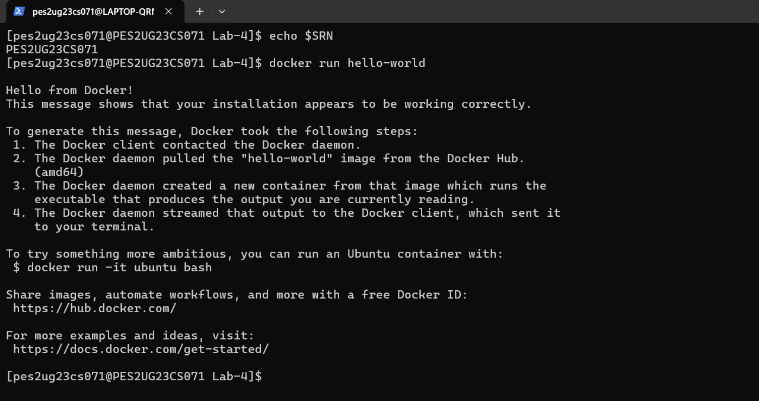
SS-2
SS-3:
SS-4:
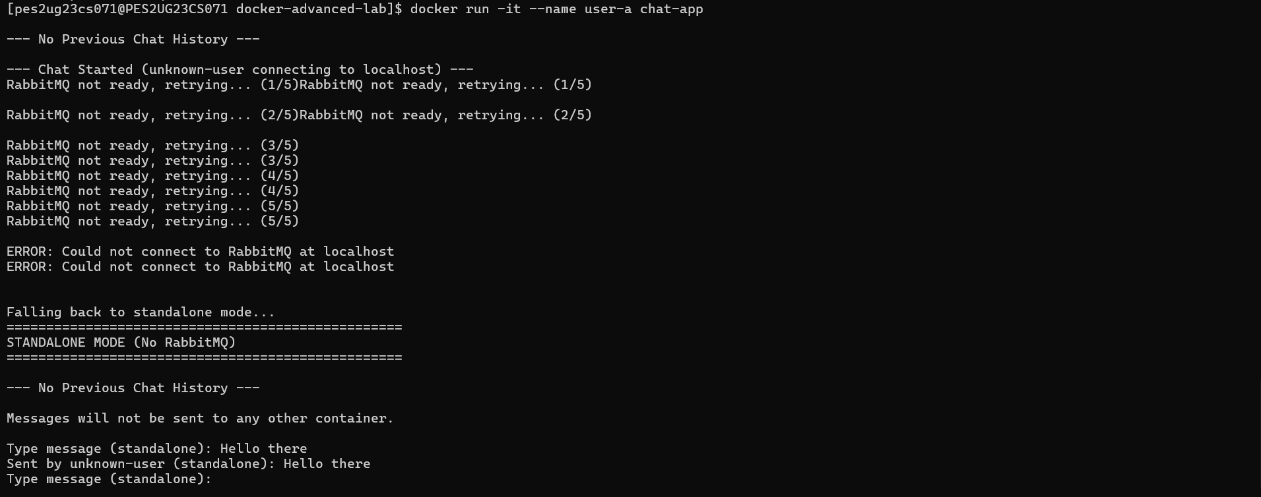
SS-5:
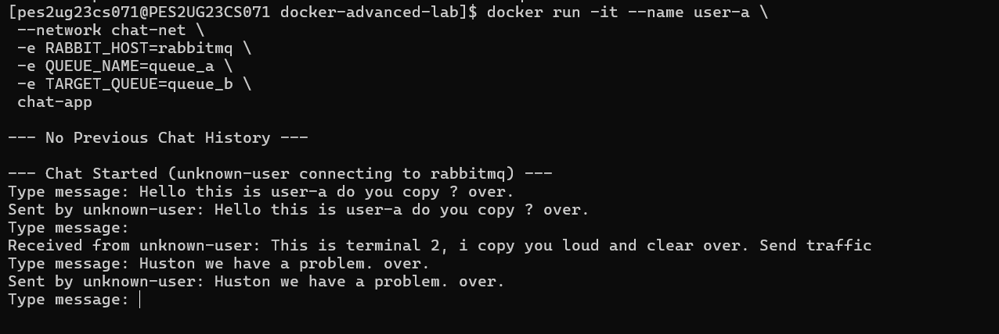
SS-6:
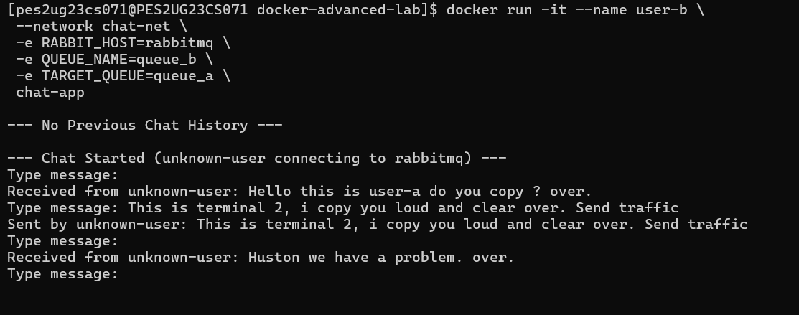

SS-7:
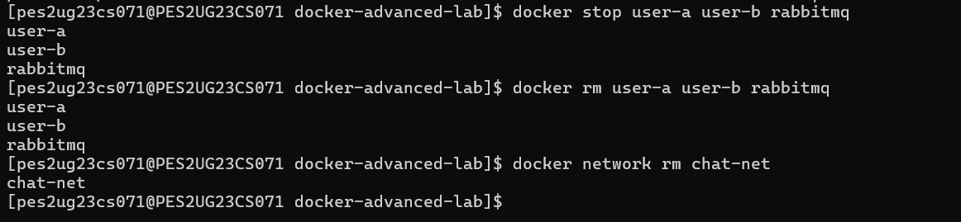
SS-8:
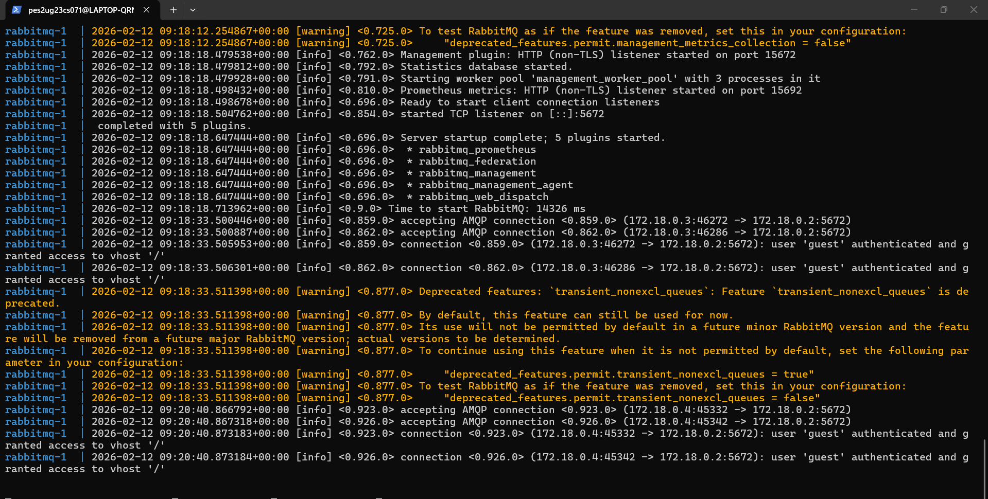
SS-9:
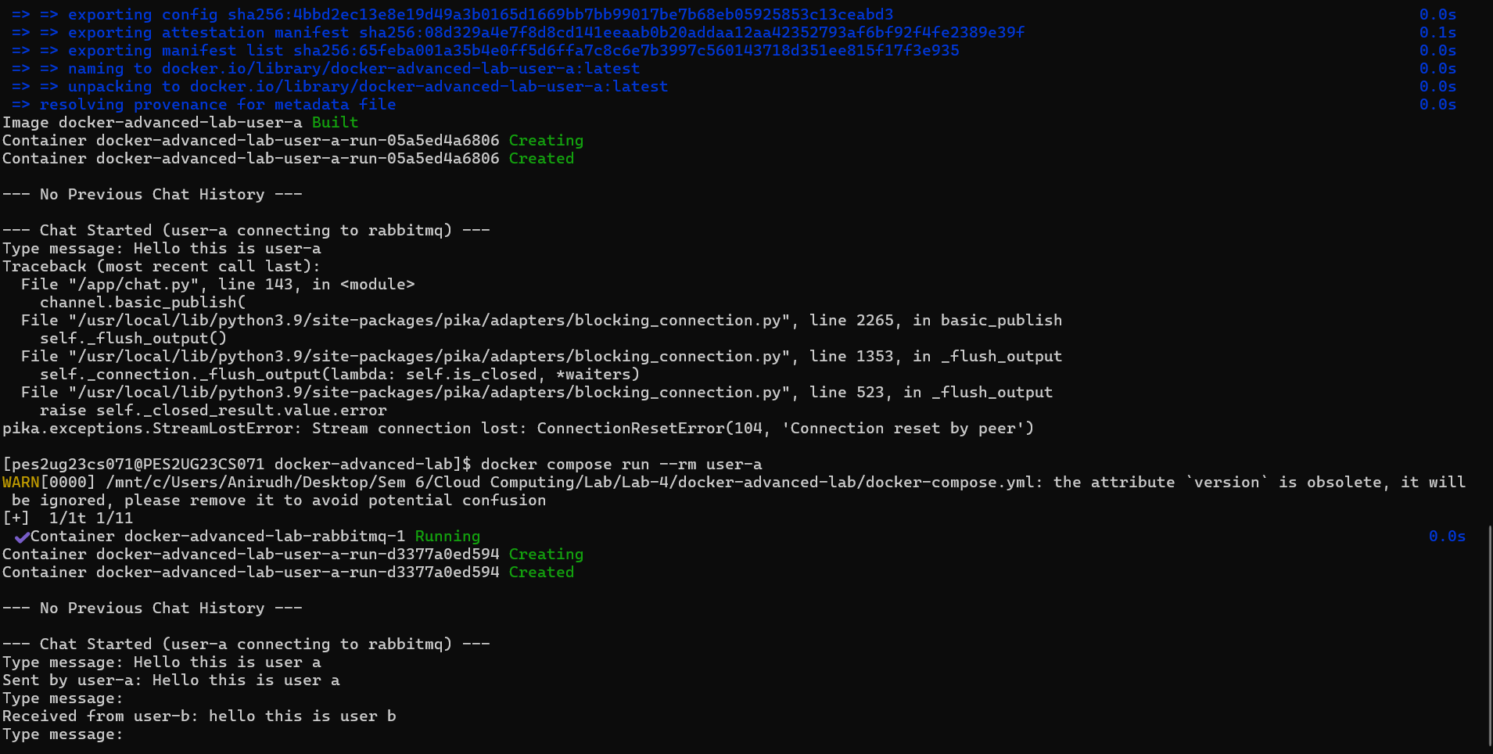
SS-10:
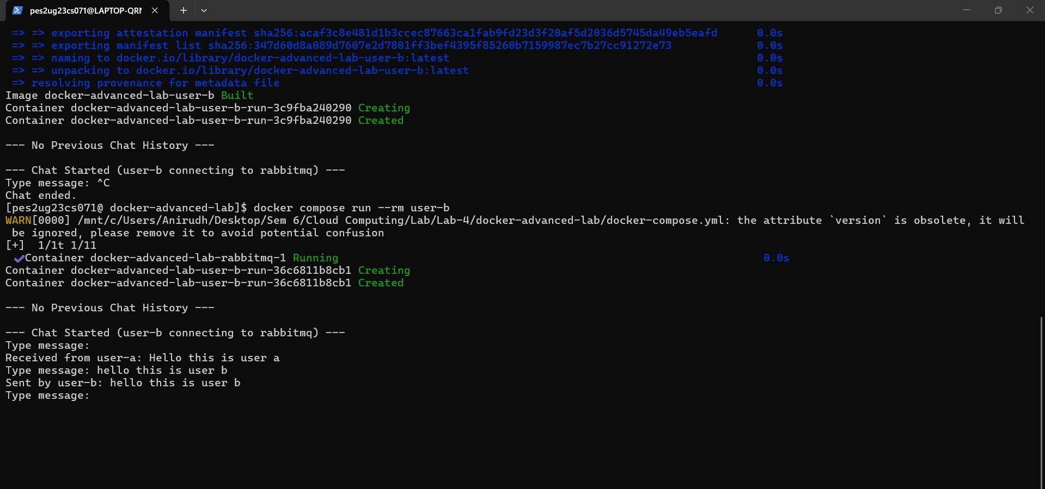
SS-11 USER-A:
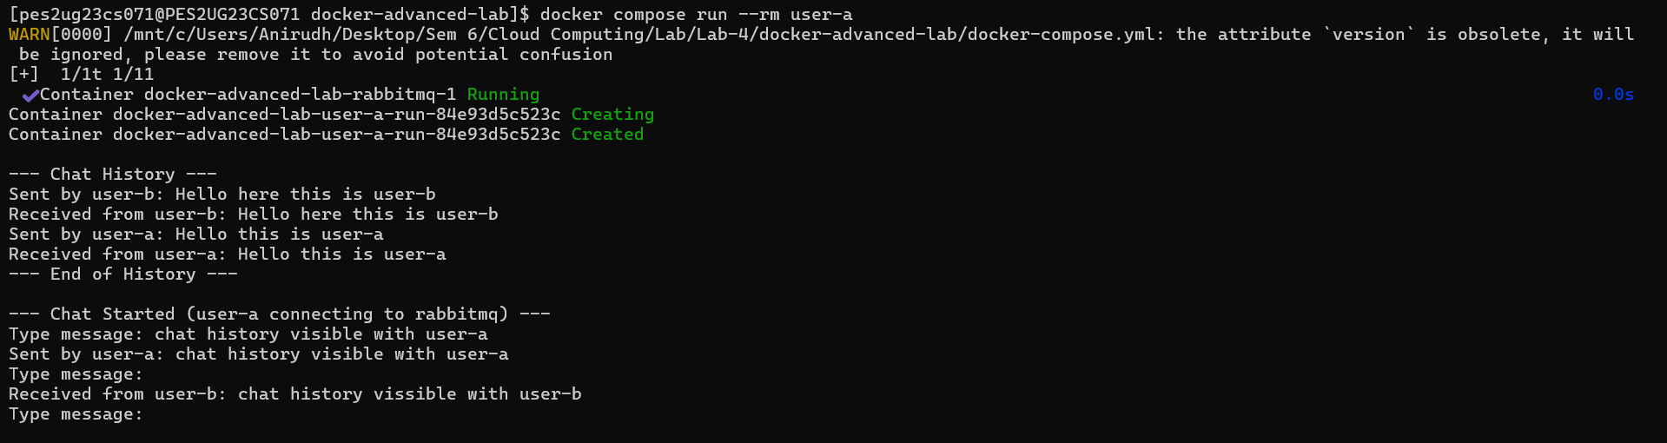
SS-12 USER-B:
