CLOUD COMPUTING
LAB-2
SRN: PES2UG23CS071
NAME: ANIRUDH MURALEEDHARAN’
SS-1:
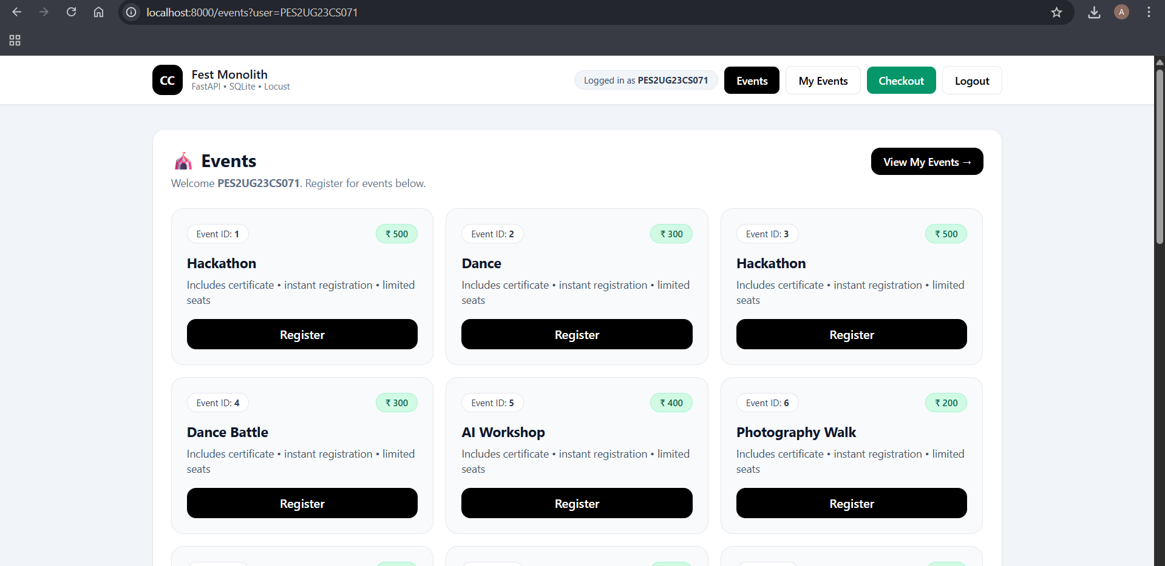
SS-2:
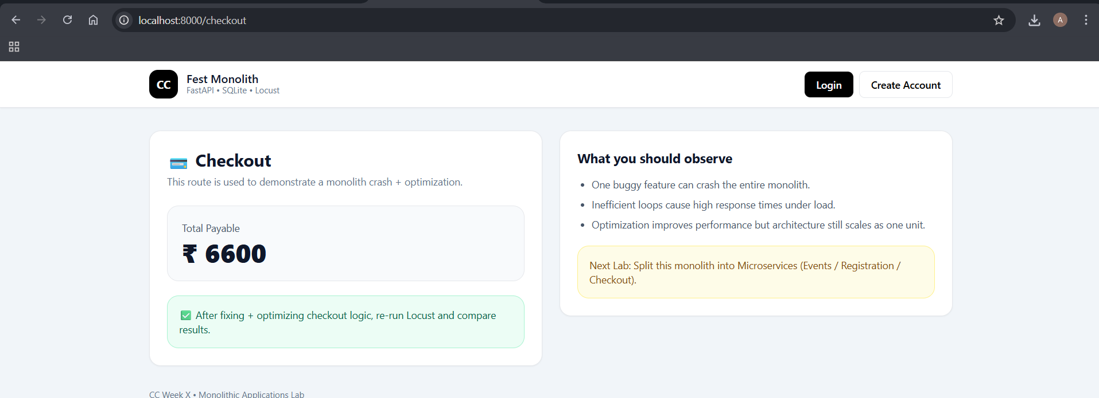

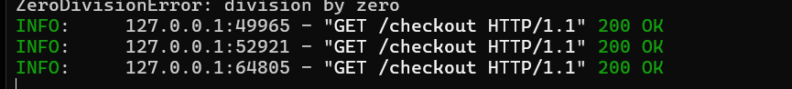

SS-3
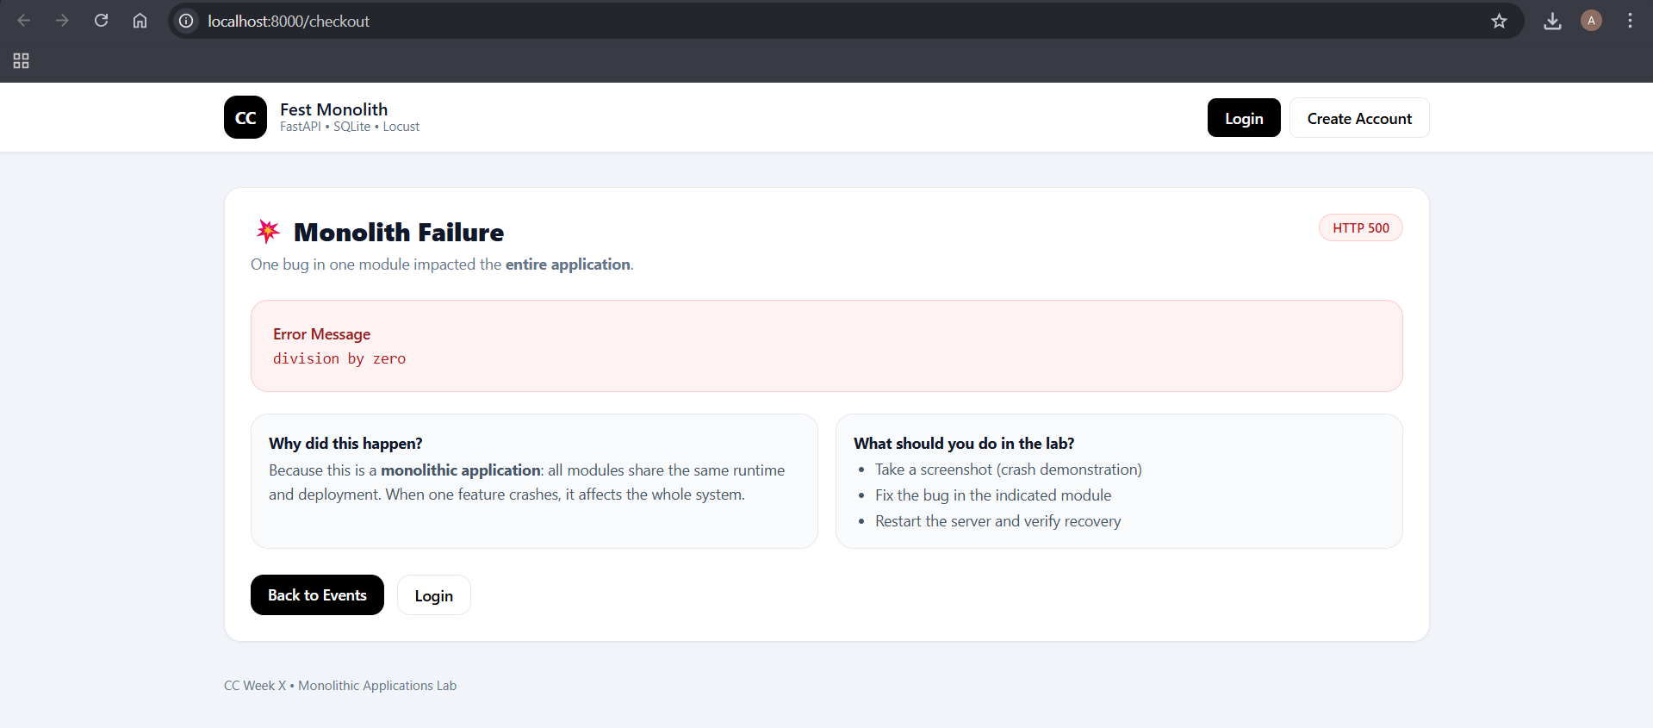
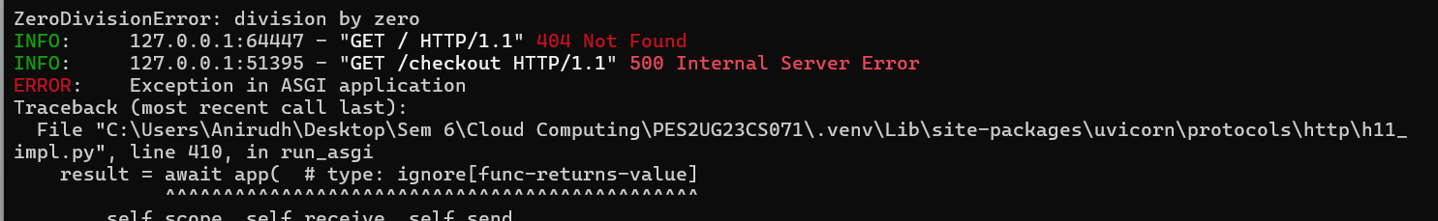
SS-4:
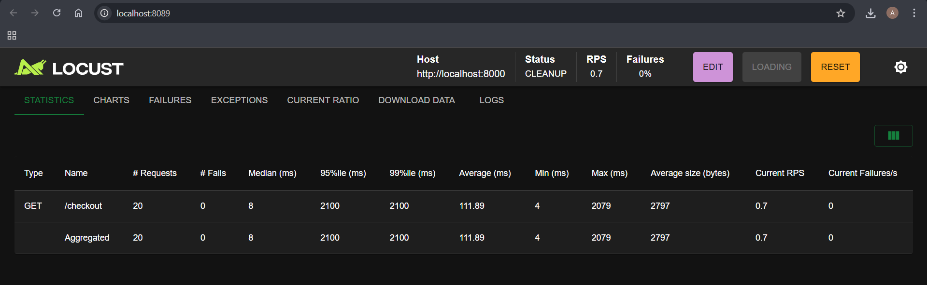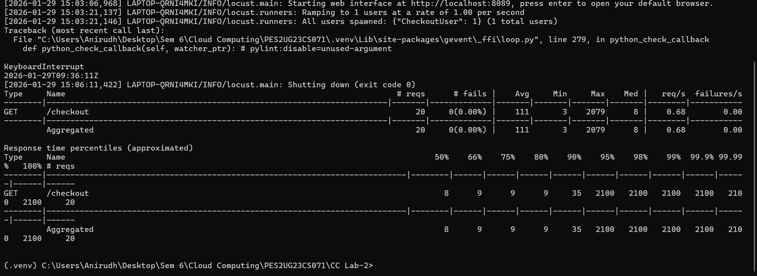

SS-5:
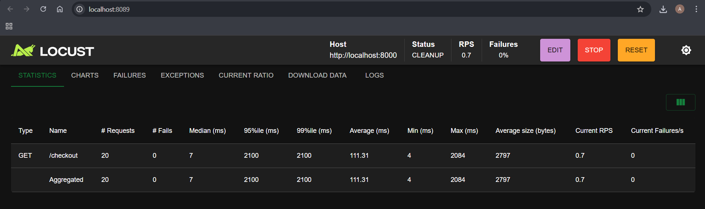
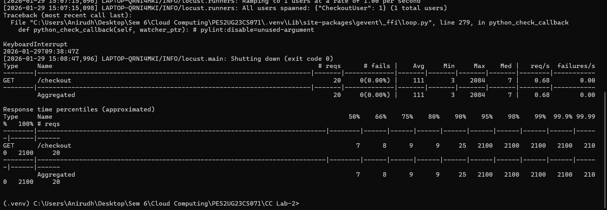
SS-6:
BEFORE:
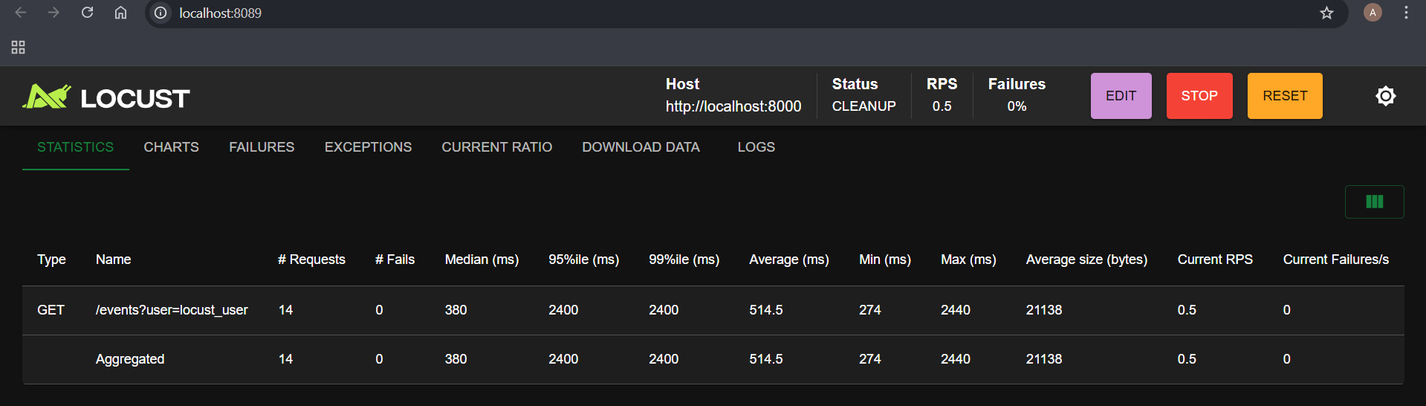
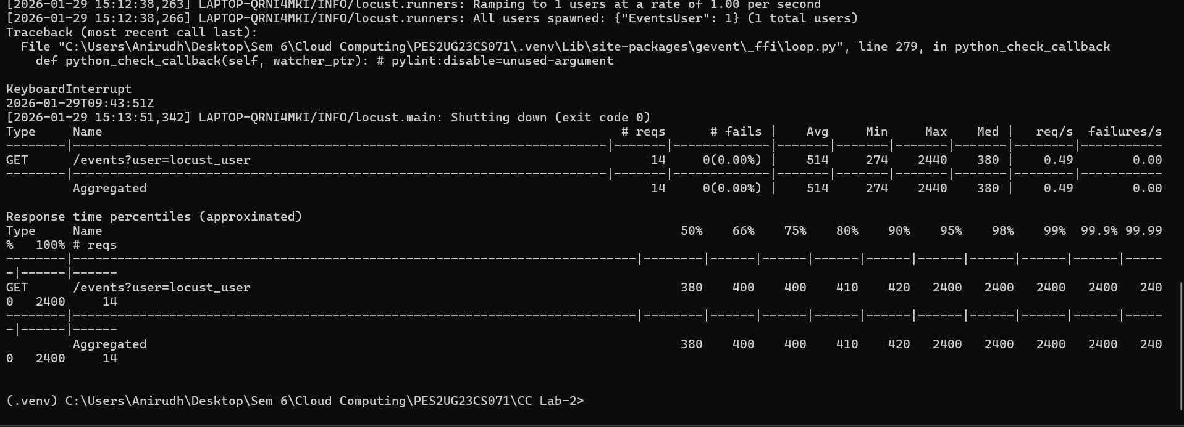
SS-7:
AFTER:
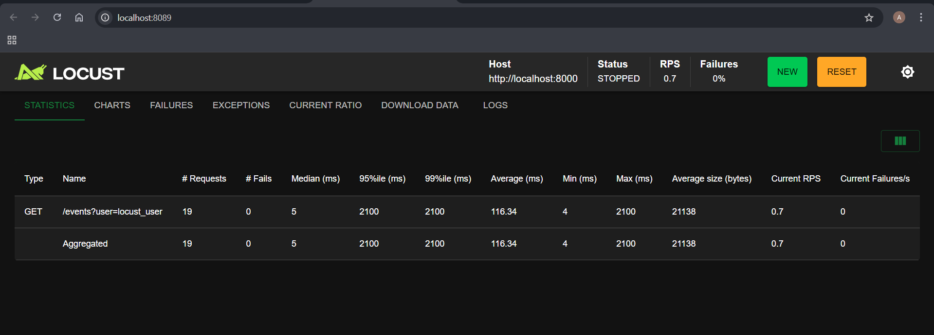
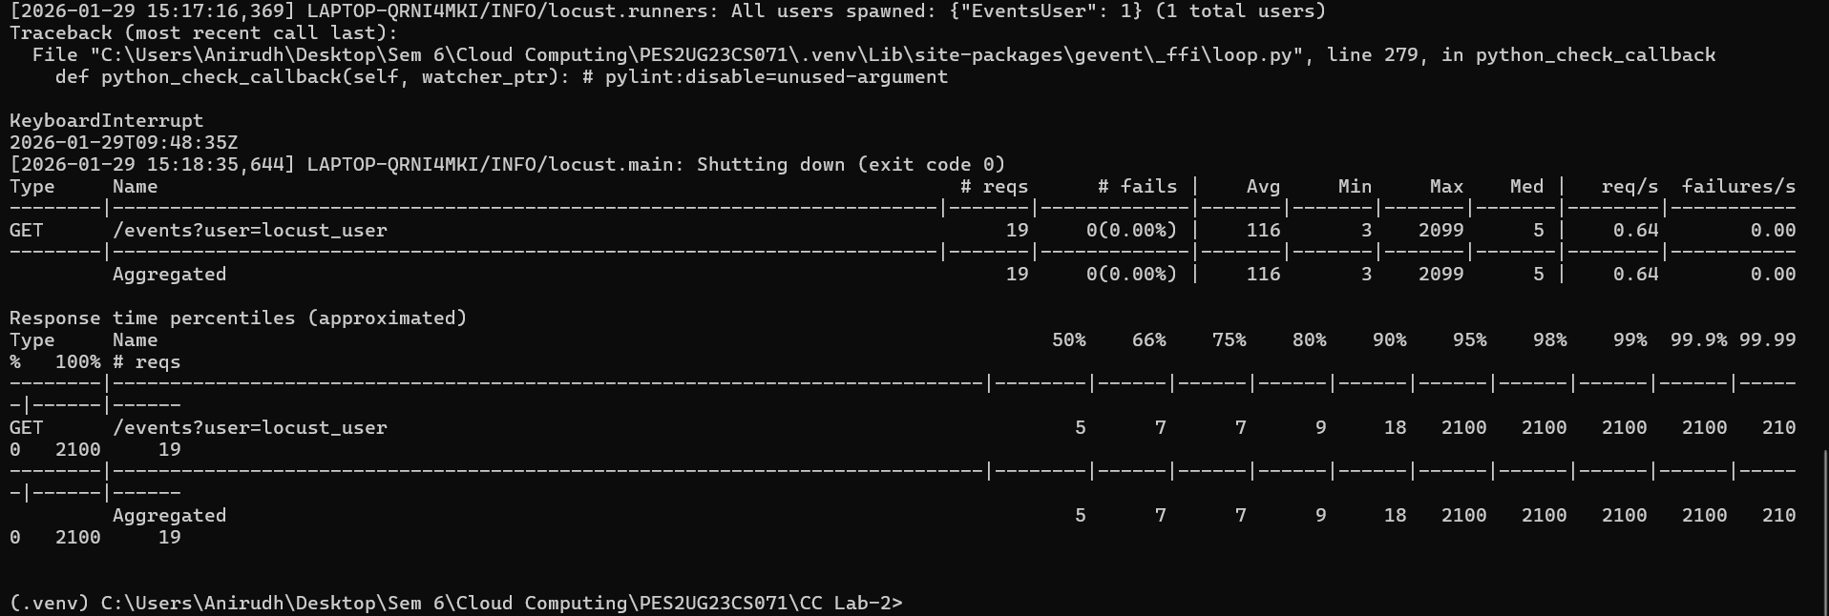
SS-8:
BEFORE: 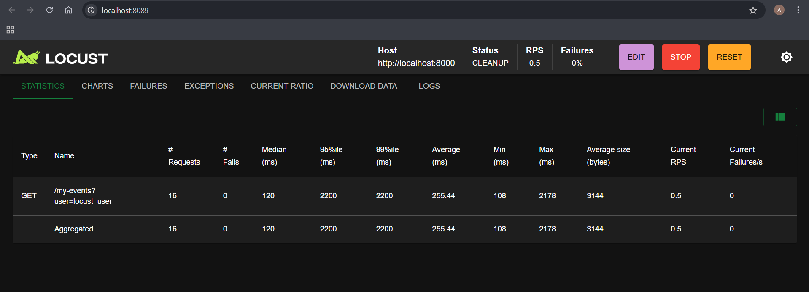
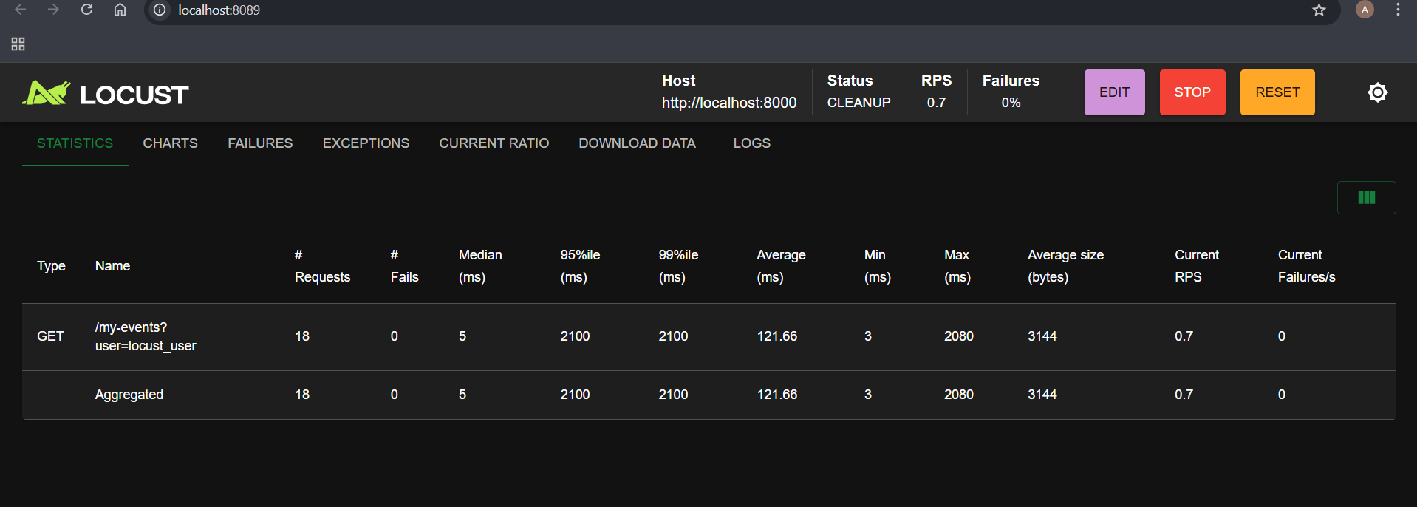
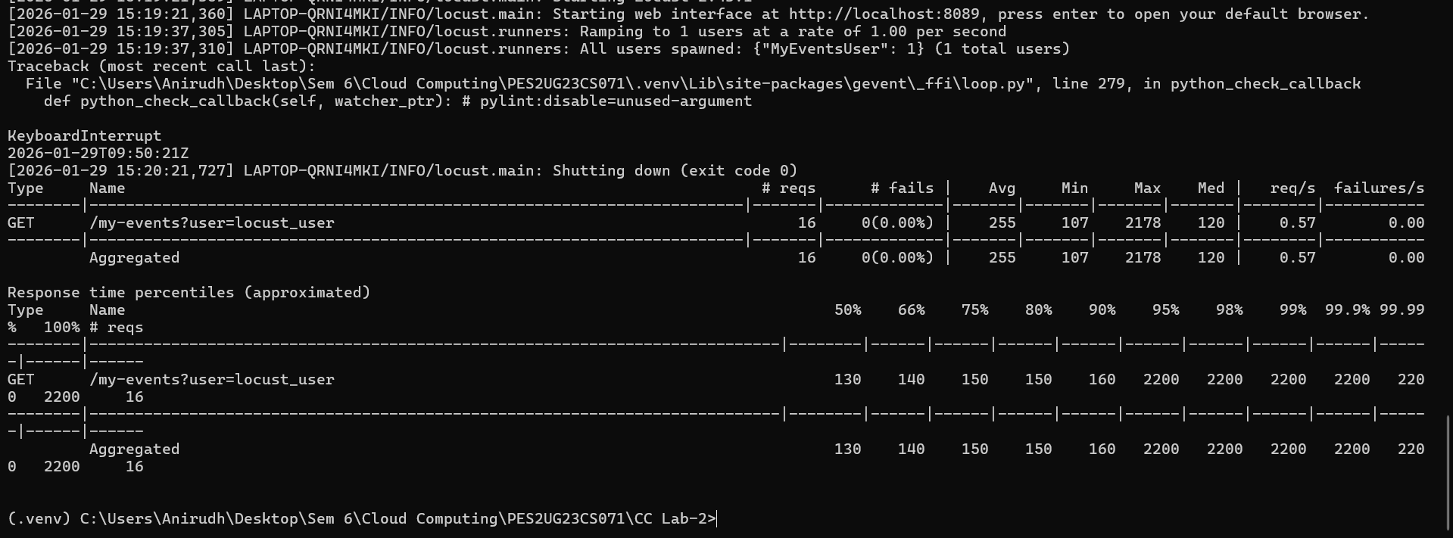
SS-9:
AFTER:
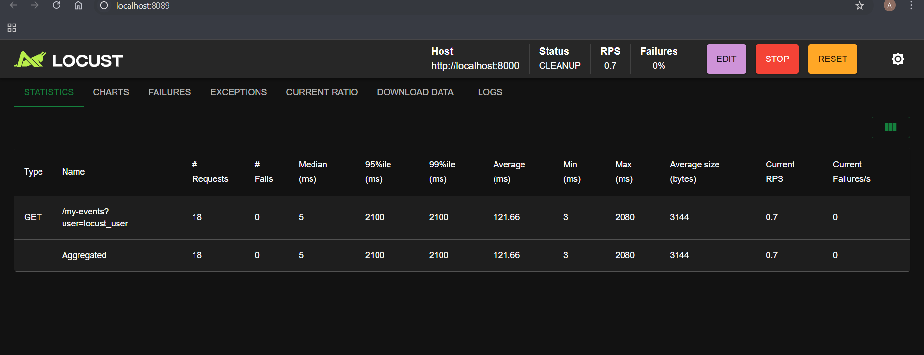
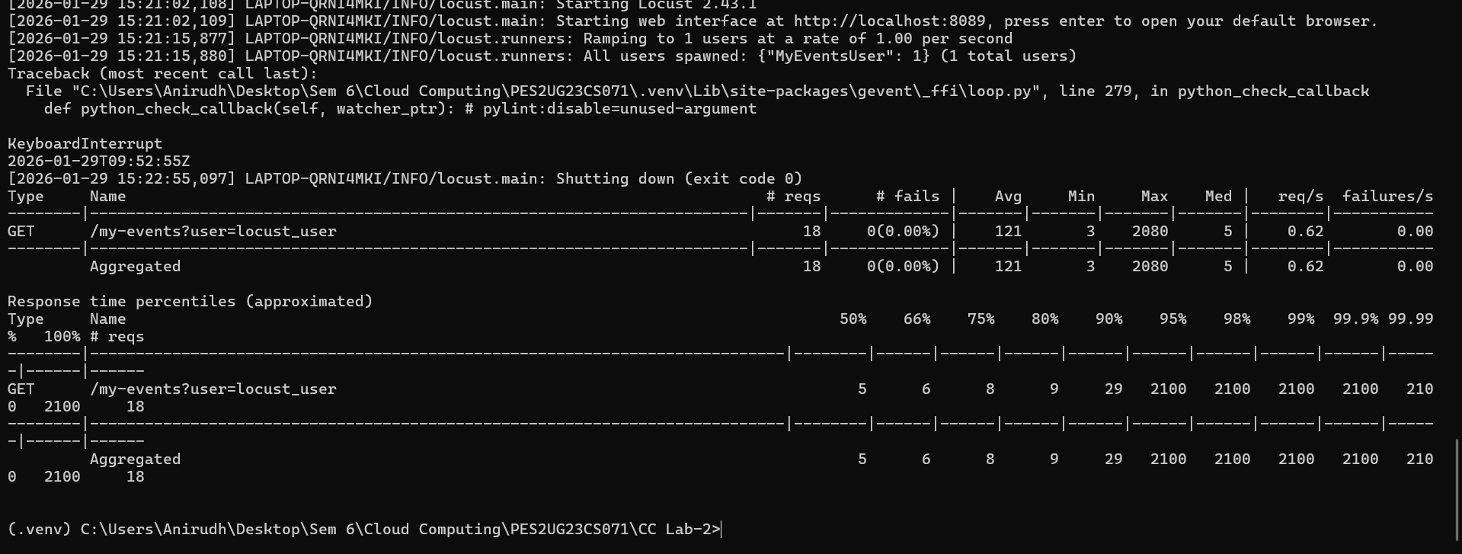

/events Route:
Performance Issue: Each time this route was accessed, the server executed a large loop that served no functional purpose. This caused unnecessary CPU usage and increased the page load time.
Modification: The redundant loop was removed so that the route now only retrieves event information from the database and renders the page.
Performance Benefit: By eliminating the extra processing, the server handles requests more efficiently, resulting in faster responses.

/my-events Route:
Performance Issue: This endpoint contained an artificial loop that iterated millions of times, introducing avoidable delays for every request.
Modification: The loop was removed, leaving only the essential database query and template rendering logic.
Performance Benefit: With unnecessary computations eliminated, the server responds quicker and the endpoint performs noticeably better.

