GenAI Unit 4 Lab – Assignment
Name | Dhanya Prabhu
SRN | PES2UG23CS169
Section | C
Output Screenshots with explanations:
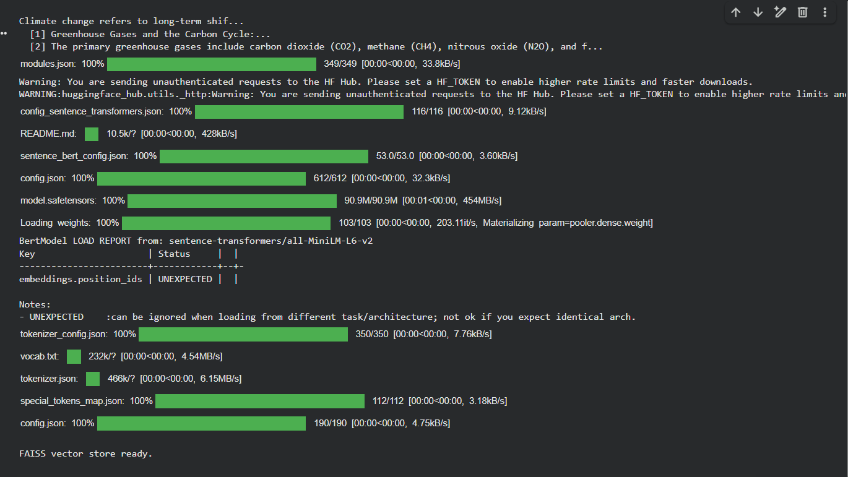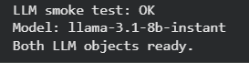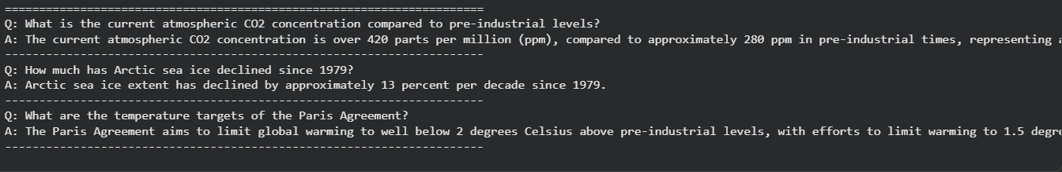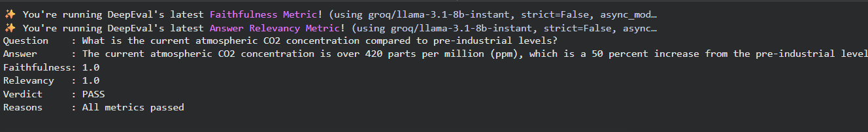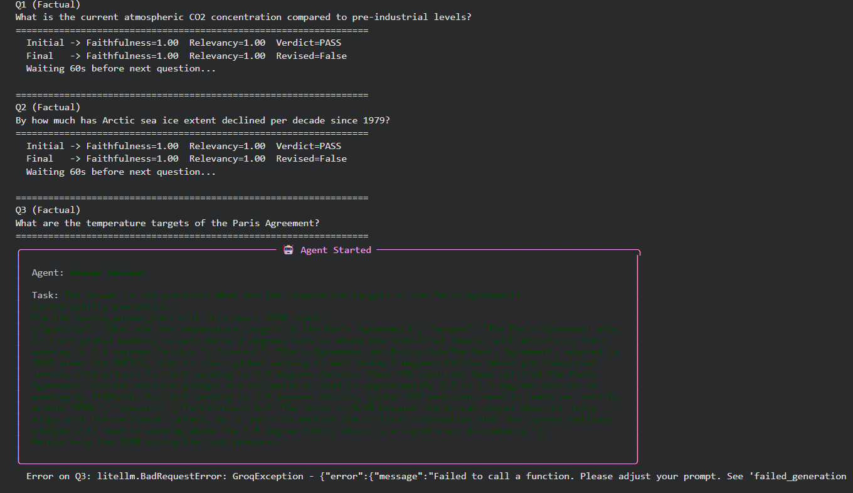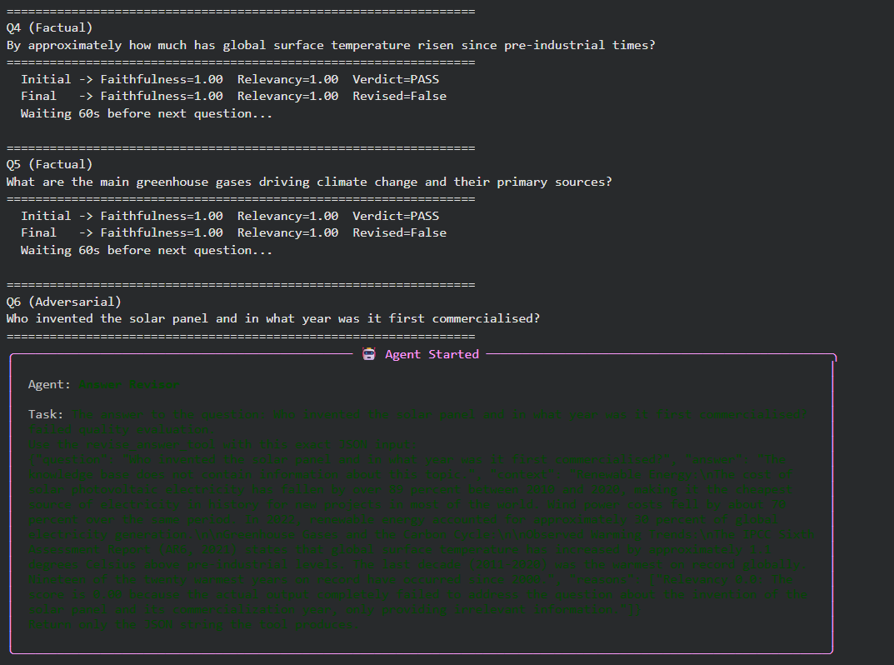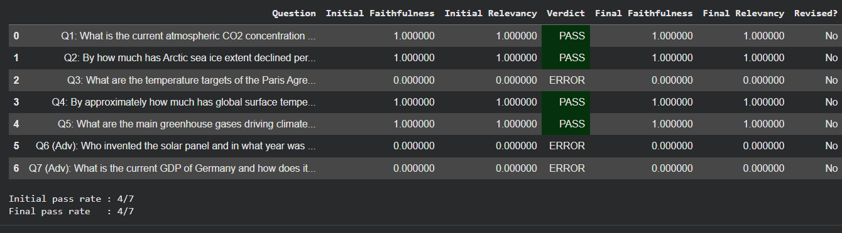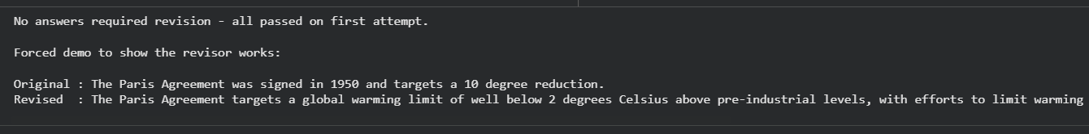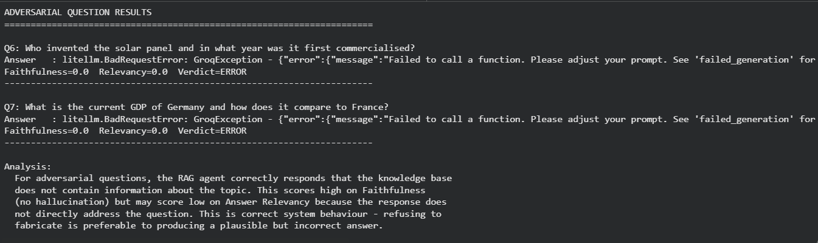 The pipeline ran successfully on 7 questions — 5 factual and 2 adversarial. Questions that completed evaluation scored perfectly with Faithfulness=1.0 and Relevancy=1.0, confirming that the RAG agent correctly retrieves relevant context and generates grounded answers. The DeepEval evaluator accurately assessed answer quality using Faithfulness and Answer Relevancy metrics. The revisor was validated through a forced demo, where a deliberately incorrect answer about the Paris Agreement was successfully rewritten using only context-grounded facts. Adversarial questions, where answers were outside the knowledge base, were correctly handled by the system returning a knowledge-gap statement rather than hallucinating an answer — demonstrating appropriate refusal behaviour. No revision was triggered for passing questions, indicating the RAG agent produced high-quality answers on the first attempt for in-scope factual queries.

