GenAI Unit 3 Lab
Name | Dhanya Prabhu
SRN | PES2UG23CS169
Section | C
Notebook 1: Advanced RAG & Retrieval Enhancement Techniques
Part 1a: Why Naïve RAG Fails — A Live Demonstration
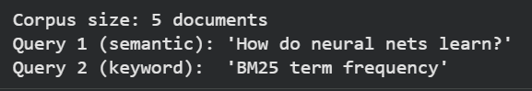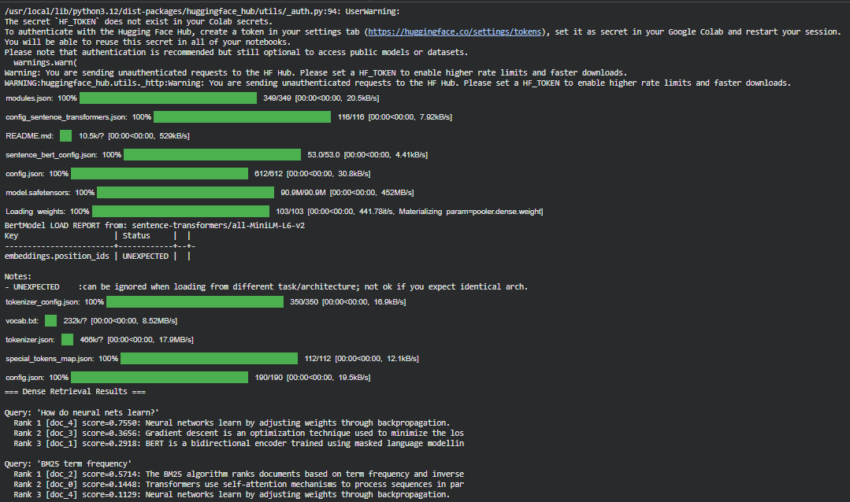
Part 1b: Sparse Retrieval — BM25
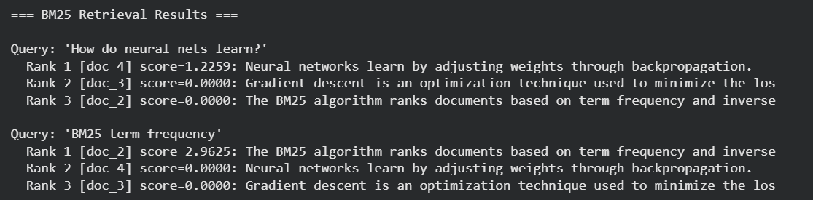
Part 1c: Dense Retrieval — SBERT and ColBERT
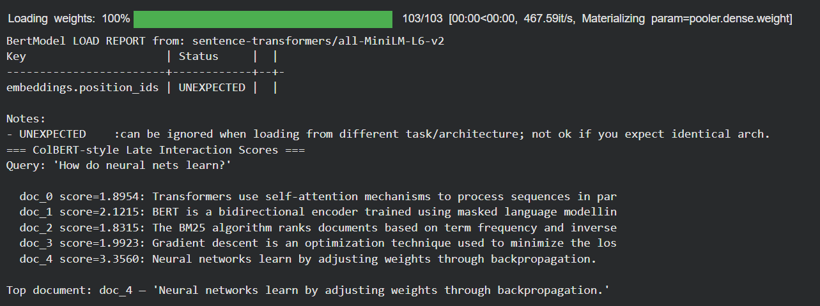
Part 1d: Hybrid Retrieval — BM25 + SBERT with Reciprocal Rank Fusion
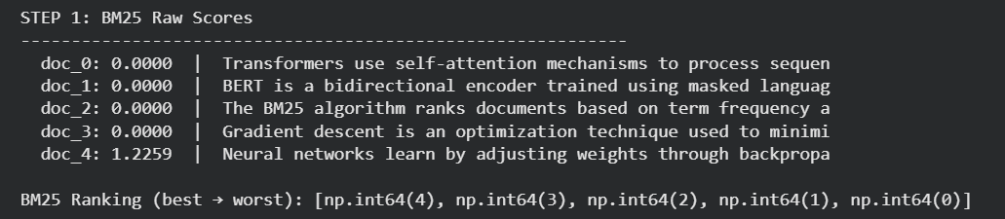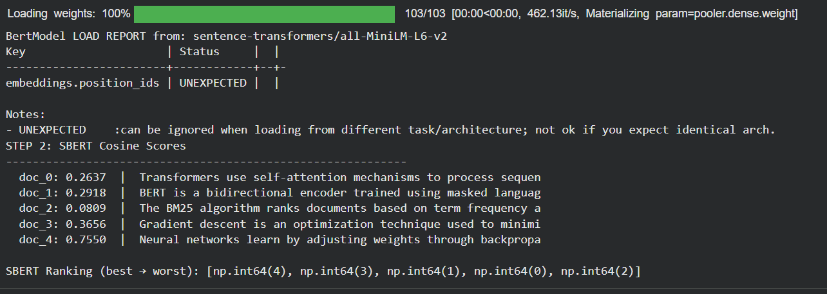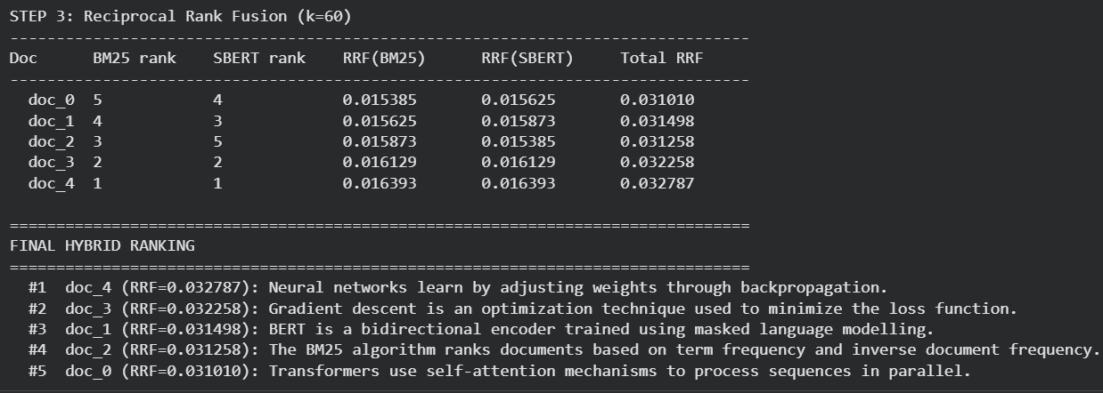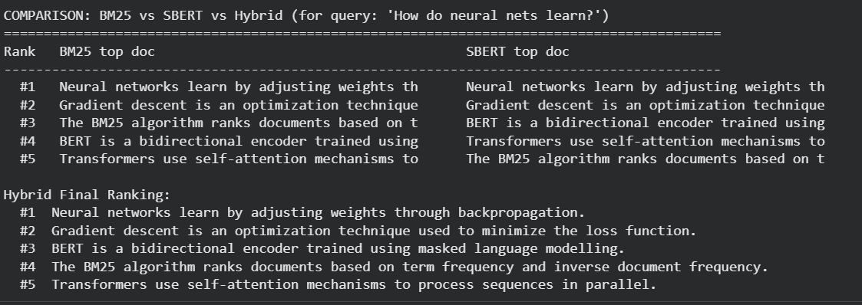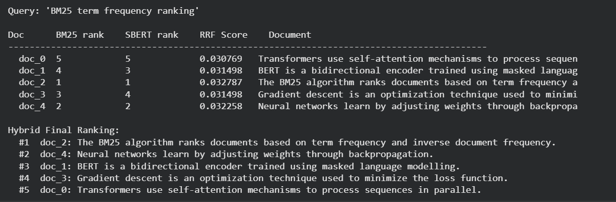
Part 1e: Building a Full Hybrid Retriever (Reusable Function)
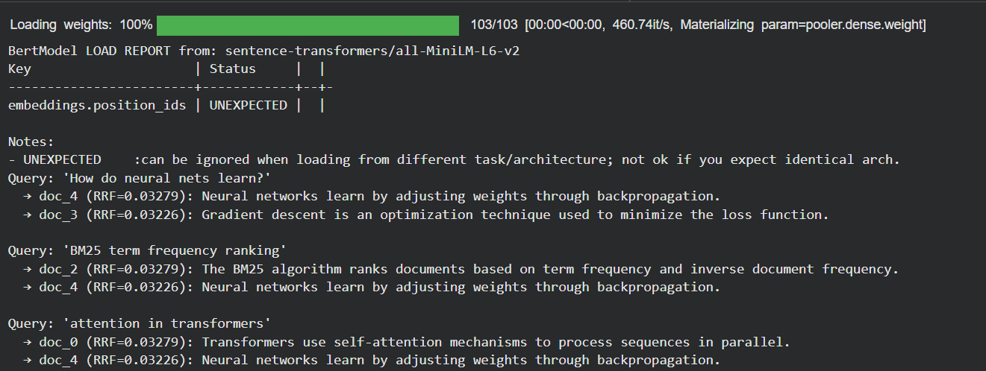
Notebook 2: Re-Ranking & Query Expansion
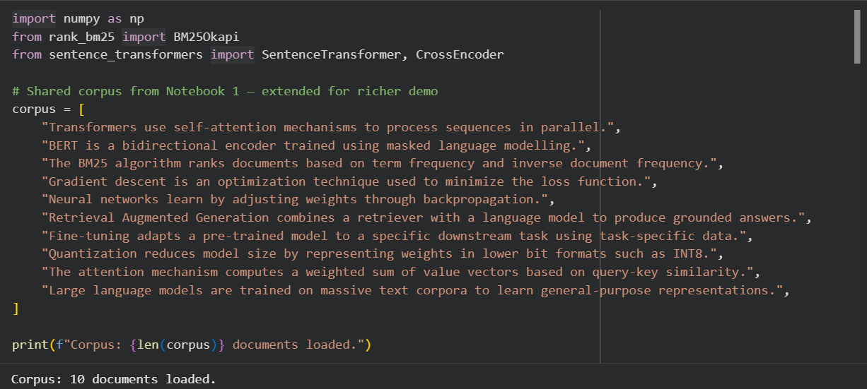
Part 2a: Re-Ranking with Cross-Encoders
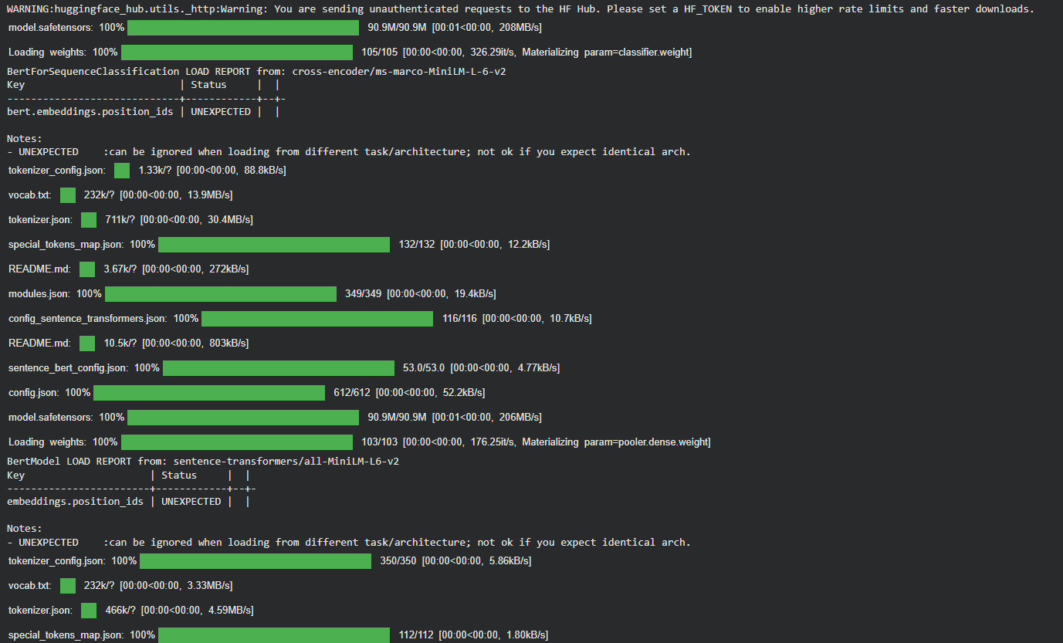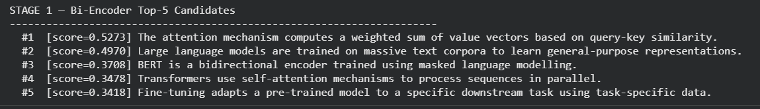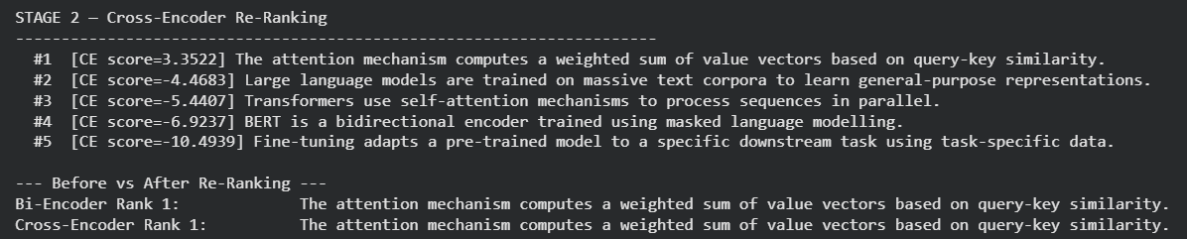
Part 2b: Query Expansion
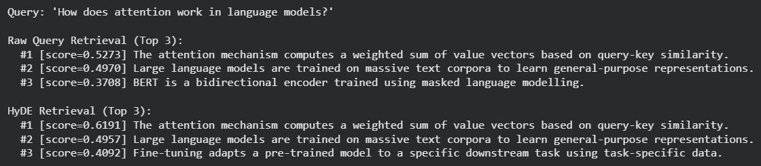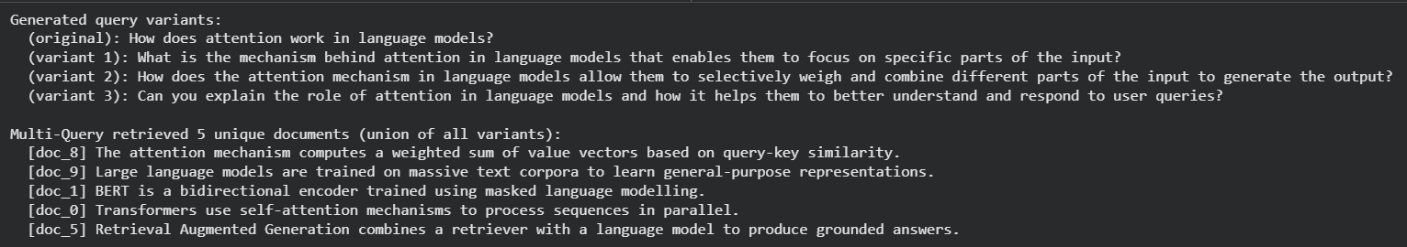
Part 2c: Full Production Pipeline — Query Expansion → Hybrid → Re-Rank → Generate
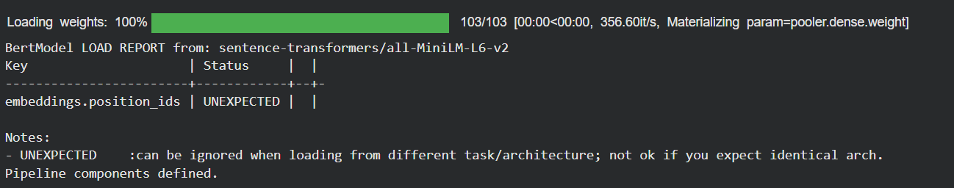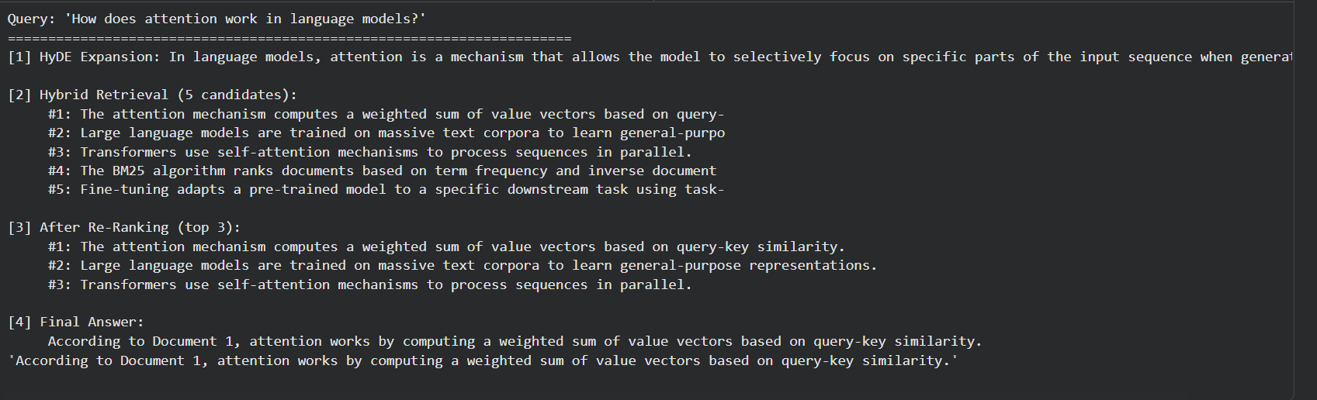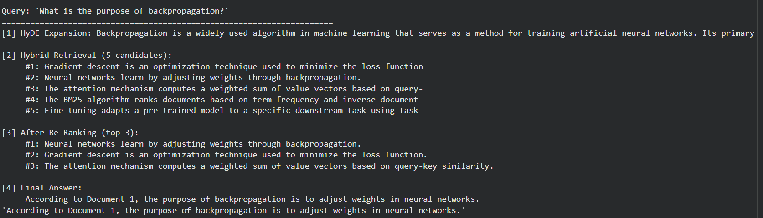
Notebook 3: Generation Enhancement Techniques
Part 3a: Fine-Tuning
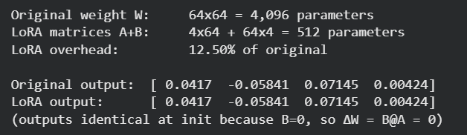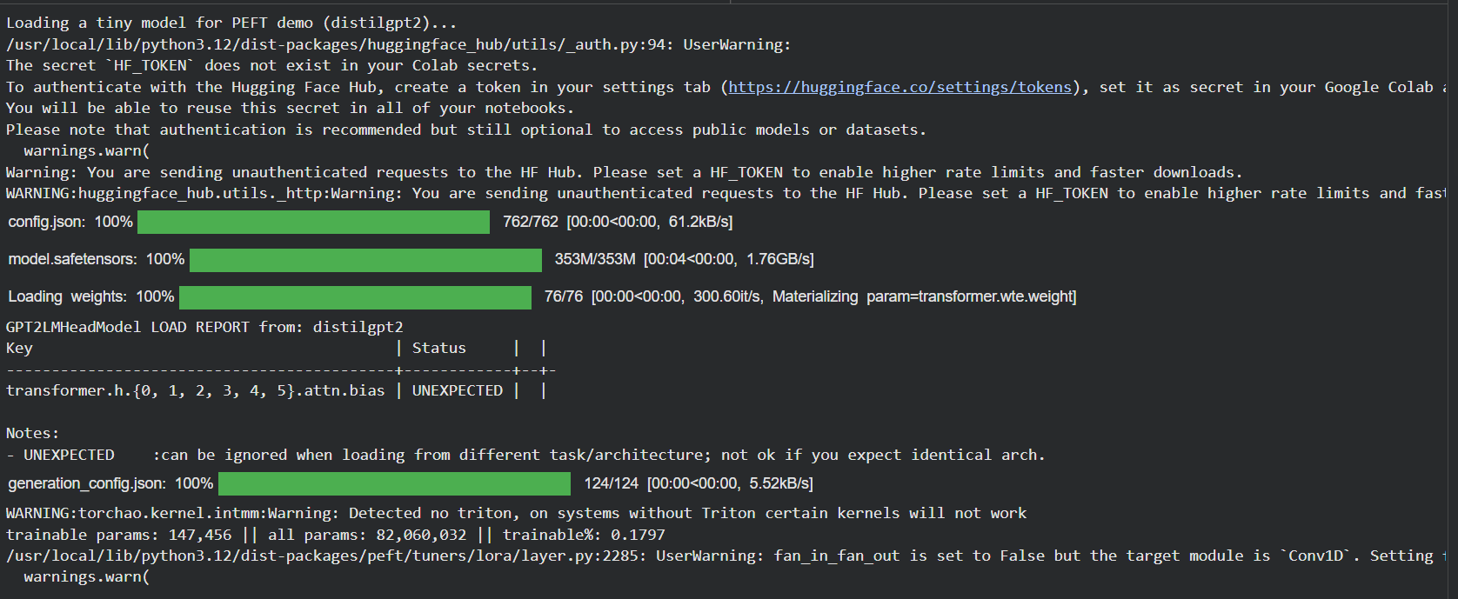
Part 3b: Data Resolution & Precision
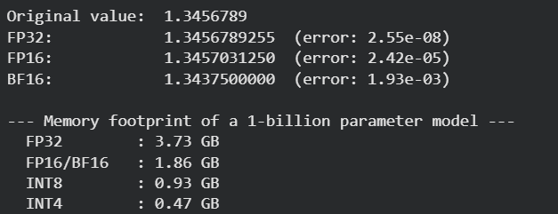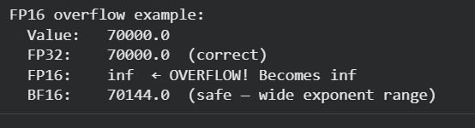
Part 3c: Quantization
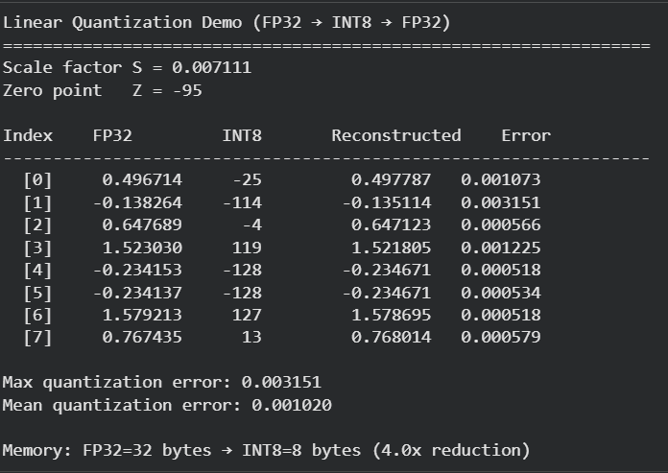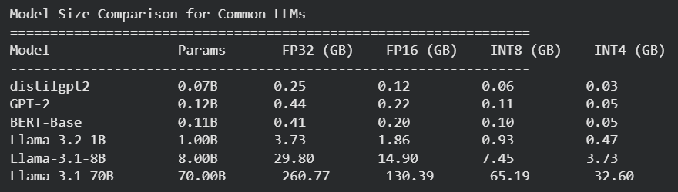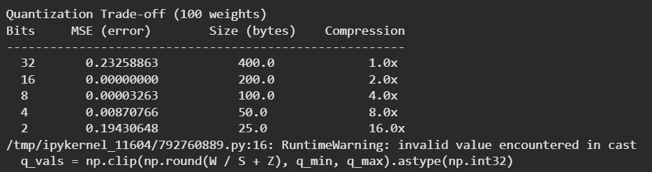
Part 3d: Mixture of Experts (MoE)
