

UE23CS352B - Object Oriented Analysis & Design

Mini Project Report

Simplified Clinical Audit

Submitted by:

Team Members
NAME | SRN
Varun Namboodiri | PES2UG23CS678
Vijay Raghav Reddy | PES2UG23CS688
Nithin NM | PES2UG24CS816
Utsav Shekhar | PES2UG23CS664

6 - K

Prof. Vanitha M
January - May 2026

DEPARTMENT OF COMPUTER SCIENCE AND ENGINEERING
FACULTY OF ENGINEERING

PES UNIVERSITY
(Established under Karnataka Act No. 16 of 2013) 100ft Ring Road, Bengaluru – 560 085, Karnataka, India

Problem Statement: To audit whether treatment plans for patients diagnosed with [specific condition] adhere to recommended clinical guidelines, and to identify discrepancies.
Key Features:
For the storage:-
Used the help of JSONL for maintaining the persistence.
For the Backend part:-
- Strong Input validation layer
- Fail-fast security design
- Controlled retry mechanism
- Usage of a layered architecture
- Heavy usage of the factory design pattern
- Usage of final keyword to make the programming defensive
- Masking of the sensitive data
- Handling of the exceptions
- Usage of a loose coupling
- Validation of the domain inside the entities
- Authentication of the users (only the doctors and admins are authorized to use the same)
- Access is time-bound (with the maximum limit at 15 minutes)
- Can prevent injection-style abuse patterns
- Password hashing using the help of SHA-256
- Basic honeytrapping to decoy the attackers
- Auto-cleaning of expired sessions, thereby eliminating any zombie sessions
- Creation of the reports after every entry of a clinical report
For the User Interface:-
- Used the help of the JavaFX for the front-end part
- Can enter in dosage amounts, patient name, ailment, doctor name, specialization and the medicine used over here
- Usage of a role-based secure access
- Usage of the material design principles
- Event-driven interaction model
- Usage of the scanner bridge, so that there would be a bridge between the UI and our back-end system

Models:
Use Case Diagram:
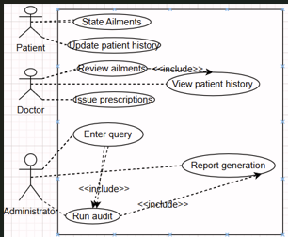
Class Diagram: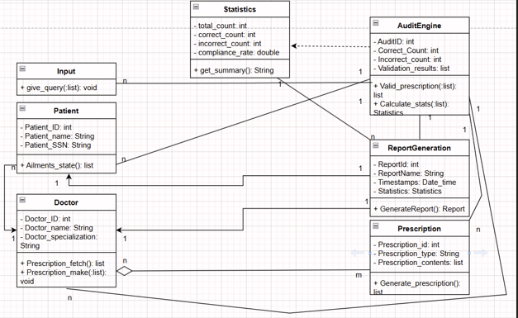

State Diagram: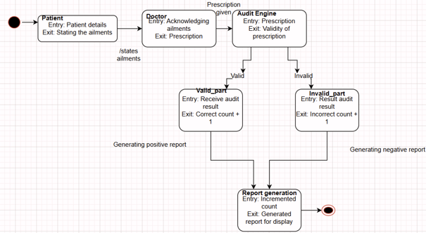
Activity Diagram: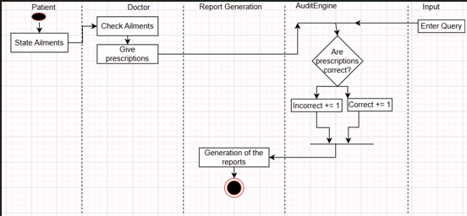

Design Principles, and Design Patterns:

MVC Architecture used? Yes (this is for the front-end)

Design Principles

SOLID Design Principles:-

Single Responsibility Principle

Dependency Inversion Principle

Liskov Substitution Principle

Open Closed Principle

Interface Substitution Principle

GRASP Design Principles

Design Patterns

Creational Design Pattern:-

Dependency Injection

Mimicry of the Facade behavior

Implementation of the MVC for the front-end

Event Driven architecture for the front-end UI

Partial implementation of the MVC for the back-end

Factory Design Pattern

Github link to the Codebase: (repository should be public)
https://github.com/pes2ug23cs678-gif/ClinicalAuditCode

Screenshots

UI:

Individual contributions of the team members:

Name | Module worked on
Varun Namboodiri | Backend module
Vijay Raghav Reddy | Backend module
Nithin NM | Frontend module
Utsav Shekhar | Frontend module

