PES2UG23CS678_Varun

Screenshot 1:-
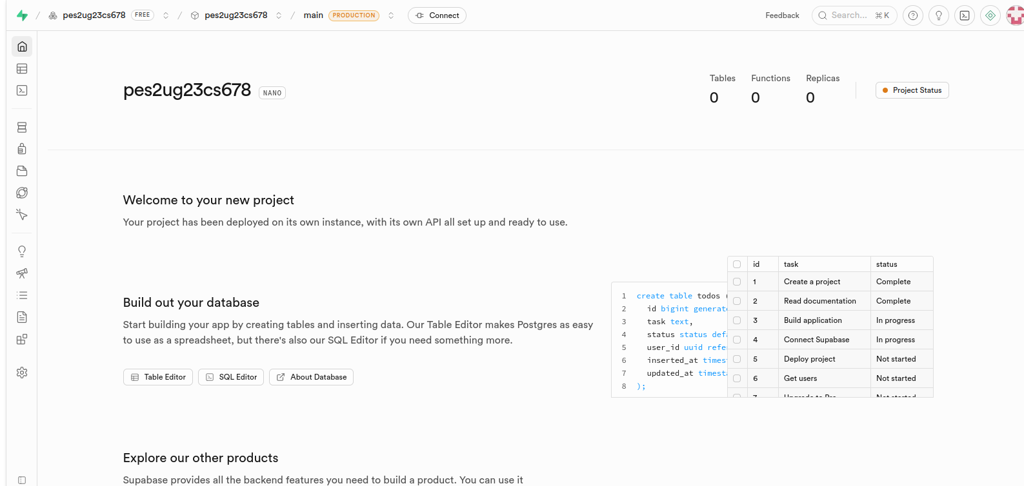
Screenshot 2:-
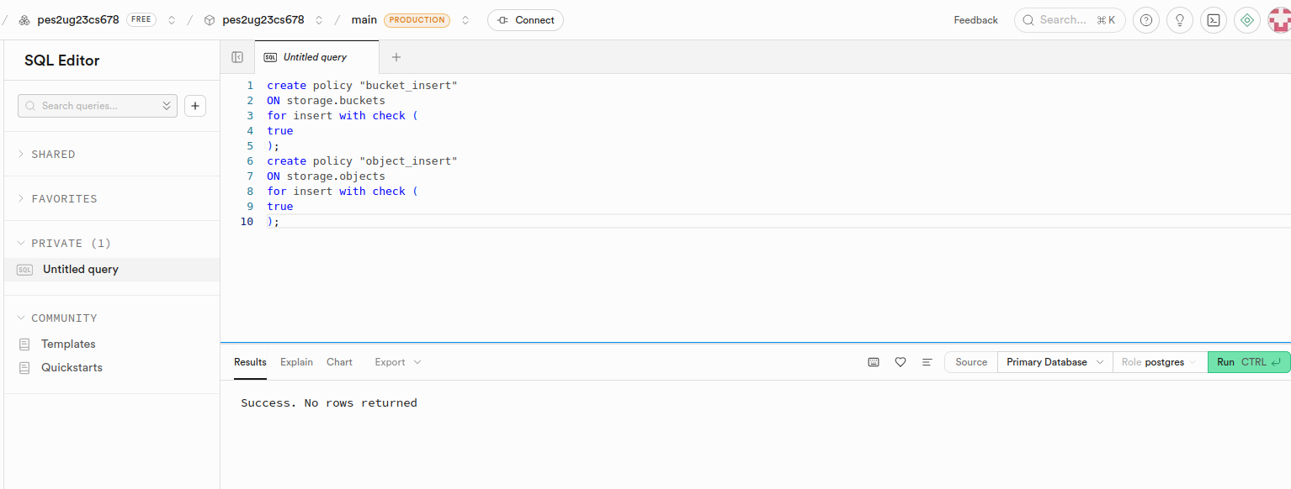
Screenshot 3:-
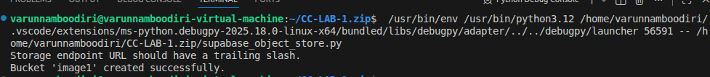
Screenshot 4:-
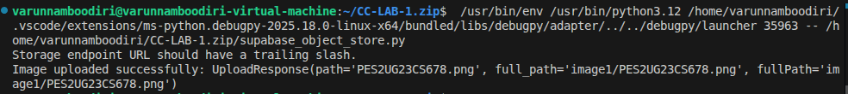
URL Number 1:-
https://xsikuzpkrkvdewscqhhy.supabase.co/storage/v1/object/public/image1/PES2UG23CS678.png

Screenshot 5:-
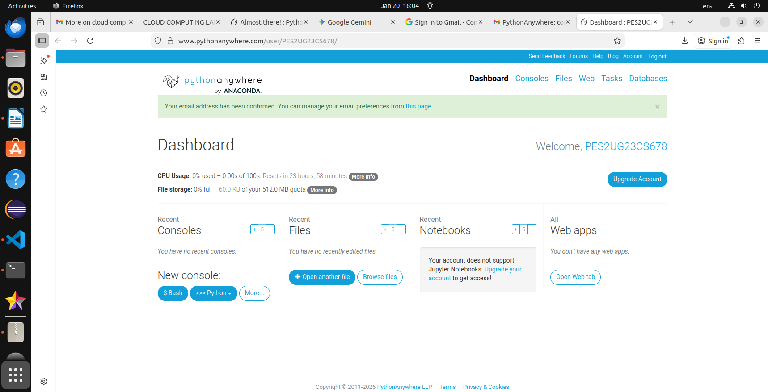
Screenshot 6:-
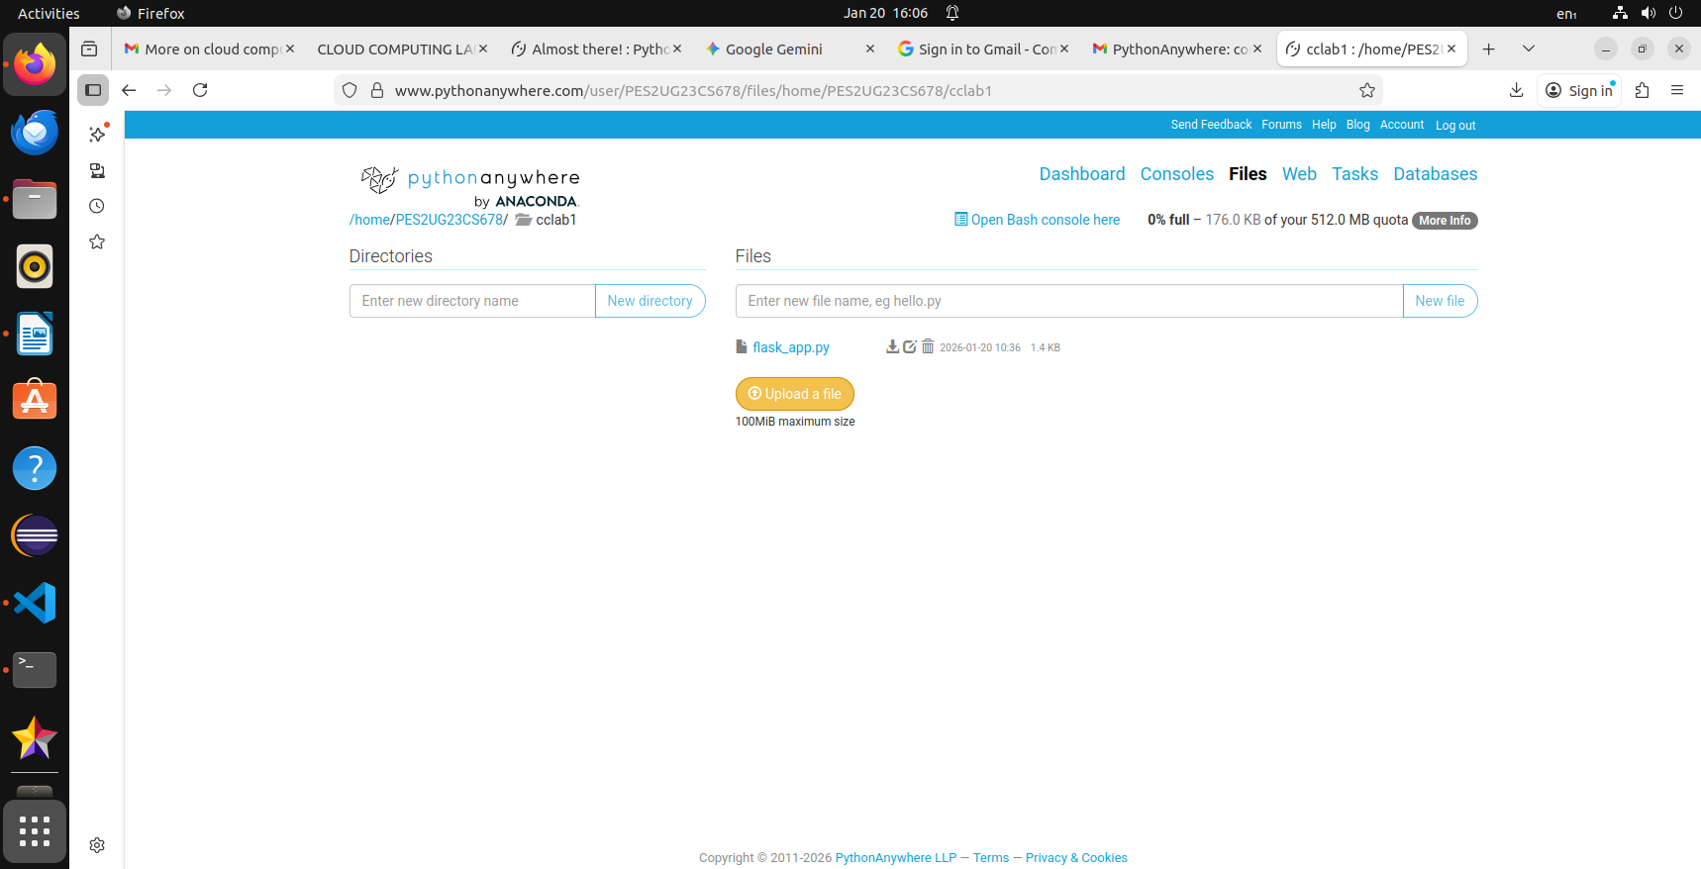
Screenshot 7:-
Screenshot 8:-
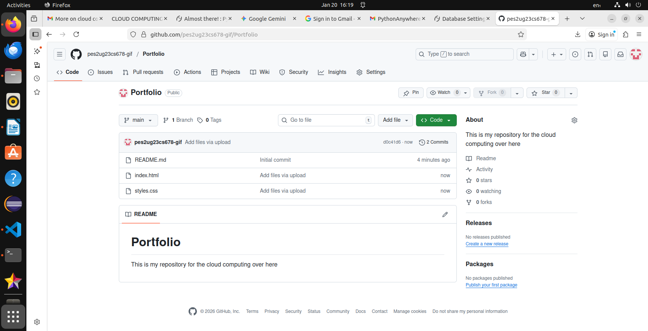
Screenshot 9:-
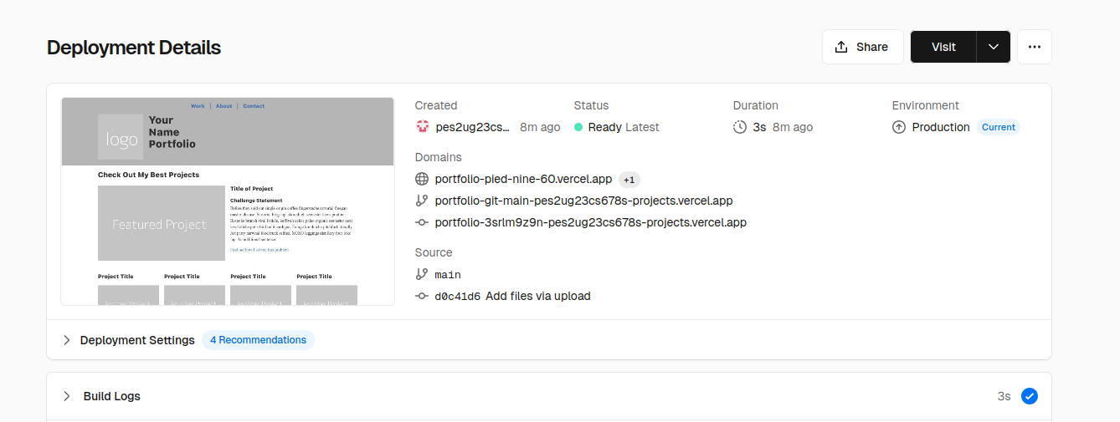
URL Link to the vercel application:- https://portfolio-pied-nine-60.vercel.app

