WD-Activity-Based-Learning
CASE STUDIES:
- Online Food Ordering Website
- Healthy Food and Nutrition Website
- Tourism and Heritage Information Website
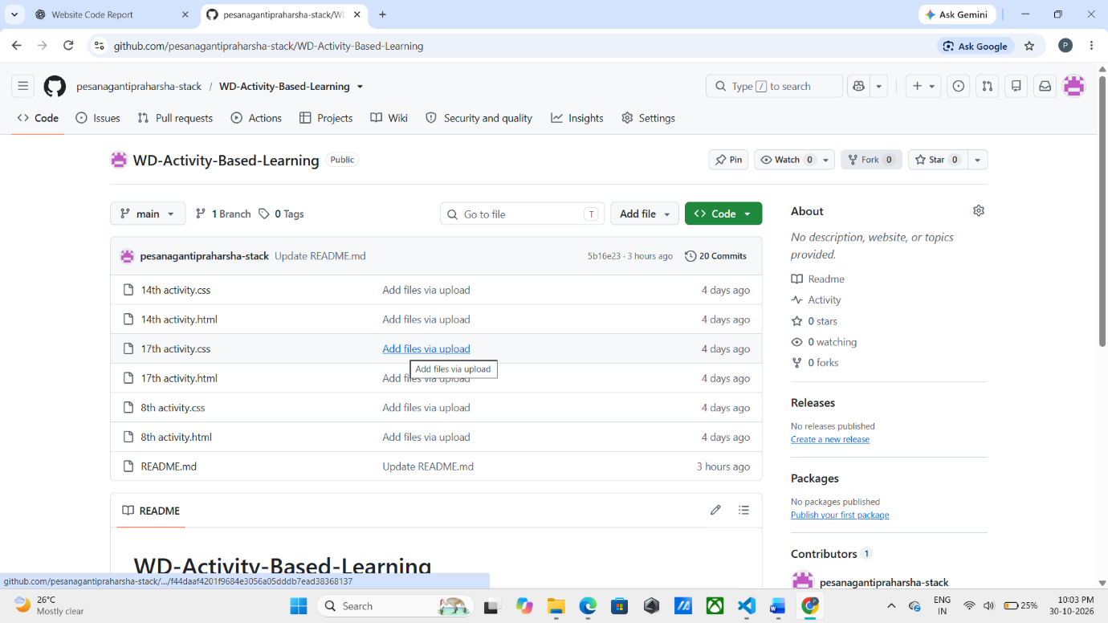
Case Study-1
Activity 8: Online Food Ordering Website
Project Title: Foodie – Online Food Ordering Website
1. Introduction
The Foodie Online Food Ordering Website is a simple and responsive website developed using HTML and CSS. It allows customers to explore different food items, view prices, check special offers, and read customer reviews.
The website provides an attractive interface with food images, menu categories, restaurant ratings, and order buttons. The main objective of this project is to create a user-friendly food ordering interface using basic web development technologies.
2. Explanation
The Foodie website uses HTML to structure the webpage and CSS to improve its appearance and responsiveness.
The website contains the following sections:
- Header: Displays the Foodie logo and navigation links such as Home, Menu, Reviews, and Offers.
- Hero Section: Contains a background image, restaurant rating, delivery information, and an Order Now button.
- Special Offers: Displays a 30% discount offer for first-time customers.
- Food Menu: Displays food items such as Cheese Pizza, Veg Burger, Italian Pasta, and Fresh Drink with images and prices.
- Order Buttons: Uses simple JavaScript alerts to display confirmation messages when clicked.
- Customer Reviews: Shows customer feedback and star ratings.
- Footer: Contains restaurant copyright and contact information.
CSS properties such as Flexbox, background images, border-radius, box-shadow, and media queries are used to create an attractive and mobile-friendly layout.
3. HTML Code
File Name: index.html

<!DOCTYPE html>
<html>
<head>
<title>Foodie - Online Food Ordering</title>
<meta name="viewport" content="width=device-width, initial-scale=1">
<link rel="stylesheet" href="8th activity.css">
</head>
<body>

<header>
<h2>🍔 Foodie</h2>
<nav>
<a href="#">Home</a>
<a href="#menu">Menu</a>
<a href="#reviews">Reviews</a>
<a href="#offers">Offers</a>
</nav>
</header>

<section class="hero">
<h1>Delicious Food Delivered!</h1>
<p>Fresh food from Foodie Restaurant ⭐ 4.8</p>
<p>Fast Delivery | Best Quality | Great Taste</p>
<a href="#menu" class="btn">Order Now</a>
</section>

<section id="offers" class="offer">
🎉 Special Offer: Get 30% OFF on your first order!
</section>

<section id="menu">
<h2>Our Menu</h2>
<p>Categories: 🍕 Pizza | 🍔 Burger | 🍝 Pasta | 🥤 Drinks</p>

<div class="container">

<div class="card">
<img src="https://images.unsplash.com/photo-1513104890138-7c749659a591?w=500" alt="Pizza">
<h3>Cheese Pizza</h3>
<p>₹249</p>
<button onclick="alert('Pizza added to order!')">Order Now</button>
</div>

<div class="card">
<img src="https://images.unsplash.com/photo-1568901346375-23c9450c58cd?w=500" alt="Burger">
<h3>Veg Burger</h3>
<p>₹149</p>
<button onclick="alert('Burger added to order!')">Order Now</button>
</div>

<div class="card">
<img src="https://images.unsplash.com/photo-1473093295043-cdd812d0e601?w=500" alt="Pasta">
<h3>Italian Pasta</h3>
<p>₹199</p>
<button onclick="alert('Pasta added to order!')">Order Now</button>
</div>

<div class="card">
<img src="https://images.unsplash.com/photo-1544145945-f90425340c7e?w=500" alt="Drink">
<h3>Fresh Drink</h3>
<p>₹99</p>
<button onclick="alert('Drink added to order!')">Order Now</button>
</div>

</div>
</section>

<section id="reviews">
<h2>Customer Reviews</h2>
<p>⭐⭐⭐⭐⭐ "Amazing food and quick delivery!" - Rahul</p>
<p>⭐⭐⭐⭐⭐ "Best pizza in town!" - Priya</p>
</section>

<footer>
<p>© 2026 Foodie Restaurant | Contact: foodie@example.com</p>
</footer>

</body>
</html>
4. CSS Code
File Name: 8th activity.css

* {
margin: 0;
padding: 0;
box-sizing: border-box;
}

body {
font-family: Arial, sans-serif;
background: #fff8f0;
text-align: center;
}

header {
background: #ff5722;
color: white;
padding: 18px;
display: flex;
justify-content: space-between;
align-items: center;
}

nav a {
color: white;
text-decoration: none;
margin: 10px;
}

.hero {
padding: 90px 15px;
color: white;
background: linear-gradient(#0008,#0008),
url('https://images.unsplash.com/photo-1504674900247-0877df9cc836?w=1400') center/cover;
}

.hero h1 {
font-size: 38px;
}

.hero p {
margin: 15px;
}

.btn, button {
background: #ff5722;
color: white;
border: none;
padding: 12px 22px;
border-radius: 6px;
cursor: pointer;
}

.btn {
display: inline-block;
text-decoration: none;
}

.offer {
background: #ffe082;
padding: 20px;
font-weight: bold;
}

section {
padding: 30px 15px;
}

.container {
display: flex;
justify-content: center;
flex-wrap: wrap;
gap: 20px;
margin-top: 25px;
}

.card {
background: white;
width: 230px;
padding: 15px;
border-radius: 12px;
box-shadow: 0 4px 12px #0002;
}

.card img {
width: 100%;
height: 150px;
object-fit: cover;
border-radius: 10px;
}

.card h3, .card p {
margin: 12px;
}

button:hover, .btn:hover {
background: #d84315;
}

#reviews {
background: #fff0df;
line-height: 2.5;
}

footer {
background: #333;
color: white;
padding: 20px;
}

@media(max-width: 600px) {
header {
flex-direction: column;
gap: 15px;
}

nav a {
margin: 5px;
}

.hero h1 {
font-size: 27px;
}

.card {
width: 90%;
}
}
5.output
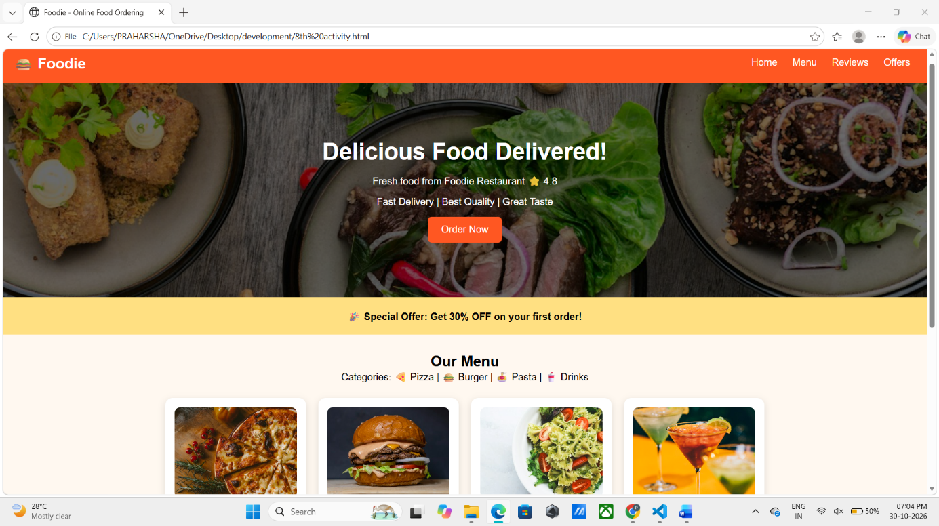

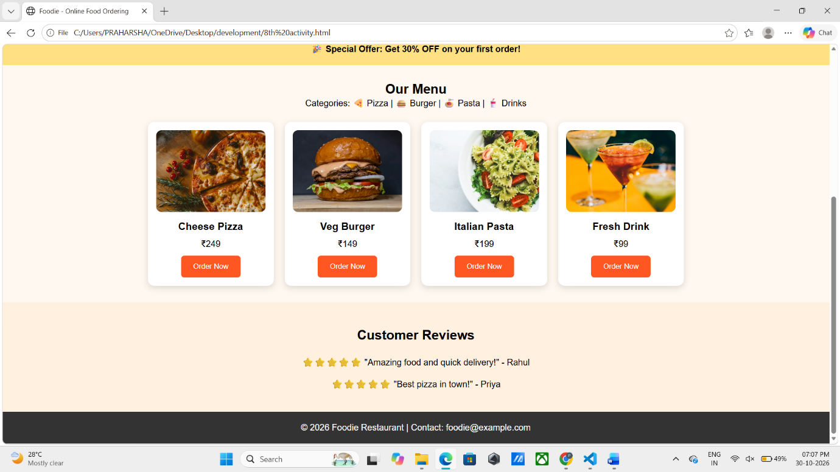
6. Conclusion
The Foodie Online Food Ordering Website was successfully designed using HTML and CSS. This project demonstrates the practical implementation of semantic HTML elements, navigation links, background images, Flexbox, food cards, hover effects, and responsive design.
The website provides a simple and attractive interface for exploring food items, viewing prices, checking offers, and reading customer reviews. Basic JavaScript alerts are used to demonstrate order-button interactions.
Through this project, we gained practical knowledge of creating and styling a responsive webpage using HTML and CSS.
Case Study-2
Activity 14: Healthy Food and Nutrition Website
Project Title: HealthyLife – Healthy Food & Nutrition Website
1. Introduction
The Healthy Food and Nutrition Website is a simple and responsive website developed using HTML and CSS. It provides information about nutritious food, healthy recipes, balanced meal plans, and healthy eating tips.
The website, named HealthyLife, helps users explore different food categories, ingredients, and recipes through an attractive and user-friendly interface. The main objective of this project is to promote awareness about balanced nutrition while demonstrating basic web development concepts.
2. Explanation
The HealthyLife website uses HTML to create the webpage structure and CSS to improve its design and responsiveness.
The website contains the following sections:
- Header: Displays the HealthyLife logo and navigation links such as Home, Recipes, Meal Plans, and Tips.
- Hero Section: Contains a welcome message and an Explore Recipes button.
- Food Categories: Displays different food groups, including fruits, vegetables, whole grains, dairy, and proteins.
- Healthy Recipes: Displays Vegetable Salad, Oatmeal Bowl, and Fruit Bowl with images, ingredients, and approximate calorie information.
- View Recipe Buttons: Uses simple JavaScript alerts to display basic recipe instructions.
- Meal Plans: Provides a sample balanced meal plan containing breakfast, lunch, snacks, and dinner.
- Healthy Eating Tips: Displays useful suggestions for maintaining balanced eating habits.
- Footer: Contains website copyright information.
CSS properties such as Flexbox, background images, border-radius, box-shadow, hover effects, and media queries can be used to make the website attractive and responsive.
3. HTML Code
File Name: index.html

<!DOCTYPE html>
<html>
<head>
<title>Healthy Food & Nutrition</title>
<meta name="viewport" content="width=device-width, initial-scale=1">
<link rel="stylesheet" href="14th activity.css">
</head>
<body>

<header>
<h2>🥗 HealthyLife</h2>
<nav>
<a href="#home">Home</a>
<a href="#recipes">Recipes</a>
<a href="#plans">Meal Plans</a>
<a href="#tips">Tips</a>
</nav>
</header>

<section class="hero" id="home">
<h1>Eat Healthy, Live Happy!</h1>
<p>Discover nutritious and delicious food recipes</p>
<a href="#recipes" class="btn">Explore Recipes</a>
</section>

<section>
<h2>Food Categories</h2>
<p>🍎 Fruits | 🥦 Vegetables | 🌾 Whole Grains | 🥛 Dairy | 🫘 Proteins</p>
</section>

<section id="recipes">
<h2>Healthy Recipes</h2>
<div class="container">

<div class="card">
<img src="https://images.unsplash.com/photo-1512621776951-a57141f2eefd?w=500" alt="Salad">
<h3>Vegetable Salad</h3>
<p>Ingredients: Tomato, Cucumber, Carrot</p>
<p>Approx. 120 kcal / serving</p>
<button onclick="alert('Mix chopped vegetables and serve fresh!')">View Recipe</button>
</div>

<div class="card">
<img src="https://images.unsplash.com/photo-1517673400267-0251440c45dc?w=500" alt="Oats">
<h3>Oatmeal Bowl</h3>
<p>Ingredients: Oats, Milk, Banana</p>
<p>Approx. 250 kcal / serving</p>
<button onclick="alert('Cook oats with milk and add banana!')">View Recipe</button>
</div>

<div class="card">
<img src="https://images.unsplash.com/photo-1490645935967-10de6ba17061?w=500" alt="Healthy Food">
<h3>Fruit Bowl</h3>
<p>Ingredients: Apple, Banana, Berries</p>
<p>Approx. 180 kcal / serving</p>
<button onclick="alert('Chop and combine fresh fruits!')">View Recipe</button>
</div>

</div>
</section>

<section id="plans">
<h2>Sample Balanced Meal Plan</h2>
<div class="plan">
<p>🌅 Breakfast: Oats with Fruits</p>
<p>☀️ Lunch: Rice, Dal & Vegetables</p>
<p>🌇 Snack: Fruits & Nuts</p>
<p>🌙 Dinner: Roti with Vegetable Curry</p>
</div>
</section>

<section id="tips">
<h2>Healthy Eating Tips</h2>
<p>✔ Eat a variety of nutritious foods</p>
<p>✔ Drink enough water</p>
<p>✔ Include fruits and vegetables</p>
<p>✔ Enjoy regular, balanced meals</p>
</section>

<footer>
<p>© 2026 HealthyLife | Eat Well, Live Well</p>
</footer>

</body>
</html>
4. CSS Code
File Name: 14th activity.css
The following CSS is prepared to match your HTML code.

* {
margin: 0;
padding: 0;
box-sizing: border-box;
}

body {
font-family: Arial, sans-serif;
background: #f4fff4;
text-align: center;
color: #333;
}

header {
background: #2e7d32;
color: white;
padding: 18px;
display: flex;
justify-content: space-between;
align-items: center;
}

nav a {
color: white;
text-decoration: none;
margin: 10px;
}

nav a:hover {
color: yellow;
}

.hero {
padding: 90px 15px;
color: white;
background: linear-gradient(#0007, #0007),
url('https://images.unsplash.com/photo-1490645935967-10de6ba17061?w=1400') center/cover;
}

.hero h1 {
font-size: 38px;
}

.hero p {
margin: 15px;
}

.btn, button {
background: #43a047;
color: white;
border: none;
padding: 12px 22px;
border-radius: 6px;
cursor: pointer;
}

.btn {
display: inline-block;
text-decoration: none;
}

button:hover, .btn:hover {
background: #1b5e20;
}

section {
padding: 35px 15px;
}

section h2 {
margin-bottom: 20px;
color: #2e7d32;
}

.hero h1 {
color: white;
}

.container {
display: flex;
justify-content: center;
flex-wrap: wrap;
gap: 20px;
margin-top: 25px;
}

.card {
background: white;
width: 280px;
padding: 15px;
border: 2px solid #e0e0e0;
border-radius: 12px;
box-shadow: 0 4px 12px #0002;
}

.card img {
width: 100%;
height: 160px;
object-fit: cover;
border-radius: 10px;
}

.card h3, .card p {
margin: 12px;
}

.card button {
margin-top: 10px;
}

#plans {
background: #e8f5e9;
}

.plan {
background: white;
max-width: 500px;
margin: auto;
padding: 20px;
border: 2px solid #a5d6a7;
border-radius: 10px;
line-height: 2.5;
}

#tips {
background: #f1f8e9;
line-height: 2.5;
}

footer {
background: #1b5e20;
color: white;
padding: 20px;
}

@media(max-width: 600px) {
header {
flex-direction: column;
gap: 15px;
}

nav a {
margin: 5px;
}

.hero h1 {
font-size: 27px;
}

.card {
width: 90%;
}
}
5.Output
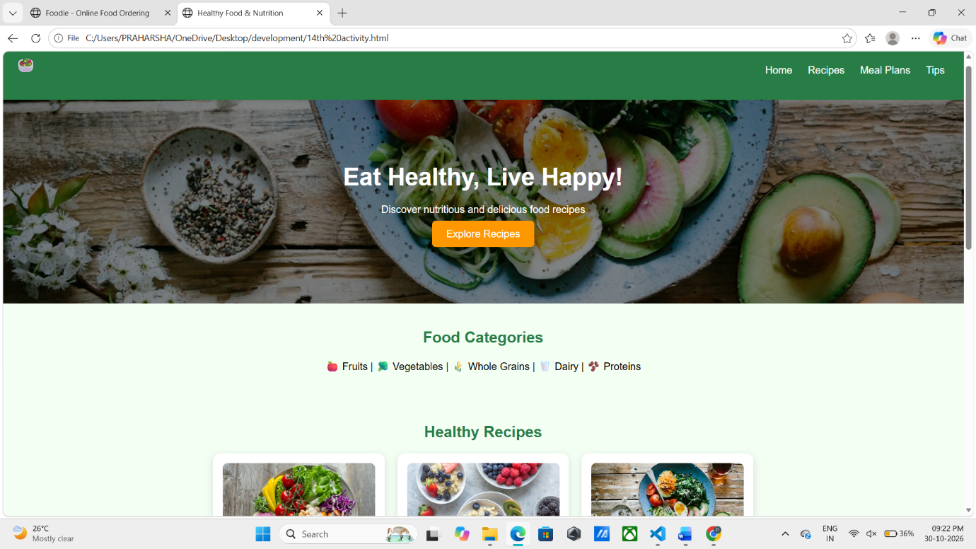

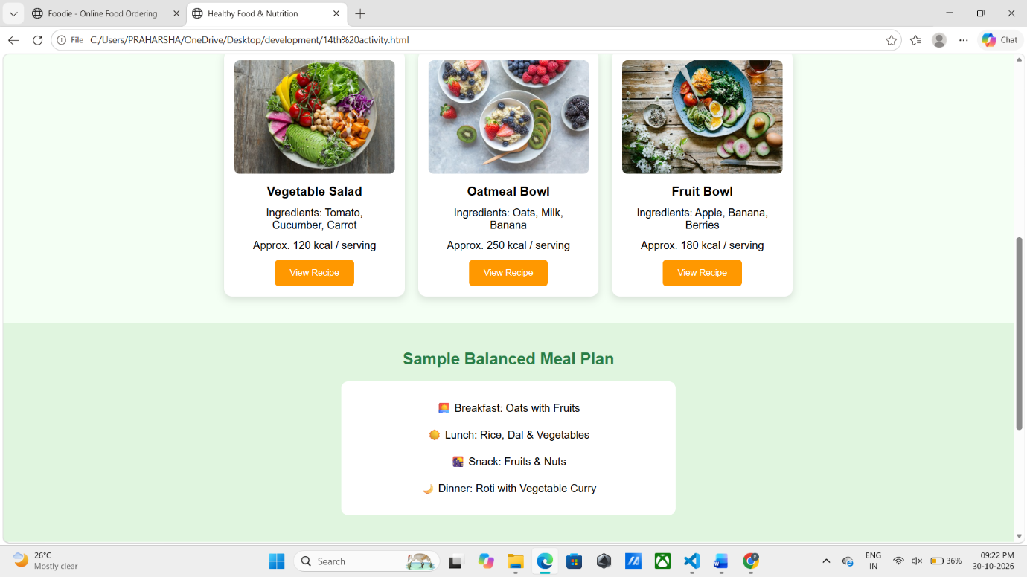
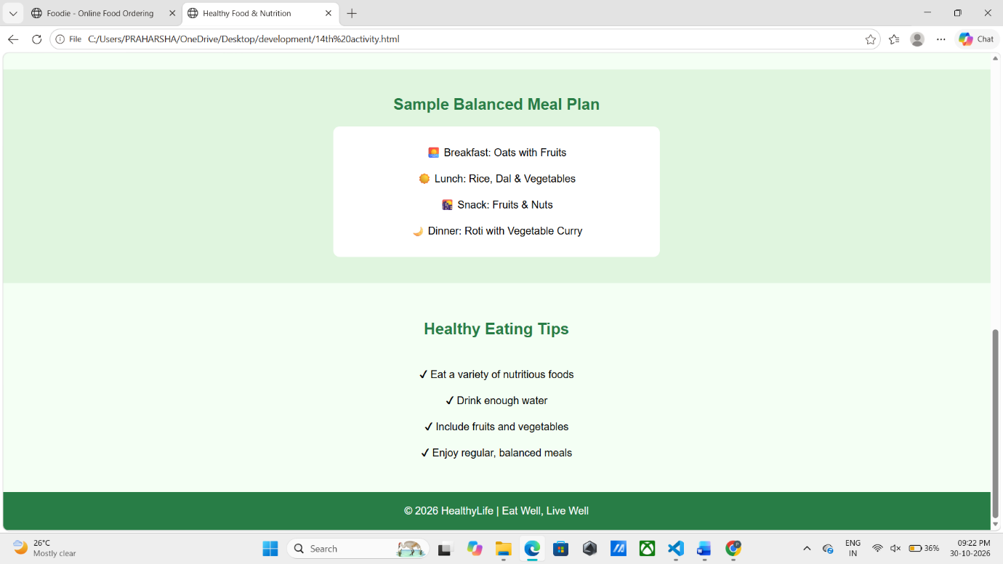

6. Conclusion
The HealthyLife – Healthy Food and Nutrition Website was successfully designed using HTML and CSS. This project demonstrates the practical implementation of semantic HTML elements, navigation links, recipe cards, background images, Flexbox, border properties, and responsive web design.
The website provides a simple and attractive platform for exploring nutritious recipes, sample balanced meal plans, food categories, and healthy eating tips. Basic JavaScript alerts are used to display recipe instructions.
Through this project, we gained practical knowledge of developing a responsive and user-friendly website using HTML and CSS.

Case Study-3
Activity 17: Tourism and Heritage Information Website
Project Title: Explore India – Tourism and Heritage Website
1. Introduction
The Tourism and Heritage Information Website is a simple and responsive website developed using HTML and CSS. It provides information about famous tourist destinations, historical monuments, Indian culture, festivals, local cuisine, and travel tips.
The website, named Explore India, helps visitors discover India's rich cultural heritage and beautiful destinations through an attractive and user-friendly interface. The main objective of this project is to create an informative tourism website using basic web development technologies.
2. Explanation
The Explore India website uses HTML to structure the webpage and CSS to improve its appearance and responsiveness.
The website contains the following sections:
- Header: Displays the Explore India logo and navigation links such as Home, Places, Culture, and Travel Tips.
- Hero Section: Contains an attractive background image, a welcome message, and an Explore Now button.
- Tourist Destinations: Displays famous places such as the Taj Mahal, Hawa Mahal, and Kerala with images, locations, and attraction types.
- Culture and Festivals: Provides information about Indian festivals such as Diwali, Holi, and Pongal.
- Local Cuisine: Highlights famous Indian dishes, including Hyderabadi Biryani, Dosa, and Rajasthani Thali.
- Travel Tips: Provides useful suggestions for safe and responsible travelling.
- Image Gallery: Displays photographs of Indian monuments and architecture.
- Footer: Contains website copyright and tourism information.
CSS properties such as Flexbox, background images, border-radius, box-shadow, and media queries are used to create an attractive and mobile-friendly website.
3. HTML Code
File Name: index.html

<!DOCTYPE html>
<html>
<head>
<title>Explore India Tourism</title>
<meta name="viewport" content="width=device-width, initial-scale=1">
<link rel="stylesheet" href="17th activity.css">
</head>
<body>

<header>
<h2>🌍 Explore India</h2>
<nav>
<a href="#home">Home</a>
<a href="#places">Places</a>
<a href="#culture">Culture</a>
<a href="#tips">Travel Tips</a>
</nav>
</header>

<section class="hero" id="home">
<h1>Discover Incredible India</h1>
<p>Explore Heritage, Culture & Beautiful Destinations</p>
<a href="#places" class="btn">Explore Now</a>
</section>

<section id="places">
<h2>Famous Tourist Destinations</h2>
<p>Explore by Region & Attraction Type</p>

<div class="container">

<div class="card">
<img src="https://images.unsplash.com/photo-1564507592333-c60657eea523?w=500" alt="Taj Mahal">
<h3>Taj Mahal</h3>
<p>North India | Historical Monument</p>
<p>Agra, Uttar Pradesh</p>
</div>

<div class="card">
<img src="https://images.unsplash.com/photo-1599661046827-dacff0c0f09a?w=500" alt="Hawa Mahal">
<h3>Hawa Mahal</h3>
<p>West India | Heritage Palace</p>
<p>Jaipur, Rajasthan</p>
</div>

<div class="card">
<img src="https://images.unsplash.com/photo-1606293926075-69a00dbfde81?w=500" alt="Kerala">
<h3>Kerala</h3>
<p>South India | Nature</p>
<p>Beautiful Backwaters</p>
</div>

</div>
</section>

<section id="culture">
<h2>Culture & Festivals</h2>
<div class="container">
<div class="card">
<h3>🪔 Diwali</h3>
<p>Festival of Lights</p>
</div>
<div class="card">
<h3>🎨 Holi</h3>
<p>Festival of Colours</p>
</div>
<div class="card">
<h3>🌾 Pongal</h3>
<p>South Indian Harvest Festival</p>
</div>
</div>
</section>

<section class="food">
<h2>Famous Local Cuisine</h2>
<p>🍛 Hyderabadi Biryani | 🥞 Dosa | 🥘 Rajasthani Thali</p>
</section>

<section id="tips">
<h2>Travel Tips</h2>
<p>✔ Carry essential documents</p>
<p>✔ Respect local traditions</p>
<p>✔ Check weather before travelling</p>
<p>✔ Keep tourist places clean</p>
</section>

<section>
<h2>Image Gallery</h2>
<div class="gallery">
<img src="https://images.unsplash.com/photo-1548013146-72479768bada?w=500" alt="Indian Heritage">
<img src="https://images.unsplash.com/photo-1524492412937-b28074a5d7da?w=500" alt="Taj Mahal">
<img src="https://images.unsplash.com/photo-1599661046827-dacff0c0f09a?w=500" alt="Indian Architecture">
</div>
</section>

<footer>
<p>© 2026 Explore India | Tourism & Heritage</p>
</footer>

</body>
</html>
4. CSS Code
File Name: 17th activity.css

* {
margin: 0;
padding: 0;
box-sizing: border-box;
}

body {
font-family: Arial, sans-serif;
background: #fffaf0;
text-align: center;
}

header {
background: #174d3c;
color: white;
padding: 20px;
display: flex;
justify-content: space-between;
align-items: center;
}

nav a {
color: white;
text-decoration: none;
margin: 10px;
}

.hero {
padding: 100px 15px;
color: white;
background: linear-gradient(#0007,#0007),
url('https://images.unsplash.com/photo-1524492412937-b28074a5d7da?w=1400') center/cover;
}

.hero h1 {
font-size: 40px;
}

.hero p {
margin: 20px;
}

.btn {
background: orange;
padding: 12px 25px;
color: white;
text-decoration: none;
border-radius: 6px;
}

section {
padding: 40px 15px;
}

h2 {
margin-bottom: 20px;
color: #174d3c;
}

.container {
display: flex;
justify-content: center;
flex-wrap: wrap;
gap: 20px;
margin-top: 25px;
}

.card {
background: white;
width: 260px;
padding: 15px;
border-radius: 12px;
box-shadow: 0 4px 12px #0002;
}

.card img {
width: 100%;
height: 170px;
object-fit: cover;
border-radius: 8px;
}

.card h3, .card p {
margin: 12px;
}

.food {
background: #ffe6b3;
}

#tips {
line-height: 2;
}

.gallery {
display: flex;
justify-content: center;
flex-wrap: wrap;
gap: 15px;
}

.gallery img {
width: 280px;
height: 180px;
object-fit: cover;
border-radius: 10px;
}

footer {
background: #174d3c;
color: white;
padding: 20px;
}

@media(max-width:600px) {
header {
flex-direction: column;
gap: 15px;
}

nav a {
margin: 5px;
}

.hero h1 {
font-size: 28px;
}

.card, .gallery img {
width: 90%;
}
}
5.Output
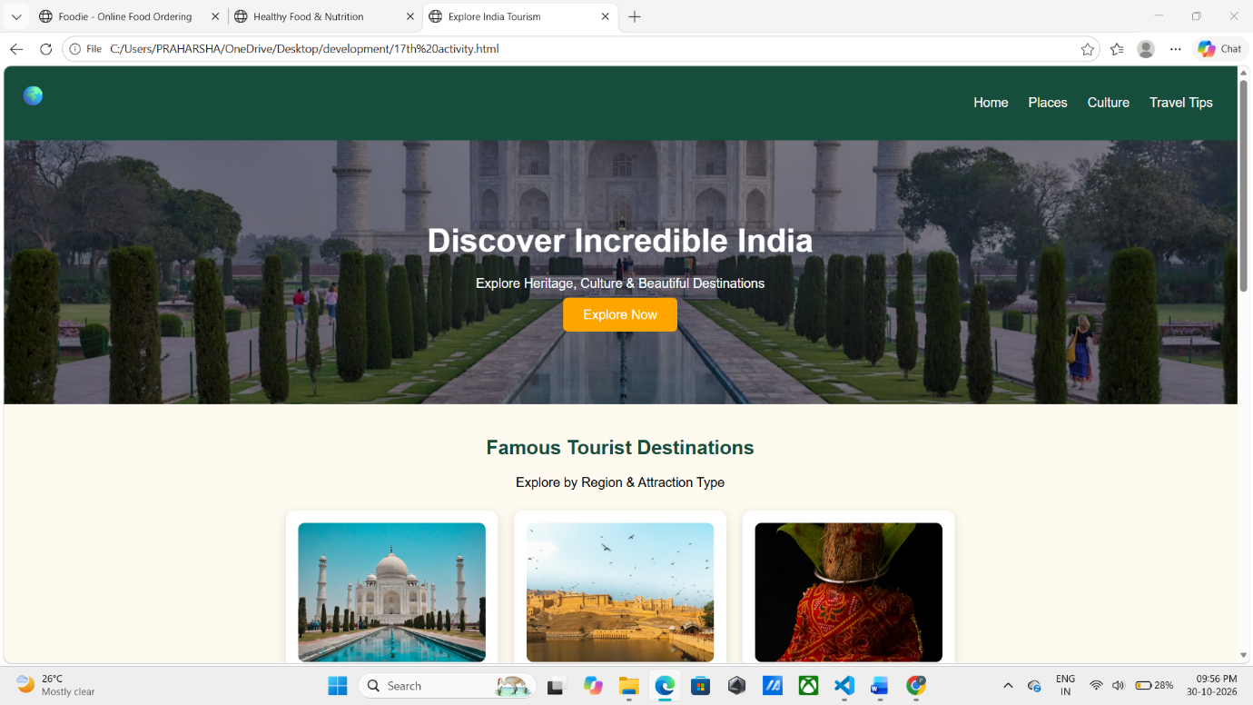

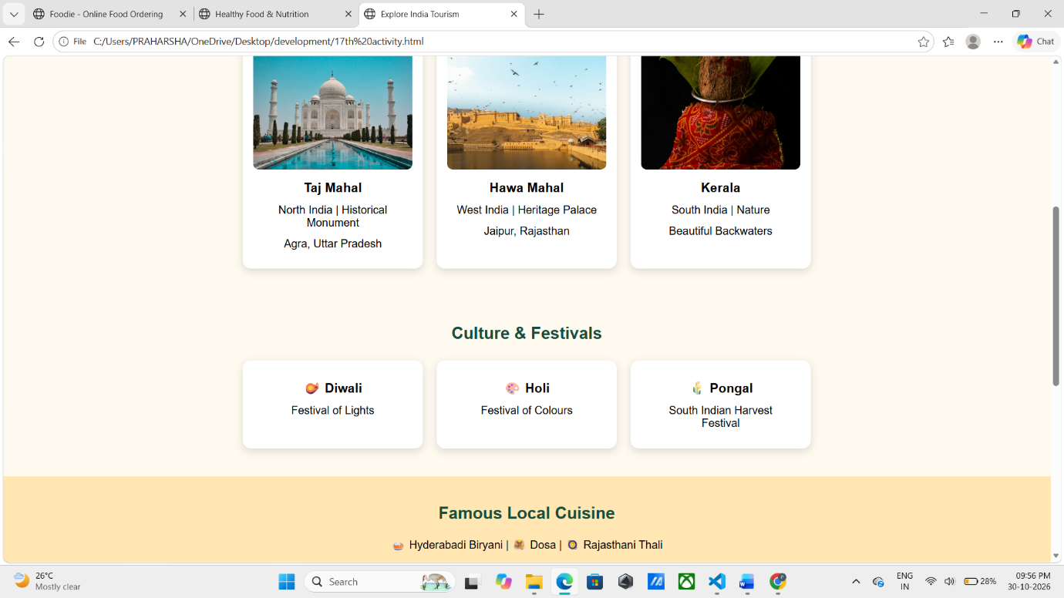

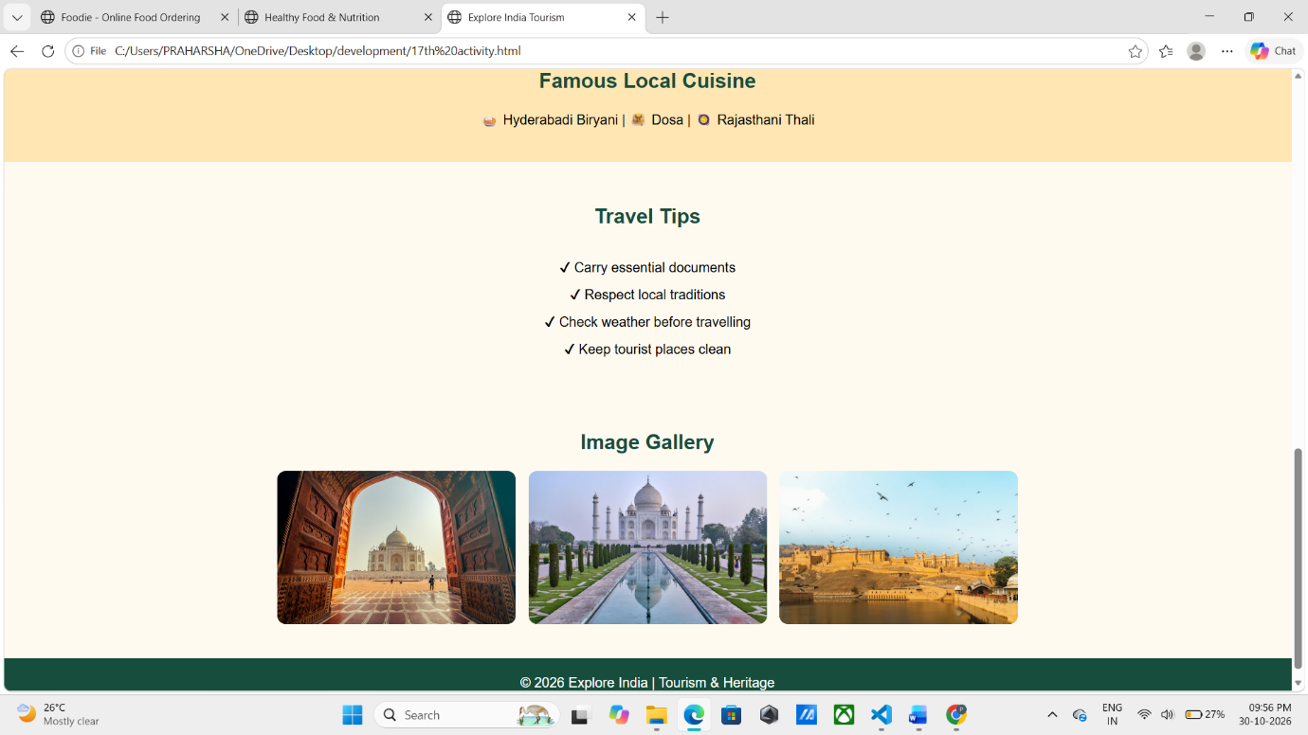

6. Conclusion
The Explore India Tourism and Heritage Website was successfully designed using HTML and CSS. This project demonstrates the practical implementation of semantic HTML elements, navigation links, image galleries, information cards, background images, Flexbox, and responsive web design.
The website provides an attractive and informative platform for exploring India's famous tourist destinations, cultural festivals, local cuisine, and travel tips.
Through this project, we gained practical knowledge of creating a responsive tourism website and organizing different types of information using HTML and CSS.

