- t vs. δz(t) with steady-state identification (accompanied by a description of steady-state criterion used), and helix snapshots (≥ 5) with labeled axes/units/time:

Figure 1 shows the axial tip displacement δz(t) under a constant tensile load F=Fchar.
The transient response is oscillatory due to inertia and structural flexibility, with clear exponential decay. To identify steady state, I applied the criterion:
$$\frac{∣δz\left(t\right)-δz\left(t-1\right)∣}{∣δz\left(t\right)∣}∣<1\%$$
The displacement stabilizes around:
δz* = -0.0015523549747709614 (m)
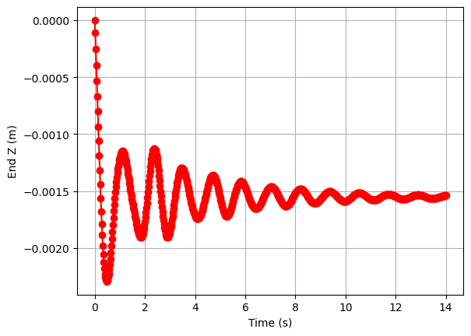
Figure 1. Time history of axial displacement δz(t) under constant load F=F_{char}. Steady state is identified when changes over a 1 s window fall below 1%.

Figures 2(a–e) show five snapshots of the helix configuration at increasing times
(t = 0, 3.70, 7.45, 11.20, 14.95 s). All axes are labeled and scaled equally. As the simulation progresses, the helix stretches downward and then settles into a steady configuration while maintaining its overall geometry (because the displacements are small an obvious change in the spring isn’t seen here).

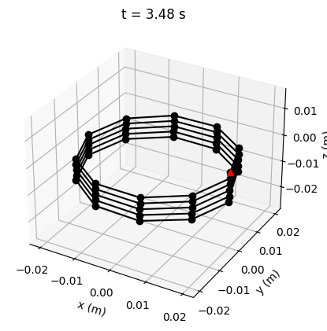
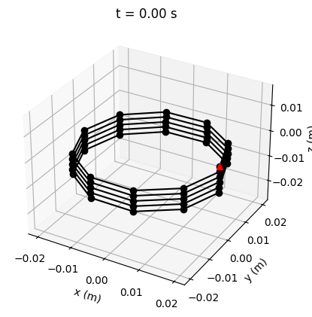
b)
a)

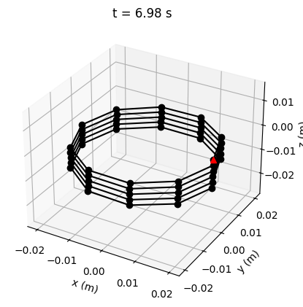
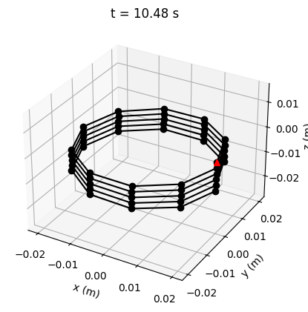
d)
c)

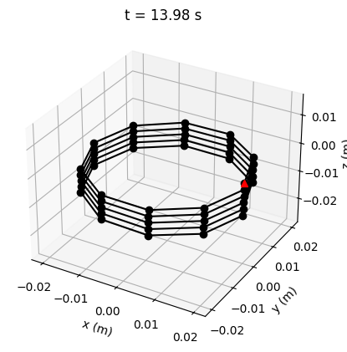
e)

Figure 2. Five snapshots of the helix at (a) t = 0.0 s, (b) t = 3.48 s, (c) t = 6.98 s, (d) t = 10.48 s, (e) t = 13.98 s
- F vs. δ∗z with zero-intercept best-fit line:
The force sweep results you obtained:
F (N) | δz*(m)
1.989e-07 | 1.5598e-05
5.336e-07 N | 4.1841e-05
1.431e-06 | 1.1222e-04
3.840e-06 | 3.0091e-04
1.030e-05 | 8.0603e-04
2.764e-05 | 2.1522e-03
7.414e-05 | 5.6766e-03
1.989e-04 | 1.4248e-02
Table 1. Numerical values of δz* for each F with a constant F_{char}

The best-fit line through the origin, using the relation:

$$F=k *δz$$

gives:

k = 0.0127605356877123 N/m

Figure 3 shows the simulation points and the fitted line. The linear region is extremely well-behaved, confirming the simulation captures the expected small-displacement spring behavior.

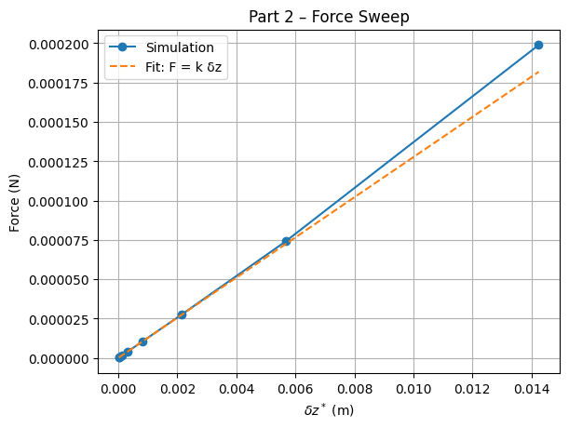
Figure 3. Force–displacement curve from Part 2 showing simulation data and the zero-intercept linear fit F=k δz∗.
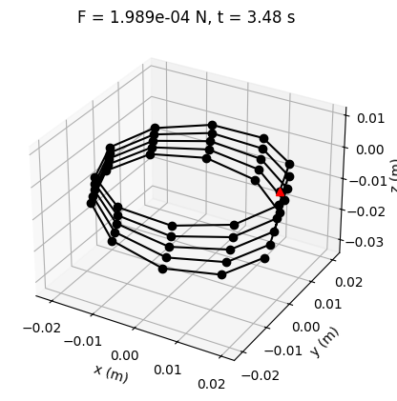
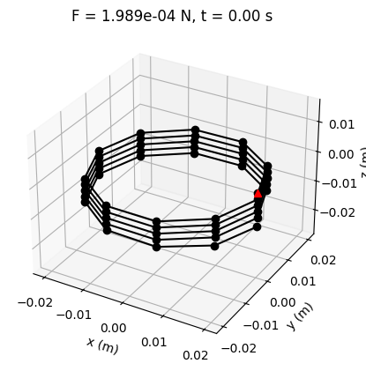
Also, a sample of the spring displacement is included here for the max force of 10F_{char}:
b)
a)

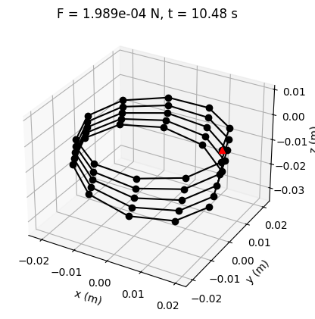
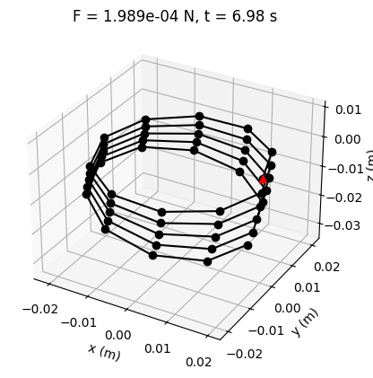
c)
d)

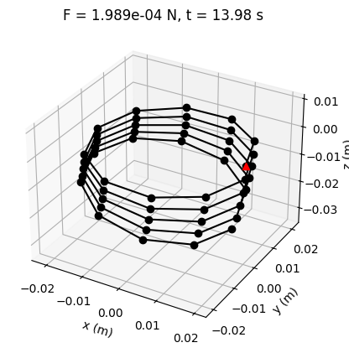

e)

Figure 4. Five snapshots of the helix at (a) t = 0.0 s, (b) t = 3.48 s, (c) t = 6.98 s, (d) t = 10.48 s, (e) t = 13.98 s with F=10F_{Char}
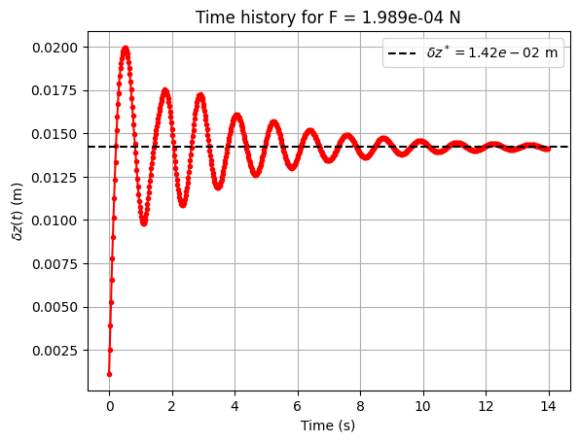
Figure 5. Time history of axial displacement δz(t) under constant load F=10F_{char}. (For a better look, the change in length has been plotted with a positive sign)

(3) k vs. Gd4/(8ND3) with the slope-1 reference:
By variying the coil diameter D from 0.01 m to 0.05 m. The corresponding DER-computed stiffnesses were found:
D (m) | K (N/m)
0.010 | 1.074e+00
0.0144 | 3.998e-01
0.0189 | 1.947e-01
0.0233 | 1.099e-01
0.0278 | 6.860e-02
0.0322 | 4.616e-02
0.0367 | 3.293e-02
0.0411 | 2.458e-02
0.0456 | 1.902e-02
0.0500 | 1.512e-02
Table 2. Numerical values of k for each D with a varying F_{char.}
The textbook close-coiled approximation predicts:
$$Ktext​=\frac{Gd^{4}}{8ND^{3}}​$$
Figure 6, the plot of DER stiffness k(D) versus the textbook quantity Gd⁴/(8ND³) shows:
- a strong positive correlation,
- a generally linear trend,
- and the correct qualitative dependence:
larger helix diameter⇒more flexible spring⇒k decreases

The general trend is correct but the DER data fall below the slope-1 line at larger D. This is expected because:
- The textbook formula assumes
  - small deformation
  - thin wire
  - close-coiled geometry
  - pure torsion in the wire.
- The helix has finite pitch, bending contributions, non-uniform strain, and 3D elastic rod behavior that is not captured in the classical closed-form approximation.
Thus, qualitative agreement is correct, and quantitative mismatch is expected, exactly as the homework file states.

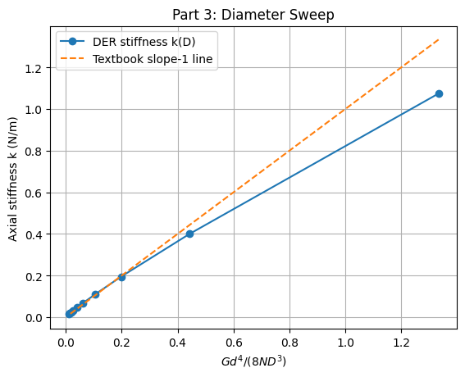
Figure 6. DER-computed stiffness k(D) versus the textbook torsional spring quantity Gd⁴/(8ND³). The dashed line is the classical prediction K_{text}​=x (slope 1).

