

CP2406 – Programming 3

Assignment 1

Name: Ung Ta Hoang Tuan

JCU ID: 13870011

Teacher: KumMeng Lum

User Stories:

User Story 1:

In terms of the consumer, I'd like to expand simulator customization so that I can change the vehicle, street, and length. The priority is high, and the estimated turnaround time is four days. Create a new city map, add some streets, and run the simulation for testing.

User Story 2:

I would like to save my built city for later use so that I don't lose any of the improvements I've made to my personalized city. The priority level is Medium, and the estimated turnaround period is three days. After changing the city, press the save button to save the city with a name for testing.

User Story 3:

I would like to prevent colliding with other vehicles by calculating the gap between them and me so that I can run the simulator without any issues. The priority is high, and the estimated time is three days. During training, keep a close eye on the vehicles while the software runs simulations.

User Story 4:

I want the stop button to bring the simulator to a halt while moving vehicles are on the road so that I can end the simulation process. The priority is high, and the estimated turnaround period is two days. To conduct the checking, push the stop button and keep an eye on all termination vehicles.

Developer User Stories:

Developer User story 1:

As a developer, we can modify the light and traffic for the user. For this car simulator, there are bus and motorcycle options. The priority is high, and the estimated turnaround time is four days. Abstract the vehicles class for research and name some methods to drive the cars.

Developer User story 2:

Developers should also halt traffic to prevent colliding with the vehicle in front of them; there would be no errors. The priority is low, and the estimated turnaround period is two days. In terms of research, obtain the gab gap from the front of vehicles and invoke some methods from the vehicles.

Developer User story 3:

I can load some of the user's data so that it can load and run again once the program has begun. The priority level is Medium, and the estimated turnaround period is one day. For research, read the data file from a particular path and load it in the main process.

Developer User story 4:

The software was created by the developer to save all the data that could be lost by customers. The priority is high, and the estimated turnaround time is three days. Save all data as a file in the main method for checking, then load the data to display the map again.

UML Diagram:

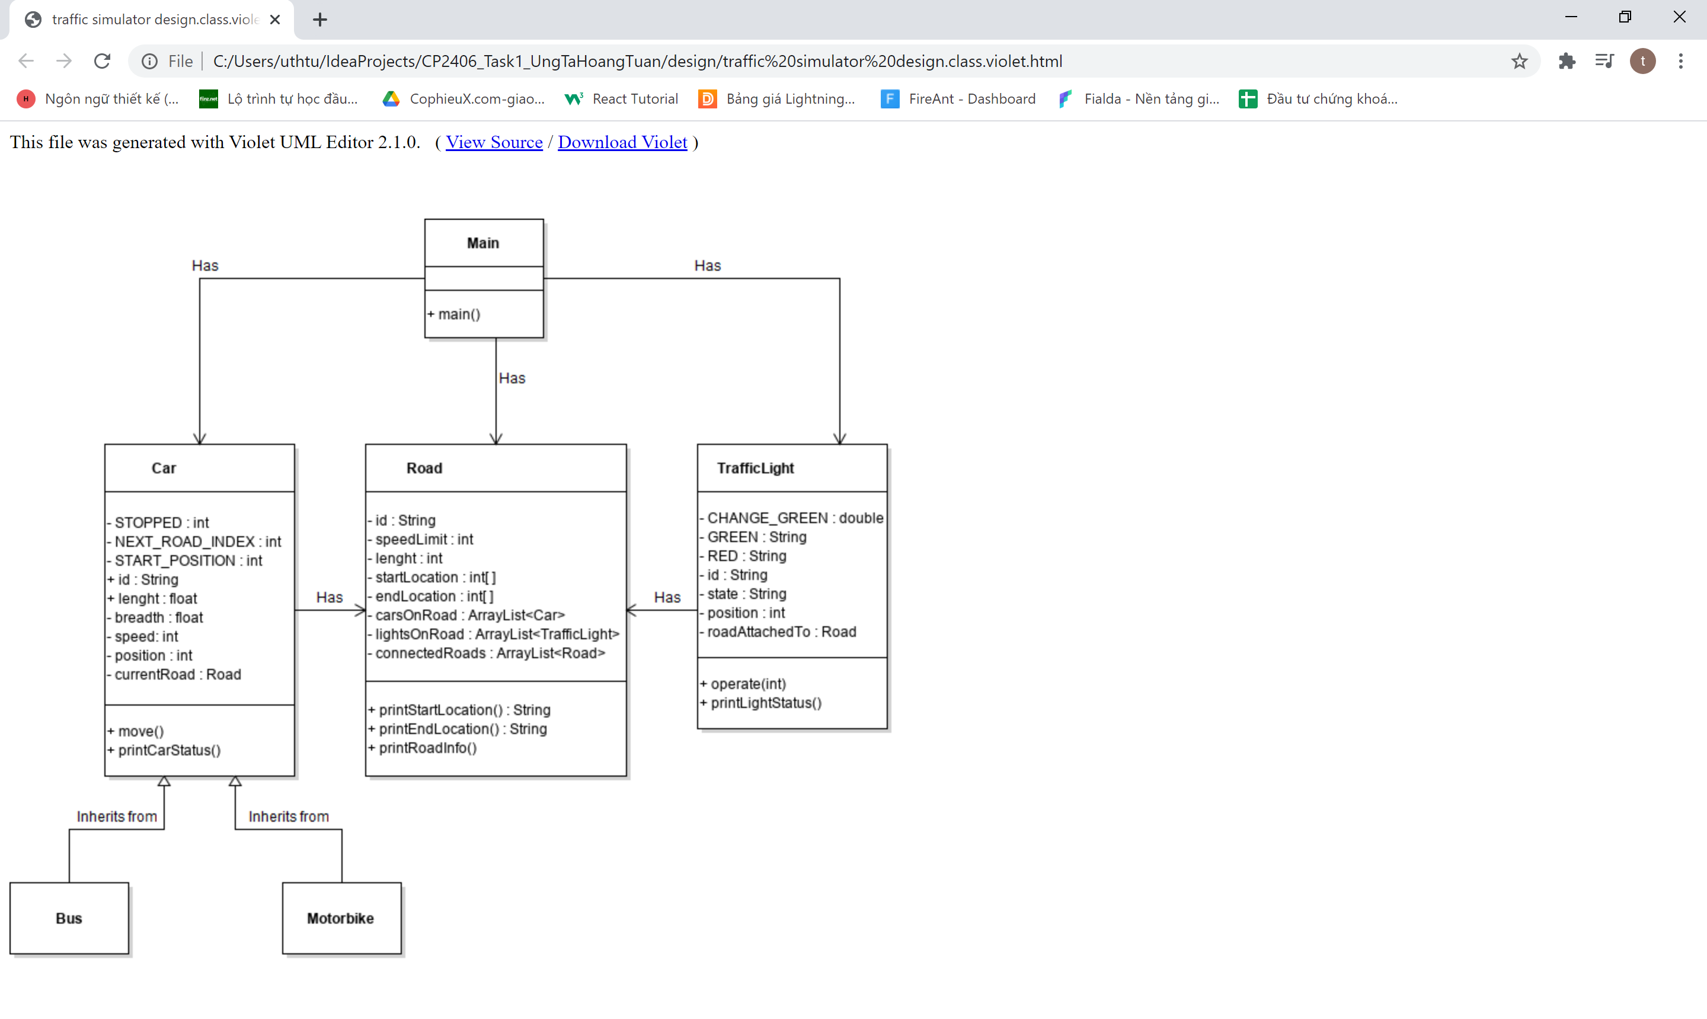

GitHub Link:

<https://github.com/peshin-ai/CP2406_Task1_UngTaHoangTuan>

