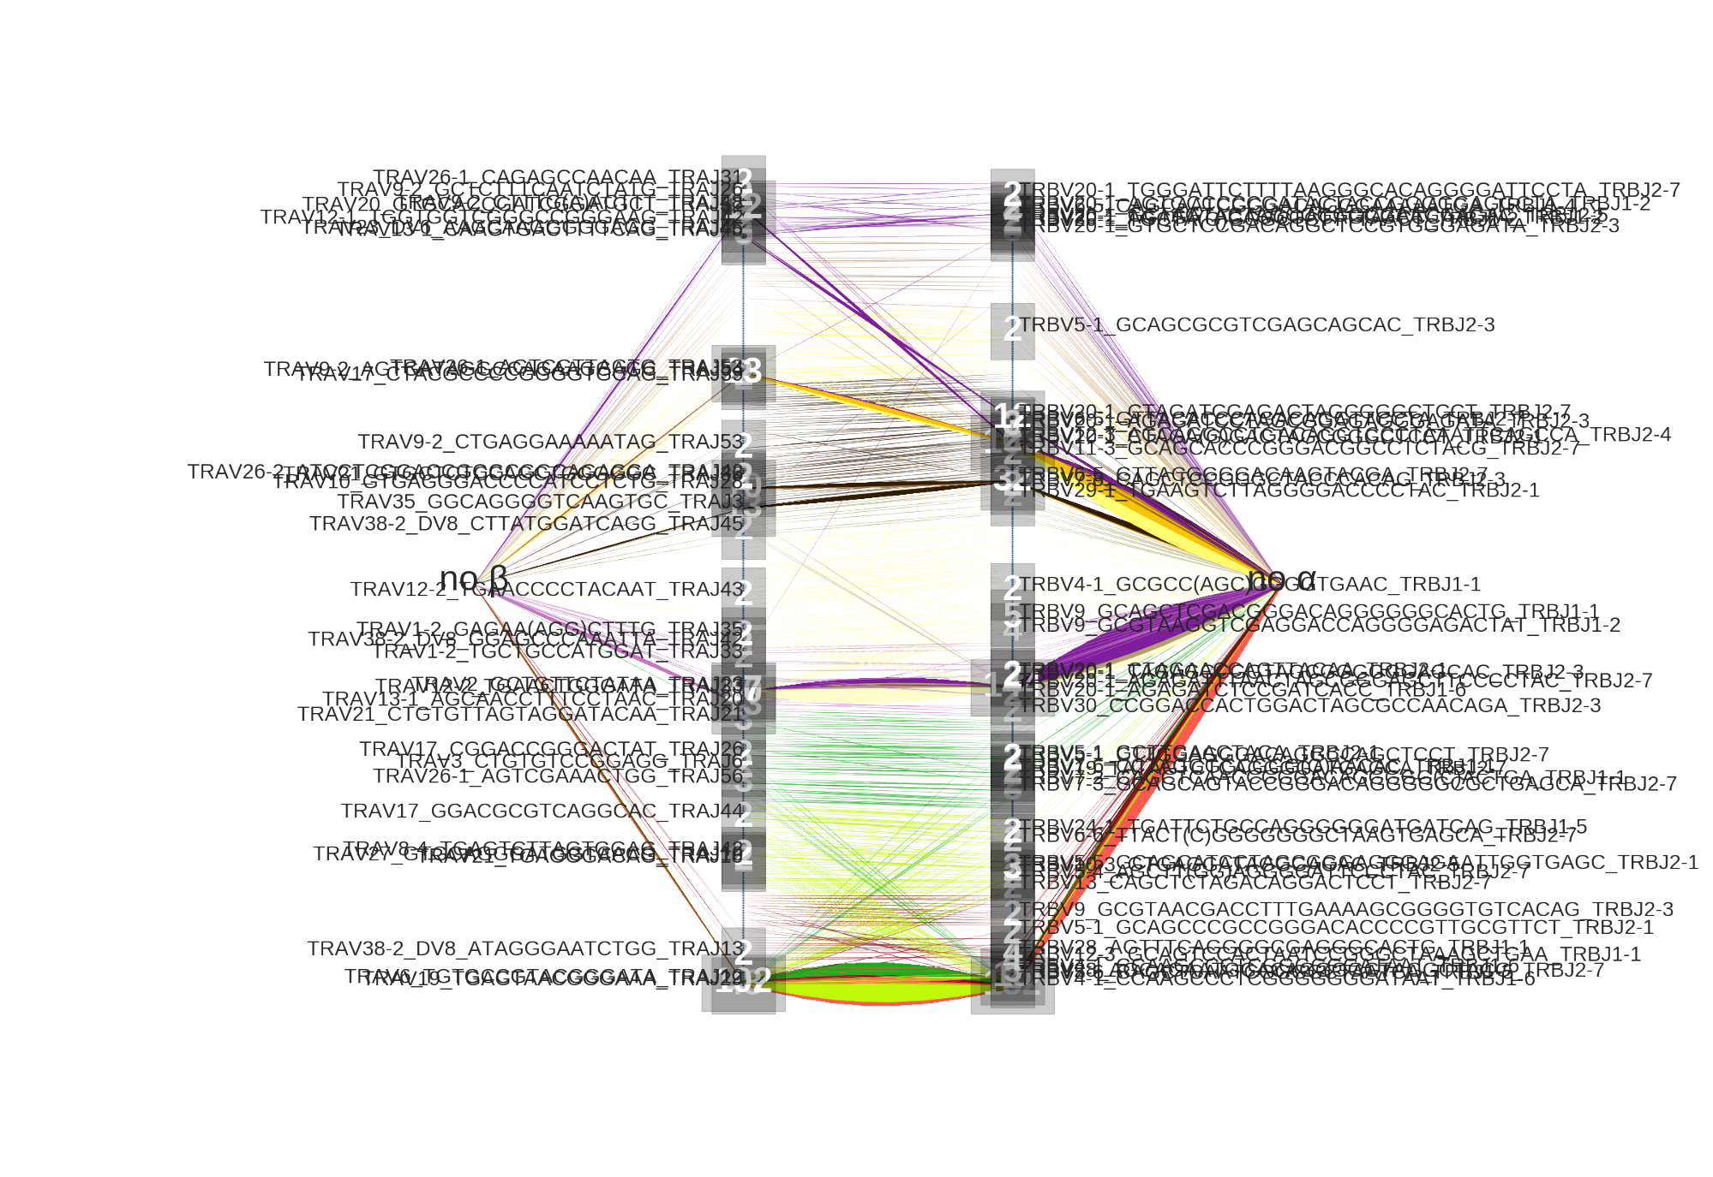

**TRAY921AGdBAYA66GSASégé66 TR**

A.

C.

TRAV26-2ER3T3-RSSSSSSSSSggae TRAV35 GGCAGGGGTCAAGFGC TRAV38-2 DV8 CTTA т CCCCTACAAT TRAJ4

GSGOTGAAC TRBJ1-1

TRAV12-31 - < یZ - -2. GAGAAAG OTAsYryryLyLS00ryLyYSSySSKSKKZYS TRAVးနိမ္မိ%;(မ္ဘ" ငှါဒွိမွီဇုံဒွိုနိူ-HဒြိုÅန္တီ ' =-14:EV2ë A:LAAFA

**မ္ဘီရှီဒွိုဇိုင္ငံဒီဇို့ဖွံ့နှံ့Gပေါ်ဦff;Ré2-ငှါRBJ2-7 ܐ̈ܠܠ**

&AASIC RA3 颂 ႔(၃႔yါဠိဂို့PARŞREAâ戀刊 然物 ACTGGACTAGCGCCAACAGA TRBJ2-3

LLLLLLLLS0SyyyLyyyyykTTSTZYSuSuSuS LOLLS0S0TLTTyyOyOLOO00OOkLSLL00000 RA¥ತ್ಯಗಳಳ್ಲಿÏ E RBV#é-Š ဒိဋ္ဌိဇုံခြုံရိုဒီ့႔:B၃JHaား ၄

TRAV17. GGACGCGTCAGGCAC TRAJ -

Z G 175 TRAWAW&fgS$36A6GEasAG te figéTSEeegeâSSSSSSéYesAEelg-REB317

|႕န္ဌိစ္ဆိဒ္ဒိဌိဇုံနှီ{éနှီဝှို႔ဦéè၃ န္တိဇုရှ်မုံ့နုံခြုံဖုံစ္စုပ္စုပ္န္ဟင္တၾTGAGC_TRBJ2-1

9 GCGTAACGACCTTTGAAAAGCGGGGTGTCACAG TRBJ2-3 CGCCGGGACACCCCGTTGCGTTCT TRBJ2-1 ՇG(Ճ(Ճյի SejaAA. IRBJ1-1 RBJ2-7

**Υ**

**TRAV38-2 DV8 ATAGGGAATCTGG TRA 3. TRAMs/196TGAGGAACGGGAAA TRAJ2a2**