Lab 2a Basic Switch Configuration

# Objective

* Configure a switch with a name and an IP address.
* Configure passwords to ensure that access to the CLI is secured.
* Configure switch port speed and duplex properties for an interface.
* Save the active configuration.
* View the switch browser interface.

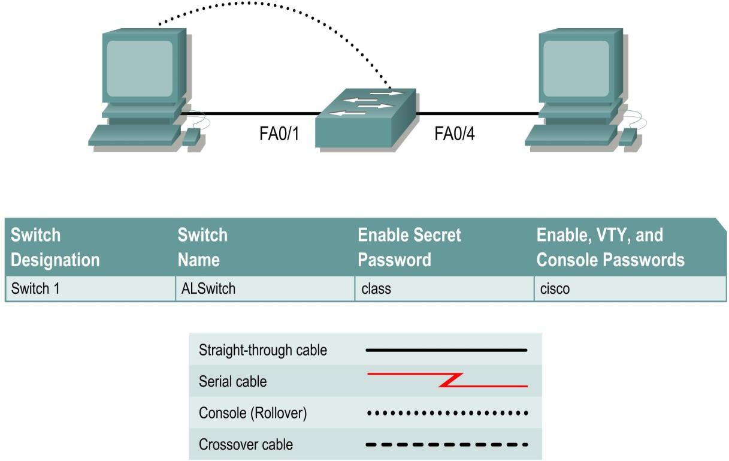

# Preparation

Cable a network similar to the one in the diagram. The configuration output used in this lab is for a 2950 series switch.

# Step 1 Enter privileged mode

1. Privileged mode gives access to all the switch commands. Many of the privileged commands configure operating parameters. Therefore, privileged access should be password-protected to prevent unauthorized use. The privileged command set includes those commands contained in user EXEC mode, as well as the **configure** command through which access to the remaining command modes is gained.

Switch>**enable** Switch#

1. Notice the prompt changed in the configuration to reflect privileged EXEC mode.

# Step 2 Examine the current switch configuration

1. Examine the following current running configuration file:

Switch#**show running-config**

1. How many Ethernet or Fast Ethernet interfaces does the switch have? 24
2. What is the range of values shown for the VTY lines? 0-4 5-15
3. Examine the current contents of NVRAM as follows: Switch#**show startup-config**

%% Non-volatile configuration memory is not present

1. Why does the switch give this response? Not present(Faulty NVRAM or corrupted)  
   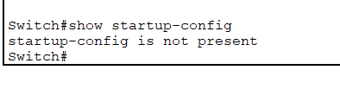

# Step 3 Assign a name to the switch

1. Enter **enable** and then the configuration mode. The configuration mode allows the management of the switch. Enter **ALSwitch**, the name this switch will be referred to in the following:

Switch#**configure terminal**

Enter the configuration commands, one for each line. End by pressing **Ctrl-Z**. Switch(config)#**hostname ALSwitch**

ALSwitch(config)#**exit**

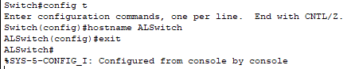

1. Notice the prompt changed in the configuration to reflect its new name. Type **exit** or press **Ctrl-Z** to go back into privileged mode.

# Step 4 Examine the current running configuration

1. Exam the current configuration that follows to verify that there is no configuration except for the hostname:

ALSwitch#**show running-config**

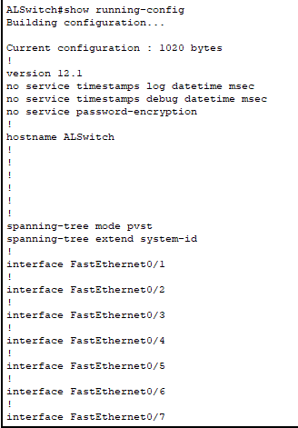

1. Are there any passwords set on the lines? no
2. What does the configuration show as the hostname of this switch? ALSwitch  
     
   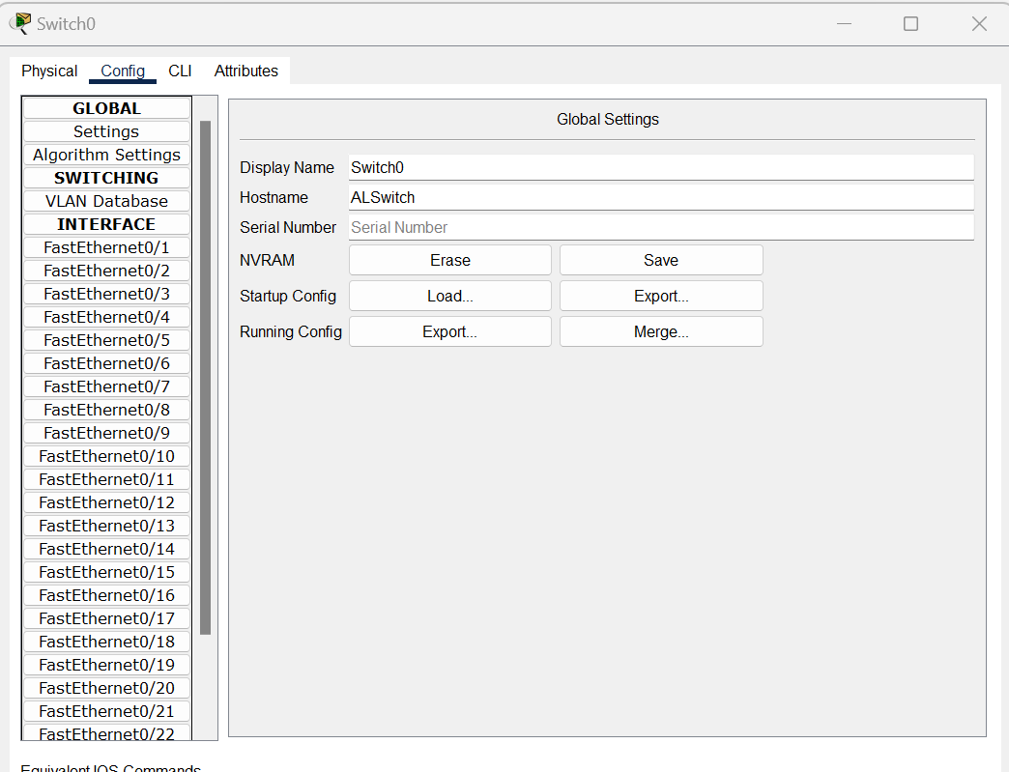

# Step 5 Set the access passwords

Enter config-line mode for the console. Set the password on this line as **cisco** for login. Configure the vty lines 0 to 15 with the password cisco as follows:

ALSwitch#**configure terminal**

Enter the configuration commands, one for each line. End by pressing **Ctrl-Z**.

ALSwitch(config)#**line con 0** ALSwitch(config-line)#**password cisco** ALSwitch(config-line)#**login** ALSwitch(config-line)#**line vty 0 15** ALSwitch(config-line)#**password cisco** ALSwitch(config-line)#**login** ALSwitch(config-line)#**exit  
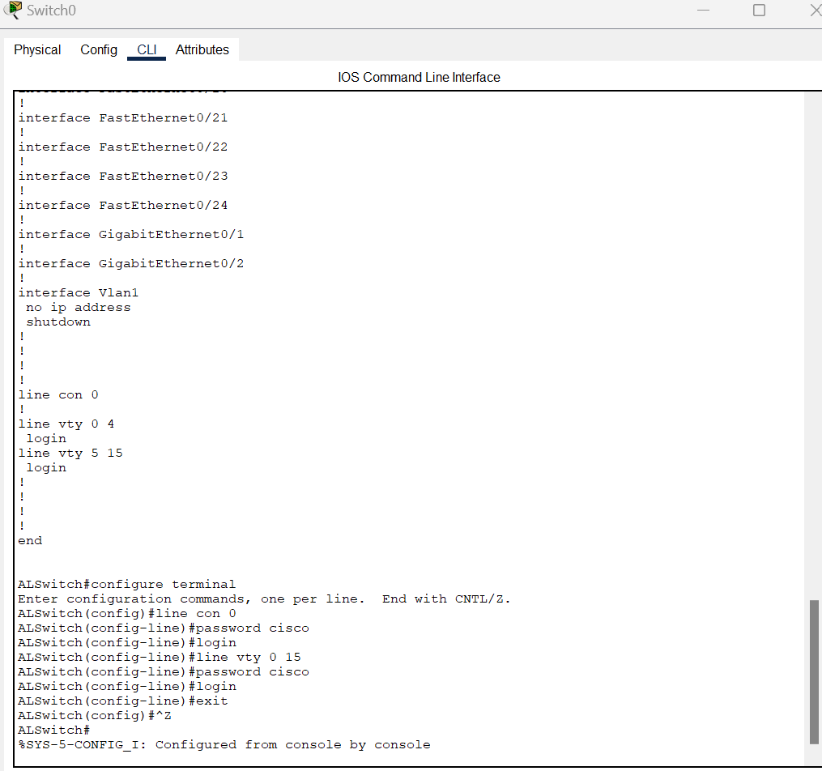**

# Step 6 Set the command mode passwords

1. Set the **enable password** to cisco and the **enable secret password** to **class** as follows:

ALSwitch(config)#**enable password cisco**

ALSwitch(config)#**enable secret class**

ALSwitch(config)#**exit**

ALSwitch #**show interface fastethernet 0/4** (Note: this can be a trunk or access port)

**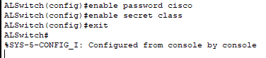  
Or**

ALSwitch #**show interface gigabitethernet 0/1** (Note: this can be a trunk or access port)  
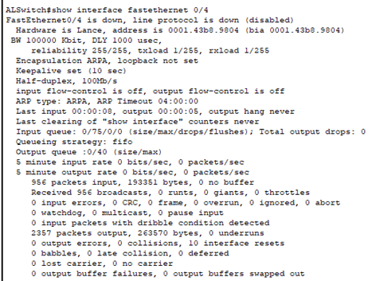

1. Which password takes precedence, the enable password or enable secret password? Enable Password over secret

# Step 7 Configure the layer 3 access to the switch

1. Set the IP address of the switch to 192.168.1.2 with a subnet mask of 255.255.255.0 as follows:

**Note:** This is done on the internal virtual interface VLAN 1.

ALSwitch(config)#**interface VLAN 1**

ALSwitch(config-if)#**ip address 192.168.1.2 255.255.255.0**

ALSwitch(config-if)#**exit  
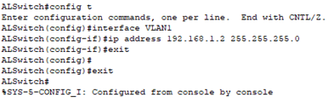**

1. Set the default gateway for the switch and the default management VLAN to 192.168.1.1 as follows:

ALSwitch(config)#**ip default-gateway 192.168.1.1**

ALSwitch(config)#**exit  
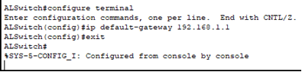**

# Step 8 Verify the management LANs settings

1. Verify the interface settings on VLAN 1 as follows:

ALSwitch#**show interface VLAN 1  
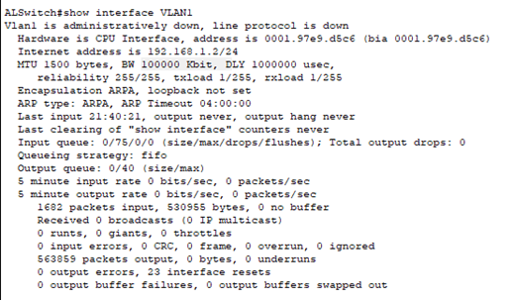**

1. What is the bandwidth on this interface?100000 kbit
2. What are the VLAN states: VLAN1 is administratively down , Line protocol is down
3. Enable the virtual interface using the **no shutdown** command

ALSwitch#**configure terminal** ALSwitch(config)#**interface VLAN 1** ALSwitch(config-if)#**no shutdown** ALSwitch(config-if)#**exit  
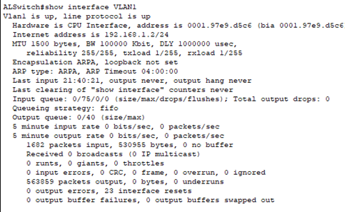**

1. What is the queuing strategy? FIFO

# Step 9 Save the configuration

* 1. The basic configuration of the switch has just been completed. Back up the running configuration file to NVRAM as follows:

**Note:** This will ensure that the changes made will not be lost if the system is rebooted or loses power.

ALSwitch#**copy running-config startup-config** Destination filename [startup-config]?[**Enter**] Building configuration... [OK]

ALSwitch#

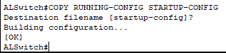

* 1. Configuration upload is successfully completed.

# Step 10 Examine the startup configuration file

1. To see the configuration that is stored in NVRAM, type **show startup-config** from the privileged EXEC (enable mode).

ALSwitch#**show startup-config  
  
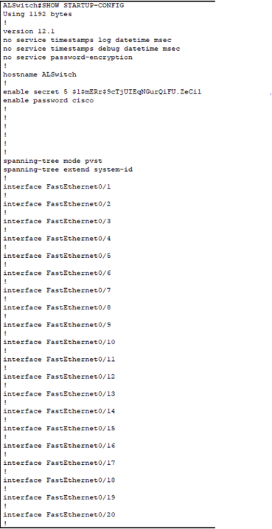**

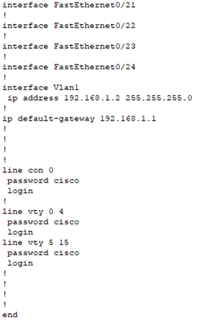

1. What is displayed? C.
2. Are all the changes that were entered recorded in the file? Yes all are perfect

# Step 11 Exit the switch

Logoff the switch by typing **exit** as follows: ALSwitch#**exit**

Once these steps are completed, logoff by typing **exit**, and turn all the devices off.

**Step 12**

Once you have completed the configurations, do the following steps: i) add two more PCs, ii) ping between PCs, iii) trace route between PCs, and iv) telnet from one of the PC to the switch.

**References:**

CISCO Networking Academy Program: Switching Basics and Intermediate Routing v 3.1