# Lab 2b - Switch configuration

**Objectives**

Perform an initial configuration of a Cisco 2960 switch.

# Tasks

In this activity, you will connect 4 PCs to a Cisco Catalyst 2960 switch and you will configure the following settings on the Cisco Catalyst 2960.

Host name Console password vty password



Privileged EXEC mode password Privileged EXEC mode secret

1. What additional feature does Cisco 2960 switch compared to Cisco 2950 switch?

Compared to the Cisco 2950 switch, the Cisco 2960 switch has more sophisticated security features including 802.1X, Layer 3 routing, and improved QoS (Quality of Service).

Once you have completed the configurations, do the following steps: i) ping between PCs, ii) trace route between PCs, and iii) telnet from one of the PC to the switch.  
  
Switch>enable

Switch#configure terminal

Enter configuration commands, one per line. End with CNTL/Z.

Switch(config)#hostname <2b>

<2b>(config)#line console 0

<2b>(config-line)#password 2b

<2b>(config-line)#login

<2b>(config-line)#exit

<2b>(config)#line vty 0 15

<2b>(config-line)#password 2b

<2b>(config-line)#login

<2b>(config-line)#exit

<2b>(config)#enable password 2b

<2b>(config)#enable secret 2b

The enable secret you have chosen is the same as your enable password.

This is not recommended. Re-enter the enable secret.

<2b>(config)#enable secret 2bb

<2b>(config)#write memory

^

% Invalid input detected at '^' marker.

<2b>(config)# write memory

^

% Invalid input detected at '^' marker.

<2b>(config)# exit

<2b>#

%SYS-5-CONFIG_I: Configured from console by console

<2b># copy running-config startup-config

Destination filename [startup-config]?

Building configuration...

[OK]

<2b>#

1. <2b>#

i) 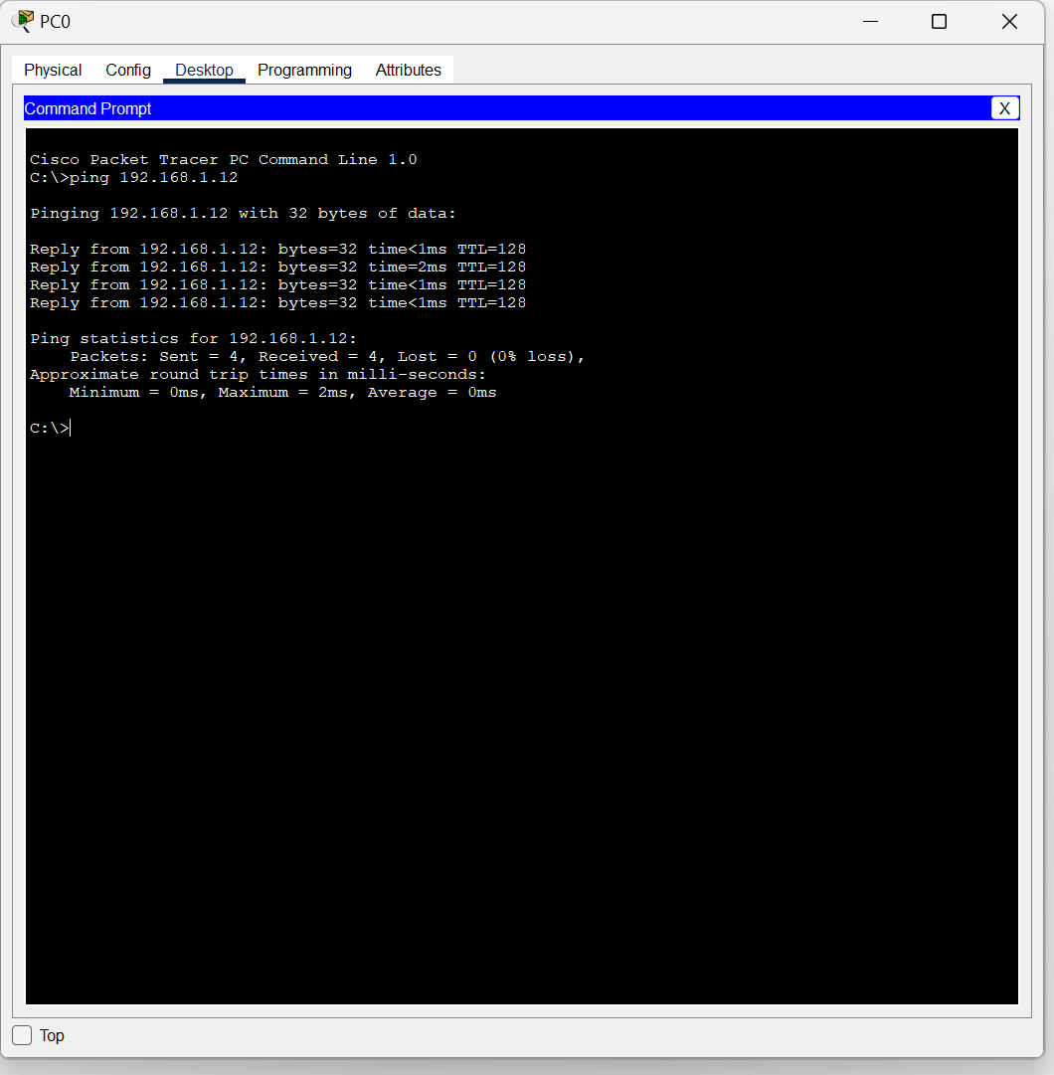

ii)  
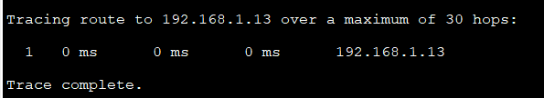

iii)

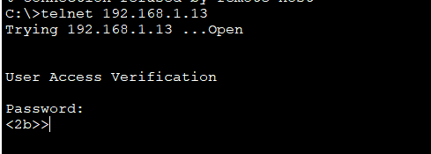

Extra part of the code

<2b>#

<2b># enable

<2b># configure terminal

Enter configuration commands, one per line. End with CNTL/Z.

<2b>(config)# line vty 0 15

<2b>(config-line)# password 2bb

<2b>(config-line)# login

<2b>(config-line)# exit

<2b>(config)# interface vlan 1

<2b>(config-if)# ip address 192.168.1.13 255.255.255.0

<2b>(config-if)#no shutdown

<2b>(config-if)#

%LINK-5-CHANGED: Interface Vlan1, changed state to up

%LINEPROTO-5-UPDOWN: Line protocol on Interface Vlan1, changed state to up

%IP-4-DUPADDR: Duplicate address 192.168.1.13 on Vlan1, sourced by 0001.43D0.5166

<2b>(config-if)#exit

<2b>(config)# show ip address brief

^

% Invalid input detected at '^' marker.

<2b>(config)#Switch# show ip interface brief

^

% Invalid input detected at '^' marker.

<2b>(config)# exit

<2b>#

%SYS-5-CONFIG_I: Configured from console by console

<2b>#Switch# show ip interface brief

^

% Invalid input detected at '^' marker.

<2b>#show ip interface brief

Interface IP-Address OK? Method Status Protocol

FastEthernet0/1 unassigned YES manual up up

FastEthernet0/2 unassigned YES manual up up

FastEthernet0/3 unassigned YES manual up up

FastEthernet0/4 unassigned YES manual up up

FastEthernet0/5 unassigned YES manual down down

FastEthernet0/6 unassigned YES manual down down

FastEthernet0/7 unassigned YES manual down down

FastEthernet0/8 unassigned YES manual down down

FastEthernet0/9 unassigned YES manual down down

FastEthernet0/10 unassigned YES manual down down

FastEthernet0/11 unassigned YES manual down down

FastEthernet0/12 unassigned YES manual down down

FastEthernet0/13 unassigned YES manual down down

FastEthernet0/14 unassigned YES manual down down

FastEthernet0/15 unassigned YES manual down down

FastEthernet0/16 unassigned YES manual down down

FastEthernet0/17 unassigned YES manual down down

FastEthernet0/18 unassigned YES manual down down

FastEthernet0/19 unassigned YES manual down down

FastEthernet0/20 unassigned YES manual down down

FastEthernet0/21 unassigned YES manual down down

FastEthernet0/22 unassigned YES manual down down

FastEthernet0/23 unassigned YES manual down down

FastEthernet0/24 unassigned YES manual down down

GigabitEthernet0/1 unassigned YES manual down down

GigabitEthernet0/2 unassigned YES manual down down

Vlan1 192.168.1.13 YES manual up up

<2b>#