HUMAN REPRODUCTIVE BIOLOGY WITHOUT MEMORIZATION
  - Understand Reproductive Anatomy, Hormonal Regulation, Fertilization, Pregnancy, and Human Development Through Biological Mechanisms
Perry Yates
2026
Table of Contents

Copyright
HUMAN REPRODUCTIVE BIOLOGY WITHOUT MEMORIZATION
Subtitle: Understand Reproductive Anatomy, Hormonal Regulation, Fertilization, Pregnancy, and Human Development Through Biological Mechanisms
First Edition
© 2026 Perry Yates. All rights reserved.
Published by INKFREEDOMPUBLISHING
No part of this publication may be reproduced, stored in a retrieval system, or transmitted in any form or by any means — electronic, mechanical, photocopying, recording or otherwise — without the prior written permission of the publisher, except for brief quotations in reviews and for non-commercial educational use permitted by law.
The right of Perry Yates to be identified as the author of this work has been asserted in accordance with applicable copyright law.
Disclaimer. This book is an educational resource for students and professionals. It is not a substitute for personalised medical advice, diagnosis or treatment. Readers with personal health concerns should consult a qualified healthcare professional. Clinical practices evolve; recommendations summarised here reflect published guidance at the time of writing.
Medical accuracy. Reasonable care has been taken to ensure the scientific content reflects established mainstream reproductive biology and embryology. Suggestions for corrections are welcomed by the publisher.
ISBN: 978-1-7375038-0-0 (print) · 978-1-7375038-1-7 (eBook)
Printed in the country of manufacture. First printing, 2026.
Publisher: INKFREEDOMPUBLISHING · www.inkfreedompublishing.example

Publisher Information
INKFREEDOMPUBLISHING is an independent academic publishing house dedicated to mechanism-first science education — books that explain why and how, not merely what. INKFREEDOMPUBLISHING publishes university-level textbooks across the life sciences, medicine and allied health. We value scientific accuracy, accessible prose and durable design. Correspondence about this title may be directed to the publisher’s editorial office.
Front matter production note. This edition was typeset on a 6 × 9 inch trim for print and produced simultaneously as a reflowable EPUB 3 ebook. Eighty-eight original diagrams were created for this edition.

Dedication
For every student who was told biology is just facts to memorise — this book is proof that it is a story of causes and effects, written in cells, hormones and time.
And for the two people who gave me my first lessons in human biology: my parents.

Preface
Most reproductive biology is taught backwards. Students memorise a list of hormones, a calendar of the menstrual cycle, a diagram of the uterus — and then wonder why none of it connects. When the examination arrives, the knowledge collapses. The fault is not the student’s memory; it is the teaching. Biology that is understood is remembered automatically, because every fact is anchored to a mechanism.
This book was written from a simple conviction: if you understand the mechanism, you do not need to memorise the fact. Every chapter therefore begins with a biological question — Why does the hypothalamus pulse GnRH? Why does one follicle win the race? Why must the endometrium be receptive before implantation? — and proceeds to answer it mechanistically, step by step. Anatomy is taught as the stage on which physiology is performed. Hormones are taught as messages with senders, receivers and feedback loops. Development is taught as a continuous choreography from gamete to child, not as a gallery of disconnected stages.
This approach serves every reader the book is written for: the undergraduate biologist who wants deep understanding rather than exam cramming; the medical, nursing and midwifery student who must connect mechanism to clinical care; the biomedical scientist who needs anatomical context for the bench; and the curious independent learner who refuses to believe that the most intimate system in the human body cannot be understood logically.
A few commitments shape every page. First, accuracy before elegance: where the science is settled, this book states it plainly; where the evidence is emerging or uncertain, that uncertainty is named rather than hidden. Second, mechanism before memorisation: every fact worth knowing is connected to the reason it is true. Third, respect as rigor: differences in sex development and reproductive variation are presented with scientific precision and humane language, because biology does not owe anyone a simplified story.
Reproductive biology is not a collection of trivia. It is the most consequential sequence of events in human life — two cells meeting, dividing, implanting, building an organ for exchange, growing a brain, and beginning again. I hope this book lets you see the machinery, and in seeing it, remember it.
Perry Yates

How to Use This Textbook
Read actively. Each chapter opens with learning objectives and a central question. Read the objectives first, keep the question in mind, and check at the end whether you can now answer it.
Follow the figures. Eighty-eight original diagrams are placed beside the text that explains them. Each figure is referenced in the prose; do not skip them. Sketch a few yourself — drawing a pathway is one of the strongest ways to internalise it.
Respect the boxes. Clinical relevance boxes connect mechanisms to practice; they are context, not personal medical advice. Key point boxes distil the single sentence worth retaining. Mechanism boxes walk step-by-step sequences.
Test yourself honestly. Every chapter closes with at least ten review questions spanning multiple choice, short answer, explanation and application. Attempt them before reading the answers. The answers are detailed — they teach, not merely confirm.
Traverse, don’t just read. Reproductive biology is recursive: Chapter 7 explains the hormonal logic that Chapters 5, 6 and 8 apply; Chapter 14 returns to the corpus luteum you met in Chapter 6. Cross-references are signposted throughout (e.g. → Chapter 10). Use them.
Terminology. British spelling is used throughout (oestrogen, colour, fertilisation), except in direct quotations and official names. Technical terms are defined on first use, bolded, and collected at the end of each chapter; a master glossary and abbreviations list appear in the back matter.
Citations. Numbered Vancouver-style citations refer to the reference list at the end of the book. Evidence hierarchies are observed: landmark studies and major textbooks anchor established knowledge; emerging evidence is flagged as such.
Suggested study paths. - Medical/nursing students: Chapters 1–20 in order, with emphasis on 10–18. - Embryology focus: 2 → 11 → 12 → 13 → 14 → 19 → 20. - Endocrinology focus: 6 → 7 → 8 → 9 → 15 → 17. - Revision before examination: chapter summaries, key-point boxes, then review questions.

Learning Objectives for the Whole Book
On completing this book, you will be able to:
- Describe the organisation of the male and female reproductive systems and explain how anatomy and physiology interlock.
- Explain meiosis, fertilisation and embryonic development with reference to chromosomes, genes and inheritance.
- Trace hormonal regulation along the hypothalamic–pituitary–gonadal axis, including feedback loops and their failure in disease.
- Explain the menstrual cycle, spermatogenesis and oogenesis as integrated, mechanism-driven processes.
- Describe fertilisation, implantation, placental formation, pregnancy, labour and lactation step by step.
- Interpret common reproductive disorders in terms of disrupted mechanisms, and distinguish established knowledge from clinical judgement.
- Communicate reproductive biology accurately and respectfully, including variation such as differences in sex development.
- Apply reproductive principles to education, counselling, research and clinical contexts.

Abbreviations and Terminology
Abbreviation | Meaning
5α-reductase | Enzyme converting testosterone to dihydrotestosterone
ABP | Androgen-binding protein
AMH | Anti-Müllerian hormone
ART | Assisted reproductive technology
BBT | Basal body temperature
cAMP | Cyclic adenosine monophosphate
cGMP | Cyclic guanosine monophosphate
COCP | Combined oral contraceptive pill
CTA / MRI / ultrasound | Imaging modalities used in reproductive medicine
DHEA(S) | Dehydroepiandrosterone (sulfate)
DHT | Dihydrotestosterone
DSD | Differences in sex development
ED | Erectile dysfunction
FSH | Follicle-stimulating hormone
GnRH | Gonadotropin-releasing hormone
hCG | Human chorionic gonadotrophin
hPL | Human placental lactogen
HRT | Hormone replacement therapy
HPG axis | Hypothalamic–pituitary–gonadal axis
HSG | Hysterosalpingogram
ICM | Inner cell mass (embryoblast)
ICSI | Intracytoplasmic sperm injection
IGF | Insulin-like growth factor
IUI / IVF | Intrauterine insemination / in vitro fertilisation
LH | Luteinising hormone
LMP | Last menstrual period
MRI | Magnetic resonance imaging
NO | Nitric oxide
PCOS | Polycystic ovary syndrome
POI | Premature ovarian insufficiency
PSA | Prostate-specific antigen
RAAS | Renin–angiotensin–aldosterone system
SRY | Sex-determining region of the Y chromosome
STI | Sexually transmitted infection
TDF | Testis-determining factor (SRY protein)
ZP | Zona pellucida (ZP1–ZP4)
Terminology notes. Oocyte, ovum and egg are used precisely: the oocyte is the gamete cell; the ovum is the post-fertilisation product completing meiosis; egg is used only informally. Embryo refers to the developing human from implantation to the end of week 8; fetus from week 9 to birth. Gonad covers both ovaries and testes. Sex (biological characteristic) and gender (social identity) are distinct and are not used interchangeably in this book.

Chapter 1: Introduction to Human Reproductive Biology
Learning objectives. After studying this chapter you should be able to: - define reproduction, reproductive success, sexual reproduction and the reproductive lifespan; - explain why sexual reproduction dominates in humans and what it achieves genetically; - distinguish biological sex development from gender identity and from sexual behaviour; - trace the organisation of reproductive biology from molecules to organism; - explain how anatomy, physiology, behaviour and environment interlock to produce reproductive outcomes; - describe what the rest of this book covers and how to navigate it.
Central question. Why is reproduction the organising principle of human anatomy and physiology — and what must a serious textbook about it explain?

1.1 What reproduction is — and what it is for
Reproduction is the biological process by which an organism produces new individuals of the same kind. It is the only essential life process that is not necessary for the survival of the individual — yet it is the only one without which no lineage persists. A feature that helps an individual hide, feed or fight is biologically irrelevant across generations unless that individual reproduces. In evolutionary terms, reproductive success means leaving offspring who themselves survive and reproduce — not merely producing offspring, but producing viable, healthy, fertile offspring. A mutation that doubles survival but eliminates fertility is extinguished immediately; a mutation that halves survival but doubles fertility can sweep through a population.
Human reproduction is sexual. Sexual reproduction is the production of a new individual from the fusion of two haploid gametes — the spermatozoon (sperm), contributed by the male, and the oocyte (egg cell), contributed by the female — restoring the diploid chromosome number and generating a genetically unique individual (Figure 1.2). Asexual reproduction, by contrast, produces offspring genetically near-identical to the parent through mitosis alone (budding in hydra, fragmentation in flatworms, parthenogenesis in some aphids and lizards). Humans cannot reproduce asexually. Every human alive is the product of one sperm and one oocyte, one genome from each parent, combined once and never repeated.
Why does sexual reproduction — expensive, slower and dependent on mates — dominate the large, complex animals? The principal advantage is genetic variation. Meiosis shuffles alleles through crossing over and independent assortment (Chapter 2), and fertilisation combines two independently assorted genomes. Siblings differ, individuals differ, and that variation is the raw material of natural selection. In a world of obligate parasites, pathogens and shifting climates, variation is not luxury; it is the only durable defence. Two leading evolutionary explanations are the Red Queen hypothesis (hosts must continually generate novel genetic combinations to stay ahead of rapidly evolving parasites) and the mutation-clearance hypothesis (recombination brings deleterious recessive alleles together so selection can purge them). Sexual reproduction also carries a real cost — the ‘twofold cost of males’ (a sexual female passes on only half her genes per offspring, whereas an asexual female passes on all of hers) — which is why its evolutionary persistence is still debated. What is not debated is the outcome: variation.
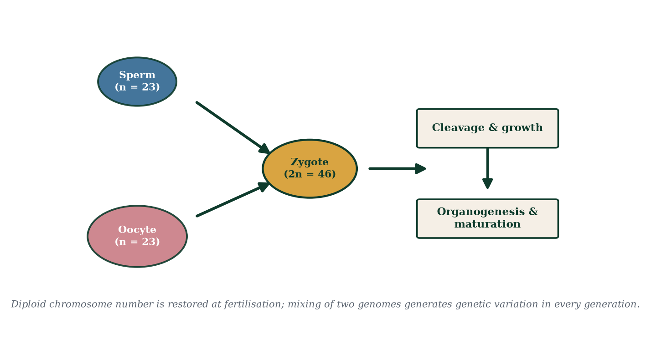
Figure 1.2 — Sexual reproduction in outline: haploid gametes fuse to form a diploid zygote; development and maturation follow.

1.2 Levels of organisation in reproductive biology
Reproductive biology is general biology applied to one specialised system. It cannot be understood at a single level of organisation (Figure 1.1):
- Molecular — DNA sequence variation, hormone receptors, enzyme kinetics, signalling cascades. Example: a single amino-acid substitution in the androgen receptor abolishes masculinisation despite normal testosterone levels.
- Cellular — gamete production in seminiferous tubules and ovarian follicles; Sertoli cell support; endometrial cell signalling; syncytiotrophoblast hCG secretion.
- Tissue — stratified squamous epithelium of the vaginal wall; the three interlacing smooth-muscle layers of the myometrium; glandular and stromal elements of the endometrium; ciliated epithelium of the fallopian tube.
- Organ — testes, ovaries, uterus, cervix, vagina, penis, mammary glands, placenta.
- Organ system — the integrated hypothalamic–pituitary–gonadal (HPG) axis, linking brain, gonads and target organs through feedback.
- Organism — reproductive lifespan, fertility patterns, pregnancy, lactation, ageing — embedded in behaviour, relationships, culture and society.
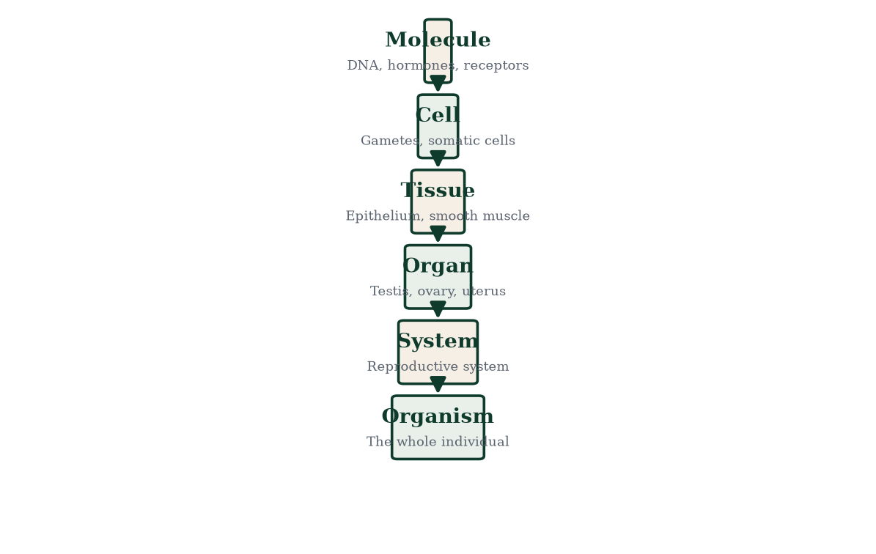
Figure 1.1 — Levels of biological organisation applied to human reproduction. Mechanisms at each level constrain and enable the levels above them.
A discipline worth practising throughout this book: whenever a reproductive claim appears, ask at which level does this operate, and what is happening one level below? ‘The corpus luteum supports early pregnancy’ is true at the organ level; it becomes complete only when we descend to luteal progesterone acting on nuclear receptors in endometrial stromal cells, altering transcription of genes that drive secretory transformation (Chapters 6, 7, 8 and 14). Mechanistic thinking is a habit, not a gift.

1.3 Biological sex development in outline
Biological sex is not a single switch but a cascade of sequential, genetically and hormonally controlled steps (Figure 2.7; Chapters 2 and 19):
- Chromosomal sex — set at fertilisation. Typically 46,XX (the oocyte always contributes an X) or 46,XY (the sperm contributes X or Y). The Y chromosome carries SRY, the principal switch toward testis development.
- Gonadal sex — by week 7 of embryonic life the bipotential gonad differentiates into testis or ovary. SRY drives SOX9 expression in supporting-cell precursors → Sertoli cells → anti-Müllerian hormone (AMH) secretion and testicular organisation. Without SRY (typical XX), WNT4/RSPO1 signalling drives ovarian differentiation.
- Hormonal sex — from ~week 8–9, testicular Sertoli cells secrete AMH (regressing the Müllerian ducts) and Leydig cells secrete testosterone (stabilising the Wolffian ducts → epididymis, vas deferens, seminal vesicles). Testosterone is converted by 5α-reductase in target tissues to dihydrotestosterone (DHT), which drives external masculinisation (phallus, scrotum, prostate). In the absence of these signals, the Müllerian ducts develop into the uterine tubes, uterus and upper vagina.
- Phenotypic sex — observed internal and external genitalia; depends on hormones and on functional receptors in target tissues.
- Pubertal activation — reactivation of the HPG axis [2] superimposes secondary sexual characteristics, the growth spurt, fertility and sexual maturation.
Each step is independently variable, and variation at earlier steps cascades into later ones. Individuals are not defined by any single marker; Chapter 19 examines differences in sex development (DSDs) explicitly and rejects the notion that chromosomes, genitalia, hormone levels or brain organisation alone constitute ‘the’ definition of sex.
Gender identity — a person’s innate, personal sense of being male, female, both, neither or differently gendered — is a distinct dimension of human experience influenced by complex, incompletely understood interplay of biology, development and environment. It is not determined by the appearance of genitalia at birth. Sexual orientation describes the pattern of emotional and sexual attraction; sexual behaviour describes action; both are distinct from reproductive biology proper, which explains capacity and mechanism, not identity or desire. This book uses ‘male’ and ‘female’ for typical developmental patterns and organs, treats variation as ordinary biology (Chapter 19), and respects the reader’s right to accurate, non-stigmatising language.

1.4 Reproductive lifespan
Human reproductive function is temporally bounded at both ends of life (Figure 1.3).
Before birth: gonads differentiate (weeks 6–9). The female fetus manufactures her entire lifetime supply of primary oocytes by mid-gestation (~6–7 million at 20 weeks, falling to ~1–2 million at birth) — oogenesis is finished as a production line before the woman is born. The male fetus produces primordial germ cells that remain dormant, then proliferate as spermatogonia at puberty.
Childhood: the HPG axis is functionally silent. The brake is exerted at the hypothalamus, which suppresses pulsatile GnRH secretion; part of the brake is exquisite sensitivity of the axis to even tiny quantities of circulating sex steroids, part is central inhibition from higher centres. Mini-puberty (a brief neonatal surge) occurs in the first months of life and then subsides.
Puberty: the hypothalamic brake releases. GnRH pulses restart nocturnally, then around the clock; LH and FSH rise; gonadal steroidogenesis resumes. In girls, thelarche (breast budding) is typically first, followed by pubarche (pubic hair, adrenarche-driven), the growth spurt, and menarche (first menstruation, average ~12–13 years). In boys, testicular enlargement (volume >3–4 mL) is the first sign, followed by penile growth, pubic hair, voice deepening, the growth spurt and first ejaculation (~13–14 years). Timing is driven by genetics, nutrition, body composition (leptin is a permissive signal) and health; girls now reach menarche earlier than in the 19th century, largely attributed to improved childhood nutrition.
Adulthood: peak fertility in the twenties. Female fertility declines progressively from the early thirties as the follicle reserve shrinks and oocyte aneuploidy rises; fecundability falls from ~25–30% per cycle at age 25 to ~5% by 40. Male fertility declines more gradually from the late thirties/forties.
Menopause: in females, ~12 consecutive months without menstruation, average age ~51, marks the permanent end of ovarian cycling (Chapters 8 and 18). It is a physiological transition, not a disease — though symptoms (vasomotor, sleep, mood, urogenital) and long-term sequelae (bone, cardiovascular, metabolic) are clinically important. Males have no abrupt equivalent; testosterone and sperm parameters erode gradually over decades (Chapters 9 and 18).
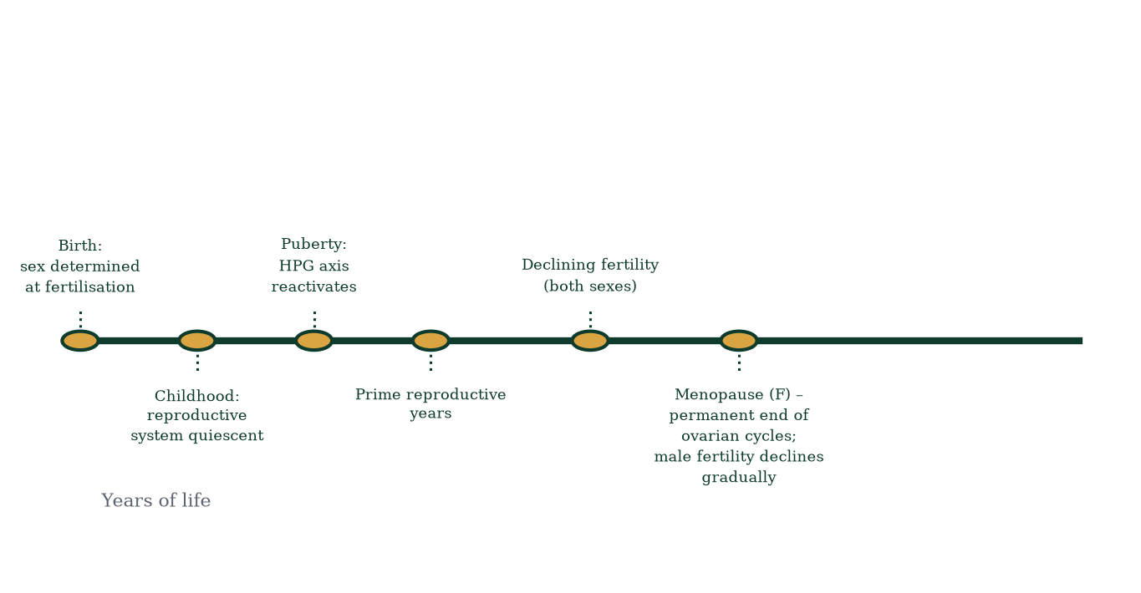
Figure 1.3 — The human reproductive lifespan. Puberty reactivates the HPG axis; menopause ends female cycling; male fertility wanes gradually.
The asymmetry between the sexes — abrupt menopause in females, gradual decline in males — is one of the great puzzles of reproductive biology. Hypotheses include the ‘grandmother hypothesis’ (selection favours post-reproductive investment in existing descendants) and the artifact of longer lifespan in modern environments. The phenomenon itself is a reminder that reproductive lifespan, like all of biology, is a trait under selection, not an engineering guarantee.

1.5 Anatomy and physiology are one subject
It is tempting to treat anatomy as a catalogue of parts and physiology as a parade of functions. They are inseparable. Every reproductive structure is shaped by its job:
- The epididymis is a ~6-metre coiled duct because sperm leaving the testis are immotile and need a long, slow residence (10–14 days) to acquire motility and fertilising capacity.
- The fallopian tube lined by ciliated epithelium beats toward the uterus because the oocyte cannot propel itself; cilia plus muscular peristalsis deliver it.
- The myometrium has three interlacing smooth-muscle layers (outer longitudinal, middle oblique/spiral, inner circular) that squeeze the fetus downward in coordinated labour and then clamp down on spiral arterioles to limit postpartum blood loss.
- The cervix produces mucus whose water content, pH and microstructure switch with the cycle: watery and alkaline around ovulation (sperm-permissive), scant and viscous at other times (mechanical barrier).
- The scrotum holds the testes 2–4 °C below core temperature because spermatogenesis is temperature-sensitive; Dartos and cremasteric muscles fine-tune position.
Running in the opposite direction, behaviour and environment reshape anatomy and physiology: lactation enlarges and sustains Lobulo-alveolar mammary units; prolonged negative energy balance suppresses GnRH pulses and can suspend cycling (functional hypothalamic amenorrhoea); stress, shift work and circadian disruption alter hormonal rhythms; exercise, smoking and nutrition modulate fertility. Anatomy, physiology, behaviour and environment form a closed causal loop (Figure 1.4). This book never asks ‘what is this part?’ without also asking ‘why is it built this way, what does it do, and what breaks when it fails?’
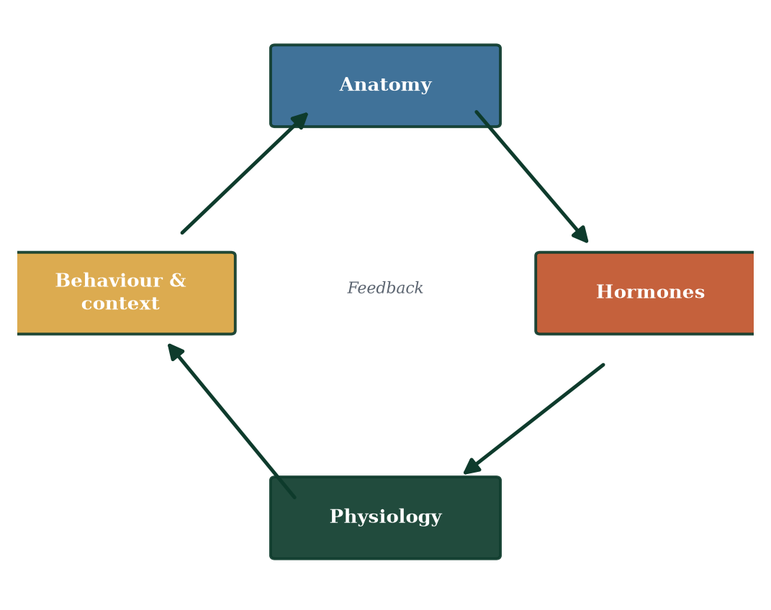
Figure 1.4 — The interlock loop: anatomy constrains physiology; physiology reshapes anatomy; behaviour and environment feed back on both.

1.6 Reproduction in context: why this book exists
Reproductive biology sits at the crossroads of medicine, public health, ethics and personal life. Roughly one in six people of reproductive age experience infertility; contraception underpins family planning and maternal survival; pregnancy is among the most demanding physiological transitions a human body undergoes; assisted reproduction routinely creates life in the laboratory; reproductive cancers touch a large fraction of the population. Yet reproductive biology is routinely taught as lists — hormone names, cycle days, organ labels — divorced from mechanism, and the knowledge evaporates within months of the examination.
The remedy is mechanistic understanding. Every chapter in this book is organised so that facts are conclusions, not premises. You will learn the menstrual cycle not as ‘day 1, day 14, day 28’ but as the visible readout of an HPG feedback loop read through its hormones; implantation not as ‘a stage’ but as a molecular negotiation between the syncytiotrophoblast and endometrial epithelium; labour not as ‘contractions begin’ but as a self-amplifying oxytocin reflex in which cervical stretch is both stimulus and effect (Chapter 16). When a fact follows from a mechanism, forgetting the fact becomes almost impossible — the mechanism rebuilds it on demand. That is the entire philosophy of this textbook.
How the science is organised. Part I (Chapters 1–4) lays the foundations: this introduction, inheritance (Ch 2), male anatomy (Ch 3), female anatomy (Ch 4). Part II (Chapters 5–9) covers gametes and hormones: spermatogenesis (Ch 5), oogenesis and the follicle (Ch 6), the endocrine axis (Ch 7), the menstrual cycle (Ch 8), and male hormonal regulation and sexual function (Ch 9). Part III (Chapters 10–13) follows fertilisation and early development: gamete meeting (Ch 10), cleavage and implantation (Ch 11), embryogenesis (Ch 12), and the fetus (Ch 13). Part IV (Chapters 14–17) covers pregnancy and birth: the placenta (Ch 14), maternal adaptation (Ch 15), labour and the postpartum period (Ch 16), and lactation (Ch 17). Part V (Chapters 18–20) addresses reproductive health and integration: disorders and contraception (Ch 18), variation and genetics (Ch 19), and the complete integrated journey (Ch 20).

1.7 A note on language, ethics and accuracy
This book uses precise terminology. Oocyte and ovum are distinct; embryo (fertilisation to week 8) and fetus (week 9 to birth) are distinct; sex (biological) and gender (identity) are distinct. Where the evidence is settled — gametogenesis, the HPG axis, implantation mechanisms — this book states the science plainly. Where evidence is emerging — for example, the mechanisms linking PCOS to insulin resistance, or the evolutionary logic of menopause — that status is declared. Correlation is not causation, and this book flags the difference rather than blurring it. And because reproduction touches every reader’s body and every family, the language throughout is deliberately respectful: differences in sex development are variations of human biology, not failures of construction.

1.8 Mechanisms and evidence in depth: myth, mechanism and the making of reproductive medicine
Reproductive biology attracts myth more reliably than any other branch of physiology. Dispelling myth by mechanism is both good scientific literacy and a good test of understanding.
The “calendar method” myth. The calendar method assumes a 28-day cycle with ovulation on day 14. Mechanism refutes both premises: follicular phase length varies by several days even in the same woman, and the fertile window extends five days before ovulation. Calendar contraception fails in roughly 20–25% of couples per year — not because women fail, but because the model is wrong.
The “period synchrony” myth. Rigorous longitudinal studies with diaries and hormone assays show no evidence that menstrual cycles synchronise between cohabiting women; apparent clustering is selection bias. Mechanistically, independent HPG axes have independent set-points; no pheromonal coupler entrains them.
The “sperm race” myth. Sperm do not sprint; they reside in cervical and isthmic reservoirs over hours to days, are released gradually, and fertilisation follows capacitation gating. The fertilising sperm is selected by membrane competence, not sprint speed.
The “all miscarriages are hormonal” myth. About half of first-trimester miscarriages are chromosomal — the fetal genome vetoes development. Hormonal, anatomical, immune and infectious causes account for the rest; mechanism dictates which investigation yields a culprit, and why karyotyping products of conception is often more informative than a progesterone level.
The “HRT causes every cancer” myth. Combined HRT modestly raises breast cancer risk, largely reversible within ~5 years of stopping; oestrogen-only HRT does not raise breast cancer risk; both reduce fractures; risk is lower when started within 10 years of menopause (the “window of opportunity”). Mechanistic literacy replaces fear with stratification.

How the field was built: a brief mechanistic history
Reproductive biology advanced when instruments arrived to watch the invisible. Spallanzani’s experiments on amphibians proved semen contained the fertilising agent; Barry first observed fertilisation in a rabbit egg; Hertwig saw pronuclear union in sea urchins; van Leeuwenhoek found the sperm; von Baer discovered the mammalian ovum; Boveri and Sutton linked chromosomes to inheritance; amniocentesis, radioimmunoassays of hormones, ultrasound, in-vitro fertilisation (Steptoe and Edwards, 1978) and genome sequencing each mechanised the next layer. Every generation of this field traded mystery for mechanism.

The economics of reproductive biology — why this subject matters at scale
One in six people of reproductive age experiences infertility (WHO). Contraception averts an estimated 230,000 maternal deaths per year globally. Preterm birth is the single largest cause of neonatal mortality. Cervical cancer is screenable and preventable. Menopause management affects half the population for a third of their lives. Reproductive medicine is not niche — it is one of the largest public-health opportunities in existence, which is why mechanistic literacy in this field is both intellectually satisfying and socially necessary.

1.9 Clinical reasoning vignettes
Case 1. A student memorises “LH triggers ovulation.” Asked why ovulation didn’t occur in a 17-year-old athlete with amenorrhoea, she cannot answer. Mechanism would tell her: energy deficit → low leptin → suppressed kisspeptin → low GnRH pulsatility → low LH → no surge → no ovulation. The fact, unanchored, is useless; the mechanism is a diagnostic tool.
Case 2. A patient asks why she feels hot during menopause. The rote answer is “hormones changing”. The mechanistic answer — oestradiol fall → KNDy neurone hyperactivity in the arcuate nucleus → erroneous heat-dissipation response — explains both the trigger and why layering clothes and cool rooms help, and why oestrogen therapy treats the cause.
Case 3. A couple ask why they cannot conceive “just one more month”. The arithmetic of fecundability (20–30% per cycle at peak) predicts ~84% conception within 12 months of regular intercourse; mechanism also predicts that timing matters only near ovulation — so “tracking fertile days” is mechanism, not superstition.

Self-check — can you derive these without notes?
- Reconstruct the menstrual cycle purely from feedback logic.
- Explain why twins are more common after ART.
- Predict the axis findings in a marathon runner with amenorrhoea.
- Explain why a vasectomy takes ~3 months to become sterile.
- Explain why oxytocin cannot induce labour before cervical ripening.
If you can derive all five from first principles in this chapter alone, you are ready to move on.

Chapter summary
- Reproduction ensures the continuity of lineages; reproductive success is fitness transmitted across generations.
- Human reproduction is sexual: two haploid gametes fuse to form a unique diploid zygote; meiosis plus fertilisation shuffle genomes.
- Biological sex is a cascade — chromosomal → gonadal → hormonal → phenotypic — with each step independently variable.
- Gender identity and sexual orientation/behaviour are distinct from biological sex and are treated respectfully, not mechanistically.
- Reproductive lifespan runs from puberty to menopause in females (~40 years) and extends longer, though declining, in males.
- Anatomy is physiology frozen in structure; physiology is anatomy in motion; behaviour and environment complete the loop.
- Mechanism, not memorisation, is the method of this book.

Key terms
Reproduction — production of new individuals. Reproductive success (fitness) — genes transmitted via offspring who themselves reproduce. Sexual reproduction — reproduction via gamete fusion. Gamete — haploid reproductive cell (sperm or oocyte). Zygote — the first cell of a new organism. HPG axis — hypothalamus–pituitary–gonad control loop. Bipotential gonad — embryonic gonad able to become testis or ovary. AMH — anti-Müllerian hormone. 5α-reductase — converts testosterone to DHT. Puberty — activation of the reproductive axis in adolescence. Menopause — permanent cessation of menstrual cycles (12 months’ amenorrhoea). Fecundability — probability of conception per cycle. DSD — differences in sex development.

Review questions
Multiple choice
- Sexual reproduction is advantageous principally because it:
  - produces more offspring per parent than asexual reproduction
  - generates genetic variation among offspring
  - requires no hormonal regulation
  - guarantees the survival of every offspring
- At fertilisation, the typical human zygote is:
  - haploid (n = 23) b) triploid (3n = 69) c) diploid (2n = 46) d) tetraploid (4n = 92)
- The typical order of sex-determining steps in development is:
  - phenotypic → gonadal → chromosomal → hormonal
  - chromosomal → gonadal → hormonal → phenotypic
  - hormonal → chromosomal → phenotypic → gonadal
  - gonadal → chromosomal → hormonal → phenotypic
- Menopause is defined clinically as:
  - twelve consecutive months without menstruation
  - any hot flush after age 45
  - ovarian oocyte depletion before birth
  - surgical removal of both ovaries
- A ~6-metre epididymis principally reflects the physiological requirement for:
  - sperm storage volume
  - completion of sperm maturation and acquisition of motility
  - protection of sperm from testosterone
  - immune tolerance of sperm
- Which best describes this book’s recommended method of study?
  - Memorising cycle-day constants
  - Anchoring every fact to its mechanism
  - Reading chapter summaries only
  - Learning Latin nomenclature before physiology
- In the levels-of-organisation framework, ‘inhibin selectively suppresses FSH’ is an example operating at the:
  - organ level only b) molecular/cellular level c) organismal level only d) tissue level only
- The most common first visible sign of male puberty is:
  - voice deepening b) growth spurt c) testicular enlargement d) facial hair
Short answer
- Define reproductive success in evolutionary terms and explain why merely producing offspring is insufficient.
- List the four levels of sex determination in typical development and give one example in which two levels diverge.
- State two leading evolutionary hypotheses for the persistence of sexual reproduction.
- Name three physiological changes of puberty shared by both sexes and one that differs by sex.
Explanation
- Explain why the textbook insists that ‘anatomy is physiology frozen in structure’, giving three reproductive examples.
- Explain the difference between biological sex, gender identity and sexual orientation, and state why the distinction matters clinically.
Application
- A 19-year-old asks why siblings differ genetically despite sharing the same parents. Using only concepts introduced so far, give a complete mechanistic answer.
- A 46,XY infant is born with female-appearing external genitalia. Outline, without diagnosing, which cascade step(s) could be involved and why this illustrates the cascade model.
- A 29-cycle-day variation between 26 and 34 days is reported in an otherwise healthy 23-year-old. Explain why this is compatible with normal HPG physiology.
- Explain why negative energy balance (e.g. in endurance athletes) can suppress menstruation, referring to the HPG axis and a permissive metabolic signal.

Answers to review questions
- b. Variation is the core advantage; sex is costly, so its persistence is maintained by variation-dependent selection (Red Queen; mutation clearance).
- c. Haploid gametes fuse; the diploid 46-chromosome constitution is restored and is unique to each individual.
- b. Chromosomal sex is set at fertilisation; gonads differentiate (SRY/WNT4); hormones then act; phenotype follows.
- a. Menopause is a retrospective definition — 12 months of amenorrhoea; the average age is ~51.
- b. Sperm exiting the testis are immotile; the slow transit permits maturation membranes to stabilise, residual bodies to be absorbed and motility to develop.
- b. Mechanistic anchoring produces durable knowledge.
- b. Inhibin synthesis by Sertoli/granulosa cells and selective FSH suppression is molecular/cellular signalling.
- c. Testicular enlargement (>3–4 mL) precedes penile growth, pubic hair, voice deepening and the growth spurt.
- Reproductive success is the transmission of one’s genes into grandchildren via offspring who themselves reproduce. Offspring who die before reproduction or are infertile contribute no further copies of the parent’s genome, so survival and fertility of offspring are part of the definition.
- Chromosomal, gonadal, hormonal, phenotypic. Divergence example: 46,XY with complete androgen insensitivity — chromosomal male, testes present (gonadal male), testosterone produced (hormonal male), but androgen receptors non-functional, so phenotype develops as female-typical external genitalia.

  - Red Queen hypothesis — ongoing co-evolutionary arms race with parasites selects for genotypic diversity; (ii) mutation clearance — recombination exposes deleterious recessive alleles to selection, purging them.
- Shared: growth spurt, adrenarche/pubertal hair, HPG reactivation, skin oiliness/acne, body composition changes. Different: menarche/breast development in females vs testicular enlargement/voice deepening in males.
- Examples: (i) epididymal length = slow maturation; (ii) fallopian tube cilia = directed oocyte transport; (iii) myometrial interlacing layers = coordinated labour contractions and postpartum haemostasis; (iv) cervical crypts and cyclical mucus = controlled sperm passage. Structure is function made visible.
- Biological sex = anatomical/endocrine characteristics; gender identity = personal sense of gender; sexual orientation = pattern of attraction. The distinction matters clinically because history-taking, counselling, screening, medication dosing and reproductive counselling must respect the person, not the label — and because conflating them causes diagnostic error and harm.
- Meiosis crosses over alleles and assorts chromosomes independently, so each gamete carries a unique allele combination; random fertilisation picks one sperm and one oocyte from the two parents’ populations of gametes; zygotic genomes therefore differ between siblings even though the parents are the same.
- Possible steps: chromosomal (e.g. SRY translocation — rare), gonadal (gonadal dysgenesis — testes fail to form or function), hormonal (testosterone or DHT synthesis failure, e.g. 5α-reductase deficiency — DHT needed for external masculinisation), or receptor level (androgen insensitivity — hormone present but ignored). Cascade logic: failure at any downstream step decouples phenotype from the upstream steps; the direction of the failure points to the responsible level (Chapter 19).
- Cycle length = follicular phase (variable) + luteal phase (~14 d, relatively fixed). GnRH pulse dynamics and follicular cohort recruitment vary cycle to cycle; variation of ±4 days around 28 is physiologic (→ Chapter 8).
- The hypothalamus gates GnRH pulsatility by energy availability; leptin (from adipose) is a key permissive signal. Sustained energy deficit lowers leptin and elevates hypothalamic inhibition, reducing GnRH pulse frequency, hence LH/FSH, hence ovarian steroidogenesis, hence cycling — a reversible state called functional hypothalamic amenorrhoea.

Chapter 2: Cells, Chromosomes, Genes, and Reproductive Inheritance
Learning objectives. After studying this chapter you should be able to: - describe the structure of DNA and the packing of chromatin into chromosomes; - explain mitosis and meiosis, and why the distinction matters for reproduction; - define genes, alleles, genotype, phenotype and the key laws of inheritance; - explain how sex chromosomes determine chromosomal sex and how variation arises; - account for the genetic contributions of each parent to offspring; - explain how crossing over, independent assortment [10] and mutation generate variation.
Central question. How does each parent contribute half a genome, and how does meiosis guarantee both continuity and novelty?

2.1 The molecule of inheritance: DNA
Every cell in the human body (except mature red blood cells) carries the same complete set of genetic instructions, written in deoxyribonucleic acid (DNA). DNA is a polymer of nucleotides, each comprising a phosphate group, a deoxyribose sugar, and one of four nitrogenous bases: adenine (A), thymine (T), guanine (G) and cytosine (C). Two antiparallel chains wind around each other to form the double helix (Figure 2.1). The chains are held together by hydrogen bonds between complementary bases — A pairs with T (two hydrogen bonds), G pairs with C (three) — which is why the base composition of any DNA obeys Chargaff’s rules (A = T, G = C) and why one strand is the perfect template for the other. Complementarity is the entire chemical basis of replication, transcription and hybridisation diagnostics.
The backbone is held together by phosphodiester bonds between the 3′ carbon of one sugar and the 5′ phosphate of the next; synthesis always proceeds 5′→3′. The molecule’s stability comes from its covalent backbone and base stacking; its accessibility is regulated by chromatin packaging. Chromatin is chromosomal DNA wound around histone octamers forming nucleosomes (‘beads on a string’), further folded into loops, domains and ultimately the compact metaphase chromosome. Histone modification (methylation, acetylation) and DNA methylation tune which genes are transcribed — the layer of epigenetic control that, among other things, erases and resets imprinted marks during gametogenesis (Chapter 19).
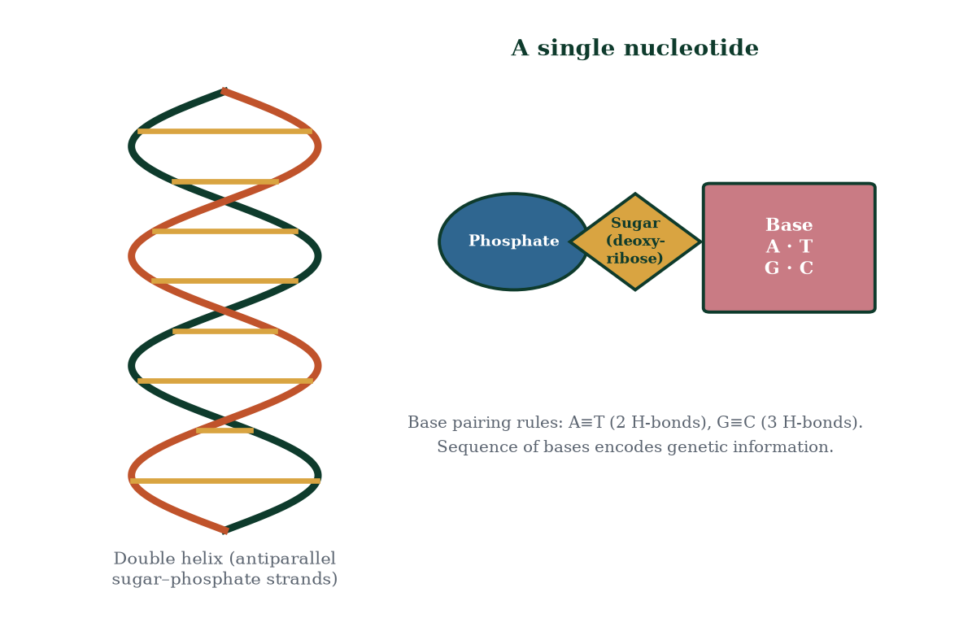
Figure 2.1 — The DNA double helix and nucleotide anatomy. Complementary base pairing (A≡T, G≡C) underlies all genetic information transfer.
A gene is a segment of DNA that encodes a functional product — almost always a protein, sometimes a functional RNA (rRNA, tRNA, microRNA). The complete DNA sequence of an organism is its genome. The human genome is ~3.2 billion base pairs long; roughly 20,000 protein-coding genes occupy only ~1.5% of it, the rest being regulatory sequence, introns, non-coding RNAs and repetitive DNA. The locus is the position of a gene on a chromosome; the alternative versions of a gene at that locus are alleles. Genotype is the allele set an individual carries; phenotype is the observable trait that results from genotype interacting with environment and chance.

2.2 Chromosomes and the human karyotype
Human somatic cells are diploid (2n = 46): 22 pairs of autosomes plus one pair of sex chromosomes — typically XX in females and XY in males. Pairs 1–22 are homologous: one member from each parent, carrying the same genes in the same order (with the same loci, though often different alleles). The sex chromosomes in males are only partly homologous: X and Y share small pseudoautosomal regions at their tips and differ elsewhere. A karyotype is the organised display of an individual’s chromosomes (Figure 2.2); the haploid number n = 23 defines gametes.
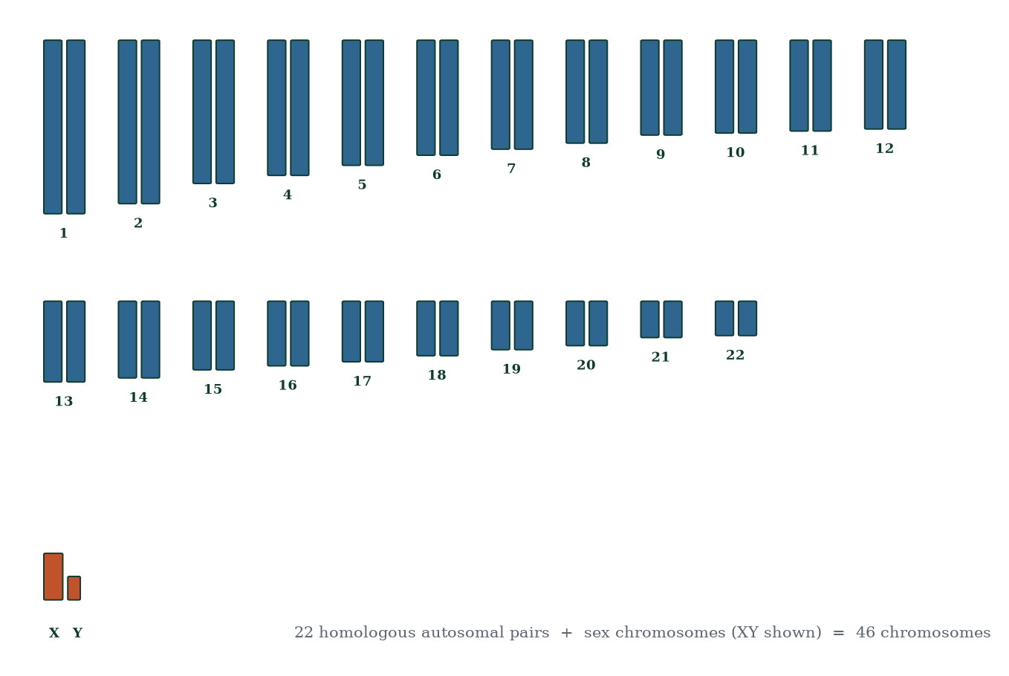
Figure 2.2 — The human karyotype: 22 homologous autosomal pairs plus the sex chromosomes. Ideogram of a typical male (46,XY).
Chromosomes are classified by centromere position (metacentric, submetacentric, acrocentric) and size. The centromere is the attachment point for spindle microtubules; the short arms are conventionally labelled p (petit) and long arms q. Chromosomes exist as long interphase threads (decondensed, actively transcribed) and condense dramatically in mitosis/meiosis for segregation, becoming visible as the classic X-shaped duplicated chromosomes (sister chromatids joined at the centromere).

2.3 Cell division I: mitosis — accurate copying
Mitosis produces two genetically identical diploid daughter cells. It is the machinery of growth, tissue maintenance and asexual propagation in general. The cycle: interphase (G1 growth; S phase — DNA replication; G2 checks) → prophase (chromatin condenses; nuclear envelope breaks down; spindle forms) → metaphase (chromosomes align at the equator, metaphase plate, under tension from kinetochore microtubules) → anaphase (cohesin is cleaved by separase; sister chromatids separate to opposite poles) → telophase (nuclei reform) → cytokinesis (cytoplasm divides via a contractile actin ring in animals). Crucially for reproduction, mitosis is what germ cells use to expand their populations before meiosis (spermatogonial stem cells; oogonial proliferation in fetal life) and what the zygote uses for cleavage divisions (Chapter 11). When mitosis goes wrong, chromosome-unstable clones emerge — one route to tumours; when germ-cell mitosis is error-prone, mutations accumulate across generations.
The cell cycle is checkpoint-guarded. G1/S, G2/M and spindle-assembly checkpoints verify DNA integrity and chromosome attachment before allowing progression. Failure permits replication of damaged or mis-segregated DNA. Reproductive tissues exploit and suffer from this: the testis tolerates remarkably high turnover because checkpoints and apoptosis cull defective cells; oocytes, by contrast, sit in meiotic arrest for decades — accumulating damage that likely contributes to age-related aneuploidy (Chapter 6).

2.4 Cell division II: meiosis — halving and shuffling
Meiosis is the specialised division that halves chromosome number and reshuffles alleles, producing haploid gametes. It comprises one round of DNA replication followed by two successive divisions (Figure 2.3, Figure 2.4).
Meiosis I — reductional division: - Prophase I (longest phase; in human oocytes lasting years): homologous chromosomes pair gene-for-gene in synapsis via the synaptonemal complex, forming bivalents (tetrads). Crossing over physically swaps chromosome arms between non-sister chromatids at chiasmata — generating recombinant chromosomes that mix maternal and paternal alleles. - Metaphase I: bivalents align at the equator; orientation of each pair is random (independent assortment). - Anaphase I: homologous chromosomes (not sister chromatids) separate — the chromosome number halves. - Telophase I / cytokinesis: two haploid cells, each with duplicated chromosomes.
Meiosis II — equational division (like mitosis): prophase II, metaphase II (chromosomes align singly), anaphase II (sister chromatids separate via centromere cleavage), telophase II → four haploid gametes.
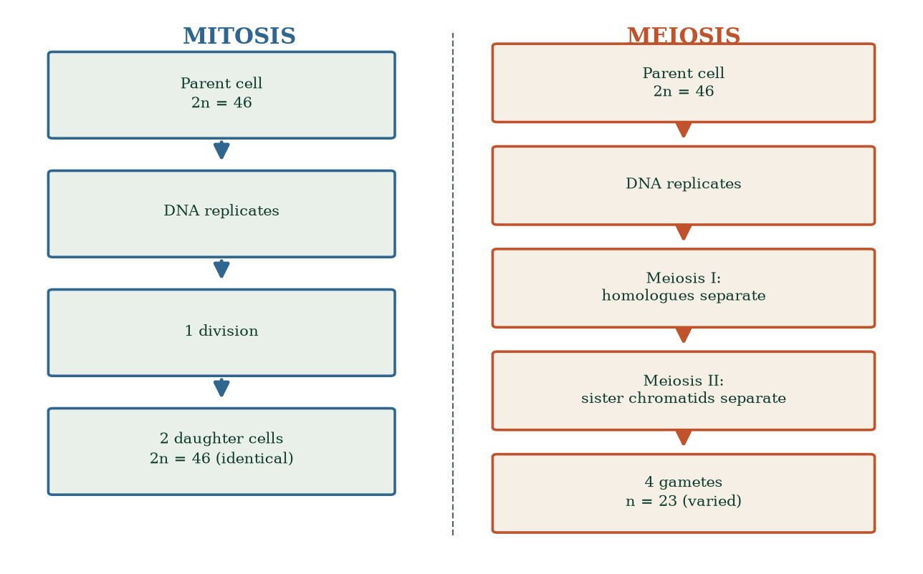
Figure 2.3 — Mitosis versus meiosis: outcome cell number, ploidy and genetic identity.
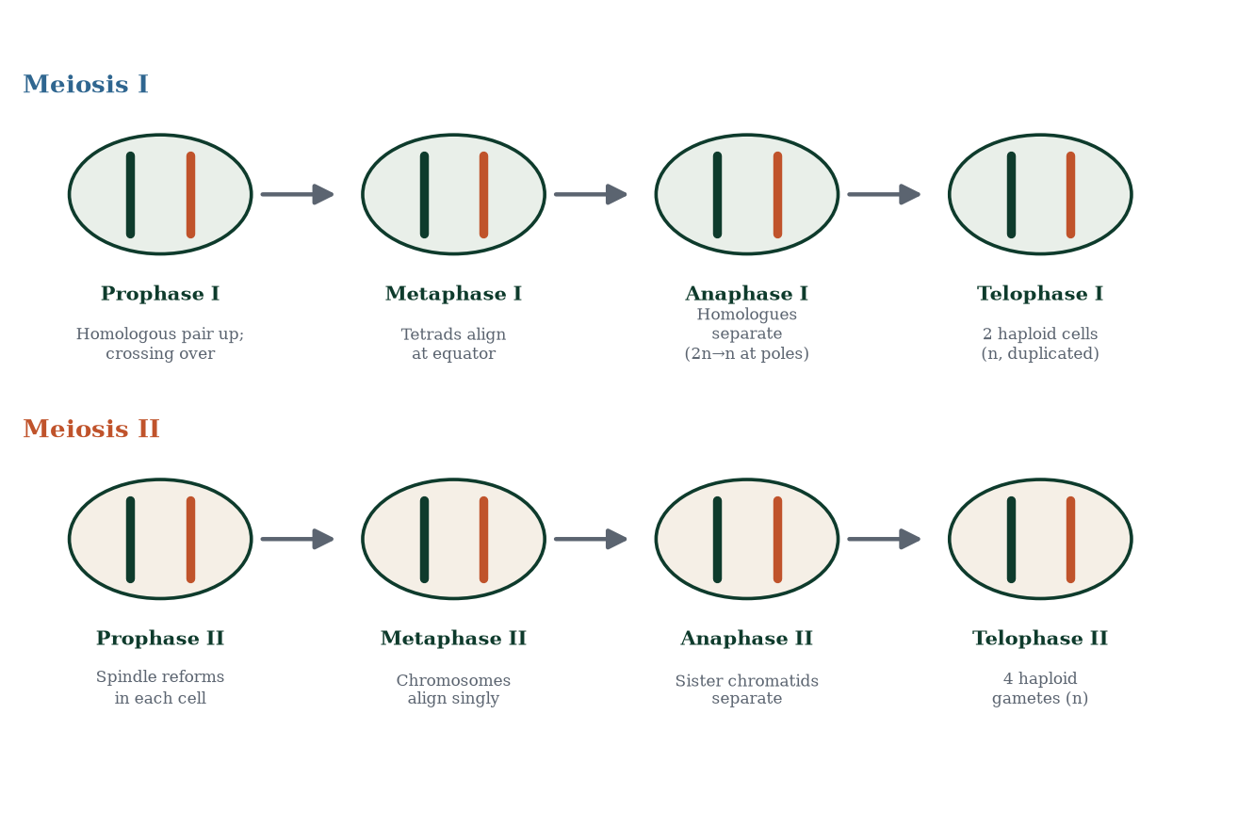
Figure 2.4 — The eight stages of meiosis I and meiosis II, showing the reduction of chromosome number and the production of haploid gametes.
Two features make meiosis the engine of variation:
- Crossing over — each human chromosome undergoes on average 1–3 chiasmata per meiosis; every chromatid becomes a unique mosaic. Exceptions prove the rule: the pseudoautosomal regions of X and Y recombine as homologues.
- Independent assortment — the maternal and paternal members of each bivalent orient randomly at the metaphase I equator, so each of the 23 pairs assorts independently: 2^23 ≈ 8.4 million gametic combinations from independent assortment alone. Combined with crossing over, the number of possible gametes from one person exceeds 10^25 — far more than the atoms in the Earth. Fertilisation then multiplies two such genomes: a unique individual is effectively guaranteed.
Nondisjunction — failure of chromosomes/chromatids to separate — produces aneuploid gametes (n+1 or n−1). After fertilisation these yield trisomic or monosomic zygotes (e.g. trisomy 21, Turner syndrome 45,X; Chapter 19). Risk rises steeply with maternal age because oocytes complete meiosis I only at ovulation, decades after the process began; spindle and cohesion proteins age with the oocyte.

2.5 From genotype to offspring: the rules of inheritance
Mendel’s law of segregation: each individual carries two alleles for each autosomal gene; they separate during gamete formation, so each gamete carries one. Law of independent assortment: alleles of genes on different chromosomes (or far apart on the same chromosome) distribute independently into gametes. Dominance: a single copy of a dominant allele can determine phenotype; recessive phenotypes appear only when both alleles are recessive. Incomplete dominance and co-dominance (e.g. ABO blood group: IA and IB are co-dominant, both dominant to i) refine the picture.
Punnett squares make segregation explicit. For a monohybrid cross of two heterozygotes (Aa × Aa): 1 AA : 2 Aa : 1 aa genotypically, 3 dominant : 1 recessive phenotypically. Dihybrid cross (AaBb × AaBb): 9:3:3:1 phenotypic ratio when genes assort independently. Linked genes (same chromosome, close together) violate independent assortment; recombination frequency between loci is proportional to map distance (1 map unit = 1% recombinant progeny) — the basis of genetic linkage maps and of locating disease genes.
Pedigree analysis distinguishes autosomal dominant (no generation skipping; both sexes; male-to-male transmission occurs), autosomal recessive (skips generations; consanguinity increases risk), X-linked recessive (mostly males; carrier mothers; no male-to-male transmission) and mitochondrial (always maternal transmission). Penetrance (fraction of genotype carriers showing the phenotype) and expressivity (degree of expression) modulate simple ratios. Polygenic traits (height, skin pigmentation, most quantitative traits) reflect many loci plus environment — they form continuous distributions, not Mendelian classes.

2.6 Sex chromosomes and sex determination
The 23rd pair decides chromosomal sex. The oocyte always carries X; the sperm carries X or Y with equal probability, so each conception is ~50% likely to be 46,XX [3] and ~50% 46,XY (Figure 2.5). The SRY (sex-determining region of Y) gene encodes the testis-determining factor, a transcription factor that triggers SOX9 → Sertoli cell differentiation → gonadal testis development (Figure 2.7). Without SRY, WNT4/RSPO1 signalling drives ovarian differentiation. 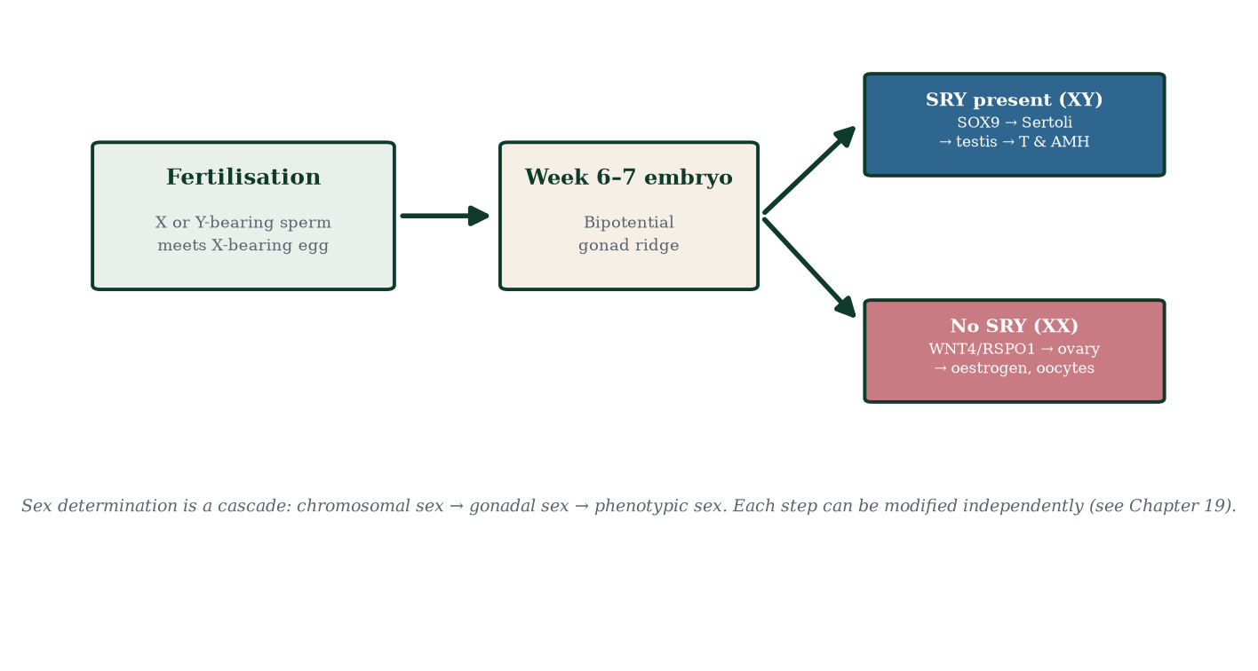
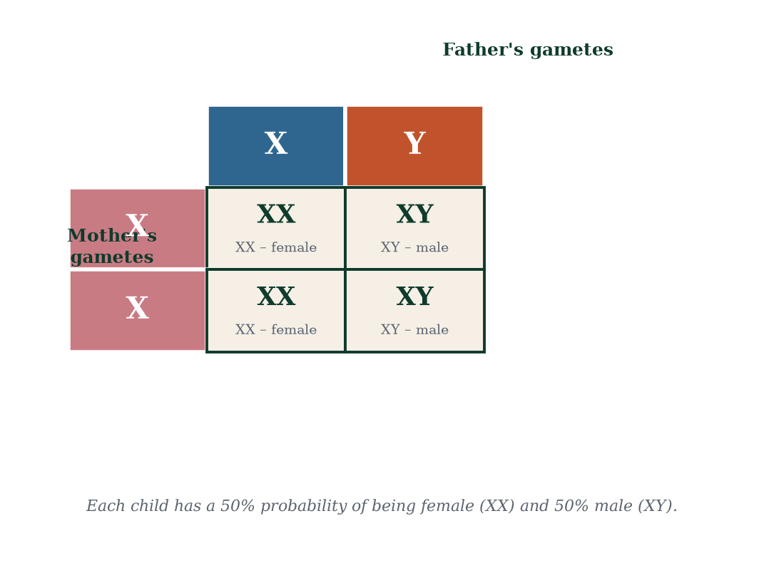
Figure 2.5 — Sex chromosome inheritance: a 50:50 probability of XX or XY offspring per conception.
Over evolutionary time, Y has eroded to ~55 protein-coding genes, surviving because male-beneficial genes near SRY were co-retained; X retains ~800 genes. Females therefore carry two doses of X-linked genes but silence one X in each cell via X-inactivation (lyonisation) early in embryonic life: one X condenses into a heterochromatic Barr body, expressed genes escape (15–25% of genes), and the choice is clonally inherited. This equalises X dosage between sexes (dosage compensation) but makes female mammals mosaics — most famously for X-linked coat-colour genes in calico cats, and clinically for carrier states of X-linked disease.

2.7 Variation: the engine and the raw material
Every human (apart from identical twins, who are clones of one zygote) is a unique genome assembled by meiosis and fertilisation (Figure 2.6). Quantify the shuffling:
- 2^23 (~8.4 × 10^6) combinations from independent assortment alone;
- additional combinatorial explosion from crossing over (effectively unlimited mosaic chromosomes);
- 2^23 × 2^23 ≈ 7 × 10^13 zygote combinations per couple before even considering crossing over — effectively infinite in practice;
- plus mutation: ~60–100 new single-nucleotide mutations arise per genome per generation — raw material for all evolution, most of it neutral, occasionally functional.
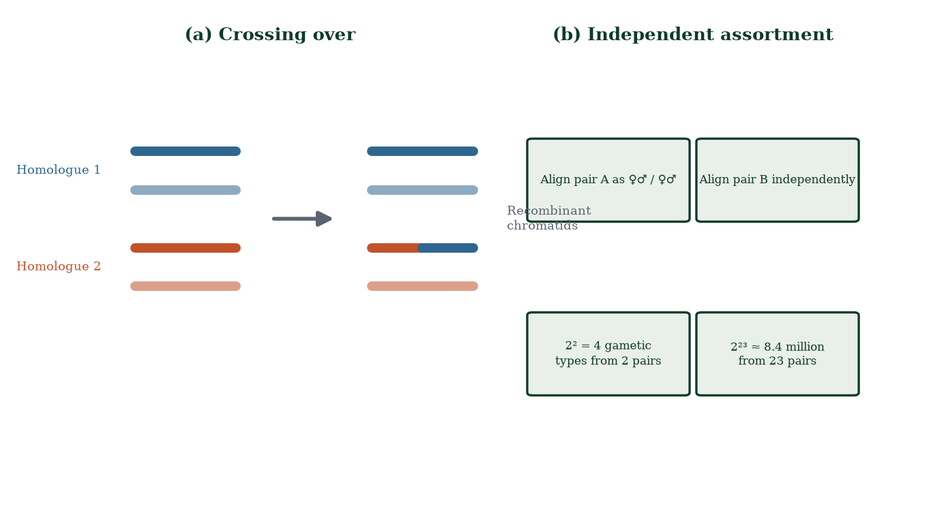
Figure 2.6 — Sources of gametic variation: crossing over (left) recombines alleles on one chromosome; independent assortment (right) randomises chromosome combinations.
Variation is not a defect to be managed; it is the reproductive system’s product. Clinically, the same mechanisms produce chromosomal disorders, unmask recessive traits, and underlie the genetic uniqueness of every family.

2.8 Epigenetics and imprinting
Not all inherited information is DNA sequence. Epigenetic marks — DNA methylation, histone modifications, non-coding RNAs — regulate gene accessibility. During gametogenesis, a specialised programme erases and re-establishes sex-specific methylation imprints. Genomic imprinting means some genes are expressed monoallelically depending on parent of origin; imprinting errors cause disorders such as Prader–Willi and Angelman syndromes (chromosome 15q11-q13) and Beckwith–Wiedemann syndrome (11p15). Imprinting breaks Mendel’s assumptions deliberately — proof that inheritance includes information beyond the sequence.

2.9 Mechanisms and evidence in depth: deeper genetics for the reproductive biologist
Mitochondrial genetics. mtDNA is 16,569 bp, circular, maternally inherited, with thousands of copies per cell. Replication is relaxed; heteroplasmy (mixtures of mutant and normal mtDNA) determines severity — threshold effect typically >60–80% mutant load before disease appears. mtDNA encodes 13 oxidative phosphorylation proteins; the rest are nuclear-encoded. Diseases: MELAS, MERRF, Leber hereditary optic neuropathy, Leigh syndrome. Random segregation at division makes siblings differ in severity — the basis of variable penetrance unknown in nuclear genetics, and the rationale for mitochondrial replacement techniques (legal in the UK since 2015).
Trinucleotide repeat expansion. Some genes carry repeated codons (CGG in FMR1, CAG in HTT, CTG in DMPK). Repeat number grows across generations — genetic anticipation: Huntington disease (CAG; ≥36 repeats penetrant, juvenile onset >60), fragile X (CGG 55–200 premutation, >200 full mutation with FMR1 methylation shut-off). Different repeats misbehave by parent of origin — CAG expands in spermatogenesis (anticipation through fathers), CGG expands in oogenesis (anticipation through mothers).
Chromosome banding and the karyotype. G-banding (Giemsa on AT-rich regions) yields the striped chromosomes enabling identification of individual chromosomes and structural anomalies; FISH maps specific loci with fluorescent probes; chromosomal microarrays and whole-genome sequencing now detect microdeletions invisible to standard karyotyping — clinical cytogenetics’ march from morphology to sequence.
Genomic imprinting in detail. Imprinting control regions carry parent-of-origin differential methylation established in gametogenesis. After fertilisation the paternal genome is actively demethylated, the maternal passively — except imprinted loci, protected by ZFP57. Failure causes Prader–Willi/Angelman (15q11-q13), Beckwith–Wiedemann and Silver–Russell (11p15) syndromes. Imprinting proves the epigenome has a lifecycle interlocked with the germ line.
Worked problem. Both parents carry cystic fibrosis (autosomal recessive; CFTR). Punnett: 25% affected, 50% carriers, 25% unaffected non-carriers — the classic result. The question they didn’t ask but should: does CF respect the 50/50 sex split? Autosomal, so yes; X-linked haemophilia, by contrast, would strike sons preferentially. Mechanism dictates options: PGT-M (embryo biopsy + CFTR screening) or NIPT can select mutation-free embryos — mechanism, not magic, dictates the possibilities.

Common errors in genetic reasoning
- “A gene is dominant so it always shows.” — incomplete penetrance and variable expressivity modify output.
- “Recessive equals rare.” — carrier frequencies matter: ~1 in 25 Europeans for CF; ~1 in 10 sickle-trait in sub-Saharan Africa.
- “Fathers transmit X-linked disease to sons.” — impossible; sons receive Y from fathers — a powerful pedigree consistency check.
- “All twins are genetically identical.” — monozygotic twins diverge epigenetically and accumulate somatic mutations.
- “More DNA means more complexity.” — 98% of our genome is non-coding; complexity is regulatory architecture, not gene count.

2.10 Clinical reasoning vignettes
Case 1. A couple, both 34, both unaware they are CF carriers, have a newborn with failure to thrive, recurrent chest infections and steatorrhoea. Sequencing confirms two CFTR mutations (ΔF508/ΔF508). Each parent’s prior risk: 1 in 25 (European carrier frequency). Mechanism: the child inherited one mutated allele from each — 1 in 4 chance for every pregnancy.
Case 2. A 38-year-old woman’s fetus is found to have trisomy 21 on NIPT. Mechanism: maternal meiotic nondisjunction at meiosis I (predominantly). The couple’s next-pregnancy recurrence: ~1–2% empirical (independent meiotic events) plus maternal-age-related risk; they should not infer that every pregnancy will be affected.
Case 3. A man carries a balanced Robertsonian translocation (14;21). Mechanistically, his gametes can produce: normal, balanced carrier, trisomy 21, monosomy 21, trisomy 14, monosomy 14 — several of which are incompatible with development; prenatal diagnosis or PGT-SR clarifies which embryos are viable.

Self-check — can you derive these without notes?
- Two balanced carriers of reciprocal translocation — what proportion of their children will be karyotypically normal AND phenotypically normal?
- Explain why mitochondrial disease severity varies among siblings (heteroplasmy).
- Derive Hardy-Weinberg equilibrium predictions for a recessive allele at frequency 0.05.
- Explain why a male with an X-linked recessive condition never transmits to sons.
- Describe how imprinting differs from X-inactivation mechanistically.

Chapter summary
- DNA’s complementary base pairing (A=T, G≡C) encodes genes; histone packaging and epigenetic marks control expression.
- Somatic cells are diploid (2n = 46); gametes are haploid (n = 23); a karyotype displays the 46 chromosomes.
- Mitosis yields identical diploid cells; meiosis yields four varied haploid gametes via one replication and two divisions.
- Meiosis creates variation through crossing over (recombinant chromosomes) and independent assortment (2^23 combinations).
- Segregation, independent assortment and dominance govern Mendelian inheritance; linkage, penetrance and expressivity refine it.
- SRY on Y initiates testis development; without SRY, ovarian development proceeds; X-inactivation equalises dosage.
- Imprinting shows inheritance includes non-sequence information.

Key terms
DNA — deoxyribonucleic acid. Nucleotide — phosphate + sugar + base. Gene — DNA segment encoding a functional product. Allele — alternative version of a gene. Locus — gene position on a chromosome. Autosome — non-sex chromosome. Karyotype — organised display of chromosomes. Diploid/haploid — 2n/n chromosome sets. Mitosis — division producing identical diploid cells. Meiosis — division halving ploidy and shuffling alleles. Synapsis — homologous chromosome pairing. Chiasmata — points of crossing over. Nondisjunction — failed chromosome separation. Aneuploidy — abnormal chromosome number. X-inactivation (lyonisation) — random silencing of one X. Genomic imprinting — parent-of-origin monoallelic expression.

Review questions
Multiple choice
- Adenine always pairs with thymine and guanine with cytosine because:
  - both are purines b) complementary hydrogen bonding c) both are pyrimidines d) they share nitrogen atoms
- How many chromosomes does a typical human somatic cell contain?
  - 23 b) 24 c) 46 d) 92
- Independent assortment of chromosomes occurs during:
  - prophase I b) metaphase I c) metaphase II d) anaphase II
- Crossing over occurs between:
  - sister chromatids b) non-sister chromatids of homologues c) X and Y exclusively d) autosomes and sex chromosomes
- A color-blind father (X^cY) and a carrier mother (X^C X^c) can produce a daughter who is:
  - affected only b) a carrier only c) affected or carrier d) neither
- Meiosis produces how many gametes from one primary germ cell?
  - 1 b) 2 c) 4 d) 8
- Which division reduces chromosome number by half?
  - meiosis I b) meiosis II c) mitosis d) cytokinesis
- A Punnett square for Aa × Aa gives genotypic ratios of:
  - 1:1 b) 3:1 c) 1:2:1 d) 1:1:1:1
Short answer
- Explain why gametes are haploid and why this matters for species chromosome number stability.
- Define crossing over and explain its contribution to variation, naming the structures involved.
- What is X-inactivation, when does it occur, and what is a Barr body?
- Distinguish autosomal dominant from autosomal recessive inheritance using pedigree features.
Explanation
- Walk through the fate of one chromosome pair from a primary spermatocyte to two sperm cells, in chronological order, naming the stages and stating the ploidy at each step.
- Explain why maternal age is the strongest known risk factor for trisomy 21, in terms of oocyte biology.
- Explain why identical twins are not genetically identical in every respect (consider mutation and X-inactivation).
Application
- Both parents are carriers of cystic fibrosis (autosomal recessive). Calculate the probability of (a) an affected child, (b) an unaffected carrier child, (c) an unaffected non-carrier child.
- A family has three sons, all with haemophilia A (X-linked recessive). What is the most likely genotype of the mother? Explain your reasoning.
- A karyotype shows 47,XX,+21. Describe the chromosomal event that produced this, identify the division in which nondisjunction most likely occurred, and state the critical oocyte process involved.

Answers to review questions
- b. A–T form two hydrogen bonds; G–C form three; purine–pyrimidine pairing also maintains constant helix width.
- c. 46 = 22 pairs of autosomes + 2 sex chromosomes.
- b. Bivalents orient randomly at the metaphase I plate; each pair’s orientation is independent.
- b. Homologous non-sister chromatids exchange segments at chiasmata in prophase I.
- c. Daughter receives X^c from father; mother gives X^C or X^c: X^C X^c (carrier) or X^c X^c (affected) — both possible, 50% each given a daughter.
- c. One meiosis yields four haploid products (one oocyte + polar bodies in females).
- a. Homologues separate in anaphase I; sister chromatids separate in meiosis II.
- c. 1 AA : 2 Aa : 1 aa.
- Gametes carry one chromosome set so that fusion (fertilisation) restores diploidy; without reduction, chromosome number would double every generation and development would be impossible.
- Crossing over is the physical exchange of chromatid segments between homologues at chiasmata during prophase I via the synaptonemal complex; it creates recombinant chromosomes mixing grandparental alleles, vastly multiplying gametic diversity.
- In early embryonic life (~X = 16–64 cells), one X per cell is randomly chosen and silenced by Xist RNA coating and heterochromatinisation; the condensed, inactive X is the Barr body; clonal inheritance maintains the chosen X silent in all descendants of that cell.
- Autosomal dominant: appears every generation, ~50% transmission from an affected heterozygote, both sexes, male-to-male possible. Autosomal recessive: horizontal pedigree (siblings affected), skipped generations, risk higher with consanguinity, both sexes equally.
- Primary spermatocyte (2n, duplicated) → prophase I (synapsis, crossing over; 2n) → metaphase I (bivalents align; 2n) → anaphase I (homologues separate) → two secondary spermatocytes (n, duplicated) → prophase II/metaphase II → anaphase II (sister chromatids separate) → four spermatids (n, unduplicated) → spermatozoa.
- Oocytes are arrested in prophase I from fetal life until ovulation — decades of cohesion decay, slower spindle assembly and checkpoint laxity increase nondisjunction at the meiosis I division completed at ovulation; hence trisomy risk rises sharply after ~35.
- Twins start from one zygote, but post-zygotic mutations diverge their genomes, and female twins independently inactivate X chromosomes in different clones; hence subtle genetic differences exist (and epigenetic drift grows with age).

  - 25% affected (aa); (b) 50% carriers (Aa); (c) 25% AA unaffected non-carriers.
- Mother is almost certainly a carrier (X^H X^h): daughters inherit mutant X from mother; each son has 50% chance of receiving it; haemophilia A is X-linked recessive, and affected sons receive their only X from their carrier mother.
- A gamete carried two copies of chromosome 21 (disomic) that, after fertilisation, gave three copies. In ~90% of cases nondisjunction is maternal; the critical error is failure of homologue separation in meiosis I (or of sister chromatids in meiosis II) during the resumption of oocyte meiosis at ovulation — a process decades in the making.

Chapter 3: Male Reproductive Anatomy
Learning objectives. After studying this chapter you should be able to: - describe the gross anatomy of the male reproductive system and the relationships between its parts; - explain the microscopic organisation of the testis, seminiferous tubules and duct system; - identify the cells responsible for spermatogenesis and testosterone production; - trace the pathway of sperm from the testis to the penile urethra; - explain the contribution of each accessory gland to semen; - relate structural specialisations to reproductive function.
Central question. How is the male reproductive system organised to produce, mature, store and deliver hundreds of millions of sperm every day — and where does the hormonal control come from?

3.1 Overview: two factories and a delivery system
The male reproductive system comprises three functional divisions (Figure 3.1): (1) the gonads — the paired testes, which manufacture sperm and testosterone; (2) the duct system — epididymides, vas (ductus) deferens and ejaculatory ducts, which transport, mature and store sperm; and (3) the accessory glands and penis — seminal vesicles, prostate, bulbourethral glands and the penis, which produce seminal fluid and deliver semen. All of this is suspended in the scrotum and pelvis, and regulated by the hypothalamic–pituitary–gonadal axis (Chapter 7). Anatomy here is not a checklist: each structure exists because a physiological problem demanded a solution.
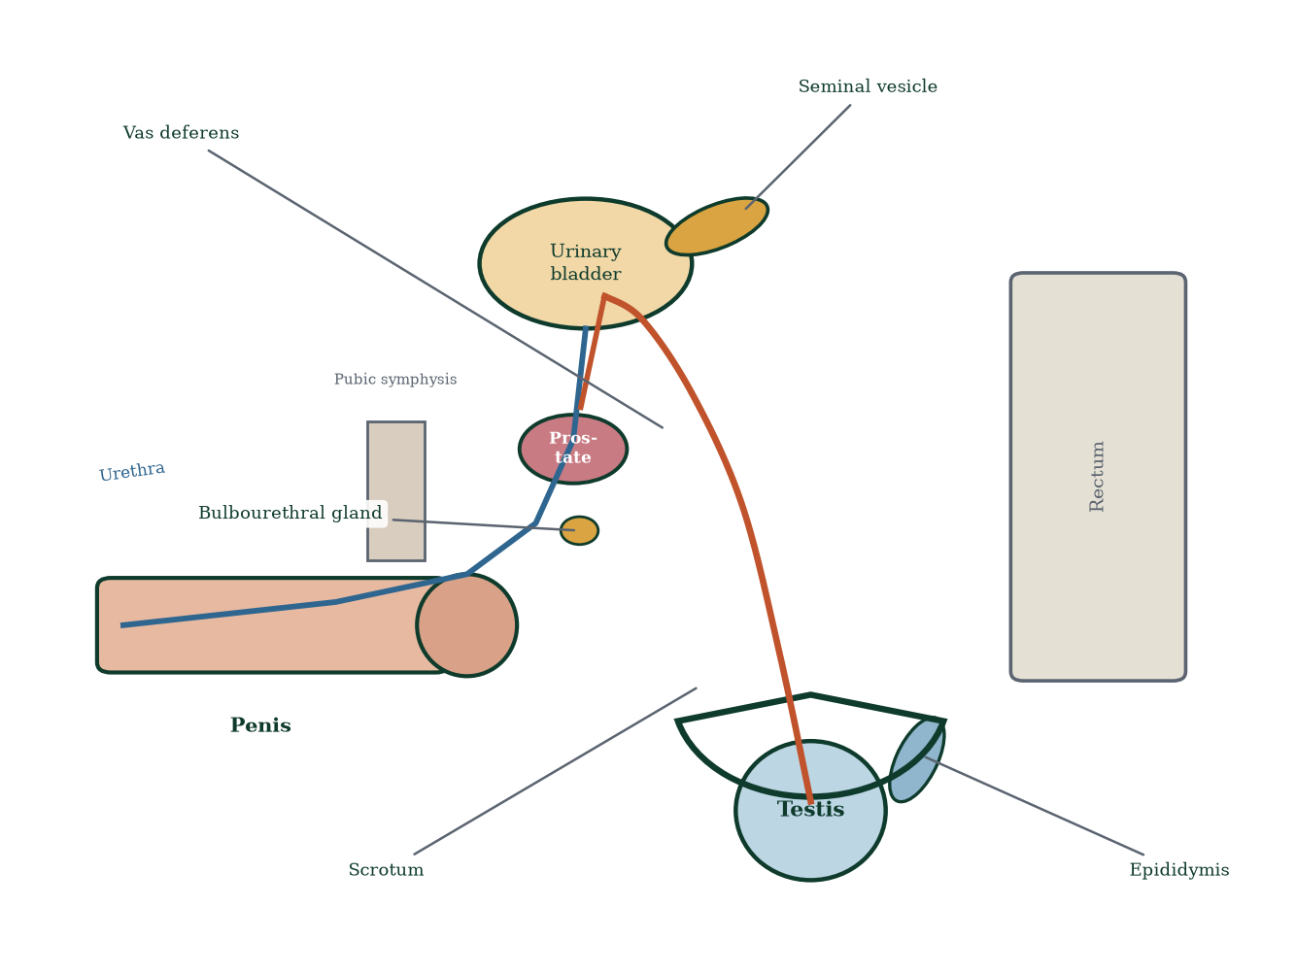
Figure 3.1 — Schematic sagittal section of the male pelvis and reproductive organs. The urethra shared by urinary and reproductive tracts traverses the prostate and penis.
Clinically, the male system matters far beyond fertility: prostate disease is among the commonest of ageing, erectile dysfunction signals vascular and metabolic health, and testicular symptoms are a frequent presenting complaint in primary care.

3.2 The scrotum: a biological refrigerator
Sperm cannot be made at core body temperature. Optimal spermatogenesis occurs ~2–4 °C below 37 °C, and the scrotum is the design solution: a cutaneous pouch divided into two compartments by a median septum, each housing one testis. Two muscle layers regulate temperature — the dartos muscle (smooth muscle in the wall, wrinkles the skin in the cold) and the cremaster muscle (skeletal muscle of the cord, raises the testis in cold, fear or cremasteric reflex stimulation). The pampiniform [27] plexus of veins winding around the testicular artery acts as a counter-current heat exchanger: arterial blood arriving at the testis is pre-cooled by outgoing venous blood, a classic biological heat-pump design shared with many mammals.
Failure of testicular descent — cryptorchidism — exposes the gonad to abdominal temperature and impairs spermatogenesis while raising germ-cell tumour risk; conversely, a short tight cord lowers the testis too far (hypermobility, torsion risk). Temperature explains why tight underwear, prolonged laptop use and sauna exposure have measurable (if modest) effects on semen parameters.

3.3 The testes: organisation from capsule to germ cell
Each testis (~4 × 3 × 2.5 cm, ~15–25 g) is enclosed by a tough fibrous capsule — the tunica albuginea — and covered by the tunica vaginalis, a serous double membrane derived from peritoneum (remnant of the processus vaginalis; its persistence produces hydrocele, its serous fluid lubricating testicular movement). Dense septa from the tunica albuginea divide the testis into ~250–300 lobules, each containing 1–4 highly coiled seminiferous tubules — the site of spermatogenesis (Figure 3.2). A single testis contains ~250–400 m of tubule. The tubules converge into the rete testis (in the mediastinum testis), then efferent ductules penetrate the capsule into the epididymis.
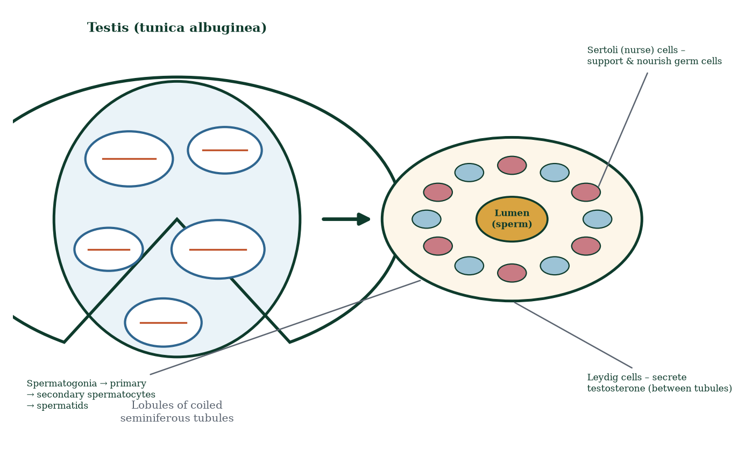
Figure 3.2 — Cross-section of the testis and a seminiferous tubule. Germ cells progress from the basement membrane toward the lumen; Sertoli cells span the wall; Leydig cells occupy interstitial tissue.

The seminiferous tubule wall, from outside in
- Basement membrane — boundary with interstitial tissue; spermatogonia sit directly on it.
- Sertoli cells — tall columnar ‘nurse’ cells that span the wall from basement membrane to lumen. They (i) nourish germ cells via gap junctions and secreted factors; (ii) form tight junctions dividing the tubule into a basal compartment (spermatogonia) and adluminal compartment (meiosis and beyond) — the blood–testis barrier, protecting haploid cells (antigenically novel) from autoimmune attack; (iii) secrete androgen-binding protein (ABP) to hold high local testosterone in the lumen, plus inhibin B (FSH feedback) and AMH (embryonic Müllerian regression); (iv) phagocytose excess cytoplasm shed as residual bodies; (v) secrete fluid to drive sperm toward the rete testis.
- Germ cells — at progressive stages: spermatogonia → primary spermatocytes → secondary spermatocytes → spermatids → spermatozoa (Figure 3.3; Chapter 5). Spermatogonial stem cells self-renew continuously, sustaining production for life.
- Peritubular myoid cells — contractile smooth-muscle-like cells enclosing each tubule; their rhythmic contractions propel sperm (which cannot yet swim) toward the rete testis.
- Interstitial (Leydig) cells — between tubules, in clusters with blood vessels and lymphatics; they synthesise testosterone in response to LH. Testosterone is essential for meiosis completion and male phenotype; local concentration in the tubule lumen (~50–100× serum) is what ABP maintains.
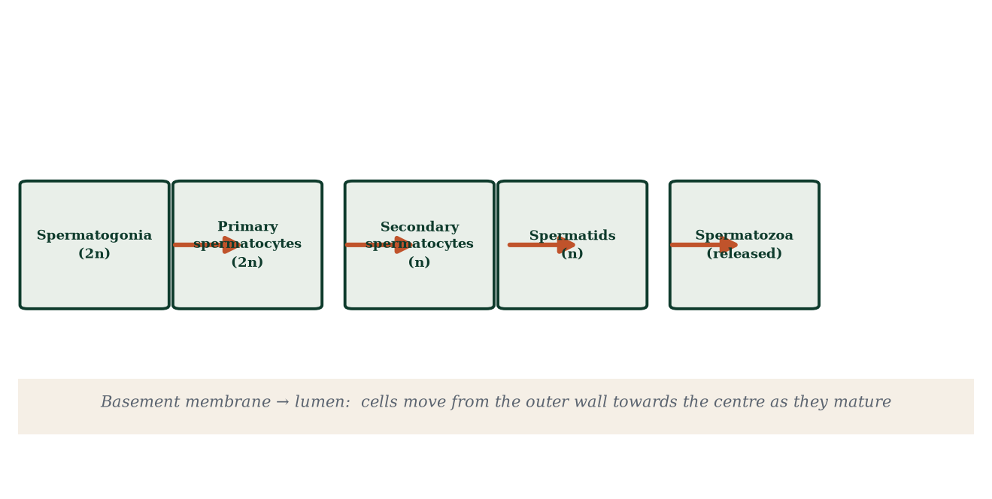
Figure 3.3 — The spermatogenic wave: cells move from the basal wall toward the lumen as they differentiate; the basement membrane marks the outer boundary, the lumen faces the duct system.

Hormonal control in one paragraph
GnRH (pulsatile, hypothalamus) → LH and FSH (anterior pituitary). LH → Leydig cells → testosterone. FSH → Sertoli cells → spermatogenesis support, ABP, inhibin B. Testosterone feeds back negatively on the hypothalamus and pituitary; inhibin B suppresses FSH selectively (Chapter 7). Remove the axis (hypogonadotropic hypogonadism, or exogenous testosterone suppressing endogenous LH/FSH) and spermatogenesis collapses — a reminder that anatomy and endocrinology are one system.

3.4 The epididymis: warehouse and finishing school
Each epididymis is a single, exquisitely coiled duct (~6 m) draped along the posterior testis, divided into head (caput — receives efferent ductules), body (corpus) and tail (cauda — continuous with the vas deferens). Functions:
- Sperm maturation — as sperm transit (10–14 days), their surface membrane is remodelled (protein and lipid rearrangements, decapacitation factor coating), motility is expressed (forward progression), and chromatin completes condensation.
- Sperm storage — the cauda holds millions of sperm for weeks; frequent ejaculation empties the reserve, infrequent ejaculation lets sperm be resorbed by macrophages.
- Absorption — the resorb ~90% of luminal fluid, concentrating sperm ~20-fold.
- Swim-lane provision — epididymal fluid is acidic, lactate-rich, low in glucose — it keeps sperm quiescent and conserves their metabolic reserves.
Epididymal obstruction (infection, vasectomy sequelae, congenital) produces obstructive azoospermia: normal production, no delivery — clinically distinct from non-obstructive (production) azoospermia, and a textbook example of why anatomy and physiology must be reasoned through together.

3.5 The vas (ductus) deferens and ejaculatory duct
The vas deferens (~30–45 cm) ascends from the epididymal tail in the spermatic cord (with testicular artery, pampiniform plexus, cremaster, lymphatics and the genital branch of the genitofemoral nerve), traverses the inguinal canal, hooks around the inferior epigastric artery, crosses the ureter (‘water under the bridge’ to reach the pelvis), passes medial to the seminal vesicle, and joins the duct of the seminal vesicle to form the ejaculatory duct (~2 cm), which tunnels through the prostate to open on the seminal colliculus (verumontanum) in the prostatic urethra — precisely where the prostatic utricle opens. The vas wall is thick smooth muscle with sympathetic (α-adrenergic) fibres — its powerful peristalsis at ejaculation is pure smooth-muscle hydraulics, and its narrow lumen explains its vulnerability to impact injury and its utility in vasectomy (a 2–3 mm segment is simply excised and the ends sealed).

3.6 Accessory glands: engineering the seminal plasma
Semen is more than sperm: only ~2–5% of its volume is spermatozoa; the rest is seminal plasma, secreted by three glands (Figure 3.4, Figure 3.5).
Seminal vesicles (~5 cm, paired, posterior to bladder) contribute ~60–70% of volume: fructose (primary fuel for sperm — fructolysis, not oxidative glucose, powers flagellar motility), prostaglandins (stimulate female tract motility and may aid sperm transport), fibrinogen-like proteins (clotting after ejaculation, retaining semen near the cervix), alkaline pH (neutralises vaginal acidity), and semenogelin (seminal vesicle-specific protein used clinically to detect semen presence). Androgen-dependent; atrophy after castration or anti-androgen therapy.
Prostate (~walnut-sized, ~20 g, encircling the urethra at the bladder neck, below the sphincter) contributes ~25–30%: citric acid (buffering), zinc (antibacterial, sperm chromatin stability), prostate-specific antigen (PSA) and other serine proteases — liquefying the coagulated semen within ~20–30 minutes post-ejaculation (semenogelin hydrolysis), releasing sperm to swim; prostatic acid phosphatase; and kallikreins. The prostate’s capsule and periurethral zones explain its dual disease burden: benign hyperplasia (median/transition zone) obstructs the urethra, cancer arises mostly in the peripheral zone. PSA is an organ-specific, not disease-specific, marker — elevated in inflammation, hyperplasia and cancer alike; its use is population screening, not diagnosis in isolation.
Bulbourethral (Cowper’s) glands (pea-sized, paired, in the deep perineal space) contribute ~5% as clear pre-ejaculate: mucus lubricating the urethra, and neutralisation of residual urinary acidity — a smart anticipatory design (the urethra is shared). Their secretion can carry sperm (pre-ejaculate is not sterile contraception).
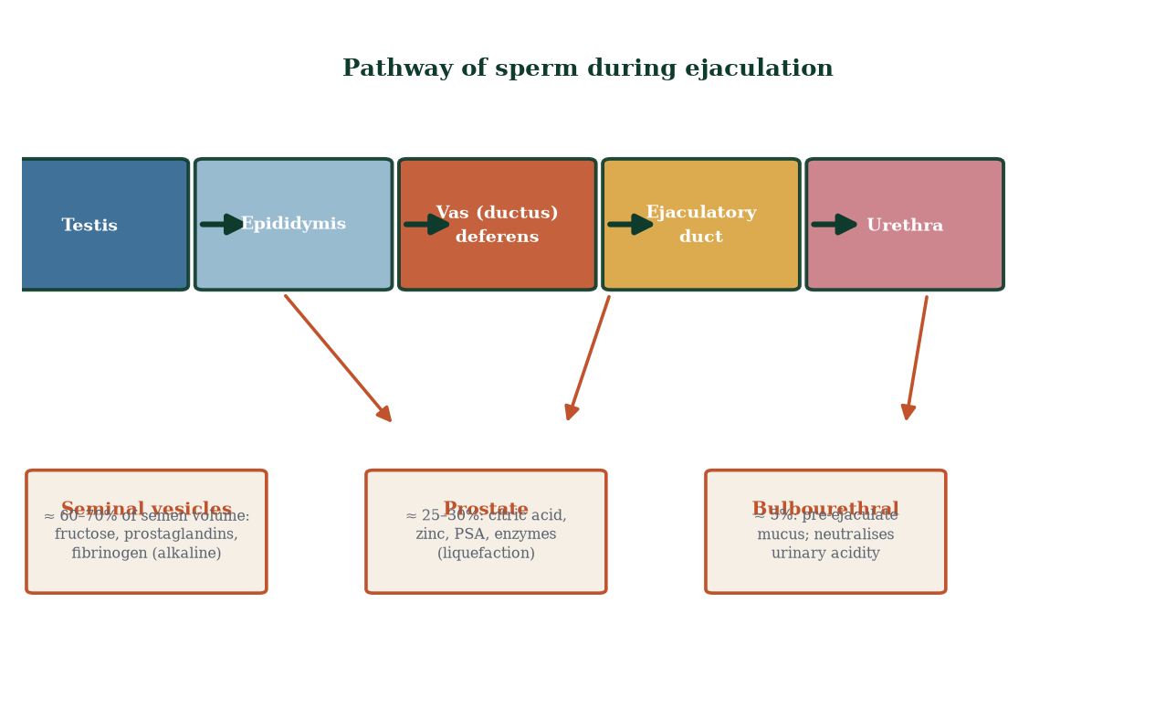
Figure 3.4 — The sperm pathway from testis to penile urethra, and the accessory glands that add seminal plasma.
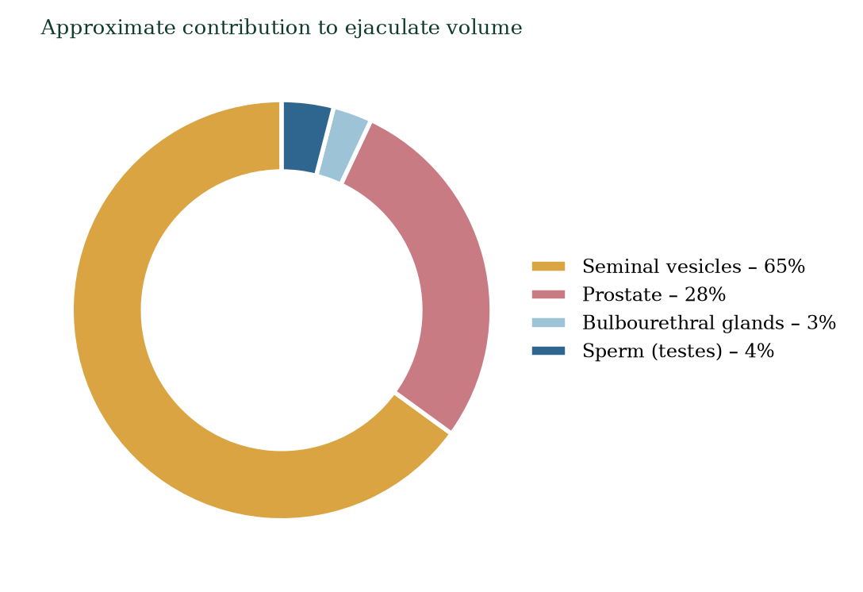
Figure 3.5 — Approximate contributions to ejaculate volume: seminal vesicles dominate; sperm cells are a small fraction.

3.7 The penis: the delivery organ
The penis has two dorsal corpora cavernosa (paired erectile bodies, continuous proximally with the crura attached to the ischiopubic rami) and one ventral corpus spongiosum surrounding the urethra, expanding at the tip into the glans penis (Figure 3.1). All three are specialised sinusoidal erectile tissues — networks of trabecular smooth muscle and endothelium lined spaces (cavernosal sinusoids) surrounded by the fibrous tunica albuginea (thick around cavernosa, thin around spongiosum to permit ejaculation). Erection is a vascular event: parasympathetic nitric-oxide-mediated relaxation of trabecular and helicine arteriolar smooth muscle floods the sinusoids, compressing emissary veins against the tunica — veno-occlusion — raising intracorporeal pressure (Chapter 9). Flaccidity is the default sympathetic (adrenergic) state.
The prepuce (foreskin) is a retractable fold of skin protecting the glans in the flaccid state; it is richly innervated and vascular. The penile skin and dartos muscle permit dramatic dimensional change without tissue damage — an example of connective tissue engineering.

3.8 The spermatic cord and supporting structures
The spermatic cord is a fascial-wrapped conduit containing: vas deferens, testicular artery, pampiniform venous plexus (heat exchange → testicular vein), lymphatics (draining to para-aortic nodes — hence testicular cancer spread), autonomic nerves, and the genital branch of the genitofemoral nerve + cremaster muscle. Varicocele — dilated pampiniform veins — is the commonest correctable cause of male infertility, impairing spermatogenesis by warming and by reflux of renal metabolites. Torsion of the cord twists the testicular artery and vein, causing ischaemia within hours — a surgical emergency. Knowing cord contents lets you reason anatomically through both emergencies rather than memorising them.
The inguinal canal conveys the cord through the abdominal wall — a site of weakness (inguinal hernia). The processus vaginalis, a fetal peritoneal diverticulum, normally obliterates; persistence → indirect inguinal hernia and hydrocele.

3.9 Inguinal and pelvic relationships that matter clinically
Three anatomical facts recur across reproductive medicine: (i) the ureter crosses deep to the vas deferens and uterine artery — ‘water under the bridge’ — making pelvic surgery on vas/uterine artery a risk to ureters; (ii) testicular lymph drains to para-aortic nodes, so testicular cancer metastasises to retroperitoneum, not groin; (iii) the prostate abuts the rectum (posteriorly) and the bladder neck (superiorly) — digital rectal examination and transrectal ultrasound reach it, and benign hyperplasia obstructs the bladder outlet. Anatomy is clinical geography.

3.10 Mechanisms and evidence in depth: reading the semen analysis and the groin
Semen analysis — every parameter is mechanism. Volume reflects seminal vesicle output (alkaline, fructose-rich) — low volume with acidic pH and absent fructose suggests vesicle obstruction or bilateral ejaculatory duct cysts. Concentration reflects spermatogenesis and abstinence interval (2–7 days) — fever weeks earlier suppresses it. Motility reflects epididymal maturation plus mitochondrial and flagellar function (axoneme dynein ATPase). Morphology reflects spermiogenesis quality — the WHO lower reference limit for normal forms is 4% (strict Kruger criteria). Round cells on microscopy are leukocytes or immature germ cells — differentiate by peroxidase; >1 million WBC per mL suggests infection.
The groin as reproductive anatomy. Three passage points matter: (i) the inguinal canal carrying the spermatic cord (male) or round ligament (female) — weakness yields direct hernias (through Hesselbach’s triangle, medial to the inferior epigastric vessels) or indirect hernias (through the deep ring, congenital, follows the cord into the scrotum); (ii) the femoral canal (female-predominant); (iii) the obturator canal (rare; obturator hernia in thin elderly women presenting with medial thigh pain). Palpation distinguishes: inguinal swellings lie above and medial to the pubic tubercle; femoral lie below and lateral.
Hydrocele and varicocele. Hydrocele — fluid in the tunica vaginalis (remnant of the processus vaginalis); painless, transilluminates; surgical repair if symptomatic. Varicocele — dilated pampiniform plexus (~15% of men, ~40% of infertile men); left-dominant because the left testicular vein meets the renal vein at 90°; graded I–III; treat when sperm parameters are reduced — semen analysis improves in ~60–80% of repaired varicoceles. Mechanism: thermal and hydrostatic injury to spermatogenesis.
Testicular tumours present as painless masses — peak age 25–35; risk ×20 with undescended testis; ultrasound diagnostic; AFP, β-hCG and LDH are tumour markers; cure >90% even with metastatic disease using modern chemotherapy.
Zonal prostate anatomy maps disease. Peripheral zone (70%) — cancer; transition zone (~10%) — BPH; central zone (~25%) — rarely diseased. This geometry explains DRE findings (peripheral posteriorly palpable), biopsy strategy, and TURP resection planes. PSA rises from any prostatic epithelium — cycling, prostatitis, BPH, or cancer — mechanism before interpretation.

Common errors in male reproductive reasoning
- “Low volume means low fertility.” — volume is mostly vesicle/prostate; count and motility matter more.
- “One bad analysis means infertility.” — analysis is noisy; WHO recommends at least two samples, 2–4 weeks apart.
- “Varicocele always causes infertility.” — most men with varicoceles are fertile; treat only documented abnormality.
- “PDE5 inhibitors cause erections.” — they amplify NO-gated signalling; without stimulation, no erection.

3.11 Clinical reasoning vignettes
Case 1. A 24-year-old man undergoes an orchidectomy for a painless testicular mass. AFP was 340, β-hCG negative. Pathology: seminoma, stage I. Mechanism: malignancy of germ cells of spermatogenic lineage; seminomas are often AFP-negative (that’s why non-seminomas raise AFP). Surveillance protocol: 5-year marker monitoring; cure rate >95%.
Case 2. A 50-year-old man reports erectile dysfunction of recent onset plus exertional chest pain. The mechanistic triage: ED and ischaemic heart disease share endothelial dysfunction — narrow penile arteries (1–2 mm) manifest before wider coronary arteries (3–4 mm) — ED is an early coronary warning sign. Cardiac workup before PDE5 prescription (nitrate interaction risk).
Case 3. A 28-year-old with infertility and a tender scrotal swelling on the left. Varicocele — pampiniform plexus dilation, 90-degree angle junction of left testicular vein into renal vein. Treat if sperm abnormalities documented — mechanism is thermal and oxidative injury to spermatogenesis.

Self-check — can you derive these without notes?
- Why is the left testicle lower than the right (pampiniform anatomy)?
- Explain the veno-occlusive mechanism of erection and why nitrates interact with PDE5 inhibitors.
- A man produces zero motile sperm despite normal FSH/LH. Where is the lesion?
- Differentiate hydrocele from epididymal cyst by transillumination and palpation.
- Why does TURP often cause retrograde ejaculation?

Chapter summary
- The scrotum plus counter-current heat exchange keep the testes ~2–4 °C below core temperature for spermatogenesis.
- The testis contains ~250–400 m of seminiferous tubules; Sertoli cells nurse germ cells and build the blood–testis barrier; Leydig cells make testosterone.
- Sperm transit the epididymis (~10–14 days) to mature and are stored in the cauda.
- The vas deferens delivers sperm by sympathetic-driven peristalsis to the ejaculatory duct, which empties into the prostatic urethra.
- Seminal plasma: seminal vesicles ~65% (fructose, alkaline buffer), prostate ~28% (liquefaction enzymes, Zn, citrate), bulbourethral ~5% (mucus, neutralisation).
- The penis is three erectile sinusoidal bodies; erection is parasympathetic NO-mediated veno-occlusion.
- Cord contents, ureter relations and lymphatic drainage are constant clinical reference points.

Key terms
Tunica albuginea — fibrous testicular capsule. Seminiferous tubule — sperm-producing tubule. Sertoli cell — supporting cell; barrier, ABP, inhibin B, AMH. Leydig cell — testosterone-secreting interstitial cell. Rete testis — collecting network. Epididymis — maturation and storage duct. Vas deferens — muscular transport duct. Ejaculatory duct — union of vas and seminal vesicle duct through prostate. Seminal vesicle — fructose-rich alkaline secretion. Prostate — liquefaction enzymes, zinc, citrate, PSA. Cowper’s glands — pre-ejaculate. Corpus cavernosum/spongiosum — erectile bodies. Blood–testis barrier — Sertoli tight junctions. Counter-current exchange — pampiniform plexus cooling arterial blood.

Review questions
Multiple choice
- Spermatogenesis is optimal at what relative temperature?
  - core 37 °C b) 2–4 °C below core c) 5 °C above core d) any constant temperature
- Sertoli cells are responsible for all EXCEPT:
  - forming the blood–testis barrier b) secreting ABP and inhibin B
  - phagocytosing residual bodies d) synthesising testosterone
- Which structure first transports sperm away from the testis?
  - vas deferens b) epididymis c) ejaculatory duct d) efferent ductules → rete testis
- Seminal vesicles contribute approximately how much of ejaculate volume?
  - 5% b) 10% c) 25–30% d) 60–70%
- Fructose in semen is produced by the:
  - prostate b) testes c) seminal vesicles d) bulbourethral glands
- The blood–testis barrier is formed by:
  - peritubular myoid cells b) Leydig cells c) Sertoli tight junctions d) tunica albuginea
- Which ligament/plexus cools testicular arterial blood?
  - cremaster b) pampiniform plexus c) Dartos d) spermatic fascia
- Ejaculatory ducts open into the:
  - penile urethra b) membranous urethra c) prostatic urethra d) spongy urethra at the meatus
Short answer
- Explain the two mechanisms by which the scrotum/cord regulates testicular temperature.
- Name the compartments of the seminiferous tubule wall and describe what happens in each compartment.
- Describe the functions of the epididymis in order of sperm arrival.
- Why is PSA an organ-specific but not disease-specific test?
Explanation
- A man with an obstructed vas deferens has normal testosterone and normal sperm production. Explain how his azoospermia arises and how clinicians distinguish this from production failure.
- Explain how the anatomy of the testicular vein/pampiniform plexus relates to varicocele formation and infertility.
- Explain the shared design principle between the male urethra’s dual use and the Cowper’s gland secretion.
Application
- A 17-year-old boy with a painful acutely swollen left testis is brought to the emergency department. Using anatomy, name the most urgent diagnosis and explain why minutes matter.
- A couple seeks fertility counselling. Semen analysis shows low volume, acidic pH and absent fructose. Which gland is likely underperforming, and why is pH relevant to sperm survival?
- Explain why testicular cancer rarely spreads to inguinal lymph nodes first, and trace the expected nodal drainage.

Answers to review questions
- b. ~34–35 °C; cremaster/dartos and the pampiniform heat exchanger maintain it.
- d. Testosterone is made by Leydig cells.
- d. Order: seminiferous tubules → rete testis → efferent ductules → epididymis → vas → ejaculatory duct → urethra.
- d. Seminal vesicles ~60–70% of volume.
- c. Seminal vesicles secrete fructose, the main sperm fuel.
- c. Adjacent Sertoli cell tight junctions segregate basal from adluminal compartments.
- b. Pampiniform plexus wraps the testicular artery and pre-cools blood.
- c. At the seminal colliculus of the prostatic urethra.
- Scrotal skin (dartos smooth muscle) wrinkles/adjusts surface area and the cremaster raises/lowers the testes; the pampiniform plexus counter-current exchange cools arterial inflow by drawing heat into outgoing venous blood.
- Basal compartment: spermatogonia on the basement membrane, protected; adluminal compartment: meiotic cells and spermatids, isolated behind the blood–testis barrier, bathed in lumenal fluid rich in ABP-bound testosterone — essential because haploid antigens would otherwise trigger autoimmunity.
- Arrival from efferent ductules → maturation phase in caput/body (membrane remodelling, motility acquisition, decapacitation-coat stabilisation) → concentration by resorption → final storage in cauda until ejaculation; excess sperm are resorbed.
- PSA is secreted by both normal and abnormal prostatic epithelium; it rises with benign hyperplasia, inflammation/manipulation and cancer; it indicates prostatic tissue mass/leakiness, not cancer specifically.
- Production may be normal, but sperm cannot enter the ejaculate — obstructive azoospermia (low-volume semen, normal FSH/inhibin, palpable epididymal fullness). Non-obstructive azoospermia shows small testes, high FSH, low inhibin B — different anatomy fails at a different step.
- Left testicular vein drains into the renal vein at 90° (right drains into IVC at acute angle); higher hydrostatic pressure on the left favours varicocele (more common on the left); impaired counter-current cooling and metabolite reflux reduce spermatogenesis and sperm DNA quality.
- The urethra is shared by semen (basic, sperm need near-neutral pH) and urine (acidic). Cowper’s mucus flushes and neutralises residual acid just before ejaculation, protecting sperm — an elegant sequential design rather than anatomical duplication.
- Testicular torsion: cord twist compresses/occludes the testicular artery (and vein); testicular viability falls within ~4–6 h; immediate surgical scrotal exploration and detorsion is mandatory. Anatomy tells you the cord, the artery and the clock all turn together.
- Seminal vesicles (fructose + alkaline pH contribution). Vaginal pH ~4.0 is spermicidal for motility; the vesicle alkaline buffer raises ejaculate pH to ~7.2–7.8, essential for sperm motility until capacitation in the female tract.
- Testicular lymphatics ascend with the gonadal vessels to para-aortic (lumbar) nodes; inguinoscrotal skin drains to inguinal nodes instead. Hence testicular cancer metastasises to para-aortic nodes first; scrotal skin cancers spread to inguinal nodes.

Chapter 4: Female Reproductive Anatomy
Learning objectives. After studying this chapter you should be able to: - describe the external and internal female reproductive anatomy and its relations; - explain the structure of the ovary and the developmental stages of the follicle; - describe the uterus, endometrium, myometrium and cervix and their cyclical changes; - explain the anatomy of the fallopian tubes, vagina and vulva and their functions; - describe the mammary gland and its development; - relate pelvic anatomy to clinical practice.
Central question. How is the female reproductive tract built to receive gametes, host implantation, nourish a fetus and deliver it — and how does this architecture relate to its hormonal control?

4.1 Overview: architecture in service of cycles
The female reproductive system is a coordinated set of organs organised around cycles — the ovarian and uterine cycles (Chapter 8) — plus a support apparatus for pregnancy, parturition and lactation (Figure 4.1). It comprises: (1) the ovaries, which produce and release oocytes and secrete steroid hormones; (2) the fallopian (uterine) tubes, which capture the oocyte and are the usual site of fertilisation; (3) the uterus, which houses and nourishes the embryo/fetus; (4) the cervix, the gatekeeper of the uterus; (5) the vagina and vulva, the copulatory and birth passage and the external structures; (6) the mammary glands, part of the overall reproductive system in functional terms (they are skin appendages whose development is hormonally tied to reproduction — Chapter 17); and (7) the pelvic floor and supporting ligaments, which maintain everything in position.
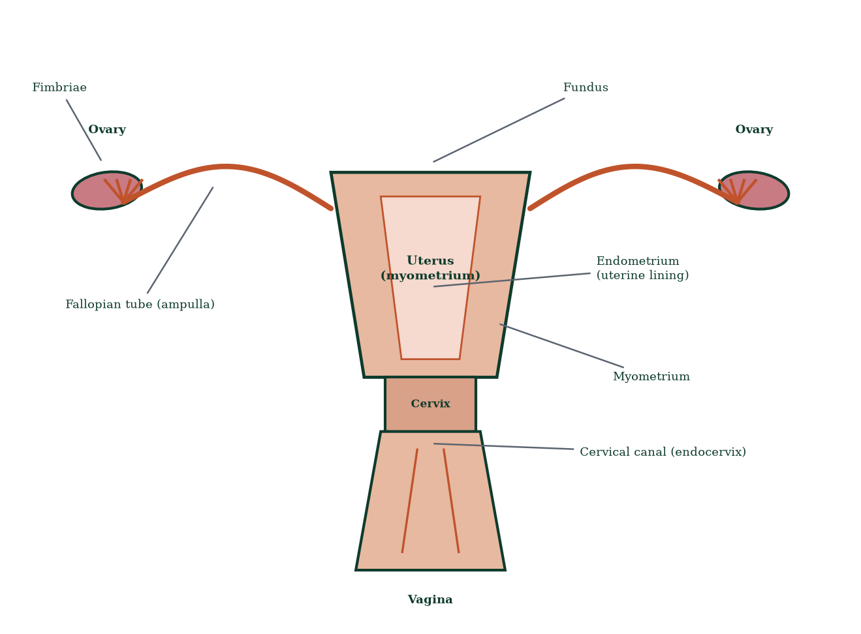
Figure 4.1 — Schematic frontal section through the female pelvis showing the ovaries, fallopian tubes, uterus, cervix and vagina.
The defining architectural theme is cyclical remodelling: the endometrium is built up and shed; cervical mucus switches character; the breasts change; the cervix dilates; even the ovarian surface ruptures and heals monthly. Female reproductive anatomy is architecture in motion.

4.2 The ovaries: the gametic and endocrine core
The ovaries are paired, almond-shaped organs (~3–4 × 2 × 1 cm; 4–8 g) lying on the ovarian fossa on the lateral pelvic wall, anchored by the ovarian ligament (to uterus), suspensory (infundibulopelvic) ligament (carrying ovarian vessels from the aorta/IVC region) and mesovarium (broad ligament). They are NOT within the peritoneal cavity lumen — they are intraperitoneal organs covered by germinal epithelium (misnamed: it does not produce germ cells; primordial germ cells arrive by week 6 of development from the yolk sac endoderm and migrate along the dorsal mesentery into the genital ridge).
Internally the ovary has a central medulla (vessels, nerves, loose connective tissue) and peripheral cortex (follicles in a dense stroma) (Figure 4.2). The surface is covered by simple cuboidal/columnar surface (‘germinal’) epithelium under which lies the tunica albuginea — modified dense connective tissue. The ovary has no ducts; oocyte release is into the peritoneal cavity, to be captured by the fimbriae (Section 4.4).

Follicle types, in developmental order (details in Chapter 6)
- Primordial follicle — primary oocyte arrested in prophase I (dictyotene) since fetal life, surrounded by a single layer of flat pre-granulosa cells; the resting reserve (~1–2 million at birth, ~300,000–400,000 at puberty).
- Primary follicle — granulosa cells become cuboidal and proliferate; the oocyte enlarges; zona pellucida (glycoprotein shell ZP1–ZP4) forms between oocyte and granulosa.
- Secondary (antral) follicle — granulosa proliferates to multiple layers; theca layers organise outside the basement membrane; fluid-filled antrum appears; granulosa-aromatase begins converting theca-derived androgens to oestrogens.
- Tertiary / pre-ovulatory (Graafian) follicle — huge antrum, oocyte eccentric on a cumulus oophorus, surrounded by corona radiata; destined for ovulation.
- Corpus luteum — collapsed follicle transformed into progesterone/oestrogen-secreting endocrine body (~2–4 cm transient gland); corpus albicans — fibrous scar after involution.
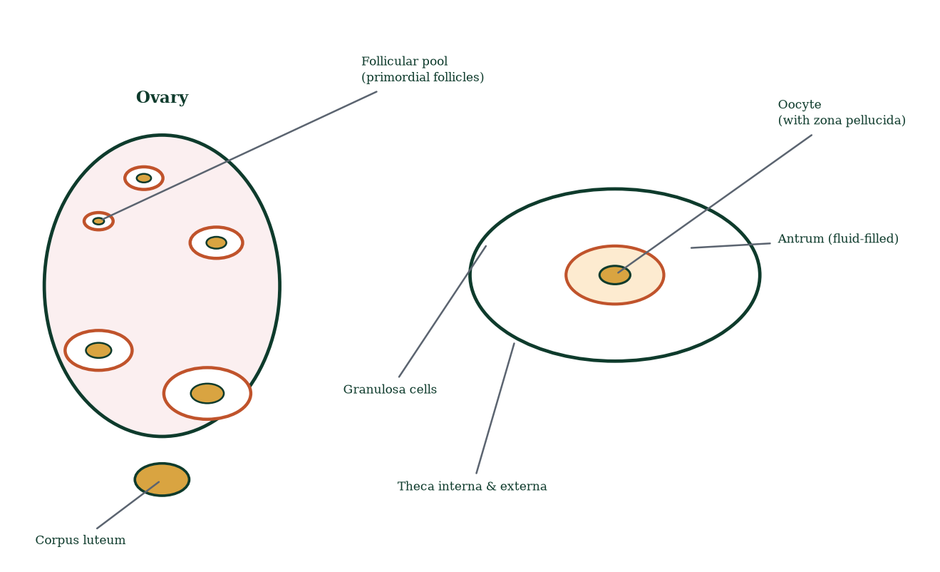
Figure 4.2 — Left: distribution of follicle types in the ovarian cortex and the corpus luteum. Right: mature (tertiary/Graafian) follicle anatomy.
A defining quantitative fact: the ovary contains ~400,000 viable primordial follicles at puberty but ovulates only ~400 in a lifetime; >99% are lost by atresia (programmed degeneration), an ongoing, FSH-independent process refined each cycle by contest. Ovarian ageing is follicle-pool ageing (Chapter 6).

4.3 The uterus: the muscular, glandular cradle
The uterus is a hollow, pear-shaped muscular organ ~7.5 cm long in nulliparous women, ~30–40 g, situated in the true pelvis between bladder (anterior) and rectum (posterior), anteverted/anteflexed over the bladder in many individuals. Regions: fundus (above tubal ostia), body/corpus, isthmus (~1 cm constricted junction with cervix), cervix. Wall layers, from lumen outward (Figure 4.3):
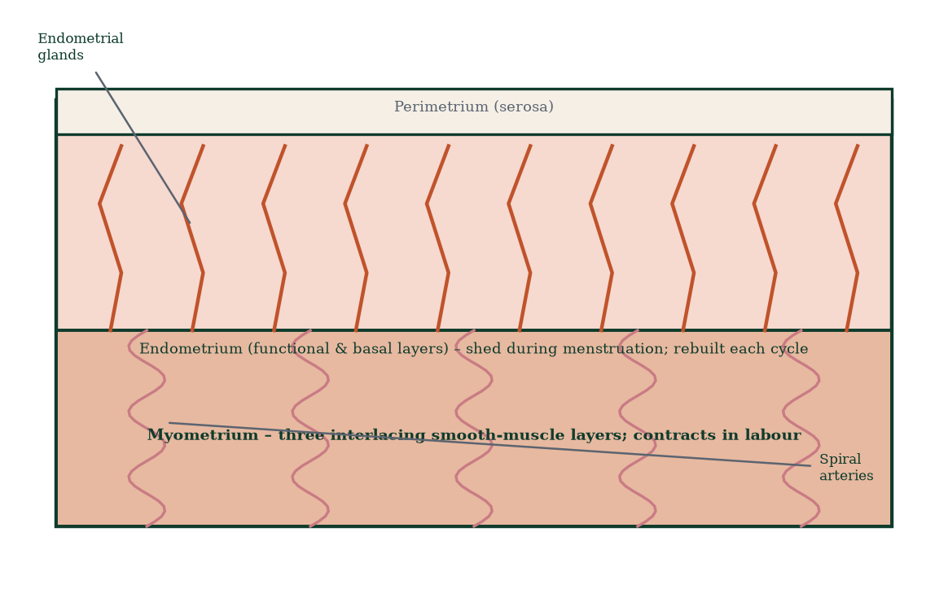
Figure 4.3 — The three layers of the uterine wall. The endometrium cycles; the myometrium generates labour; the perimetrium covers the surface.
- Endometrium — highly vascular mucosal lining. Two strata: (i) the stratum functionale (upper ~two-thirds), which thickens, secretes and is shed monthly in menstruation; and (ii) the stratum basale (~1 mm), which survives menstruation and regenerates the functional layer. Endometrium contains endometrial glands in a vascular stroma; spiral (coiled) arterioles selectively supply the functionale and undergo progesterone-withdrawal vasospasm at shedding (Chapter 8). Endometrial thickness measured by ultrasound tracks cycle phase and is clinically central to implantation assessment and endometrial pathology (polyp, hyperplasia, carcinoma).
- Myometrium — three interlacing smooth-muscle layers (outer longitudinal; middle oblique/spiral around vessels — the ‘living ligatures’ that occlude spiral arterioles after delivery; inner circular at the cornua and internal os). It undergoes massive hypertrophy in pregnancy (cell number and size rise enormously) and generates the coordinated fundal-dominant, polarity-reversed contractions of labour (Chapter 16).
- Perimetrium — thin serous (visceral peritoneum) covering the fundus and body.

Supporting ligaments
The uterus is suspended by the broad ligament (peritoneal fold), round ligaments (to labia majora via inguinal canal), transverse cervical (cardinal) ligaments (lateral; carry uterine artery; the chief support), uterosacral ligaments (posterior, to sacrum) and the pubocervical fascia. Weakness → prolapse (uterine/pelvic organ prolapse), a major cause of morbidity and a routine surgical domain.

4.4 The fallopian (uterine) tubes: capture and transport
Each tube (~10 cm) runs in the upper margin of the broad ligament from the uterine cornu to the ovary, in four segments (lateral→medial) (Figure 4.4):
- Infundibulum — open, funnel-shaped, with finger-like fimbriae that drape the ovary at ovulation, sweeping the released cumulus–oocyte complex into the tube (the ovary releases into the peritoneal cavity; the fimbriated end captures). Fimbrial pathology (pelvic inflammatory disease) → infertility or ectopic pregnancy.
- Ampulla — widest, longest, highly folded, the usual site of fertilisation and of early cleavage.
- Isthmus — narrow, straight, muscular; stores sperm transiently; contraction waves propel the ovum.
- Intramural (interstitial) — passes through the uterine wall to open at the tubal ostium.
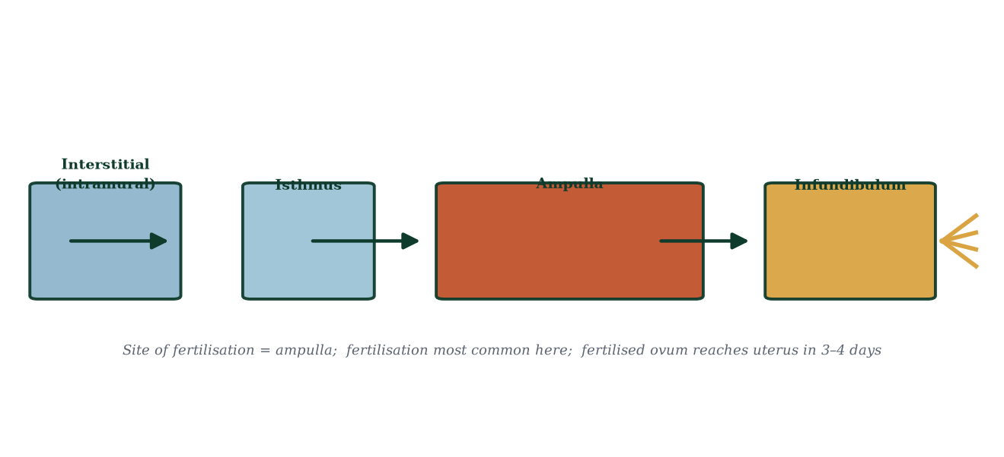
Figure 4.4 — The four segments of the fallopian tube; fimbriae at the infundibulum face the ovarian surface.
Wall structure: mucosa (tall ciliated columnar + secretory non-ciliated peg cells producing tubal fluid — nutrition + progesterone-dependent changes), a muscular layer (inner circular, outer longitudinal) for peristalsis, and serosa. Ciliated beating + muscular peristalsis deliver the ovum to the uterus in ~3–4 days — deliberately out of phase with early cleavage so the embryo arrives when the endometrium is ready (window of implantation, Chapter 11).
Ectopic (tubal) pregnancy occurs when implantation happens in the tube — most often ampullary — and is a leading cause of first-trimester maternal mortality when ruptured; it is, mechanistically, a failure of transport or an abnormal adhesive environment.

4.5 The cervix: the gatekeeper
The cervix is the fibrous (collagen/elastin, ~10–15% smooth muscle) lower cylinder of the uterus, ~2.5–3 cm, projecting into the vagina. Two parts: endo-cervix (canal; simple columnar mucus-secreting epithelium) and ecto-cervix (portio; stratified squamous). The junction — the squamocolumnar junction (transformation zone [27]) — is where >90% of cervical cancers arise, which is why cervical cytology and HPV testing target it.
Functions change with the cycle: - Ovulation (oestrogen primed): mucus becomes copious, clear, watery, alkaline (pH ~8), with parallel microscopic channels — sperm swim through; Spinnbarkeit stretchability >8–10 cm. - Luteal phase (progesterone): scant, thick, opaque, viscous, acidic — hostile barrier; ferning (fern pattern on drying) lost. - Pregnancy: mucus plug seals the canal; cervix softens (Goodell’s sign) and colours blue-purple (Chadwick’s sign) — later ripens (collagens glycosaminoglycan remodelling) under relaxin, prostaglandins and mechanical pressure before labour (Chapter 16); effaces and dilates to 10 cm. - Navigation: internal os (to uterine cavity), external os (to vagina) — inspectable on speculum examination.
The cervix has abundant elastic fibres allowing extreme dilation while resisting prolapse — collagen architecture, not muscle, is the engineering material.

4.6 The vagina: the muscular passage
The vagina is a fibromuscular canal ~8–10 cm long, from the external os to the hymenal ring/vestibule, anterior to rectum, posterior to bladder/urethra, lined by non-keratinised stratified squamous epithelium rich in glycogen. Glycogen-fed lactobacilli [1] produce lactic acid (pH ~3.8–4.5) — a low pH barrier protecting against pathogens; antibiotics, douching, semen, infection (bacterial vaginosis, candidiasis, STIs) and menopause (oestrogen withdrawal → thinning, dryness, alkalinisation) disrupt it. Rugae (transverse folds) allow dramatic distension in intercourse and birth; the fornices (anterior/posterior/lateral recesses) surround the cervix — the posterior fornix is the thinnest route to the pouch of Douglas (culdocentesis landmark; ectopic rupture). Bartholin’s glands at the posterolateral introitus and Skene’s (paraurethral) glands provide lubrication.

4.7 The vulva and perineum
External structures: mons pubis, labia majora (skin + adipose; analogous to scrotum), labia minora (hairless mucocutaneous folds joining anteriorly at the clitoris — glans, crura, corpora cavernosa homologous to dorsal penile bodies — and posteriorly at the fourchette), vestibule (between the minora; contains the urethral meatus, vaginal introitus and vestibular/Bartholin gland ducts), perineal body (fibromuscular midline anchor of perineal muscles). The clitoris is the principal sensory organ of female sexual response; its structure (paired crura + body + glans, ~10 cm erectile tissue) mirrors the penis embryologically.
The pelvic floor — levator ani (puborectalis, pubococcygeus, iliococcygeus) + coccygeus + fascial sphincters — supports the pelvic viscera. Childbirth stretches/tears it (third/fourth degree tears, levator avulsion) → prolapse and incontinence; hence perineal massage, second-stage techniques and postpartum pelvic rehabilitation.

4.8 The mammary glands: reproductive skin appendages
Mammary glands are modified sweat glands (ectoderm) whose entire developmental programme is tied to reproduction. Structure (Figure 4.5): 15–20 lobes, each a compound tubuloalveolar gland; lobes contain lobules of alveoli (secretory units lined by simple cuboidal epithelium + surrounding myoepithelial cells that contract to eject milk); lobules drain into lactiferous ducts converging on the lactiferous sinus and opening at the nipple (multiple pores); between ducts lies adipose and connective tissue; Cooper’s ligaments (suspensory) anchor to skin and fascia. The areola contains sebaceous (Montgomery) glands whose lipoid secretion lubricates and guides infant chemosensation. Development: fetal rudiment → prepubertal quiescence → pubertal ductal growth (oestrogen) → cyclical changes (luteal progesterone → mild oedema, tenderness) → pregnancy: lobuloalveolar proliferation (oestrogen + progesterone + prolactin + hPL), areolar pigmentation, colostrum by mid-pregnancy → lactation (Chapter 17) → involution after weaning.
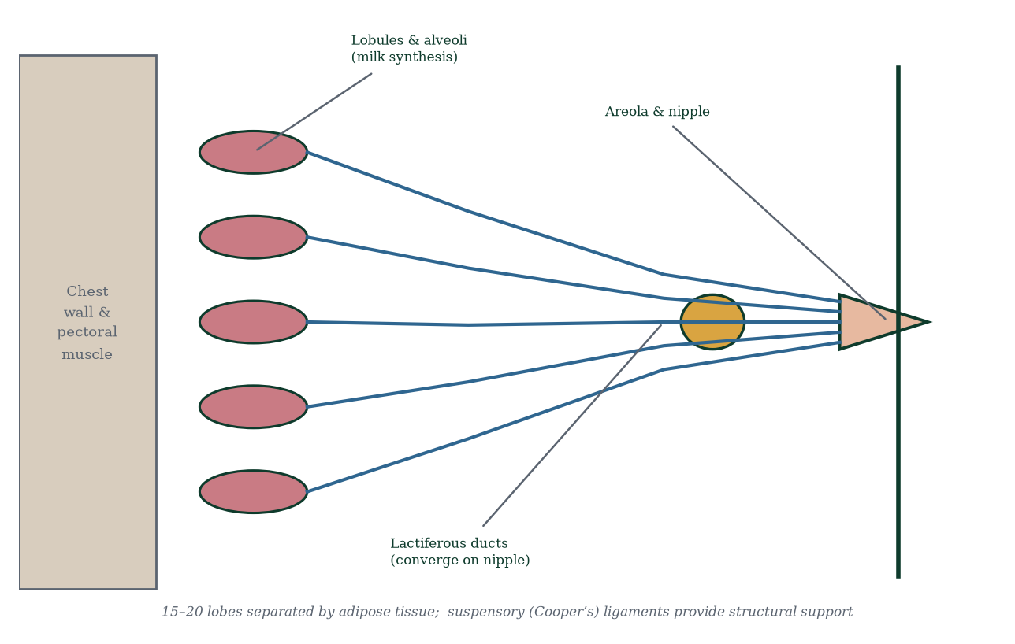
Figure 4.5 — The mammary gland: lobes, lobules, ducts and nipple. Alveoli synthesise milk; myoepithelial cells eject it.

4.9 Pelvic vasculature and nerves (clinical anatomy essentials)
- Arterial: ovarian artery (aorta) + uterine artery (internal iliac) — anastomosing widely; ligation safe but ureter at risk (crosses under uterine artery — ‘water under the bridge’).
- Venous: ovarian veins → right to IVC, left to renal vein; pampiniform/uterine venous plexuses.
- Lymphatic: fundus drains with ovarian vessels to para-aortic nodes; body/cervix/upper vagina to internal/external iliac and sacral nodes; lower vagina and vulva to superficial inguinal nodes — hence the distinct lymphatic patterns of cervical vs vulval cancer.
- Nervous: autonomic (superior/inferior hypogastric plexus) for uterus/viscera; somatic pudendal nerve for perineum/external genitalia — the vulva is somatically innervated and thus highly sensitive; uterus is visceral (pain referred to back/suprapubic region via T11–L1).
- Pouch of Douglas — rectouterine fossa; the most dependent point when standing; free fluid (blood, pus) collects here — clinically tappable.

4.10 Mechanisms and evidence in depth: the vulva, vagina and pelvic floor — the forgotten anatomy
The vulva in detail. Labia majora — hair-bearing, fat-rich folds; homologues of the scrotum. Labia minora — thin, hairless, pigmented folds meeting anteriorly at the clitoral hood and posteriorly at the fourchette; richly innervated homologues of ventral penile skin. Clitoris — paired crura (~10 cm erectile bodies) plus body and glans; principal organ of female sexual response; no urinary function. Vestibule — between the minora, containing the urethral meatus, vaginal introitus, and openings of Skene (paraurethral) and Bartholin glands (posterolateral); Bartholin cyst or abscess is a common clinic presentation — duct obstruction → retention or infection. Introitus — partly occluded by hymen variants (annular, cribriform, or — pathologically — imperforate: hematocolpos at menarche).
The vagina’s pH economy and microbiome. Healthy pH is 3.8–4.5, maintained by lactobacilli fermenting glycogen to lactic acid. Disruption gives bacterial vaginosis (non-inflammatory discharge, clue cells; associated with preterm birth risk), candidiasis (cottage-cheese discharge with normal pH), or trichomoniasis (frothy discharge, pH >4.5). Oestrogen sustains epithelium and glycogen; menopause → atrophy → alkalinisation → infections and dyspareunia — treatable with local oestrogen.
The pelvic floor — three layers and fascial supports. Layer 1 (superficial perineal): bulbospongiosus, ischiocavernosus, superficial transverse perineal. Layer 2 (deep perineal pouch): deep transverse perineal, external urethral sphincter. Layer 3 (pelvic diaphragm): levator ani (puborectalis, pubococcygeus, iliococcygeus) and coccygeus. Fascial supports: cardinal and uterosacral ligaments (uterus), pubocervical fascia (bladder), rectovaginal fascia (rectum). Weakness → prolapse (cystocele, rectocele, uterine, apical), graded Baden–Walker I–IV; treated with pessary, pelvic-floor physiotherapy or surgery. Childbirth injury dominates; postpartum supervised pelvic-floor rehabilitation should be offered to every mother.
The breast’s microenvironment — more than milk. Ductal carcinoma in situ follows duct anatomy (casting calcifications); lobular carcinoma spreads single-file (E-cadherin loss). Nipple discharge — physiological (multiple ducts, bilateral, milky) versus pathological (single duct, spontaneous, bloody) — mechanism distinguishes. Fibroadenoma (rubbery, mobile, <30 years) versus cyst (smooth, fluctuant) versus cancer (hard, fixed, skin/nipple change) — mechanism meets probability at the breast.

Common errors in female reproductive reasoning
- “Discharge always means infection.” — physiological discharge is normal; context differentiates.
- “Painful periods mean pathology.” — primary dysmenorrhoea is prostaglandin-mechanism, not psychology.
- “Pap smear detects ovarian cancer.” — it detects cervical pathology.
- “Hysterectomy ends all reproductive hormones.” — it ends uterine function; ovarian hormones persist if ovaries are retained.
- “No cervix, no smear.” — mostly true after hysterectomy for benign disease, with exceptions.

4.11 Clinical reasoning vignettes
Case 1. A 22-year-old with cyclical severe dysmenorrhoea and normal ultrasound. Mechanism: prostaglandin F2α-driven myometrial hypercontractility → ischaemic pain — primary dysmenorrhoea; NSAIDs (prostaglandin synthetase inhibitors) + heat; no imaging needed if response satisfactory.
Case 2. A 30-year-old with postcoital bleeding. Speculum examination shows a cervical ectropion (columnar epithelium everted onto ectocervix, oestrogen effect). Usually physiological; but must not miss cervical intraepithelial neoplasia — cytology ± colposcopy.
Case 3. A 55-year-old with pelvic pressure, urinary frequency and a palpably enlarged uterus. Fibroids on ultrasound — 30% of women >35 have them; mechanism: oestrogen/progesterone stimulated smooth muscle; most require only observation; IUS/tranexamic acid if symptomatic.

Self-check — can you derive these without notes?
- Walk the transformation zone’s squamocolumnar junction from puberty through menopause.
- Why is the uterine fundus antiverted and antiflexed, and what does retroversion do to fertility?
- Explain why oestrogen withdrawal causes hot flushes — arcuate KNDy hyperactivity.
- Describe the pelvic floor layers from superficial to deep and their failure modes.
- Why does progesterone thin endometrium but thicken cervical mucus?

Chapter summary
- The ovary holds the lifetime oocyte reserve; >99% of follicles undergo atresia; ~400 are ovulated.
- The uterus has three wall layers — endometrium (cyclical), myometrium (contractile), perimetrium (serous).
- Fallopian tube segments: infundibulum/fimbriae (capture) → ampulla (fertilisation) → isthmus → intramural.
- The cervix produces cycle-specific mucus; its transformation zone is the origin of most cervical cancers.
- The vagina maintains pH ~3.8–4.5 via lactobacilli; menopause removes the oestrogen protection.
- Mammary glands are reproductive skin organs whose development mirrors the cycle and pregnancy.
- Pelvic vascular, lymphatic and nerve maps are clinical infrastructure, not trivia.

Key terms
Ovarian fossa — peritoneal depression housing the ovary. Tunica albuginea — ovarian capsule. Primordial follicle — resting follicle. Corpus luteum — ovulated follicle turned endocrine gland. Stratum functionale/basale — shed/stable endometrial layers. Spiral arterioles — cycle-sensitive endometrial vessels. Transformation zone — squamous–columnar junction of cervix. Fimbriae — ovarian-end tubal folds. Pegg cells — tubal secretory cells. Pouch of Douglas — rectouterine pouch. Cooper’s ligaments — suspensory breast ligaments. Levator ani — pelvic floor muscle.

Review questions
Multiple choice
- Fertilisation most commonly occurs in the:
  - uterine cavity b) ampulla of the fallopian tube c) isthmus d) cervical canal
- Which endometrial layer survives menstruation?
  - stratum functionale b) stratum basale c) stratum compactum d) both shed equally
- The uterine artery is a branch of the:
  - abdominal aorta b) external iliac c) internal iliac d) femoral
- Oestrogen-dominant cervical mucus at mid-cycle is typically:
  - thick, opaque, scant b) clear, watery, alkaline with ferning c) blood-stained d) absent
- A woman at the age of 45 ovaries contain approximately how many primordial follicles?
  - 400 b) 300,000 c) ~10,000 or fewer d) 1,000,000
- The principal muscle(s) of the pelvic floor are:
  - obturator internus b) piriformis c) levator ani d) transversus abdominis
- Which epithelium lines the vaginal wall?
  - simple columnar b) stratified keratinised squamous c) non-keratinised stratified squamous d) transitional
- Which ligament provides the main passive support of the uterus?
  - round b) ovarian c) cardinal (transverse cervical) d) broad
Short answer
- Name the four segments of the fallopian tube and state the function of each.
- Describe the layers of the uterine wall and the fate of the endometrium across one cycle.
- Explain how cervical mucus changes across the cycle and the functional reason for each change.
- Describe the blood supply of the uterus and the surgical significance of the uterine artery’s course.
Explanation
- Explain why >99% of a woman’s ovarian follicles never ovulate, and what determines which follicle wins each month.
- Explain how lactation’s hormonal control maps onto mammary histology — naming the two key hormones and their target cells.
- A patient asks why her “waters of life” (oestrogen) symptoms increased near mid-cycle and disappeared after the period. Explain mechanistically.
Application
- After pelvic inflammatory disease, a woman has an ectopic pregnancy. Which part of the tube is most likely involved and why?
- A postmenopausal woman on an anti-estrogen drug reports vaginal dryness and dyspareunia. Explain the anatomy and physiology behind this.
- Why does cervical cancer screening target the transformation zone, and how does this follow from embryology?

Answers to review questions
- b. The ampulla’s large diameter and secretory environment suit fertilisation and early cleavage.
- b. The basale is the regenerative layer; functionale is shed.
- c. Internal iliac (anterior division); it crosses superior to the ureter.
- b. Facilitating sperm transport at ovulation; progesterone reverses it in the luteal phase.
- c. Follicle pool depletes steeply; menopause approaches; ~400 are ovulated over a lifetime.
- c. Pubococcygeus, puborectalis, iliococcygeus (+ coccygeus).
- c. Rich in glycogen → lactobacilli → acid pH.
- c. Cardinal ligaments anchor cervix/upper vagina laterally; round ligaments maintain anteversion but are weak.
- Infundibulum/fimbriae (capture ovum); ampulla (fertilisation); isthmus (gamete storage, transport); intramural (opens into uterus, uterotubal junction valve).
- Functionale: builds, vascularises, secretes, sheds. Basale: persists and regenerates. Myometrium: hypertrophies in pregnancy, contracts in labour. Perimetrium: serous covering.
- Follicular/oestrogen: copious, watery, alkaline, ferning/stretchable — admits sperm. Luteal/progesterone: scant, viscous, acidic, no ferning — barrier; pregnancy: mucus plug.
- Uterine artery (internal iliac) runs medially in the cardinal ligament, crosses above the ureter (“water under the bridge”), anastomoses with ovarian artery. Surgery on uterine/tubal vessels must visualise the ureter or it is ligated/transected accidentally.
- Atresia is the default fate: most primordial follicles degenerate without completing development; each month only a cohort responds to FSH and one (or more) reaches pre-ovulatory status (“dominance”, Chapter 6); the rest of the cohort undergo atresia. Selection conserves the reserve and enforces single (occasionally multiple) ovulation.
- Prolactin binds receptors on alveolar secretory epithelium → milk protein and lactose synthesis; oxytocin binds myoepithelial cell receptors → contraction → milk ejection; progesterone withdrawal after delivery permits milk synthesis; regular emptying maintains prolactin drive (“supply–demand”) (Chapter 17).
- Oestrogen rises with the growing follicle, peaks pre-ovulation, then falls; progesterone rises post-ovulation; at menses both fall — mood, libido, mucus and breast tenderness track these hormonal transitions, which is why symptoms cluster mid-cycle and pre-menstruation.
- Ampullary (or isthmic) — ciliated transport may be damaged or adhesions may not hold the embryo for the 3–4-day journey to the uterus; most ectopics are tubal (ampullary ~70%).
- Oestrogen maintains thickness, vascularity and glycogenation of the stratified squamous epithelium; anti-oestrogen and menopause reduce it, epithelium thins, lubrication falls, pH rises; symptoms result — treat by addressing oestrogen signalling, not by memorising symptom lists.
- The transformation zone is where columnar endocervical epithelium meets squamous ectocervical epithelium; repeated metaplasia makes cells susceptible to HPV-driven malignant transformation; hence cytology/HPV testing sample this zone.

Chapter 5: Spermatogenesis and Sperm Function
Learning objectives. After studying this chapter you should be able to: - trace the steps from spermatogonial stem cell to spermatozoon; - distinguish mitosis, meiosis and spermiogenesis in this pathway; - describe sperm structure and how it supports function; - explain capacitation, hyperactivation and the acrosome reaction; - describe the hormonal and environmental factors affecting sperm production.
Central question. How does a testis turn a diploid stem cell into a haploid, motile, fertilisation-competent cell — continuously, from puberty to old age?

5.1 The big picture: a continuous production line
Spermatogenesis is the name for the whole programme that produces spermatozoa — it begins at spermarche (puberty) and continues throughout life, declining gradually with age. It runs on a spermatogenic cycle [31] of ~64–74 days in humans from stem cell to released spermatozoon, with a new cycle initiated every ~16 days (the cycle of the seminiferous epithelium), so production is continuous rather than batch-like. Both testes together produce roughly 100–300 million sperm per day. Production happens in the seminiferous tubules, under Sertoli-cell nursing and the hormonal command of FSH, LH and testosterone. 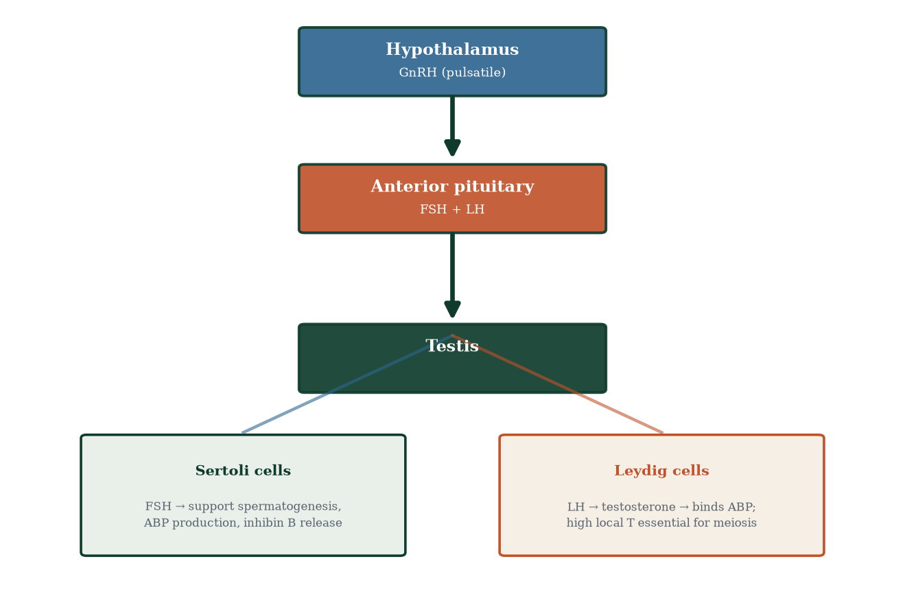
Three phases define the pathway (Figure 5.1):
- Spermatocytogenesis (mitosis) — spermatogonial stem cells self-renew and produce committed spermatogonia that proliferate.
- Meiosis (spermatocyte phase) — primary spermatocytes undergo meiosis I; secondary spermatocytes undergo meiosis II; four spermatids result.
- Spermiogenesis (metamorphosis) — round spermatids transform into streamlined sperm: acrosome, flagellum, nuclear condensation, cytoplasm disposal.
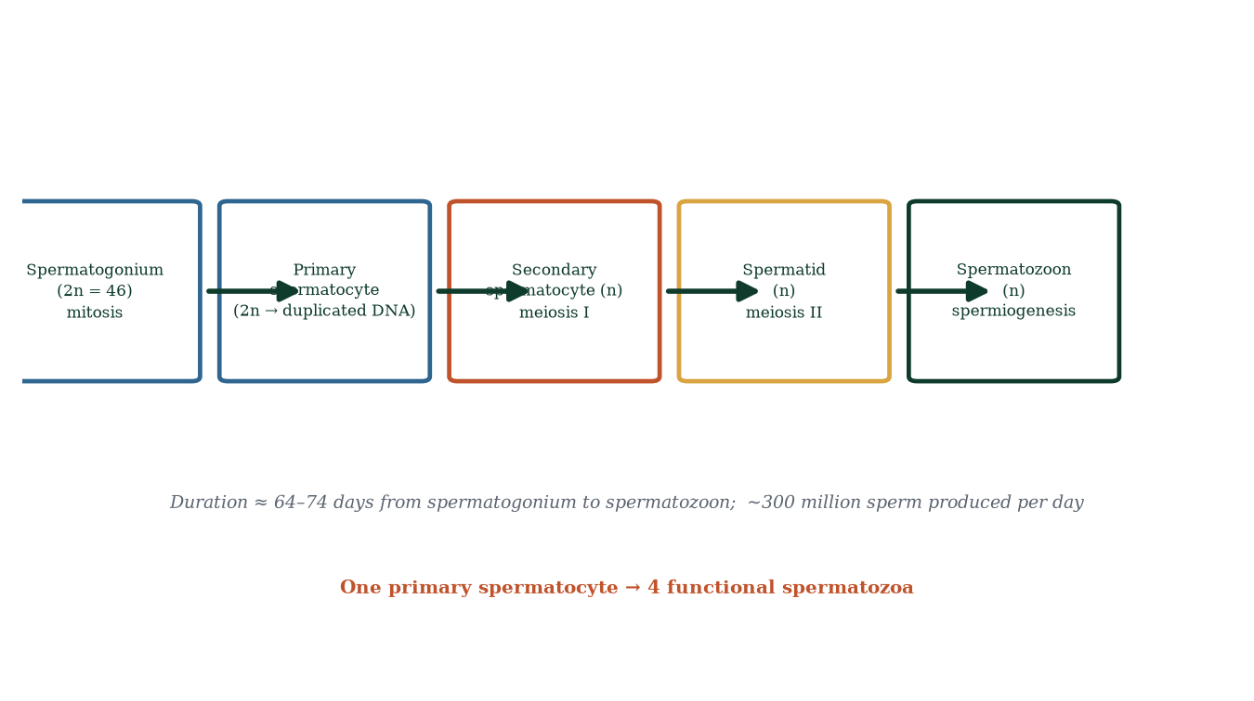
Figure 5.1 — Stages of spermatogenesis with chromosome number. One primary spermatocyte yields four functional spermatids.

5.2 Phase 1 — Spermatocytogenesis: stem cells and amplification
At the basement membrane sit two populations: type A spermatogonia — including the true spermatogonial stem cells (Ad, dark nucleus, quiescent reserve) and Ap (pale nucleus, actively dividing) — and type B spermatogonia, the committed progenitors destined for meiosis. Type A cells divide mitotically; some daughter cells remain as self-renewing stem cells (maintaining the factory indefinitely) and some differentiate to type B. Type B spermatogonia divide once or twice more, grow, replicate DNA in S phase and become primary spermatocytes — the largest germ cells in the tubule and the cells that will actually perform meiosis.
Why stem-cell renewal matters: an adult male may produce over a trillion sperm in a lifetime. The system solves persistence by a stem-cell pool that is both self-renewing and elastic — it can expand output under stimulation (e.g., high gonadotrophins after testosterone withdrawal) and contracts under injury or stress.

5.3 Phase 2 — Meiosis: halving the genome
Detailed in Chapter 2; here applied specifically:
- Primary spermatocyte (2n, 4C) — DNA replicated; chromosomes consist of two sister chromatids. Enters meiosis I; prophase I is prolonged (~2 weeks) — homologues synapse, crossing over generates recombinant chromatids.
- Anaphase I — homologous chromosomes separate; chromosome number halves: two secondary spermatocytes (n, 2C) form.
- Meiosis II — without DNA replication; sister chromatids separate at anaphase II → four spermatids (n, 1C).
- All four products survive — unlike oogenesis, where three polar bodies are discarded. This symmetry reflects male strategy: maximal gamete number.
Meiosis is the most vulnerable step — checkpoints (the spindle assembly checkpoint) and pervasive apoptosis eliminate cells with mis-segregated chromosomes; most defective germ cells die quietly. Failure modes show up clinically as reduced sperm counts, poor morphology and aneuploidy (Chapter 19).

5.4 Phase 3 — Spermiogenesis: from round cell to rocket
Round spermatids are useless on their own. Spermiogenesis (Figure 5.3) converts them into functional sperm through coordinated remodelling:
- Acrosome formation — the Golgi apparatus generates the acrosomal vesicle, which caps the anterior nucleus; it carries hyaluronidase and acrosin, essential for zona penetration (Chapter 10).
- Nuclear condensation — histones are replaced by protamines (arginine-rich DNA-packing proteins); the nucleus flattens and compacts — the head becomes ~5–6 µm of almost purely DNA, protected from the oxidative environment it will traverse.
- Flagellum assembly — a centriole templates the axoneme: the classic 9+2 microtubule arrangement (nine outer doublets, two central singlets), powered by dynein ATPases; outer dense fibres and the fibrous sheath add stiffness and resilience; mitochondrial sheath wraps the midpiece to fuel the motor.
- Cytoplasm disposal — excess cytoplasm is stripped off into a residual body, phagocytosed by Sertoli cells; the residual body can be expelled into the lumen.
- Mitochondrial organisation — mitochondria migrate to the midpiece in a helical sheath, producing ATP for flagellar motion.
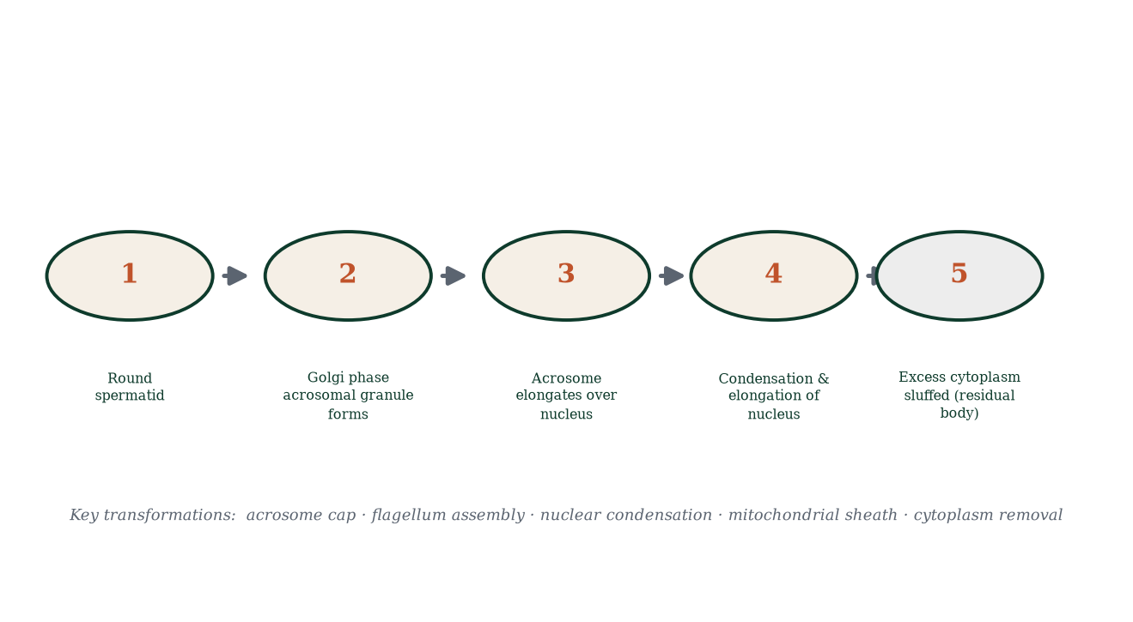
Figure 5.3 — The five stages of spermiogenesis: acrosome biogenesis, nuclear condensation, flagellum assembly and cytoplasmic sloughing.
The finished spermatozoon (Figure 5.2) is ~55–60 µm long (one of the smallest human cells): a head (nucleus + acrosome), a neck (centriole), a midpiece (mitochondrial sheath + axoneme), a principal piece (fibrous sheath) and an end piece. It is essentially a delivery vehicle for paternal DNA — no ribosomes, no ER, minimal cytoplasm, ~3 pg of DNA.
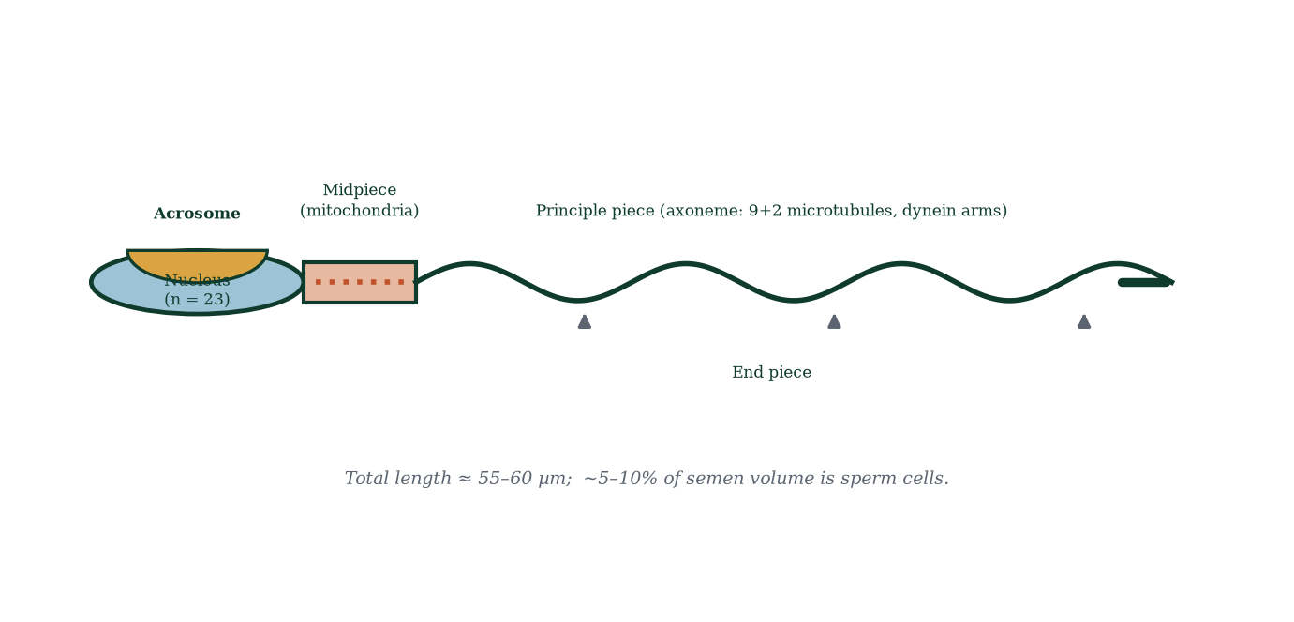
Figure 5.2 — Spermatozoon anatomy: acrosome cap, haploid nucleus, midpiece mitochondria, and the 9+2 axoneme of the tail.

5.5 After the testis: maturation in the epididymis
Spermatozoa released into the tubule lumina are morphologically complete but functionally helpless — they do not move forward and cannot fertilise. Over 10–14 days in the epididymis: - membrane lipid composition shifts (increasing unsaturation → flexibility for the acrosome reaction); - surface coated with decapacitation factors (stabilising and delaying premature capacitation); - epididymal glycoproteins and sterols reorganise the zona-binding apparatus; - motility develops from twitching to progressive forward motion; - water is resorbed (~90%), concentrating sperm.

5.6 Capacitation and the acrosome reaction (teased out in Chapter 10)
Capacitation is the final, female-tract-dependent activation: removal of seminal decapacitation coat, cholesterol efflux (membrane fluidity ↑), increased intracellular cAMP and Ca²⁺, and development of hyperactivated motility — forceful, whip-like tail beats needed to penetrate the cumulus and zona. Proper capacitation is why freshly ejaculated sperm cannot fertilise immediately and why sperm require several hours in the female tract.
Hyperactivation may also help sperm detach from the oviductal epithelium (the isthmic reservoir) when they sense the fertilisation signal from the egg–cumulus complex (progesterone gradients + chemoattractants) — an elegant ‘final acceleration trigger’.

5.7 Factors affecting sperm production (and what evidence actually shows)
Established influences with human evidence:
- Temperature: fever, tight garments, hot baths raise scrotal temperature and suppress output for weeks (spermatogenesis recovers after sperm cycle turnaround ~2–3 months).
- Smoking: associated with modestly reduced concentration and motility in meta-analyses; cessation improves parameters partially.
- Alcohol: heavy use depresses testosterone and sperm quality; moderate use shows weaker, inconsistent associations.
- Anabolic steroids / exogenous testosterone: profoundly suppress LH/FSH → oligospermia/azoospermia (reversible over months after cessation). This is the classic pharmacology-meets-reproductive-biology trap.
- Obesity: aromatase conversion of testosterone to oestrogens in adipose tissue blunts the axis; scrotal heat and insulin resistance compound the effect.
- Age: gradual decline from ~40 onward — lower semen volume, concentration, motility and morphology; higher DNA fragmentation; increased risk of de novo mutations and (weakly) some offspring disorders.
- Occupation/toxins: pesticides (dibromochloropropane), solvents, heavy metals, ionising radiation, chemotherapy and heat all impair spermatogenesis — evidence from occupational cohorts.
- Varicocele: left-dominant venous insufficiency; the commonest correctable male infertility factor.
Unproven or weak: mobile phones, laptops, underwear style (beyond modest temperature effects), dietary supplements (zinc/folate show small signals in some trials but no replacement for reducing clear harms). Evidence discipline matters: reproductive ‘facts’ in the press frequently overreach the data.

5.8 Mechanisms and evidence in depth: sperm quality, DNA damage and male fertility pharmacology
Sperm DNA fragmentation. Sperm chromatin is uniquely compact but not immune to damage. Sources: (i) oxidative stress — sperm membranes are rich in polyunsaturated fatty acids and their cytoplasm is antioxidant-poor; (ii) abnormal chromatin packaging — residual histones instead of protamines in immature sperm; (iii) apoptosis checkpoint failure — damaged cells survive when repair falters; (iv) insults — heat, toxins, radiation, smoking, varicocele. Measured by TUNEL, SCSA, comet assay. High fragmentation reduces IVF success and raises miscarriage; management: varicocele repair (best evidence), antioxidants (weak/mixed evidence), smoking cessation.
Sperm epigenetics and paternal effects. Sperm carry methylation marks; paternal lifestyle modulates the sperm methylome (animal data strong, human data emerging). Paternal age raises de novo mutations; some autosomal dominant disorders accumulate preferentially through fathers — the “selfish spermatogonial selection” phenomenon (Apert syndrome and FGFR2) — activating mutations let certain spermatogonia outgrow their peers.
Normozoospermia is not fertility guaranteed. Fertility depends on the ecosystem — cervical receptivity, timing, oocyte quality, uterus — and both partners’ genetics. Normal analysis with persistent infertility defines the unexplained category (~10% of couples) — managed empirically (lifestyle, timed intercourse, IUI) before escalation.
Anabolic steroids — pharmacology as anti-fertility agent. Exogenous testosterone suppresses hypothalamic GnRH via direct and aromatised feedback → LH/FSH collapse → intratesticular testosterone falls below 1% of normal → spermatogenesis arrests within weeks; counts near zero within ~3 months; recovery after cessation takes ~3–12 months, occasionally longer; prolonged high doses can cause persistent azoospermia. Mechanism explains why a drug that makes users feel stronger reliably sterilises them.
Heat and spermatogenesis — controlled human data. Scrotal heating (45–47 °C, 15–30 min daily for weeks) significantly reduces sperm output; saunas and hot baths have measurable effects; laptops on laps raise scrotal temperature ~2–3 °C; tight underwear trials show inconsistent results. Mechanism is sound (heat-sensitive meiotic spindles and chromatin); behavioural amplification is real but modest for most men.

Common errors in sperm reasoning
- “Volume equals count.” — independent parameters.
- “Abnormal morphology means defective children.” — morphology is not fate.
- “One low count rules out fertility.” — serial samples required.
- “Natural supplements are safe.” — quality, dose, interactions all unregulated.

5.9 Clinical reasoning vignettes
Case 1. A 29-year-old gym enthusiast on 10-week testosterone cycles undergoes semen analysis: azoospermia. Mechanism: exogenous T silenced hypothalamic GnRH → LH/FSH collapse → intratesticular T (normally 50–100× serum) fell → spermatogenesis arrested. Counselling: stop; recovery typically within 6–12 months; check FSH before resuming anything.
Case 2. A couple TTC for 18 months: normal count, 12% motility, 6% normal forms, normal hormones. Mechanism: sperm functional deficit, not quantity — IUI (post-wash motile fraction inseminated into uterus) bypasses cervical filtering; 3 cycles then IVF/ICSI if no success.
Case 3. A 42-year-old with 34% sperm DNA fragmentation and two early miscarriages. Mechanism: oxidative chromatin damage; varicocele — repair followed by 6-week recheck (one spermatogenic cycle is ~72–76 days); couple’s prognosis improved.

Self-check — can you derive these without notes?
- Why does sperm count fluctuate week to week more than ovarian reserve does?
- Trace a sperm from spermatogonium to ejaculate with approximate timings at each stage.
- Why does fever suppress sperm output for ~2–3 months afterwards?
- Explain the blood–testis barrier’s dual role — immune protection and microenvironment creation.
- Why do varicoceles more often affect the left testicle?

Chapter summary
- Spermatogenesis = spermatocytogenesis (mitosis) → meiosis → spermiogenesis; ~64–74 days; millions produced daily.
- One primary spermatocyte → four sperm (all products survive).
- Spermiogenesis: acrosome, condensed nucleus (protamines), 9+2 axoneme, mitochondrial sheath, cytoplasm sloughed.
- Epididymal transit (10–14 d) confers motility and fertilising competence.
- Capacitation (cholesterol efflux, hyperactivation) and the acrosome reaction (hyaluronidase, acrosin) are required for fertilisation and occur largely in the female tract.
- Temperature, hormones (FSH/LH/testosterone axis), smoking, steroids, obesity, age and toxins modulate production — with human evidence backing the major ones.

Key terms
Spermatogonium — germline stem cell on the basement membrane. Primary spermatocyte — meiotic cell entering meiosis I. Spermatid — post-meiotic haploid precursor. Spermiogenesis — morphological transformation of spermatid to sperm. Acrosome — enzyme cap for zona penetration. Axoneme — 9+2 microtubule flagellar core. Residual body — discarded spermatid cytoplasm. Capacitation — final activation in female tract. Hyperactivation — whip-like motility pattern. ABP [32] — androgen-binding protein maintaining high intratubal testosterone. Atresia — default degenerative fate. Decapacitation factor — coat stabilising membrane against premature activation.

Review questions
Multiple choice
- What is the approximate duration of human spermatogenesis from stem cell to spermatozoon?
  - 8 days b) 16 days c) 64–74 days d) 6 months
- All four products of one meiosis survive in spermatogenesis because:
  - polar bodies fuse b) male strategy favours maximal gamete numbers c) Sertoli cells refuse to phagocytose d) they divide again
- Which structure becomes the genetic payload of the sperm head?
  - acrosome b) condensed haploid nucleus c) mitochondrion d) residual body
- Acrosomal enzymes include:
  - amylase and maltase b) hyaluronidase and acrosin c) trypsin and chymotrypsin d) pepsin and renin
- Capacitation occurs:
  - in the testis b) in the epididymis c) in the female reproductive tract d) during emission
- Replacing histones with protamines serves to:
  - initiate acrosome reaction b) compact and protect DNA c) power the tail d) build the blood–testis barrier
- Exogenous testosterone causes male infertility primarily by:
  - directly destroying Sertoli cells b) suppressing LH/FSH and intratesticular testosterone c) blocking epididymal transport d) increasing scrotal temperature
- One primary spermatocyte produces, in a single meiosis:
  - one spermatozoon b) two spermatozoa c) four spermatozoa d) thousands
Short answer
- Distinguish the products and purposes of mitosis and meiosis in spermatogenesis.
- Name the five morphological transformations of spermiogenesis.
- Explain why freshly ejaculated sperm cannot immediately fertilise an oocyte.
- State two established and two unproven factors affecting sperm production.
Explanation
- Explain the role of the blood–testis barrier in spermatogenesis and the danger it protects against.
- Trace the hormonal control of spermatogenesis from hypothalamus to tubule and name the specific roles of FSH and LH.
- Explain how mitochondrial placement in sperm reflects their function.
Application
- A patient on an anabolic-steroid cycle has non-detectable sperm on analysis. Walk through the mechanism and the expected time course of recovery after cessation.
- A febrile illness last month coincides with a low sperm count today. Explain the delayed effect in terms of the spermatogenic cycle.
- A man asks about “sperm-safe” hot baths for easing joint pain. What would you counsel, with mechanisms?

Answers to review questions
- c. ~64–74 days; a new cohort starts every ~16 days.
- b. Male reproductive strategy: volume and variation over resource investment in each gamete.
- b. The nucleus carries paternal DNA; the acrosome is an enzyme cap.
- b. Hyaluronidase disperses cumulus; acrosin digests zona pellucida.
- c. Cholesterol efflux, decapacitation-coat removal and ionic shifts occur in the female tract.
- b. Protamines pack DNA ~10× more densely than histones, protecting it for the journey.
- b. Exogenous testosterone suppresses hypothalamic GnRH output, collapsing intratesticular testosterone and FSH support — the tubule shuts down.
- c. Meiosis I halves, meiosis II separates chromatids — four haploid round spermatids.
- Mitosis: self-renewal of spermatogonia and clonal expansion (same ploidy; no recombination); meiosis: halving of chromosome number and allele shuffling (recombination) — producing genetically varied haploid cells.
- Acrosome biogenesis; nuclear condensation (protamines); flagellum/axoneme assembly; mitochondrial midpiece formation; excess cytoplasm sloughed as residual body (phagocytosed by Sertoli cells).
- Capacitation — membrane destabilisation, cholesterol loss, removal of decapacitation coat, hyperactivation — must occur first; acrosome reaction and zona binding are downstream of this priming.
- Established: heat, anabolic steroids/exogenous testosterone, smoking (modest), obesity (modest), varicocele, occupational toxins. Unproven/weak: phones/laptops beyond trivial heat effects; alkaline diets; most nutraceuticals.
- Adjacent Sertoli cell tight junctions divide the tubule; meiotic/haploid antigens are never seen by the immune system during education; their exposure triggers autoimmune orchitis and infertility; the barrier is also an electrochemical/nutritional microenvironment gatekeeper.
- Pulsatile GnRH → anterior pituitary LH and FSH. LH targets Leydig cells → testosterone → intratubal testosterone (via ABP) sustains meiosis; FSH targets Sertoli cells → ABP secretion, inhibin B, nutrient support, and maintenance of the germ-cell microenvironment; testosterone and inhibin B feed back on the axis (Chapters 7 and 9).
- Mitochondria are helically wrapped around the midpiece immediately behind the nucleus, placing ATP production next to the axoneme’s dynein ATPases — minimising diffusion loss and maximising the thrust needed for the epididymal journey and oviduct penetration.
- Testosterone suppresses GnRH → LH/FSH fall → testosterone production in Leydig cells ceases and ABP support disappears → spermatogonia and spermatocytes fail; sperm counts fall over ~8–10 weeks (one spermatogenic cycle). Recovery after cessation generally takes 3–6 months (often longer), guided by drug class and duration — needs clinical oversight.
- Sperm spend ~64–74 days developing; heat-sensitive spermatocytes/spermatids in the meiosis and spermiogenesis window are hit hardest; symptoms on semen analysis lag the fever by one to two cycles — count recovers over 1–3 months.
- Counsel against prolonged hot-water immersion during the years of pursuing conception: chronic scrotal heating impairs output with measurable but modest effects; brief showers are unlikely to matter; alternatives (topical anti-inflammatory) should be discussed with his clinician — not memorise “avoid heat”, understand why heat impairs meiosis/spermiogenesis.

Chapter 6: Oogenesis and Ovarian Follicle Development
Learning objectives. After studying this chapter you should be able to: - trace oocyte development from primordial germ cell to ovum; - explain the two meiotic arrests and their release; - describe follicular growth from primordial to pre-ovulatory follicle; - explain dominant follicle selection, ovulation and corpus luteum formation; - describe ovarian ageing and its consequences.
Central question. Why does the female body keep one lifetime’s oocytes under arrest for decades, release one per cycle — and run out, predictably, mid-life?

6.1 The radical design: a lifetime supply, arrested
Unlike males, who manufacture sperm continuously from puberty, females are born with their entire future gamete supply already produced. Primordial germ cells migrate into the genital ridge at weeks 5–6, proliferate as oogonia, envelop supporting cells as primordial follicles, and enter meiosis in utero — every primary oocyte reaches prophase I and arrests there by birth. No new oocytes are made after fetal life. This single fact dictates the timing and biology of female fertility, its predictable decline, and menopause.
Numbers tell the story (Figure 6.4): ~6–7 million oogonia peak at ~20 weeks’ gestation; ~1–2 million primary oocytes at birth; ~300,000–400,000 primordial follicles at puberty; ~400 ever ovulated; the pool is exhausted at menopause. Depletion is by atresia — programmed apoptosis of oocytes and granulosa cells — which eliminates >99.9% of all follicles ever formed. Atresia is the default; only a few follicles per cycle escape and one is selected to ovulate.

6.2 Two arrests, two releases: the oocyte’s schedule
Oogenesis (Figure 6.1) is a production line with two deliberate pause buttons.
Arrest 1 — Prophase I (dictyotene), set before birth. Homologous chromosomes have synapsed, crossing over has occurred, and the oocyte parks in diplotene of prophase I. Arrest is maintained by cAMP/cGMP held high inside the oocyte (cGMP flows in from surrounding granulosa cells through gap junctions), which inhibits maturation-promoting factor (MPF). The big idea: the oocyte is frozen at the exact point where its DNA is duplicated but not divided.
Release 1 — resumed at puberty/each cycle, just before ovulation. The LH surge phosphorylates and closes gap junctions (via connexin remodelling), cGMP influx stops, oocyte cAMP collapses, MPF activates → meiosis I resumes → the oocyte divides asymmetrically: one large secondary oocyte (keeps nearly all cytoplasm) and one tiny first polar body (which may or may not divide again). The secondary oocyte arrests again in metaphase II.
Arrest 2 — Metaphase II. Maintained by cytostatic factor (c-Mos/ERK). The oocyte sits there, ovulated, viable for ~12–24 hours, waiting in the ampulla.
Release 2 — fertilisation. When sperm enters (Chapter 10), intracellular Ca²⁺ oscillations triggered by sperm phospholipase C zeta inactivate cytostatic factor → meiosis II completes → second polar body extruded → maternal pronucleus forms. No sperm = no meiosis II. Oocyte meiosis is literally licensed by fertilisation.
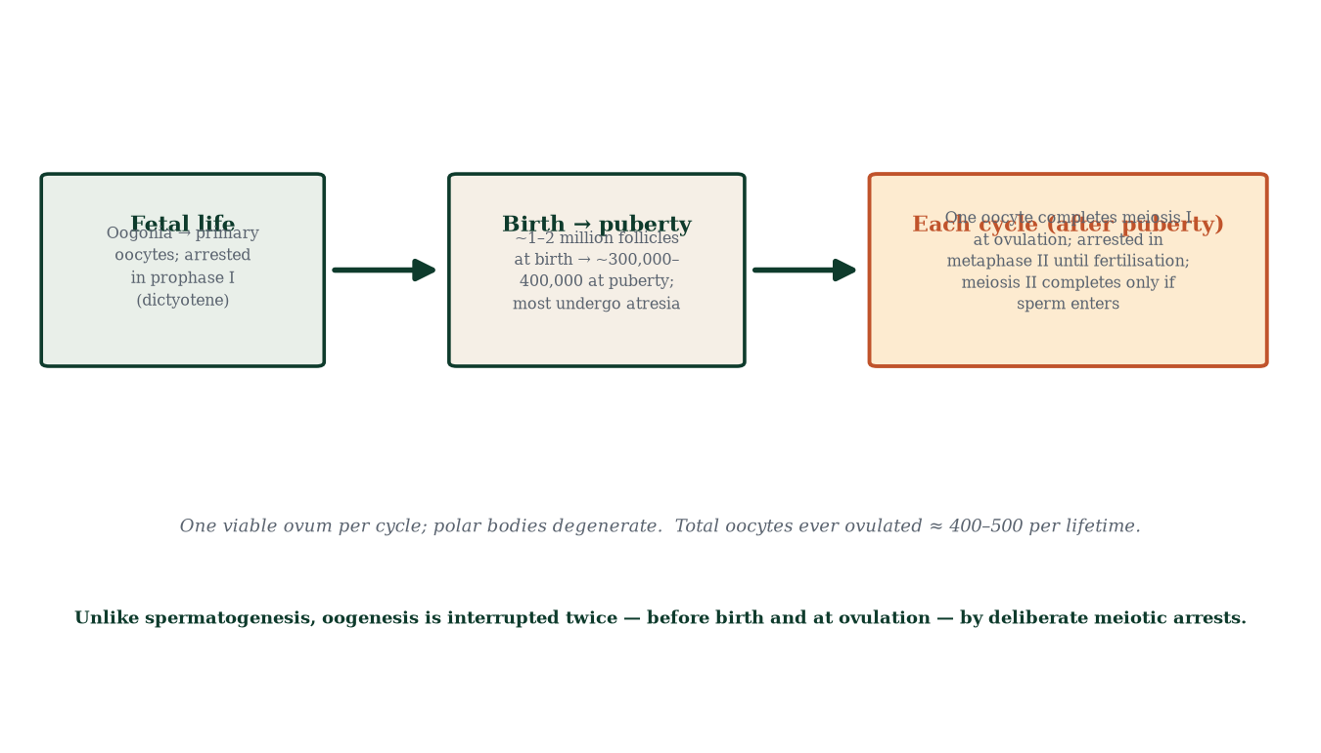
Figure 6.1 — Oogenesis timeline with the two meiotic arrests and their triggers: LH surge releases arrest 1; sperm entry releases arrest 2.
One viable ovum per cycle (and three polar bodies that disintegrate) — the opposite of the male strategy. The imbalance exists because the embryo, until the placenta takes over, must live on the oocyte’s cytoplasmic provisions (mRNAs, mitochondria, yolk substitutes used historically).

6.3 Follicular development: from primordial to pre-ovulatory
The follicle is the oocyte’s house, food supply and hormone factory. Development is staged histologically (Figure 6.2):
- Primordial follicle — oocyte + one flat layer of granulosa cells; resting for years to decades; the reserve. Recruitment of primordial follicles into the growing pool is gonadotrophin-independent (continuous, stochastic).
- Primary follicle — cuboidal granulosa cells multiply; the oocyte grows; the zona pellucida forms (ZP1–ZP4 glycoproteins; species-specific sperm recognition; ZP2/ZP3 → acrosome reaction trigger, Chapter 10).
- Secondary follicle — granulosa layers multiply (several layers); thecal cells organise outside the basement membrane (theca interna — steroidogenic; theca externa — contractile fibrous); small fluid pockets coalesce into the antrum.
- Tertiary / early antral → pre-ovulatory (Graafian) follicle — antrum expands dramatically; oocyte sits eccentrically on the cumulus oophorus; innermost granulosa cells form the corona radiata (they remain attached at ovulation and enter the tube with the oocyte — sperm must digest through them).
- Ovulation → corpus luteum → corpus albicans.
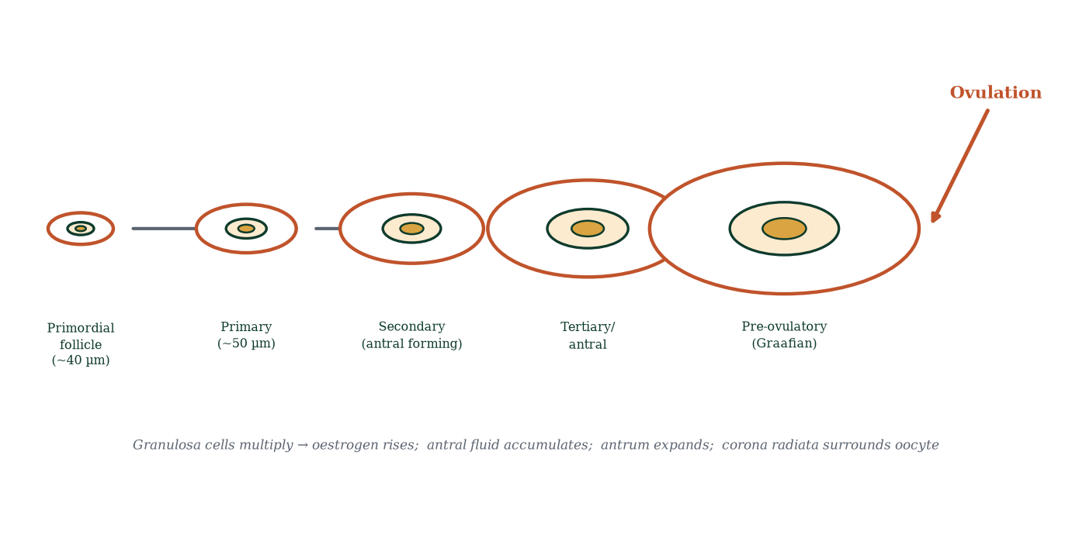
Figure 6.2 — Follicle development series, from ~40 µm primordial to pre-ovulatory Graafian follicle, followed by ovulation.
Hormonal logic built into this sequence: granulosa cells express aromatase (converts theca-derived androgens to oestradiol under FSH stimulation); theca cells respond to LH by producing androstenedione and testosterone, which diffuse into granulosa (the two-cell, two-gonadotrophin [6] theory). Also, granulosa cells secrete inhibin B in the early follicular phase (suppresses FSH) and inhibin A in the luteal phase; both fine-tune the axis (Chapter 7). Activin from granulosa stimulates FSH locally and promotes differentiation.

6.4 The follicular race and dominance
Each cycle, a cohort of antral follicles (typically ~3–11 recruited at age 25, fewer later) begins growing from ~2–5 mm. As they mature they become FSH-dependent; FSH stimulates granulosa proliferation and oestradiol production; oestradiol and inhibin B negatively feedback and FSH falls in the late follicular phase. The cohort faces selection by a narrowing hormone window: only the follicle with (a) the most FSH receptors, (b) highest local oestradiol, (c) largest size — and thence best FSH sensitivity — survives the decline. That follicle (dominant follicle) acquires LH receptors on granulosa cells (previously granulosa answered only FSH; after LH-receptor acquisition it answers LH too, a switch that primes it for ovulation). The rest of the cohort undergo atresia. Usually one follicle dominates; two can co-dominate (source of dizygotic twinning). This is a direct demonstration of selection by rising threshold: the winner is the one that kept its sensitivity while everyone else lost theirs.

6.5 Ovulation: the rupture
The LH surge (triggered when oestradiol exceeds ~200 pg/mL for ~48 h, switching feedback from negative to positive — the only physiological positive feedback in this axis) acts on the pre-ovulatory follicle. Events (Figure 6.3), in order:
- LH phosphorylates granulosa to shift from oestrogen to progesterone-predominant production (progesterone in late follicular fluid is itself ovulation-triggering).
- Prostaglandins (especially PGE2, PGF2α) and local collagenase (via plasminogen activators) digest the follicular wall at the stigma; proteases degrade tunica albuginea.
- The follicle ruptures ~24–36 h after surge onset: the cumulus–oocyte complex is extruded into the peritoneal cavity.
- The fimbriae sweep the complex into the ampulla (Chapter 10).
- The collapsed follicle seals with fibrin and reorganises.
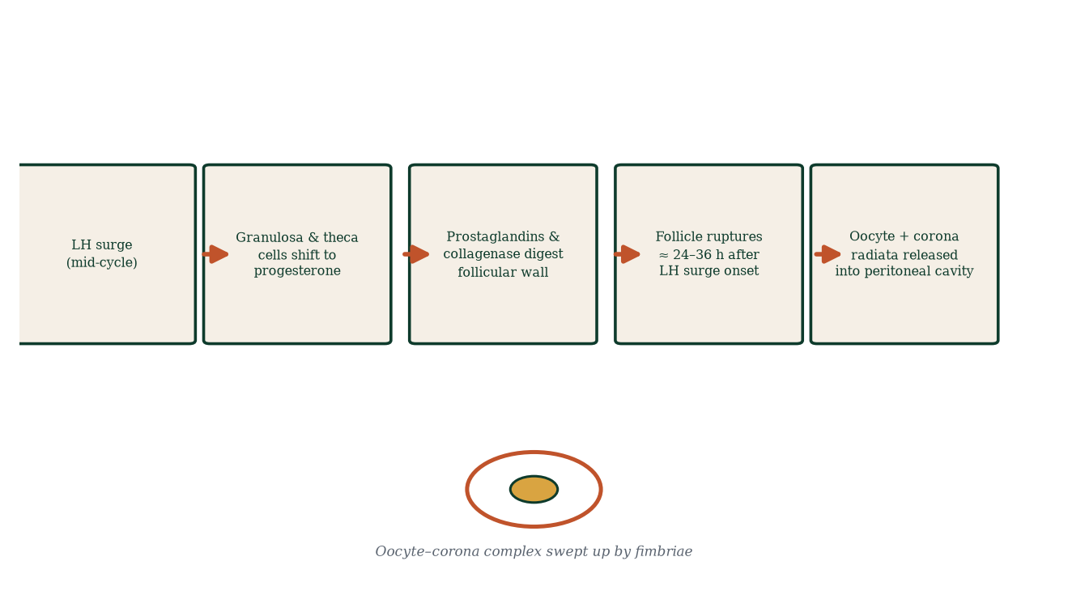
Figure 6.3 — The ovulation cascade: LH surge → enzymatic wall digestion → follicular rupture → capture by fimbriae.
Clinical pearls: mid-cycle pain (Mittelschmerz) corresponds to peritoneal irritation by follicular fluid/blood; basal temperature rises ~0.3–0.5 °C after ovulation (progesterone thermogenesis) — the basis of fertility tracking (Chapter 18); a positive LH urine strip predicts ovulation 24–36 h ahead.

6.6 The corpus luteum: pregnancy-or-not switchboard
After rupture, granulosa and thecal cells luteinise under LH → corpus luteum forms: a highly vascularised temporary endocrine organ (~2–4 cm). It secretes progesterone (essential to prepare and stabilise the endometrium for implantation — Chapters 8, 11), oestradiol (smaller), and inhibin A. Its lifespan is ~12–14 days. If no hCG arrives from an implanting embryo by day ~10–12 post-ovulation, LH support wanes, the corpus luteum involutes (corpus luteolysis — mediated partly by local PGF2α/endothelin), becomes corpus albicans (a white fibrous scar), progesterone and oestrogen crash → spiral arteriole vasospasm → endometrium sheds → menstruation. If a blastocyst implants, hCG “rescues” the corpus luteum (Chapter 11, Figure 11.4) — prolonging progesterone secretion until the placenta takes over at ~7–10 weeks (Chapter 14). Loss of corpus luteum function before placental steroid takeover = luteal phase defect, implicated (somewhat controversially) in early miscarriage and infertility.

6.7 Ovarian ageing and the end of the reserve
The oocyte pool declines monotonically and exponentially. AMH [7] (anti-Müllerian hormone) secreted by growing antral/pre-antral granulosa cells is the best clinical estimate of ovarian reserve (low AMH = low reserve); inhibin B and antral follicle count (AFC) on ultrasound are the others. Perimenopause (~mid-40s): cycles shorten and become irregular as the cohort shrinks (still-elevated oestrogen against falling FSH threshold) — the ‘hot flash’ prodrome; menopause: 12 months’ amenorrhoea (average ~51); post-menopause: chronically high FSH/LH, low oestradiol — not ovarian ‘failure of the pituitary’ but simple exhaustion of the follicle pool (Chapter 18). Premature ovarian insufficiency (<40) can be autoimmune, genetic (Fragile X premutation), surgical, iatrogenic (chemo-/radiotherapy) — genetic testing and fertility preservation (oocyte cryopreservation) matter here.
Oocyte quality declines faster than quantity: spindle dysfunction, cohesion decay, mitochondrial decline → rising aneuploidy (trisomy risk: ~1:1,500 at age 20 → ~1:30 at 45). This is the mechanistic substrate of the maternal-age effect.
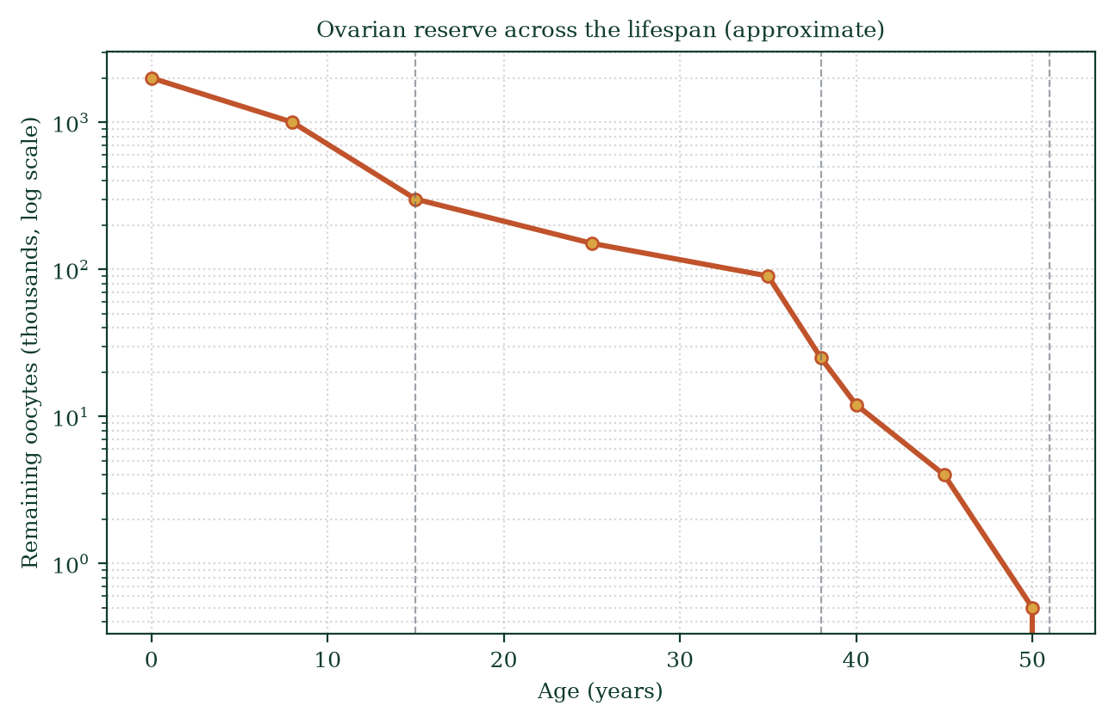
Figure 6.4 — Declining oocyte reserve across the female lifespan (logarithmic scale); the shaded window spans the menopausal transition.

6.8 Mechanisms and evidence in depth: two cells, two gonadotrophins in biochemical detail
Theca cells (LH-driven). LH binds its GPCR → Gs → adenylyl cyclase → cAMP → PKA → StAR protein activation → cholesterol into mitochondria → CYP11A1 converts it to pregnenolone → CYP17 yields androstenedione (and DHEA in some tissues). The theca is the ovary’s androgen factory. Theca also secretes IGF-1, cytokines (IL-1, IL-6) and VEGF (follicle angiogenesis). LH additionally triggers the ovulatory cascade and luteal progesterone shift.
Granulosa cells (FSH-driven). FSH binds GPCR → Gs → cAMP → PKA → aromatase (CYP19) transcription → conversion of theca-derived androstenedione/testosterone into oestrone/oestradiol. FSH also induces LH receptor expression on late-stage granulosa (priming for the surge) and stimulates inhibin B and activin secretion. Granulosa cells secrete follistatin — activin-binding protein limiting activin action (autocrine fine-tuning).
Why both cells and both gonadotrophins are mandatory. Neither cell type can make oestradiol alone: theca lacks aromatase, granulosa lacks CYP17. Androgens diffuse freely across the basement membrane to their partner cell. Disruption at either step collapses oestrogen — PCOS (thecal excess) or premature ovarian insufficiency (granulosa loss).
Atresia — the molecular mechanism. Growing follicles compete for FSH. Granulosa cells deprived of FSH undergo apoptosis: mitochondrial cytochrome-c release, caspase-3/9 activation, Bax upregulation, Bcl-2 downregulation. The surviving follicle’s oestradiol and inhibin B suppress FSH further — a built-in winner-amplifying feedback loop.
Oocyte competence acquisition. The oocyte must be transcriptionally silent and stocked with maternal mRNAs, proteins and mitochondria before ovulation — its dowry for the days before zygotic genome activation (day 2–4). Larger oocytes carry more mitochondria and maternal mRNA; this is the mechanistic basis of age-related fertility decline.

Common errors in oogenesis reasoning
- “Ovulation alternates ovaries strictly.” — predominantly yes, but both can ovulate in a year; inter-ovulatory interval varies.
- “AMH counts your eggs.” — it estimates the growing cohort, not a literal inventory.
- “Mid-cycle pain means cyst rupture.” — Mittelschmerz is normal ovulatory pain.
- “The pill uses up eggs.” — no; atresia proceeds regardless; pills only block dominant follicle selection.

6.9 Clinical reasoning vignettes
Case 1. A 30-year-old with eight months of trying to conceive, AMH 0.6 ng/mL. Mechanism: diminished ovarian reserve — the growing-follicle cohort is small; per-cycle antral follicle recruitment is low; time-to-pregnancy stretches. Options: prompt conception attempts; consider early fertility consultation; oocyte cryopreservation if delaying for life reasons — mechanism, not destiny; pregnancies still occur.
Case 2. A 27-year-old with PCOS and BMI 34: irregular menses, acne, hirsutism, LH:FSH 2.5:1. Mechanism: insulin resistance → thecal androgen excess → follicular arrest → anovulation. Weight loss, metformin, letrozole — sequential mechanistic steps before IVF.
Case 3. A woman at 36 wants to delay pregnancy. Mechanism: oocyte quantity and quality fall; at 40, ~50% of natural conception cycles still yield pregnancy but aneuploidy rises steeply; mechanism-based counselling: fertility preservation (oocyte/embryo freezing) or timed childbearing.

Self-check — can you derive these without notes?
- Why does the dominant follicle survive when others undergo atresia?
- Explain the “two-cell two-gonadotrophin” rule and why granulosa cells need theca cooperation.
- Derive why AMH tracks growing (pre-antral and small antral) follicles, not the primordial pool.
- Why does the LH surge occur mid-cycle and last ~48 hours?
- Predict the hormone profile of a cycle where the dominant follicle fails to ovulate (luteinised unruptured follicle).

Chapter summary
- Females are born with all the oocytes they will ever have; oogenesis is arrested twice (prophase I, metaphase II); sperm entry releases the second arrest.
- Folliculogenesis: primordial → primary → secondary → antral → pre-ovulatory → ovulation → corpus luteum → albicans.
- Granulosa (FSH, aromatase) + theca (LH, androgens) = two-cell, two-gonadotrophin oestrogen synthesis.
- Selection: cohort grows under FSH; falling FSH late in the follicular phase selects the dominant follicle by FSH-receptor density; it gains LH receptors and ovulates.
- LH surge (positive oestrogen feedback) triggers wall digestion and rupture; oocyte with corona radiata is captured by fimbriae.
- Corpus luteum = progesterone power station (12–14 days); rescued by embryonic hCG or it involutes → menses.
- Reserve declines with age; AMH/AFC estimate it; menopause is follicular exhaustion.

Key terms
Primordial follicle — resting oocyte + flat granulosa. Zona pellucida — glycoprotein shell of the oocyte. Cumulus oophorus / corona radiata — granulosa cells riding with the oocyte. Antrum — follicle fluid cavity. Graafian (pre-ovulatory) follicle — selected ovulatory follicle. Two-cell two-gonadotrophin theory — theca (LH, androgens) + granulosa (FSH, aromatase) = oestradiol. Dominant follicle — FSH-threshold winner. Corpus luteum — post-ovulation progesterone gland. Atresia — programmed follicle death. AMH — reserve marker. Mittelschmerz — mid-cycle ovulation pain.

Review questions
Multiple choice
- In utero, oocytes arrest in:
  - metaphase II b) prophase I (dictyotene) c) anaphase I d) interphase
- The two-cell, two-gonadotrophin theory assigns which roles?
  - LH/granulosa; FSH/theca b) FSH/theca; LH/granulosa c) LH/theca; FSH/granulosa d) FSH/follicle; LH/corpus luteum only
- Which hormone triggers the LH surge?
  - progesterone b) inhibin B c) oestradiol (sustained rise) d) hCG
- At ovulation, the oocyte is arrested in:
  - prophase I b) metaphase I c) metaphase II d) anaphase II
- The corpus luteum secretes progesterone for approximately:
  - 2 days b) 5 days c) 12–14 days d) 30 days
- Follicle-stimulating hormone primarily acts on:
  - theca cells b) granulosa cells c) Leydig cells d) corpus luteum only
- The oocyte reserve at puberty is approximately:
  - 6–7 million b) 1–2 million c) 300,000–400,000 d) 400
- Maturation of primordial follicles is:
  - entirely FSH-driven b) gonadotrophin-independent and stochastic c) LH-dependent d) switched off until puberty
Short answer
- Explain the two arrests of oogenesis and what releases each.
- Describe the selection mechanism that produces a single dominant follicle in most cycles.
- State three functions of the corpus luteum.
- Define atresia and state its quantitative significance.
Explanation
- Explain why maternal age is the strongest risk factor for trisomy, in terms of oocyte biology.
- Explain the two-cell, two-gonadotrophin theory step by step, and why both cell types are required for oestradiol.
- Walk through the chronology from LH surge to oocyte in the tube, in order.
Application
- A couple trying to conceive: urine LH strips go positive on cycle day 12. When is she most fertile, and why?
- A 38-year-old’s AMH is below the reference range. Explain what this means for her fertility counselling.
- A woman has shortened, irregular cycles at 46. Explain the mechanism behind this and the expected hormonal pattern.

Answers to review questions
- b. Oocytes enter meiosis in fetal life, complete crossing over, and arrest in prophase I.
- c. Theca under LH makes androgens; granulosa under FSH aromatises them to oestrogens.
- c. Sustained high oestradiol (>~200 pg/mL, 2 days) flips feedback from negative to positive → LH surge.
- c. Fertilisation releases the metaphase II arrest.
- c. Around 12–14 days unless rescued by hCG.
- b. Granulosa; theca answers LH.
- c. ~6–7M at 20 weeks → 1–2M at birth → ~300–400k at puberty → ~400 ovulated.
- b. Recruitment is continuous and gonadotrophin-independent; early growth is also largely independent, then FSH-dependent stages follow.
- Arrest 1 (prophase I): held by high intra-oocyte cAMP/cGMP; released by the LH surge closing gap junctions and collapsing cAMP/cGMP. Arrest 2 (metaphase II): held by cytostatic factor; released by fertilisation-triggered Ca²⁺ oscillations (PLCζ).
- Cohort of antral follicles recruited; FSH rises, all grow; oestradiol + inhibin B rise and FSH falls; follicles with fewer FSH receptors undergo atresia; the most FSH-sensitive follicle survives, gains LH receptors on granulosa, produces most oestradiol, and ovulates.

  - Progesterone to convert endometrium to secretory state; (ii) oestradiol + inhibin A to suppress FSH (prevent new cohort recruitment mid-luteal phase); (iii) its continued secretion is what sustains early pregnancy until the placenta assumes the role.
- Atresia = apoptosis-driven degeneration of oocytes and follicles at any stage; >99% of all follicles ever formed are lost this way — the process by which the single dominant follicle emerges and the pool steadily depletes.
- Oocytes arrest in prophase I from fetal life to ovulation — cohesion proteins and spindles age; checkpoint fidelity falls; nondisjunction rises with age; hence trisomy 21 risk rises from ~1:1500 (age 20) to ~1:30 (age 45).
- LH binds theca cells → cholesterol → androstenedione/testosterone; these diffuse across the basement membrane into granulosa cells; FSH binds granulosa → upregulates aromatase → androgens converted to oestrone/oestradiol. No theca → no substrate; no granulosa → no aromatase: hence “two cells, two gonadotrophins, one product.”
- LH surge → granulosa shift to progesterone and plasminogen activator induction → prostaglandin-mediated proteolysis of follicular wall → rupture ~24–36 h → oocyte-cumulus complex released → captured by fimbriae → transported to ampulla (where it’s fertilisable for ~12–24 h).
- Ovulation follows the LH peak by ~24–36 h; maximum fertility spans the 5 days before plus the day of ovulation — insemination on days 12–14 gives the highest per-cycle conception probability (Chapter 18).
- AMH reflects granulosa output of the remaining growing follicles; low AMH predicts diminished ovarian reserve, longer time-to-pregnancy and lower stimulation response in IVF; it does not predict uterine health — she may conceive but with reduced oocyte yield; she should be offered timely fertility counselling and, if delaying, oocyte cryopreservation discussion.
- Shortened, irregular cycles reflect a shrinking follicular cohort: fewer follicles → lower inhibin B → FSH rises; some cycles ovulate early (short follicular phase), some don’t (anovulatory) — oestrogen fluctuates wildly; vasomotor symptoms begin before periods stop; eventually 12 months without menses = menopause (average 51).

Chapter 7: The Reproductive Endocrine System
Learning objectives. After studying this chapter you should be able to: - describe the hypothalamic–pituitary–gonadal (HPG) axis and its components; - explain GnRH, FSH, LH, testosterone, oestrogens, progesterone and inhibin/activin; 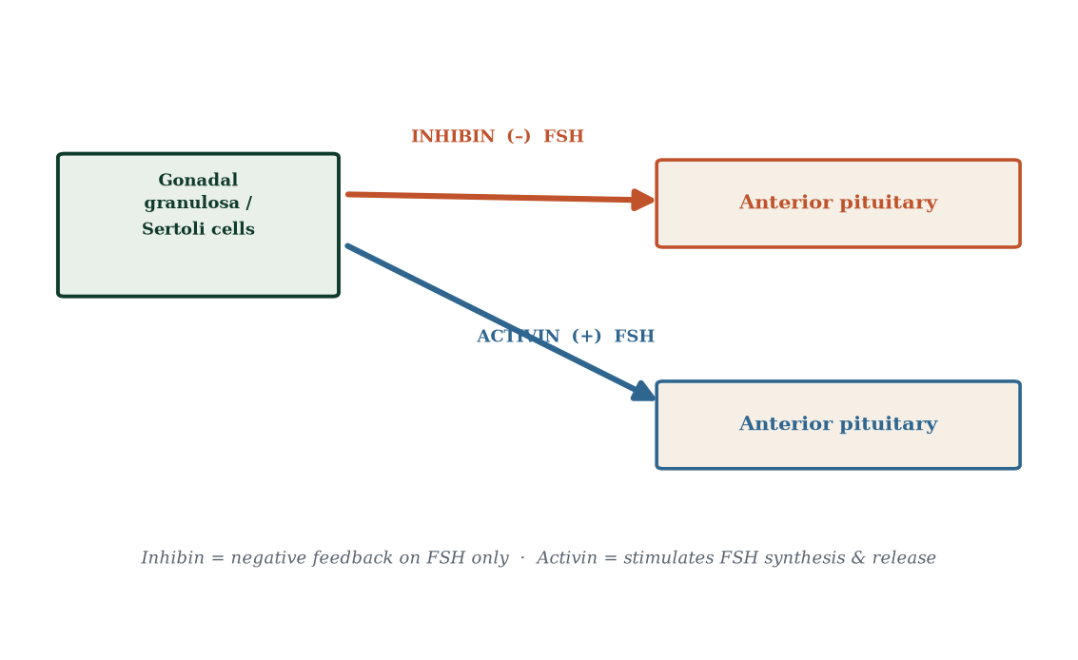
- explain negative and positive feedback in the axis;
- describe steroid hormone synthesis and receptor mechanisms;
- explain how feedback fails in common clinical conditions;
- interpret hormone patterns clinically.
Central question. How does one master control loop — brain to gonad and back — choreograph gametogenesis, the cycle, pregnancy and puberty?

7.1 The architecture of the HPG axis
The reproductive endocrine system is a three-tier servomechanism (Figure 7.1): a controller (hypothalamus), an amplifier/dispatcher (anterior pituitary), and effectors (gonads) that talk back through feedback. A useful metaphor: the hypothalamus is a thermostat set-point generator, the pituitary the wiring to the boiler, the gonads the boiler and radiators — with room temperature feed-backing to the thermostat.
Tier 1 — the hypothalamus. The key neurons (arcuate nucleus, preoptic area, also ventromedial) synthesise gonadotropin-releasing hormone (GnRH), a decapeptide. Critically, GnRH is released not continuously but in pulses (once every ~60–120 minutes): pulse frequency and amplitude are decoded differentially by the pituitary. High-frequency pulses favour LH synthesis; lower-frequency pulses favour FSH. Continuous GnRH administration (as with long-acting agonists) desensitises gonadotrophs and shuts the axis down — the basis of GnRH-agonist therapy (prostate cancer, endometriosis, IVF protocols). The hypothalamus is under modulation by stress, nutrition, sleep, circadian rhythm, higher brain centres and, decisively, by the feedback signals from the gonads themselves.
Tier 2 — the anterior pituitary. Gonadotroph cells (~10–15% of anterior pituitary cells) synthesise and secrete luteinising hormone (LH) and follicle-stimulating hormone (FSH) — glycoprotein hormones sharing a common α-subunit (with TSH and hCG) but distinct β-subunits conferring receptor specificity. They also produce prolactin (in lactotrophs; crucial for lactation, Chapter 17). Secretion is pulsatile [32], locked onto each GnRH pulse, and is down-modulated by inhibin and sex-steroid feedback.
Tier 3 — the gonads. Testes and ovaries respond with steroids (testosterone, oestradiol, progesterone) and peptides (inhibin A and B, testicular; granulosa inhibins) plus the gametes themselves.
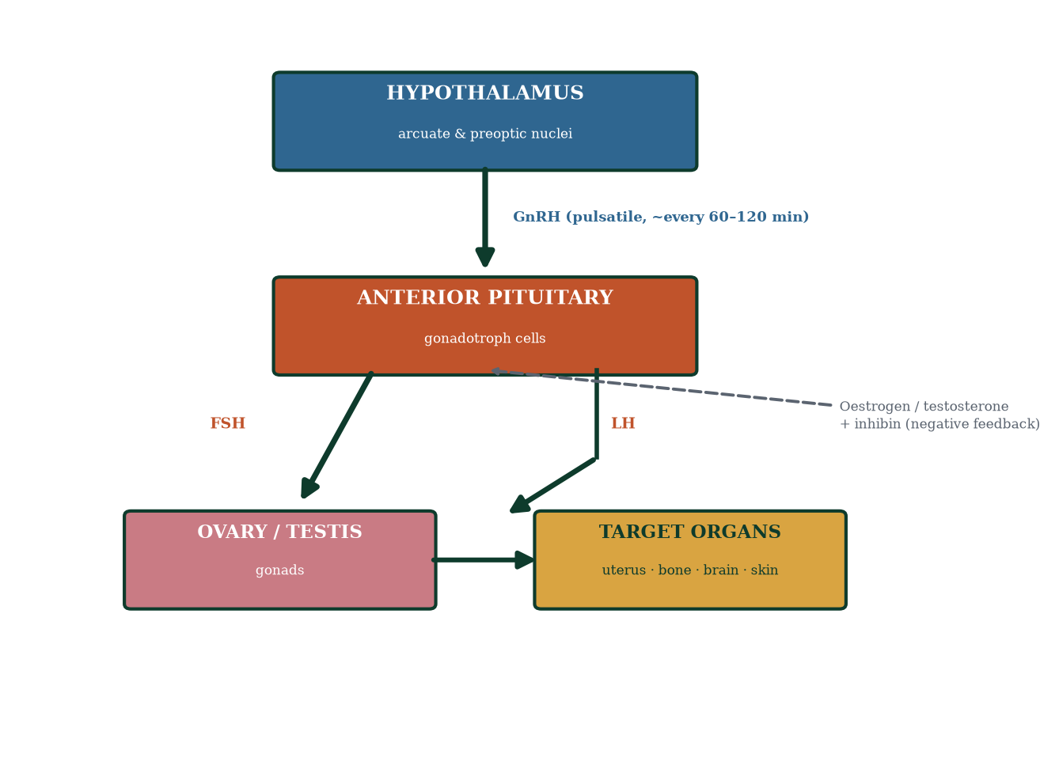
Figure 7.1 — The hypothalamic–pituitary–gonadal axis. GnRH pulses drive FSH/LH, which drive gonadal steroid and gamete production; steroids feed back to brain and pituitary.

7.2 The messenger molecules in detail
GnRH — decapeptide (pyroGlu-His-Trp-Ser-Tyr-Gly-Leu-Arg-Pro-Gly-NH2); receptor is a GPCR (GnRHR) on gonadotrophs; pulsatility is essential; analogues are long-acting (agonists desensitise) or antagonists (block immediately).
LH — acts on Leydig cells (testosterone), thecal cells (androstenedione), granulosa cells (after LH-receptor acquisition at dominance → ovulation trigger + progesterone), and the corpus luteum (progesterone support).
FSH — acts on Sertoli cells (spermatogenesis support, ABP, inhibin B) and granulosa cells (aromatase, proliferation, inhibin B/A, follicular growth).
Testosterone — C19 steroid. In males: fetal masculinisation of internal ducts, pubertal virilisation, spermatogenesis (high intratubal levels via ABP), libido, muscle/bone anabolism, erythropoiesis, negative feedback (direct and via conversion to estradiol). In females: small amounts from ovarian theca and adrenal (mostly as DHEA/androstenedione); contributes to libido and pubic hair; excess → hirsutism/virilisation.
Oestradiol (E2) — C18 steroid (also oestrone E1, oestriol E3 in pregnancy). In females: endometrial proliferation, cervical mucus, LH surge feedback switch, bone closure, lipid effects, neuro/mood. In males: a large fraction of testosterone is aromatised to E2 for bone health and fertility (low E2 → bone loss).
Progesterone — C21 steroid. Effects: endometrial secretory transformation; cervical mucus thickening; myometrial quiescence (blocks oestrogen-driven gap junctions and contractility); thermogenic (+0.3–0.5 °C BBT); natriuretic/diuretic; breast alveolar growth (with oestrogen); immunomodulation in pregnancy; smooth-muscle relaxation throughout (ureter, gut → reflux, constipation).
Inhibin A and B — glycoproteins; B peaks mid-follicular (granulosa of growing follicles), marking follicle reserve and suppressing FSH; A peaks mid-luteal (corpus luteum), also suppressing FSH. Clinically: low inhibin B / high FSH → diminished ovarian reserve.
Activin — enhances FSH synthesis and granulosa differentiation; locally active feedback modulator.

7.3 Feedback: negative — and the single positive feedback
Negative feedback (the set-point). Testosterone/oestradiol/progesterone feed back to the hypothalamus (suppress GnRH pulse generator — mainly via kisspeptin [6] neurons upstream of GnRH cells) and pituitary (reduce gonadotroph sensitivity). Inhibin B selectively suppresses FSH; steroids suppress both (and often LH preferentially at high levels). This loop holds baseline hormone levels stable (Figure 7.2) — the axis behaves like any classic endocrine negative-feedback controller.
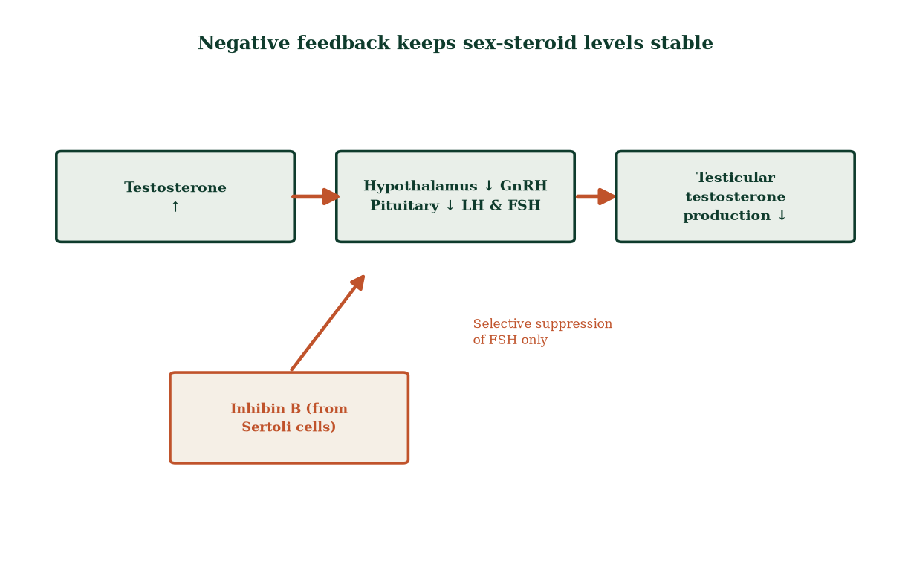
Figure 7.2 — Negative feedback: rising testosterone reduces GnRH/LH/FSH; inhibin B adds selective FSH suppression.
Positive feedback (the unique ovulation trigger). When oestradiol from the dominant follicle exceeds ~200 pg/mL for ~48 hours, the feedback flips sign: the surge of GnRH and LH (10–20× baseline) follows, instead of suppression. The mechanism involves kisspeptin neurons in the anteroventral periventricular nucleus (AVPV) responding to high E2 with increased kisspeptin → surge GnRH. Kisspeptin neurons are also the pacemaker of puberty: mutations in KISS1 or GPR54/KISS1R cause hypogonadotropic hypogonadism — puberty never comes. The positive feedback is evolution’s elegant way to align the rupture of the follicle with peak endometrial readiness.

7.4 Steroid biosynthesis: one pathway, many hormones
All steroids derive from cholesterol (Figure 7.3). The adrenals and gonads share enzymes; the pattern of products differs by tissue because of differential enzyme expression and compartmentalisation:
Cholesterol → pregnenolone (CYP11A1, rate-limiting) → progesterone (or 17α-hydroxypregnenolone) → 17-hydroxyprogesterone → androstenedione (C19) → testosterone (C19). Alternative: pregnenolone → dehydroepiandrosterone (DHEA) → androstenedione → testosterone. Testosterone can: (a) act directly (e.g. on muscle, bone, spermatogenesis); (b) be converted by 5α-reductase to dihydrotestosterone (DHT) (more potent androgen — external genitalia, prostate, androgen-pattern hair, sebaceous glands); (c) be converted by aromatase (CYP19) to oestradiol (granulosa, adipose tissue, brain, bone). In females, thecal androstenedione is aromatised to oestrone/oestradiol by granulosa aromatase (FSH-induced). In pregnancy, the fetal adrenal (fetal zone) produces DHEA-sulfate, converted by the placenta (which lacks CYP17) to oestriol — a major oestrogen and marker of fetal-placental wellbeing.
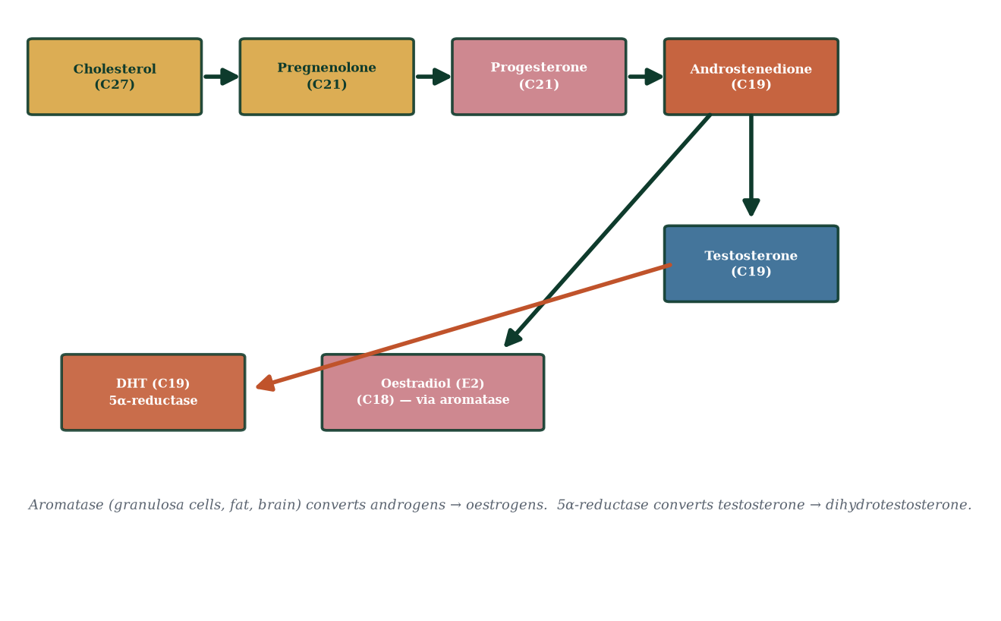
Figure 7.3 — Steroidogenic pathway: cholesterol is the common precursor; differential enzyme expression across tissues shapes the hormone profile.
Non-classical actions. Some steroids also act via membrane (non-genomic) receptors — rapid (seconds–minutes) effects (e.g., neuronal modulation, vascular smooth muscle). These complement the classic slow genomic pathways and are clinically relevant (e.g., rapid progesterone effects on mood reported; still an active research area).

7.5 Hormone mechanisms: crossing membranes, changing genes
Steroids are lipophilic and cross cell membranes freely. Inside the cell they bind specific intracellular nuclear receptors — Ligand-binding domain + DNA-binding domain — which sit in cytoplasm (e.g., glucocorticoid receptor) or nucleus (oestrogen, progesterone, androgen receptors) bound to heat-shock proteins. Ligand binds → chaperone release → receptor dimerises → binds hormone response elements (HREs) in target-gene regulatory DNA → recruits co-activators (HAT chromatin opening) → transcription rises or falls within hours (Figure 7.5). Specificity is achieved at three levels: (i) receptor expression, (ii) HRE specificity, (iii) co-regulator complement. This is why the same hormone casts different net effects in uterus vs brain vs bone.
Peptide hormones (GnRH, LH, FSH, inhibin) are hydrophilic; they bind cell-surface GPCRs or kinase receptors and work via second messengers — cAMP/PKA (LH/FSH → adenylyl cyclase), phospholipase C/IP3/Ca²⁺ (GnRH), or serine/threonine kinase cascades (activin/inhibin via ALK receptors/SMAD). Signalling is fast (seconds–minutes) and enzymatically amplified.
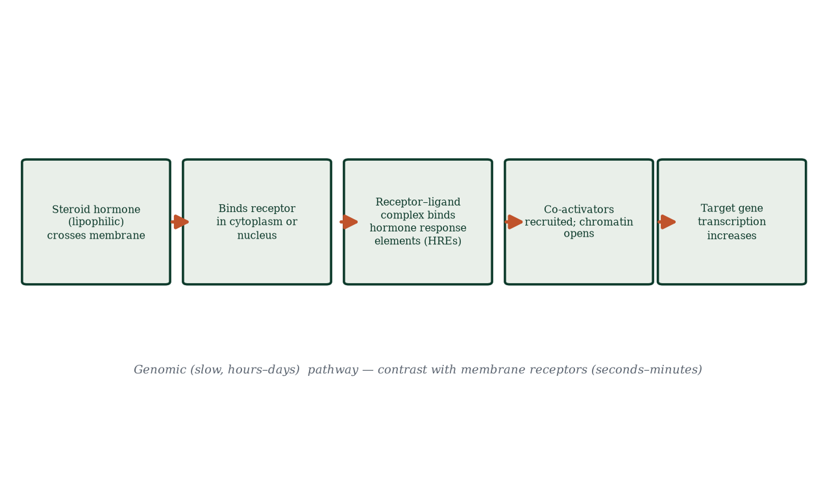
Figure 7.5 — Genomic mechanism of steroid signalling: crossing the membrane, binding the receptor, binding HREs, opening chromatin, changing gene expression.

7.6 Feedback in failure: reading the axis clinically
The axis is a perfect diagnostic tool because every part can be located by two hormones:
- Primary gonadal failure (gonads don’t make steroids): low E2/testosterone, high LH/FSH (pituitary shouts at a silent gonad). Examples: primary ovarian insufficiency, anorchia, post-chemotherapy.
- Central (hypothalamic or pituitary) failure: low E2/testosterone with low or inappropriately normal LH/FSH. Examples: Kallmann syndrome (GnRH neuron migration failure + anosmia), hypothalamic amenorrhoea (energy deficit/stress), pituitary tumour.
- Polycystic ovary syndrome: relatively high LH:FSH ratio, high androgens, anovulation (Chapter 18).
- Pubertal delay: high gonadotrophins = gonadal disease; low = central; low FSH/LH with constitutional delay = benign late-bloomer pattern (diagnosis of exclusion).
- Menopause: high FSH (and LH), low oestradiol — the lab signature of reserve exhaustion.

7.7 Axis ontogeny: from fetus to puberty
The HPG axis is active in utero (kisspeptin–GnRH–gonadotrophins drive fetal gonadal mini-differentiation and the neonatal ‘mini-puberty’ of the first months), then falls silent through childhood (prepubertal restraint), then reawakens in adolescence. The childhood brake is not merely hormonal — it is wired: inhibitory GABA glutamate signalling suppresses GnRH pulse generator; leptin (fat signal) permissively restrains the brake loosening. Puberty is not just ‘more hormones’; it is a timed network reconfiguration — and its timing tells us the brain monitors growth, energy stores and health before it permits fertility.

7.8 Summary of hormone actions on target tissues
Hormone | Source | Main targets | Key actions
GnRH | Hypothalamus | Anterior pituitary | FSH/LH release (pulsatile)
FSH | Anterior pituitary | Sertoli, granulosa | Gametogenesis support, aromatase induction, inhibin release
LH | Anterior pituitary | Leydig, theca, corpus luteum | Testosterone/androgens, ovulation trigger, luteal support
Inhibin B | Granulosa/Sertoli | Pituitary | Selective FSH suppression
Inhibin A | Corpus luteum/granulosa | Pituitary | FSH suppression (luteal)
Activin | Granulosa | Pituitary (local) | Enhances FSH
Testosterone | Leydig cells | Most tissues | Androgen phenotype, spermatogenesis support, feedback
DHT | 5α-reduced T | External genitalia, prostate | Masculinisation of external genitalia
Oestradiol (E2) | Ovarian/extragonadal | Uterus, bone, brain | Endometrial proliferation, BBT effects (indirect via P), feedback switch
Progesterone | Corpus luteum/placenta | Endometrium, uterus, brain | Secretory endometrium, myometrial quiescence, BBT rise

7.9 Mechanisms and evidence in depth: the pulse generator and the inhibin economy
The GnRH pulse generator. In the hypothalamic arcuate nucleus, kisspeptin/neurokinin B/dynorphin (KNDy) neurones fire in ~90-minute synchrony, releasing kisspeptin pulses that drive GnRH neurones in the preoptic area. GnRH reaches the anterior pituitary via the hypothalamic–hypophyseal portal circulation (concentrations ~100-fold higher than systemic). Pulse frequency encodes meaning: rapid pulses (~1/hour) favour LH; slow pulses (~1/3–4 hours) favour FSH; no pulses — no reproductive axis at all. Continuous GnRH (rather than pulsatile) desensitises and downregulates its receptor — the entire rationale of GnRH agonists used in IVF and endometriosis.
The inhibin economy. Inhibin B (granulosa A/B subunits, rising in early follicular phase) reports FSH-driven cohort health; inhibin A (dominant with the LH surge and through the luteal phase) reports the selected follicle and corpus luteum. Both selectively suppress FSH — FSH is the axis’s throttle for cohort growth, and its suppression is the self-limiting edge of selection. Inhibins also rise in male Sertoli cells, reporting spermatogenic activity — the same logic in both sexes.
Prolactin’s peculiar control. Unlike every other pituitary hormone, prolactin is under tonic inhibitory control — by hypothalamic dopamine (tuberoinfundibular pathway). Stalk compression interrupts dopamine delivery → prolactin rises (“disconnection hyperprolactinaemia”) — a beautiful inverse of the usual axis logic, and the first thing to check for any cause of secondary infertility with galactorrhoea.
Feedback from end organs completes the loop. Gonads report three signals: steroids (oestradiol, progesterone, testosterone, inhibins), peptides (activins), and biochemical activity (aromatase, etc.). The hypothalamus and pituitary read all three; the axis is a many-input controller, not a thermostat with one dial. Obesity re-sets feedback through aromatase adipose conversion; starvation suppresses it through leptin and kisspeptin; age dulls it through receptor changes.

Common errors in axis reasoning
- “FSH high always means ovarian failure.” — in the luteal phase and early menopause it is expected; context rules.
- “Testosterone pills raise the whole axis.” — they silence it via feedback.
- “Progesterone-only pills don’t stop ovulation.” — partially true (60%) — not absolute; discipline matters.
- “LH surge = ovulation happened.” — the surge precedes ovulation by ~24–36 h; it predicts, not reports.

7.10 Clinical reasoning vignettes
Case 1. A 28-year-old with secondary amenorrhoea, galactorrhoea and prolactin 2,800 mIU/L. Mechanism: pituitary lactotroph adenoma (prolactinoma) — stalk effect absent; mechanism-based treatment: cabergoline (dopamine agonist) — normalises prolactin, restores menses and fertility within weeks; surgery reserved for resistant/growing adenomas.
Case 2. A man with total testosterone 4.1 nmol/L and LH 12 IU/L. Mechanism: primary (hypergonadotropic) hypogonadism — the pituitary is shouting at a failing testis (Klinefelter until proven otherwise — check karyotype).
Case 3. A woman with primary amenorrhoea, absent breasts, high FSH and LH, normal uterus on ultrasound. Mechanism: primary gonadal failure (streak gonads) — Turner syndrome until karyotype excludes it.

Self-check — can you derive these without notes?
- Reconstruct the axis from a single elevated hormone: which pituitary/gonad hormone pattern proves hypothalamic suppression?
- Why is kisspeptin the master regulator and where do it act?
- Explain how GnRH agonists work versus antagonists — receptor occupancy vs desensitisation.
- Why does obesity via adipose aromatase lower testosterone in men?
- Derive the PRL-disconnection syndrome from dopamine anatomy.

Chapter summary
- The HPG axis is a three-tier servo: hypothalamic GnRH pulses → pituitary FSH/LH → gonadal steroids/peptides, with feedback completing the loop.
- GnRH must be pulsatile; continuous administration desensitises the pituitary (drug design).
- Inhibin B (follicular) and inhibin A (luteal) selectively suppress FSH; steroids feed back on both hypothalamus (kisspeptin) and pituitary.
- One positive feedback exists: high sustained oestradiol flips to positive feedback → LH surge → ovulation.
- Steroid biosynthesis radiates from cholesterol; tissue enzyme complement shapes products (aromatase, 5α-reductase decide the hormone’s final form).
- Steroid receptors are nuclear transcriptional regulators; peptide hormones are membrane GPCR/kinase messengers.
- Axis labs are diagnostic architecture: high gonadotrophins = gonadal failure; low = central.

Key terms
GnRH — hypothalamic decapeptide pulsatile releaser. Gonadotroph — FSH/LH-secreting pituitary cell. Kisspeptin — master upstream signal of GnRH neurons. Negative feedback — hormone suppresses its own upstream drive. Positive feedback — oestradiol-driven LH surge. Aromatase — C19→C18 conversion. 5α-reductase — testosterone→DHT. Two-cell two-gonadotrophin theory — theca(LH/androgens) + granulosa(FSH/aromatase). Nuclear receptor — intracellular steroid receptor altering transcription. HREs — DNA response elements bound by receptors.

Review questions
Multiple choice
- Continuous GnRH administration would:
  - increase FSH/LH permanently b) desensitise gonadotrophs and suppress the axis c) have no effect d) trigger pregnancy
- Which subunit do LH and FSH share with TSH and hCG?
  - β b) γ c) α d) δ
- Selective FSH suppression is mediated by:
  - oestradiol b) progesterone c) inhibin d) testosterone
- Positive feedback leading to the LH surge is triggered by:
  - rising progesterone b) falling oestradiol c) sustained high oestradiol d) inhibin A
- Aromatase converts:
  - cholesterol to pregnenolone b) testosterone to DHT c) androgens to oestrogens d) progesterone to aldosterone
- Steroid hormone receptors primarily signal via:
  - membrane ion channels b) GPCRs c) nuclear receptors altering gene transcription d) tyrosine kinase cascades
- High LH and FSH with low oestradiol suggests:
  - central hypothalamic failure b) primary gonadal failure c) normal ovulation d) polycystic ovary syndrome
- Kisspeptin neurons are required for:
  - lactation b) the pulse generator and puberty onset c) bone growth d) implantation
Short answer
- Explain why GnRH must be pulsatile and what happens when it is not.
- Name the two cell types and two hormones of the two-cell two-gonadotrophin theory.
- Differentiate genomic (nuclear) and rapid (membrane) steroid signalling.
- Explain how inhibin A and inhibin B differ in source and timing.
Explanation
- Walk through the feedback logic of a normal menstrual cycle’s first 14 days, step by step, naming hormones.
- Explain how a GnRH agonist can both suppress and, paradoxically, transiently stimulate the axis — and give two clinical uses.
- Explain why 5α-reductase and aromatase are decisive enzymes in sex-hormone action.
Application
- A marathon runner with low BMI has amenorrhoea with low FSH, low LH, low oestradiol but normal prolactin and TSH. Localise the lesion and explain the mechanism.
- A couple wants contraception based on the hormonal axis. Explain how combined oestrogen–progestin pills use feedback to prevent conception.
- A 45-year-old woman’s FSH is elevated with low oestradiol. What does the axis tell you, and what confirmatory step is required clinically?

Answers to review questions
- b. Continuous GnRH desensitises GnRH receptors (“flare” then suppression) — the basis of agonist pharmacology.
- c. Common α-subunit; receptor specificity from β-subunits (LHβ/FSHβ/βTSH/βhCG).
- c. Inhibin selectively restrains FSH synthesis; steroids modulate both.
- c. ~200 pg/mL for ~48 h flips feedback to positive → LH surge.
- c. Aromatisation of C19 androgens → C18 oestrogens.
- c. Steroids are lipophilic; they bind nuclear receptors dimerising onto HREs.
- b. Gonad silent; pituitary shouts — primary gonadal failure.
- b. Kisspeptin drives GnRH pulse generator; loss (KISS1/KISS1R mutations) = hypogonadotropic hypogonadism.
- Pulsatility prevents receptor desensitisation and differentially decodes LH vs FSH; continuous exposure suppresses gonadotrophs (pharmacologically exploited, e.g. in IVF and prostate cancer).
- Theca cell (LH, androstenedione) + granulosa cell (FSH, aromatase) = oestradiol; neither alone can produce oestrogen.
- Genomic: receptor in/near nucleus → HRE binding → transcription altered over hours–days (e.g., endometrial proliferation). Non-genomic: membrane receptors → cAMP/IP3/Ca²⁺ within seconds–minutes (rapid neuronal, endothelial effects).
- Inhibin B: granulosa of growing cohort follicles, early-mid follicular peak, marker of reserve. Inhibin A: corpus luteum, mid-luteal peak, luteal FSH restraint.
- Day 1: FSH nudges growing cohort; oestradiol rises gradually with follicle growth; E2/inhibin B feed back → FSH falls; dominant follicle survives; E2 crosses threshold ~48 h → positive feedback → LH surge → ovulation (day ~14) — Chapter 8 elaborates.
- Initial “flare”: agonist briefly stimulates receptors; then sustained high levels internalise/desensitise GnRH receptors → LH/FSH fall. Uses: endometriosis symptom control, prostate cancer androgen deprivation (with anti-androgen cover initially), IVF down-regulation protocols.
- They determine the potency and tissue action of androgen vs oestrogen signals: 5α-reductase amplifies testosterone to DHT in prostate/external genitalia; aromatase diversifies testosterone to oestradiol for bone/fertility; blockade (finasteride for BPH; aromatase inhibitors for ER+ breast cancer) exploits these control points.
- Hypothalamic (functional hypothalamic amenorrhoea): energy deficit/low leptin suppresses kisspeptin/GnRH pulsatility → low LH/FSH → low E2; prolactin/TSH normal argues against pituitary; mechanism is reversible by restoring energy availability, not a broken gonad.
- Exogenous oestradiol/progestin provide negative feedback → GnRH/LH/FSH suppressed → no follicular development → no ovulation; progestin thickens cervical mucus and thins endometrium adding barriers — feedback exploitation, not organ damage.
- High FSH + low oestradiol = primary ovarian insufficiency pattern (depleted reserve); confirm with repeat measurement ≥4 weeks apart (FSH > 25–40 IU/L on two occasions, low AMH, antral follicle count); clinical assessment, bone density and pregnancy counselling follow.

Chapter 8: The Menstrual Cycle and Ovulation
Learning objectives. After studying this chapter you should be able to: - describe the ovarian and uterine cycles and how they relate; - explain the follicular, ovulatory and luteal phases mechanistically; - interpret the classic hormone graphs of the cycle; - explain cycle variation and the biological mechanism of menstruation; - apply cycle physiology to contraception, fertility and clinical disorders.
Central question. How does one endocrine feedback loop produce a precisely timed monthly rhythm of ovulation and endometrial shedding — and why does it sometimes vary, skip or misfire?

8.1 Two cycles, one clock
The menstrual cycle is really two coordinated cycles running on one clock: the ovarian cycle (what the ovary is doing — follicular phase, ovulation, luteal phase) and the uterine (endometrial) cycle (what the lining is doing — menstrual, proliferative, secretory phases). They are synchronised by the shared hormonal drive (Figures 8.1 and 8.2). Cycle day 1 = first day of bleeding. A theoretical cycle is 28 days (follicular 14 + luteal 14), but real cycles run 21–35 days in most women, almost all variability coming from the follicular phase; the luteal phase is ~12–14 days [7], relatively fixed. This single asymmetry explains most clinically observed cycle variation.
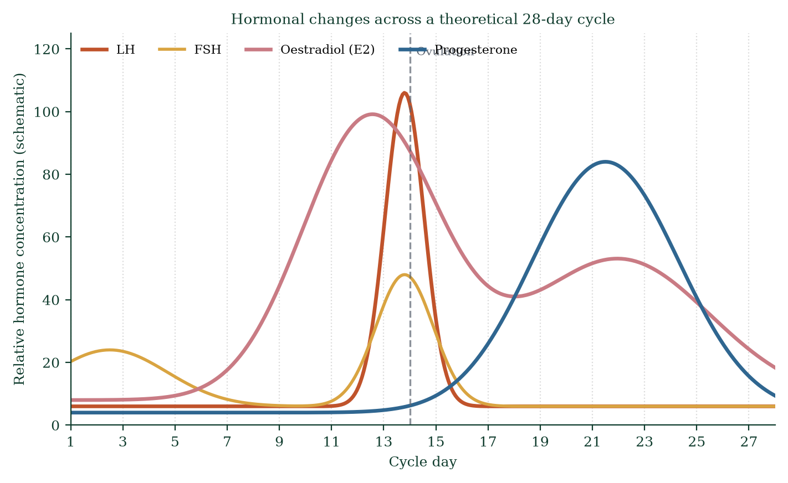
Figure 8.1 — Relative hormone concentrations across a theoretical 28-day cycle (LH, FSH, oestradiol, progesterone).
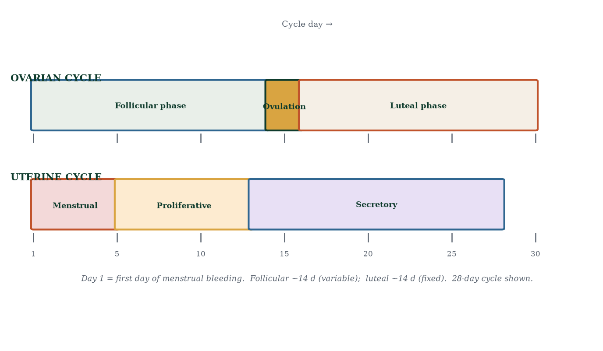
Figure 8.2 — The ovarian cycle (follicular, ovulation, luteal) and uterine cycle (menstrual, proliferative, secretory) on the same day axis.

8.2 The follicular phase, day by day
- Day 1–5: menstruation. Low progesterone and oestrogen (corpus luteum died last cycle) remove endometrial support → spiral arteriole vasospasm → ischaemia → shedding. FSH begins rising as its restraint (oestradiol, inhibin A) falls; a cohort of antral follicles (3–11, age-dependent) is recruited.
- Day 6–12: cohort grows; granulosa multiply; aromatase output rises; oestradiol climbs; oestradiol + inhibin B progressively suppress FSH. Two-week selection race: the follicle with the most FSH receptors wins; the others undergo atresia. Rising E2 rebuilds the endometrium (proliferative phase) — glands elongate, stroma cellular, spiral arteries lengthen (oestrogen is trophic for all of it).
- Day ~13–14: dominant follicle now secretes E2 at >200 pg/mL — sustained ~48 h. Feedback flips positive (Chapter 7, kisspeptin-AVPV). LH surge (10–20× baseline, peaks ~day 14). Follicular rupture ~24–36 h after surge onset → ovulation.
- Cervical mucus follows oestrogen: scant and viscous early; copious, clear, alkaline and stretchy at peak fertility — the standard teaching target for natural family planning.

8.3 The luteal phase, day by day
- Day 15–22: corpus luteum forms (granulosa/thecal luteinisation under LH); progesterone surges; the endometrium converts to the secretory state — glands tortuous and glycogen-laden, stroma oedematous, blood vessels coiled — a nutritious bed awaiting an embryo. Progesterone thickens cervical mucus (barrier), raises basal temperature (+0.3–0.5 °C), and suppresses myometrial contractility. FSH/LH stay suppressed via progesterone/oestradiol/inhibin A.
- Day 23–28: if no implantation signal (no hCG), the corpus luteum involutes at day ~10–12 post-ovulation → progesterone and oestradiol crash; spiral arteriole vasospasm → ischaemic necrosis → menstruation. The cycle begins again.
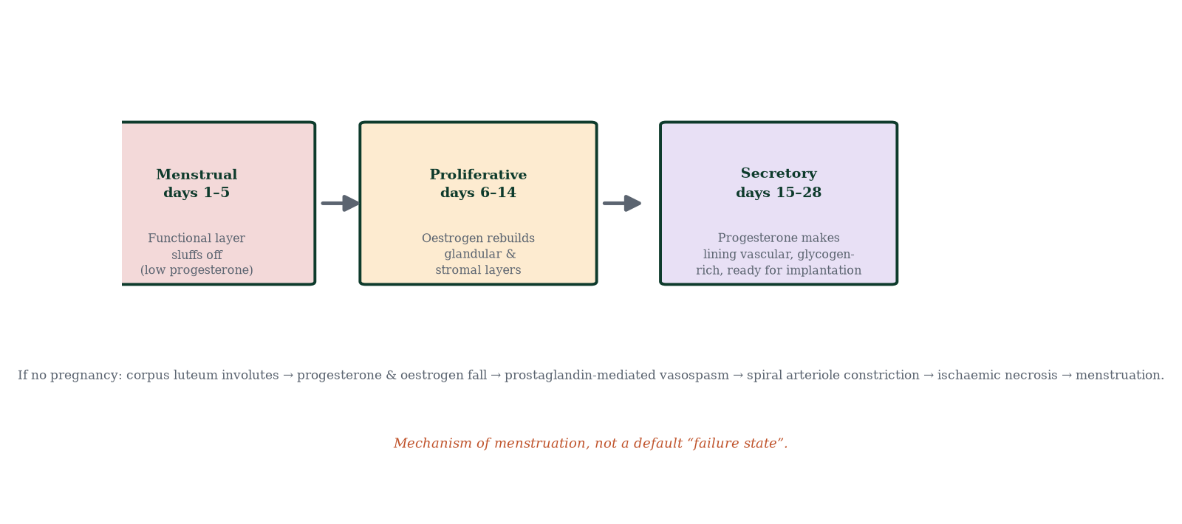
Figure 8.3 — Endometrial remodelling across the cycle: shedding, rebuilding, secretory transformation, and the hormonal trigger for shedding.

8.4 The endometrium in detail
The endometrium is ~1–2 mm at cycle start, ~5–7 mm proliferative, ~10–14 mm secretory. Two strata (Chapter 4): the stratum functionale (shed and rebuilt) and stratum basale (regenerative source). Histological signposts: mitoses (proliferative), subnuclear glycogen vacuoles (earliest secretory sign, day 17–18), intraluminal secretion (day 19–21), stromal predecidualisation (day 23–26). Spiral arterioles are the star performers of menstruation: progesterone withdrawal → local PGF2α and endothelin → vasospasm → tissue ischaemia → matrix metalloproteinase activation → bleeding. Menstrual blood differs from circulatory blood (mostly arterial, with endometrial fibrinolysis keeping it liquid). Average blood loss ~30–40 mL; >80 mL is menorrhagia — clinically relevant for iron deficiency.

8.5 Cycle variation across the population
Most cycles fall between 21 and 35 days (Figure 8.4) — a normal distribution with standard deviation ~3–5 days. Outlier patterns: anovulatory cycles (no LH surge; no progesterone rise; oestrogen unopposed — irregular, often heavy, bleeding), oligomenorrhoea (cycles >35 days, common in PCOS), polymenorrhoea (<21 days), amenorrhoea (primary or secondary). Adolescents and perimenopausal women show high variability (immature or shrinking cohort dynamics). Stress, energy deficit, travel, illness and some medications (SSRIs, antipsychotics → prolactin) perturb the axis (Chapter 7).
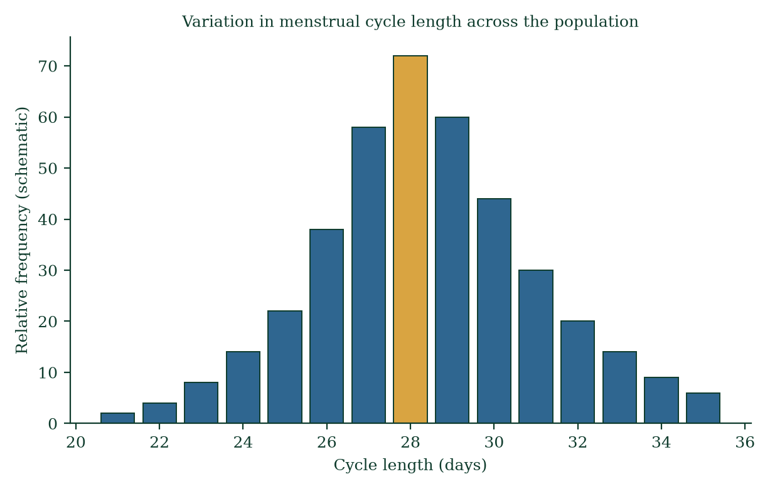
Figure 8.4 — Distribution of cycle lengths in the population; 28 days is the mode, not a requirement.

8.6 Reading the cycle hormonally — worked example
Day | FSH | LH | E2 | Progesterone
3 | Rising | Low | Low | <1 ng/mL
8 | Mid | Low | Rising | <1
13 | Falling | Rising | High | small
14 (ovulation) | spike | Peak | peak | rising
18 | Suppressed | Suppressed | Moderate | High
24 | Suppressed | Suppressed | Moderate-high | Peak
28 | Rising | Low | Crashing | Crashing
Pregnancy equivalent: hCG replaces LH-like support from day ~8–10 post-fertilisation → corpus luteum survives → no bleed → cycle absent. This is exactly why a missed period is the cardinal sign of pregnancy — the feedback loop never completes its reset.

8.7 Basal body temperature and fertility awareness
Progesterone is thermogenic: BBT rises ~0.3–0.5 °C within 24 h of ovulation and stays high until menses (Figure 8.5). Tracking BBT confirms ovulation retrospectively; combined with mucus observation and (optionally) LH urine strips, it defines the fertile window (~5 days before ovulation + day of ovulation). Fertility awareness-based methods (FAMs) exploit this; typical-use failure rates depend heavily on discipline and are higher than hormonal contraception (Chapter 18).
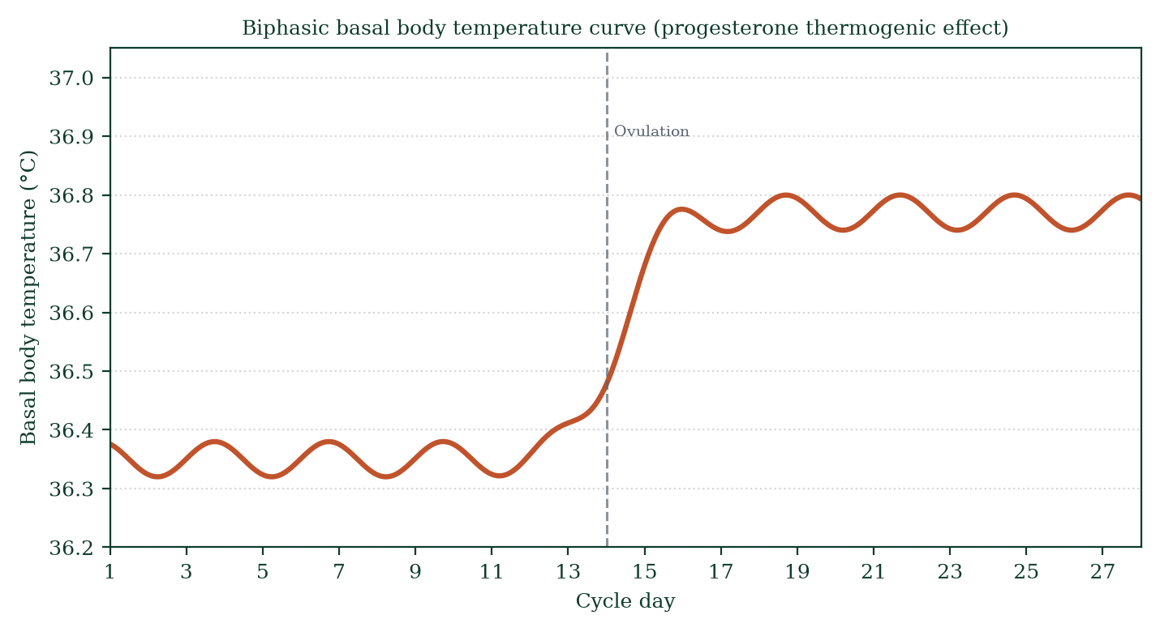
Figure 8.5 — Biphasic BBT curve: the post-ovulatory progesterone-driven rise, used clinically to confirm ovulation.

8.8 Mechanisms of menstruation — and why it is not a “default failure”
Menstruation is triggered, not absent. It is the terminal event of a feedback loop where no embryo signalled. Mechanistically: progesterone withdrawal → (1) spiral arteriole vasospasm, (2) increased prostaglandin F2α and endothelin, (3) endometrial MMPs degrade matrix, (4) functionalis detaches and exits. Menstrual cramps (dysmenorrhoea) are prostaglandin-driven myometrial contractions — hence NSAIDs (prostaglandin synthesis inhibitors) work. The narrative “the uterus preparing a bed and being disappointed monthly” is mechanistically wrong: the endometrium cycles by design, sheds by design, and would not know an embryo if it were lying on it — the embryo is what triggers the exception (hCG), not the rule.

8.9 Clinical spotlights
- Amenorrhoea: primary (never menstruated by 16; think outflow obstruction, ovarian dysgenesis, hypothalamic) vs secondary (≥3 months absent after established cycling; most commonly pregnancy, POI, PCOS, hypothalamic). Localise via FSH/LH pattern (Chapter 7).
- Dysmenorrhoea: primary (prostaglandin excess — NSAIDs first-line), secondary (endometriosis, adenomyosis, fibroids).
- Heavy menstrual bleeding (menorrhagia): fibroids, polyps, adenomyosis, coagulopathy (von Willebrand), anovulation; quantify iron deficiency.
- Irregular bleeding on contraception: breakthrough ovulation (pill missed), atrophic endometrium (POP/implant), or malignancy in older women — must be evaluated.

8.10 Mechanisms and evidence in depth: the in-vitro embryology parallel
Every event in the natural cycle has a laboratory twin — comparing them sharpens understanding and reveals what clinics do routinely:
- Ovarian stimulation mimics the follicular phase pharmacologically: FSH injections recruit a cohort (not one); GnRH agonist/antagonist prevents premature LH surge (taking over the hypothalamic brake); trigger with hCG (mimics LH) times the final maturation; the oocytes are “ovulated” into a collection tube instead of the peritoneal cavity.
- The ovulation trigger is the exact analogue of the LH surge — both act on follicular granulosa/thecal cells to resume meiosis, loosen the cumulus (hyaluronidase-mediated) and activate proteases for wall rupture.
- Progesterone after trigger mirrors the corpus luteum — luteal support maintains secretory endometrium through the implantation window.
- Implantation still occurs only in a recipient uterus: hormonal support cannot substitute for a receptive endometrium.
- Contraception in reverse. COCPs do pharmacologically what the cycle already does — suppress folliculogenesis and stabilise the axis artificially; GnRH agonists suppress the axis for therapeutic purposes; aromatase inhibitors remove the oestrogen feedback signal to treat breast cancer. Same endocrinology, different goals.

Common errors in cycle reasoning
- “Ovulation always day 14.” — follicular variability; luteal ~12–14 d is fixed.
- “Oestrogen is the fertility hormone, progesterone is for period.” — both essential; progesterone is the embryo hormone.
- “Urine LH kits are 100%.” — false positives (PCOS), false negatives (surge missed, 12 h sampling window); correlate with symptoms.
- “Hormonal birth control harms future fertility.” — fertility returns; no evidence of permanent suppression.

8.11 Clinical reasoning vignettes
Case 1. A 31-year-old with regular cycles wants natural family planning. She tracks BBT and mucus: BBT rises 0.3 °C on sustained plateau; mucus becomes clear, stretchy, ferning pattern on microscopy; LH strip turns positive at 10:00. Mechanism: luteal progesterone raises core temperature; oestradiol peaks thin cervical mucus; LH surge precedes ovulation by ~24–36 h. Intercourse timed from LH+ to ovulation+1 day.
Case 2. A woman with a 34-day cycle complains periods are “late”. Mechanism: follicular phase longer by ~6 days; luteal phase still ~13 days; ovulation day ~day 20–21 — not pathology; mechanism reassurance prevents unnecessary hormonal treatment.
Case 3. A couple both 35; six months TTC with intercourse only on calendar day 14 of a 30-day cycle. Day-14 intercourse misses the real fertile window; mechanism says have sex every 1–2 days from day 9 to ovulation day (day 16); their conception probability per cycle roughly doubles.

Self-check — can you derive these without notes?
- Draw and label a 28-day cycle hormone panel: LH, FSH, oestradiol, progesterone.
- Why does BBT rise only after ovulation and not predict it?
- Explain mid-cycle pain (Mittelschmerz) mechanistically.
- Derive why COCPs contain oestrogen + progestin — what each contributes.
- Why do ovulation-kit surges sometimes not lead to ovulation (LUF syndrome)?

Chapter summary
- The menstrual cycle = ovarian + uterine cycles, synchronised by the HPG axis; day 1 = bleeding.
- Follicular phase (variable): FSH recruitment → cohort → oestradiol rise → dominant follicle → positive feedback → LH surge → ovulation ~day 14.
- Luteal phase (fixed): progesterone prepares endometrium; absent hCG → corpus luteum involutes → menses.
- Endometrial phases: menstrual → proliferative → secretory; spiral arteriole vasospasm underlies shedding.
- Cycle variation (21–35 d) is physiologic and dominated by follicular phase differences; luteal phase ~14 d.
- Menstruation is an active, progesterone-withdrawal-triggered process, not a failure state.
- BBT and mucus charting confirm ovulation; FAMs exploit this window.

Key terms
Follicular phase — FSH-driven follicle growth (variable length). Luteal phase — progesterone-dominant ~fixed 14 days. LH surge — positive-feedback ovulation trigger. Proliferative phase — oestrogen-driven endometrial rebuild. Secretory phase — progesterone-driven endometrial maturation. Stratum functionale — shed layer. Spiral arteriole — vasospastic menses vessel. Dysmenorrhoea — prostaglandin-driven cramping pain. Oligomenorrhoea/polymenorrhoea — long/short cycles. Anovulation — cycle without ovulation. Menorrhagia — >80 mL blood loss.

Review questions
Multiple choice
- Day 1 of the cycle is defined as:
  - day of ovulation b) first day of menstrual bleeding c) day after menses ends d) day of LH peak
- The variability in cycle length is mostly due to the:
  - luteal phase b) follicular phase c) menstrual phase d) ovulation itself
- Which hormone is responsible for basal body temperature rise?
  - oestradiol b) LH c) progesterone d) FSH
- Ovulation occurs approximately how long after the LH peak?
  - 1–2 hours b) 24–36 hours c) 3 days d) 7 days
- The secretory phase is driven by:
  - oestrogen b) progesterone c) inhibin B d) hCG
- Spiral arterioles are supplied by the:
  - radial arteries b) arcuate arteries c) both, in sequence d) neither
- The fertile window spans:
  - ovulation day only b) 5 days before ovulation plus the day of ovulation c) the luteal phase d) day 1–7
- Which of the following is TRUE of menstruation?
  - it results from continuous progesterone b) it requires progesterone withdrawal c) it never causes pain d) it has no vascular component
Short answer
- Define the uterine and ovarian cycles and their synchronisation.
- Explain the two-stage selection of the dominant follicle and the fate of the rest.
- Describe the endometrial histological signs of the early, mid and late secretory phases.
- Distinguish primary and secondary dysmenorrhoea mechanistically.
Explanation
- Explain, step by step, how falling progesterone causes menstrual bleeding — from receptor level to tissue level.
- Explain why a missed period is the cardinal symptom of pregnancy in terms of the luteal rescue mechanism.
- Walk through the hormonal changes from day 1 to day 28 with reference to feedback, in order.
Application
- A woman’s cycles are 28 days but she is unsure when ovulation occurred. Name two home methods to confirm ovulation retrospectively or prospectively.
- A 34-year-old with regular 26-day cycles and normal exam has heavy bleeding with large clots. Where do you start the mechanism-based workup?
- Explain why NSAID use relieves dysmenorrhoea but does not address its cause — distinguish mechanism from cause.

Answers to review questions
- b. Convention; also the clinically relevant anchor for dating.
- b. Luteal phase is ~12–14 days, relatively constant; follicular phase length shifts.
- c. Progesterone acts on the hypothalamic thermostat (+0.3–0.5 °C).
- b. LH peak → rupture 24–36 h later.
- b. Secretory transformation is progesterone’s signature.
- c. Arcuate → radial → spiral arterioles; vasospasm of spiral arterioles triggers shedding.
- b. Sperm survive ~5 days; oocyte viable ~12–24 h.
- b. Progesterone withdrawal activates prostaglandin/MMP cascades → shedding.
- Ovarian: follicular → ovulatory → luteal. Uterine: menstrual → proliferative → secretory. Synchronised by shared HPG drive; uterine phases are the endometrial readout of ovarian hormones.
- Cohort recruited by FSH; as oestradiol + inhibin B rise, FSH falls; follicles differ in FSH-receptor density; the most sensitive survives (dominant); it gains LH receptors and ovulates; the remainder undergo atresia (apoptosis).
- Day 17–18: subnuclear glycogen vacuoles (earliest sign); day 19–21: intraluminal secretion; day 23–26: stromal predecidualisation, stromal oedema, peak spiral-arteriole coiling.
- Primary: prostaglandin F2α excess → painful uterine cramping without pelvic pathology (presents with menarche); secondary: pathology (endometriosis, adenomyosis, fibroids, infection) — it may present later, change pattern, and be progressive; it does not mean “psychosomatic.”
- Progesterone falls (corpus luteum involutes) → (i) loss of secretory support to glandular epithelium; (ii) endothelin/PGF2α rise → endothelial vasospasm of spiral arterioles → tissue ischaemia/reperfusion injury; (iii) MMP activation degrades stromal matrix; (iv) functionale dissociates and expels — bleeding is arterial with endometrial fibrinolysis preventing clotting in the lumen.
- hCG from the implanting embryo mimics LH continuing corpus luteum progesterone output; no progesterone crash, no vasospasm, no shed — a missed period reflects a successfully rescued luteal feedback loop.
- Day 1: low E2/P; FSH rises; cohort recruited. Days 6–12: E2 rise; FSH falls (negative feedback); E2 rebuilds endometrium. Day ~13/14: E2 >200 pg/mL ×48 h → positive feedback → LH surge → ovulation. Days 15–27: corpus luteum → progesterone (endometrium secretory, BBT up, FSH suppressed). Day 28: no hCG → corpus luteum involutes → E2/P crash → menses.
- Prospectively: urine LH strips (predict 24–36 h ahead); retrospectively: BBT charting (confirms ovulation post hoc); cervical mucus stretch (Spinnbarkeit) as supporting sign.
- Heavy bleeding on regular 26-day cycles suggests a structural/haemodynamic cause: start with history (clots, duration), pelvic exam and TVUS (fibroids, polyps, adenomyosis), FBC/ferritin (iron deficiency), consider coagulopathy screen (von Willebrand) if lifelong heavy menses, TSH and prolactin — reason from anatomy and hormones, not empiricism alone; biopsy if endometrial thickness/red flags.
- NSAIDs block cyclooxygenase → reduce PGF2α → less cramping — mechanism addressed, cause (prostaglandin excess) is corrected symptomatically, not cured; endometriosis-driven pain needs mechanism-targeted management (hormonal suppression, surgery) — reflecting the reason this book distinguishes mechanism from diagnosis (Chapter 18).

Chapter 9: Male Reproductive Hormonal Regulation and Sexual Function
Learning objectives. After studying this chapter you should be able to: - explain the hormonal control of male reproduction across the lifespan; - describe the erection mechanism from nerve signal to cavernosal engorgement; - describe emission, ejaculation and the male sexual response cycle; - explain the pharmacology of PDE5 [1] inhibitors mechanistically; - describe age-related changes in male reproductive function.
Central question. How do the same hormonal players choreograph spermatogenesis, sexual response, fertility and ageing in the male — and where does the chain break?

9.1 The male axis in steady state
Male reproduction is governed by the same three-tier HPG axis (Chapter 7), with male-specific wiring. GnRH pulses → pituitary LH and FSH. LH targets Leydig cells → testosterone. FSH targets Sertoli cells → spermatogenesis support + inhibin B. Testosterone feeds back (direct and aromatised oestradiol) on hypothalamus and pituitary; inhibin B selectively restrains FSH. Male feedback is thus dominated by testosterone (with local aromatisation to estradiol playing a decisive role — as shown by men with aromatase deficiency: tall stature, osteoporosis, unfused epiphyses).
Diurnal rhythm: testosterone peaks in the early morning and reaches its nadir in the evening (~25–30% variation) — clinically relevant: measure morning testosterone. Variability: strong sleep dependence (REM sleep spikes); sleep deprivation blunts testosterone — one mechanism linking sleep disorders to reproductive health.

9.2 The male sexual response cycle
Classically described in four phases — excitement → plateau → orgasm → resolution — with resolution followed (humans uniquely) by a refractory period during which re-erection is impossible. Phases are mediated by the interplay of parasympathetic (excitement/erection; S2–S4), sympathetic (emission; T11–L2) and somatic (ejaculation/expulsion via pudendal nerve S2–S4) nervous activity with endocrine modulation (testosterone permissive, not acutely causal, for erection; psychological state dominant via descending cortical control).
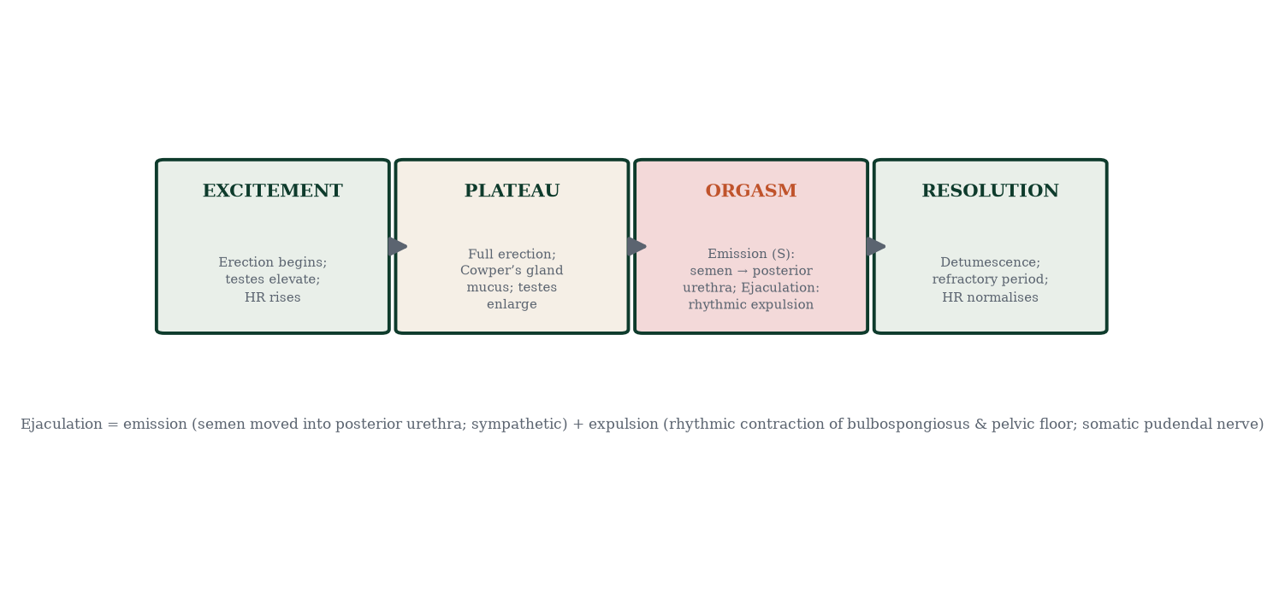
Figure 9.2 — Phases of the male sexual response and their neural control: parasympathetic excitement, sympathetic emission, somatic expulsion, resolution with refractory period.

9.3 Erection: a vascular event with neural ignition
The erectile state is a special case of smooth-muscle blood-flow control:
- Stimulus — tactile (reflexogenic, S2–S4) or psychogenic/cortical (T11–L2 modulation) → parasympathetic nerves release nitric oxide (NO) and acetylcholine.
- Molecular cascade — NO diffuses into cavernosal smooth-muscle cells → activates guanylyl cyclase → converts GTP to cGMP → cGMP activates protein kinase G → Ca²⁺ falls (reduced influx, enhanced sequestration) → myosin light-chain phosphatase dephosphorylates → smooth muscle relaxes.
- Hemodynamics — helicine arterioles and trabecular smooth muscle relax → sinusoids expand; venous outflow occluded by subtunical venules compressed against the tunica albuginea → intracavernosal pressure rises toward mean systolic pressure (rigidity).
- Termination — PDE5 degrades cGMP → smooth muscle re-contracts → detumescence.
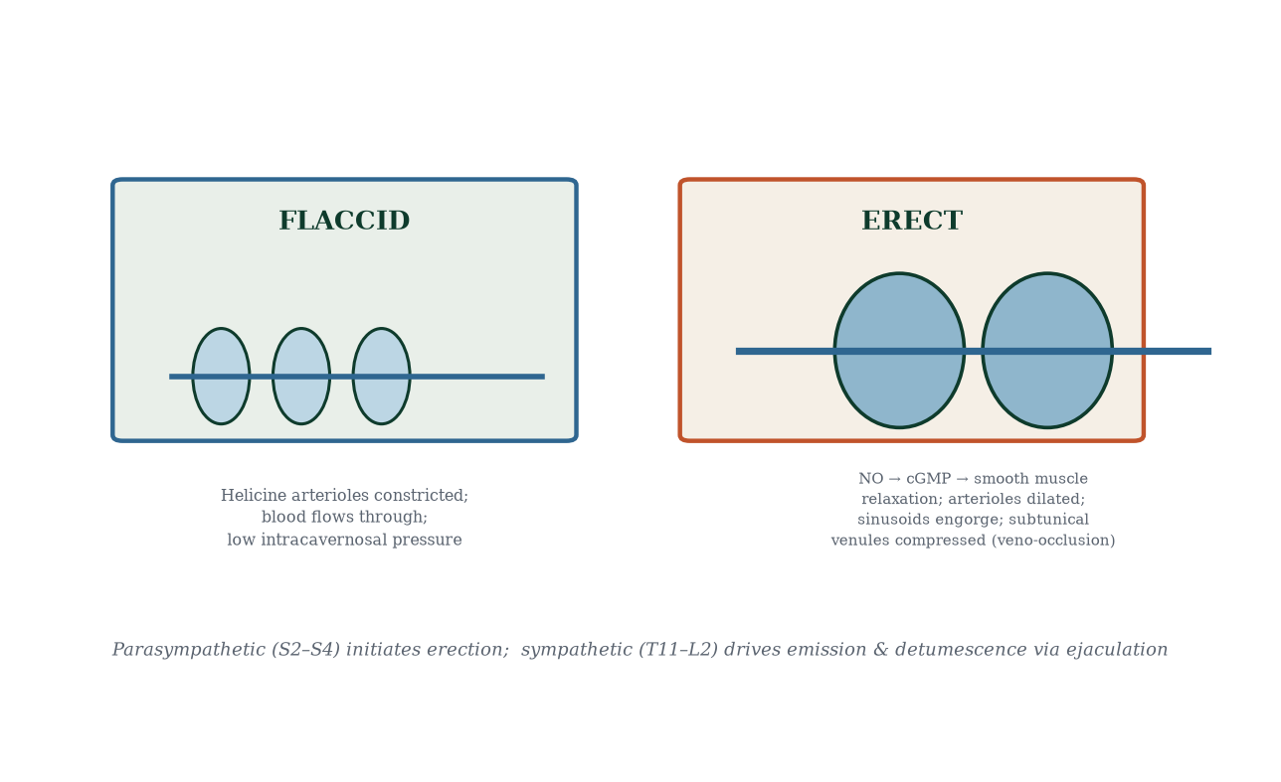
Figure 9.1 — Flaccid versus erect penis: NO–cGMP-mediated smooth-muscle relaxation, sinusoidal engorgement and veno-occlusion versus the default sympathetic state.
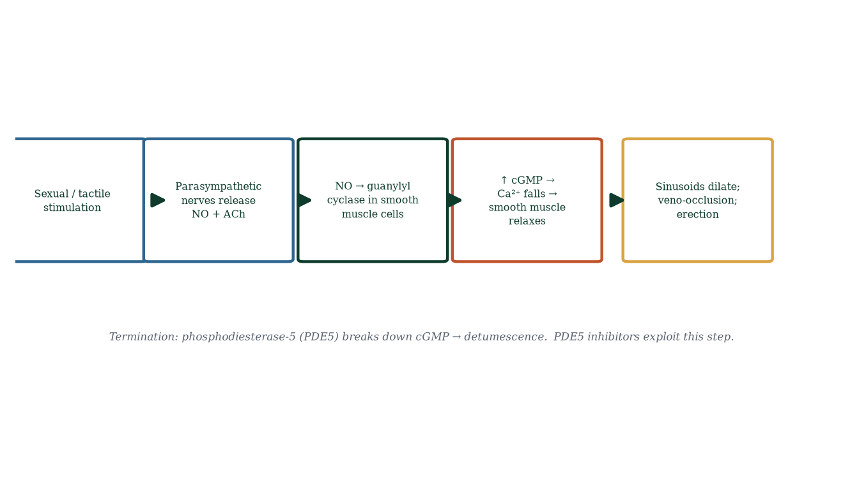
Figure 9.4 — The NO–cGMP pathway; PDE5 inhibitors act at the terminal step.
PDE5 inhibitors (sildenafil [18] etc.) block cGMP breakdown — they do not cause erection by themselves; sexual stimulation is required to release NO; they amplify and prolong the signal. Contraindications: concurrent nitrates (profound hypotension). This is pharmacology as physiology exam question.

9.4 Emission, ejaculation and the urethral sphincter trick
- Emission (sympathetic T12–L2, hypogastric nerve): smooth muscle of vas deferens, seminal vesicles, prostate contracts → semen moves into the posterior (prostatic) urethra; bladder neck (internal sphincter) contracts to prevent retrograde ejaculation.
- Ejaculation proper (expulsion) — semen in posterior urethra → afferent impulses via pudendal nerve → spinal reflex → bulbospongiosus and pelvic floor muscles contract rhythmically (3–10 contractions at ~0.8 s) → semen expelled in spurts.
- Bladder neck closure is the key coordination step; failure → retrograde ejaculation (diabetes with autonomic neuropathy, prostate surgery, α-blockers) — semen ≠ urine but semen ends up in bladder.

9.5 Endocrine maintenance of spermatogenesis and sexual function
Testosterone’s local role: intratubal testosterone (~50–100× serum) is required for meiosis and spermatid maturation; serum testosterone correlates poorly with fertility per se but matters hugely for libido and secondary sexual function. ABP (Sertoli) carries testosterone; inhibin B reports Sertoli activity. SHBG binds much serum testosterone — only free testosterone is bioactive; SHBG rises with age and hyperthyroidism, lowering free T even at normal total T.

9.6 Testosterone across the lifespan
In utero: ~weeks 9–18 testicular mini-surge drives Wolffian/external masculinisation (DHT). Neonatal “mini-puberty” (first ~6 months): testosterone rises (significance still debated; relevant for cryptorchidism and micropenis treatment). Childhood: axis silent. Puberty: testicular volume >3–4 mL, rising testosterone, virilisation. Adulthood: plateau (third decade). Decline: ~0.4–1% per year after ~30–40; symptomatic late-onset hypogonadism (<300 ng/dL with symptoms twice) is a diagnosis requiring confirmation + evaluation, not a fashionable panacea (controversies: cardiovascular safety, prostate monitoring, polycythaemia).
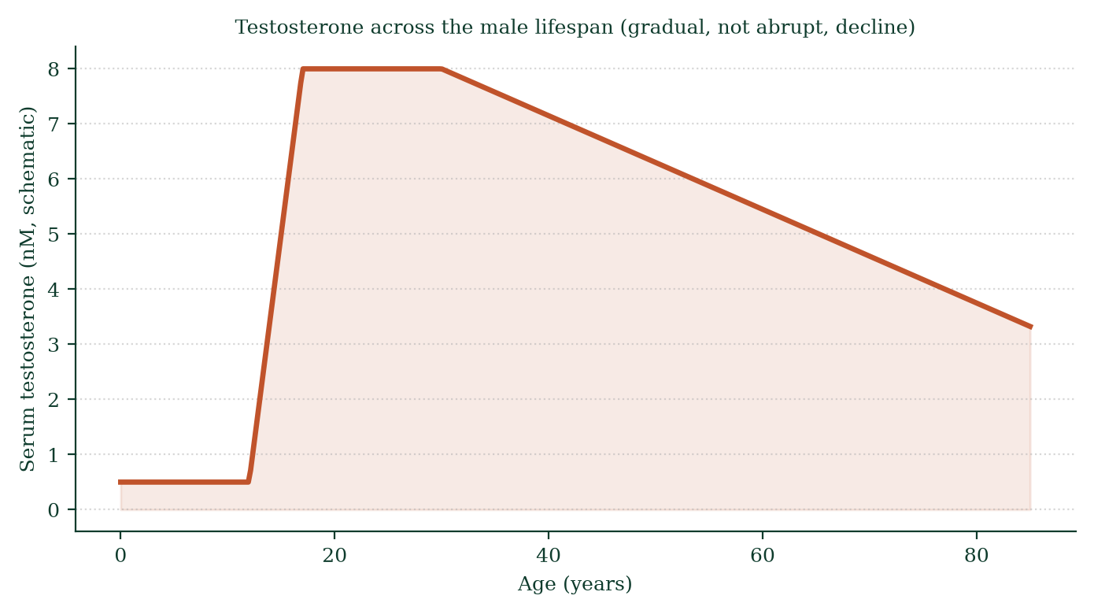
Figure 9.3 — Testosterone trajectory across the lifespan: high neonatal/pc fetal peaks, puberty rise, adult plateau, gradual age-related decline.

9.7 Age-related male reproductive change in detail
- Free testosterone ↓; SHBG ↑ (~1% per year); LH may rise compensatorily (partial primary component).
- Sperm: volume ↓; concentration ↓ modestly; motility ↓; morphology ↓; DNA fragmentation ↑ (~0.7% per year).
- Sexual response: longer latency to erection/orgasm, less rigidity, longer refractory period.
- Prostate: stromal and glandular hyperplasia in transitional zone (BPH) — LUTS; cancer risk with age.
- Vascular: same atherosclerosis that affects coronary arteries — erectile dysfunction is a sentinel vascular risk marker — it precedes coronary events by ~3–5 years on average; ED warrants cardiovascular risk assessment, not just a pill.

9.8 Clinical pharmacology highlights (mechanism-first)
- PDE5 inhibitors: see above; effective with intact NO signalling (failed in severe diabetes with autonomic neuropathy less reliably).
- 5α-reductase inhibitors (finasteride, dutasteride): block T→DHT → shrink prostate (BPH), treat male-pattern hair loss; adverse effects: libido/erectile decline, gynaecomastia.
- GnRH agonists (leuprolide): initial flare → receptor downregulation → medical castration → prostate cancer hormone deprivation.
- Anti-androgens (bicalutamide) and abiraterone (CYP17 inhibitor): block androgen action/synthesis in advanced prostate cancer.
- α-blockers (tamsulosin): relax bladder neck/prostatic smooth muscle → relieve BPH obstruction; can cause retrograde ejaculation.

9.9 Mechanism in depth: how the axis actually times male reproduction
The male axis is deceptively simple-looking in textbooks — GnRH, LH, FSH, testosterone, inhibin, feedback — yet its temporal choreography is one of the most elegant control systems in physiology. Dissected mechanistically:
GnRH pulse decoding. Gonadotrophs read pulse frequency and amplitude differentially through differential receptor desensitisation kinetics. Faster pulses (every ~60 min) favour LHβ-gene transcription; slower pulses (every ~2–3 h) favour FSHβ-gene transcription. The mechanism involves differential activation of ERK MAPK (early, high-frequency) versus Smad/β-catenin pathways (sustained, lower-frequency). This is why exogenous gonadotrophin or pump-driven GnRH therapy must mimic physiological patterns — a continuous infusion destroys the code (Chapter 7).
Inhibin B as a feedback reporter. Sertoli cells secrete inhibin B in response to FSH and spermatogenic activity. Inhibin B is a heterodimer (α + βB subunits) binding betaglycan/coreceptors on gonadotrophs, recruiting TGF-β type II receptors, activating SMAD2/3 — which directly repress the FSHβ promoter. Inhibin therefore answers the question “is enough spermatogenesis happening?” — if yes, FSH quietens. Men with Sertoli-only syndrome or post-chemotherapy azoospermia show high FSH (no inhibin B feedback) with normal-range testosterone (Leydig cells often spared) — a classic diagnostic dissociation.
Testosterone’s two feedback faces. Testosterone suppresses GnRH (via kisspeptin neurons of the arcuate nucleus — testosterone reduces KNDy neuron kisspeptin output) and FSH/LH at the pituitary. But a large fraction of testosterone’s feedback is actually mediated after aromatisation to oestradiol — aromatase is expressed in hypothalamus and pituitary. Men with aromatase deficiency develop tall stature (unfused epiphyses), osteopaenia/osteoporosis, and unusually high gonadotrophins despite high testosterone — proof that male bone and axis regulation lean heavily on local oestrogen synthesis.
Receptor pharmacology at the nucleus. Androgen receptor (AR) is a nuclear receptor with a long N-terminal domain (transactivation), central DNA-binding domain (two zinc fingers binding androgen response elements, AREs) and C-terminal ligand-binding domain. DHT binds with ~5-fold higher affinity than testosterone and generates a more stable receptor–DNA complex — hence why DHT-driven tissues (prostate, external genitalia, acne) respond to sub-nanogram DHT concentrations. AR mutations (not merely hormone levels) cause androgen insensitivity syndrome — receptors present but non-functional; phenotype diverges from chromosomal sex (Chapter 19).
Why nocturnal sleep is non-negotiable. Testosterone secretion is driven by LH pulses entrained to REM sleep; total sleep deprivation over one week can reduce daytime testosterone by 10–15% — an experimentally demonstrated, common, reversible cause of low T. Obstructive sleep apnoea both lowers T and raises cardiovascular risk — screening for it in ED + hypogonadism is mainstream.

9.10 Clinical spotlight: male infertility work-up through the axis
Semen analysis (WHO reference limits: volume ≥1.4 mL; concentration ≥16 million/mL; total motility ≥42%; progressive motility ≥30%; normal morphology ≥4%) triages the problem:
- Low concentration, normal FSH/LH/testosterone → likely obstructive or ejaculatory duct issue — imaging (scrotal ultrasound, vasography) and surgical correction; normal production, blocked plumbing.
- Low concentration, high FSH, small testes → non-obstructive (primary testicular failure): varicocele repair (selective), FSH/hMG limited efficacy; donor sperm / ICSI as options.
- Normal concentration, zero motility → immotility with live cells: rare genetic (dysplasia of fibrous sheath) or functional (anti-sperm antibodies, necrozoospermia).
- Zero sperm with low FSH → central (hypogonadotropic): Kallmann, functional, anabolic steroids — treat the axis (clomiphene/hMG) rather than the testis.
- DNA fragmentation → varicocele, smoking, oxidative stress — lifestyle targets and intrauterine/ICSI strategies.
The entire male infertility algorithm is one axis read sensorily — no memorised work-up survives contact with mechanistic reasoning.

9.11 Evidence checkpoint (what the data actually support)
- Weight loss improves testosterone, erectile function and semen parameters in obese men (randomised evidence).
- PDE5 inhibitors restore function in ~60–70% of men with mixed ED but do not treat the underlying vascular risk.
- Testosterone therapy in truly deficient men improves libido, bone density and muscle mass; in non-deficient men (T >350 ng/dL) outcomes are inconsistent and risks (erythrocytosis, prostate, CV) real — hence diagnostic rigour required before therapy.
- Smoking cessation improves semen parameters modestly; vaping data are immature.
- Tight underwear findings are inconsistent; heat avoidance of saunas has weak-to-moderate evidence — advise moderation, not abstinence.

9.11 Mechanisms and evidence in depth: the vasomotor cascade and PDE5 reality check
Erection as a haemodynamic event. Sexual stimulation releases nitric oxide (NO) from parasympathetic nitrergic nerves and endothelium in the corpus cavernosum. NO activates soluble guanylyl cyclase → cGMP → smooth-muscle relaxation in the helicine arterioles → high-flow engorgement of sinusoids; subtunical venules are compressed against the tunica albuginea (veno-occlusive mechanism) trapping blood. PDE5 breaks down cGMP — so sildenafil/tadalafil block the breakdown and amplify the existing NO-cGMP signal. Three clinical corollaries: (i) no NO release → no effect (not an aphrodisiac); (ii) nitrates are dangerous combined with PDE5 inhibitors (both raise cGMP/cGMP-like vasodilation — profound hypotension); (iii) psychogenic ED shows preserved nocturnal erections (limbic activation intact) vs organic ED where sleep erections fade.
The refractory period and emission. After ejaculation, prolactin rises and sympathetic tone dominates; a further erection is impossible for minutes to hours — the mechanism of the male refractory period. Emission (sympathetic, T10–L2: vas deferens and seminal vesicle contraction into the prostatic urethra) precedes expulsion (somatic reflex, S2–S4: bulbospongiosus/ischiocavernosus rhythmic contraction + bladder neck closure preventing retrograde ejaculation). Retrograde ejaculation = bladder neck failure — post-TURP or autonomic neuropathy — diagnosed by sperm in urine after orgasm.

Common errors in male sexual reasoning
- “ED is a vascular disease only.” — neurogenic, hormonal, psychogenic, drug-induced (SSRIs, β-blockers) contribute.
- “Testosterone cures all male sexual dysfunction.” — only when genuinely hypogonadal.
- “PDE5 failure means nothing else will work.” — dose titration, partner factors, and intracavernosal therapy exist.

9.12 Clinical reasoning vignettes
Case 1. A 45-year-old man with new ED and HbA1c 8.1%. Mechanism: diabetes silently destroys endothelial nitric-oxide signalling — both in penile arteries and coronary vessels; his ED is a coronary warning; treat the diabetes and refer for cardiac assessment; PDE5 inhibitors first-line if no nitrate use.
Case 2. A 30-year-old on venlafaxine reports anorgasmia. Mechanism: serotonergic inhibition of the orgasm centre (medullary/sympathetic pathways); options: dose adjustment, switch SSRI class (bupropion — dopaminergic/noradrenergic), or accept mechanism and reframe expectations.
Case 3. A 55-year-old reports reduced ejaculate volume. Mechanism: retrograde ejaculation (bladder neck incompetence) post-TURP; bladder scan post-orgasm showing sperm in urine confirms; sperm can be recovered for IUI if fertility desired — mechanism-based management.

Self-check — can you derive these without notes?
- Explain the NO–cGMP–PDE5 cascade and its drug targets.
- Differentiate emission (sympathetic, T10–L2) from expulsion (somatic, S2–S4).
- Why does SSRI cause anorgasmia in both sexes (shared serotonergic pathways)?
- Explain the morning erection — REM-associated parasympathetic surge.
- Why does sildenafil not work without sexual stimulation?

Chapter summary
- The male axis is testosterone-dominant feedback with inhibin B fine-tuning FSH; diurnal/sleep rhythm matters clinically.
- Erection = NO → cGMP → smooth-muscle relaxation → sinusoidal engorgement + veno-occlusion; PDE5 degrades cGMP; drugs amplify the signal.
- Emission (sympathetic) → bladder neck closure → expulsion (somatic bulbospongiosus); bladder neck failure = retrograde ejaculation.
- Testosterone is needed in high local concentration for meiosis; serum T permissive for libido and function.
- Male decline is gradual (~0.4–1% per year testosterone; progressive sperm quality decline); ED is a cardiovascular sentinel.
- Pharmacology here is physiology: every drug class maps onto a step of the pathway.

Key terms
Kisspeptin — upstream GnRH driver. ABP — androgen-binding protein. SHBG — sex hormone-binding globulin. Nitric oxide (NO) — endothelial/neuronal vasodilator. cGMP — smooth-muscle second messenger. PDE5 — cGMP-degrading phosphodiesterase. Veno-occlusion — subtunical venous compression. Emission — sympathetic transit of semen to posterior urethra. Refractory period — post-orgasmic recovery window. Late-onset hypogonadism — symptomatic low T with reproducibly low levels. BPH — transitional-zone prostatic hyperplasia.

Review questions
Multiple choice
- Testosterone levels characteristically peak at:
  - midday b) early morning c) evening d) midnight
- The molecular mediator of smooth-muscle relaxation in erection is:
  - cAMP b) IP3 c) cGMP d) ATP
- The enzyme that terminates the erection signal is:
  - guanylyl cyclase b) PDE5 c) aromatase d) 5α-reductase
- Retrograde ejaculation results from failure of the:
  - bulbospongiosus b) internal (bladder neck) sphincter c) Dartos d) detrusor
- Emission is controlled primarily by the:
  - parasympathetic system b) somatic pudendal nerve c) sympathetic system d) enteric system
- PDE5 inhibitors work only if there is:
  - intact NO signalling b) high cGMP c) low PDE5 d) high testosterone
- Erectile dysfunction is a sentinel marker for:
  - renal failure b) cardiovascular/systemic vascular disease c) hyperthyroidism d) prostate cancer
- DHT is produced from testosterone by:
  - aromatase b) 5α-reductase c) CYP17 d) HSD17β
Short answer
- Explain why morning samples are preferred for testosterone measurement.
- Describe the four phases of the male sexual response and their neural control.
- Explain the bladder neck closure’s role in normal ejaculation.
- Define refractory period and list factors that shorten/lengthen it.
Explanation
- Walk through the biochemical cascade from sexual stimulation to cavernosal rigidity, step by step.
- Explain how finasteride can both improve BPH symptoms and reduce libido — one mechanism, two effects.
- Explain why erectile dysfunction can precede coronary disease by years.
Application
- A 58-year-old with diabetes and ED asks for sildenafil. Outline the mechanism-based counselling, including nitrates and assessment of vascular risk.
- A man on a GnRH agonist for prostate cancer develops hot flushes and bone loss. Explain both by axis logic.
- A 35-year-old reports reduced morning erections for 6 months with fatigue. Which axis workup is indicated and why morning sampling matters?

Answers to review questions
- b. Diurnal peak early morning; nadir evening; sleep/REM major driver.
- c. NO → guanylyl cyclase → cGMP → PKG → Ca²⁺ fall → relaxation.
- b. PDE5 hydrolyses cGMP; inhibitors prolong it.
- b. Internal sphincter fails → semen enters bladder retrogradely.
- c. Sympathetic hypogastric nerves drive emission.
- a. Without NO release (stimulation/intact nerves), cGMP never rises; drugs merely spare it from breakdown.
- b. Same endothelial NO machinery; penile arteries (~1–2 mm) occlude before coronaries (~3–4 mm).
- b. 5α-reductase type 2 mostly.
- Peak diurnal phase with least sampling variability; evening values may spuriously fall into “low” range.
- Excitement (parasympathetic) → plateau → orgasm (sympathetic emission + somatic expulsion) → resolution (sympathetic detumescence + refractory period).
- Bladder neck contracts under sympathetic tone, sealing the posterior urethra entry into the bladder — forcing semen anteriorly; failure = retrograde ejaculation (diabetes, TURP, α-blockers).
- Refractory = post-orgasm period when another erection/orgasm is physiologically impossible; younger men minutes, older men hours–days; genetics, frequency of intercourse, arousal context, hormonal status modulate.
- Stimulation → sacral parasympathetic nerves → NO release → smooth muscle GC activation → cGMP ↑ → PKG → Ca²⁺ ↓ → MLCP dephosphorylates myosin → trabecular/helicine relaxation → sinusoidal engorgement → subtunical venules compressed → veno-occlusion → rigidity.
- Finasteride blocks 5α-reductase → DHT falls → prostate epithelium (DHT-dependent) regresses → BPH symptoms improve; but DHT also drives libido/virilisation centrally and peripherally — its decline reduces sexual desire; one enzyme, one substrate, two clinical faces.
- Penile arteries are smaller and atherosclerosis signals systemic endothelial dysfunction; ED appears before anginal symptoms because the smaller vascular bed becomes symptomatic first — hence ED is a stateable CV risk marker, mandating risk-factor screening.
- Explain: sildenafil augments NO-cGMP signalling but will not create desire; sexual stimulation still required; absolute contraindication with nitroglycerin/nitrates (dangerous BP drop) and caution with α-blockers; ED in diabetics may reflect autonomic neuropathy (reduced nitric signalling) — response rate lower; refer to cardiology for risk assessment; review glycaemic control, lipids, exercise; also screen for hypogonadism symptoms.
- Agonist initially flares then desensitises GnRH receptors → LH/FSH collapse → testosterone to castrate levels; hot flushes are a hypogonadal vasomotor response (as in menopause); bone loss follows loss of testosterone/oestradiol’s protective effect on bone remodelling — both are predictable consequences of therapeutic axis shutdown, monitor bone density and manage symptoms.
- Measure morning total testosterone (± SHBG/free testosterone), LH, FSH, prolactin, TSH, HbA1c/lipids; morning sampling catches the physiological peak; low T with low LH/FSH → central (urgent pituitary evaluation, prolactinoma/functional), low T with high LH/FSH → primary testicular failure; normal T → look elsewhere (psychogenic, relational, sleep apnoea, medication — SSRIs).

Chapter 10: Sexual Intercourse, Sperm Transport, and Fertilization
Learning objectives. After studying this chapter you should be able to: - trace sperm migration from the vagina through the cervix, uterus and tube; - explain capacitation and the acrosome reaction mechanistically; - describe zona binding, sperm–oocyte membrane fusion and polyspermy block; - explain zygote formation and the restoration of diploidy.
Central question. How can a microscopic sperm, deposited far from the egg, find and penetrate it — and how does biology make sure only one succeeds?

10.1 The odds, and the design that beats them
A single ejaculate delivers ~40–300 million sperm into the vagina; only a few hundred reach the ampulla; typically one fertilises. Everything between deposit and fusion is a hostile obstacle course engineered by the female tract: acidity (pH ~4), cervical mucus architecture, uterine immunology, isthmic storage, and a zona shell around the oocyte. Yet a fertilisable egg and motile sperm in the same tube in the fertile window almost always meet — biology stacks the odds with multiple overlapping mechanisms (Figure 10.1).
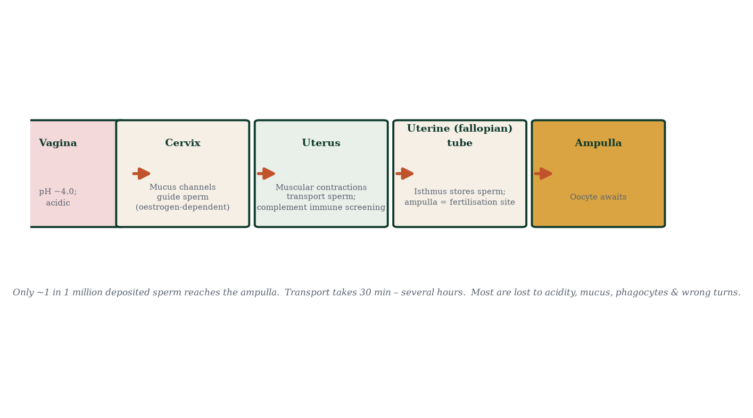
Figure 10.1 — Route of sperm from vagina to ampulla; the vast attrition is a filter for viable, motile, competent sperm.

10.2 Vaginal and cervical phase (minutes)
- Vagina — pH ~4; sperm motility impaired; semen’s alkaline buffer raises pH to ~7.2 enabling swimming; sperm form swimming streams along mucus strands.
- Cervix — mucus architecture switches with cycle phase (Chapter 4). At ovulation: hydrated, parallel glycoprotein channels; sperm swim through in ~1–2 minutes; the crypts release them over hours (reservoir effect). At other phases: mucus is impenetrable. Sperm with abnormal morphology/motility cannot navigate → cervical selection filter #1.
- Cervical mucus also filters out leukocytes and abnormal sperm; a fraction reaches the uterotubal junction within ~5 minutes; most remain stored and released gradually.

10.3 Uterine transit and the immune encounter (minutes–hours)
Uterine contractions (stimulated by prostaglandins in semen — oxytocin also equipotential via sexual climax) create pressure gradients wafting sperm forward. The endometrial immune environment (macrophages, neutrophils, uterine NK cells) phagocytoses defective sperm — selection filter #2. The uterotubal junction (narrow, muscular) meters sperm entry into the tube — filter #3. Sperm are also stored in the isthmic reservoir of the tube, bound to ciliated epithelium; they are released in a hyperactivated state in response to ovulatory signals (progesterone gradient) — filter #4 temporally aligns sperm readiness with the egg’s arrival.

10.4 Capacitation (hours)
Capacitation (Chapter 5) is completed in the female tract: cholesterol efflux via albumin-mediated transfer; membrane fluidity increases; surface decapacitation coat is removed; Ca²⁺ influx rises; intracellular cAMP climbs; flagellar beating converts to hyperactivated pattern — high amplitude, asymmetric whip — generating thrust to escape the isthmic reservoir and penetrate cumulus mass. Without capacitation: no zona binding, no acrosome reaction, no fusion.
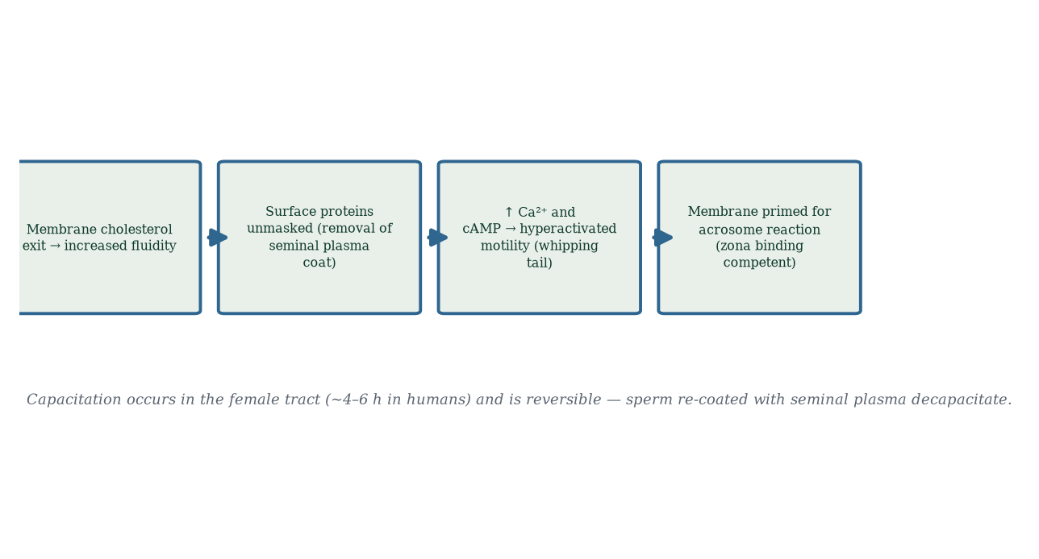
Figure 10.2 — Capacitation: sequential membrane and ion changes converting an epididymal sperm into a fertilisation-competent one.

10.5 The acrosome reaction and zona penetration
Sperm reaching the oocyte in the ampulla encounter: (1) cumulus oophorus (corona radiata cells in hyaluronic-acid matrix) — hyaluronidase and hyperactivated motility disperse it; (2) zona pellucida (ZP1–ZP4 glycoproteins) — sperm head binds ZP3 (species-specific ligand; human zona is hard to study because it doesn’t fit animal models well), which triggers the acrosome reaction: fusion of acrosomal and plasma membranes; exocytosis of acrosin (a serine protease) and other enzymes; digestion of a path. The inner acrosomal membrane surface then binds ZP2; motility plus proteolysis drills a tunnel.
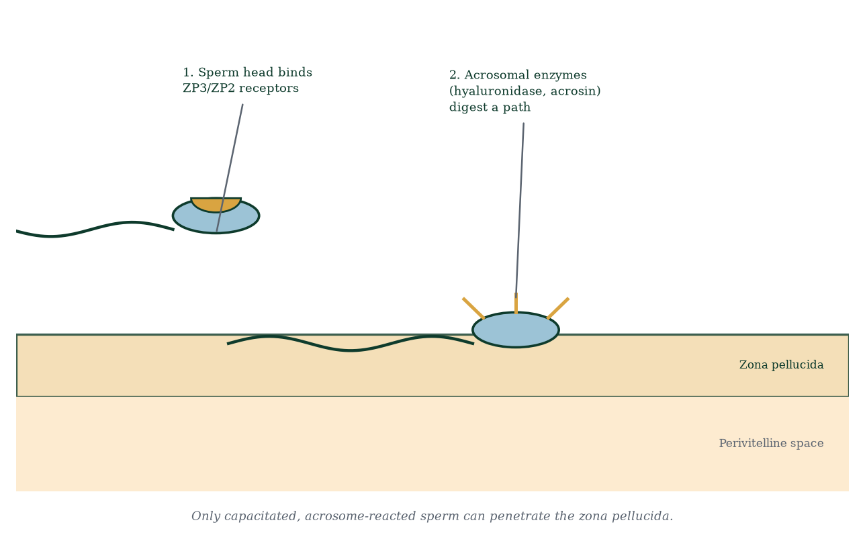
Figure 10.3 — Sperm binding to and digesting through the zona pellucida; acrosomal exocytosis creates the proteolytic tunnel.

10.6 Fusion and polyspermy prevention
Once through the zona, the sperm reaches the perivitelline space and binds the oocyte plasma membrane via izumo1 [2] (sperm) binding Juno (oocyte) — the essential fertilisation pair. Fusion follows within seconds. Polyspermy (which would be lethal — triploid embryos fail) is prevented twice (Figure 10.4):
- Fast block — membrane depolarisation (Na⁺ influx, +30 to +50 mV); electrical prevention of further fusion; begins within seconds; important in species with external fertilisation (sea urchins), brief in humans.
- Slow block (cortical reaction) — Ca²⁺ wave sweeps the oocyte (triggered by PLCζ from sperm); cortical granules fuse with the oolemma and release enzymes (proteases, ovoperoxidase) that cleave ZP2 and harden the zona (“fertilisation membrane”) — permanent block; also Juno shedding into vesicles reduces available fusion receptors.
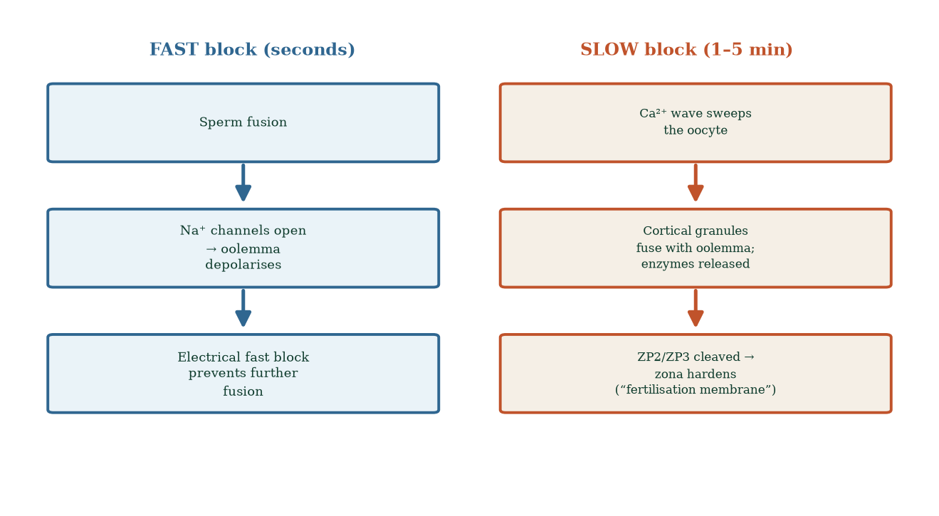
Figure 10.4 — Two-stage prevention of polyspermy: the electrical fast block and the cortical-reaction slow block that hardens the zona.

10.7 The zygote: restoring diploidy
Sperm entry → Ca²⁺ oscillations → meiosis II completion → second polar body extruded → maternal pronucleus forms. Sperm nucleus decondenses (protamines replaced by maternal histones) → paternal pronucleus forms. Pronuclei migrate toward each other, replicating DNA (S phase) — then first mitotic division (~30 h post-fertilisation). The zygote (2n = 46, XX or XY) now exists — a unique genome never before assembled. Mitochondrial DNA is exclusively maternal (sperm mitochondria are tagged for destruction by ubiquitin after fusion) — hence maternal inheritance of mtDNA diseases.
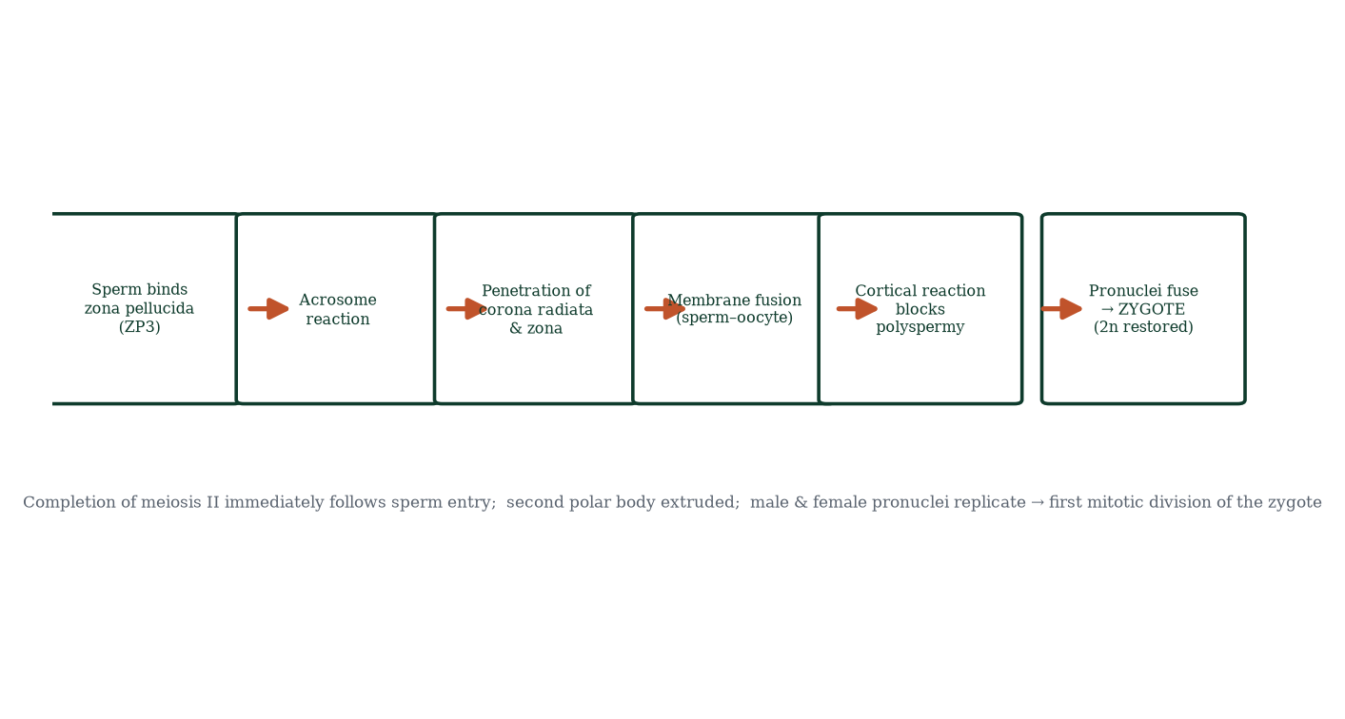
Figure 10.5 — Fertilisation sequence: binding, acrosome reaction, penetration, fusion, cortical block, pronuclear fusion → zygote.

10.8 Fertilisation location, timing and clinical correlates
Fertilisation normally occurs in the ampulla within ~12–24 h of ovulation; sperm are viable ~5 days. Hence the fertile window: the 5 days preceding ovulation + day of ovulation. Sperm DNA quality (fragmentation) matters; smoking and age increase it. Failure of fertilisation (despite normal gametes) can reflect zona-binding or Juno–izumo defects — now recognised as specific infertility phenotypes amenable to ICSI bypass (Chapter 18). Polyspermy is vanishingly rare in vivo due to the double block; dispermic zygotes (2 sperm) occur in ~1 per several thousand conceptions — non-viable (diandric triploidy).

10.9 Mechanism in depth: the choreography of membrane fusion
Fertilisation is one of the most membrane-intensive events in biology. Consider what must happen, in molecular order, for two cells that spent their entire lives as independent entities to become one:
1. The Ca²⁺ oscillations — the embryo’s first heartbeat. Sperm deliver phospholipase C zeta (PLCζ), a soluble enzyme that diffuses into the oocyte and hydrolyses PIP2 into IP3 and DAG. IP3 opens IP3 receptors on the oocyte’s endoplasmic reticulum → Ca²⁺ floods the cytoplasm in ~10 oscillations, ~every 5 minutes. These oscillations: (i) inactivate cytostatic factor (CSF) → meiosis II resumes; (ii) activate cortical granule exocytosis (the slow block); (iii) decondense the sperm nucleus; (iv) recruit the maternal mRNA translation machinery needed for the first cell divisions (zygotic genome activation comes later, ~day 2–4 in humans). PLCζ is the molecular key that converts sperm presence into an embryonic programme — its absence or deficiency (genetic syndromes, subfertility) causes fertilisation failure amenable to assisted oocyte activation (artificial Ca²⁺ ionophore/electrical stimulation) in some IVF labs.
2. Izumo1–Juno biochemistry. Izumo1 (sperm immunoglobulin-like type I membrane protein) binds Juno (GPI-anchored folate receptor 4 family member) on the oocyte. The interaction is required for fusion; Izumo1-null sperm fail fusion but are fine for motility and Zona penetration. Juno is shed from the oocyte surface (as vesicles) within ~45 minutes of fusion — a receptor-level polyspermy lockout in addition to zona hardening.
3. Membrane fusion mechanics. Fusion requires CD9 on the oocyte and other tetraspanins — no single fusogenic protein fully replicates the sea-urchin model; human fusion appears to use a Juno–Izumo anchoring step followed by CD9-dependent membrane apposition and fusion pore formation — active research territory where mechanism is not yet complete. This honesty matters: reproductive biology is not finished.

10.10 Clinical spotlight: predicting and aiding fertilisation
- Timed intercourse/IUI (intrauterine insemination) exploits the fertile window deliberately; ~10–20% per-cycle success in mild unexplained infertility.
- ICSI bypasses every step from cumulus/zona to membrane fusion — reserves IVF’s most invasive tool for male-factor failure or unexplained failure.
- Sperm DNA fragmentation testing (TUNEL assay) guides varicocele surgery and lifestyle counselling; extreme fragmentation predicts IVF failure.
- Calcium oscillation assessment and oocyte activation protocols are last-resort options for total fertilisation failure — some centres offer this routinely.
- The smoking/audit: one of the clearest reversible determinants of sperm DNA quality is smoking; cessation for ≥3 months measurable improvement in fragmentation indices — because sperm are uniquely vulnerable to oxidative damage in their paternal DNA.

10.11 Evidence checkpoint (fertilisation biology in translation)
- IVF with ICSI achieves fertilisation rates of ~70–80% of injected oocytes; total fertilisation failure in ~1–3% of cycles.
- Juno expression declines with oocyte age — one molecular reason age reduces fertilisability beyond chromosomal issues.
- ZP2 hardening is irreversible; zona thickness varies between women and is anecdotally implicated in sporadic failed fertilisation with fresh oocytes (assisted hatching — partial zona removal — is used in limited IVF settings with mixed evidence).
- MtDNA diseases (e.g., MELAS, LHON, Leigh syndrome spectrum) are transmitted exclusively through oocytes — hence mitochondrial replacement techniques (“three-parent IVF”) in the UK legalised in 2015; mechanism understanding makes this radical technology possible.

10.11 Mechanisms and evidence in depth: why most sperm fail — the selection funnel in numbers
Of the ~100–300 million sperm deposited: half leak from the vagina, millions die in acidic vaginal pH (pH ~4), thousands perish at the cervix unless mucus is oestrogen-permissive (mid-cycle), many are trapped in crypts, immune cells phagocytose the rest — leaving ~100–1000 reaching the ampulla. The funnel is deliberate: only competent, capacitation-ready, membrane-intact sperm survive — selection is the point of the female tract, not a bug. Sperm also carry surface molecules (e.g., CD46, TEX family) involved in immune evasion during transit — the same challenge the placenta solves later (Chapter 14).
Capacitation chemistry. Freshly ejaculated sperm cannot fertilise. Capacitation — cholesterol removal from the plasma membrane, rise in membrane fluidity, Ca²⁺ and HCO₃⁻ influx via channels (CatSper, SLC4), cAMP rise, PKA activation, protein tyrosine phosphorylation — takes ~4–6 h in the tract. Result: hyperactivated motility (whip-like, high-amplitude) and acrosome reactivity. Without capacitation, no zona penetration, no fertilisation.
Polyspermy prevention — two independent blocks. Fast block (electrical: membrane depolarisation post-fusion) and slow block (cortical granule exocytosis → zona hardening via ovastacin/zinc). Failure of either → polyspermy → triploidy → development arrest — mechanism explains why most triploid conceptions miscarry.

Common errors in fertilisation reasoning
- “Fertilisation happens immediately.” — capacitation takes hours; transport takes hours.
- “All sperm reach the egg.” — the funnel eliminates >99.999%.
- “Twins arise from one egg splitting always.” — dizygotic (two eggs) is more common; monozygotic split timing determines chorionicity.

10.12 Clinical reasoning vignettes
Case 1. A couple fail to conceive for 2 years. Intercourse exclusively after ovulation day (track-and-deploy only on BBT-positive days). Mechanism: sperm need ~4–6 h capacitation and the ~24 h oocyte window closes fast — arriving same-day misses the earlier days when sperm reservoirs build; solution: intercourse every 1–2 days in the 5-day pre-ovulation window.
Case 2. A woman with endometriosis attempts natural conception for 12 months, fails; tubal HSG patent. Mechanism: inflammatory peritoneal environment → reduced fertilisation/implantation competence; early IVF is evidence-based step before repeated natural cycles.
Case 3. A 36-year-old with 38% sperm DNA fragmentation and normal everything else: two failed IVF cycles with poor fertilisation. Mechanism: sperm DNA damage → poor embryo development; ICSI (bypasses zona/binding) does not repair DNA — instead optimise: varicocele repair, antioxidants (mixed evidence), or donor sperm as last resort.

Self-check — can you derive these without notes?
- Trace the sperm funnel from ejaculate to ampulla with approximate numbers.
- Explain capacitation sequence: cholesterol efflux, CatSper activation, tyrosine phosphorylation.
- Describe the zona reaction and why it blocks polyspermy mechanistically.
- Compare IVF vs ICSI indications precisely.
- Explain why timing intercourse to LH positivity works but calendar day 14 fails.

Chapter summary
- Sperm selection through the female tract is a multi-stage filter: acidity, mucus, immune surveillance, isthmic storage, hyperactivation gating.
- Capacitation and the acrosome reaction are sequential, female-tract-dependent activation events.
- Zona binding (ZP3) → acrosome reaction (acrosin/hyaluronidase) → zona drilling → fusion via izumo1–Juno.
- Polyspermy prevented electrically (fast) and enzymatically (cortical reaction, slow block, Juno shedding).
- Fertilisation triggers Ca²⁺ oscillations → meiosis II completion → paternal/maternal pronuclei → first mitosis.
- mtDNA is maternally inherited; the zygote is the first diploid cell of a unique organism.
- Fertile window = 5 days pre-ovulation + ovulation day.

Key terms
Capacitation — female-tract membrane priming. Hyperactivation — whip-like motility. Acrosome reaction — exocytosis of acrosomal enzymes. ZP3/ZP2 — zona pellucida ligands. Izumo1–Juno — fusion pair. Cortical reaction — Ca²⁺-triggered zona hardening. Pronucleus — haploid genome container before fusion. PLCζ — sperm factor triggering Ca²⁺ oscillations. Perivitelline space — zona–oocyte gap. Fertile window — 5 days pre-ovulation + ovulation day.

Review questions
Multiple choice
- Sperm transport through the cervix is facilitated by:
  - viscous luteal mucus b) oestrogen-primed hydrated channels c) progesterone plugging d) epithelial dead ends
- The sperm receptor on the oocyte is:
  - ZP2 b) Juno c) CD46 d) Izumo1
- Which completes meiosis II in the oocyte?
  - LH surge b) sperm entry c) FSH d) ovulation
- The cortical reaction hardens the zona by:
  - Na⁺ influx b) ZP2 cleavage and cross-linking c) depleting ATP d) depolarising membrane
- Sperm DNA is delivered to the oocyte packaged with:
  - histones b) protamines c) nucleoplasmin d) no proteins
- Fertilisation normally occurs in the:
  - uterine cavity b) cervical canal c) ampulla d) isthmus
- Maternal mitochondrial inheritance is because:
  - oocyte mtDNA is protected b) sperm mitochondria are ubiquitinated and destroyed c) paternal mtDNA never enters d) only oocyte mitochondria exist
- The izumo1 protein is found on:
  - the zona pellucida b) the oocyte membrane c) the sperm surface d) Sertoli cells
Short answer
- List the barriers sperm must overcome from vagina to oocyte, in order.
- Describe the two polyspermy blocks and their timing.
- Explain the roles of ZP3 and acrosin in fertilisation.
- Explain why the fertile window precedes ovulation rather than following it.
Explanation
- Explain why capacitation in the epididymis would be deleterious — what would go wrong?
- Walk through the sequence from ejaculation to first cleavage in chronological order, with approximate timing.
- Explain how Juno–izumo binding ensures species specificity to some extent.
Application
- A couple has unexplained infertility with normal gametes and tubes. Name the fertilisation-specific molecular phenotypes worth considering and the lab test.
- A patient is advised that “only one sperm can fertilise the egg.” Explain the two mechanisms that enforce this, and what happens if both fail.
- A woman underwent IVF with ICSI after years of unexplained infertility. Explain why ICSI bypasses the stages covered in this chapter.

Answers to review questions
- b. Oestrogen-primed parallel channels admit sperm; progesterone mucus blocks.
- b. Izumo1 (sperm) ↔ Juno (oocyte) is the essential fusion receptor pair.
- b. PLCζ-driven Ca²⁺ oscillations from sperm activate meiosis II completion.
- b. Cortical granule enzymes cleave ZP2 and cross-link zona proteins — the fertilisation membrane.
- b. Protamines; they are exchanged for maternal histones post-entry.
- c. Ampulla of the fallopian tube.
- b. Paternal mitochondria are ubiquitinated and degraded post-fusion.
- c. Izumo1 is a sperm surface immunoglobulin-like protein required for fusion.
- Vaginal acidity → cervical mucus → uterine immune surveillance → uterotubal junction metering → isthmic reservoir binding → cumulus dispersal → zona penetration → fusion.
- Fast (membrane depolarisation via Na⁺ influx, seconds, transient); slow (Ca²⁺ wave → cortical granule exocytosis → zona hardening via ZP2 cleavage, minutes, permanent); Juno shedding adds a receptor-level lockout.
- ZP3: species-specific oocyte-side ligand, triggers the acrosome reaction; acrosin: serine protease in the acrosome dissolving zona matrix and inner zona structures, creating the fertilisation tunnel.
- Sperm survive ~5 days; oocyte only ~12–24 h; having sperm in place before the egg arrives maximises the chance that a capacitated, hyperactivated sperm is at the ampulla when the oocyte is released.
- Premature activation in the epididymis would cause energy waste, premature acrosome reaction, and loss of fertilising capacity by the time sperm reached the egg — the tract is deliberately separated into “training” (epididymis) and “final activation” (female tract) compartments.
- Ejaculation (0) → vaginal pool; cervical transit (minutes) → reservoir storage (hours, released gradually) → uterine transit → isthmic reservoir; peri-ovulation release + capacitation completion; cumulus penetration → zona binding/acrosome reaction → fusion (12–24 h post-ovulation window) → Ca²⁺ wave → meiosis II → pronuclei → first mitosis (~30 h post-fertilisation).
- Izumo1 and Juno co-evolved; subtle surface compatibility requirements add molecular specificity, though human ZP3 discrimination is less strict than in many species — which is why human zona binding is relatively easy to bypass and why hybrid embryos in closely related species occur rarely.
- Consider Juno–izumo defects (rare), PLCζ deficiency (failure to trigger Ca²⁺ oscillations — can be tested by injecting sperm extract into test oocytes or by Ca²⁺ imaging), and zona-binding defects; ICSI circumvents all of these; genetic counselling for X-linked PLCζ cases.
- Fast block (electrical, seconds) and slow block (cortical reaction, permanent). Dispermic fertilisation → triploid zygote (69 chromosomes) — invariably non-viable or results in partial molar pregnancy — demonstrating the stakes of the mechanism.
- ICSI injects a single sperm directly into the oocyte cytoplasm: it bypasses cervical/uterine/tubal transport, cumulus dispersal, zona binding/penetration and the acrosome reaction and fusion receptor engagement entirely — fertilisation is engineered, so failures point to oocyte activation/early cleavage defects rather than to the natural pathway.

Chapter 11: Cleavage, Blastocyst Formation, and Implantation
Learning objectives. After studying this chapter you should be able to: - describe cleavage, morula and blastocyst formation; - explain trophoblast differentiation and inner cell mass development; - explain the mechanism and timing of implantation; - describe the maternal–embryonic endocrine interactions (hCG [19] rescue); - apply these mechanisms to early pregnancy clinical problems.
Central question. How does a 0.1 mm ball of identical cells become a two-part organism — one part to build a baby, one to build a placenta — and how does it then install itself inside the mother?

11.1 Cleavage: division without growth
The zygote divides by mitosis but without overall growth — cells (blastomeres) halve with each division; zona pellucida keeps the ball the same size. By day 2: 4-cell; day 3: 8-cell; compaction (adherens junctions tighten; blastomeres flatten and polarize); day 3–4: morula (16–32 blastomeres); day 5–6: blastocyst (~100–200 cells, still within the zona).
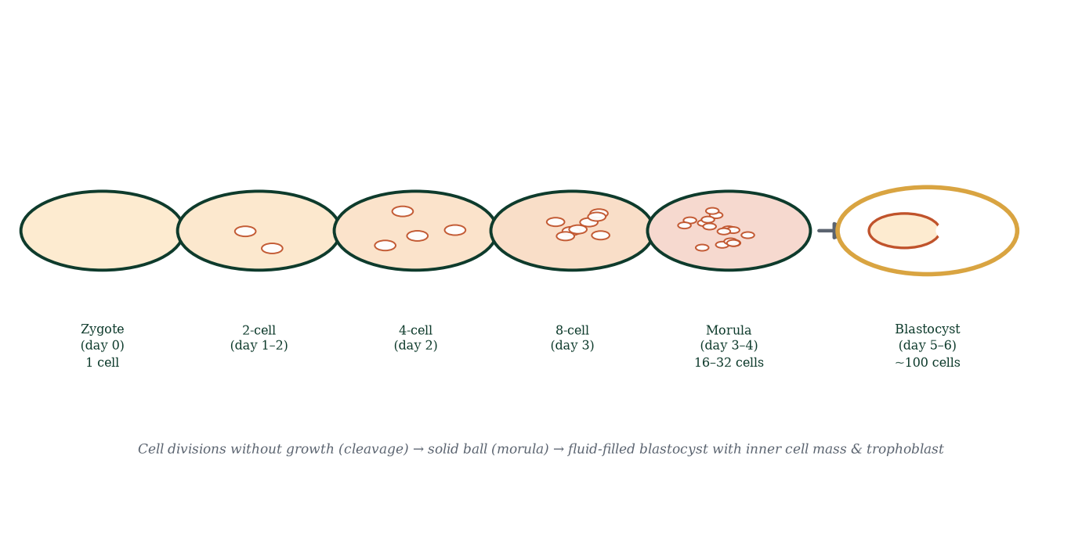
Figure 11.1 — Cleavage stages: zygote → 2-cell → 4-cell → 8-cell → morula → blastocyst. Divisions partition the egg without growth.
Two cell-fate decisions occur during cleavage:
- Inside vs outside cells (from the 16-cell stage) — cells at the surface experience different cues (positional, cell contact) than those inside. Outer cells become trophoblast (future placenta); inner cells become inner cell mass (ICM, embryoblast) (future embryo). Mechanism: differential Hippo/YAP signalling — in outside cells YAP stays nuclear (→ CDX2 → trophoblast genes); in inside cells YAP is phosphorylated/cytoplasmic (→ SOX2/OCT4/NANOG → pluripotency maintained).
- Trophoblast → cytotrophoblast + syncytiotrophoblast [5] — the syncytial (multinucleated, non-mitotic) layer is the invasive, hormone-secreting outer layer; cytotrophoblast is the proliferative inner layer.
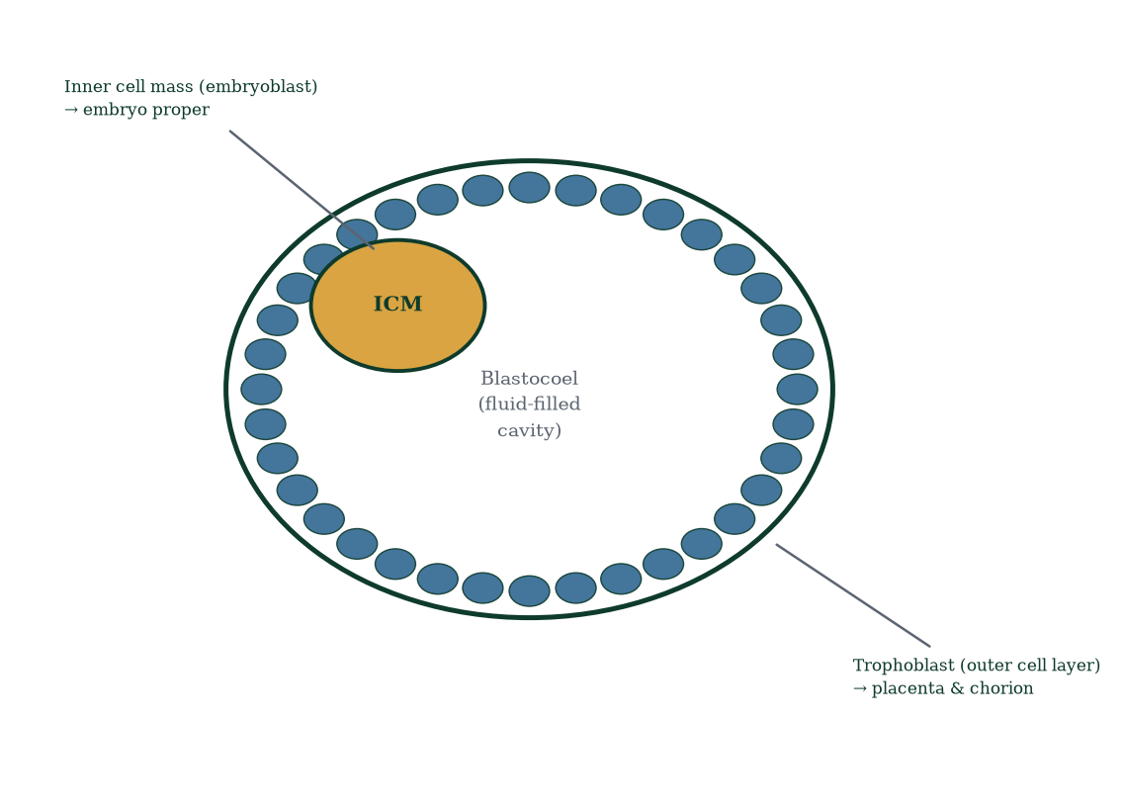
Figure 11.2 — Blastocyst anatomy: outer trophoblast, inner cell mass, and fluid-filled blastocoel cavity.

11.2 Hatching and the journey to the uterus
By day 5–6 the blastocyst “hatches” from the zona pellucida (enzymatic digestion + expansion pressure). While this happens in the tube (~day 3–5), the embryo floats: the tube’s cilia and muscle propel it toward the uterus — a journey of ~3–4 days. Arrival ~day 4–5. The endometrium must be in its window of implantation (~day 20–24 of a textbook 28-day cycle — a narrow ~2–4-day receptive interval): oestrogen-primed, progesterone-matured, with pinopodes protruding from luminal epithelium, adhesion molecules (integrins αvβ3, selectins) upregulated, and apposition forces (uterine fluid uptake, ciliary beat) ready. Implantation outside this window fails.

11.3 Implantation in molecular detail
Implantation (Figure 11.3) occurs in three overlapping phases — apposition, adhesion, invasion — over days 6–12:
- Apposition (day 6–7) — the hatched blastocyst aligns its ICM pole against the endometrial epithelium; loose mutual orientation (embryonic pole faces the wall).
- Adhesion (day 7–8) — trophoblast surface ligands (L-selectin, trophinin) engage endometrial receptors; tight/adherens junction formation seals contact; the trophoblast starts merging into syncytiotrophoblast — a multinucleated syncytium (no cell boundaries) that invades aggressively.
- Invasion (day 8–12) — syncytiotrophoblast secretes proteases (matrix metalloproteinases), invades between epithelial cells, breaches basement membrane, and erodes maternal capillaries (spiral arterioles) — lacunae (maternal blood pools) form; implantation is interstitial (fully embedded) by day 11–12; a fibrin closing plug seals the surface (transient bleeding is common — mistaken for a light period = “implantation bleeding”).
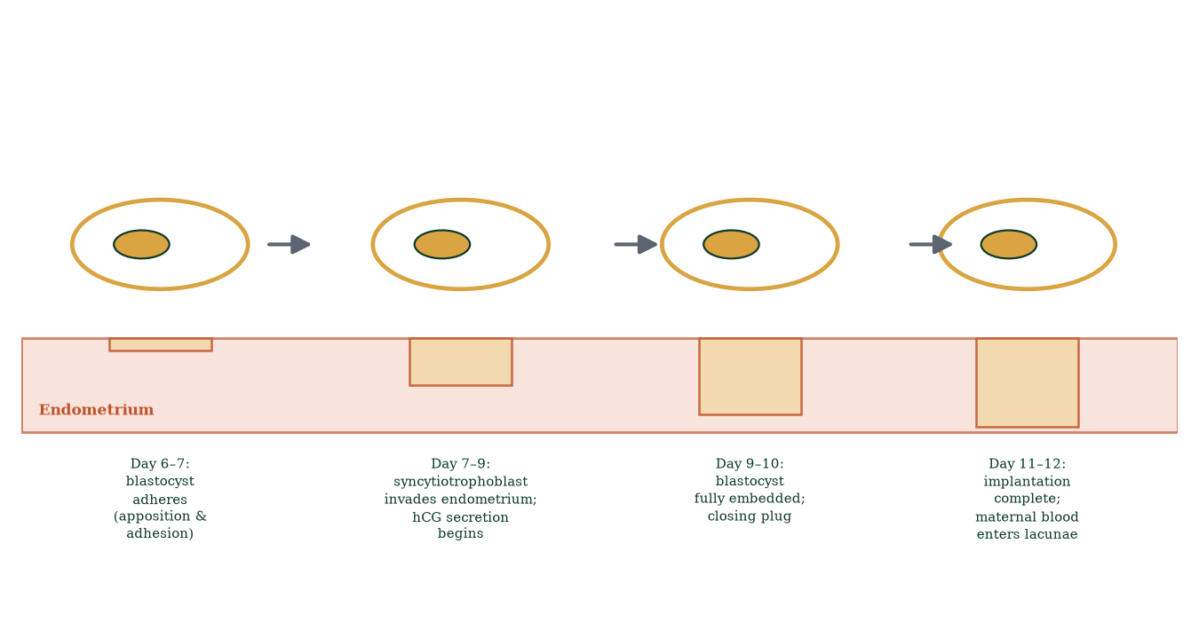
Figure 11.3 — Implantation sequence: apposition → adhesion → invasion by syncytiotrophoblast; complete embedding by day 11–12.

11.4 hCG: the biochemical signal of pregnancy
Within ~6 days of fertilisation, syncytiotrophoblast secretes human chorionic gonadotrophin (hCG) — structurally similar to LH (same α subunit, β subunit with 25% difference conferring receptor affinity). hCG binds LH receptors on the corpus luteum, “rescuing” it from involution — progesterone production continues, the endometrium stays secretory, menses never come. hCG also: promotes angiogenesis of uterine vasculature; nudges placental steroidogenesis (later weeks); maintains tolerance at the maternal–fetal interface; and is the analyte of pregnancy tests (urine/serum — qualitative or quantitative).
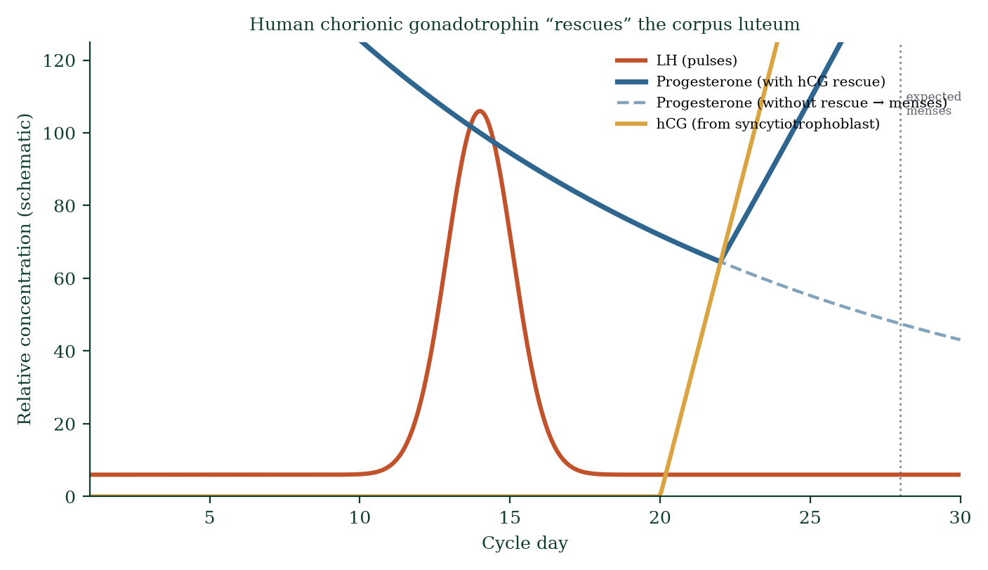
Figure 11.4 — hCG rescue of the corpus luteum sustains progesterone output and prevents menstruation; hCG becomes the analyte of pregnancy testing.
hCG rises exponentially (doubling time ~48 h), peaks ~week 9–10 (~100,000 mIU/mL), then falls steeply as the placenta takes over progesterone/oestrogen synthesis (~weeks 7–12) — the luteal–placental shift. Ectopic and failing pregnancies show abnormal hCG curves (slow doubling, plateau, fall) — serial β-hCG is a clinical diagnostic tool.

11.5 The embryo within the endometrium
By day 9–12 the embryo is a bilaminar disc — epiblast (embryo proper) and hypoblast (yolk sac lining) — beneath which lies the yolk sac (early nutrition, later hematopoiesis — blood cells form here first; the embryo’s own gut forms from it) and above which the amniotic cavity forms (epiblast → amnioblasts → amnion). The extraembryonic mesoderm splits to create the chorionic cavity; chorionic villi later elaborate the placenta (Chapter 14). Maternal vessels open into lacunae; maternal–embryonic exchange begins before the placenta is definitive — diffusion across trophoblast layers is the first “placenta”.

11.6 Clinical spotlights in early pregnancy
- Implantation bleeding (~day 20–26): light spotting as the blastocyst digs in; must be distinguished from menses.
- Ectopic pregnancy: implantation in tube/cervix/ovary/abdominal cavity — expectant/medical (methotrexate)/surgical depending on stability; leading cause of first-trimester maternal mortality worldwide; prior tubal surgery, PID, IVF increase risk.
- Early miscarriage (~10–20% of recognised pregnancies): most due to chromosomal aneuploidy — the embryo is culled by nature’s quality control; the body completes the feedback loop (progesterone falls, bleeding starts).
- IVF: multiple embryos transferred raise multiples’ risk — now single embryo transfer is standard where feasible; ovarian stimulation aims at ~10–20 eggs.
- Recurrent implantation failure: embryo causes (chromosomal) vs endometrial causes (chronic endometritis, thin lining, immunological factors) — active research frontier.

11.7 Mechanism in depth: the syncytiotrophoblast is a biological invention
The human implantation is among the most invasive in the animal kingdom. Reflect on what the trophoblast must do: cross the epithelial barrier, digest stromal matrix, erode arterial endothelium, deposit itself into the maternal circulation, and do so without killing the host or being killed itself. The design solutions:
Syncytium formation. Trophoblast cells fuse their membranes (via syncytin genes, derived from endogenous retroviral envelope genes — an extraordinary fact: placental syncytia exist because of ancient retroviral infections). The syncytiotrophoblast is a giant, multinucleated, non-mitotic epithelium that covers the villi — the only direct contact between conceptus and maternal blood. Its surface is resistant to immune attack (HLA-G expression inhibits maternal NK cells; Fas ligand; IDO-mediated local tryptophan depletion suppressing T-cell activation).
Lacunae and the haemochorial placenta. Maternal spiral arterioles open into lacunae around day 9–11; by week 10–12 the uteroplacental circulation is established. Before this, the conceptus lives on uterine gland histotroph (secretion-rich nutrition — “uterine milk”). The switch histotrophic → haemotrophic nutrition around week 10–12 coincides with the luteal–placental steroid shift — a coordinated physiological handover.
Why implantation can fail — molecular mismatches. Receptivity requires synchrony: embryo adhesiveness window and endometrial receptivity window must overlap. Out-of-phase embryo transfer in IVF fails; chronic endometritis distorts pinopode formation; endometrial dating studies (“window of implantation” assays) are commercially available but their added value in unselected infertility remains uncertain — evidence is mixed and sometimes negative.

11.8 Clinical spotlight: miscarriage, ectopic care, and IVF embryo selection
- Threatened miscarriage: bleeding with live fetus — 90%+ continue to term; progesterone supplementation evidence is mixed (helps subgroups with low progesterone).
- Missed miscarriage: non-viable pregnancy retained — progesterone stops; uterus begins shedding process; managed expectantly, medically (mifepristone + misoprostol), or surgically.
- Complete vs incomplete miscarriage: ultrasound distinguishes retained products (incomplete → intervention) from empty cavity (complete → reassurance).
- Ectopic: risk of tubal rupture → intraperitoneal haemorrhage; medical methotrexate for stable small ectopics; surgery (salpingectomy/salpingostomy) for ruptured/unstable or large — every woman with pain + positive pregnancy test needs ectopic exclusion.
- Embryo selection in IVF: morphology graded; time-lapse imaging; PGT-A (aneuploidy screening) selects chromosomally normal embryos — raises per-transfer success but raises cost/ethical issues; doesn’t change natural IVF success overall for all patients; important in advanced maternal age and recurrent miscarriage.

11.9 Mechanisms and evidence in depth: implantation as an immunological negotiation
Implantation is a controlled inflammatory event, not a passive nesting. The blastocyst secretes enzymes (heparanase, metalloproteinases) to lyse into the endometrium; endometrial epithelium expresses selectins (resembling inflammatory vessel rolling — leukocytes do the same), trophoblast integrins and selectin ligands mediate firm adhesion; decidualisation (progesterone-driven stromal transformation) creates specialised, immune-privileged tissue.
hCG’s schedule explains pregnancy tests. Syncytiotrophoblast begins hCG secretion ~day 8 post-fertilisation (before implantation completes); urinary/ blood assays detect it ~day 10–14. Levels double every ~48 h in viable early gestation — falling doubling time predicts miscarriage or ectopic (which rises sub-abnormally: <53% in 48 h for most ectopics).
Immune dialogue specifics. Trophoblast HLA-G (non-classical, inhibitory) ligates maternal KIRs on uterine NK cells → NK cytokines promote vascular remodelling, not killing; Tregs suppress anti-paternal responses (semi-allograft tolerance); decidual macrophages clear apoptotic debris and remodel matrix. Failure → recurrent implantation failure or recurrent miscarriage — mechanism is being unpicked by research, therapies emerging (intralipid/immunoglobulin — evidence still contested).

Common errors in implantation reasoning
- “Bleeding means miscarriage.” — implantation bleeding occurs in ~25% (light, brief); context rules.
- “hCG can’t be detected until missed period.” — modern assays detect earlier.
- “Twins implant separately always.” — dizygotic often share one placental site.

11.10 Clinical reasoning vignettes
Case 1. A 27-year-old with 8 weeks’ amenorrhoea, sharp left iliac fossa pain, β-hCG 1,200 IU/L plateauing. Mechanism: tubal implantation — ectopic until proven otherwise; no doubling in 48 h; transvaginal ultrasound: empty uterus + adnexal mass. Medical (methotrexate) or surgical (laparoscopy) management.
Case 2. A couple with three first-trimester miscarriages; antiphospholipid screening positive. Mechanism: antibody-mediated placental infarction/thrombosis at implantation–placentation interface; aspirin + low-molecular-weight heparin improves live-birth rates; mechanism-based therapy.
Case 3. A 29-year-old post-IVF with day-3 embryo transfer, pregnancy test negative on day 14. Mechanism: implantation failure or suboptimal embryo; natural implantation rate per embryo transfer ~30–40%; counselling: mechanisms of receptivity (endometrial window) being investigated; single embryo transfer policy maintained to avoid twins.

Self-check — can you derive these without notes?
- Walk the timeline from fertilisation to implantation completion with key events each day.
- Explain why β-hCG can be detected before missed menses.
- Describe the receptive endometrium — what makes days 19–24 special.
- Derive the mechanism of placenta previa (low implantation) and its consequences.
- Why does the syncytiotrophoblast not express MHC class I, and what does it express instead?

Chapter summary
- Cleavage partitions the zygote without growth; compaction polarises blastomeres at the 8–16-cell stage.
- First lineage decision: outer → trophoblast (placenta), inner → inner cell mass (embryo), mediated by Hippo/YAP–CDX2 vs SOX2/OCT4/NANOG.
- Hatched blastocyst implants in the endometrial window of implantation (~day 20–24): apposition → adhesion → invasion (syncytiotrophoblast + MMPs).
- hCG rescues the corpus luteum; progesterone sustains the endometrium; hCG is the pregnancy-test analyte.
- Early pregnancy loss is usually chromosomal; recurrent implantation failure warrants embryo and endometrial work-up.

Key terms
Blastomere — cleavage-stage cell. Morula — solid 16–32-cell ball. Blastocyst — hollow ball with ICM + trophoblast. Syncytiotrophoblast — invasive syncytial outer trophoblast. Hypoblast — primitive endoderm lining yolk sac. Window of implantation — receptive endometrial interval. hCG — embryonic LH-mimetic hormone. Luteal–placental shift — placental steroid takeover (~7–12 weeks). Pinopodes — epithelial implantation markers. Compaction — cell–cell adhesion polarisation at 8-cell.

Review questions
Multiple choice
- Cleavage divisions are unusual because they:
  - involve DNA loss b) occur without cell growth c) skip mitosis d) double the cytoplasm
- The inner cell mass gives rise to:
  - placenta b) embryo proper c) chorion d) yolk sac only
- The blastocyst implants approximately on:
  - day 2–3 post-ovulation b) day 6–12 post-ovulation c) day 15–18 d) day 28
- hCG is produced by the:
  - corpus luteum b) hypothalamus c) syncytiotrophoblast d) hypoblast
- hCG doubles approximately every:
  - 12 hours b) 48 hours c) 4 days d) week
- The window of implantation is limited to approximately:
  - 1 day b) 2–4 days c) 7 days d) 10 days
- The first cell lineage decision in the blastocyst is driven by:
  - SRY b) Hippo/YAP signalling c) LH d) hCG
- The yolk sac in the human embryo primarily provides:
  - oxygen b) nutrition only c) early haematopoiesis d) insulation
Short answer
- Explain compaction and its role in the first lineage decision.
- Name the three phases of implantation and the key molecular players.
- Explain the luteal–placental shift and its clinical timing.
- What is the window of implantation and what endometrial features define it?
Explanation
- Walk through the fate of one outer cell and one inner cell from the 16-cell stage to day 12, in order.
- Explain why an hCG curve that plateaus or falls is ominous, distinguishing failing intrauterine from ectopic pregnancy.
- Explain why most early miscarriages are “designed” by nature — what is the biological logic?
Application
- A woman misses her period; urine hCG is positive. Her serum hCG is 1,200 IU/L, rising to only 1,400 over 48 h. What does this pattern suggest and what are the possibilities?
- After IVF, she receives pregnancy test day 12 post-transfer showing positive hCG. Outline the expected next clinical steps.
- A patient has three consecutive first-trimester miscarriages. Outline the mechanism-based workup categories.

Answers to review questions
- b. Cleavage = mitosis minus growth; zona fixed volume.
- b. ICM → embryo; trophoblast → placenta/chorion; hypoblast → yolk sac.
- b. Apposition ~day 6, adhesion ~day 7–8, invasion to day 11–12.
- c. Syncytiotrophoblast is the definitive early hCG source (then placenta).
- b. Exponential doubling ~48 h until peak ~week 9–10.
- b. ~Day 20–24 of a normal 28-day cycle.
- b. Positional Hippo/YAP → nuclear YAP → CDX2 outer cells; inside cells → SOX2/OCT4/NANOG.
- c. First blood cells form there; gut origins; early nutrition role eclipsed early by yolk sac placenta.
- At 8–16 cells, E-cadherin adhesion tightens, blastomeres flatten/polarise; inside vs outside positions emerge; differential Hippo/YAP signalling fixes first fate decision.
- Apposition (loose orientation); adhesion (selectins/trophinin ↔ endometrial receptors); invasion (syncytiotrophoblast MMP secretion, maternal spiral artery erosion, lacunae).
- hCG from day 6–7 rescues corpus luteum → progesterone till ~week 7–12; then placenta synthesises progesterone/oestrogens directly; corpus luteum involutes; hCG falls; implantation-to-placenta handover is the luteal–placental shift.
- Receptivity ~day 20–24: oestrogen priming, progesterone maturation, pinopode expression by luminal epithelium, integrin αvβ3 upregulation, low uterine peristalsis — absent in this window, implantation fails.
- Outer cell: position sensing → Hippo off (nuclear YAP) → CDX2 on → trophoblast → outer layer → cytotrophoblast proliferation/syncytiotrophoblast → invades endometrium, secretes hCG/MMPs → placenta foundations. Inner cell: Hippo on (cytoplasmic YAP) → SOX2/OCT4/NANOG maintained → ICM → epiblast (embryo) and hypoblast (yolk sac) → gastrulation (Chapter 12).
- Rise <53–66% in 48 h (or plateau/decline) indicates abnormal early pregnancy. Possibilities: failing intrauterine pregnancy, ectopic pregnancy, very early or late implantation. Discriminate with transvaginal ultrasound when hCG > ~1,500–2,000 mIU/mL (“discriminatory zone”) — gestational sac visible; without it, ectopic must be excluded clinically.
- Most chromosomally abnormal embryos fail to establish hCG rescue adequately → progesterone crashes → endometrium sheds — nature’s quality control prevents investment in non-viable genomes; recurrent losses prompt cytogenetic analysis of products of conception.
- Suboptimal rise — suggests ectopic or failing intrauterine pregnancy; ultrasound at discriminatory zone, serial hCG until doubling pattern clarified, urgent evaluation if pain/bleeding; cannot assume normal progression.
- Serum hCG quantification, repeat at 48–72 h (doubling check), transvaginal ultrasound at ~hCG 1,500–2,000 to locate gestational sac, progesterone support per protocol, fetal viability by ~6–7 weeks — and counselling about multiples risk if two embryos transferred.
- Categories: (1) embryonic — chromosomal aneuploidy (products-of-conception karyotyping); (2) endometrial/uterine — septum, adhesions, chronic endometritis (imaging/hysteroscopy); (3) endocrine — progesterone insufficiency, thyroid, diabetes, prolactin; (4) immune/thrombophilic — antiphospholipid syndrome; (5) lifestyle/environmental — smoking, weight; (6) genetic parental balanced translocations (parental karyotype).

Chapter 12: Embryonic Development
Learning objectives. After studying this chapter you should be able to: - describe gastrulation and the three germ layers; - explain neurulation [4] and neural crest cell migration; - describe body folding and its consequences; - outline organogenesis and the major week-by-week events; - connect germ-layer origin to the organs each produces.
Central question. How does a two-layered disc become a body with a brain, a gut, a heart and limbs — and why are weeks 3–8 both miraculous and medically dangerous?

12.1 From bilaminar disc to trilaminar embryo — gastrulation
Week 3 (post-fertilisation). The bilaminar disc (epiblast + hypoblast) reorganises into three germ layers via gastrulation, one of the fundamental events of all of embryology. A primitive streak — a thickened groove — appears along the midline of the epiblast; epiblast cells migrate inward through it (ingression), displacing hypoblast cells and forming a middle layer. Three layers result (Figure 12.1):
- Ectoderm — outer layer → epidermis + nervous system.
- Mesoderm — middle layer → muscle, bone, blood, heart, kidneys, gonads, connective tissues.
- Endoderm — inner layer → lining of gut, respiratory tract, and associated glands (liver, pancreas), bladder/urethra lining.
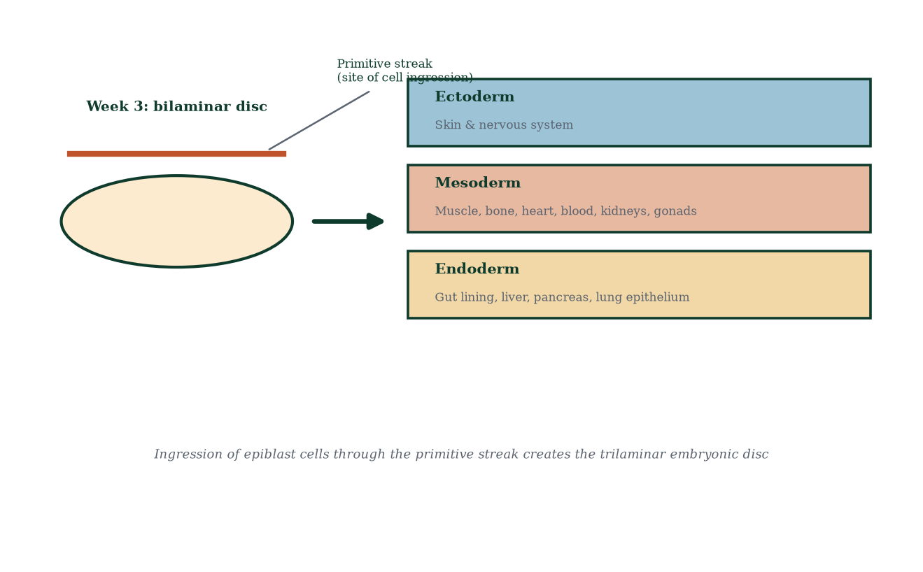
Figure 12.1 — Gastrulation: ingression through the primitive streak converts the bilaminar disc into the trilaminar embryonic disc (ectoderm, mesoderm, endoderm).
Crucially, cells ingressing from different positions along the streak become different mesodermal derivatives (axial notochord, paraxial, intermediate, lateral plate) — position = fate. The notochord (axial mesoderm rod) forms along the midline and is the primary organiser: it induces the overlying ectoderm to become neural plate (Chapter 12.2) and later regresses, leaving only the nucleus pulposus of intervertebral discs.

12.2 Neurulation — the making of the nervous system
The notochord secretes sonic hedgehog (SHH) and other morphogens; the overlying ectoderm thickens into the neural plate (day 18–19); its edges (neural folds) rise and fuse in the midline (day 21–28) forming the neural tube (Figure 12.2). Closure proceeds from the cervical region rostrally and caudally — two neuropores (anterior and posterior) close last (day 25, day 27–28). Failure: - Anencephaly (rostral neuropore fails) — incompatible with life. - Spina bifida (caudal neuropore fails) — ranges from occult to severe open myelomeningocele; prevented substantially by folic acid 400 µg [15] before conception to week 12 (raises folate-dependent methyl donor capacity for rapid neural tube cell division). The MRC Vitamin Study (1991) proved this — one of the greatest public-health triumphs of reproductive medicine.
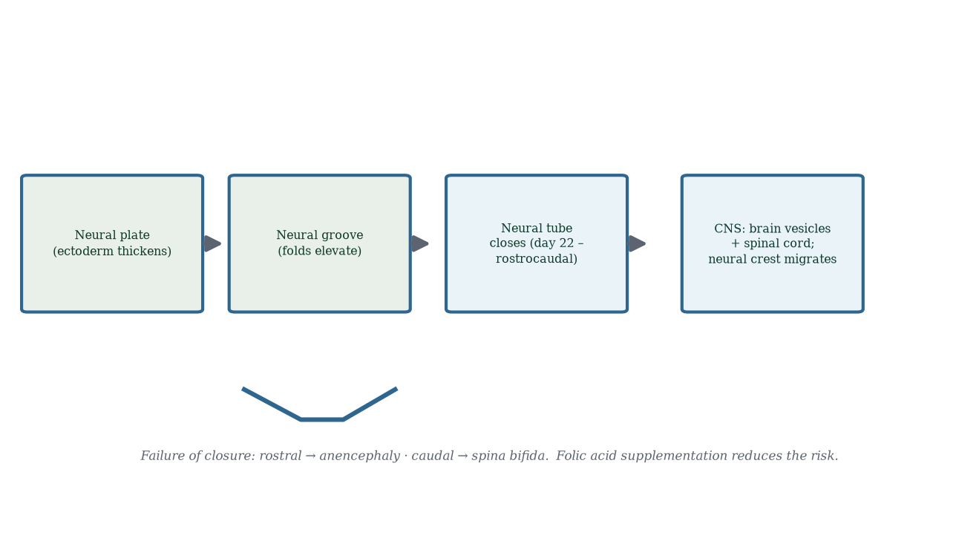
Figure 12.2 — Neurulation: neural plate → folding groove → closed neural tube; neural crest cells migrate away to form peripheral nervous system and more.
The cells at the fold edges — neural crest — delaminate and migrate extensively: they become sensory neurons (dorsal root ganglia), sympathetic/parasympathetic ganglia, adrenal medulla (chromaffin cells), melanocytes, facial cartilage and bone (via branchial arches), part of the heart outflow tract (truncus arteriosus septation), and Schwann cells. Neural crest is sometimes called the “fourth germ layer” because of its breadth — its mispatterning causes Hirschsprung disease, neuroblastoma, Waardenburg syndrome and DiGeorge syndrome.

12.3 Body folding — flat to 3D
Between days 21–28 the flat disc folds into a cylinder (Figure 12.3):
- Cranial fold — the developing forebrain folds under; the heart tube (initially cranial) swings ventrally and caudally into position; the oropharyngeal membrane shifts to the future mouth region.
- Caudal fold — the cloacal membrane and connecting stalk (future umbilical cord) move ventrally; the hindgut forms.
- Lateral folds — the lateral margins fold ventrally and meet at the midline, converting the flat endoderm into a gut tube closed by the body wall (somatopleure outside; splanchnopleure inside).
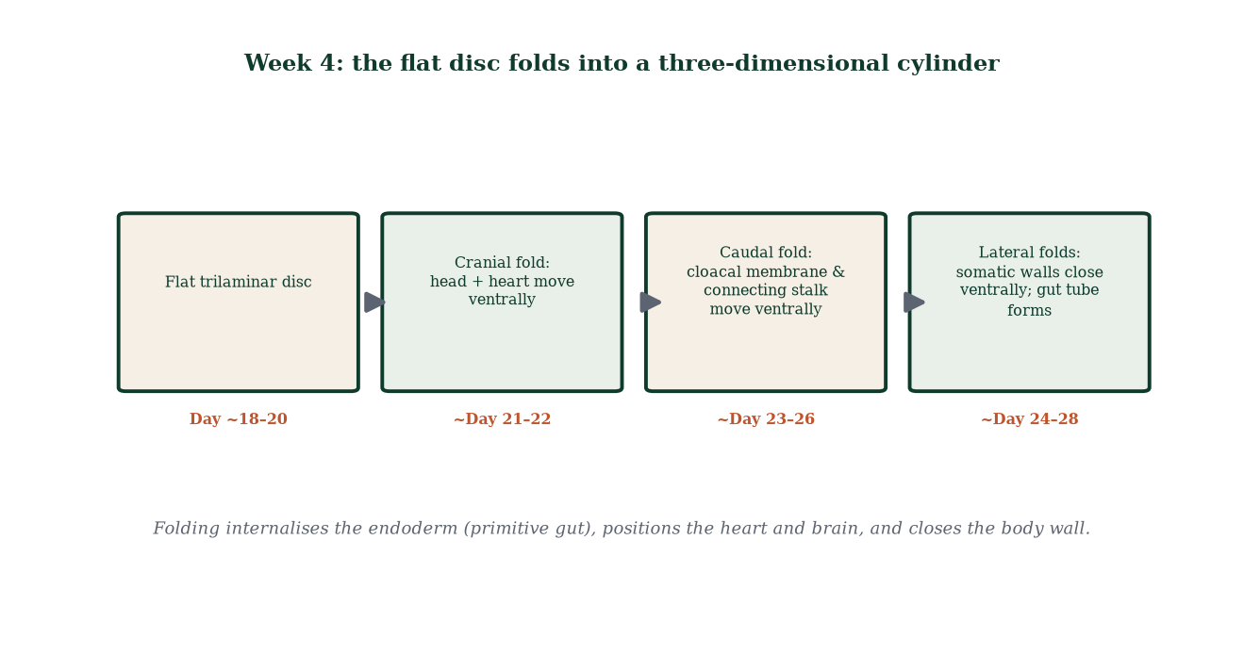
Figure 12.3 — Embryonic folding: cranial, caudal and lateral folds convert the disc into a body with a ventral gut, a ventral heart and a dorsal neural tube.
Consequences: the embryonic cavity becomes the intraembryonic coelom → pericardial, pleural, peritoneal cavities; the yolk sac shrinks and is incorporated into the gut; the amniotic cavity expands to envelop the embryo — the defining landmark of a “true” embryo.

12.4 Organogenesis — weeks 4 to 8
All major organ systems begin in this interval (Figure 12.4) — the same interval when the embryo is exquisitely vulnerable to teratogens (alcohol, drugs, infections, radiation, maternal metabolic disease).
- Day 22–25: heart begins to beat — the first functional organ; the embryonic heart is a simple tube that loops and septates over weeks.
- Week 4: limb buds appear (upper limb bud day 26, lower day 28); pharyngeal (branchial) arches form — arteries, nerves, muscles and skeletal elements of the face and neck derive from them.
- Week 5: optic vesicles and lens placodes form; nasal placodes; forebrain vesicles expand.
- Week 6: hand plates; digital rays appear; heart completes septation; auricles migrate; umbilical cord resolves.
- Week 7: digits separate (webbing disappears by programmed cell death/apoptosis); ossification begins; external ear forms.
- Week 8: eyelids fuse; tail regresses; external genitalia still sex-indifferent; embryo ~30 mm at day 56 — end of the embryonic period; the “tail” and webbed fingers are gone. From week 9: fetal period (Chapter 13).
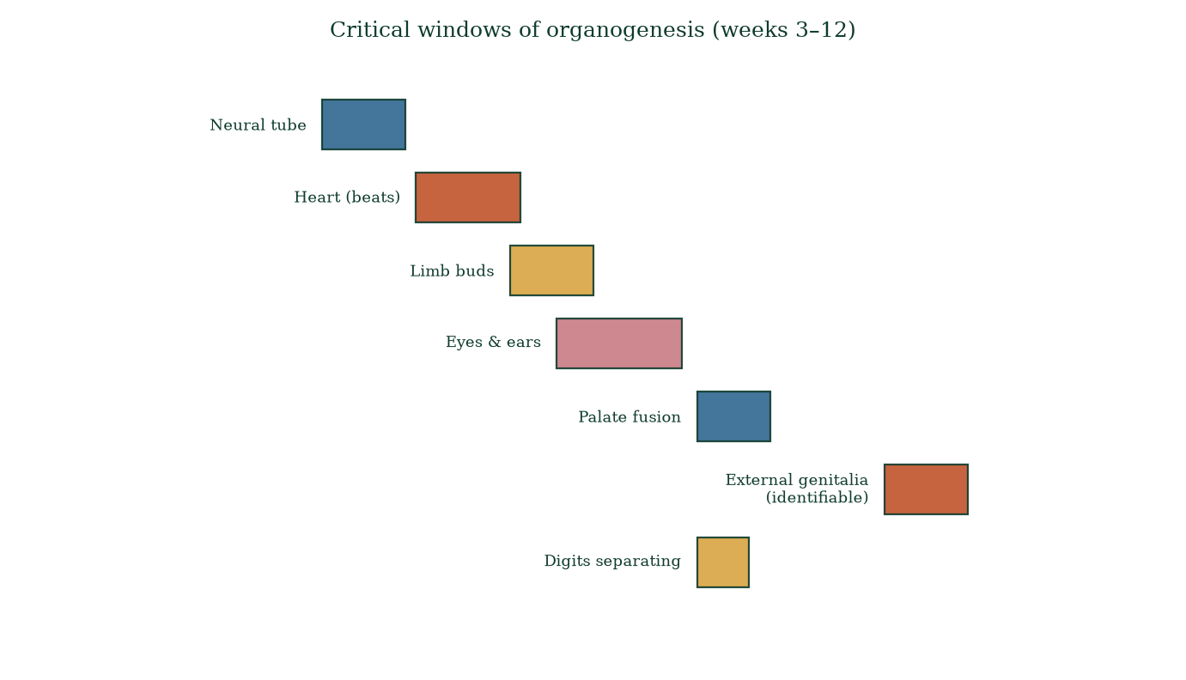
Figure 12.4 — Organogenesis Gantt chart: critical windows (blue = fetal window; red/gold = embryonic organogenesis when teratogen risk peaks).

12.5 Derivatives of the three germ layers (the map that explains everything)
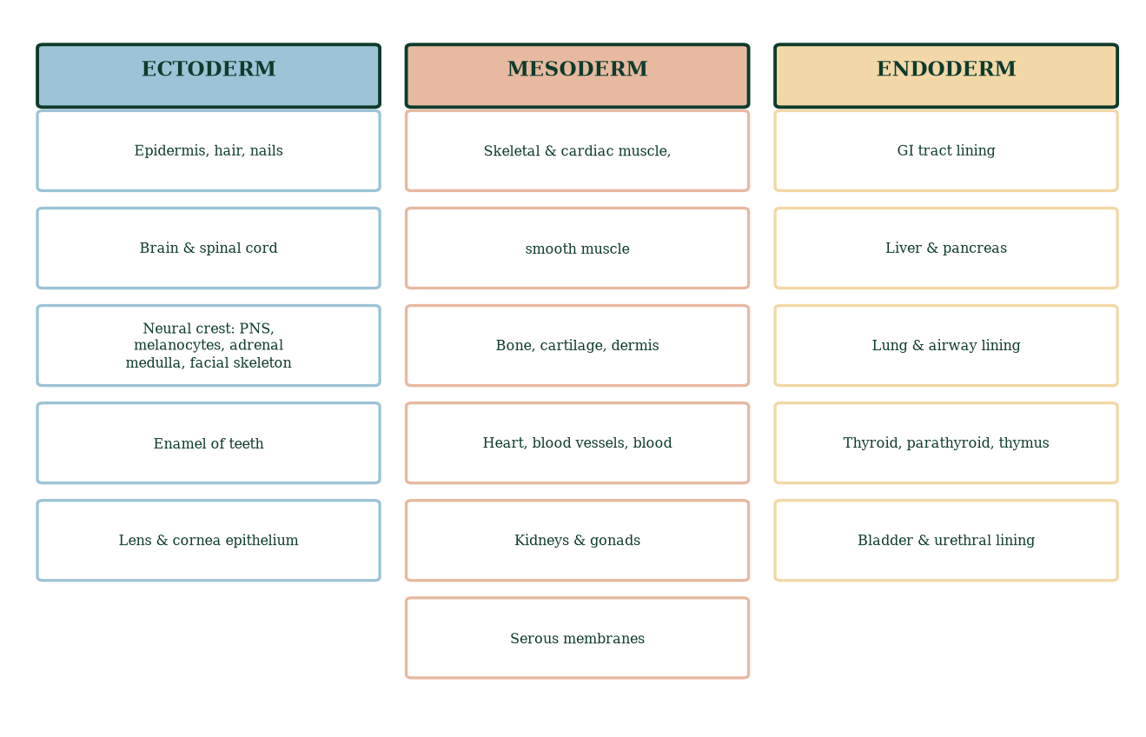
Figure 12.5 — Germ-layer derivatives: ectoderm → skin/CNS; mesoderm → muscle/bone/blood/heart/kidneys/gonads; endoderm → gut/liver/pancreas/lung linings.
Memory aid that is actually mechanistic: the outermost layer wraps and protects and senses (skin, nerves); the middle layer builds the machinery (muscles, bone, pump, filters); the innermost lines the tubes through which food and air pass. Endoderm also makes the lining of the middle ear, thymus, thyroid and parathyroids — hence endodermal-pouch disorders span DiGeorge (thymic/parathyroid) to pharyngeal arch syndromes (DiGeorge facial features).

12.6 Clinical spotlights
- Teratology principles: the earlier the insult, the more catastrophic it may be (all-or-none in weeks 1–2 — death or survival; structural malformations weeks 3–8; functional/growth problems weeks 9+).
- Neural tube defects: folic acid; inositol may help folate-resistant cases; AFP screening; foetal MRI when suspected.
- Congenital heart disease (most common group of malformations, ~1% of births): ventricular septal defect commonest; many detectable on 20-week scan.
- Congenital diaphragmatic hernia, gastroschisis, limb reduction defects, cleft lip/palate — all classically produced in weeks 4–8.
- Warfarin, ACE inhibitors, valproate, isotretinoin, thalidomide, rubella, CMV, Zika — classic teratogens in organogenesis; the placenta is permissive, not protective (Chapter 14).

12.7 Mechanism in depth: morphogens and positional information
Why does midline mesoderm form a notochord and not muscle? Why does ectoderm above the notochord become nervous tissue and ectoderm to the sides become skin? The answer is morphogen gradients. The notochord secretes SHH ventrally; the dorsal ectoderm and paraxial mesoderm secrete BMP4; the dorsal organiser regions (node, anterior visceral endoderm) secrete noggin and chordin, which sequester BMP4. Where SHH is high and BMP4 low (ventral midline) → neural/motor fates; where both moderate → intermediate neural identities; where BMP4 high and SHH absent → epidermis and neural crest border. Along the anteroposterior axis, retinoic acid, FGFs and WNT gradients pattern hindbrain segments (rhombomeres) and spinal cord; Hox genes (four clusters in mammals) assign positional identity to each segment exploited by somites, neural crest and endoderm alike. Mutations in these signalling pathways are now being found in human birth defects and in cancers where developmental signalling is reactivated — embryology literally underwrites oncology.

12.8 Clinical spotlight: prenatal screening and diagnosis
- First trimester screen (11–14 weeks): nuchal translucency ultrasound + maternal serum PAPP-A/β-hCG (+ maternal age) → risk estimate for trisomy 21/18/13.
- Non-invasive prenatal testing (NIPT): cell-free fetal DNA in maternal plasma (≥10 weeks) → highly sensitive/specific aneuploidy screening; not diagnostic (positive predictive value varies with prior risk; cannot diagnose balanced translocations or determine parent of origin).
- Diagnostic tests: chorionic villus sampling (week 10–13) and amniocentesis (week 15+) — sample fetal chromosomes (karyotype/microarray); small miscarriage risk (~0.5–1%).
- 20-week anomaly scan: structural survey — cardiac planes, brain, spine, limbs, face, kidneys, abdominal wall defects; site of multidisciplinary joint decision-making when anomalies are found.
- Preconception counselling: folic acid, rubella immunity, medication review, glycaemic control (HbA1c), avoidance of known teratogens — the single highest-leverage intervention point in all of developmental medicine.

12.9 Mechanisms and evidence in depth: morphogens — the body plan as concentration readout
The embryonic body axis is laid down by morphogens — signalling molecules forming gradients read by cells as positional information (Wolpert’s classic concept, confirmed at molecular level):
- SHH (Sonic hedgehog) — secreted by the notochord (and later floor plate); ventral neural tube/myoderived fates — concentration distinguishes: high → floor plate/motor neurones; intermediate → interneuron classes; low → other fates.
- BMP/Wnt — antagonised by noggin, chordin, follistatin from node/organiser — dorsalisation (neural identity) requires active antagonism of BMPs; default neural state is achieved by blocking a brake.
- Retinoic acid (RA) — vitamin A gradient patterning hindbrain/spinal cord; teratogenic in excess (isotretinoin embryopathy) — the classic demonstration that a morphogen overdose is a malformation syndrome.
- Hox genes — colinear clusters; 3′ genes expressed anteriorly/early, 5′ posteriorly/later — nested expression domains confer segment identity; gain/loss-of-function mutate body maps.
Neural tube defects occur at days 18–28 — neural plate → folds → tube (anterior neuropore closes day ~25, posterior day ~27). Failure of closure: anencephaly (anterior), spina bifida (posterior). Folic acid periconception (400 µg/d) reduces NTD recurrence ~70% (MRC trial) — mechanism: one-carbon metabolism supplies methyl groups for DNA synthesis/cell division during extreme proliferation.

Common errors in development reasoning
- “Organs form in the order we name them.” — heart and nervous system first, limbs, then lungs/skin.
- “Gastrulation is just invagination.” — it is the event defining germ layers and body axes.
- “Teratogens act only in week 3.” — susceptibility varies by organ; CNS vulnerable throughout.

12.10 Clinical reasoning vignettes
Case 1. A 24-year-old on isotretinoin (acne) reports a positive pregnancy test. Mechanism: retinoic acid is a morphogen — teratogenic in the first trimester (craniofacial, cardiac, thymic malformations). Discontinue immediately; folic acid; detailed anomaly scan; mechanism awareness prevents recurrence.
Case 2. A 30-year-old with a family history of neural tube defects and her own valproate use for epilepsy. Mechanism: neural tube closes day 18–28; folate and valproate affect one-carbon metabolism and histone deacetylase — NTD risk ~1–2% (valproate); folic acid 5 mg/day + alternatives; anomaly scan at 20 weeks.
Case 3. A woman at 6 weeks has chorionic villus sampling; fetus found to have 46,XY. Mechanism: CVS samples trophoblast — placental tissue may not match fetal karyotype in ~1–2% of cases (confined placental mosaicism); amniocentesis clarifies if discordant.

Self-check — can you derive these without notes?
- Reconstruct the primitive streak cascade — what happens if it fails to form?
- Explain how SHH patterns neural tube fate by concentration gradient.
- Derive why anterior neuropore closure failure yields anencephaly specifically.
- Compare CVS vs amniocentesis in terms of timing, tissue and complication rates.
- Explain Hox colinearity — how is spatial gene expression mapped to segment identity?

Chapter summary
- Gastrulation (week 3) builds the three germ layers via primitive streak ingression; the notochord drives neurulation.
- Neurulation (day 18–28) forms the neural tube; SHH from notochord organises it; neural crest migrates widely.
- Body folding (week 4) converts disc to cylinder: gut tube internalised, heart positioned, coelom formed.
- Organogenesis = weeks 4–8; heart beats by day 22; all major systems are recognisable by week 8; the embryonic period ends at day 56.
- Ectoderm = skin/CNS; mesoderm = muscle/bone/heart/blood/kidneys/gonads; endoderm = gut/gland linings.
- Teratogen sensitivity peaks weeks 3–8; folic acid prevents neural tube defects.

Key terms
Primitive streak — site of cell ingression in epiblast. Gastrulation — formation of the three germ layers. Notochord — axial mesoderm organiser. Neural plate/tube — ectodermal precursor of CNS. Neural crest — migratory multipotent cells. Somite — paraxial mesoderm blocks (muscle/vertebrae/dermis). Coelom — embryonic body cavity. Organogenesis — weeks 4–8 organ formation. Teratogen — agent causing malformation. Somatopleure — outer body wall; splanchnopleure — gut wall; neural crest derivatives — melanocytes, ganglia, adrenal medulla, facial skeleton.

Review questions
Multiple choice
- Gastrulation converts the disc from:
  - trilaminar to bilaminar b) bilaminar to trilaminar c) hollow to solid d) two layers to four
- The primitive streak appears in which week?
  - week 1 b) week 2 c) week 3 d) week 5
- Neural tube closure completes by:
  - day 18 b) day 28 c) week 6 d) week 10
- The heart first beats around:
  - day 10 b) day 15 c) day 22 d) week 8
- Folic acid prevents:
  - heart defects b) neural tube defects c) cleft palate d) limb reduction
- Neural crest cells do NOT give rise to:
  - melanocytes b) adrenal medulla c) vertebrae d) dorsal root ganglia
- The embryonic period ends at:
  - day 28 b) day 56 c) week 12 d) week 20
- Which organ system is identifiable FIRST?
  - kidneys b) lungs c) heart d) digits
Short answer
- Explain the fate-map logic of gastrulation (position of ingression → derivative).
- Name three derivatives each of ectoderm, mesoderm and endoderm.
- Describe the mechanism by which folic acid reduces neural tube defects.
- Define teratogen and name the rule of timing.
Explanation
- Explain why the earlier an insult occurs, the more severe the malformation — the “all-or-none” period vs organogenesis.
- Walk through neurulation step by step, naming days and structures.
- Explain the notochcord’s role as organiser — from SHH to neural tube floor plate.
Application
- A woman takes warfarin in week 6 for a mechanical valve. Explain, mechanistically, the risk to the embryo.
- An infant born with a myelomeningocele. Trace the failure back to the week and mechanism, and explain the prevention strategy.
- Why does the 20-week scan focus on cardiac four-chamber and outflow tracts? Connect it to septation timing.

Answers to review questions
- b. Epiblast ingression through primitive streak generates three definitive layers.
- c. Week 3 (day 14–15).
- b. Anterior neuropore day 25; posterior neuropore day 27–28.
- c. Day 22–25; heart tube begins its first weak peristaltic beats.
- b. ~70% reduction in neural tube defects with periconceptional folic acid.
- c. Vertebrae are paraxial mesoderm (somites). Neural crest forms peripheral ganglia, melanocytes, chromaffin cells, facial skeleton.
- b. Day 56 (end of week 8); from week 9 the fetus.
- c. Heart (day 22) precedes limbs (day 26/28), kidneys (~week 5), lungs (~week 5).
- Cell position at ingression along the streak maps to mesodermal fate: anterior → head process/notochord; medial → paraxial → intermediate → lateral plate; posterior → extraembryonic and tail structures — positional cues read as fates via morphogen gradients.
- Ectoderm: CNS, skin, lens. Mesoderm: heart/blood, muscle/bone, kidneys/gonads. Endoderm: gut lining, liver/pancreas, lung lining (also thyroid/thymus).
- Folic acid is a methyl-donor cofactor for nucleotide synthesis and methylation; rapid neural tube cell proliferation is folate-hungry; insufficiency cripples closure — supplementation before conceptus formation prevents the closure failure.
- Teratogen = agent producing abnormal development; vulnerability window: pre-implantation = all-or-none (death or normal); organogenesis weeks 3–8 = structural defects; fetal period = growth/functional effects.
- Weeks 1–2: no committed lineages — damage either kills the conceptus (no pregnancy recognised) or leaves it normal (all-or-none); weeks 3–8: organ formation — damage disrupts patterning (heart septation, neural tube) → major structural malformations; weeks 9+: organs exist — damage reduces size/function, not pattern.
- Day 18: notochord induces neural plate (SHH); day 19–20: folds rise, groove deepens; day 21–22: folds meet at cervical level, tube forms; closure rostral (day 24–25, anterior neuropore) and caudal (day 26–28, posterior neuropore); neural crest delaminates and migrates; mesoderm flanks → somites.
- Notochord secretes SHH ventrally → ventral neural tube floor plate induced (motoneuron identity); also noggin/chordin inhibition of BMP above → dorsal neural identity; gradients specify dorsoventral neuronal fates — molecular positional information read out by transcription factors (Class I/II) → distinct neural cell types.
- Warfarin crosses the placenta; in week 6 fetal protein C activation and vitamin-K-dependent carboxylation are active; warfarin inhibits gamma-carboxylation → impaired bone/cartilage calcification and epiphyseal tendons (nasal hypoplasia, stippled epiphyses — chondrodysplasia punctata); switch to LMWH/pre-conception planning — the 6th week is squarely organogenesis; the anomaly is mechanistically DHT/vitamin K-epoxide reductase-linked.
- Failure of posterior neuropore closure (day 27–28) → open neural tube → myelomeningocele; mechanism is ineffective SHH-independent closure driven by folate-dependent proliferation; prevention = periconceptional folic acid 400 µg daily (5 mg if risk factors) for at least 1 month pre-conception to week 12.
- Cardiac septation completes week 7–8; outflow tract rotation and membraneous septum form in weeks 5–8; abnormalities (VSD, ASD, tetralogy, AV septal defect) are energetically and mechanically visible by week 18–22 as four-chamber view plus outflow tracts — hence the 20-week anomaly scan targets these exact planes.

Chapter 13: Fetal Development
Learning objectives. After studying this chapter you should be able to: - distinguish embryonic from fetal development; - describe fetal growth, organ maturation, neurological development; - explain fetal circulation and its changes at birth; - list the major developmental milestones by week; - explain the concept of fetal viability and limit of viability.
Central question. How does a 30-mm embryo become a 3.3-kg, air-breathing, milk-starving newborn — and what does the fetus actually do all day?

13.1 What the fetal period is for
From week 9 to birth, the fetal period (Figure 13.1) is about growth and maturation, not patterning. All organ primordia already exist; they enlarge, differentiate and become physiologically competent. Crown–rump length goes from ~3 cm (week 9) to ~36 cm (week 38) and birth weight from a few grams to ~3.3 kg — a 1,000-fold increase. The fetus is not passive dough: it practices breathing movements, swallows amniotic fluid, sucks its thumb, cycles between sleep states, responds to sound — all in preparation for independent life.
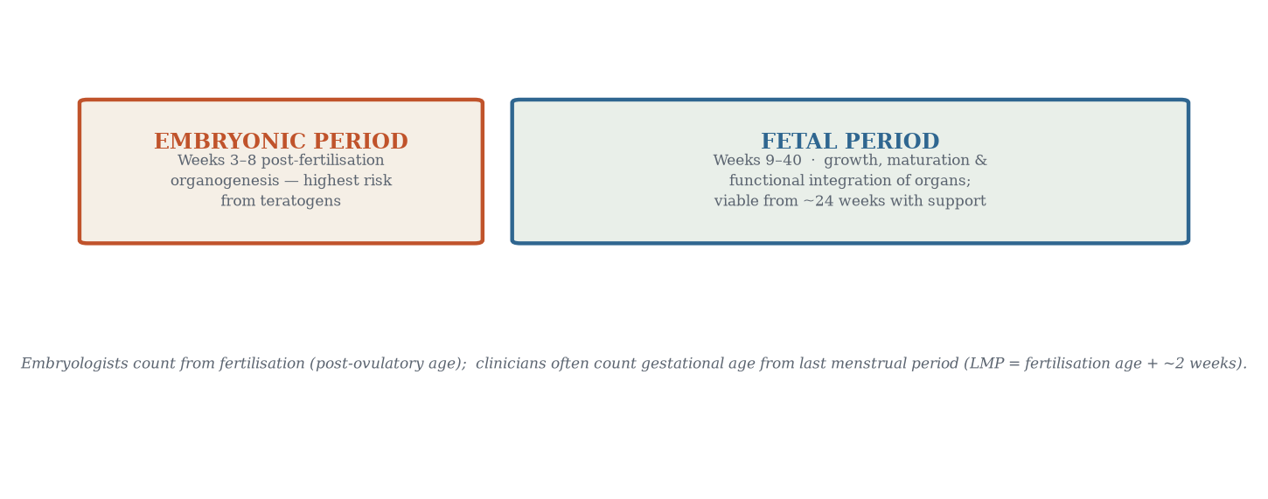
Figure 13.1 — The two great chapters of human development: embryonic patterning (weeks 3–8) and fetal growth and maturation (weeks 9–40).
An embryologist counts age from fertilisation; clinicians quote gestational age from LMP (fertilisation age + ~2 weeks). A “40-week” pregnancy is ~38 weeks from conception. Confusing the two is the single commonest source of date errors in obstetrics.

13.2 Growth curves and allometry
Fetal growth is sigmoidal (slow early, maximal mid-late third trimester): ~1 g/day in early pregnancy, ~35 g/day at ~30–34 weeks (Figure 13.2). Allometry — differential organ growth rates — means the head is disproportionately large early (cephalocaudal gradient; neural tissue first) and approaches adult proportions by term. The brain quadruples in size across the third trimester; the lungs’ alveoli multiply massively; subcutaneous fat is laid down in the final 8–10 weeks (the difference between a 28-weeker with paper-thin skin and a 38-weeker).
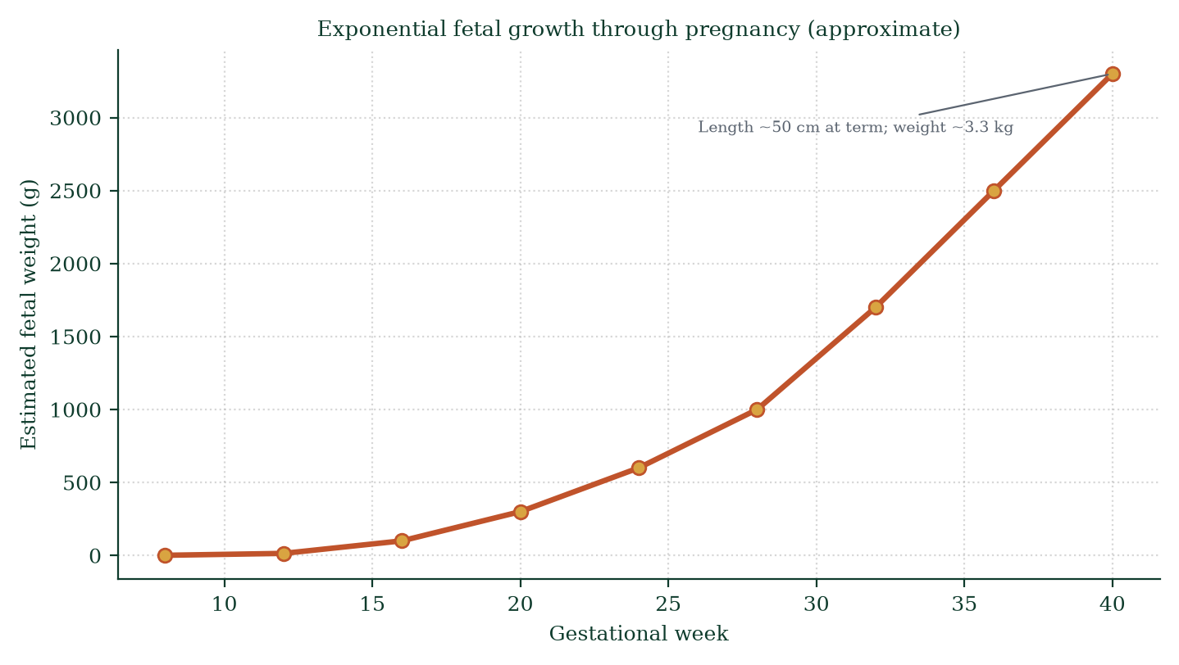
Figure 13.2 — Fetal weight across gestation (approximate). Exponential third-trimester growth; ~3.3 kg at term.

13.3 Neurological development — from reflex arc to behaviour
The neural tube is in place by week 4, but the brain spends the entire fetal period organising:
- Weeks 8–16: neuronal proliferation peaks (up to 250,000 neurons/min); migration along radial glia to cortical layers; gyri and sulci begin to appear (week 24–26); myelination of the spinal cord begins ~week 20–24; fetal movements detectable by the mother (quickening) ~16–20 weeks.
- Weeks 20–28: sleep–wake cycles (quiet vs active sleep) emerge; sensory systems come online — hearing by ~22–26 weeks (auditory cortex responds to maternal voice and music — habituation experiments show learning in utero); olfaction; taste (amniotic fluid flavours: garlic, carrot — neonates prefer flavours experienced prenatally).
- Weeks 28–40: EEG maturation; cortical folding; cerebellar growth spurt; myelination continues (continues into adulthood); brain-sparing in fetal hypoxia — redistribution of cardiac output prioritises brain, heart, adrenals over gut/periphery — detectable by Doppler ultrasound as reduced middle-cerebral artery pulsatility index (the “brain-sparing effect” — a central Doppler sign of placental insufficiency).

13.4 Fetal circulation — the plumbing before and after birth
The fetus has no functioning lungs; gas exchange is placental. Fetal circulation (Figure 13.3) solves the obvious problem: oxygenated blood from the placenta must reach the body without detouring through collapsed, high-resistance lungs. Three shunts do the job:
- Ductus venosus — shunts blood from umbilical vein past the liver into the inferior vena cava (liver still receives some oxygenated blood via portal circulation).
- Foramen ovale — right-to-left atrial shunt; oxygenated blood passes directly into left atrium → left ventricle → aorta → coronary arteries and brain (best oxygen to the most oxygen-hungry organs).
- Ductus arteriosus — pulmonary artery → descending aorta; bypasses the high-resistance lungs; ~90% of right ventricular output goes via the ductus to the aorta.
At birth, the first breath drops pulmonary vascular resistance dramatically (lung fluid clears; oxygen dilates pulmonary arterioles); left atrial pressure exceeds right → foramen ovale closes (valve flap seals; functionally closed in hours, anatomically in months). Placental flow ceases (cord clamped) → ductus venosus closes (functional within minutes, structural in days) → falling prostaglandins remove ductal smooth muscle relaxation → ductus arteriosus closes (functionally within 10–15 h; anatomically ligamentum arteriosum within weeks). Failure: persistent ductus arteriosus (especially in preterm [24] infants — treated with NSAIDs; term failure may need closure). A patent foramen ovale persists in ~25–30% of adults — usually asymptomatic, relevant in paradoxical embolism and cryptogenic stroke.
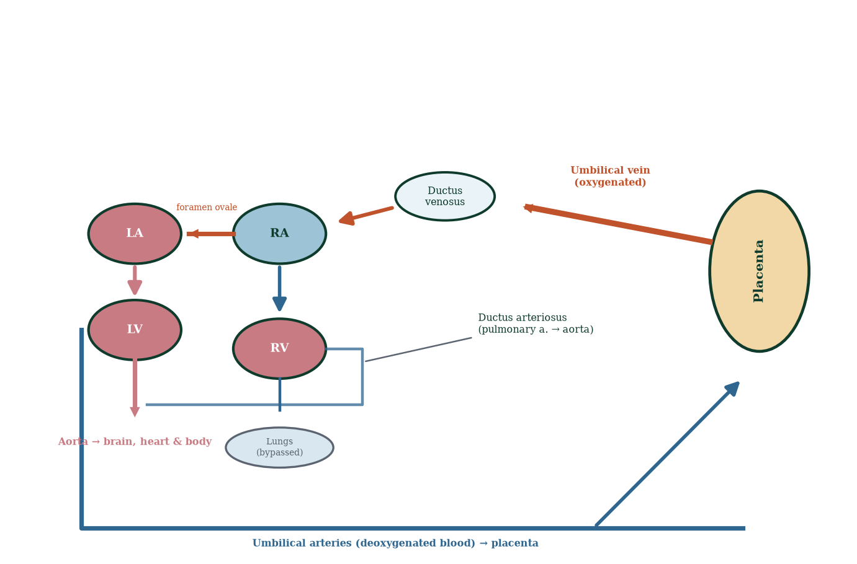
Figure 13.3 — Fetal circulation: placental oxygenation → ductus venosus → right atrium → foramen ovale (brain/coronaries) or right ventricle → ductus arteriosus → body; umbilical arteries return deoxygenated blood to placenta.

13.5 Organ maturation system by system (fetal weeks 9–40)
- Respiratory: branching continues; surfactant [8] (type II pneumocytes) begins ~week 24; lecithin:sphingomyelin ratio >2 by ~week 34 signals lung maturity; first breaths at delivery clear lung fluid (vaginal squeeze + adrenergic surge). Respiratory distress syndrome of prematurity = surfactant deficiency.
- Gastrointestinal: meconium accumulates (week 12+); swallowing practice from ~week 12; liver and pancreas mature; gut rotation completes ~week 10–11; physiological umbilical hernia (midgut herniated into cord from week 6, returns by week 12) — failure → omphalocele.
- Renal: kidneys make urine from week 10 (fetal contribution to amniotic fluid); nephrogenesis completes ~week 36; newborn GFR is low — preterm infants handle fluids/drugs differently.
- Endocrine: thyroid axis matures mid-pregnancy; adrenal fetal zone produces DHEA-sulfate (steroid precursors for placental oestriol); pancreas insulin by week 10 — fetal islet cells respond to glucose; chronic maternal hyperglycaemia → fetal hyperinsulinaemia → macrosomia (“large for gestational age” — the mechanistic basis of gestational diabetes complications, Chapter 15).
- Genital: external genitalia sex-recognisable by ~week 12 (ultrasound); testes descend into scrotum in third trimester (cryptorchidism if not).
- Skin: lanugo (fine hair) week 20; vernix caseosa (cheesy protective coating) week 20–38; eyelids fuse to week 26; fat deposition final 8 weeks.

13.6 Viability, limit of viability and prematurity
Viability — the capacity to survive outside the uterus — improves with gestational age and neonatal care. Periviable birth = 22–25 weeks. At 24 weeks, ~50–60% survival; at 28 weeks, >90%; at 32 weeks, >97%. Outcomes are driven by lung maturity (surfactant), brain maturity (intracranial haemorrhage risk), skin (water loss), and temperature regulation. Preterm birth (<37 weeks) is the single largest cause of neonatal mortality worldwide (~15 million preterm births/year; ~1 million neonatal deaths). Causes: inflammation/infection, cervical insufficiency, multiple pregnancy, placental abruption, maternal vascular disease, idiopathic. Prevention strategies: cervical cerclage (insufficiency), progesterone (prior preterm birth), aspirin (pre-eclampsia prevention), smoking cessation — modest, mechanism-targeted gains.

13.7 Major milestones — a timeline
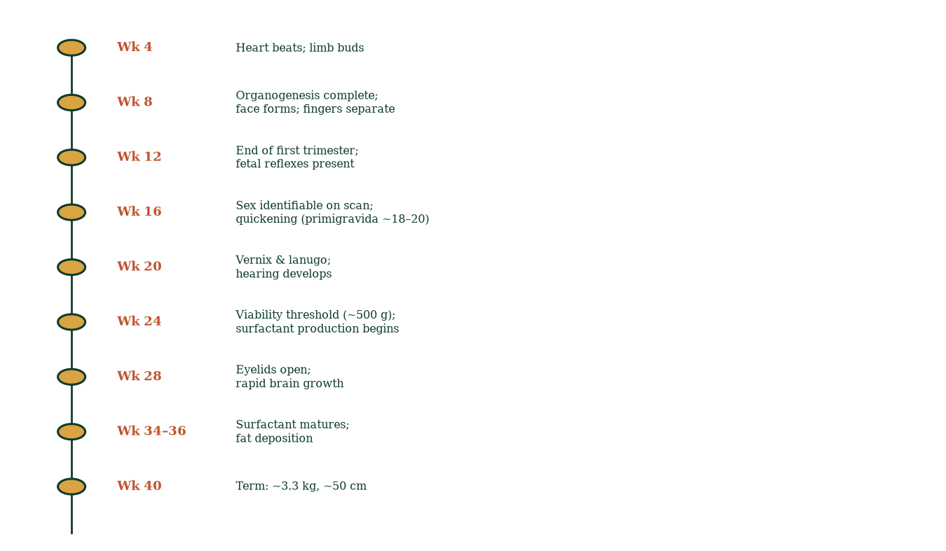
Figure 13.4 — Developmental milestones by gestational week; the 24-week line marks approximate viability.

13.8 Clinical spotlights
- Growth restriction (FGR/IUGR): discordant fundal growth, Doppler abnormalities (umbilical, middle cerebral artery) — management: surveillance, early delivery when compromised.
- Macrosomia (>4–4.5 kg): gestational diabetes; shoulder dystocia risk.
- Oligohydramnios (low fluid): renal agenesis, placental insufficiency; polyhydramnios: diabetes, gut atresia.
- Fetal bradycardia/tachycardia — CTG interpretation is reflex + cord compression + hypoxia.
- Teratogen timing (Chapter 12): after embryonic period, structural defects rare; functional/growth effects dominate (alcohol → FAS across all windows; ACE inhibitors → renal failure in third trimester; NSAIDs → ductus closure in uterus).

13.9 Mechanism in depth: the fetal adrenal–placental unit and the fetal HPG axis
Two elegant mechanistic systems deserve attention because they illustrate that the fetus is an active endocrine organ, not a parasite:
The fetal adrenal zone. The fetal adrenal cortex has a specialised zone (the fetal zone) that makes large quantities of DHEA-sulfate — an androgen precursor the placenta cannot make because it lacks 17α-hydroxylase (CYP17). DHEA-sulfate crosses to the placenta, is desulfated and aromatised to oestriol — the dominant oestrogen of pregnancy and an index of fetal wellbeing (low oestriol → fetal adrenal/liver pathology, anencephaly, placental sulfatase deficiency). This is a genuine fetal–placental endocrine organ: the fetus supplies the substrate, the placenta supplies the missing enzymes — neither could produce oestriol alone.
Fetal gonadal activity. The fetal testes secrete testosterone and INSL3 from ~week 9–12 (mini-testosterone surge) — required for Wolffian differentiation and descent; fetal ovaries are quiescent until puberty. After birth, removal of placental oestrogen suppression unleashes a brief mini-puberty (first 3–6 months) with LH/FSH rises in both sexes — the axis then falls silent until puberty. Disorders here: cryptorchidism (undescended testes), micropenis — clinically treatable in mini-puberty by hormonal stimulation.

13.10 Evidence checkpoint: what prematurity actually costs
- Every gestational week gained in the periviable range markedly improves survival and reduces morbidity (bronchopulmonary dysplasia, intraventricular haemorrhage, necrotising enterocolitis, retinopathy of prematurity, cerebral palsy).
- Antenatal corticosteroids (betamethasone) accelerate lung/organ maturation and reduce RDS and IVH — one of the highest-impact interventions in obstetrics.
- Magnesium sulfate for the mother reduces cerebral palsy risk in anticipated preterm birth — neuroprotection via mechanism (NMDA antagonism), not mystery.
- “Kangaroo care” (skin-to-skin) improves thermoregulation, breastfeeding and survival in low-birth-weight infants — physiology made nurturing.

13.11 Mechanisms and evidence in depth: fetal programming — the developmental origins hypothesis
The Barker hypothesis (DOHaD — developmental origins of health and disease): the fetal environment — nutrition, stress, hypoxia — calibrates organ development permanently (thrifty phenotype). Low birth weight predicts higher adult risk of hypertension, T2DM, dyslipidaemia. Mechanisms: epigenetic programming (DNA methylation changes at metabolic genes), permanent nephron/adipocyte number, vascular remodelling, HPA axis set-point. Evidence: ecological (Barker’s UK cohorts), Dutch Hunger Winter (1944–45 famine offspring), animal models (maternal protein restriction → offspring metabolic disease). Criticism: residual confounding (socioeconomic), causation incomplete in humans — the strongest human evidence comes from famine cohorts (random exposure) — but the principle is broadly accepted: what the mother eats and how she lives during gestation echo into her child’s adult health.
Fetal growth curves are mechanistic outputs. Growth velocity peaks ~30–32 weeks (~200 g/week); growth decelerates approaching term as placenta plateaus. Serial fundal height, symphysis–fundal height discordance >3 cm or flattening growth on ultrasound → fetal growth restriction (FGR, formerly IUGR) — triggers Doppler surveillance (umbilical artery absent/reversed end-diastolic flow = severe placental insufficiency) and timing-of-delivery deliberation.
Semi-viable and periviable birth (22 +0 to 25 +6 weeks) — modern neonatology survives some of these babies (intact survival rises steeply week by week); lung maturation (surfactant ~week 36+ but steroids accelerate), eye development (retinopathy of prematurity), brain maturation — the organs lag in sequence; resuscitation decisions take place at the edge of biology.

Common errors in fetal development reasoning
- “Full term means fully formed.” — term marks gestational age; organ maturation continues after birth.
- “Fetal heart rate variation doesn’t matter.” — every deceleration pattern has a mechanism.
- “Blood transfusions fix fetal anaemia safely in all cases.” — intrauterine transfusion exists for severe cases only.

13.12 Clinical reasoning vignettes
Case 1. A 32-week preterm labour with intact membranes. Mechanism: surfactant production incomplete (needs ≥34 weeks for reasonable maturity), brain vulnerable to IVH, thermoregulation immature. Antenatal corticosteroids (betamethasone ×2) accelerate lung maturation and reduce IVH/NEC; MgSO4 if <32 weeks for neuroprotection; transfer to tertiary perinatal centre.
Case 2. A fetus at 28 weeks shows absent end-diastolic flow in umbilical artery Doppler. Mechanism: placental insufficiency — high placental resistance starves fetus of oxygen/nutrients; close surveillance; delivery timing when reversed flow appears.
Case 3. A 22-week anomaly scan shows a diaphragmatic hernia. Mechanism: pleuroperitoneal canal failure (week 9–10) → abdominal contents herniate into thorax → lung hypoplasia — severity proportional to timing and liver position; immediate postnatal respiratory support; mechanism explains why early closure saves lives.

Self-check — can you derive these without notes?
- Draw the three-shunt fetal circulation and name structures enabling lung bypass.
- Explain why ductus venosus closes functionally within minutes of birth and anatomically within weeks.
- Trace surfactant production and the reason for type II pneumocyte maturation with steroids.
- Explain HbF’s higher oxygen affinity and its functional significance in utero.
- Predict the consequences of premature closure of the ductus arteriosus in utero.

Chapter summary
- The fetal period (week 9–birth) is growth and maturation, not patterning; size increases ~1,000×.
- Brain and lungs mature late; third-trimester fat deposition differentiates the term infant.
- Fetal circulation uses three shunts (ductus venosus, foramen ovale, ductus arteriosus) bypassing the lungs and liver; all close at birth.
- Surfactant (week 24–34) and viability (week 22–25) define the limits of prematurity.
- Quickening ~16–20 weeks; fetal learning measurable; brain-sparing is detectable by Doppler.
- LMP vs fertilisation dating matters clinically.

Key terms
Fetus — week 9 to birth. Allometry — differential growth rates. Quickening — first perceived movement. Ductus venosus — umbilical vein → IVC shunt. Foramen ovale — atrial septal shunt. Ductus arteriosus — pulmonary artery → aorta shunt. Surfactant — lung surface tension reducer. Viability — outside-womb survival capacity. IUGR/FGR — growth restriction. Brain-sparing — Doppler redistribution to cerebral flow. Periviable — 22–25 weeks.

Review questions
Multiple choice
- Gestational age is measured from:
  - fertilisation b) LMP c) implantation d) quickening
- Fetal weight reaches ~1 g at approximately:
  - week 8 b) week 10 c) week 12 d) week 16
- The ductus arteriosus connects the:
  - umbilical vein to IVC b) right atrium to left atrium c) pulmonary artery to aorta d) aorta to lungs
- At birth, the foramen ovale closes because:
  - prostaglandins rise b) left atrial pressure exceeds right c) the cord is clamped d) surfactant rises
- Surfactant production becomes functionally adequate around:
  - week 16–18 b) week 20–22 c) week 24–34 d) week 38
- Quickening is typically felt at:
  - 8–10 weeks b) 12–14 weeks c) 16–20 weeks d) 28 weeks
- The leading single cause of neonatal mortality worldwide is:
  - congenital heart disease b) prematurity c) infection d) birth asphyxia
- The “brain-sparing effect” refers to:
  - fetal head preservation by mother b) redistribution of blood flow to brain in hypoxia c) reduced brain growth d) skull protection
Short answer
- Name the three fetal circulatory shunts and their fates after birth.
- Explain the cephalocaudal gradient with an example.
- Distinguish embryonic from fetal periods in terms of teratogenic vulnerability.
- Describe three fetal behaviours demonstrating neurological maturation.
Explanation
- Walk through the transition from fetal to neonatal circulation immediately after the first breaths, in order.
- Explain why a 28-week infant is viable but a 23-week infant has guarded prognosis — name the three limiting systems.
- Explain the mechanism by which maternal hyperglycaemia produces a large baby.
Application
- A Doppler shows absent end-diastolic flow in the umbilical artery and reduced middle cerebral pulsatility index. Interpret mechanistically and outline management.
- A woman in labour at 27 weeks delivers. Explain, with mechanisms, what will happen to the ductus arteriosus and foramen ovale in the neonate.
- Which fetal milestones are useful clinically for dating and counselling at (a) 12 weeks, (b) 20 weeks, (c) 34 weeks?

Answers to review questions
- b. LMP; fertilisation age ≈ LMP − 2 weeks.
- b. ~week 10–12; most growth is third trimester.
- c. Bypasses high-resistance lungs; closes within hours of birth.
- b. Lung expansion drops PVR; pulmonary venous return rises LA pressure; flap valve seals.
- c. L:S ratio >2 by ~34 weeks; RDS risk high below.
- c. ~16–20 weeks (earlier in multiparas).
- b. ~15 million preterm births annually; ~1 million neonatal deaths.
- b. Hypoxia redistributes CO — brain/heart/adrenals prioritised; Doppler detectable.
- Ductus venosus → ligamentum venosum (days); foramen ovale → fossa ovalis (hours–months); ductus arteriosus → ligamentum arteriosum (hours–weeks; functional 10–15 h).
- Development proceeds head-to-tail: brain and heart early; hands before feet; upper limbs ahead of lower; brain grows fastest early — hence a 20-week head is ~50% of body length proportionally.
- Embryonic: structural patterning → major malformations if insulted. Fetal: growth/functional units → growth restriction, functional deficits (e.g., brain microcephaly), not new anatomy.
- Sucking (week 12–15), swallowing, breathing movements (week 20–24), sleep–wake cycling (weeks 26–30), habituation to repeated sound (weeks 28+) — evidence of learning.
- First breath: oxygen → lung fluid resorption + pulmonary vasodilation; PVR falls precipitously; pulmonary flow ↑; LA pressure ↑ → foramen ovale flap closes; cord clamped → SVR ↑; ductus venosus flow stops → closes; prostaglandins fall → ductus arteriosus constricts within hours; pulmonary and systemic circulations now function in series.
- Lungs (surfactant deficit → RDS/ventilation), brain (germinal matrix fragility → intraventricular haemorrhage), skin/thermoregulation (water/heat loss, immature barrier); 23 weeks adds immaturity of every neural and endocrine control system; 28-week prognosis >90% survival with modern care.
- Maternal glucose crosses placenta freely; fetal insulin secretion (from week 10) is stimulated chronically → fetal hyperinsulinaemia → anabolic hormone (growth factor-like action at IGF-1 receptor) + increased substrate delivery → macrosomia (>4.5 kg) with risks of shoulder dystocia, hypoglycaemia at birth, and later metabolic programming.
- Absent/reversed end-diastolic flow = high placental resistance (spiral arteriole remodelling failure); reduced MCA pulsatility = cerebral redistribution (brain-sparing) — the fetus is compensating for chronic hypoxia. Manage with intensive surveillance (CTG, growth scans, Dopplers), steroids for lung maturity if preterm delivery likely, early delivery if decompensation.
- The first breaths drop PVR; placental clamp → SVR ↑; LA pressure > RA → foramen ovale closes; prostaglandins fall → ductus arteriosus constricts and closes — in preterm infants closure is slower and often incomplete (patent ductus) — may require NSAIDs (indomethacin/ibuprofen) or surgical ligation if symptomatic heart failure ensues.

  - 12 weeks — crown–rump length dating; nuchal translucency + first trimester screen; (b) 20 weeks — sex, cardiac planes, placental localisation, liquor volume; quickening soon after; (c) 34 weeks — estimated fetal weight, liquor, placental grade, presentation, labour planning.

Chapter 14: The Placenta and Maternal-Fetal Physiology
Learning objectives. After studying this chapter you should be able to: - describe placental development and structure; - explain gas exchange, nutrient transfer and waste removal across the placenta; - describe placental hormones and the luteal–placental shift; - explain the immunological paradox of pregnancy and the placenta’s solution; - relate placental pathology to clinical conditions.
Central question. How can a foreign organ, built from fetal cells, live inside the mother for nine months — taking nutrients, secreting hormones, modulating immunity — without being rejected?

14.1 Development of the placenta
The placenta derives from the trophoblast — the same outer cells that invaded the endometrium at implantation (Chapter 11). Key steps:
- Week 2–3 — trophoblast differentiates into cytotrophoblast (proliferative) and syncytiotrophoblast (invasive); lacunae form and maternal blood enters them (day 9–11).
- Week 3–4 — chorionic villi sprout (primary villi, then secondary with mesoderm core, then tertiary with capillaries) — the basic tree architecture established early.
- Week 5–10 — villi branch profusely; anchoring villi attach the placenta to decidua basalis; floating villi bathe in maternal blood (haemochorial [8] arrangement).
- Week 10–12 — uteroplacental circulation established; trophoblast plugging of spiral arterioles relaxes; the luteal–placental shift occurs — the placenta takes over steroid production.
- By week 40 — discoid (flat, round) organ ~500 g, ~22 cm diameter, ~2.5 cm thick; maternal surface (cotyledons, lobulated, red) and fetal surface (chorionic plate, white, with radiating umbilical vessels underneath; cord inserted centrally usually).
Two fetal surfaces/membranes: amnion (inner, against liquor; smooth) and chorion (outer, against decidua) — fused together by week 12+.
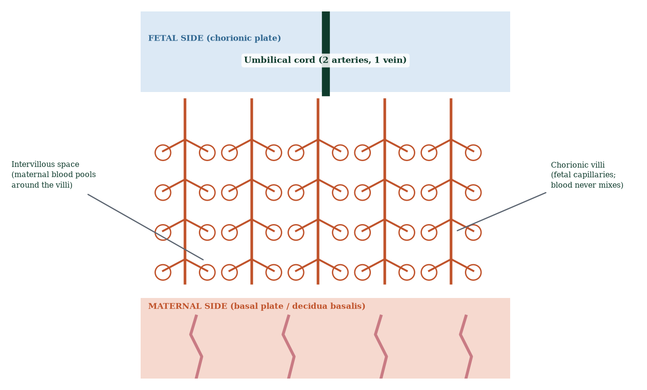
Figure 14.1 — Placental cross-section: fetal side (chorionic plate + cord), intervillous space, chorionic villi bathed in maternal blood, basal plate on the maternal side.

14.2 The chorionic villus — where the exchange actually happens
Each villus (Figure 14.2) is a tree of fetal capillaries wrapped in trophoblast. The exchange surface is the fetal capillary endothelium + basement membrane + syncytiotrophoblast cytoplasm (all that separates maternal blood in the intervillous space from fetal blood). Total surface area ~12–14 m² at term; fetal capillary length ~550 km (an oft-quoted estimate). Maternal blood flows from spiral arterioles into intervillous space (~600 mL/min flow at term); returns via uterine veins. No mixing of circulations — a haemochorial placenta. Diffusion and active transport rules apply (Fick’s law; concentration gradients; facilitated transport; pinocytosis; active pumps).
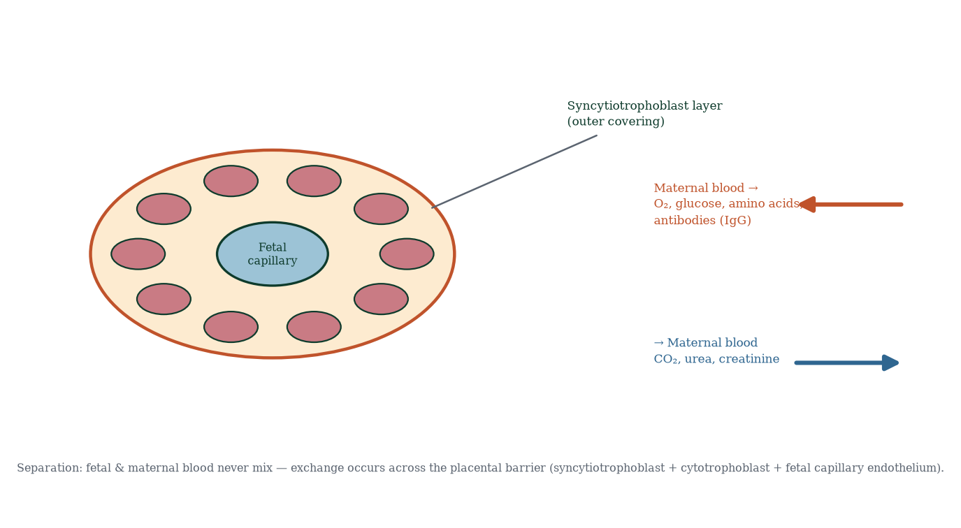
Figure 14.2 — The chorionic villus: syncytiotrophoblast, cytotrophoblast remnants, villous stroma with fetal capillaries — the exchange barrier.

14.3 What crosses, and how
Substance | Mechanism | Direction
Oxygen | Simple diffusion (gradient pO2: maternal ~50 mmHg → fetal ~20–30) | Mother → fetus
CO2 | Simple diffusion | Fetus → mother
Glucose | Facilitated diffusion (GLUT1) | Mother → fetus (fetal fuel)
Amino acids | Active transport (Na+-linked) | Mother → fetus (growth)
Free fatty acids | Limited diffusion; DHA actively transferred | Mother → fetus (brain)
Calcium, iron | Active transport | Mother → fetus
Vitamins | Active/facilitated | Variable
IgG antibodies | Receptor-mediated (FcRn) transcytosis | Mother → fetus (passive immunity)
Alcohol, nicotine, caffeine, drugs | Simple diffusion | Mother → fetus (teratogens!)
Urea, creatinine | Simple diffusion | Fetus → mother
Hormones | Variable (hPL, steroids) | Mostly placenta-derived
Key principles: (1) the placenta is a selective filter, not a wall — most maternal drugs cross to some degree; (2) passive immunity via maternal IgG protects the newborn for ~3–6 months (half-life ~21–28 days; breast milk adds IgA mucosal protection); (3) the placenta can metabolise some drugs (11β-hydroxysteroid dehydrogenase 2 inactivates cortisol — protecting the fetus from maternal glucocorticoid excess).

14.4 Placental hormones — the endocrine organ
The placenta is, gram for gram, the largest endocrine organ of pregnancy:
- hCG — luteal rescue (Chapter 11); peaks ~week 9–10; hyperemesis gravidarum correlates with high hCG (multiple pregnancy, molar disease).
- Progesterone — from week ~7–12 source of progesterone (luteal–placental shift); maintains myometrial quiescence (suppresses gap junctions, oxytocin receptors, prostaglandin synthesis), cervical mucus plug, decidualisation; progesterone withdrawal triggers labour onset (Chapter 16).
- Oestrogens — mainly oestriol (from fetal adrenal DHEA-S via placental sulfatase/aromatase — Figure 14.3); oestriol rises steadily to term; functions: uterine growth, blood flow, breast duct growth, myometrial gap junction upregulation (pro-labour!).
- Human placental lactogen (hPL / hCS) — rises steadily; insulin antagonist (lipolysis, glucose sparing for fetus) → drives the diabetogenic state of pregnancy; promotes breast alveolar development; lipolysis supplies maternal free fatty acids as maternal fuel.
- Placental growth hormone (hPGH) — regulates maternal IGF-1; contributes to insulin resistance.
- Corticotropin-releasing hormone (CRH) — placenta makes CRH (unlike non-pregnant axis where CRH is hypothalamic) — drives fetal/maternal cortisol; CRH rises exponentially late; timing of CRH vs progesterone withdrawal may gate labour onset (the “placental clock” hypothesis of labour timing).
- Relaxin — from corpus luteum/decidua; softens cervix and pubic symphysis; vasodilates; involved in quiescence.
- Inhibin/activin — modulate maternal FSH/placental function.
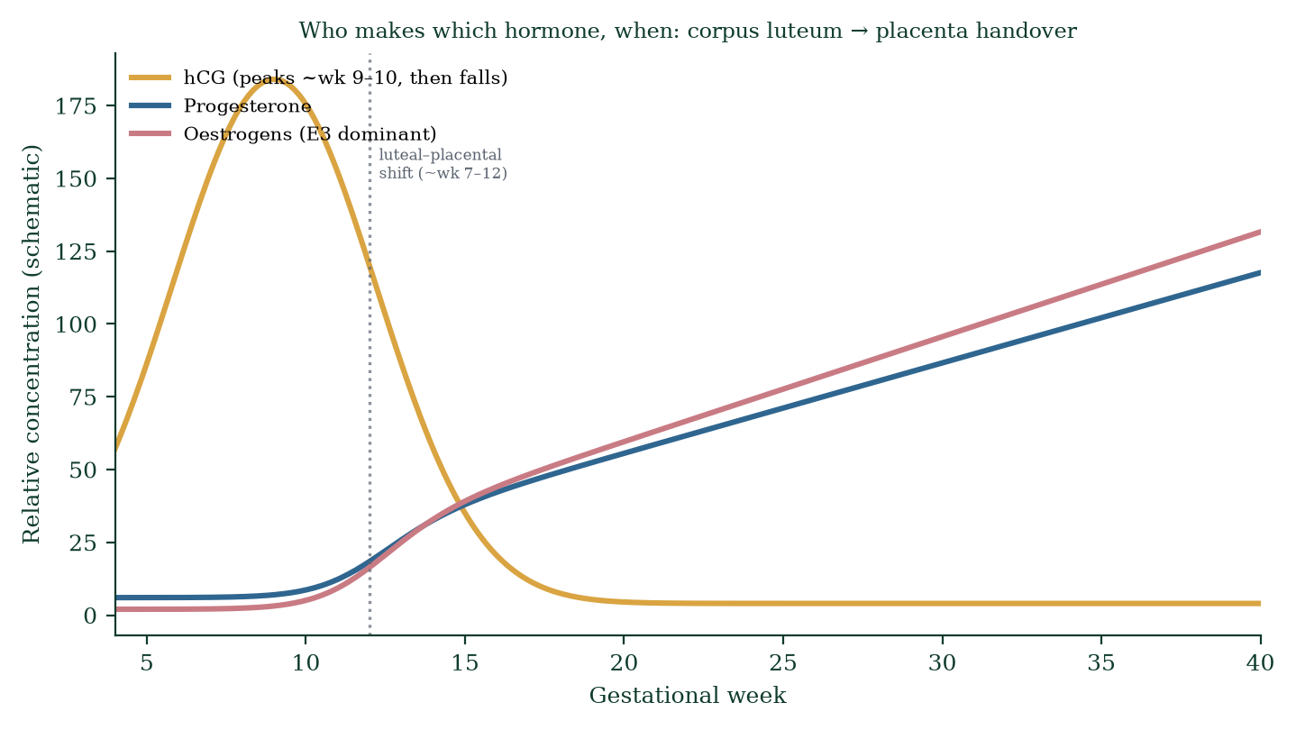
Figure 14.3 — hCG peaks early and falls as the luteal–placental shift hands steroid synthesis to the placenta; oestriol rises steadily toward term.

14.5 The immunological paradox and its solution
Half the fetus is paternal — immunologically foreign. The immune system should attack it — yet pregnancy is tolerated. Solutions:
- Trophoblast HLA profile — syncytiotrophoblast expresses no HLA-A/B (would provoke classic rejection); extravillous trophoblast expresses HLA-G (non-classical, tolerogenic — engages inhibitory KIRs on uterine NK cells, preventing cytotoxic attack), HLA-C, HLA-E — signalling peace.
- Uterine NK cells — abundant (70% of decidual leukocytes) but distinct: they don’t kill but remodel — they promote spiral arteriole remodelling (the deep plugging and dilatation enabling high-flow low-resistance placental perfusion). Failure → pre-eclampsia [20] spectrum (poor remodelling → high-resistance circulation → placental hypoperfusion → maternal anti-angiogenic state → hypertension/proteinuria).
- Treg cells — maternal CD4+CD25+FOXP3+ regulatory T cells expand dramatically; suppress anti-fetal responses.
- IDO (indoleamine 2,3-dioxygenase) — trophoblast enzyme depleting local tryptophan — starving cytotoxic T cells of their essential amino acid.
- Progesterone immunomodulation — anti-inflammatory at the maternal–fetal interface.
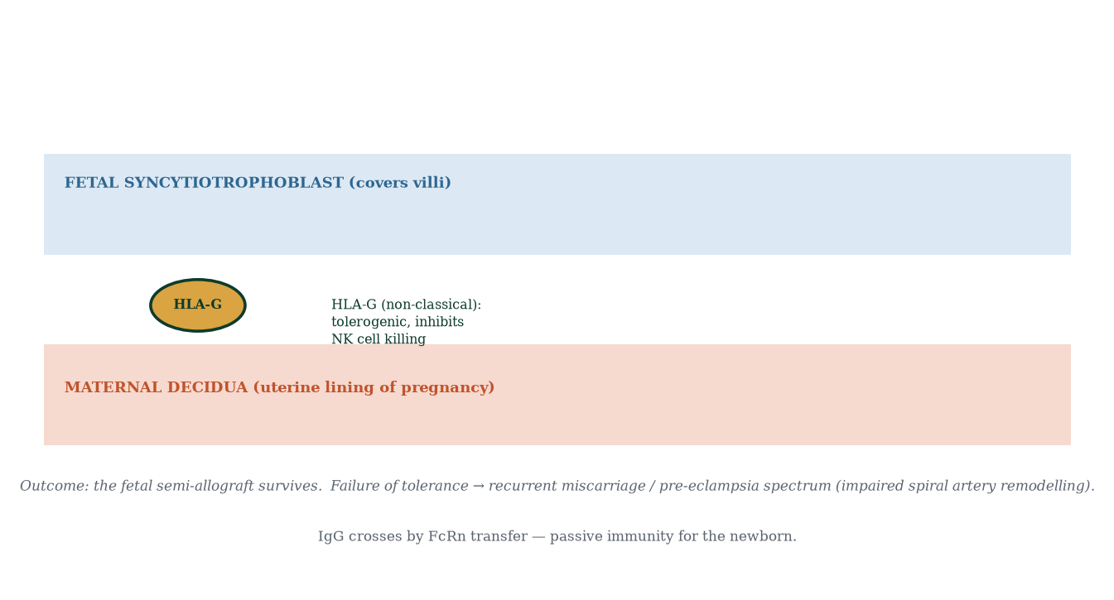
Figure 14.4 — The maternal–fetal immune interface: HLA-G, tolerogenic NK cells, Treg expansion, IDO — a truce, not an ignorance.
Failure modes: recurrent miscarriage (antiphospholipid antibody syndrome, NK-cell dysregulation — controversial), pre-eclampsia, fetal growth restriction — all, mechanistically, diseases of the maternal–fetal interface.

14.6 Placental pathology in overview
- Placenta praevia — placenta over/ encroaching on the internal os → painless third-trimester bleeding; delivery by caesarean.
- Placental abruption — premature separation → painful bleeding + fetal distress; emergency.
- Placenta accreta/increta/percreta — abnormal invasion into myometrium/through wall (often accompanies praevia + prior caesarean); life-threatening haemorrhage at delivery.
- Pre-eclampsia — see above; maternal anti-angiogenic syndrome (↑ sFlt-1, ↓ PlGF).
- Placental insufficiency — failed spiral artery remodelling; IUGR; Doppler abnormalities; early delivery when compromised.
- Molar pregnancy — abnormal trophoblast proliferation (complete: 46,XX all-paternal; partial: triploid diandric) with markedly elevated hCG; premalignant potential.

14.7 Mechanism in depth: steroid shuttling and the placental enzyme deficit
The placenta is enzymatically incomplete — it lacks CYP17 (17α-hydroxylase) and CYP11B1/CYP11B2 (11β/18-hydroxylase). Consequences:
- The placenta cannot make androgens or oestrogens from progesterone alone — it needs fetal (and maternal adrenal) DHEA/DHEA-S as substrate. Hence the fetal–placental unit: fetus provides DHEA-S → placenta sulfatase + aromatase → oestriol (mostly) and oestrone/oestradiol.
- The placenta cannot make aldosterone/cortisol — it can make progesterone from cholesterol (CYP11A1 present) but not extend the pathway; maternal adrenal remains the cortisol source; 11β-HSD2 (placental) converts maternal cortisol → inactive cortisone, protecting the fetus — insufficiency of this enzyme is linked to a “fetal programming” route to hypertension and metabolic disease in adulthood (Barker/DOHaD hypothesis — correlation vs cause caveat applies, but mechanistically plausible).
- Progesterone withdrawal timing — in most species labour follows progesterone withdrawal; humans keep high progesterone until term; the functional “withdrawal” is probably local — altered progesterone receptor isoforms (PR-A vs PR-B) and increased expression of co-repressors in the myometrium — molecular, not serum, withdrawal. This is why serum progesterone is an imperfect labour predictor.

14.8 Clinical spotlight: placental imaging and its diagnostics
- Ultrasound placental localisation — anterior/posterior/fundal; low-lying <20 mm from os at 20 weeks → repeat scan at 32/36 weeks; praevia if os covered.
- Doppler: uterine artery pulsatility index at 20–24 weeks predicts pre-eclampsia/IUGR; umbilical artery end-diastolic flow tracks placental resistance; middle cerebral artery pulsatility reflects cerebral redistribution (brain-sparing).
- Placental histopathology after delivery often reveals the mechanism of prior complications (infarction, fibrin deposition, villitis of unknown aetiology, chronic inflammation) — the placenta is the only organ routinely available for post-mortem mechanistic study in obstetrics.
- Biomarkers: soluble fms-like tyrosine kinase-1 (sFlt-1) and PlGF ratios are validated to help rule out pre-eclampsia in women with suspected disease (rule-out more than rule-in — correlation/causation caveats intact).

14.9 Mechanisms and evidence in depth: the placenta as endocrine organ beyond ten glands
The placenta is endocrinologically unique: it synthesises, never stores, steroid hormones — production rates quoted in mg/day in late pregnancy. hCG rescues the corpus luteum by day 8; oestriol production requires fetal adrenal DHEA-S — the maternal blood level of oestriol is a three-organ readout (fetal adrenal + fetal liver + placenta), which is why unexplained oestriol collapse flags fetal adrenal failure (anencephaly, congenital adrenal hypoplasia, sulfatase deficiency). hPL (human placental lactogen, homologous to growth hormone) rises across gestation — its lipolytic action liberates free fatty acids and ketones for the mother while insulin resistance spares glucose for the fetus; maternal insulin secretion doubles to compensate. Placental CRH drives the fetal HPA axis and possibly triggers labour timing (Chapter 16). Relaxin (corpus luteum dominant, placenta contributes) softens cervix/ligaments; elevated relaxin explains symphysis pubis pain.
Placental transport math — why hypoxia kills fetuses. Placental intervillous PO₂ is only 30–35 mmHg (maternal PO₂ ~90 mmHg); the fetus tolerates this because fetal haemoglobin (HbF) binds oxygen tighter (P50 ~19 vs maternal ~26 mmHg) — left shift by design; cardiac output per kg doubles; ductus venosus shunts oxygenated umbilical blood directly to the heart (bypassing liver). Fetal oxygen reserve is ~2 minutes. Maternal hypotension (epidural) → uteroplacental hypoperfusion → late decelerations — one reason supine hypotension syndrome exists (IVC compression, third trimester).

Common errors in placental reasoning
- “Placenta doesn’t cross antibodies.” — IgG crosses actively (FcRn); IgM does not (why ABO/Rh disease behaves differently).
- “Pre-eclampsia cures at birth.” — resolved by delivery, but anti-angiogenic state persists days–weeks; postpartum surveillance matters.
- “Placental hormones are optional luxuries.” — remove the placenta and pregnancy cannot survive — the placenta is the pregnancy endocrinology.

14.10 Clinical reasoning vignettes
Case 1. A 34-week primigravida with BP 165/110, proteinuria 2+, headache, blurred vision. Mechanism: pre-eclampsia — failed spiral artery remodelling → placental ischaemia → anti-angiogenic milieu (sFlt-1) → maternal endothelial dysfunction. Magnesium sulfate for seizure prophylaxis; urgent delivery; mechanism, not mystery.
Case 2. A 36-week woman presents with painless bright-red bleeding. Placenta previa — implantation over internal os; ultrasound confirms; avoid vaginal examination (catastrophic haemorrhage risk); caesarean at 37–38 weeks.
Case 3. A woman at 29 weeks with absent uterine artery notching but reversed umbilical flow. Mechanism: uteroplacental insufficiency — placenta cannot transfer nutrients; fetal growth restriction follows; delivery timing balances prematurity vs hypoxia risk.

Self-check — can you derive these without notes?
- Explain the luteal–placental shift in steroid production — which tissue takes over and when.
- Trace the pathways of IgG and iron transport across the placenta.
- Explain why fetal haemoglobin has higher O2 affinity than maternal HbA.
- Describe the mechanism of HLA-G and maternal tolerance of the semi-allograft fetus.
- Derive why pre-eclampsia features elevated liver enzymes and low platelets (HELLP).

Chapter summary
- The placenta derives from trophoblast; haemochorial; maternal blood bathes villi without mixing.
- Exchange: O2/CO2 diffusion; glucose facilitated; amino acids active; IgG via FcRn; drugs cross freely — the placenta is a filter, not a wall.
- Placental hormones: hCG, progesterone (post-shift), oestriol (fetal-adrenal-placental unit), hPL (anti-insulin), CRH (labour timing), relaxin.
- Tolerance: HLA-G, tolerogenic NK cells, Tregs, IDO-mediated tryptophan depletion, progesterone — active truce, not passive ignorance.
- Pathology spans praevia, abruption, accreta, pre-eclampsia, insufficiency, moles — all readable from mechanism.

Key terms
Haemochorial placenta — maternal blood directly bathes villi. Syncytiotrophoblast — syncytial surface of villi. Intervillous space — maternal blood pool around villi. Spiral arterioles — maternal uterine vessels remodelled by trophoblast/NK. Luteal–placental shift — placental takeover of steroids ~week 7–12. hPL — placental anti-insulin hormone. HLA-G — tolerogenic MHC class Ib. FcRn — IgG transfer receptor. Placenta praevia/accreta/abruption — implantation-site pathologies.

Review questions
Multiple choice
- The placenta is described as haemochorial because:
  - it contains haemoglobin b) maternal blood directly bathes the villi c) fetal blood mixes with maternal d) it has two circulations
- Which immunoglobulin crosses the placenta?
  - IgA b) IgM c) IgG d) IgE
- The dominant oestrogen of pregnancy is:
  - oestrone b) oestradiol c) oestriol d) estetrol
- Placental CRH is unusual because it:
  - is made only in the fetus b) is hypothalamic in non-pregnant state c) is not released in pregnancy d) is an inhibitory hormone
- HLA-G expression by trophoblast primarily:
  - activates NK cells b) inhibits uterine NK cytotoxicity c) kills maternal T cells d) causes pre-eclampsia
- Placenta praevia presents classically with:
  - painful bleeding b) painless third-trimester bleeding c) first-trimester bleeding d) no bleeding
- hPL primarily causes:
  - hypoglycaemia b) insulin resistance c) diuresis d) myometrial contractility
- Spiral artery remodelling failure is implicated in:
  - placenta praevia b) pre-eclampsia and IUGR c) twins d) polyhydramnios
Short answer
- Outline placental development from trophoblast to definitive discoid placenta (timeline).
- List five substances that cross the placenta and their transport mechanisms.
- Explain how the placenta maintains maternal tolerance of the fetal allograft.
- Define the luteal–placental shift and state its clinical significance.
Explanation
- Explain the fetal–adrenal–placental unit for oestriol production, step by step.
- Explain why a drug that crosses the placenta does not necessarily require a dose increase — the four factors governing fetal drug exposure.
- Explain the mechanism of pre-eclampsia in terms of spiral artery remodelling and anti-angiogenic imbalance.
Application
- A 34-week scan shows absent end-diastolic flow in the umbilical artery. Explain what this means for placental function and fetal risk.
- A woman at 36 weeks presents with painful bleeding and fetal bradycardia. Most likely diagnosis and mechanism?
- Explain why maternal IgG provides newborn immunity but wanes by ~6 months.

Answers to review questions
- b. Maternal blood directly contacts syncytiotrophoblast; three tissue layers separate fetal blood.
- c. IgG via FcRn-mediated transcytosis; IgM is too large; IgA doesn’t cross (breast milk supplies it).
- c. Oestriol from fetal adrenal DHEA-S — the unique fetal-placental steroid.
- b. CRH is normally hypothalamic; in pregnancy the placenta makes CRH, driving the “placental clock” hypothesis of labour onset.
- b. HLA-G engages inhibitory KIRs on uterine NK cells → tolerance instead of cytotoxicity.
- b. Painless bleeding as the placenta over or near the os is pulled apart by lower-segment stretching/effacement.
- b. hPL (with hPGH, cortisol, progesterone) induces maternal insulin resistance — sparing glucose for fetus.
- b. Failed remodelling → high-resistance, low-flow placenta → IUGR; maternal endothelial dysfunction → pre-eclampsia.
- Zygote → blastocyst (day 5–6) → trophoblast invasion (day 7–12) → lacunae + early villi (week 2–3) → branching villous tree + chorionic plate + umbilical cord (week 4–10) → uteroplacental perfusion established + luteal–placental shift (week 7–12) → definitive discoid placenta (week 12 onward); growth continues to term.
- Oxygen (diffusion), CO2 (diffusion), glucose (facilitated, GLUT1), amino acids (active, Na-linked pumps), IgG (receptor-mediated transcytosis via FcRn), O2 gradient, vitamins (active).
- HLA-G (inhibitory), tolerogenic NK cells (remodelling not killing), Treg expansion, IDO tryptophan depletion locally, progesterone anti-inflammatory effects, syncytiotrophoblast’s lack of classic MHC — the truce is active and local, not systemic tolerance.
- The corpus luteum produces progesterone until ~week 7–12; then the placenta synthesises progesterone and oestrogens directly, corpus luteum involutes; hCG falls; clinically: progesterone withdrawal at ~week 7 fails → miscarriage; the shift is why early-pregnancy progesterone support works; hCG fall marks established placental autonomy.
- Fetal adrenal fetal zone makes DHEA-S → maternal blood → placenta desulfates (sulfatase) → 16α-hydroxylation in fetal liver → placenta aromatises → oestriol; hence low oestriol signals fetal adrenal or liver failure — and the placenta can’t make it without the fetus (unique coupled unit).
- Amount crossing depends on: (i) molecular weight (<500 Da crosses freely), (ii) lipid solubility, (iii) protein binding, (iv) placental enzymatic metabolism, (v) maternal–fetal concentration gradients, (vi) gestational age (more blood flow late) — the general rule is that most drugs cross to a degree, so avoidance of unnecessary drugs is prudential; dose needs usually don’t change mechanistically.
- Trophoblast fails to invade and remodel spiral arterioles deeply → vessels stay narrow, high-resistance → placental hypoxia/ischaemia → release of sFlt-1 (soluble VEGF receptor) and sEng → sequester maternal VEGF/PlGF → maternal endothelial dysfunction → hypertension, proteinuria, oedema, multi-organ risk; ultimately due to failed placental genetics + maternal immune interplay.
- Absent end-diastolic flow = high placental resistance (failed spiral artery remodelling, reduced villous surface); fetus faces chronic hypoxia risk; management: intensified surveillance (growth, liquor, CTG, Dopplers), steroids if preterm, early delivery if decompensating.
- Placental abruption — premature shearing of placenta from decidua; pain + bleeding (revealed) or concealed haemorrhage; fetal hypoxia → bradycardia; DIC risk; immediate caesarean if fetus viable and unstable — the mechanism is mechanical failure of the anchoring villi.
- IgG half-life ~21–28 days; ~50% of maternal IgG is transferred in the final weeks; titres peak at birth then decline; by ~3–6 months maternal IgG is largely gone; the newborn’s own IgG production rises gradually by 3–6 months — hence the “immunity gap” and the window of susceptibility (and the reason breast-fed infants get mucosal IgA protection in the interim).

Chapter 15: Pregnancy and Maternal Adaptation
Learning objectives. After studying this chapter you should be able to: - explain how the conceptus is maintained (hCG, progesterone, oestrogen); 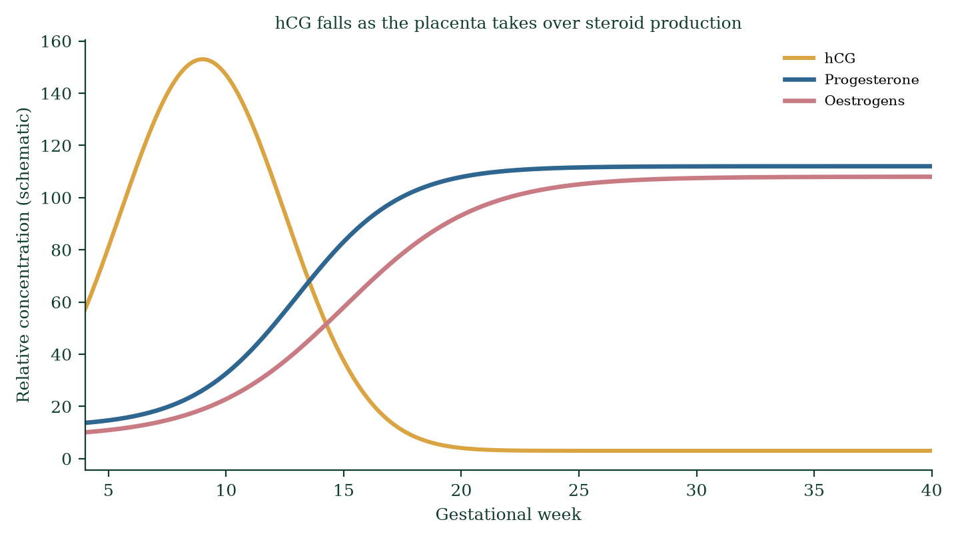
- describe maternal cardiovascular, respiratory, renal, GI, metabolic and immune adaptations;
- explain trimester-specific changes;
- connect adaptations to clinical signs and symptoms;
- explain the diabetogenic stress of pregnancy and gestational diabetes [30].
Central question. How does one body safely host a genetically foreign organism for nine months — supplying it with blood, oxygen, nutrients and hormones, then giving birth — and why do things so often feel “wrong” while being perfectly normal?

15.1 Endocrine maintenance of early pregnancy
After implantation, the corpus luteum is sustained by embryonic hCG (Chapter 11, Figure 11.4). Progesterone keeps the endometrium secretory, prevents myometrial contractions, and sustains the decidua (the pregnant endometrium). Oestrogen maintains endometrial vascularity and primes breasts and myometrium. By ~week 7–12 the placenta assumes full steroidogenic autonomy (Figure 14.3). hCG falls steeply; progesterone and oestriol keep rising toward term.

15.2 Cardiovascular adaptations — the biggest shift
Maternal blood volume rises ~40–50% by 32–34 weeks (plasma disproportionately > RBC → physiological haemodilution/anaemia of pregnancy — haemoglobin falls ~1–2 g/dL even while red-cell mass increases ~20–30%). Cardiac output rises ~30–50% (stroke volume first, then rate) via early vasodilation (nitric oxide, progesterone) → fall in systemic vascular resistance → tachycardia preserved; blood pressure falls mid-pregnancy, returns toward baseline by term. Heart displaced up and left; systolic flow murmur (~90% of pregnancies); mild dyspnoea on exertion normal by third trimester.
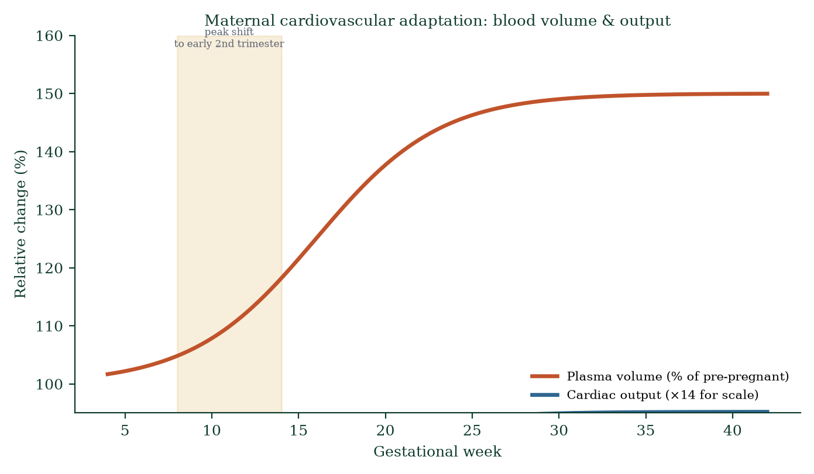
Figure 15.1 — Plasma volume and cardiac output across gestation; the second-trimester dip in blood pressure parallels vasodilation.
Why the design? The placenta demands high-flow, low-resistance perfusion; maternal kidneys must raise GFR; sudden haemorrhage at delivery must be survivable (hence expanded volume); thermoregulation (surface area for heat dissipation).
Clinical correlates: supine hypotensive syndrome (aortocaval compression by gravid uterus — roll to left lateral); pre-eclampsia (failure to lower SVR → hypertension + proteinuria); mild ankle oedema normal (progesterone vasodilation + venous compression); ankle oedema with headache/visual symptoms = not normal — evaluate pre-eclampsia.

15.3 Respiratory adaptations
Progesterone is a direct respiratory stimulant: tidal volume rises ~40% from weeks 4–8 (the earliest measurable cardiorespiratory change); minute ventilation rises; PaCO2 falls (~28–32 mmHg — chronic mild respiratory alkalosis, compensated by renal HCO3 excretion). The enlarging uterus elevates the diaphragm (~4 cm); rib cage flares; breathing becomes more diaphragmatic. Dyspnoea of pregnancy is common, positional and normal — reassuring if oxygen saturation is normal. Asthma may improve or worsen in pregnancy (many improve); respiratory infections are more dangerous (wider airway, less reserve).

15.4 Renal adaptations
Renal plasma flow and GFR rise ~40–50% (progesterone + vasodilation); creatinine falls (~0.4–0.6 mg/dL vs non-pregnant 0.7–1.1 — a “normal” creatinine may actually signal renal impairment in pregnancy); urinary glucose excretion rises (tubular reabsorption threshold falls — mild glycosuria can be normal; do not overcall diabetes); ureteral dilation (mechanical + progesterone smooth muscle relaxation) — physiological hydronephrosis; pyelonephritis risk (asymptomatic bacteriuria treated in pregnancy for this reason). Urinary frequency (pressure + high GFR) — normal; but dysuria/fever = infection until proven otherwise. Nausea-related renin activation and aldosterone maintain volume; progesterone opposes sodium retention somewhat.

15.5 Gastrointestinal adaptations
Progesterone relaxes smooth muscle → delayed gastric emptying → reflux/heartburn (LOS pressure falls), constipation (colon transit slows), gallbladder stasis (biliary sludge; stones). Nausea/vomiting of pregnancy (NVP) affects ~70–80% — correlates with hCG peak (week 9–10); hyperemesis gravidarum (1–2%) — severe, needs IV fluids, electrolyte correction, thiamine (Wernicke prevention), antiemetics. Hunger/aversion changes reflect olfactory priming (protective against teratogenic foods) — mechanism partially understood.

15.6 Metabolic adaptations — two bodies, one metabolism
Pregnancy is first anabolic (maternal fat stores accumulate in early pregnancy) then catabolic (late pregnancy insulin resistance spares glucose for fetus; lipolysis supplies maternal fuel; free fatty acids become preferential maternal fuel — see Chapter 15.4 in the evidence checkpoint). hPL drives insulin resistance; placental TNF-α, CRH, cortisol, progesterone contribute; placental growth hormone adds too. Blood glucose normally falls in early pregnancy; late pregnancy shows mild postprandial hyperglycaemia. Gestational diabetes (GDM) (~3–9%) — failure of beta-cell compensation → macrosomia, neonatal hypoglycaemia (fetal hyperinsulinaemia), pre-eclampsia, later maternal type 2 diabetes. Screen with OGTT at 24–28 weeks (risk-stratified earlier screening for high-risk women).
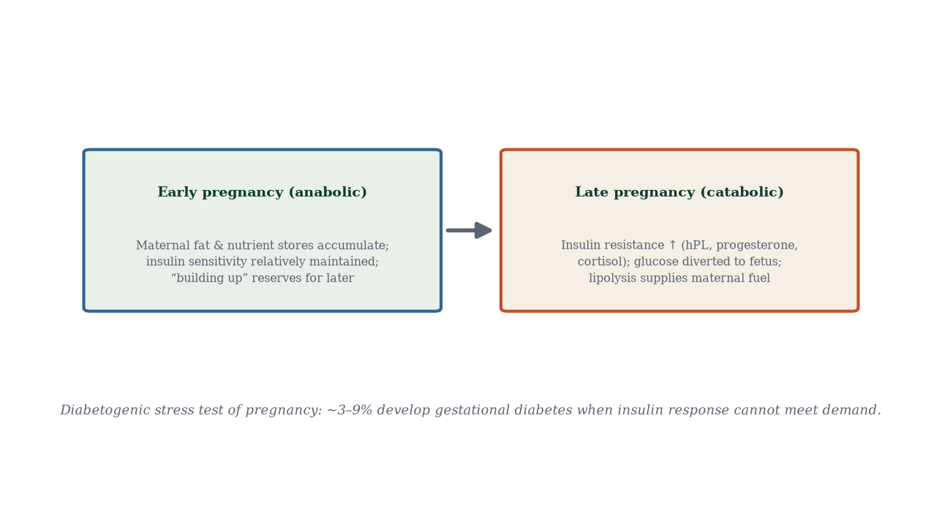
Figure 15.4 — Two metabolic states of pregnancy: early anabolic fat accumulation, late catabolic insulin resistance securing fetal glucose supply.

15.7 Endocrine and immune adaptations
- Thyroid: hCG weakly stimulates TSH receptors (shared α-subunit) → transient TSH suppression in first trimester; total T4 rises (increased TBG from oestrogen); free T4 normal; iodine requirement ↑ (fetal brain needs maternal T4 until fetal thyroid matures ~week 12–14; maternal hypothyroidism damages fetal neurodevelopment).
- Adrenal: cortisol rises (both maternal ACTH drive and placental CRH stimulation); aldosterone rises (volume expansion); ACTH increases ~3×.
- Pancreas: beta-cell mass doubles (prolactin, hPL, placental lactogen stimulate); insulin secretion rises to compensate resistance.
- Parathyroid: PTH rises — calcium drawn for fetal bone (maternal bone turnover accelerates; mostly recovered post-lactation); vitamin D metabolism activated (kidney 1α-hydroxylase).
- Immune: T-helper shift from Th1 (cell-mediated) to Th2 (antibody) — supports tolerance; but overall cell-mediated immunity is mildly suppressed — pregnancy worsens some infections (influenza, malaria, varicella, listeria) while others ease; autoimmune disease activity can flare or remit (RA often improves, SLE often flares).

15.8 Trimester timeline
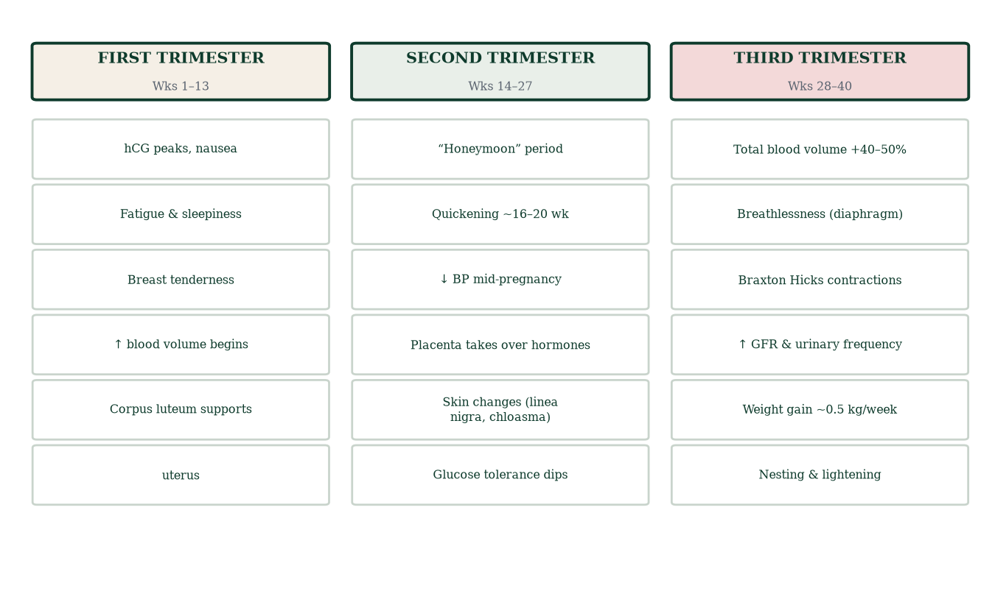
Figure 15.2 — Trimester map of adaptations: first-trimester nausea and fatigue, second-trimester “honeymoon”, third-trimester breathlessness and Braxton Hicks.
First trimester (weeks 1–13): hCG peak, nausea, fatigue, breast tenderness, amenorrhoea, mood changes; most early miscarriage occurs here. Second trimester (weeks 14–27): maternal wellbeing, quickening ~16–20 weeks, fundal growth ~1 cm/week after 20 weeks, skin changes (linea nigra, chloasma), BP nadir mid-pregnancy, gestational diabetes screening 24–28 weeks. Third trimester (weeks 28–40): breathlessness, Braxton Hicks contractions, urinary frequency, weight gain ~0.5 kg/week (mostly fetal, placental and fluid), oedema, pelvic pressure, nesting behaviours, cervical ripening pre-labour.

15.9 Normal vs not-normal symptoms — the clinical triage lens
Normal: fatigue, nausea, mild dyspnoea, mild ankle oedema, heartburn, frequency, Braxton Hicks, leaking colostrum, linea nigra, chloasma, palmar erythema, spider naevi. Not normal: severe headache/visual changes (pre-eclampsia), unilateral calf swelling/dyspnoea (VTE), persistent vomiting (hyperemesis), fever (infection), vaginal bleeding (praevia/abruption/labour), reduced fetal movements (hypoxia), dysuria. Pregnancy physiology explains most symptoms — but the clinician’s job is to recognise the deviations.

15.10 Mechanism in depth: why pregnancy is a “diabetogenic stress test”
Consider what the fetus must achieve nutritionally: grow from 0 to 3.3 kg in 40 weeks, quadrupling brain weight, laying down bone, making haemoglobin — all from raw glucose, amino acids and lipids delivered via the placenta. Maternal adaptations funnel substrate toward the fetus even at cost to the mother:
- hPL and placental growth hormone directly antagonise insulin receptor signalling (kindle via IRS-1 downregulation and altered p85 phosphatidylinositol signalling) — raising maternal glucose for fetal uptake.
- Placental CRH and cortisol amplify insulin resistance and lipolysis.
- Progesterone opposes insulin action in smooth and skeletal muscle.
- TNF-α from adipose/placenta adds inflammatory insulin resistance.
- Maternal beta-cell compensation: beta-cell mass doubles (prolactin, hPL, placental lactogen drive proliferation); insulin secretion rises ~1.5–2×.
- When compensation fails → GDM: fasting hyperglycaemia, postprandial excursions → fetal hyperinsulinaemia → macrosomia, neonatal hypoglycaemia, shoulder dystocia, pre-eclampsia, caesarean risk — and a 7–10× lifetime risk of maternal type 2 diabetes. The 50% of GDM women who won’t develop T2DM are protected by maintaining beta-cell reserve — weight loss postpartum is protective, mechanistically, not just aesthetically.

15.11 Evidence checkpoint (adaptations that changed practice)
- Routine iron supplementation only when indicated by ferritin (universal prophylaxis debate ongoing; WHO recommends in settings of high prevalence).
- Low-dose aspirin (75–150 mg) before 16 weeks in high-risk women reduces pre-eclampsia (~15–20% relative risk reduction) — anti-platelet mechanism targeting placental microthrombi.
- Antenatal corticosteroids for threatened preterm birth — lung maturity accelerated.
- Avoid ACE inhibitors, warfarin (switch pre-conception), tetracyclines, retinoids; most antibiotics considered safe; risk–benefit always applies.
- Influenza and Tdap and COVID-19 vaccination in pregnancy recommended — passive antibody transfer protects the neonate (mechanism via FcRn — Chapter 14).

15.12 Mechanisms and evidence in depth: the immune shift and maternal tolerance revisited
Pregnancy was once thought to require pure Th2 immunosuppression — the “Th1→Th2 shift” model. Modern data show something subtler: immune recalibration by trimester. First trimester = pro-inflammatory (implantation/placentation requires controlled inflammation); second = anti-inflammatory (rapid fetal growth tolerance); third = pro-inflammatory again (to permit parturition — labour is inflammatory). Enduring mechanisms: decidual NK cells with tolerogenic phenotype (CD56^bright), HLA-G expression, tryptophan catabolism by IDO (IDO inhibition causes fetal rejection in animal models), Treg expansion (FoxP3+), macrophage M2 phenotypes. Failure modes: pre-eclampsia, recurrent miscarriage, preterm labour — all studied through this lens, all incompletely solved — an active frontier, not settled textbook fact.
Exercise and pregnancy — mechanistic safety. Moderate exercise improves maternal insulin sensitivity (counters gestational diabetogenic drift), cardiovascular conditioning (hyperdynamic heart tolerates it), and mood — recommended unless contraindication (pre-eclampsia, preterm labour risk, severe anaemia, restrictive lung disease). Risks: supine hypotension (avoid static supine lying >20 weeks), hyperthermia (keep core <38 °C), dehydration, abdominal trauma sports. Mechanism tells you both the benefit and the boundary.

Common errors in maternal adaptation reasoning
- “Pregnancy means eating for two.” — ~+10% energy only; quality over quantity.
- “Supplements can’t hurt.” — vitamin A excess is teratogenic; iron only if indicated.
- “Sickness in early pregnancy means healthy pregnancy.” — epidemiologically true-ish but never reassuring enough to ignore red flags.

15.13 Clinical reasoning vignettes
Case 1. A 28-week primigravida with fasting glucose 5.4 mmol/L on OGTT. Mechanism: GDM — late-gestation insulin resistance (hPL, hPGH, TNF-α, placental PR signalling) exceeds beta-cell compensation → hyperglycaemia. Diet first; metformin or insulin if persistent; glucose control prevents macrosomia, shoulder dystocia, neonatal hypoglycaemia.
Case 2. A 30-week woman with sudden dyspnoea and pleuritic chest pain. Mechanism: pregnancy is a prothrombotic state (↑ fibrinogen, ↓ protein S, venous stasis from IVC compression) → PE risk ×5. D-dimer elevated normally in pregnancy; V/Q or CTPA; treat low-molecular-weight heparin.
Case 3. A 33-week woman on routine scan notes fetal breech. Mechanism: ~3% at term; ECV (external cephalic version) offered from 36 weeks if no contraindication; failing that, planned caesarean vs vaginal breech counselling.

Self-check — can you derive these without notes?
- Explain why blood volume rises 40–50% but blood pressure falls in mid-pregnancy.
- Derive the physiological insulin resistance of late pregnancy from hPL structure.
- Why does GFR rise ~50% and creatinine fall to 35–45 µmol/L?
- Explain the mechanism of morning sickness associated with hCG peak.
- Why is supine lying to be avoided after 20 weeks?

Chapter summary
- Early pregnancy maintenance: hCG → corpus luteum → progesterone → endometrium; luteal–placental shift by week 7–12.
- CV: +40–50% volume, +30–50% cardiac output, mid-pregnancy BP dip; respiratory: progesterone-driven ↓PaCO2; renal: ↑GFR, low creatinine, mild glycosuria.
- GI: delayed emptying; nausea peaks with hCG; metabolic: early anabolic, late insulin-resistant (hPL) — GDM risk; immune: Th2 shift, mild immunosuppression.
- Trimester map: 1st = hCG/nausea; 2nd = honeymoon/quickening; 3rd = breathlessness/Braxton Hicks/nesting.
- Distinguish normal adaptations from pathological deviations (pre-eclampsia, VTE, hyperemesis, infection).

Key terms
Luteal–placental shift — placental steroid takeover. Haemodilution — plasma-dominant volume expansion. Spider naevi/palmar erythema — oestrogen vasodilation signs. Gestational diabetes — insulin resistance of the second half. hPL — placental anti-insulin hormone. Hyperemesis — severe nausea/vomiting. Braxton Hicks — painless practice contractions. Linea nigra — midline hyperpigmentation. Supine hypotensive syndrome — aortocaval compression. Anaemia of pregnancy — haemodilution.

Review questions
Multiple choice
- Maternal blood volume rises by approximately:
  - 10% b) 25% c) 40–50% d) 80%
- Progesterone’s earliest detectable effect is on the:
  - kidney b) respiratory centre c) bone d) skin
- Which best explains physiological anaemia of pregnancy?
  - iron deficiency b) plasma expansion outstripping RBC mass c) haemolysis d) marrow suppression
- Peak hCG occurs at:
  - week 3–4 b) week 9–10 c) week 20 d) week 36
- Gestational diabetes screening is recommended at:
  - booking b) 12–14 weeks c) 24–28 weeks d) delivery
- The earliest trimester-1 symptom correlates with peak:
  - progesterone b) oestriol c) hCG d) hPL
- Normal PaCO2 in pregnancy is approximately:
  - 45 mmHg b) 40 mmHg c) 28–32 mmHg d) 55 mmHg
- Fetal hyperinsulinaemia from maternal hyperglycaemia causes:
  - microsomia b) macrosomia c) IUGR d) no change
Short answer
- Explain the luteal–placental shift and its clinical importance.
- List five cardiovascular changes in pregnancy.
- Explain why urinary glucose is often detected in normal pregnancy.
- Describe the metabolic switch from early to late pregnancy.
Explanation
- Walk through the mechanism of supine hypotensive syndrome and its prevention.
- Explain why systolic murmurs are common and normal in pregnancy.
- Distinguish physiological dyspnoea from pathological dyspnoea in pregnancy.
Application
- A woman at 28 weeks has a fasting glucose of 5.6 mmol/L on OGTT. Interpret and explain the mechanism of GDM.
- A 30-year-old at 32 weeks has bilateral ankle swelling, BP 125/70, no proteinuria, normal symptoms. Explain.
- A woman with pre-pregnancy hypertension presents at 30 weeks with severe headache and visual changes. Name the syndrome and the mechanism; outline immediate significance.

Answers to review questions
- c. Plasma + ~45%, RBC +~20–30% → haemodilution.
- b. Tidal volume rises from week 4–8.
- b. Plasma expansion > RBC increase — haemodilution, not iron loss (though iron deficiency may coexist).
- b. hCG peaks ~week 9–10, then falls steeply.
- c. 24–28 weeks (OGTT at 24–28); earlier if risk factors.
- c. Nausea correlates with the hCG peak; severity roughly parallels level.
- c. Chronic respiratory alkalosis compensated renally.
- b. Fetal hyperinsulinaemia = growth factor → macrosomia; also neonatal hypoglycaemia.
- Placenta takes over steroid production ~week 7–12; if corpus luteum fails before the shift (e.g., luteal progesterone defect), miscarriage occurs; hCG fall marks established placental autonomy — basis of early pregnancy support and timing of miscarriage risk.
- ↑ blood volume, ↑ cardiac output, ↓ SVR, ↓ BP mid-pregnancy (return to baseline term), ↑ heart rate (~15–20 bpm), ↑ RBC mass, haemodilution, physiological flow murmur, palmar erythema/spider naevi (oestrogen), supine hypotension.
- Tubular glucose reabsorption threshold falls and GFR rises → filtered glucose load exceeds reabsorptive capacity — mild glycosuria, a normal finding; distinguish from diabetes by fasting glucose/OGTT.
- Early: anabolic — glycogen/fat deposition, insulin sensitivity maintained, maternal nutrient stores built. Late: catabolic — insulin resistance (hPL, progesterone, CRH, TNF-α, cortisol), glucose sparing for fetus, lipolysis supplies maternal energy, postprandial hyperglycaemia mild — adaptive fetal-first fuel allocation.
- Gravid uterus compresses IVC + aorta when supine → ↓ venous return → ↓ cardiac output → hypotension/dizziness/pallor; prevented by left lateral positioning — the basis of the left-tilt in labour wards and resuscitation.
- Hyperdynamic circulation: high flow across valves + displaced heart + low viscosity blood → 90% develop innocent flow murmurs; pathological murmurs are diastolic, other signs or hyperkinetic pathology — mechanism distinguishes benign from not.
- Physiological: effort/positional, oxygen saturation normal, no wheeze/chest pain — progesterone-driven hyperventilation, diaphragmatic elevation; pathological: resting dyspnoea, low saturations, tachycardia out of proportion, asymmetric symptoms — consider PE, pneumonia, cardiac failure, asthma exacerbation — always investigate red flags.
- Elevated fasting glucose above pregnancy thresholds — diagnostic of GDM depending on criteria (IADPSG: fasting ≥5.1 mmol/L); mechanism: placental hormones (hPL, progesterone, CRH, TNF-α, cortisol) → peripheral insulin resistance; inadequate beta-cell compensation → hyperglycaemia — screen early, manage with diet/exercise/metformin/insulin; postpartum OGTT at ~12 weeks; lifetime T2DM risk.
- Bilateral dependent ankle oedema without proteinuria or hypertension = physiological third-trimester oedema (venous compression + low oncotic pressure + sodium retention); normal; advise leg elevation, avoid prolonged standing; reassure; educate red flags (headache, visual, epigastric pain, sudden generalised oedema).
- Pre-eclampsia — failed spiral artery remodelling → placental hypoperfusion → anti-angiogenic sFlt-1 secretion → maternal endothelial dysfunction → hypertension, proteinuria, neuro symptoms (headache, visual aura, hyperreflexia) = imminent eclampsia risk; immediate obstetric referral — delivery is the only cure; magnesium sulfate for seizure prophylaxis; BP management; monitoring — a maternal emergency.

Chapter 16: Labour, Childbirth, and Postpartum Physiology
Learning objectives. After studying this chapter you should be able to: - explain the mechanisms initiating labour; - describe the stages of labour [8] and cervical changes; - explain the roles of oxytocin and prostaglandins in uterine contractions; - describe delivery of the baby and placenta; - explain uterine involution and postpartum recovery.
Central question. How does a quiescent pregnant uterus transform into a powerfully contracting organ on command — and who gives the command?

16.1 The great question of labour: what starts it?
After 37+ weeks of silence, labour begins. The cascade involves, at minimum: - Progesterone withdrawal (functional, local) — PR isoform switching (PR-B → PR-A relative dominance) in myometrium; loss of progesterone’s anti-contractile and anti-inflammatory grip — even though serum levels stay high. - Oestrogen upregulation — rises relative to progesterone; induces oxytocin receptors and gap junctions in myometrial cells — assembling the electrical syncytium that contracts in coordination. - Prostaglandins (PGE2 and PGF2α) — cervical ripening (collagen breakdown, glycosaminoglycan remodelling) and myometrial contractions; rising fetal cortisol + CRH may trigger placental progesterone switch and fetal lung surfactant release (signals maturity to the maternal axis). - Mechanical stretch — fetal growth stretches myometrium (activation) and cervical tissue; the Ferguson reflex (cervical stretch → afferent nerves → hypothalamus → posterior pituitary oxytocin → stronger contractions) is the classic positive-feedback loop of labour (Figure 16.1). - Inflammatory activation — fetal lung surfactant released into amniotic fluid activates decidual/macrophage NF-κB → inflammatory mediators (IL-1β, IL-6, IL-8, TNF-α) → prostaglandin synthesis — the “fetal clock signals readiness” hypothesis. - CRH from placenta rises exponentially — drives fetal and maternal cortisol; timing hypothesis.
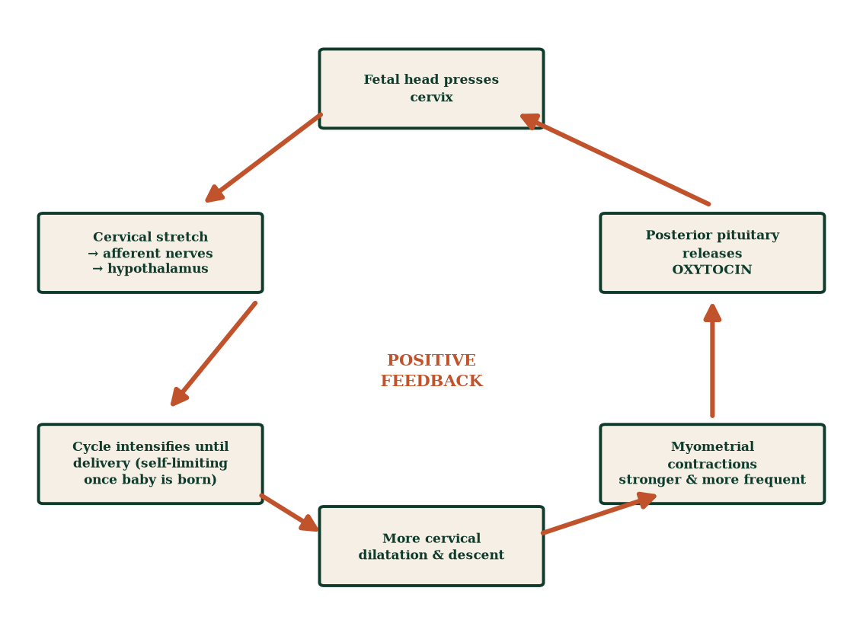
Figure 16.1 — Oxytocin positive feedback: cervical stretch → hypothalamus → posterior pituitary → myometrium → more stretch → more oxytocin — until delivery ends the loop.

16.2 Stage 1 — cervical dilation
- Latent phase (0–4 cm): irregular contractions, slow dilation over hours; cervical softening, effacement (thinning from ~2 cm to paper-thin) and early opening.
- Active phase (4–10 cm): regular, strong, 3–5 contractions/10 min; cervix dilates ~1 cm/h (first labour) or ~1.5 cm/h (subsequent); formalised by the Friedman curve (Figure 16.3). Contractions are fundal-dominant with polarity reversal (the lower segment relaxes/dilates as the upper segment contracts/retracts) — uterine muscle cells never fully relax between contractions (retraction shortens them progressively).
- Cervical ripening precedes and accompanies dilation: collagen remodels (MMP activation, glycosaminoglycan influx, water content rises), cervix becomes soft, anterior, effaced, dilated — driven by prostaglandins, relaxin, pressure and oestrogen.
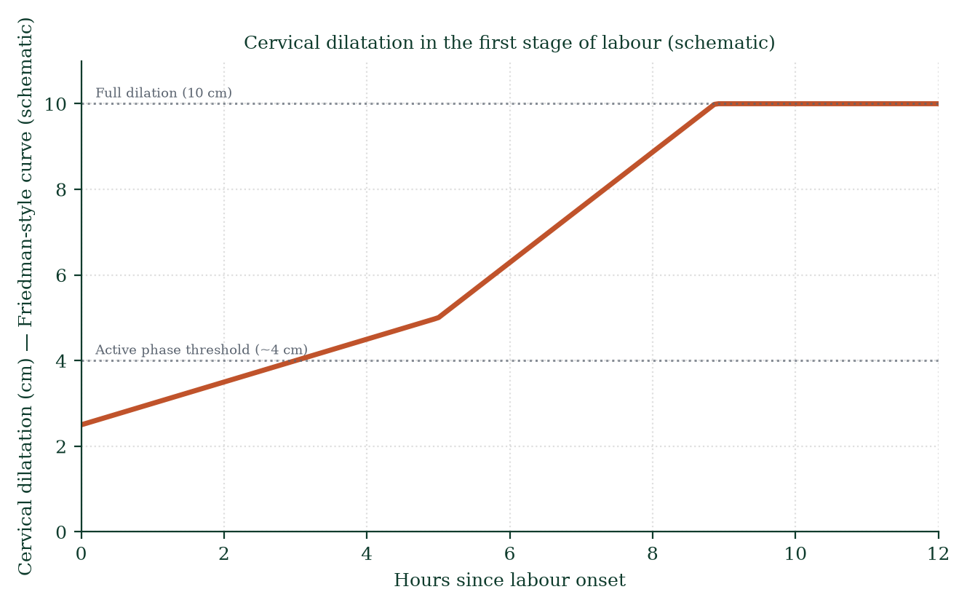
Figure 16.3 — Friedman-style cervical dilatation curve: slow latent phase, accelerating active phase, deceleration near full dilation (10 cm).

16.3 Stage 2 — expulsion
Full dilation (10 cm) → birth. Mechanics: uterine contractions (driving) + maternal expulsive efforts (abdominal muscles + diaphragm, bearing down with contraction) + pelvic floor resistance shaping descent (cardinal movements: engagement → descent → flexion → internal rotation → extension → restitution → expulsion). Duration: minutes in multiparas, up to 2 h in primiparas (longer with epidural). Moulding of the fetal skull (fontanelle overlap) accommodates the pelvis.

16.4 Stage 3 — placental separation and delivery
The placenta was attached to the decidua basalis; after birth of the baby, the uterus contracts and retracts — the placental bed (7–8 cm) collapses, shearing anchoring villi from decidua where cleavage occurs → placental separation (Schultze mechanism: fetal surface presents, “shiny Schultze”; Duncan mechanism: maternal surface presents, “dirty Duncan”). Complete within ~5–30 min. Bleeding limited by: (i) uterine retraction clamping spiral arterioles (“living ligatures”); (ii) clotting cascade activation; (iii) oxytocin-mediated continued contraction post-delivery. Routine active management (10 IU IM/IV oxytocin at delivery + controlled umbilical cord traction + uterine massage) reduces postpartum haemorrhage (PPH) by ~60% compared to expectant management. PPH = >500 mL (vaginal) or >1000 mL (caesarean) — atony accounts for ~70% of PPH; managed with uterotonics (oxytocin, misoprostol, carboprost, ergometrine if appropriate) + mechanical/surgical methods if refractory.
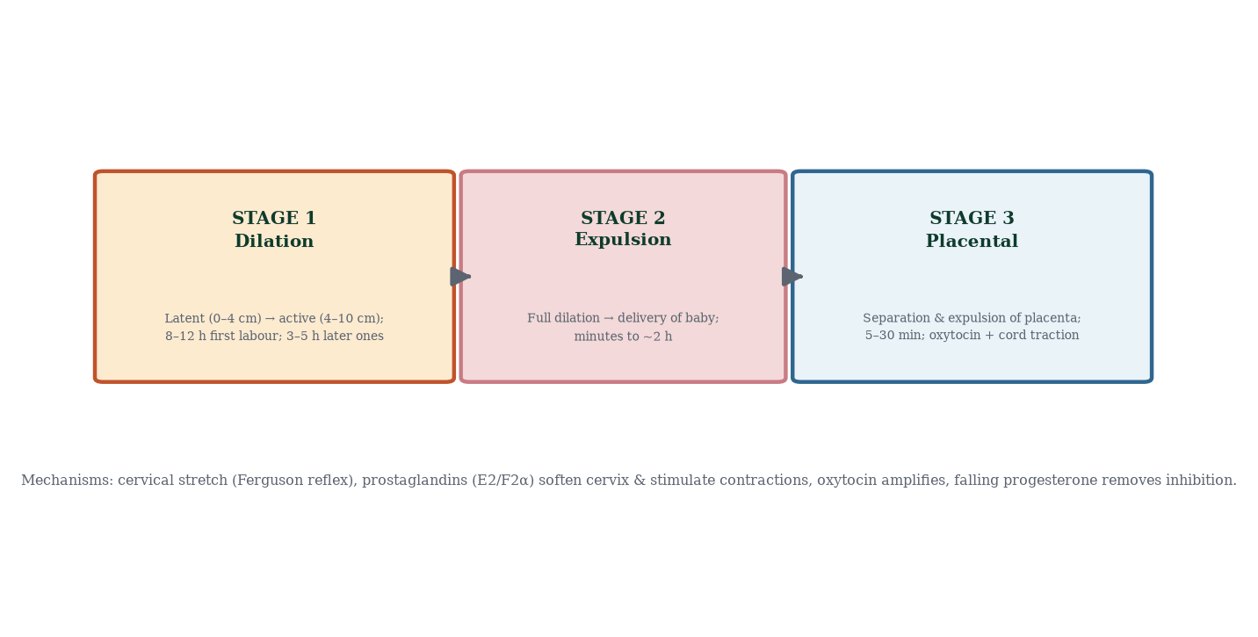
Figure 16.2 — The three stages of labour and their mechanisms.

16.5 The immediate postpartum period
- Uterine involution — uterus shrinks from ~1 kg to ~60–70 g over ~6 weeks; fundus descends ~1–2 cm/day; complete by ~6 weeks. Facilitated by oxytocin surges (breastfeeding triggers them — evolutionary design: suckling → uterine contraction → less bleeding).
- Lochia — vaginal discharge: rubra (days 1–4, red — blood/decidua), serosa (days 4–10, pink/brown), alba (up to 6 weeks, white/yellow/leukocytes). Persistent/foul lochia → infection.
- Breast changes — colostrum immediately postpartum; milk “comes in” day 2–5 (Chapter 17); prolactin and oxytocin maintain lactation.
- Haemodynamic shift — cardiac output remains elevated days; plasma volume falls; diuresis; risk of thromboembolism maximal at 6 weeks postpartum (hypercoagulability of pregnancy persists — VTE prophylaxis after caesarean/high-risk).
- Mood changes — “baby blues” (day 3–10, common, self-limiting) vs postpartum depression (10–15%, requires treatment — screen with EPDS); psychosis (rare, emergency).
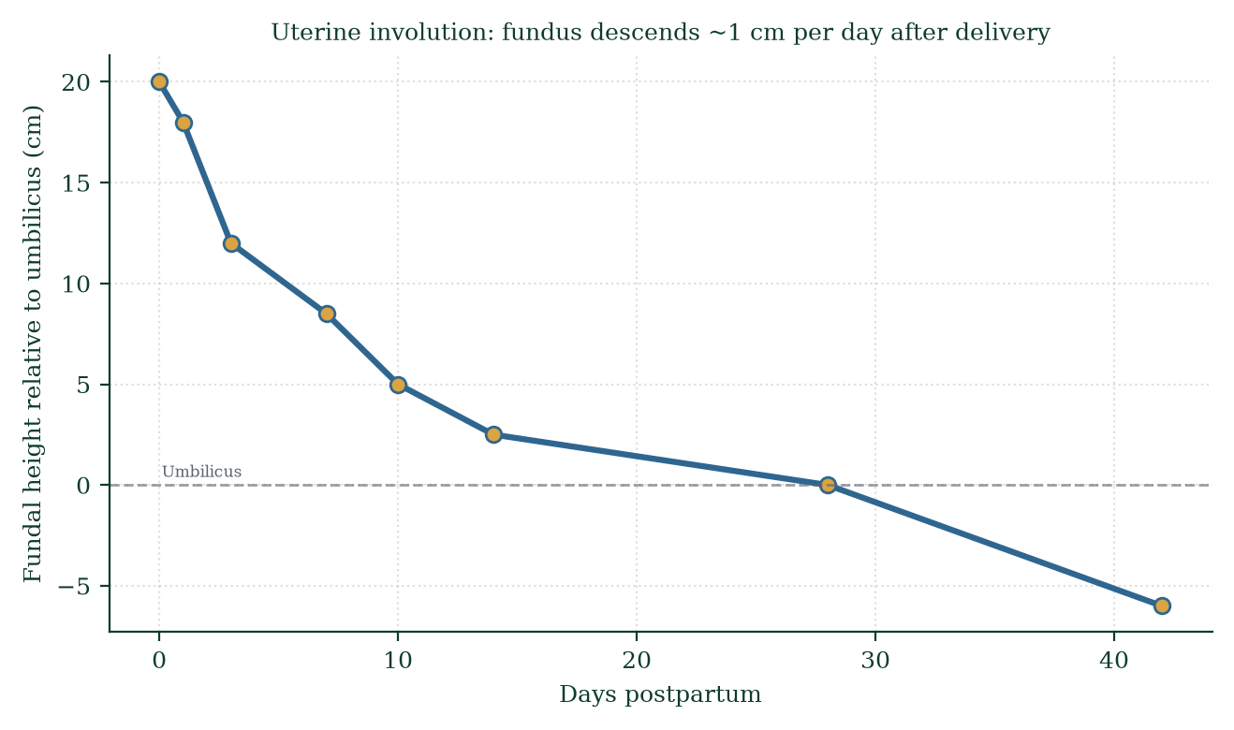
Figure 16.4 — Uterine involution: fundal height relative to umbilicus falls roughly 1 cm per day; uterus returns to pelvis by ~day 14.

16.6 Postpartum recovery in fuller scope
Recovery domains: (1) uterine involution; (2) perineal healing (tears, episiotomy); (3) continence (pelvic floor rehabilitation); (4) breastfeeding establishment; (5) contraception resumption (ovulation may return before menses — prolactin suppresses but doesn’t reliably prevent ovulation; lactational amenorrhoea method only valid under strict criteria); (6) nutrition and anaemia recovery; (7) vaccination (Tdap, influenza) — reflect maternal health post-birth; (8) return of sexual activity (usually advised after ~6 weeks, perineal healing permitting); (9) mental health screening; (10) postpartum review at 6 weeks (BP, wounds, mood, contraception, contraception).

16.7 Clinical spotlights
- Induction of labour — prostaglandin E2 (cervical ripening), misoprostol, oxytocin infusion; Foley catheter balloon; indications: post-term, pre-eclampsia, IUGR, diabetes, ruptured membranes, maternal request ≥39 weeks.
- Augmentation — oxytocin during established labour for suboptimal progress; monitor closely (uterine hyperstimulation, CTG changes).
- Preterm labour — tocolytics (nifedipine, atosiban) to gain 48 h for steroids; magnesium sulfate neuroprotection; cerclage for incompetence.
- Postpartum haemorrhage drills — oxytocin 10 IU; ergometrine if no hypertension; carboprost if no asthma; tranexamic [35] acid within 3 h; balloon tamponade; theatre for surgical options — a well-rehearsed protocol saves lives.
- Puerperal sepsis — fever postpartum: endometritis (tender uterus, foul lochia) — broad-spectrum antibiotics; perineal wound infection.

16.8 Mechanism in depth: the molecular anatomy of a contraction
A uterine contraction is a smooth-muscle event built on the same machinery as vascular smooth muscle, but far more powerful. Each contraction wave:
- Action potential propagation — oestrogen has upregulated gap junctions (connexin-43) between myometrial cells — the uterus is now an electrical syncytium; one excited cell propagates the wave fundus-to-cervix.
- Oxytocin receptor saturation — maternal oxytocin receptors rise ~100-fold near term (progesterone withdrawal permits this); oxytocin binding → Gq protein → phospholipase C → IP3 + DAG → IP3 opens ER Ca²⁺ channels → cytosolic Ca²⁺ rises.
- Calcium–calmodulin → MLCK — Ca²⁺-calmodulin activates myosin light-chain kinase → phosphorylates myosin light chains → actin–myosin cross-bridge cycling → force generation.
- Prostaglandins PGE2/PGF2α potentiate every step — they sensitise cells to oxytocin and directly trigger contractions; hence NSAIDs (indomethacin) stop preterm labour by blocking cyclooxygenase-derived PG synthesis (with fetal risks — ductus arteriosus closure — hence limited use).
- Myometrial retraction — after each contraction, cells shorten permanently; the uterus progressively thickens at the top and thins at the lower segment/cervix — the geometry that allows a 3.3 kg baby to exit through a 10 cm cervix.
- Relaxin + collagen remodelling — cervical ripening dissolves collagen cross-links via MMP-1/8/9 under prostaglandin control; the cervix transitions from rigid to plastic — softening precedes dilation (a rigid cervix will not dilate — hence the role of ripening agents).

16.9 Evidence checkpoint (labour management)
- Delayed cord clamping (≥60 s) increases neonatal iron stores — recommended for vigorous term infants.
- Routine episiotomy is not recommended — restrictive use only; perineal tears are preferable to prophylactic cuts.
- Continuous CTG in low-risk labour does not improve perinatal outcomes and increases caesarean risk — intermittent monitoring is preferred; reserved for high-risk.
- Freedom of movement in labour reduces instrumental delivery rates vs continuous supine positioning.
- Tranexamic acid within 3 h of birth reduces PPH-related death in studies (WOMAN trial) — an inexpensive, mechanism-based antifibrinolytic.
- Skin-to-skin at birth improves thermoregulation, breastfeeding initiation and bonding.

16.10 Mechanisms and evidence in depth: cervical ripening — the prelude to labour
Cervical ripening (“softening and opening”) precedes dilation by days–weeks. Collagen dissolution: matrix metalloproteinases (MMP-1, MMP-8, MMP-9) degrade type I/III collagen; cervical glycosaminoglycans (dermatan sulfate narrows spacing between collagen fibrils less rigidly), inflammatory cells influx (monocytes → macrophages releasing IL-1β, TNF-α, IL-8), prostaglandin E2 and F2α actions. When ripening is inadequate, induction of labour fails — hence mechanical (Foley balloon) and pharmacological (PGE2, misoprostol) ripening as clinical step before oxytocin; Bishop score quantifies readiness.
Labour pharmacology by mechanism. Oxytocin agonists (syntocinon) — myometrial contractions; prostaglandins (PGE2) — ripening + contractions; ergometrine — smooth muscle including uterus and vessels (avoid in hypertension); tocolytics — β2-agonists, calcium channel blockers, NSAIDs (indomethacin) suppress contractions to delay preterm labour (used for 48 h, for steroid maturation). Magnesium sulfate — for eclampsia prophylaxis/treatment and fetal neuroprotection. Tranexamic acid — anti-fibrinolytic, first-line adjunct in major haemorrhage (WOMAN trial).

Common errors in labour reasoning
- “Oxytocin starts labour.” — it amplifies started labour; the trigger is not one molecule.
- “Back labour means malposition.” — occiput posterior causes severe back pain — cardinal movement sequence explains.
- “Postpartum bleeding is always uterine atony.” — trauma (tears, episiotomy), tissue (retained placenta), thrombin (coagulopathy) — the 4 Ts mnemonic — mechanism triage.

16.11 Clinical reasoning vignettes
Case 1. A 29-year-old at 39 weeks, regular contractions, cervix 4 cm. She asks why her contractions “come every five minutes but don’t feel like much”. Mechanism: efficient contractions are pacemaker waves across the fundus; coordinated by connexin-43 syncytium; gap junctions mature with oestrogen dominance; cervical dilation occurs only with synchronous contractions against yielding cervix.
Case 2. A multipara in active labour, 8 cm, syntocinon infusion running; FHR late decelerations. Mechanism: uteroplacental insufficiency + hyperstimulation — stop the infusion, reposition (left lateral), IV fluids, consider tocolysis (terbutaline), expedite delivery if no recovery.
Case 3. Third stage, placenta not delivered in 30 min despite controlled cord traction and uterine massage. Mechanism: retained placenta — placenta accreta spectrum (prior caesarean risk) or abnormal adherence; manual removal under anaesthesia; mechanism-based triage.

Self-check — can you derive these without notes?
- Describe the molecular chain: oxytocin → Gq → PLC → IP3/DAG → Ca²⁺ → MLCK → contraction.
- Explain cervical ripening versus dilation — different mechanisms, different therapies.
- Trace the four cardinal movements of the vertex presentation.
- Explain controlled cord traction/signalling in active management of third stage.
- Derive the mechanism of primary postpartum haemorrhage — uterine atony, trauma, retained tissue, coagulopathy.

Chapter summary
- Labour onset: functional progesterone withdrawal, oestrogen rise, prostaglandin activation, mechanical stretch, Ferguson-reflex oxytocin positive feedback, fetal CRH clock.
- Stage 1 dilation (latent 0–4 cm, active 4–10) — contractions fundal-dominant; cervix effaces/dilates under prostaglandins/MMP remodelling.
- Stage 2 expulsion with cardinal movements; Stage 3 placental separation with oxytocin-contracted uterus limiting haemorrhage.
- Active management of third stage (oxytocin + cord traction + massage) cuts PPH risk.
- Involution ~1 cm/day; lochia sequence rubra→serosa→alba; postpartum hypercoagulability peaks ~6 weeks.
- Postpartum recovery spans physical, endocrine, immunological, metabolic and psychological domains.

Key terms
Ferguson reflex — cervical stretch → oxytocin positive feedback. Effacement — cervical thinning. Friedman curve — dilatation vs time. Retraction — incomplete relaxation between contractions. Cardinal movements — seven fetal rotations of birth. Schultze/Duncan mechanism — placental presentation variants. Lochia — postpartum discharge. PPH — postpartum haemorrhage (>500/1000 mL). Uterotonics — contraction agents. Involution — uterine shrinkage ~1 cm/day. Braxton Hicks — practice contractions.

Review questions
Multiple choice
- The primary driver of first-stage contractions is:
  - oxytocin alone b) prostaglandins + oxytocin interplay with oestrogen priming c) maternal effort d) fetal movement
- The Ferguson reflex describes:
  - milk ejection b) cervical stretch → oxytocin release c) neonatal suckling d) uterine quiescence
- The active phase of labour begins at:
  - 0 cm b) 2 cm c) 4 cm d) 8 cm
- Full cervical dilatation is:
  - 5 cm b) 7 cm c) 10 cm d) 12 cm
- Active management of third stage includes:
  - expectant monitoring only b) oxytocin + cord traction + uterine massage c) caesarean d) nothing
- The “living ligatures” that limit postpartum bleeding are the:
  - cervical muscles b) retraction of oblique myometrial fibres around spiral arterioles c) pelvic floor d) perineal muscles
- Lochia rubra corresponds to:
  - days 1–4 b) days 4–10 c) weeks 2–4 d) after 6 weeks
- VTE risk is highest during:
  - first trimester b) second trimester c) the 6 weeks postpartum d) labour
Short answer
- List the four key drivers of labour onset.
- Explain the difference between Braxton Hicks and true labour contractions.
- Describe the cardinal movements of labour in order.
- Define postpartum haemorrhage and outline first-line management.
Explanation
- Explain, mechanistically, why oxytocin’s positive feedback loop terminates at delivery.
- Explain why breastfeeding accelerates uterine involution.
- Walk through active management of the third stage and the mechanism of each component.
Application
- A woman in labour at 39 weeks has painful, irregular contractions every 8 minutes and cervix 1 cm. Explain the phase and expected natural history.
- A woman 20 minutes post-delivery develops heavy bleeding with a boggy uterus. Most likely cause and mechanism; outline management.
- At day 3 postpartum, a woman reports mood swings, tearfulness, anxiety. Is this normal? Distinguish from pathology.

Answers to review questions
- b. Oestrogen primes receptors; prostaglandins dilate/ripen; oxytocin amplifies contractions; progesterone withdrawal removes the brake.
- b. Classic positive feedback loop.
- c. ~4 cm marks active phase (modern definitions vary 4–6 cm).
- c. 10 cm = full dilatation — fetal head can pass.
- b. Oxytocin 10 IU IM/IV + controlled cord traction + fundal massage — reduces PPH.
- b. Interlacing oblique fibres clamp spiral arterioles.
- a. Rubra days 1–4 → serosa 4–10 → alba up to 6 weeks.
- c. Hypercoagulability peaks postpartum (persists ~6 weeks).

  - Functional progesterone withdrawal (PR isoform switch), (ii) oestrogen rise (oxytocin receptors, gap junctions), (iii) prostaglandins (ripening + contractility), (iv) stretch/Ferguson reflex + fetal CRH timing clock.
- Braxton Hicks: irregular, painless (or mildly uncomfortable), unchanged cervix, do not strengthen over time, subside with rest/hydration — false labour; true contractions: regular, rhythmic, intensify, cause progressive cervical change.
- Engagement → descent → flexion → internal rotation → extension → restitution → external rotation/expulsion — seven cardinal movements navigating the pelvic curve.
- 500 mL vaginal / >1000 mL caesarean blood loss; causes: atony (commonest), trauma, retained products, coagulation — 4 Ts; first-line: oxytocin, uterine massage, bimanual compression, ergometrine/carboprost/misoprostol/tranexamic acid; escalate to balloon/surgical (B-Lynch, ligation, hysterectomy).
- Delivery removes the stimulus (cervical stretch + uterine distension) → afferent signal stops → hypothalamus stops phasic oxytocin surge → contractions subside; the system only sustains itself while the cervix is stretched — a self-extinguishing positive feedback loop.
- Suckling → afferent nerves → hypothalamus → posterior pituitary oxytocin → myometrial contraction → uterine tightening → reduced bleeding and faster involution — physiology couples nutrition of the infant to maternal recovery.
- Oxytocin at delivery → sustained contraction → immediate clamping of spiral arterioles; controlled cord traction → delivers placenta without inversion; uterine massage → maintains tone; early skin-to-skin + cord blood — combined, they cut PPH incidence by ~60% vs expectant care.
- Latent phase; may linger hours; contractions will become longer, stronger, more regular; cervix effaces and begins to dilate; latent → active transition when contractions every 3–5 min and cervical change; reassurance, hydration, ambulation; analgesia/epidural if desired — no need to admit if membranes intact and low-risk.
- Uterine atony — the uterus has failed to retract effectively after delivery (multiparity, prolonged labour, multiple gestation, polyhydramnios, anaesthesia, retained placenta) → bleeding from spiral arteriole beds; management: uterine massage, oxytocin, ergometrine, carboprost, misoprostol, tranexamic acid, IV access, crossmatch, balloon/surgical if refractory.
- “Baby blues” (50–80%) at day 3–5 — mood swings, tearfulness, anxiety — self-limiting ≤2 weeks, reassurance, support, sleep, feeding help; postpartum depression (>2 weeks persistent, anhedonia, functional decline, thoughts of harm) — requires screening (EPDS) and treatment (therapy ± SSRI — compatible with breastfeeding); psychosis — emergency.

Chapter 17: Lactation and Breast Physiology
Learning objectives. After studying this chapter you should be able to: - describe mammary gland development across puberty, pregnancy and lactation; - explain the hormonal control of milk synthesis (prolactin [1]) and milk ejection (oxytocin); - describe colostrum, transitional and mature milk composition; - explain physiological changes during breastfeeding and weaning; - relate lactation to contraception, fertility and maternal bonding.
Central question. How does a nutrient factory that lies dormant for decades spring into production within hours of birth — and run itself afterwards with nothing more than a baby’s suckling?

17.1 Development of the breast across the lifespan
The breast begins as an ectodermal thickening (“mammary ridge”, week 4–6) that canalises to form the ductal tree long before birth. At puberty, oestrogen (+ growth hormone) drives duct elongation and branching; progesterone (after menarche) develops lobuloalveolar units; adipose and connective tissue grow. Across each cycle, minor changes occur (mild oedema and tenderness premenstrually). In pregnancy, the full programme activates: oestrogen + progesterone complete lobuloalveolar proliferation, ducts/sinuses enlarge, areola darkens, Montgomery glands enlarge; the breast can nearly double in mass. By mid-pregnancy, alveolar secretory cells produce colostrum (small amounts leak). After birth, delivery removes placental progesterone/oestrogen — and lactation begins.

17.2 Milk synthesis — the prolactin–progesterone handoff
- Progesterone withdrawal at delivery is the single most important trigger: progesterone blocks prolactin’s full milk-synthetic effect at the alveolar cell. Removing it, prolactin can act — milk “comes in” day 2–5 (lactogenesis II).
- Prolactin (anterior pituitary) binds prolactin receptors on alveolar cells → JAK–STAT signalling → transcription of milk protein genes (β-casein, α-lactalbumin), lactose synthetase expression (drives lactose + water volume), lipid synthesis (short/medium-chain fatty acids).
- Prolactin secretion is under tonic dopaminergic inhibition from the hypothalamus; suckling reduces dopamine → prolactin surges with each feed (breast emptying triggers the next supply).
- Milk removal (“supply = demand”) is essential: milk accumulation raises feedback inhibitor of lactation (FIL) in the alveoli → signals alveolar cells to down-regulate synthesis → diminished supply without emptying. This is the mechanistic basis of the frequent-feed advice and of early-lactation faltering when scheduled feeding replaces demand feeding.
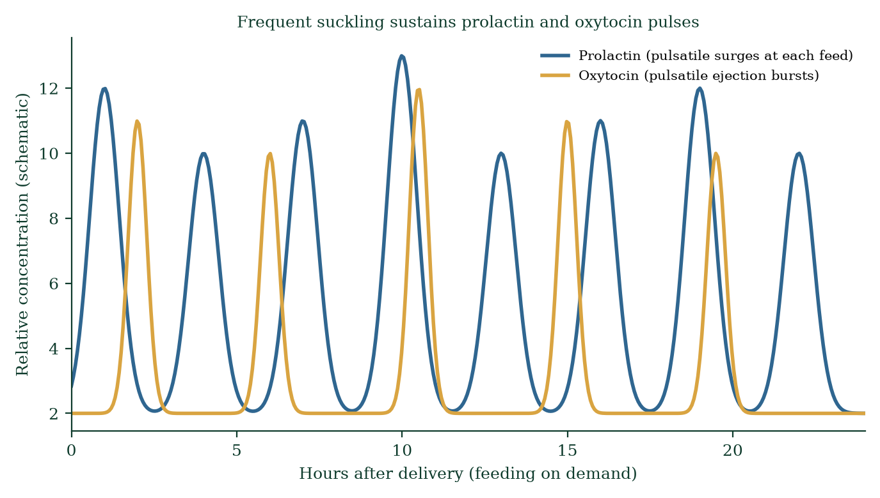
Figure 17.3 — Prolactin and oxytocin surges at each feed sustain lactation; feed frequency drives supply.

17.3 Milk ejection — the oxytocin reflex
Prolactin fills the breast; oxytocin empties it. Suckling stimulates nipple afferents → spinal cord → hypothalamus → posterior pituitary oxytocin release in pulses → myoepithelial cells around alveoli contract → milk ejected into ducts → available at the nipple. This is a conditioned reflex — it can be triggered by seeing, hearing, thinking of the baby; it can be inhibited by stress (adrenaline blocks oxytocin — hence the myth of “milk drying up with worry” has real hormonal basis).
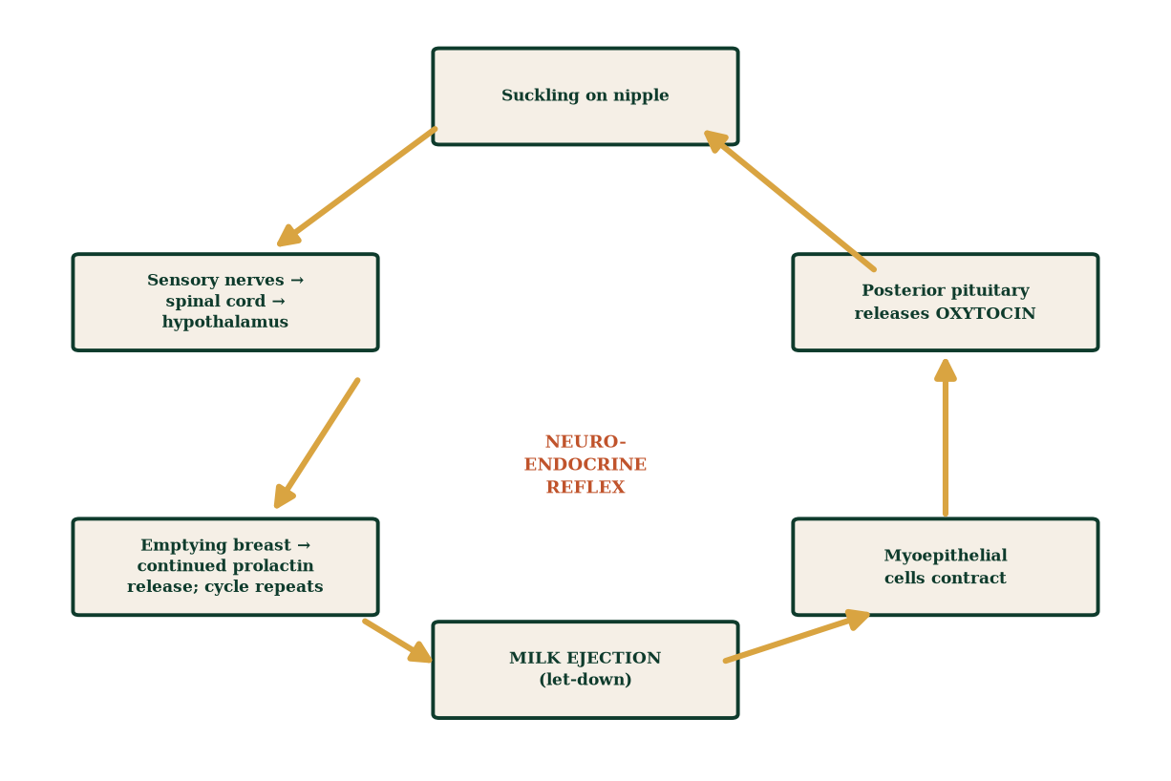
Figure 17.2 — The milk-ejection (let-down) reflex: suckling → oxytocin → myoepithelial contraction → milk flow; a conditioned neuroendocrine loop.

17.4 Milk composition through time
Colostrum (days 0–4): small volumes (~30–90 mL/day), thick, yellow, rich in protein (immunoglobulin A — mucosal immunity; lactoferrin; lysozyme), leukocytes, growth factors (EGF — gut maturation), vitamin A, minerals; low fat, low lactose, mild laxative (helps pass meconium; prevents jaundice by reducing enterohepatic bilirubin reabsorption). Nature’s first immunotherapy and gut primer.
Transitional milk (days 5–14): volume surges; fat and lactose rise; immunoglobulins fall.
Mature milk (week 2+): ~750–800 mL/day (exclusive feeding); foremilk (watery, thirst-quenching) vs hindmilk (fat-rich, satiety); energy ~65–70 kcal/100 mL; protein ~0.9 g/100 mL (whey-predominant — easier to digest than casein-dominant cow’s milk); lactose ~7 g/100 mL (brain development — galactose backbone); fat ~4 g/100 mL (LCPUFAs — DHA crucial for retinal/brain); oligosaccharides (HMOs) — prebiotic, feeding Bifidobacterium infantis (the infant’s gut flora is essentially breastfed by the mother); antibodies (sIgA continually coating gut lining).
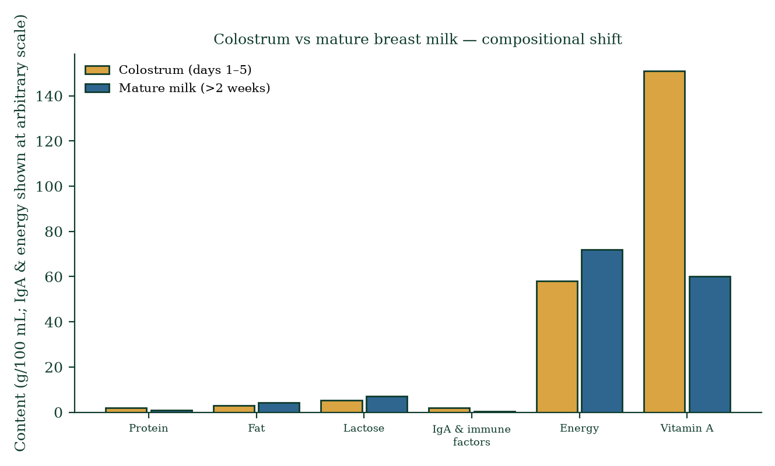
Figure 17.4 — Colostrum vs mature milk composition.

17.5 Physiological changes during breastfeeding
- Maternal: continued amenorrhoea while feeding frequently (prolactin suppresses GnRH pulsatility — lactational amenorrhoea method works only with strict criteria: <6 months, exclusive feeding, amenorrhoea); uterine involution facilitated by oxytocin (Chapter 16); weight loss modest; bone density transient dip (recovered after weaning); need for extra ~500 kcal/day and fluids; iodine and vitamin D considerations.
- Infant: jaw/oral development (sucking mechanics), immunity transfer (respiratory/GI infection reduction ~50% in exclusive breastfeeding [23]), reduced SIDS risk, gut microbiome seeding, attachment/bonding (multisensory — skin, scent, warmth).
- Hormonal: oxytocin also primed for bonding/calm (reduces cortisol); prolactin has mild anxiolytic/sleep-promoting effects in mother (post-feed drowsiness).

17.6 Weaning and involution
Weaning (gradual or abrupt) removes the demand → prolactin/oxytocin pulses fade → alveoli undergo apoptosis → glandular tissue reverts to predominantly adipose state with residual ductal tree; breast size may change; fertility returns as GnRH pulsing resumes. After menopause, further involution; adipose replaces glandular tissue.

17.7 Breast anatomy recap for clinical practice
Breast tissue extends from ~2nd–6th rib, sternum to midaxillary line (tail of Spence into the axilla) — cancers can arise in the tail. Lymphatic drainage (>75% to axillary nodes) — hence axillary staging; medial breast → internal mammary nodes. Any breast lump merits triple assessment: clinical exam + imaging (ultrasound <35, mammography >35) + biopsy. Breastfeeding complications: mastitis (engorgement → duct blockage → infection — Staph. aureus commonest — treat with continued feeding + antibiotics), cracked nipples (latch problem — correct technique, not cessation), engorgement (frequent feeding/pumping).

17.8 Clinical spotlights
- Breastfeeding support — Baby-Friendly Hospital Initiative — skin-to-skin within 1 h, rooming-in, feeding on demand; effective support halves premature cessation.
- Contraindications — maternal HIV (resource-dependent guidance), HTLV-1, active herpes on breast, galactosaemia (infant), TB (until 2 weeks of treatment), chemotherapy/radioactive isotopes.
- Medication review — most drugs compatible; SSRIs low transfer; always check; avoid codeine (ultra-rapid metabolisers → infant morphine toxicity).
- Donor milk banks — for preterm/ill neonates unable to be fed by mother.

17.9 Mechanism in depth: receptor signalling at the alveolar cell
Prolactin receptor (PRLR) is a cytokine-class receptor: ligand binding → receptor dimerisation → JAK2 phosphorylation → recruitment/phosphorylation of STAT5 → nuclear STAT5 dimers bind milk-protein gene promoters (β-casein, WAP, α-lactalbumin) → transcription. Lactose synthesis is the volume driver: α-lactalbumin + galactosyltransferase = lactose synthetase; lactose’s osmotic pull draws water into the lumen — milk volume tracks lactose production, which is why prolactin surges directly scale supply.
Oxytocin receptor (OTR) on myoepithelial cells: Gq-coupled → PLC → IP3/DAG → Ca²⁺ rise → contraction. Myoepithelial cells wrap alveoli like a basket — their contraction raises intra-alveolar pressure, forcing milk into the ductal tree. The ducts are lined by epithelium with smooth muscle at intervals — peristaltic waves assist transport to the nipple pores. 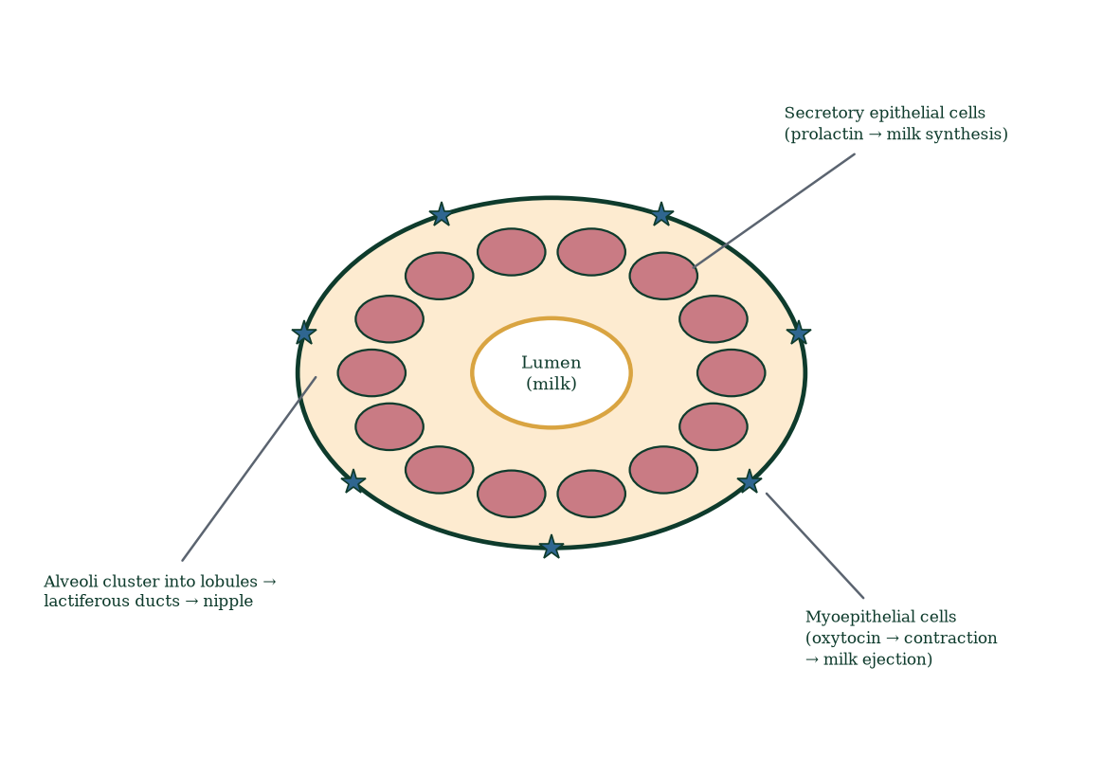
Progesterone’s block — progesterone competes with prolactin for signalling competence via PR-B transcriptional interference and suppression of PRLR expression; it is THE brake on milk synthesis removed abruptly at placental delivery — which is why milk can appear before the first feed if the placenta is retained or removed but breastfeeding is not started (progesterone falls regardless).

17.10 Evidence checkpoint (what breastfeeding does and doesn’t do)
- Exclusive breastfeeding for 6 months halves GI and respiratory infection risk (strong RCT/meta-analytic evidence) and reduces SIDS risk.
- Effect on child IQ: modest (~2–3 points) and confounded by maternal education/socioeconomic status — correlation vs causation caveat again; do not overclaim.
- Effect on maternal breast/ovarian cancer risk: protective in large cohort studies; dose-related.
- “Breast is best” is directionally true but must be delivered without guilt: formula feeding is safe; differences in high-income settings are modest; maternal mental health and realistic capacity matter — support, not judgement, is the intervention.

17.11 Mechanisms and evidence in depth: milk synthesis cell biology
The alveolar secretory cell is a professional protein factory. Prolactin via PRLR → JAK2 → STAT5 → milk protein gene transcription (β-casein, WAP, α-lactalbumin, κ-casein). α-Lactalbumin modifies galactosyltransferase into lactose synthetase — producing lactose from glucose and galactose; lactose’s osmotic pull draws water into the lumen (milk is ~87% water but osmolar regulation is by lactose). Triglycerides synthesised from glucose/short-chain fatty acid uptake via lipoprotein lipase; secretory vesicles package casein micelles; apical exocytosis releases them with water and electrolytes; fat droplets bud off by apocrine secretion with membrane cloak. Tight junctions paracellular pathways seal the lumen at early lactogenesis but leak during weaning/mastitis.
FIL — the autocrine supply throttle. Whey protein feedback inhibitor of lactation (FIL) accumulates locally as milk stasis builds; FIL reversibly inhibits further milk protein synthesis — supply auto-regulates on a per-breast basis, explaining cluster feeding, one-sided dominance, and engorgement resolution with emptying. Mechanism, again, trumps willpower.
HMOs (human milk oligosaccharides) — >150 identified structures; indigestible by infants; prebiotic substrates selectively feeding bifidobacteria; decoy receptors trapping pathogens; immune-active metabolites from gut fermentation. No formula has matched this complexity — genuine reason to value breastmilk.

Common errors in lactation reasoning
- “Breasts must be emptied at every feed.” — no; drainage is matched by FIL; partial emptying is the norm.
- “Mastitis always requires antibiotics.” — Quite common early; treat with continued drainage + analgesia first; antibiotics if systemic signs or >24–48 h.
- “Most women can’t make enough milk.” — perceived insufficiency is common; true low supply is rare (<5%) and often fixable.

17.12 Clinical reasoning vignettes
Case 1. A first-time mother, day 3 postpartum, breasts rock-hard, baby struggling to latch, crying, mother exhausted. Mechanism: primary engorgement — milk synthesis begins (progesterone withdrawal) faster than emptying; firm areolae prevent effective latch; baby gets no milk → more signal → more stasis → more engorgement. Solution: hand expression/skin-to-skin/short frequent feeds; soften areolae before latch; reassure — this is the classic day-3 crisis; supportive lactation consultant.
Case 2. A 4-week breastfeeding mother develops a tender, red, wedge-shaped area on the upper outer breast with fever 38.4 °C. Mechanism: mastitis — Staphylococcus aureus ascends through cracked nipple ducts + milk stasis → infection. Continue feeding (does not harm baby), analgesics, warm compress; antibiotics if systemic toxicity or >24–48 h without improvement.
Case 3. A 35-week pregnancy with painless, spontaneous bloody nipple discharge, bilateral ducts. Mechanism: physiological — pregnancy can produce colostrum-like discharge from ductal stimulation. Distinguish from single-duct spontaneous bloody discharge (papilloma, carcinoma) — clinical evaluation if pathological pattern.

Self-check — can you derive these without notes?
- Trace the pathway: prolactin → JAK/STAT → β-casein gene transcription.
- Explain the feedback inhibitor of lactation (FIL) autocrine loop.
- Derive why suckling suppresses fertility (hypothalamic dopamine ↔/↓GnRH pulses).
- Explain why breastfeeding should begin within minutes of birth.
- Describe the myoepithelial cell basket anatomy and its oxytocin responsiveness.

Chapter summary
- Mammary development: ridge → ducts (oestrogen, puberty) → alveoli (progesterone, cycles) → proliferation (pregnancy) → secretion (post-labour progesterone withdrawal).
- Prolactin = synthesis (alveolar cells, FIL feedback); oxytocin = ejection (myoepithelial cells, conditioned reflex); supply = demand.
- Colostrum nourishes and immunises; mature milk evolves; HMOs feed the infant’s microbiome.
- Lactation suppresses fertility (LAM criteria); involution follows weaning.
- Clinical: support, mastitis management, drug review, contraindications.

Key terms
Lactogenesis I/II — colostrum onset / milk “coming in”. Prolactin — milk synthesis hormone. Oxytocin — milk ejection hormone. Myoepithelial cells — contractile cells ejecting milk. FIL — feedback inhibitor of lactation. Colostrum — first milk, immunological. HMOs — human milk oligosaccharides. LAM — lactational amenorrhoea method. Montgomery glands — areolar sebaceous secretions. Cooper’s ligaments — suspensory apparatus.

Review questions
Multiple choice
- Milk “comes in” after birth mainly because of:
  - rising oestrogen b) progesterone withdrawal with unopposed prolactin c) oxytocin surge d) suckling alone
- The hormone responsible for milk ejection is:
  - prolactin b) oxytocin c) oestriol d) hPL
- Colostrum is especially rich in:
  - lactose b) sIgA c) fat d) water
- Milk removal is necessary to maintain supply via:
  - prolactin surges b) FIL accumulation when breast full c) oxytocin d) cortisol
- Breast lymph drains mostly to:
  - internal mammary b) para-aortic c) axillary nodes d) inguinal
- Lactational amenorrhoea requires:
  - any breastfeeding b) exclusive feeding <6 months + amenorrhoea c) pumping only d) night feeds only
- The “let-down” reflex is mediated by:
  - prolactin only b) conditioned oxytocin release c) voluntary muscle d) adrenaline
- Which mammalian gland product uniquely feeds infant gut flora?
  - lysozyme b) HMOs c) casein d) lactose
Short answer
- Outline mammary development from ridge to lactating breast (timeline).
- Explain the FIL autocrine feedback mechanism.
- Describe the conditioning of the let-down reflex.
- List four clinical contraindications to breastfeeding.
Explanation
- Explain why progesterone withdrawal is the trigger for lactogenesis II, mechanistically.
- Compare colostrum and mature milk and explain the “first vaccine” concept.
- Walk through a full breastfeeding feed — hormonal sequence from infant rooting to infant satiety.
Application
- A mother on day 2 postpartum reports breasts “not in yet” and worries. Explain expected timeline and support actions.
- A mother on day 5 has a painful, red, hot breast and fever. What is the likely diagnosis, mechanism and management?
- A mother asks whether she can use LAM as contraception. State the exact criteria and the failure caveat.

Answers to review questions
- b. Progesterone withdrawal unleashes prolactin’s full effect — lactogenesis II.
- b. Oxytocin → myoepithelial contraction.
- b. sIgA; also lactoferrin, EGF, vitamin A.
- b. FIL accumulates when milk stays → down-regulates synthesis → supply follows demand.
- c. >75% to axillary (levels I–III) — hence axillary staging.
- b. Strict criteria; >98% effective only with all three.
- b. Conditioned neuroendocrine reflex — sight/sound/thought can trigger oxytocin.
- b. Oligosaccharides feed Bifidobacterium infantis specifically.
- Ridge (week 4–6) → canalised ducts → prepubertal latency → pubertal ductal growth (oestrogen) → luteal alveolar growth → pregnancy lobuloalveolar proliferation → colostrum mid-pregnancy → lactogenesis II post-delivery → mature milk ~week 2+ → involution on weaning.
- Milk stasis → FIL (whey protein) accumulates in alveolar lumen → binds receptors suppressing synthesis → supply diminishes; emptying removes FIL → synthesis resumes — the autocrine basis of demand-feeding.
- Suckling afferents → hypothalamus; repeated pairing of contexts (infant cues) with feeds recruits higher centres — seeing/hearing baby → conditioned oxytocin release before suckling starts (milk leaks in anticipation); stress/catecholamines suppress it — hence environment matters clinically.
- Maternal HIV (where indicated by guidelines), HTLV-1/2, galactosaemia, active untreated TB/herpes lesions on breast, ongoing chemotherapy/radioactive isotopes, substance use per guidelines — individualise.
- Progesterone competitively inhibits prolactin receptor signalling at the alveolar cell; delivery drops it within hours–days → prolactin receptors unblocked → full milk protein/lactose transcription → massive volume rise on day 2–5; prolactin is present during pregnancy but functionally held off the trigger.
- Colostrum: low fat, high immunoglobulin A, leukocytes (macrophages, lymphocytes), growth factors, laxative — immunological adaptation and gut maturation + meconium passage; mature milk: energy-dense, growth-oriented — different jobs; “first vaccine” because sIgA coats the infant gut lumen, neutralising pathogens before they penetrate — passive mucosal immunity specific to the mother’s environment.
- Infant rooting/sucking → nipple afferents → spinal → hypothalamus: (i) dopamine falls → prolactin surge for next feed; (ii) oxytocin pulses → myoepithelial contraction → let-down after ~30–60 s of suckling; milk flows; infant feeds (foremilk→hindmilk); satiety signals; mother feels calm (oxytocin); breasts empty (FIL cleared) → synthesis resumes; repeat every 2–3 h in early weeks.
- Normal — colostrum precedes full milk; day 2–5 typical for “milk in”; support exclusive feeding 8–12×/24 h, skin-to-skin, check latch, avoid formula top-ups unless medically indicated, monitor wet/dirty nappies and weight; recheck day 3–4; reassurance — colostrum is low volume by design and sufficient.
- Lactational mastitis — duct occlusion/engorgement → milk stasis → bacterial overgrowth (Staph. aureus) → inflammation; manage with continued emptying (feed/pump — do not stop), warm compresses, analgesia (ibuprofen), antibiotics if not improving in 24–48 h or systemic illness (flucloxacillin), check latch, rest; abscess needs drainage; breastfeeding usually continues safely with infection.
- LAM effective only if: (1) <6 months postpartum, (2) exclusive/near-exclusive breastfeeding, (3) amenorrhoea persists — together ~98% effective. Any breach (supplementing, return of menses, >6 months) → use other contraception; ovulation precedes first menses — do not wait for a period to act.

Chapter 18: Reproductive Health, Fertility, Contraception, and Reproductive Disorders
Learning objectives. After studying this chapter you should be able to: - define fertility, infertility [11] and fecundability; - explain the mechanisms of major contraceptive methods; - describe assisted reproductive technologies and their mechanisms; - explain common reproductive disorders mechanistically (PCOS, endometriosis, fibroids, ED, cancers, menopause); - distinguish biological mechanism from clinical diagnosis and treatment.
Central question. How do we intervene — safely, effectively and ethically — in a system this fundamental, and what does each intervention do to the mechanism?

18.1 Fertility and infertility defined
Fertility — the capacity to conceive; fecundability — probability of conception per cycle (~20–30% at peak fertility; ~10% by 38; ~5% by 42); infertility — failure to conceive after 12 months of regular unprotected intercourse (6 months if >35 or known factor). ~1 in 6 couples experience it; ~50% male factor (alone or combined); ~50% female factor; ~10% unexplained. Primary = never conceived; secondary = achieved before but now cannot.

18.2 Contraception — mechanisms, not slogans (Figure 18.1)
Methods and mechanism classes:
- Suppress ovulation — COCP (combined oestrogen+progestin), POP (progestin only), implant (etonogestrel), injection (DMPA), patch/ring: negative feedback → GnRH/LH/FSH suppressed → no follicular development → no ovulation; progestin adds cervical mucus thickening + endometrial thinning. Typical-use failure ~7–9% (COCP), 0.05% implant.
- Barrier — condoms (male/female): prevent sperm entry; only method also protecting against STIs; typical failure ~13–18%.
- Spermicidal/copper — copper IUD: copper ions toxic to sperm (enzyme disruption) ± anti-implantation (endometrial inflammation); >99% effective for 10+ years; emergency contraception within 5 days (most effective).
- Hormonal IUD — levonorgestrel local release: thick cervical mucus + endometrial atrophy (sometimes ovulation suppressed); 3–7 yr.
- Permanent — vasectomy (vas excision — azoospermia after ~3 months/20 ejaculations), tubal ligation (tubal blockage) — near-100%; failure/recanalisation exists; regret risk; consider counselling.
- Fertility awareness methods — BBT, mucus, LH strips (Chapter 8); failure 8–24% typical use — requires discipline.
- Emergency contraception — levonorgestrel 1.5 mg within 72 h (delays ovulation) ~1–2% failure; ulipristal 30 mg within 120 h (progesterone-receptor modulator); copper IUD (most effective) — none cause established pregnancy to terminate.
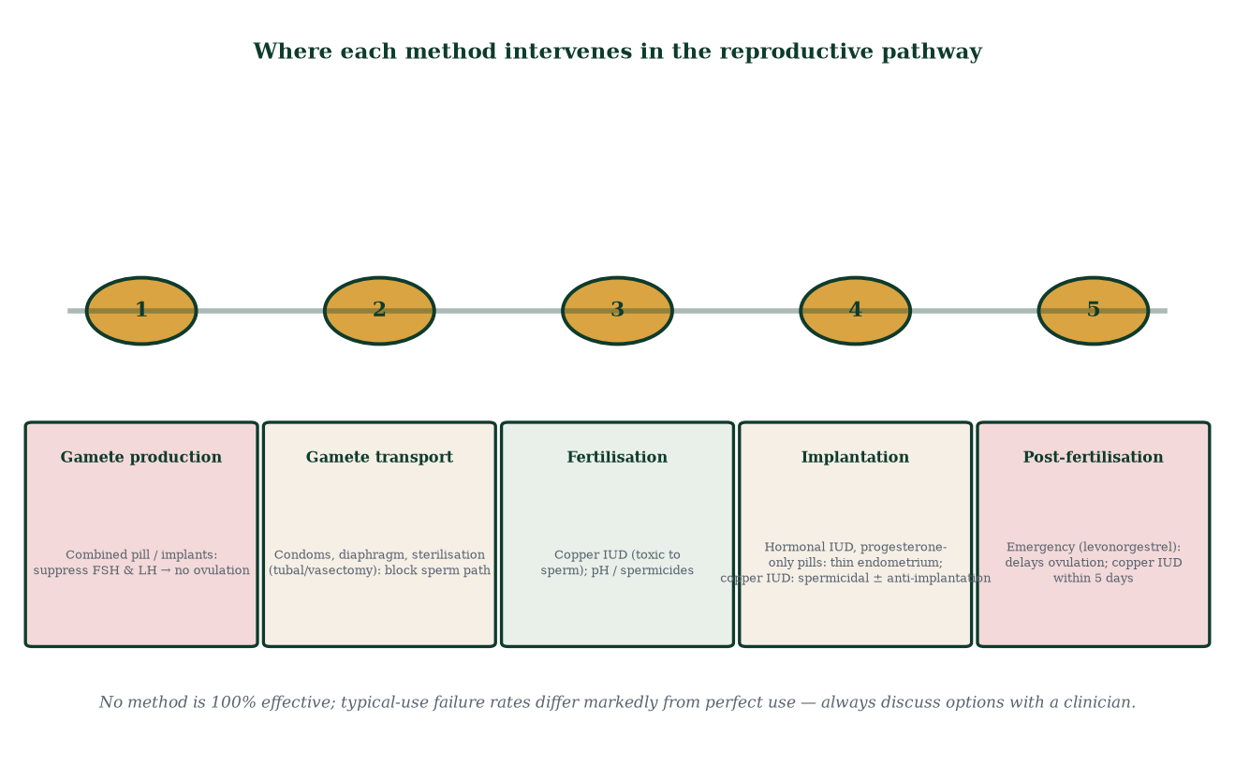
Figure 18.1 — Contraceptive mechanisms mapped onto the reproductive pathway: suppression of ovulation, barriers to transport, post-fertilisation prevention.
Emergency contraception reassurance: none act as abortifacients — they prevent fertilisation/implantation before establishment; copper IUD is effective regardless of body weight and after ovulation.

18.3 Assisted reproductive technologies
- Ovulation induction — clomiphene citrate (oestrogen-receptor antagonist at hypothalamus → ↑GnRH → ↑FSH → cohort growth); letrozole (aromatase inhibitor — reduces oestrogen feedback locally; increasingly first-line, especially PCOS); gonadotrophins (FSH/hMG injections) for poor responders.
- IUI — sperm preparation + timed insemination into uterus; good for mild male factor, cervical factor, unexplained subfertility (~10–20%/cycle).
- IVF — controlled ovarian stimulation (daily FSH ± antagonist) → trigger (hCG or GnRH agonist) → egg collection → fertilisation (conventional or ICSI) → culture to blastocyst (day 5–6) → single embryo transfer → luteal support.
- ICSI — single sperm injected into oocyte — bypasses all sperm-side barriers (Chapter 10); near-universal for severe male factor (<5 million motile/mL or failed fertilisation history).
- PGT — PGT-M (monogenic), PGT-SR (structural rearrangements), PGT-A (aneuploidy) — embryo biopsy at blastocyst stage ± cryopreservation; reduces miscarriage in specific cohorts; does not increase live birth per started cycle broadly.
- Donor gametes/surrogacy — for absolute factor failure (no eggs/uterus); legal/ethical variability.
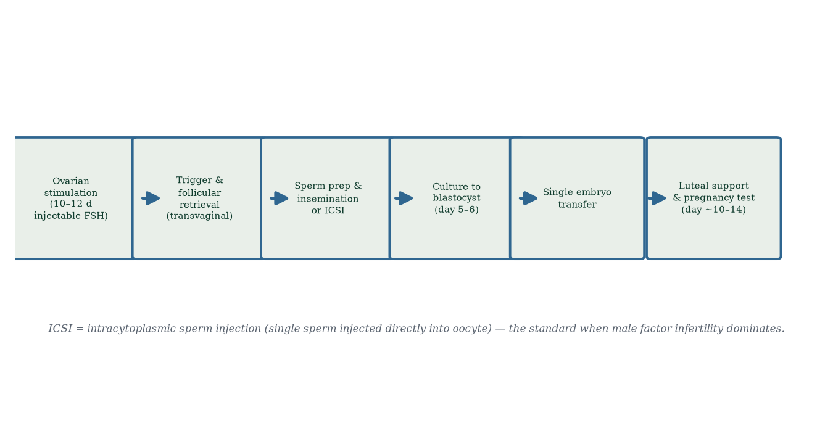
Figure 18.2 — IVF/ICSI pipeline: stimulation → trigger → collection → fertilisation → culture → transfer → luteal support.
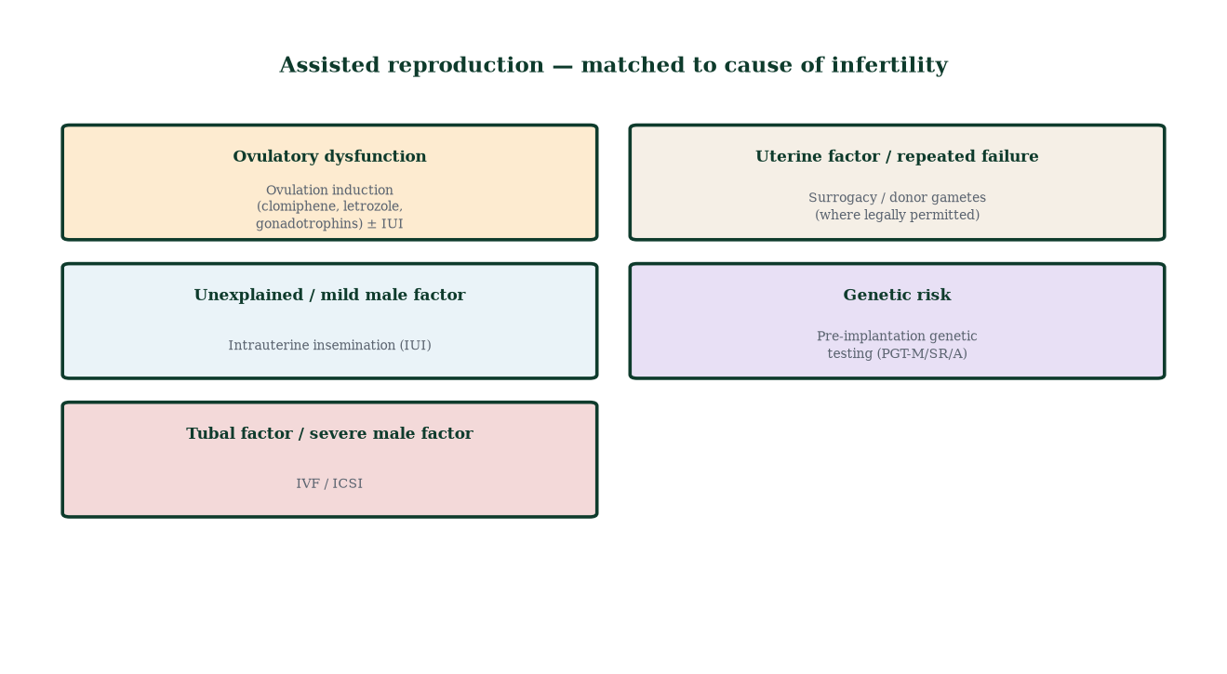
Figure 18.6 — ART matched to cause of infertility: from ovulation induction to full IVF/ICSI.

18.4 The fertile window and fertility awareness
Probability of conception peaks ~2 days before ovulation (Figure 18.3). Sperm survive ≤5 days; oocyte ~12–24 h → only the ~6-day window matters. Natural family planning and fertility apps use BBT, mucus, cycle tracking — accuracy depends on cycle regularity and discipline.
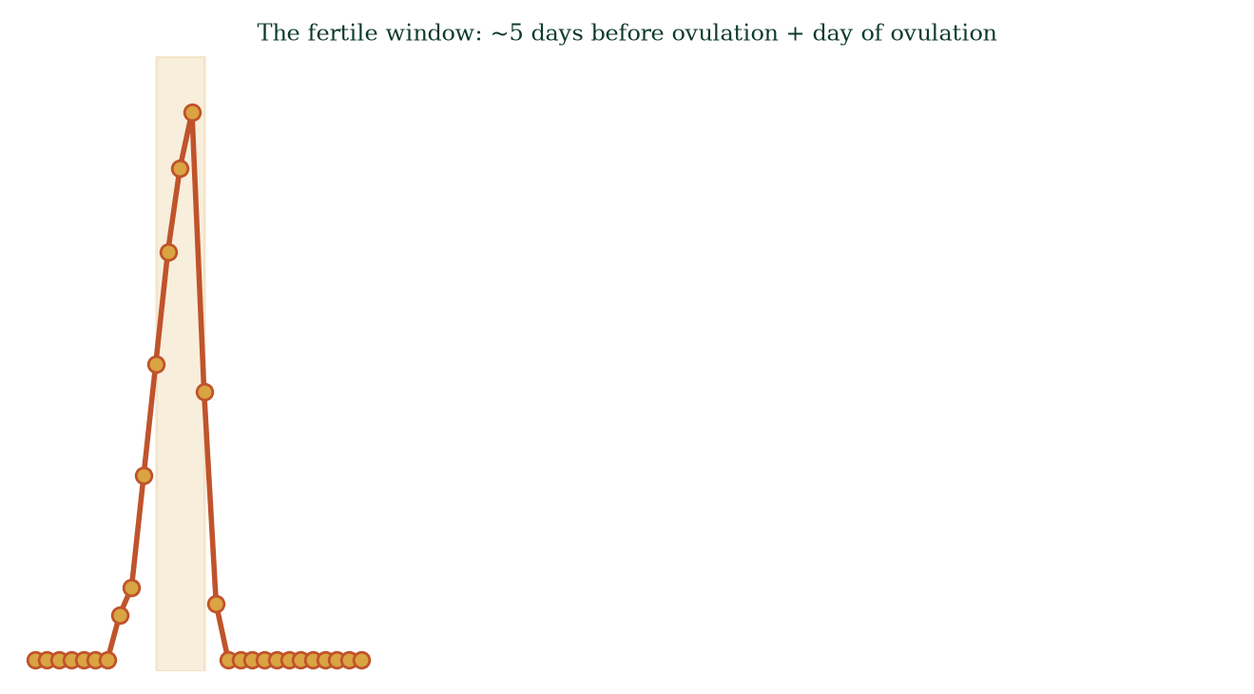
Figure 18.3 — Relative fecundability across the cycle; the fertile window spans ~5 days before ovulation + ovulation day.

18.5 PCOS, endometriosis, fibroids — mechanism comparison
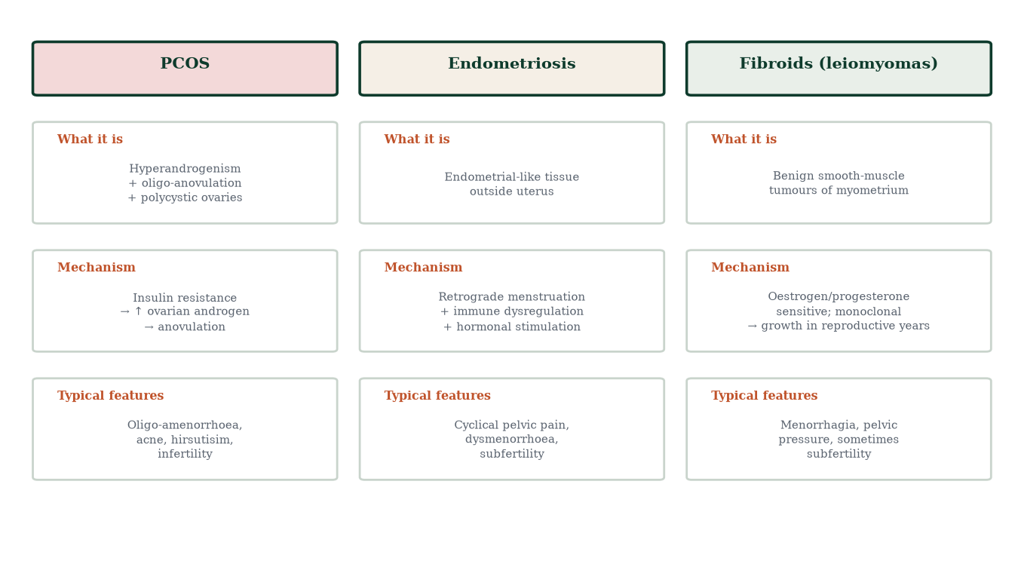
Figure 18.4 — PCOS, endometriosis and fibroids: definition, mechanism, typical features.
PCOS (~10% women) — hyperandrogenism + ovulatory dysfunction + polycystic ovarian morphology; insulin resistance drives hyperinsulinaemia → ovarian theca androgen overproduction + hepatic SHBG suppression → free androgens rise → follicular arrest → anovulation → irregular menses, acne, hirsutism, infertility; long-term metabolic risk (T2DM) — management: lifestyle, combined pill, metformin, letrozole for fertility.
Endometriosis (~10%) — endometrial-type tissue outside uterus (ovary — chocolate cysts; peritoneum; bowel; diaphragm) — retrograde menstruation + immune dysfunction + oestrogen-dependent survival; symptoms: dysmenorrhoea, dyspareunia, infertility, chronic pelvic pain; diagnosis by imaging or laparoscopy with histology; treatment: NSAIDs, hormonal suppression (COCP, GnRH agonists), laparoscopic excision; fertility may need IVF.
Fibroids (leiomyomas) — benign smooth-muscle myometrial tumours, oestrogen/progesterone sensitive; present with menorrhagia, pressure symptoms, sometimes infertility (submucosal); most need no treatment; options: IUS, tranexamic acid, GnRH agonists pre-op, myomectomy (fertility desire), hysterectomy/uterine artery embolisation (definitive, no fertility).

18.6 Sexually transmitted infections
- Chlamydia trachomatis — silent in ~70% women; ascending infection → PID → tubal damage → subfertility/ectopic risk; screening under 25 recommended; treat doxycycline 100 mg BD 7 d (treat partner).
- Gonorrhoea — similar pathway; increasing antibiotic resistance.
- HPV — oncogenic types (16/18) → cervical, anal, oropharyngeal cancers; vaccine (Gardasil 9) prevents; screening by cytology/HPV testing; warts from low-risk types.
- HIV — vertical transmission pre-ART ~25–40%; with ART <1–2%; breastfeeding depends on setting/guidance.
- Syphilis — congenital syphilis resurgent; screen in pregnancy; treat benzathine penicillin.
- HSV — neonatal herpes risk if primary lesion at delivery; caesarean indicated when lesions present.
- Prevention: condoms, mutual monogamy, screening, vaccination, prompt treatment.

18.7 Reproductive cancers — mechanisms
- Cervical — HPV E6/E7 oncoproteins inactivate p53 and Rb → uncontrolled proliferation; smoking + immunosuppression accelerate; screened via cytology/HPV; prevented by vaccination + screening.
- Endometrial — unopposed oestrogen (obesity — aromatase; PCOS anovulation; tamoxifen; exogenous oestrogen without progestin) → hyperplasia → carcinoma; most common gynaecological cancer in high-income countries.
- Ovarian — epithelial (high-grade serous — fallopian tube origin increasingly accepted), often late presentation; BRCA1/2 risk; CA-125 non-specific; salpingo-oophorectomy in high-risk.
- Testicular — germ cell tumours (seminoma/non-seminoma) in young men (peak 25–35); risk factor: cryptorchidism; >90% cure with modern chemotherapy; present as painless solid testicular mass — self-examination awareness.
- Prostate — adenocarcinoma (mostly peripheral zone), age-related; PSA screening controversial (many indolent, some lethal); MRI + biopsy; localised = surgery/radiation ± active surveillance.
- Breast — ductal/lobular; risk increases with oestrogen exposure (lifetime cycles, age at menarche/menopause, nulliparity), BRCA, lifestyle; Chapter 4 anatomy; screening mammography >50 (varies).

18.8 Menopause — the endocrine shutdown
Ovarian reserve exhausted → oestradiol and inhibin crash → FSH/LH surge (loss of negative feedback) → amenorrhoea + vasomotor symptoms — hot flushes and night sweats — caused by dysregulated hypothalamic thermoregulation driven by kisspeptin/KNDy neuron hyperactivity in the arcuate nucleus + genitourinary syndrome (vaginal atrophy, dyspareunia, recurrent UTIs) + bone loss + lipid changes → long-term CVD and osteoporosis risk. Diagnosis retrospective (>12 months amenorrhoea; FSH >25–40 IU/L supports if needed). Management: HRT (symptom relief — benefits/risks stratified by age, route, progesterone use), vaginal oestrogen (local — safest), non-hormonal options, bisphosphonates for bone (Chapter 19/20 refer).
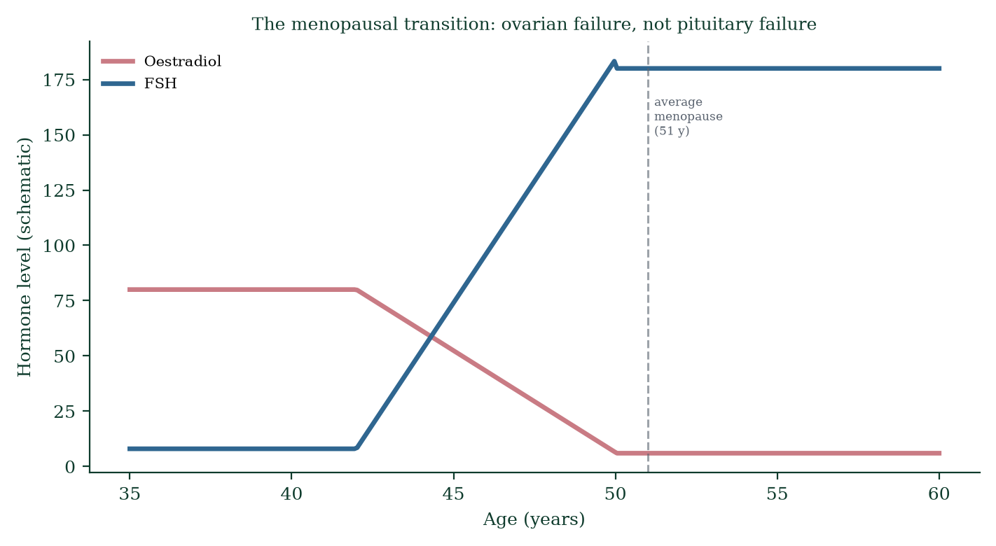
Figure 18.5 — Perimenopausal transition and menopause: inhibin and oestradiol fall, FSH rises; average menopause ~51.

18.9 Reproductive ageing in males
Gradual decline (Chapter 9): testosterone ~0.4–1%/year, free T falls more (SHBG rises), semen parameters decline slowly (volume, motility, morphology), DNA fragmentation increases, erectile latency prolongs, refractory period lengthens, prostate enlarges (BPH) — no sharp “andropause” but a slope.

18.10 Mechanism vs clinical diagnosis — an explicit distinction
This book teaches mechanisms. Clinical practice applies them. Example: PCOS the mechanism is insulin-resistant hyperandrogenism with anovulation; the diagnosis is Rotterdam criteria (2 of 3: oligo/anovulation, hyperandrogenism, polycystic ovaries). Example: low morning testosterone the mechanism is axis failure; the diagnosis requires two low morning measurements plus symptoms plus exclusion of reversible causes. Confusing mechanism with diagnosis produces both over- and under-treatment. Whenever this book names a disease, it names the mechanism that underlies it — the diagnosis is the clinician’s job, individualised to the patient.

18.11 Mechanism in depth: why contraception works when it does
Each contraceptive method is applied physiology — understanding the mechanism predicts both efficacy and failure modes:
- COCP mechanism, failure mode. Suppresses ovulation via combined negative feedback; skipping >48 h or interacting drugs (enzyme inducers — rifampicin, some antiepileptics) break suppression → escape ovulation → pregnancy. The “pill failure” cases in the literature almost always trace to missed pills or interactions — not random failure.
- POP mechanism, failure mode. Progestin-only pills mainly thicken cervical mucus and thin endometrium; ovulation suppressed only ~60% of cycles — hence strict timing (within 3 h, or 12 h for desogestrel) — a half-mechanism demands discipline.
- LNG-IUS mechanism. Local levonorgestrel keeps mucus hostile and endometrium atrophic; systemic levels low; spotting common early; bleeding reduction ~90% — treats heavy menstrual bleeding mechanistically.
- Copper IUD failure mode. If a device migrates (uterine expulsion ~5% in year 1) or is malpositioned, efficacy collapses — insertion check matters.
- Vasectomy. Sterilisation of the vas; success ≠ immediate — azoospermia confirmed on 2 consecutive semen analyses (~3 months, ~20 ejaculates) before unprotected intercourse resumes; recanalisation rare but real.
- The truth about typical-use numbers. WHO MEC (Medical Eligibility Criteria) gives method safety categories 1–4; effectiveness tables (Trussell’s data) reflect typical behaviour — counselling must include failure probabilities, not ideals.

18.12 Evidence checkpoint (ART and unexplained infertility)
- IVF for unexplained subfertility improves live-birth rates vs expectant management when duration exceeds ~2–3 years (evidence-based, Cochrane [14] 2015 analysis) — but mild/moderate cases may conceive naturally with time; patient-centred counselling matters.
- Single embryo transfer (SET) is now standard of care — twins are an iatrogenic complication with higher neonatal morbidity; SET with blastocyst culture gives equivalent cumulative live birth with sane multiplicity.
- PGT-A in women >35 reduces miscarriage but does not uniformly raise live-birth per retrieval — counselling must be honest about expectations.
- Oocyte cryopreservation for social/medical fertility preservation is technically successful (vitrification survival >85%) but carries no guarantees — numbers needed per child are age-dependent.

18.13 Mechanisms and evidence in depth: treatment pharmacology by mechanism
PCOS pharmacology. Combined pill — suppresses LH/androgens and stabilises cycle; metformin — insulin sensitiser, lowers androgen production indirectly; letrozole — aromatase inhibitor removes oestradiol feedback → FSH rises → cohort growth → ovulation; superior live-birth rates in RCTs (Legro 2014); anti-androgens (spironolactone) — receptor blockade for hirsutism; eflornithine cream for facial hair. Mechanism dictates sequencing: lifestyle → letrozole → add metformin → consider IVF if refractory.
Endometriosis pharmacology. First-line: COCP or progestins (suppress cycling) + NSAIDs; GnRH agonists (e.g., goserelin) — profound but temporary suppression (add-back oestrogen to protect bone) — for severe/refractory disease; GnRH antagonists now oral options; surgery excision for deep infiltrating disease; laparoscopy both diagnostic and therapeutic. Recurrence common — chronic, managed, rarely cured.
Menopause pharmacology logic. HRT = oestrogen replacement (± progesterone if uterus) — different routes (oral, transdermal, intravaginal, subcutaneous) with different safety profiles — transdermal avoids first-pass hepatic effect (no clotting-factor rise) making it the default if VTE risk; vaginal oestrogen for local symptoms (minimal systemic absorption); bisphosphonates for osteoporosis (bind hydroxyapatite surface, inhibit osteoclasts); denosumab (RANKL antibody, subcutaneous every 6 months); SERMs (raloxifene — agonist bone, antagonist breast/endometrium).
STI treatment by mechanism. Chlamydia — intracellular bacteria;doxycycline (30S ribosome inhibitor) cannot be killed by β-lactams reliably — hence not amoxicillin; pregnancy — azithromycin instead. Gonorrhoea — ceftriaxone (cephalosporin, cell wall); partner tracing mandatory. HPV — vaccination prevention, wart ablation or imiquimod (immune modifier) for low-risk types. Genital herpes — acyclovir/valacyclovir (DNA polymerase inhibition) — suppress recurrences, do not cure latency.

Common errors in reproductive pharmacology reasoning
- “Metformin treats fertility directly.” — it sensitises insulin; fertility follows if that is the driver.
- “Antibiotics fix PID quickly.” — tissue damage is permanent; early treatment only limits it.
- “Emergency contraception fails like the pill.” — different mechanism; Cu-IUD near-perfect.

18.14 Clinical reasoning vignettes
Case 1. A 30-year-old with 18-month infertility; normal semen, AMH, HSG; irregular menses. She has mild postcoital bleeding. Mechanism: unexplained infertility until proven otherwise; work up thoroughly — laparoscopy (endometriosis, adhesions) may reveal occult pathology; then IUI ×3 → IVF.
Case 2. A 26-year-old with new lump in the upper outer breast, 3 weeks, firm, irregular, fixed, skin retraction. Mechanism: malignancy until proven otherwise — triple assessment (clinical + imaging + needle biopsy) same day pathway; mechanism of hormonal risk: cumulative oestrogen exposure; early-stage disease curable in >80%.
Case 3. A couple with two early miscarriages; woman age 34, normal anatomy. Antiphospholipid antibody syndrome positive — lupus anticoagulant and anticardiolipin antibodies. Mechanism: antibody-mediated placental thrombosis; low-dose aspirin + LMWH improve live birth to ~70%; specialist supervision.

Self-check — can you derive these without notes?
- Explain why COCP prevents pregnancy but doesn’t sterilise.
- Derive the mechanism by which copper IUD can serve as emergency contraception.
- Explain why IVF cycles require GnRH agonist/antagonist suppression before stimulation.
- Compare mechanism and efficacy of levonorgestrel vs ulipristal vs Cu-IUD emergency contraception.
- Explain why oestrogen-only HRT must never be given to women with a uterus.

Chapter summary
- Infertility affects 1 in 6 couples; fecundability falls steeply after 30–35.
- Contraceptives act by: suppressing ovulation (hormonal), barriers, spermicidal (copper IUD), endometrial thinning (LNG-IUS), permanent sterilisation, fertility awareness.
- ART: ovulation induction → IUI → IVF/ICSI → PGT; matched to cause.
- PCOS = insulin-resistant hyperandrogenism; endometriosis = ectopic endometrium (oestrogen-driven, immune-dysregulated); fibroids = benign oestrogen-sensitive smooth muscle.
- STIs damage fertility silently (chlamydia); HPV vaccination prevents most cervical cancer.
- Menopause is HPG feedback unmasked by follicle exhaustion — a physiological transition, not an illness, but with real sequelae.

Key terms
Fecundability — per-cycle conception probability. COCP — combined oral contraceptive pill. IUD/IUS — copper/hormonal intrauterine device. IUI — intrauterine insemination. IVF/ICSI — in vitro fertilisation / intracytoplasmic sperm injection. PGT-A/M/SR — preimplantation genetic testing. PCOS — polycystic ovary syndrome. PID — pelvic inflammatory disease. HPV — human papillomavirus. BPH — benign prostatic hyperplasia. POI — premature ovarian insufficiency. Rotterdam criteria — PCOS diagnostic rule.

Review questions
Multiple choice
- Infertility is defined as failure to conceive after:
  - 6 months b) 12 months c) 24 months d) 18 months
- The most effective emergency contraception is:
  - levonorgestrel b) ulipristal c) copper IUD d) combined pill
- COCPs prevent pregnancy primarily by:
  - killing sperm b) negative feedback suppressing ovulation c) blocking implantation d) thickening mucus only
- First-line ovulation induction in PCOS is:
  - clomiphene b) letrozole (or clomiphene) c) IVF d) FSH injection
- Which STI most commonly causes tubal factor infertility?
  - HPV b) HSV c) Chlamydia trachomatis d) HIV
- Menopause is diagnosed by:
  - elevated FSH b) 12 months amenorrhoea c) hot flushes d) ultrasound
- Endometriosis tissue is:
  - cancerous b) ectopic endometrial-like tissue, oestrogen-responsive c) always ovarian d) unrelated to menstruation
- The fertile window spans:
  - day 1–7 b) only day 14 c) 5 days before ovulation + ovulation day d) the whole luteal phase
Short answer
- List the mechanism classes of contraception with one example each.
- Explain why copper IUD is effective as both contraception and emergency contraception.
- Describe the Rotterdam criteria for PCOS and the central mechanism.
- Outline the ART ladder from least to most invasive.
Explanation
- Explain how HPV vaccination prevents cervical cancer — mechanism from oncoprotein to clinic.
- Explain why menopause raises cardiovascular and osteoporosis risk.
- Explain how unopposed oestrogen drives endometrial cancer — the obesity/PCOS/tamoxifen link.
Application
- A 33-year-old woman TTC 14 months; cycles irregular; BMI 32; hirsutism. Mechanism-based workup?
- A couple has failed IVF twice with poor fertilisation. Which step is failing and what bypasses it?
- A 51-year-old woman with hot flushes asks if she “needs treatment”. Outline the mechanism-informed counselling.

Answers to review questions
- b. 12 months (6 if >35 or known factor).
- c. Copper IUD (>99%, works regardless of weight/timing up to 5 days).
- b. Negative feedback → no ovulation; progestin adds mucus/endometrium effects.
- b. Letrozole increasingly first-line (better live-birth in RCTs); clomiphene classic alternative.
- c. Often silent; ascending → PID → tubal scarring → infertility/ectopic.
- b. Retrospective clinical definition; FSH supports.
- b. Ectopic endometrial-like tissue, cyclically bleeding, inflammation/fibrosis, oestrogen-responsive.
- c. Sperm lifespan × oocyte lifespan.
- Ovulation suppression (COCP/implant), barrier (condom), spermicidal/toxic (copper IUD), endometrial thinning (LNG-IUS), permanent (vasectomy/tubal), fertility awareness (BBT/mucus), emergency (LNG/ulipristal/Cu-IUD).
- Copper ions disable sperm enzyme systems (hyaluronidase/acrosin function) and create a spermicidal intrauterine environment ± pre-implantation effects; >99% effective up to 5 days post-intercourse; works regardless of ovulation timing.
- Two of three: oligo/anovulation; clinical/biochemical hyperandrogenism; polycystic ovaries on ultrasound. Central mechanism: insulin resistance → hyperinsulinaemia → thecal androgen excess + ↓SHBG → free androgen ↑ → follicular arrest → anovulation.
- Lifestyle/ovulation tracking → ovulation induction (letrozole/clomiphene) → + IUI (3–6 cycles) → IVF (failed/tubal/severe male) → ICSI (male factor) → donor gametes/surrogacy (absolute failure) → PGT when genetic indication.
- HPV E6 ubiquitin-ligates p53; E7 binds/inactivates Rb → loss of cell-cycle checkpoints → dysplasia → carcinoma over 10–20 years; vaccination (Gardasil 9) induces neutralising antibodies preventing initial infection; screening catches dysplasia pre-cancer; vaccination + screening is the only cancer type we can eliminate.
- Oestrogen maintains endothelial nitric oxide (vasodilation), lipid profile (↑HDL, ↓LDL), and restrains bone resorption (suppresses osteoclasts via RANKL/OPG axis); menopause removes both — LDL rises, endothelial function falls, bone resorption outpaces formation — hence post-menopausal CVD and osteoporotic fractures rise; HRT modifies risk in selected early-window users.
- Continuous oestrogen without progesterone → endometrial proliferation without shedding → hyperplasia → atypia → carcinoma; obesity (adipose aromatase), PCOS (chronic anovulation), tamoxifen (agonist at endometrium), exogenous unopposed oestrogen — the shared mechanism; add progestin or remove the driver.
- Irregular cycles + high BMI + hirsutism = PCOS pattern: measure total/free testosterone, SHBG, LH/FSH, prolactin, TSH, glucose/insulin (OGTT), lipids, pelvic US (follicle count), Rotterdam criteria; exclude mimics (NCCAH — 17-OHP; androgen tumours if rapid virilisation); management: weight loss first-line (5–10% improves ovulation), letrozole for fertility, metformin if metabolic dysfunction.
- Poor/failed fertilisation at conventional IVF → sperm-side defect (zona binding/fusion failure) → switch to ICSI (direct injection); also review oocyte activation (PLCζ) — rare; given two failed fertilisations, ICSI is mandatory.
- Menopause = follicular exhaustion → E2 falls → vasomotor symptoms from hypothalamic KNDy hyperactivity; options: lifestyle, CBT, vaginal oestrogen (local), HRT if <60/<10 years from menopause and no contraindication (breast cancer, VTE) — cardiovascular/bone benefits concentrated in the early window; bisphosphonates for osteoporosis; she decides with her clinician — mechanism clarifies, choice remains hers.

Chapter 19: Genetics, Developmental Variation, and Reproductive Biology
Learning objectives. After studying this chapter you should be able to: - explain chromosomal variation and nondisjunction [10] mechanisms; - describe common aneuploidies and their features; - explain differences in sex development (DSDs) with respectful, precise language; - describe congenital reproductive conditions and their developmental origins; - explain why simplified classifications of sex fail biology — and respect its nuance.
Central question. What happens when the sex-determining cascade, the chromosomes or the genes do not follow the textbook — and how should biology and medicine respond?

19.1 Chromosomal variation as mechanism, not anomaly
Human chromosome number is 46 — 22 pairs of autosomes + XX or XY. Variation can arise at three points: meiotic nondisjunction (errors in chromosome segregation — Chapter 2), mitotic errors during cleavage (mosaicism — different cell lines with different karyotypes), and structural rearrangements (deletions, duplications, translocations, inversions). Most chromosomally variant conceptions miscarry spontaneously — the genome’s quality-control system at work; the pregnancies that continue define the spectrum of human variation.
Nondisjunction (Figure 19.1) — failure of paired chromosomes or sister chromatids to separate. Meiosis I errors affect all four products; meiosis II errors affect two. Aneuploidy incidence rises steeply with maternal age (Chapter 6) — cohesion and spindle breakdown in the decades-arrested oocyte.
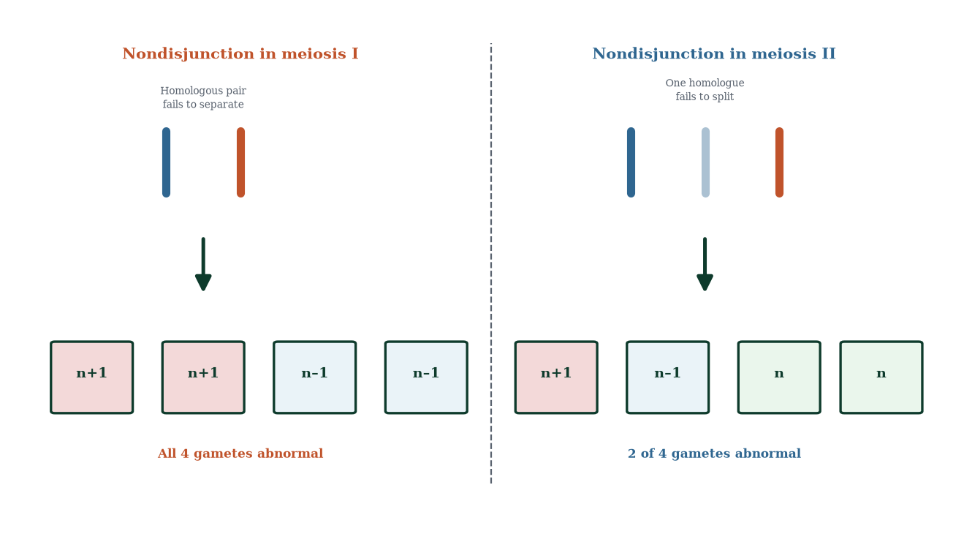
Figure 19.1 — Nondisjunction in meiosis I (all four gametes abnormal) versus meiosis II (two of four abnormal).

19.2 Common aneuploidies (Figure 19.2)
Autosomal trisomies — trisomy 21 [9] (Down syndrome: 47,XX/XY,+21) is the only autosomal full trisomy routinely compatible with a full lifespan; trisomy 18 (Edwards) and 13 (Patau) usually lead to severe multisystem disease with very high neonatal mortality. All arise from maternal meiotic nondisjunction predominantly; all risk rises with maternal age (trisomy 21: ~1:1,500 at 20 → ~1:30 at 45).
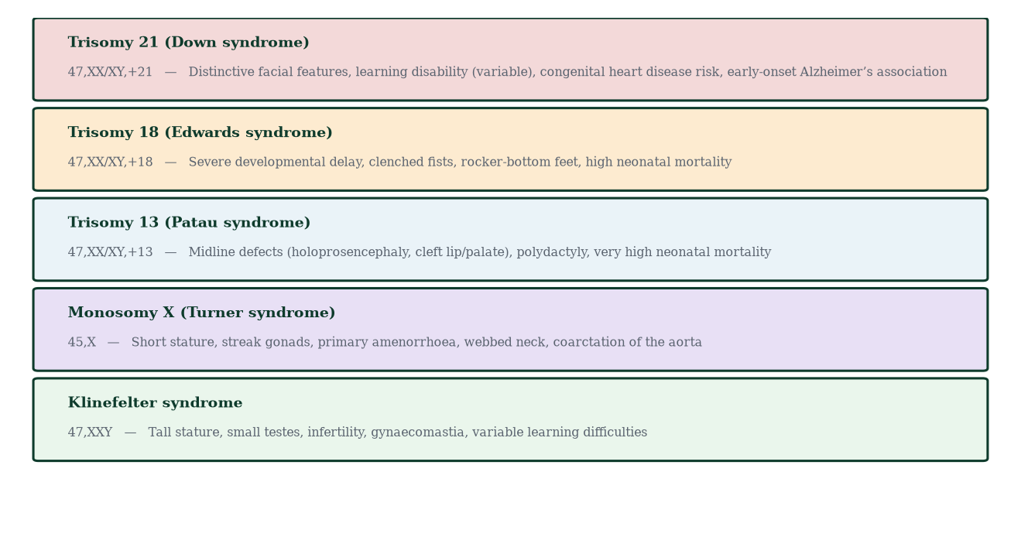
Figure 19.2 — Common autosomal aneuploidies and monosomy X: karyotypes and typical features.
Sex chromosome variations: - Monosomy X (Turner syndrome, 45,X) — the only viable monosomy; ~1:2,500 female births; short stature, webbed neck, broad chest, widely spaced nipples, streak gonads (primary ovarian insufficiency → infertility), coarctation of aorta (20%), horseshoe kidney, lymphedema of hands/feet at birth, low hairline, cubitus valgus; normal intelligence generally; fertility requires donor oocytes; GH treatment for height. - 47,XXY (Klinefelter syndrome) — ~1:600 male births; tall stature, long legs, small firm testes, infertility (azoospermia), gynaecomastia (30–50%), low testosterone, learning/language difficulties, mitral valve prolapse; fertility sometimes achievable with micro-TESE + ICSI. - 47,XXX (Triple X) — ~1:1,000; often normal phenotype; language/learning support needs variable; fertility usually intact; taller than average. - XYY (Jacobs syndrome) — ~1:1,000; tall stature; largely normal phenotype; historical myths (criminality) discredited — association with nonviolent antisocial behaviour entirely unsupported. - Mosaicism (e.g., 45,X/46,XX) — milder Turner features; often fertile.
Sex chromosome aneuploidy is usually milder than autosomal because of dosage compensation (X-inactivation silences extra Xs; small gene content of Y).

19.3 Differences in sex development (DSDs)
DSD = congenital conditions in which chromosomal, gonadal or anatomical sex is atypical. Language matters: “disorder” is discouraged; “difference” or “variation” preferred. Prevalence: ~1:4,500 births clinically recognised; broader spectrum (e.g., mild hypospadias, late-identified Klinefelter) far more common.
Mechanistic categories (Figure 19.3):
- Sex chromosome DSD — Turner, Klinefelter, chimerism/mosaicism, mixed gonadal dysgenesis (45,X/46,XY).
- Gonadal DSD — 46,XX gonadal dysgenesis (ovarian failure); 46,XY gonadal dysgenesis (Swyer syndrome — streak gonads, female external genitalia, risk of gonadoblastoma → gonadectomy recommended); mixed/ ovotesticular DSD (ovotestes with both tissues).
- Androgen DSD (46,XY) — androgen insensitivity (AIS): receptor non-function; complete (female phenotype, intra-abdominal testes, primary amenorrhoea presentation; remove testes after puberty to prevent malignancy) vs partial (variable virilisation). 5α-reductase deficiency — autosomal recessive; testosterone→DHT impaired; external genitalia ambiguous at birth (clitoromegaly, bifid scrotum); virilisation at puberty from rising testosterone; “guevedoces” of Salinas (Dominican Republic) communities — biological illustration of DHT’s necessity for external masculinisation.
- 46,XX DSD (androgen-exposed XX) — congenital adrenal hyperplasia (CAH): 21-hydroxylase deficiency → cortisol/aldosterone synthesis blocked → ACTH drive → adrenal androgen excess → virilisation of female fetus (clitoromegaly/labial fusion); most common DSD; salt-wasting crisis risk — newborn screening saves lives. Maternal androgen tumours (rare) similar effect.
- Other — persistent Müllerian duct syndrome, vanishing testes syndrome, steroidogenic enzyme defects (P450c17, StAR), WT1 mutations (Denys–Drash).
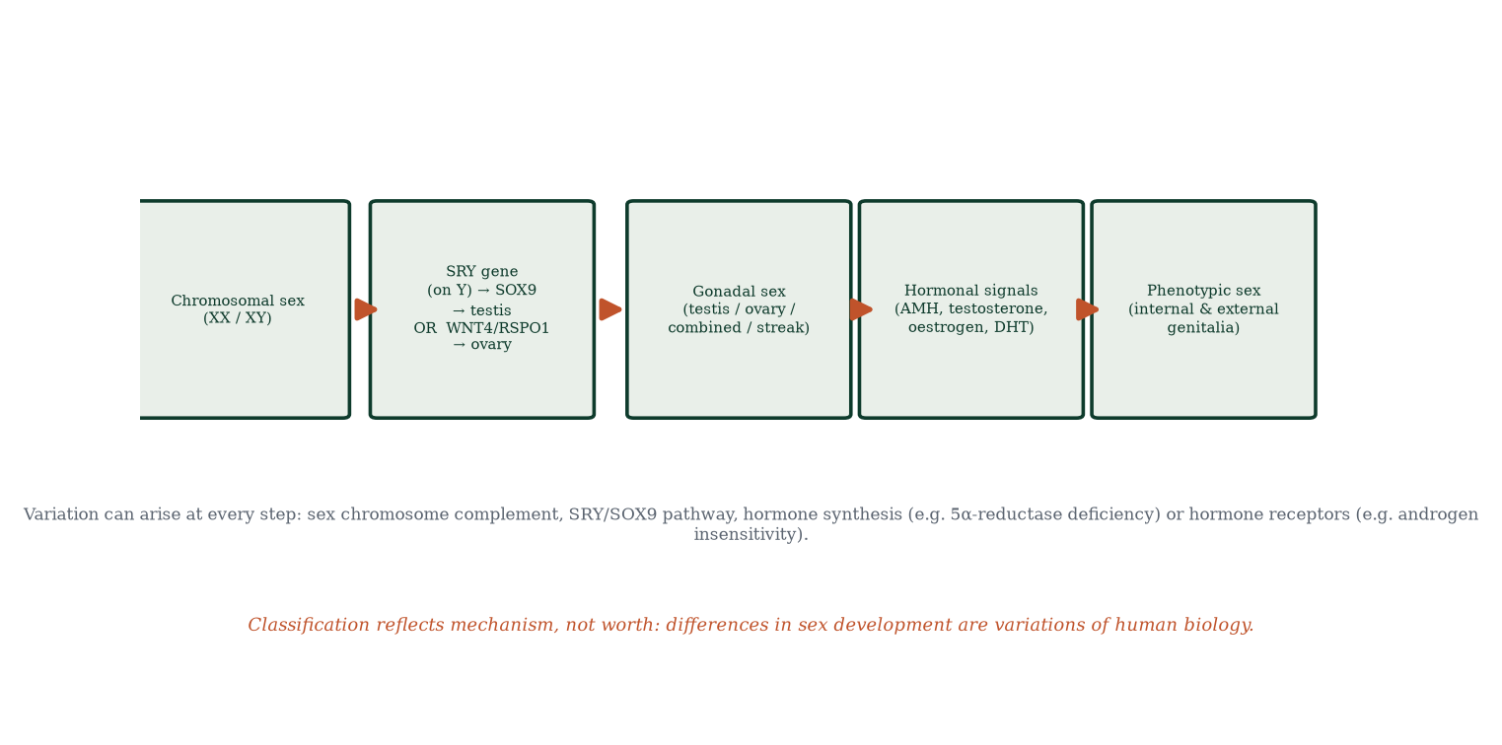
Figure 19.3 — The sex-determination cascade; variation can arise at any step — chromosomal, gonadal, hormonal or receptor level.
Principles of care: multidisciplinary team (genetics, endocrinology, surgery, psychology, ethics); no elective irreversible surgery on minors without compelling indication (defer where possible); honest disclosure; fertility counselling individualised; psychological support essential; the child’s future autonomy respected.

19.4 Congenital reproductive conditions
- Cryptorchidism — 1–3% of term male births (~30% preterm); undescended at 6 months → orchidopexy by 12–18 months — restores fertility potential and enables cancer surveillance.
- Hypospadias — urethral meatus on ventral penis (mild: glanular; severe: perineal); often with chordee (ventral curvature); surgical correction age ~6–18 months; associated with cryptorchidism in severe cases; maternal oestrogen/endocrine disruptors investigated (uncertain causation).
- Müllerian anomalies — uterine didelphys, septate/bicornuate uterus, unicornuate, cervical agenesis — MRKH syndrome (Mayer–Rokitansky–Küster–Hauser: 46,XX, normal ovaries, absent/atretic uterus/upper 2/3 vagina) — primary amenorrhoea with normal puberty (breast development from normal ovaries).
- Imperforate hymen — hematocolpos presentation at menarche (cyclical pain, no visible bleeding).
- Gonadal dysgenesis spectrum — see 19.3.
- Ovarian/testicular tumours in DSD — streak gonads with Y material have real malignant potential; individualised surveillance.
- Infertility implications — many DSDs compatible with normal life, some with fertility via assisted reproduction (donor gametes, uterine surrogacy), some not.

19.5 Limits of simplified classification
Simplified biology teaches two discrete sexes defined by chromosomes or genitalia. Real biology shows overlapping continua modulated at every cascade level. This does not erase biological sex differences (average stature, muscle mass, fat distribution, bone density, haematocrit, some disease risks) — those differences exist, are measurable, and matter clinically (drug dosing, exercise physiology, transfusion thresholds) — nor does it legitimise denying DSD-affected individuals dignity, care or identity. The scientifically correct position: sex is real, dimorphic on average, and variably developmental — a point Chapter 20 returns to.
Terminology hygiene: 46,XX / 46,XY (karyotype), gonadal sex (testis/ovary), phenotypic sex (internal/external genitalia), gender identity (person’s internal sense), gender expression (presentation), sexual orientation (attraction) — five distinct axes; conflating them has caused real clinical harm (Chapter 1). This book uses precise language and respects every individual.

19.6 Mechanism in depth: imprinting — the genome remembers its parents
Some genes are expressed from only one parent’s allele — genomic imprinting. Mechanism: parent-of-origin-specific differential DNA methylation of imprinting control regions (ICRs), established during gametogenesis (sperm and oocyte carry different methylation at ICRs; the zygote maintains them through mitosis). If the paternal allele is methylated, only maternal allele is expressed — and vice versa.
Classic disorders: - Prader–Willi syndrome (15q11–q13) — paternal deletion or maternal uniparental disomy → loss of paternally expressed genes → neonatal hypotonia, hyperphagia, obesity, hypogonadism, developmental delay. - Angelman syndrome (same region) — maternal deletion → loss of UBE3A → severe learning disability, ataxia, seizures, happy demeanour. - Beckwith–Wiedemann (11p15) — overgrowth, macroglossia, hemihypertrophy, Wilms tumour risk. - Silver–Russell (11p15/7) — growth restriction, body asymmetry.
Imprinting proves that inheritance includes epigenetic information beyond sequence — the genome’s history, not just its alphabet. It is directly relevant to reproductive biology: imprinting is erased and re-established in germ cells (failed erasure → disease), and assisted reproduction (IVF) has been investigated for subtle imprinting disturbances — mostly reassuring data, ongoing surveillance.

19.7 Evidence checkpoint (outcomes in DSD care)
- Gonadectomy decisions in CAIS balance malignancy risk (1–5% post-pubertal) against lifelong hormone replacement need; shared decision-making standard of care.
- Early vs late disclosure: honest, age-appropriate explanation from childhood outperforms secrecy — secrecy erodes trust; disclosure protects mental health.
- Fertility in CAH females: generally achievable with glucocorticoid optimisation ± assisted reproduction.
- Psychological outcomes depend more on communication and support than on surgical specifics.
- Population screening: newborn CAH screening (17-OHP) is standard in most high-income countries and saves lives from salt-wasting crisis.

19.8 Mechanisms and evidence in depth: genetic counselling — reasoning with families
Genetic counselling translates mechanism into reproductive choices. The consultation is not a test — it is risk communication:
- Pedigree construction — three generations, age at onset, miscarriages, stillbirths, consanguinity.
- Mode of inheritance elicitation — dominant (vertical, both sexes, ~50% transmission), recessive (horizontal, sibling risk 25%), X-linked (maternal → sons), mitochondrial (maternal → all children), de novo (isolated case, ~1–2% empirical recurrence).
- Risk quantification — Bayesian logic combines family history with population incidence; pre-test genetic risk is mechanism-based; post-test recalculated (e.g., a BRCA carrier mother passes 50% to daughters — reduced penetrance (60–80% lifetime risk) must be communicated numerically).
- Options articulation — PGT-M, prenatal diagnosis (CVS 11–13 wks; amniocentesis 15+ wks), NIPT (trisomy 21/18/13 + sex chromosomes, perfomed from 9–10 wks, cell-free fetal DNA in maternal plasma), expectant management, adoption — every option mechanistically described, no coercion.
- Psychosocial processing — grief, guilt (“whose fault”), family dynamics, reproductive decision-making — counsellor’s role: information + support, not answers.
A worked case. A couple has one child with cystic fibrosis (both carriers). Next pregnancy: 25% recurrence; PGT-M or early prenatal diagnosis available. If they conceive again without testing and deliver an affected daughter, they may not need another child, but the daughter herself has 100% carrier probability for future children — mechanism carries forward.

Common errors in counselling reasoning
- “Low penetrance equals not serious.” — 60% penetrance of BRCA1 is extremely significant clinically.
- “A negative NIPT means no genetic problem.” — it screens only common autosomal aneuploidies.
- “Genetic testing is deterministic.” — most variants are probabilistic; interpretation is clinical, not algorithmic.
- “If the child is healthy, we can relax.” — dynamic penetrance, later-onset disease change the picture over life.

19.9 Clinical reasoning vignettes
Case 1. A couple with a trisomy 21 baby; next pregnancy; mother 40. Mechanism: empirical recurrence ~1–2% plus maternal-age risk (at 40, ~1% baseline) — PGT-A can select euploid embryos; NIPT screening from 10 weeks; transfer decisions made jointly with the couple.
Case 2. A 17-year-old with primary amenorrhoea, normal pubarche and thelarche, ultrasound shows absent uterus. 46,XX; normal ovaries — MRKH syndrome. Mechanism: Müllerian duct failure in weeks 6–9 of development, not an endocrine disorder; vaginal dilation therapy; renal anomaly screen; psychological support; fertility requires surrogacy.
Case 3. A newborn 46,XY with bilateral non-palpable testes and a small phallus; 17-OHP elevated. Mechanism: congenital adrenal hyperplasia 46,XY? No — CAH affects 46,XX; in 46,XY with hypospadias and non-palpable testes, consider androgen synthesis defect (StAR, P450c17 deficiency). Urgent steroid replacement; DSD team involvement.

Self-check — can you derive these without notes?
- Construct a pedigree for X-linked recessive: affected grandfather → daughter → 50% carrier grandsons.
- Explain what “Lyonisation” does to X-linked gene expression and why XX females are mosaics.
- Compare karyotype, FISH, microarray — when does each add information?
- Derive why maternal age drives trisomy 21 risk at meiosis I.
- Describe CRISPR heritable editing ethics versus somatic therapy.

Chapter summary
- Chromosomal variation arises from meiotic/mitotic nondisjunction and structural rearrangements; maternal age drives meiotic error risk.
- Autosomal: trisomy 21 (viable), 18, 13 (high mortality); sex chromosome: Turner (XO), Klinefelter (XXY), XXX, XYY — milder due to dosage compensation.
- DSDs: sex chromosome DSDs, gonadal DSDs, androgen pathway DSDs (AIS, 5α-reductase deficiency, CAH) — mechanism categories, not diagnoses of worth.
- Congenital reproductive anomalies (cryptorchidism, hypospadias, MRKH, imperforate hymen) are common and treatable.
- Sex is biologically real and developmentally variable — resist both denial and oversimplification.

Key terms
Nondisjunction — failed chromosome segregation. Aneuploidy — abnormal chromosome number. Mosaicism — two or more cell lines with different karyotypes. DSD — differences in sex development. Streak gonad — fibrous non-functional gonad. AIS — androgen insensitivity syndrome. 5α-reductase deficiency — impaired T→DHT conversion. CAH — congenital adrenal hyperplasia (21-hydroxylase deficiency). MRKH — Müllerian agenesis with normal karyotype. Gonadoblastoma — germ-cell tumour risk in dysgenetic gonads.

Review questions
Multiple choice
- Trisomy 21 risk at maternal age 40 is approximately:
  - 1:10 b) 1:100 c) 1:1,000 d) 1:10,000
- The only viable full monosomy is:
  - 45,X b) 45,Y c) monosomy 21 d) monosomy 18
- The most common DSD is:
  - AIS b) congenital adrenal hyperplasia c) Turner syndrome d) Klinefelter
- Individuals with complete AIS typically present with:
  - ambiguous genitalia at birth b) primary amenorrhoea with female phenotype and testes c) salt-wasting crisis d) infertility with small testes
- X-inactivation exists to:
  - prevent recombination b) equalise X gene dosage between sexes c) silence Y d) cause mosaicism for autosomes
- Mosaicism in Turner syndrome generally results in:
  - lethal phenotype b) milder features, often fertility c) male phenotype d) no difference
- Salt-wasting CAH (21-hydroxylase deficiency) is life-threatening because of:
  - cortisol excess b) aldosterone deficiency + androgen excess c) hypoglycaemia d) hyperkalaemia alone
- DSD terminology preferred is:
  - hermaphroditism b) disorder of sex differentiation c) differences/variations in sex development d) intersex condition
Short answer
- Describe the two types of nondisjunction and their meiotic origin.
- List the four mechanistic categories of DSD with an example of each.
- Explain dosage compensation for sex chromosomes.
- Explain MRKH and its typical presentation.
Explanation
- Explain why sex chromosome aneuploidies are usually milder than autosomal ones.
- Walk through the pathway from SRY to external genitalia, identifying every step that can fail.
- Explain why maternal age is the strongest risk factor for trisomy 21.
Application
- A 16-year-old with female phenotype, primary amenorrhoea; 46,XY karyotype; intra-abdominal testes. Which cascade step failed? What is the principle of management and why?
- A newborn 46,XX with ambiguous genitalia and high 17-hydroxyprogesterone. Which mechanism? What immediate treatment?
- Parents of a newborn with XYY karyotype worry about “antisocial behaviour”. What does the evidence actually show?

Answers to review questions
- b. ~1:100 at 40 (vs 1:1,500 at 20) — meiotic nondisjunction risk climbs steeply.
- a. Monosomy X (Turner).
- b. CAH — ~1:10,000–15,000 (classic) but most common DSD requiring neonatal intervention.
- b. Female phenotype, blind vaginal pouch, inguinal/abdominal testes; present with amenorrhoea.
- b. Lyonisation silences one X per cell to match X-dose between sexes.
- b. Variable phenotype; some mosaic women have normal puberty and fertility.
- b. Aldosterone deficiency → salt wasting, hyperkalaemia, shock in first weeks; androgen excess → virilisation.
- c. Respectful person-first terminology; “disorder” and “hermaphroditism” are discouraged.
- Meiosis I nondisjunction (homologues fail to separate → all four gametes abnormal); meiosis II nondisjunction (sister chromatids fail → two normal, two abnormal). Both can involve any chromosome; maternal age-dependent.

  - Sex chromosome DSD (45,X Turner); (ii) gonadal DSD (Swyer — 46,XY streak gonads); (iii) androgen action/synthesis DSD (46,XY AIS; 5α-reductase deficiency; 46,XX CAH — androgen excess); (iv) structural anomalies (MRKH, hypospadias, cryptorchidism).
- One X per cell silenced at random in females (Lyon hypothesis) → Barr body; ~15–25% genes escape; males remain XY; equalises functional X dosage; explains Turner/Klinefelter mildness (X-inactivation/Lyon spread) — and calico-cat mosaicism as canonical demonstration.
- 46,XX; ovaries normal; Müllerian ducts fail to develop (absent uterus, upper vagina) — normal pubarche/thelarche (normal ovaries); primary amenorrhoea; renal anomalies ~25% (check kidneys); fertility requires surrogacy in most; psychological support essential.

  - X-inactivation buffers extra Xs in all sex chromosome aneuploidies; (ii) Y is gene-poor; (iii) autosomes carry dosage-sensitive developmental genes with no compensation — the embryo is exquisitely intolerant of trisomy elsewhere (most miscarry).
- SRY → SOX9 → Sertoli differentiation → AMH (Müllerian regression) + testosterone (Leydig stabilise Wolffian ducts) → DHT via 5α-reductase (external genitalia) → DHT receptor action — failures possible at: SRY (translocation, mutation), SOX9 (campomelic dysplasia), AMH/receptor (persistent Müllerian ducts), testosterone synthesis (StAR, P450c17), 5α-reductase, androgen receptor (AIS) — every step clinically demonstrated in humans.
- Oocytes arrest in prophase I from fetal life; cohesion proteins and spindles age; checkpoint stringency falls; nondisjunction at the meiosis I resumption rises with age — after ~35 exponentially. (Paternal contribution to trisomy 21 exists — ~5–10% of cases — but the maternal age effect dominates.)
- Androgen receptor level (complete AIS) — chromosomal male, gonadal male (testes), hormonal male (testosterone made normally, often high with elevated LH), phenotypic female (receptor blind). Manage with multidisciplinary DSD team; gonadectomy after puberty (malignancy risk in intra-abdominal testes); oestrogen replacement after removal; fertility counselling: no biological fertility — adoption/donor gametes; psychological support; do not reassign sex — she is female phenotypically with her own identity.
- CAH — 21-hydroxylase deficiency: cortisol and aldosterone synthesis blocked (17-OHP accumulates), ACTH surge → adrenal androgens → virilisation of 46,XX fetus; treat immediately: glucocorticoid (hydrocortisone) ± mineralocorticoid (fludrocortisone) replacement to suppress ACTH and replace cortisol; urgent electrolyte/glucose monitoring — salt-wasting crisis is fatal if missed.
- No credible evidence links XYY to aggression or criminality — early 1960s reports were methodologically flawed (institution samples); XYY men show statistically average traits with, at most, modest language delay — counselling should debunk the myth explicitly; increased height is the main consistent finding.

Chapter 20: Integrated Human Reproduction
Learning objectives. After studying this chapter you should be able to: - narrate the complete reproductive journey from gamete formation to lactation; - connect all systems and chapters into one mechanistic narrative; - explain clinical vignettes that span multiple chapters; - articulate why reproductive biology cannot be learned in fragments.
Central question. How do all the pieces — gametes, hormones, organs, embryos, placenta, birth and breastfeeding — fit into one continuous human story?

20.1 The complete journey in one narrative
Follow a single reproductive event across the whole book, and every chapter falls into place (Figure 20.1).
Cycle zero — building the gametes (Chapters 2, 5, 6). Two germline stem-cell pools, segregated since the embryonic week 4–6, spend years preparing. In the male, spermatogonia renew continuously from puberty; each meiosis shuffles alleles and four sperm leave the seminiferous tubule daily in their hundreds of millions. In the female, oocytes are arrested in prophase I from before birth; each month a follicle race selects one dominant; the LH surge releases meiosis I; the oocyte is ovulated arrested at metaphase II.
The fertile window (Chapters 7, 8). Oestradiol’s positive feedback flips the axis — the only positive feedback in human endocrinology — generating the LH surge that both triggers ovulation and readies the endometrium (with progesterone) for an embryo. BBT rises; cervical mucus becomes sperm-permissive; the corpus luteum forms and waits.
The meeting (Chapter 10). Coitus deposits 40–300 million sperm; the female tract filters them; ~100–200 reach the ampulla; capacitation primes the finalists; one binds ZP3, digests through the zona, binds Juno–izumo, fuses — Ca²⁺ oscillations from PLCζ resume meiosis II — the zygote exists. Polyspermy is prevented twice over.
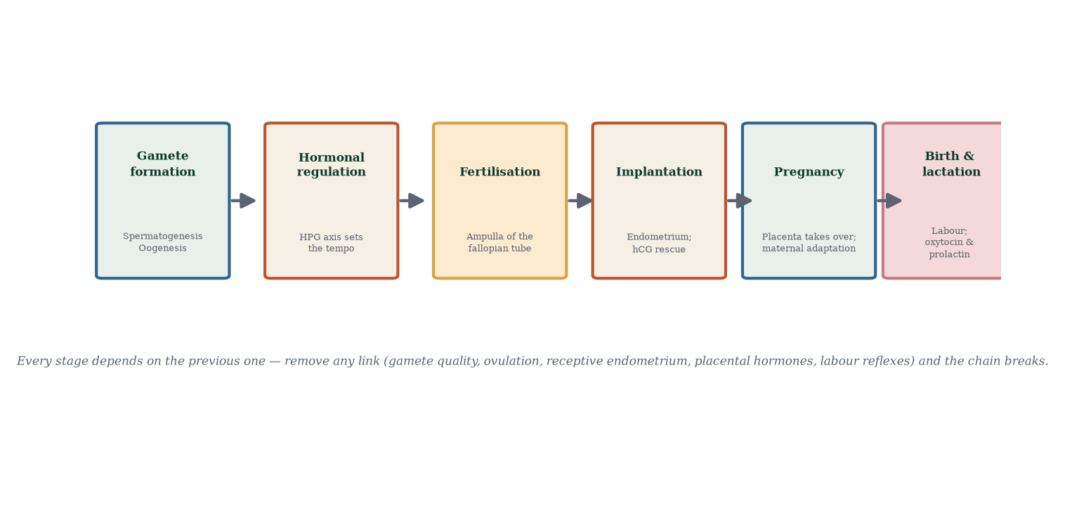
Figure 20.1 — The integrated journey from gamete formation through fertilisation, implantation, pregnancy, birth and lactation.
The arrival (Chapters 11, 12, 13). Cleavage → morula → blastocyst (trophoblast + ICM); hCG rescues the corpus luteum; implantation in the receptive window (day 6–12); gastrulation (week 3) lays the three germ layers; neurulation and folding internalise the body plan; organogenesis (weeks 4–8) — the heart beats at day 22; the fetal period (weeks 9–40) adds growth, maturation and preparation; the fetal–placental unit manufactures oestriol and hPL; maternal systems adapt massively (Chapters 14, 15).
The exit (Chapter 16). Functional progesterone withdrawal + oestrogen rise + prostaglandins + mechanical stretch → Ferguson-reflex oxytocin surge → labour stages 1–3 → the placenta cleaves away → the myometrium retracts the spiral arterioles shut → postpartum involution begins.
The nourishment (Chapter 17). Progesterone withdrawal at delivery unleashes prolactin-driven milk synthesis; suckling-driven oxytocin pulses eject milk; colostrum immunises; demand-supply matching sustains it; lactation suppresses fertility (mostly) and promotes maternal–infant physiology.
Every link in that chain is a mechanism [2] in this book — and no link is optional.

20.2 Integrated systems — where the chapters fuse
- Gametogenesis ↔ hormones: FSH/LH drive both spermatogenesis and folliculogenesis; inhibins report gamete activity back to the pituitary — a two-way conversation maintained for decades.
- Hormones ↔ anatomy: oestrogen builds the uterus and breasts; progesterone remodels them; testosterone builds the male phenotype; anatomy is impossible without the endocrine programme.
- Gametes ↔ immunity: the blood–testis barrier (Sertoli) and the trophoblast’s HLA-G/Treg truce (placenta) are the same problem — “how does the body tolerate cells with foreign or novel antigens?” — solved twice, independently, by two different tissues.
- Early pregnancy ↔ maternal metabolism: hPL diverts glucose to the fetus; maternal insulin resistance rises; the mother’s entire metabolism rewires to nourish another organism.
- Labour ↔ feedback: the only sustained positive-feedback loop in normal human physiology — it terminates itself when the stretch stimulus disappears.
- Lactation ↔ fertility ↔ contraception: suckling suppresses GnRH pulsatility; prolactin anovulation is real but incomplete; LAM works only under strict criteria — mechanism again dictates contraceptive counsel.
- Genetics ↔ variation: meiosis’s shuffling ensures every human is unique — and occasionally aneuploid; fertility medicine, screening and counselling all sit inside this same arithmetic.
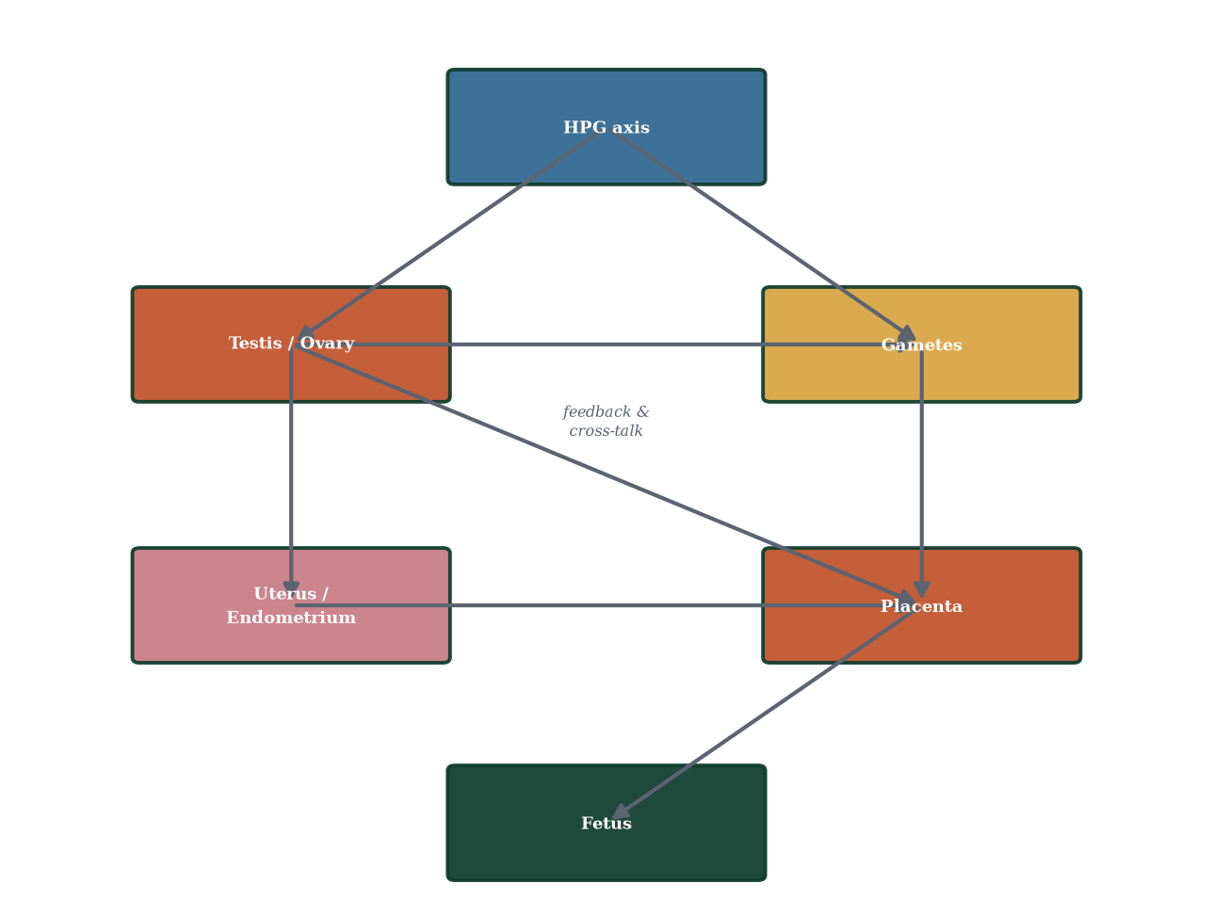
Figure 20.2 — Systems interdependence map: no part of reproduction functions in isolation; removal of any element propagates failure through the network.

20.3 Integrated clinical vignettes
Vignette 1 — The unexpected negative pregnancy test after one missed period. A 28-year-old with regular 26-day cycles has not menstruated; urine test negative. Mechanism: the test reads hCG — if implantation failed or hCG is below detection threshold, result is negative even in conception; repeat in 48–72 h; if still negative, causes include anovulation (stress, PCOS, hypothalamic), delayed ovulation, or early luteal insufficiency — check progesterone, TSH, prolactin, consider ovarian reserve; reassure that a single cycle is biological noise, repeated delays are a signal worth the axis work-up.
Vignette 2 — The IVF patient who asks “did they choose our embryo?” After stimulation, 12 oocytes retrieved; 8 fertilised; 3 reached blastocyst; one transferred; pregnancy achieved. Mechanism chain: FSH dose → cohort recruitment; hCG trigger → meiosis resumption and ovulation mimicry; ICSI bypass; blastocyst selection by morphology (+PGT-A if aneuploidy screening) — the embryo “chosen” is the one whose trophoblast and ICM structure predict successful implantation; the mother’s receptive window, embryo quality and endometrium all determine whether the test turns positive on day 12.
Vignette 3 — The athlete with amenorrhoea. A marathoner with BMI 19, intense training, amenorrhoea ×4 months. Mechanism: low leptin → hypothalamic kisspeptin suppression → GnRH pulse reduction → LH/FSH low → no folliculogenesis → low oestradiol; consequences: bone density loss (oestrogen deficiency), stress fractures, infertility; treatment: restore energy availability, reduce training load, monitor bone density; contraindicated: simply giving HRT without addressing cause.
Vignette 4 — The 46-year-old with “menopause symptoms but wants contraception”. Perimenopause: oestrogen erratic (anovulatory cycles common), progesterone scarce, pregnancy still possible — she needs contraception (until 12 months amenorrhoea) AND symptom management; mechanism: COCP masks menopause symptoms while suppressing her own erratic axis; HRT if symptomatic after menopause confirmed; both routes used in practice; fertility declines but is not zero until menopause.
Vignette 5 — The postpartum woman with a headache. Day 2 after caesarean; severe headache, blurred vision, BP 165/105, urine protein 2+. Mechanism: postpartum pre-eclampsia (onset within 48 h–6 weeks postpartum) — failed spiral artery remodelling, placental hypoperfusion resolved by delivery but anti-angiogenic state (sFlt-1) persists for weeks; emergency: magnesium sulfate, BP control, neurology review; delayed postpartum pre-eclampsia kills — mechanism ignorance here costs lives.

20.4 Reproductive biology as a way of thinking
The theme of this book has been mechanism. Everything reproductive — hormones, cells, organs, embryos — runs on cause and effect. Once you internalise that discipline, no fact is isolated, and examination answers write themselves: you reason from mechanism to conclusion. The errors in reproductive medicine are usually errors of mechanism — X-raying the wrong thing, amputating the wrong axis, giving the wrong hormone at the wrong time. The correct medicine is the one that understands the machine.

20.5 A final word — to the student
Reproductive biology is not merely the study of how babies are made. It is the study of how you were made, how every human is made, and how the species continues itself. It connects the deepest questions of identity (who am I?), fate (where did I come from?) and responsibility (what do we owe to the next generation?). The biology is intricate but coherent; the language is technical but learnable; the stakes are uniquely high. Learn it mechanistically, remember it forever, and practise it with respect.

20.6 Mechanism in depth: the systems map as a diagnostic tool
Keep Figure 20.2 open next to any reproductive case. Asking “which node failed?” organises differential diagnosis automatically. Worked through:
- Primary amenorrhoea with normal breast development, absent uterus → gonads fine (oestradiol high → breasts), Müllerian tract absent → MRKH — node: anatomy (uterus/vagina), not hormones.
- Primary amenorrhoea with absent breasts and high FSH → gonadal failure — node: ovary (streak gonads, Turner).
- Secondary amenorrhoea, low FSH, low oestradiol, athlete → axis node: hypothalamic pulse generator suppressed — node: hypothalamus/pituitary, not ovary.
- Ovulatory infertility with irregular cycles, high androgens → node: ovary (thecal hyperactivity driven by insulin resistance) — node: ovary–metabolic interface.
- Recurrent first-trimester loss + livedo reticularis → node: maternal–fetal immune interface (antiphospholipid) — node: immunity.
- Recurrent late losses + absent end-diastolic flow Doppler → node: placenta (spiral artery remodelling) — node: placenta.
- Post-term pregnancy + meconium + oligohydramnios → node: fetus/placenta — the fetal CRH clock didn’t ring on time; or placental sulfatase deficiency (placental enzyme failure) — again node: placenta.
- Postpartum haemorrhage with boggy uterus → node: myometrium — atony. Every node is reachable by reasoning.
This systems fluency — not list memorisation — is what distinguishes mechanistic masters from rote learners. It has been the argument of this book from page one.

20.7 Evidence checkpoint (the cutting edge, honestly labelled)
- Uterine transplantation — restores uterine factor infertility in ~100 reported live births worldwide; still experimental/selective.
- Mitochondrial replacement — prevents maternal mtDNA disease transmission (legal in the UK, not elsewhere) — mechanism, not miracle.
- Artificial womb / ex-vivo uterine environment (EXTEND) — preclinical; would shift viability boundaries if successful.
- Epigenetic reprogramming of the early embryo — better understanding of imprinting stability under IVF.
- Male contraceptive research — hormonal (Nestorone/testosterone gel) and non-hormonal (soluble adenylyl cyclase inhibitors, heat-based devices) — mechanism-driven design.
- Cryopreservation of ovarian/testicular tissue — already used clinically in cancer patients.
- CRISPR editing of embryos — prohibited in humans; the ethical line sits exactly at the moment one would edit heritable human genomes — reproductive biology remains at the frontier of bioethics.

20.8 Mechanisms and evidence in depth: reading an unexplained infertility case mechanistically — a masterclass
A 32-year-old woman, 30-year-old partner, 14 months TTC; cycles regular 28 d; semen normal; ultrasound normal; HSG patent; AMH normal. “Unexplained infertility” — the label hides gaps in our mechanism model. Systematic mechanistic deconstruction:
- Ovulation truly happening? Mid-luteal progesterone; LH urine kit — if both normal, ovulation confirmed; if not, subtle anovulation remains.
- Tubal patency real? HSG false negative rate ~15%; laparoscopy with dye is gold standard.
- Uterine cavity friendly? Submucosal fibroid, septum, intrauterine adhesions — saline sonohysterography or hysteroscopy; missed by HSG in a minority.
- Endometrial receptivity? ERA (endometrial receptivity assay) — transcriptomic dating of biopsy — still contested, used in recurrent implantation failure.
- Egg quality? Age-appropriate but independent variable; ICSI bypasses fertilisation failure but not oocyte immaturity.
- Sperm function beyond count? DNA fragmentation >30% doubles miscarriage risk; sperm-cervical mucus interactions not visible on routine testing.
- Immune factor? Antiphospholipid antibodies triple IF miscarriages; elevated NK cell populations are studied but not standard of care.
- Endocrine subtlety? Subtle thyroid dysfunction (TSH >2.5), prolactin borderline, vitamin D deficiency — all contested associations, routinely tested, mechanisms plausible.
The mechanistic answer. Unexplained infertility is the clinical confession of the limits of current testing, not a biological void. Step up empirically: 3–6 cycles monitored IUI (after capacitated sperm timed to surge), if fails → IVF/ICSI. ~85% of couples with unexplained infertility achieve pregnancy within 2 years of unprotected intercourse; 12% of all infertility remains genuinely unexplained after full workup.

Common errors in integrated reasoning
- “Test results normal = nothing wrong.” — tests measure probabilities, not realities.
- “Unexplained means psychological.” — rarely; it means untested or mechanism unknown.
- “IVF will always work.” — ~40% live birth per transfer <35; lower >40; couples still need realism.

20.9 Clinical reasoning vignettes
Case 1. An infertile couple, both 32, with regular cycles, normal semen, open tubes, normal AMH — “unexplained”. Mechanism: all tests measure probabilities, not realities; mechanism suggests subtle egg-quality or sperm-function deficit; 3 cycles IUI (timed capacitated sperm) → IVF. Cumulative live-birth rate 60–70% after 3 IVF cycles; realistic counselling essential.
Case 2. A 25-year-old athlete with secondary amenorrhoea × 6 months, BMI 18.5, knee injury, training 7 days/week. Mechanism: functional hypothalamic amenorrhoea — energy deficit → leptin↓ → kisspeptin↓ → GnRH↓ → LH/FSH↓ → anovulation + low oestradiol + bone loss. Treatment: restore energy availability, reduce load, monitor bone; NOT OCPs without addressing cause.
Case 3. A 52-year-old woman, 14 months amenorrhoea, hot flushes, asking about HRT. Mechanism: follicular depletion → oestradiol collapse → KNDy hyperactivity → vasomotor symptoms; transdermal HRT if no contraindication; lowest effective dose for symptom control; bone and cardiovascular benefits largest when within 10 years of menopause.

Self-check — can you derive these without notes?
- Build a complete reproductive timeline (gamete → birth → lactation) from memory.
- Identify which chapter explains each stage and how the hormones connect them.
- Construct a differential for secondary amenorrhoea with normal FSH/LH.
- Explain why delaying fertility treatment beyond age 38 requires urgency.
- Describe how a GP would sequence workup for a couple TTC 12 months — mechanism-based ordering.

Chapter summary
- The reproductive journey is one continuous mechanistic story from germ cell to grandchild.
- Hormones choreograph every stage; organs are instruments of endocrine intent.
- Feedback loops (mostly negative, one famous positive) govern pace and timing.
- Integration is the real subject of this book — gametes → fertilisation → implantation → pregnancy → birth → lactation — every arrow is a mechanism.
- Clinical mastery = mechanism reasoning applied at the bedside.

Key terms
Integration — systems acting jointly, not separately. Positive feedback — self-amplifying loop terminating at delivery. Fecundability — per-cycle conception chance. hCG rescue — embryonic hormonal life support. Ferguson reflex — labour’s self-amplifying loop. Luteal–placental shift — steroid relay. Functional hypothalamic amenorrhoea — reversible axis shutdown in energy deficit. Integrated vignettes — multi-system clinical reasoning.

Review questions
Multiple choice
- The only sustained positive-feedback loop in normal human physiology is in:
  - lactation b) labour c) ovulation induction d) menstruation
- Fertility declines most steeply in women after age:
  - 25 b) 30 c) 35 d) 40
- Mechanistically, a missed period at day 35 with negative hCG least likely indicates:
  - anovulation b) late ovulation c) early pregnancy d) ovarian cancer
- The Ferguson reflex is initiated by:
  - oxytocin b) cervical stretch c) fetal CRH d) progesterone withdrawal
- Lactational amenorrhoea is reliable only when:
  - the mother feels tired b) baby sleeps through the night c) exclusive feeding + <6 months + amenorrhoea d) any feeding pattern
- Oxytocin during lactation comes from the:
  - anterior pituitary b) posterior pituitary c) hypothalamus directly d) ovary
- Which hormone directly drives fetal glucose uptake?
  - hPL b) maternal insulin c) fetal insulin d) placental CRH
- The correct clinical approach to perimenopause is:
  - treat with HRT only b) contraception + symptom management individualised c) ignore symptoms d) surgery
Short answer
- Trace the complete journey of a fertilised egg from ampulla to birth, in order, with approximate days.
- Explain why reproductive biology is “the only integrated system spanning two bodies”.
- Name the five cascade levels of sex determination and one clinical divergence each.
- Describe one mechanism of infertility from each part of the book (gamete, hormone, tubal, uterine, immune).
Explanation
- Explain why forgetting the menstrual cycle days is harmless if you understand the HPG axis — reconstruct it mechanistically.
- Explain why a labouring woman has the strongest positive-feedback-resistant uterus in the human body — and why it terminates.
- Explain the mechanism by which lactation both nourishes the infant and suppresses the mother’s fertility.
Application
- A couple wants to optimise conception naturally. Give a mechanism-based plan.
- A woman’s AMH is low at 28. Explain what the mechanism predicts and outline options.
- A 45-year-old man asks about “his fertility window”. What does paternal age data show mechanistically?

Answers to review questions
- b. Cervical stretch → oxytocin → contractions → more stretch — terminates when stimulus disappears at delivery.
- c. ~35; aneuploidy and oocyte reserve both fall sharply then; fecundability ~5% at 42.
- d. Ovarian cancer does not cause missed periods with negative hCG typically; anovulation, late ovulation or early pregnancy do.
- b. Cervical stretch is both stimulus and effect — self-amplifying.
- c. All three criteria must hold; otherwise contraception required.
- b. Posterior pituitary releases oxytocin made by hypothalamic neurons.
- c. Fetal insulin (from fetal pancreas) — maternal insulin doesn’t cross.
- b. Individualised contraception + symptom care until menopause confirmed; not reflexive HRT.
- Fertilisation (ampulla, day 0) → cleavage (day 0–3) → morula (day 3–4) → blastocyst (day 5–6) → implantation (day 6–12) → bilaminar disc (week 2) → gastrulation (week 3) → organogenesis (weeks 4–8) → fetal period (weeks 9–40) → labour → birth; hCG detectable from day ~8 post-ovulation.
- No other physiological system requires one body to physically construct, nourish and expel another — immune tolerance, shared circulation, coupled hormonal axes, shared fate — hence integrated by necessity, and the failure modes span two organisms.
- Chromosomal (46,XX/XY; DiGeorge? no — Turner 45,X), gonadal (streak gonads in Swyer 46,XY), hormonal (5α-reductase deficiency), receptor (androgen insensitivity), phenotypic (hypospadias, clitoromegaly) — every step clinically demonstrated.
- Gamete: azoospermia (post-chemo), oocyte depletion (POI); hormone: hypogonadotropic hypogonadism, luteal insufficiency; tubal: PID adhesions; uterine: fibroid/polyp, septum; immune: antiphospholipid antibodies, elevated NK cells (contested) — every mechanism is a real clinic category.
- Day 1 bleed = progesterone/oestrogen crash after failed luteal rescue; FSH rises (low feedback); cohort grows; oestradiol rises (proliferative endometrium); dominant follicle suppresses FSH; sustained high oestradiol flips feedback positive → LH surge ~day 14; ovulation; corpus luteum makes progesterone (secretory endometrium); if no hCG rescue → involution day ~24–26; menses day 28 — reconstructible entirely from Chapter 7–8 logic without memorising days.
- Oxytocin surges are recruited by cervical stretch; contractions themselves create the stretch; the loop is bounded by anatomy — once the head is delivered, stretch ends, oxytocin falls; the loop is self-limiting by design (unlike pathological positive feedback such as in some sepsis cascades) — nature’s most violent and most self-terminating reflex.
- Suckling → hypothalamic dopamine falls → prolactin surges → milk synthesised; suckling → oxytocin pulses → milk ejected; prolactin also suppresses GnRH pulsatility → LH/FSH fall → anovulation — suckling is both the infant’s meal ticket and the mother’s birth-spacing mechanism.
- Track cycle (BBT + mucus or LH strips); time intercourse every 1–2 days in fertile window (5 days pre-ovulation + ovulation day); optimise sperm health (no smoking, moderate alcohol, normal BMI, avoid heat, 3-month optimization horizon); adequate folate (preconception); avoid lubricants toxic to sperm (use sperm-friendly ones); review medications; if not conceived in 12 months (6 if >35), seek specialist review.
- Low AMH at 28 = diminished ovarian reserve; mechanism: accelerated follicle pool depletion; options: prompt conception attempts, oocyte cryopreservation if delaying, IVF with possible donor oocytes (if POI develops), early specialist referral — age dominates reserve in fecundability models.
- Paternal age effect is real but modest: gradual semen quality decline, rising DNA fragmentation (~0.3–0.7%/year), small increases in autosomal dominant mutations (de novo), possibly higher risk of certain psychiatric/neurodevelopmental conditions — but no discrete “cliff”; mechanism = replication errors accumulating in spermatogonial stem cells across decades.

Glossary of Reproductive Biology
Acrosome reaction — exocytosis of acrosomal enzymes triggered by zona binding, enabling penetration of the zona pellucida. Activin — peptide that stimulates FSH secretion. AMH — anti-Müllerian hormone; marker of ovarian reserve and male defeminising hormone. Allele — alternative version of a gene. Aneuploidy — abnormal chromosome number. Anovulation — absence of ovulation in a cycle. Atresia — degeneration of ovarian follicles. Capacitation — final maturation of sperm in the female tract. Cholesterol — precursor of all steroid hormones. Chromosome — DNA-protein structure carrying genes. Cleavage — rapid mitotic divisions of the zygote without growth. Corpus luteum — transient progesterone-secreting endocrine gland of the post-ovulatory ovary. Cortical reaction — zona-hardening response preventing polyspermy. Crossing over — exchange of chromosomal segments between homologues in meiosis I. DHT — dihydrotestosterone, potent androgen derived from testosterone. Diploid — two chromosome sets. Dominant follicle — single follicle selected for ovulation in each cycle. Dysmenorrhoea — painful menstruation. Ectopic pregnancy — implantation outside the uterine cavity. Embryo — developing human from implantation through week 8. Endometrium — inner secretory lining of the uterus. Fecundability — probability of conception per cycle. Fetus — developing human from week 9 to birth. Folliculogenesis — development of ovarian follicles. Gamete — haploid reproductive cell. Gastrulation — formation of the three germ layers. Genomic imprinting — parent-of-origin-specific monoallelic gene expression. Germ layers — ectoderm, mesoderm, endoderm. hCG — human chorionic gonadotrophin; embryonic LH-mimetic hormone. HPG axis — hypothalamic–pituitary–gonadal axis. Implantation — embedding of the blastocyst into the endometrium. Inhibin — peptide hormone selectively suppressing FSH. Karyotype — organised display of an individual’s chromosomes. Luteinising hormone (LH) — pituitary hormone triggering ovulation and stimulating testosterone production. Meiosis — reduction division producing haploid gametes. Menopause — permanent cessation of menstruation after 12 months’ amenorrhoea. Mitosis — division of somatic cells producing identical daughters. Mittelschmerz — mid-cycle pain at ovulation. Myometrium — smooth-muscle layer of the uterus. Neurulation — formation of the neural tube from ectoderm. Nondisjunction — failure of chromosomes to separate. Oogenesis — development of oocytes in the ovary. Ovarian reserve — the pool of remaining primordial follicles. PID — pelvic inflammatory disease. PCOS — polycystic ovary syndrome. Placenta — fetomaternal organ of exchange and hormone production. Polyspermy — fertilisation by more than one sperm (blocked physiologically). Quickening — first maternal perception of fetal movements. Red Queen hypothesis — evolutionary explanation for sexual reproduction via parasite co-evolution. Sertoli cells — supporting cells of the seminiferous tubule. Spiral arterioles — coiled endometrial vessels that undergo vasospasm at menstruation. SRY — testis-determining region of the Y chromosome. Steroid hormone — cholesterol-derived lipophilic hormone. Syncytiotrophoblast — multinucleated outer trophoblast layer. Synapsis — pairing of homologous chromosomes in meiosis I. Teratogen — agent causing abnormal development. Testosterone — principal androgen, made by Leydig cells. Trophoblast — outer blastocyst layer giving rise to the placenta. Vas deferens — muscular duct conveying sperm from epididymis to ejaculatory duct. X-inactivation (lyonisation) — random silencing of one X chromosome in female cells. Zona pellucida — glycoprotein shell surrounding the oocyte.

Answers consolidated
Answers to all review questions are printed at the end of each chapter. There is no separate consolidated answer key; consult each chapter.

Acknowledgements
The author acknowledges the pioneering clinicians and scientists whose work underpins this field, and the students whose probing questions shaped the clarity of this book. Editorial production was carried out by INKFREEDOMPUBLISHING. All errata will be noted in future printings; please send corrections to the publisher.

Reference List
- Hall JE. Guyton and Hall Textbook of Medical Physiology. 13th ed. Philadelphia: Elsevier; 2015.
- Jones RE, Lopez KH. Human Reproductive Biology. 4th ed. Amsterdam: Academic Press; 2013.
- Campbell NA, Urry LA, Cain ML, Wasserman SA, Minorsky PV, Reece JB. Campbell Biology. 12th ed. New York: Pearson; 2020.
- Moore KL, Persaud TVN, Torchia MG. Before We Are Born: Essentials of Embryology and Birth Defects. 9th ed. Philadelphia: Elsevier; 2016.
- Larsen WJ. Human Embryology. 4th ed. Edinburgh: Churchill Livingstone/Elsevier; 2011.
- Strauss JF, Barbieri RL, editors. Yen and Jaffe’s Reproductive Endocrinology. 8th ed. Philadelphia: Elsevier; 2018.
- Speroff L, Fritz MA. Clinical Gynecologic Endocrinology and Infertility. 8th ed. Philadelphia: Lippincott Williams & Wilkins; 2011.
- Cunningham FG, Leveno KJ, Bloom SL, Spong CY, Dashe JS, Hoffman BL, Casey BM, Sheffield JS. Williams Obstetrics. 25th ed. New York: McGraw-Hill; 2018.
- Strachan T, Read AP. Human Molecular Genetics. 4th ed. Abingdon: Garland Science; 2011.
- Hassold T, Hunt P. To err (meiotically) is human: the genesis of human aneuploidy. Nat Rev Genet. 2001;2(4):280-291.
- Zegers-Hochschild F, Adamson GD, Dyer S, Racowsky C, de Mouzon J, Sokol R, Rienzi L, Sunde A, Schmidt L, Cooke ID, Simpson JL, van der Poel S. The International Glossary on Infertility and Fertility Care, 2017. Hum Reprod. 2017;32(9):1786-1801.
- World Health Organization. Medical eligibility criteria for contraceptive use. 5th ed. Geneva: World Health Organization; 2015.
- Trussell J. Contraceptive failure in the United States. Contraception. 2011;83(5):397-404.
- Pandian Z, Gibreel A, Bhattacharya S. In vitro fertilisation for unexplained subfertility. Cochrane Database Syst Rev. 2015;(11):CD003357.
- MRC Vitamin Study Research Group. Prevention of neural tube defects: results of the Medical Research Council Vitamin Study. Lancet. 1991;338(8760):131-137.
- Zondervan KT, Becker CM, Missmer SA. Endometriosis. N Engl J Med. 2020;382(13):1244-1256.
- Stewart EA. Uterine fibroids. Lancet. 2001;357(9252):293-298.
- Goldstein I, Lue TF, Padma-Nathan H, Rosen RC, Steers WD, Wicker PA. Oral sildenafil in the treatment of erectile dysfunction. N Engl J Med. 1998;338(20):1397-1404.
- Cole LA. hCG, the wonder of today’s science. Reprod Biol Endocrinol. 2012;10:24.
- Steegers EA, von Dadelszen P, Duvekot JJ, Pijnenborg R. Pre-eclampsia. Lancet. 2010;376(9741):631-644.
- Harlow SD, Gass M, Hall JE, Lobo R, Maki P, Rebar RW, Sherman S, Sluss PM, de Villiers TJ. Executive summary of the Stages of Reproductive Aging Workshop + 10: addressing the unfinished agenda of staging reproductive aging. J Clin Endocrinol Metab. 2012;97(4):1159-1168.
- Teede HJ, Misso ML, Costello MF, Dokras A, Laven J, Moran L, Piltonen T, Norman RJ. International evidence-based guideline for the assessment and management of polycystic ovary syndrome 2018. Melbourne: Monash University; 2018. doi:10.26180/5a1ea0d6a200a.
- Kramer MS, Kakuma R. Optimal duration of exclusive breastfeeding. Cochrane Database Syst Rev. 2012;(8):CD003517.
- Goldenberg RL, Culhane JF, Iams JD, Romero R. Epidemiology and causes of preterm birth. Lancet. 2008;371(9606):75-84.
- Barrett KE, Barman SM, Brooks HL, Yuan JXJ. Ganong’s Review of Medical Physiology. 25th ed. New York: McGraw-Hill; 2016.
- Boron WF, Boulpaep EL. Medical Physiology. 3rd ed. Philadelphia: Elsevier; 2016.
- Tortora GJ, Derrickson B. Principles of Anatomy and Physiology. 15th ed. Hoboken: Wiley; 2016.
- World Health Organization. WHO recommendations on postnatal care of the mother and newborn. Geneva: World Health Organization; 2013.
- World Health Organization. WHO recommendations on antenatal care for a positive pregnancy experience. Geneva: World Health Organization; 2016.
- International Association of Diabetes and Pregnancy Study Groups Consensus Panel. International Association of Diabetes and Pregnancy Study Groups recommendations on the diagnosis and classification of hyperglycemia in pregnancy. Diabetes Care. 2010;33(3):676-682.
- Clermont Y. Kinetics of spermatogenesis in mammals: seminiferous epithelium cycle and spermatogonial renewal. Physiol Rev. 1972;52(1):198-236.
- Knobil E, Neill JD, editors. Knobil and Neill’s Physiology of Reproduction. 3rd ed. San Diego: Academic Press; 2006.
- National Institute for Health and Care Excellence. Fertility problems: assessment and treatment. Clinical guideline CG156. London: NICE; 2013. www.nice.org.uk/guidance/cg156
- Manson JE, Chlebowski RT, Stefanick ML, et al. Menopausal hormone therapy and long-term all-cause and cause-specific mortality. The Women’s Health Initiative randomized trials. JAMA. 2017;318(10):927-938.
- WOMAN Trial Collaborators. Effect of early tranexamic acid administration on mortality, hysterectomy, and other morbidities in women with post-partum haemorrhage (WOMAN): an international, randomised, double-blind, placebo-controlled trial. Lancet. 2017;389(10084):2105-2116.
- World Health Organization. International statistical classification of diseases and related health problems, 11th revision (ICD-11). Geneva: WHO; 2019. www.who.int/standards/classifications/classification-of-diseases

