Bead on a String

Equations governing the Bead
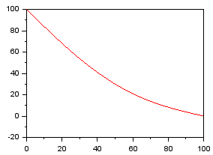
[diagram]

Figure 1 Bead on a wire, y = f(x) , units: m
Governing Equations:

Conservation of energy: Condition Potential energy converted to kinetic energy.
Manipulating to get the final result.

The distance travelled: | Time taken for interval:
Average velocity: | Where i is iteration interval.

Solution by Iteration

Curve given by: X[i] and Y[i].
Velocity given by: V[i] = (sqrt(2*g*(Y0 – Y[i])) + sqrt(2*g*(Y0 – Y[i+1])))/2
Distance given by : S[i] = sqrt(X[i] ^2 + Y[i] ^2 )
Time taken : T[i] = S[i] / V[i]
Total Time = sum( T[i] )

