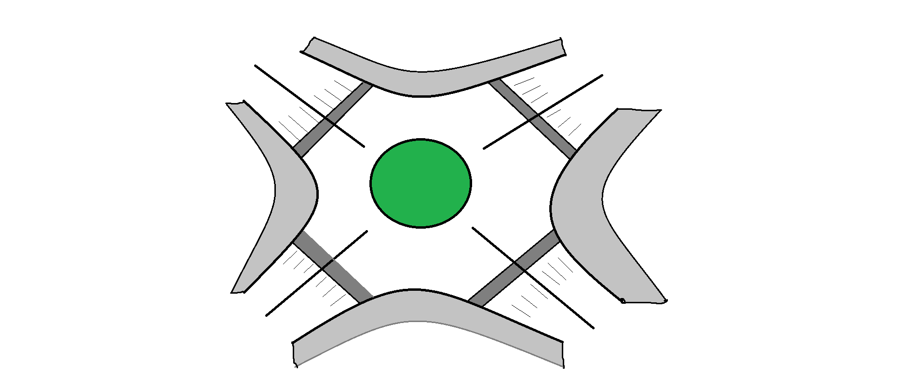

**The given image shows the road intersection for which a number of safety measures are implemented.**

The roads has been designed in keeping maximum safety of the Pedestrians

1. First and foremost is the central circle, which divides traffic for easy manoeuvrability and also slows it down for less probability of an accident.
2. The left turn will always be available to the drivers. If the driver wants to take a right turn He has to take a roundabout of the centre circle and then go to his desired path.
3. By keeping the left turn always open the vehicles are constantly moving so less traffic.
4. There is a zebra crossing meant for pedestrians to cross the roads. Which is also assisted by a speed breaker, for extra safety of pedestrians.
5. The Speedbrakers add an extra layer to slow down the drivers. Due to this the cars have already slowed down as they approach Traffic Signal Lights. making it less prone to collisions on the signal.
6. The border routes indicated by light grey colour are for cyclists, strollers and people on wheelchairs to use.
7. They have got their own lane and hence they are not slowing the vehicles on the road and can move at their own pace without any stress.
8. There is a crossing available for cyclists and handicapped people right besides zebra crossing. Which helps in maintaining their safety.
9. The speed limit is set to 20KMPH during school hours.

**Future Enhancements**

1. As a future enhancement we can make the crossing for cyclist\handicapped and pedestrians a subway.
2. Subway allows constant moving of vehicles and it also eliminates the risk of any collision with the pedestrian. To greatly reduce accidents and make traffic more efficient.
3. It will be a future enhancement, hoping that by then, the handicapped people will have some sort of vehicle which will be powered by electricity and motor for their ease. They should be able to access the subway which may have a steep climb.